Collection Type Setter based

:

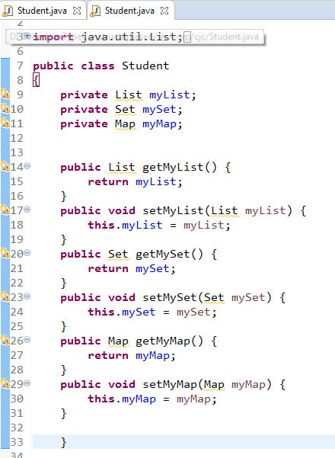

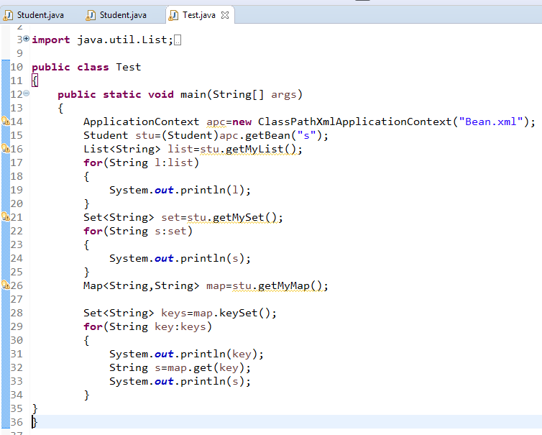

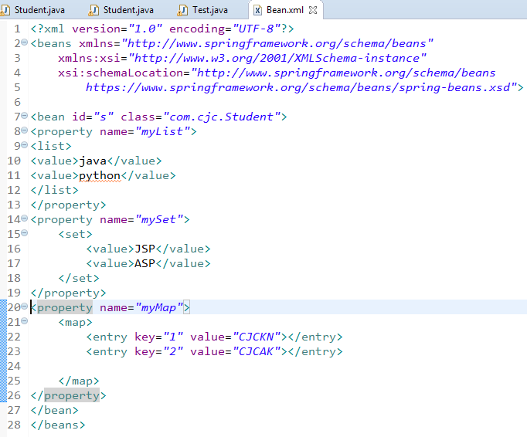

Collection Type Constructor Based:

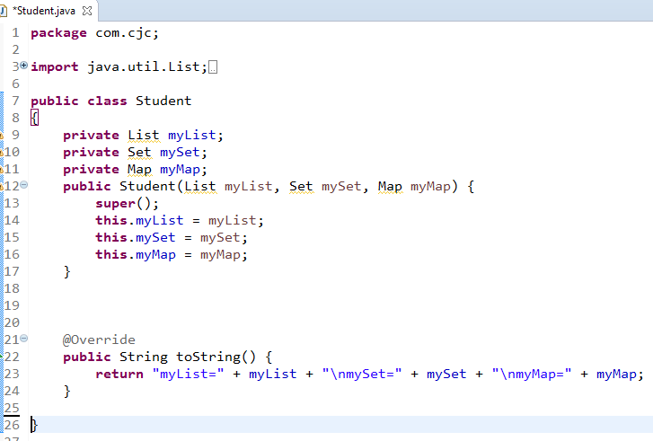

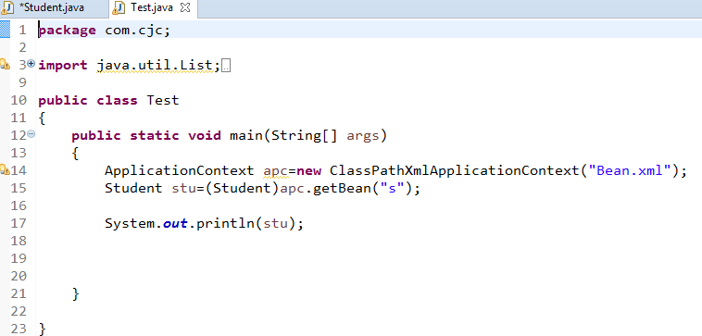

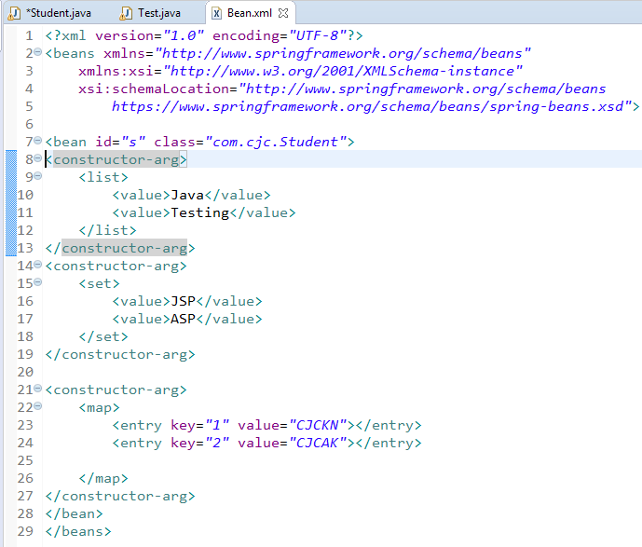

Example for how setter based will override constrctor based injection:

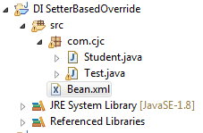

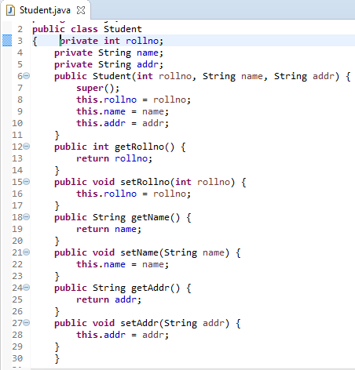

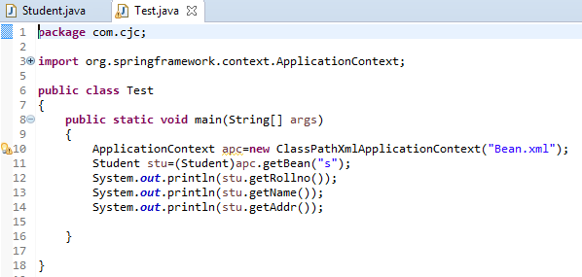

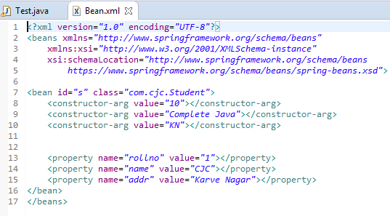

OutPut:

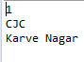

In this scenario setter based DI will Override Constructor Based Injection because first constructor will call when Object is initialize and then setter based will call so first constructor based values are set and then setter based so o/p will be 1 cjc karvenagar.

Setter Injection –byInstance:

ByInstance – creating bean inside bean

Files required : 1)Student.java

2) Address.java

3) Test.java

4)spring.xml +SpringJars

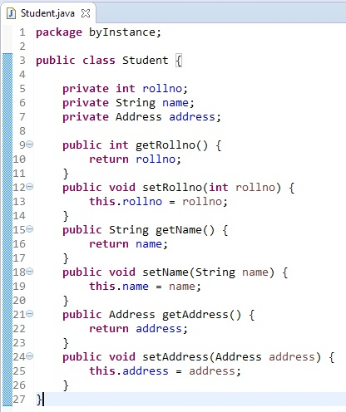

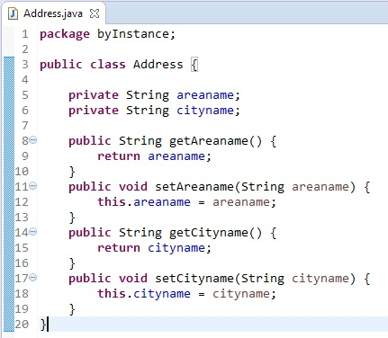

Here we are creating bean for address class inside bean of student class.

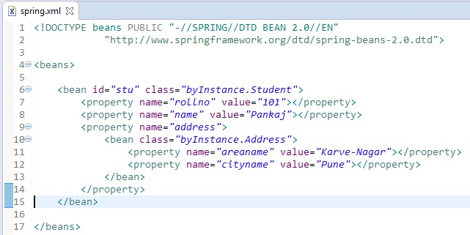

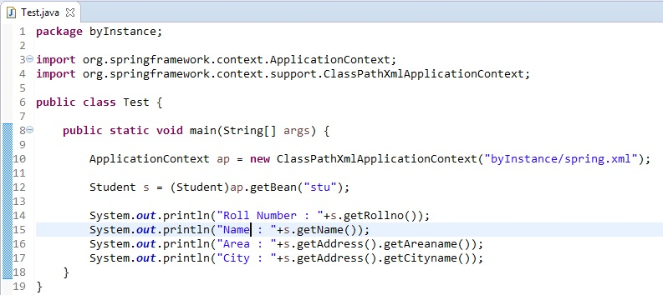

Output :

