Benchmarking LLMs against Navigation Tools
Progress update · October 2026
Ishan Mehta · Supervisor: Prof. Vinayak Naik
The question
If you ask an AI model how long a drive across Bangalore will take — without giving it a map — how close does it get to Google Maps? This update covers the first full round of that comparison.
What we did
- Picked 72 trips between 64 well-known Bangalore places (metro stations, junctions, hospitals, tech parks…), 1–29 km long and spread across the city (Figure 1).  - Asked Google Maps for the driving time of every trip at 8 am, 2 pm, 6 pm and 11 pm on each day of one week — 2,016 answers (Google’s predicted traffic, 5–11 Oct 2026).  - Asked Gemini (gemini-3.8-flash) the same 2,016 questions using only the place names, day and time — no map, no internet. It replied with a route, distance, time and traffic level.  - Compared the two answers trip by trip. Total cost: under $2 (≈ ₹160).  - An earlier pilot used tiny road segments with vague names; we redesigned it before this round. | 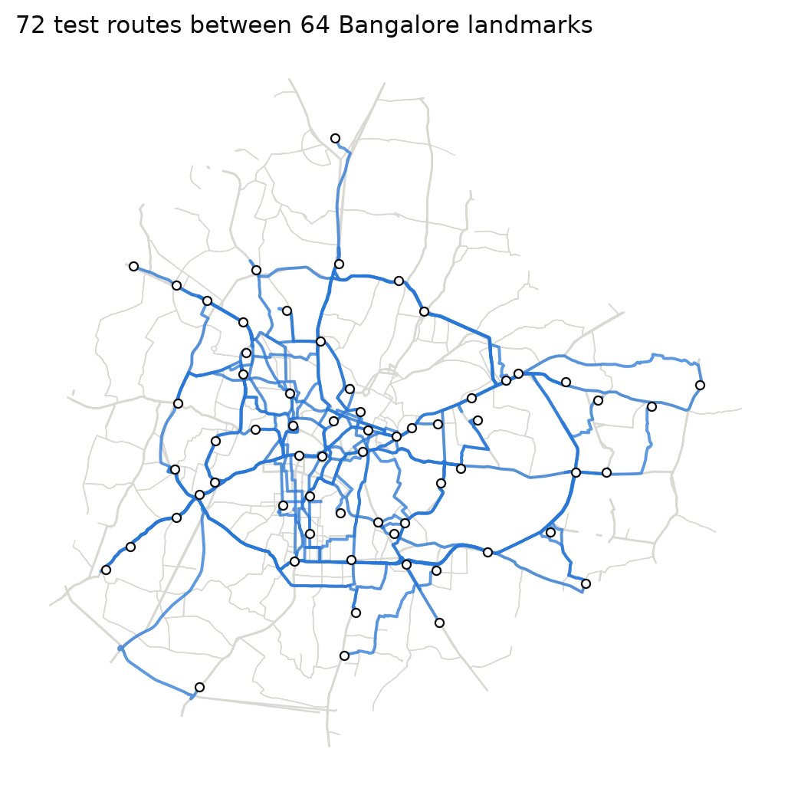  Figure 1. The 72 test routes (Google’s paths) between the landmarks.
What we found
- It knows Bangalore’s places and roads. All 64 landmarks were placed correctly (typically ~250 m off), and about 95% of the roads it names are real.
- Distances are close. Gemini’s distances are typically only ~6% longer than Google’s.
- Travel time is where it goes wrong. On weekdays it overestimates rush hour (+49% at 8 am, +36% at 6 pm) and underestimates night trips (−12%) — see Figure 2.
- It knows when traffic is bad, but exaggerates it. It roughly doubles every trip at rush hour, while Google says about 1.3×. And it applies the same multiplier to every route — a city-wide rule of thumb, not knowledge of specific roads.
- It doesn’t know the exact route. Only about 1 in 5 roads on Google’s route appear in Gemini’s answer. Short trips (1–5 km) are the hardest.
- A simple formula does about as well. Straight-line distance × typical speed for that time of day is about as accurate as Gemini.
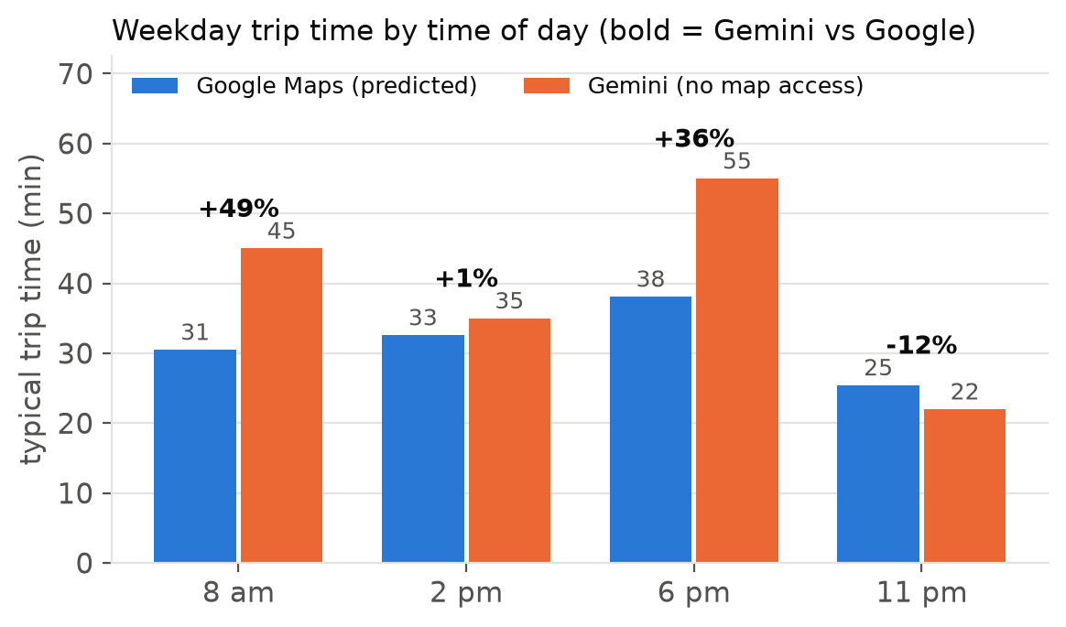
Figure 2. Typical weekday trip time at each time of day. Gemini is too slow at rush hour and too fast at night.
Key numbers at a glance
Trips compared | 2,016 (72 routes × 7 days × 4 times of day)
Landmarks placed correctly | 64 of 64
Road names that are real roads | about 95%
Distance vs Google | typically +6%
Travel time vs Google | typically +12% overall; weekdays +49% at 8 am, −12% at 11 pm
Rush-hour slowdown (peak ÷ night) | Gemini 2.2× · Google 1.3×
Google’s roads that Gemini names | about 22%
Same question asked 3 times | answers vary by only 3–4%
Cost of the whole round | $1.83 (≈ ₹160)
In short
Gemini has a good general picture of Bangalore — places, main roads, rough distances — but its sense of traffic is a stereotype (“rush hour doubles everything”) rather than real knowledge of specific roads and hours. This fits our midsem expectation that LLMs would be weak at estimating time, and partly that they know main roads better than smaller ones.
Next steps (to discuss)
- Let Gemini “think” more before answering — does reasoning reduce the rush-hour exaggeration?
- Give it extra context (road lists, typical speeds) — the core question from the midsem plan.
- Compare with ChatGPT once the model is available, and add more trips on smaller roads.
- For your OK: we added the clock time to the prompt’s time line (e.g. “Evening Rush (18:00)”), and we would like to know whether the GitHub repository can stay public.
Notes: Google’s answers are its predicted traffic for one week; one AI model tested so far. Full details, methods and all plots: project repository, branch benchmark-v2, folder docs/benchmark_v2.

