|  |  |
| --- | --- |
| Book Exchange Platform  A platform to exchange spare books | Group Members  Member 1  Member2  Member3  Virtualization and Cloud Computing (VaCC) |

# Executive Summary

The Books Exchange Platform is a cool web app that I built using Flask, JavaScript, HTML, CSS, and SQLite. It's all about doing something good for the environment by encouraging folks to swap their old books instead of buying new ones. You know, it's a small step towards reducing the impact of book production on our trees.

Using the app is super easy. You can show off your old books or make offers on books you'd like. We've added some neat features like uploading book photos, sharing details about the book's condition, and even a pagination feature for smoother performance. Privacy is a big deal for us. We only collect the info we need for the book swap, and we promise not to spill any personal details to others. Your contact info is only shared with the folks involved in the book exchange – we keep it between us.

We've thrown in some extra features, like notifications for when you get an offer and making sure that if someone deletes their offer, the offered book goes inactive. It keeps things tidy and reliable. The whole idea is to make this a sustainable community where you can swap books guilt-free. We want you to actively join in, showcase your books, and be part of something good for the environment.

In a nutshell, Books Exchange Platform is not just an app; it's a cool way to be environmentally friendly while still enjoying the joy of reading. We're always open to your ideas and contributions to make our book exchange community even more awesome. Behind the scenes, creating the Books Exchange Platform was quite an adventure. The app is primarily built using Flask, a Python web framework that makes it easy to develop robust and scalable web applications. We've sprinkled in some JavaScript for interactive elements, HTML for structuring the content, and CSS for styling to give the platform a sleek and user-friendly look.

The heart of the application lies in the SQLite database, which stores all the essential information about books, users, and the various interactions happening within the platform. It ensures that everything runs smoothly and efficiently, from showcasing books to handling offers.

Leveraging Flask, JavaScript, HTML, CSS, and SQLite, the platform seamlessly integrates into the cloud infrastructure, providing users with a virtual space to connect and exchange books. The utilization of cloud resources ensures scalability, making the platform resilient to varying user demands. The database management with SQLite exemplifies the efficiency and portability vital for cloud-based applications. By embracing the principles of virtualization and cloud computing, the Books Exchange Platform not only delivers a user-friendly experience but also aligns with the ethos of sustainable practices, fostering a virtual community committed to reducing the ecological footprint of traditional book consumption.

Table of Contents

Executive Summary 1

Problem Description 3

Project Methodology 3

Project Analysis 3

Detailed Description of the Solution 3

Cloud Technologies 3

Cost Analysis 4

Conclusion 4

Appendices 5

# Problem Statement

*The environmental impact of traditional book consumption, characterized by deforestation and resource depletion, necessitates a shift towards sustainable alternatives. This app addresses the need for a virtual platform that promotes the exchange of second-hand books, aiming to reduce the demand for new book production and contribute to eco-friendly reading practices.*

# Problem Description

The Books Exchange Platform arises from the pressing environmental concern associated with traditional book consumption. In a world grappling with deforestation and climate change, the incessant demand for new books exacerbates the problem. The project recognizes the importance of mitigating this impact by promoting the exchange of second-hand books, providing a sustainable alternative. The requirements for the project include the utilization of Flask, JavaScript, HTML, CSS, and SQLite, with specific versions outlined in the "requirements.txt" file. The structural components, including the main file (app.py), database (exchange.db), helper functions (helpers.py), and the static and templates folders, collectively form the backbone of the solution.

## Requirements for the project

This section analyzes and shows the requirements for developing app.

### Technical

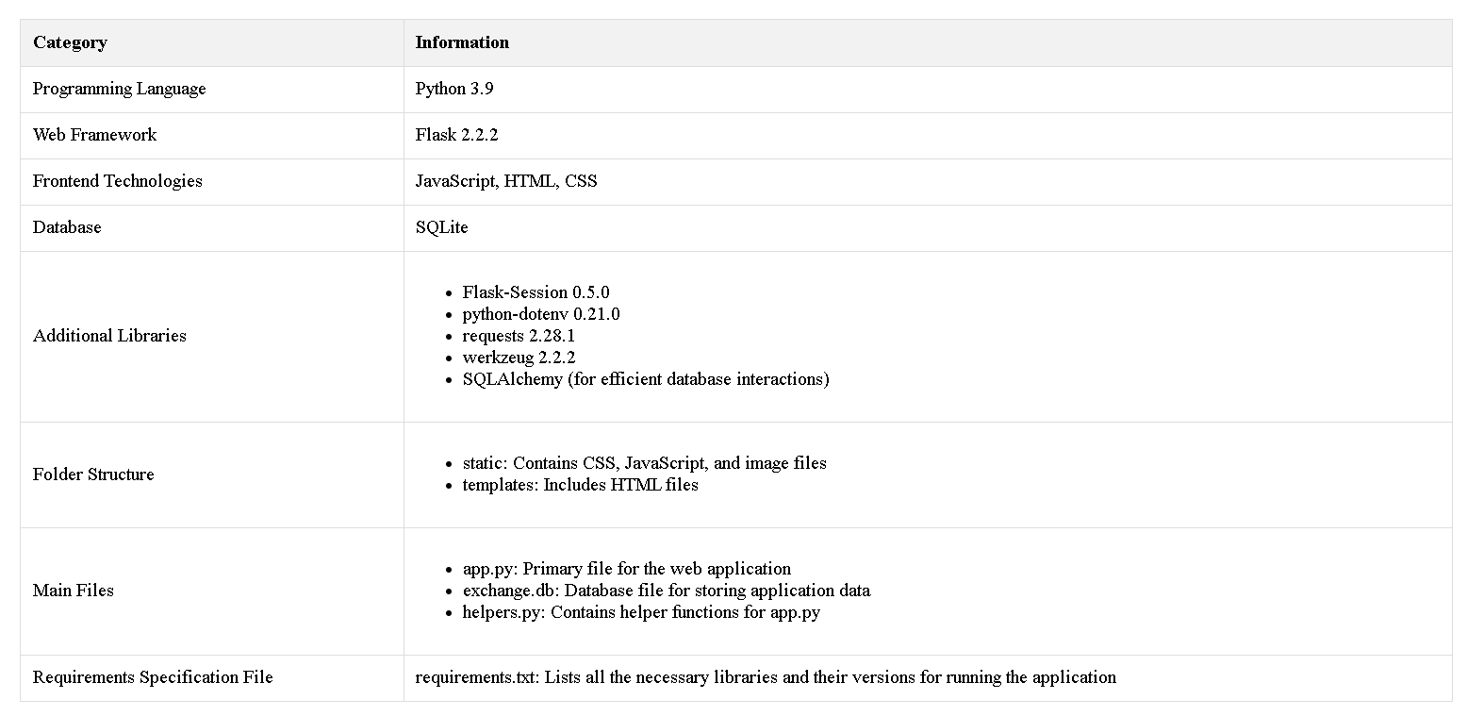

### Functionalities

* Users can upload photos of second-hand books.
* Information about the book's condition is provided.
* Users can describe the book, including its title and author.
* Viewable list of offers for all users.
* Detailed offer information is visible only to users involved in the offer.
* User-friendly navigation through the "Exchange A Book" and "OFFER A BOOK" buttons.
* Notifications for users when they receive an offer.
* Inactive status for books and offers if deleted by the respective users.
* Personal details collected for book swap purposes only.
* "Contact information" section shared only between parties involved in the book swap.
* Small info messages guide users and issue warnings against incorrect usage.
* Implemented on the index page for faster performance.
* Utilization of SQLAlchemy for efficient and scalable database interactions.
* Deployment on cloud servers for enhanced scalability and reliability.

# Project Methodology

The methodology adopted for the project blends traditional web development practices with modern cloud-centric approaches. We employed an agile development model, allowing for iterative enhancements and quick adaptation to evolving requirements. Regular testing and feedback loops were instrumental in refining the user experience and ensuring the reliability of the application. Continuous integration and deployment (CI/CD) practices facilitated seamless updates and maintenance.

# Project Analysis

The analysis phase delved into the environmental impact of traditional book consumption, emphasizing the need for a sustainable solution. User needs and behaviors were carefully studied to design an intuitive and engaging platform. The choice of Flask as the web framework and SQLite as the database was informed by considerations of simplicity, scalability, and portability. The decision to incorporate SQLAlchemy, a powerful Python SQL toolkit and Object-Relational Mapping (ORM) library, was a strategic choice to streamline database interactions. This not only enhanced the efficiency of data management but also facilitated a more maintainable and scalable database architecture.

# Detailed Description of the Solution

The Books Exchange Platform serves as a virtual space for users to exchange second-hand books, reducing the demand for new ones. Users can upload book details, including photos, condition, and descriptions. Privacy is maintained through limited sharing of personal information, ensuring a secure and trustworthy environment. Features such as notifications, inactive book statuses, and guidance messages enhance the overall user experience.

# Cloud Technologies

To align with the course theme of "Virtualization and Cloud Computing," the platform harnesses cloud technologies for scalability and reliability. The Flask application is deployed on cloud servers, ensuring that users can access the platform seamlessly. The use of cloud-based storage for book images and the SQLite database further enhances the platform's performance and availability.

# Cost Analysis

The adoption of cloud technologies introduces a cost aspect to the project. While cloud services offer scalability, the project team considered factors such as storage, data transfer, and compute resources to optimize costs. The benefits of increased reliability and reduced maintenance efforts were weighed against the associated expenses to ensure a cost-effective solution.

# Conclusion

In conclusion, the Books Exchange Platform successfully marries technology with environmental responsibility. Future work involves exploring advanced cloud services for further scalability, introducing user analytics to enhance the platform, and expanding the user base. Plans for extension include partnerships with libraries or educational institutions to amplify the impact of the book exchange community. The project lays the foundation for continued growth, aligning with the evolving landscape of virtualization and cloud computing.

# Appendices

Below is a Front screen of the ‘Book Exchange App’. It shows the books available in the app which people posted for exchange.

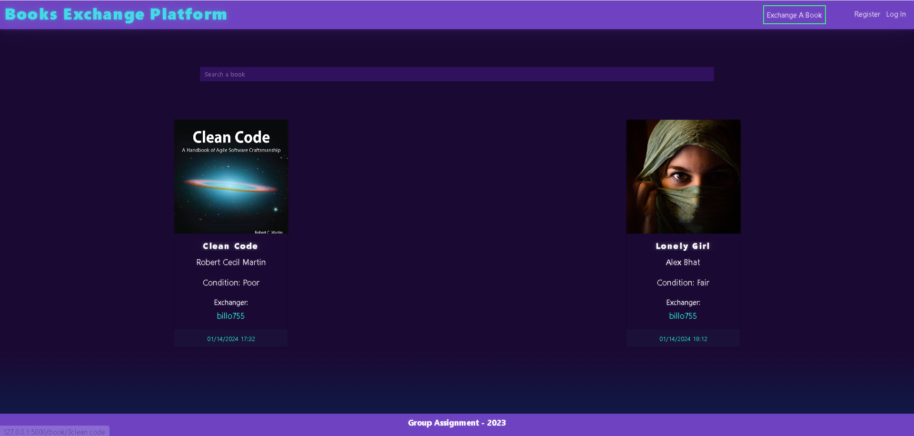

Below is a page where user can register an account in order to exchange books

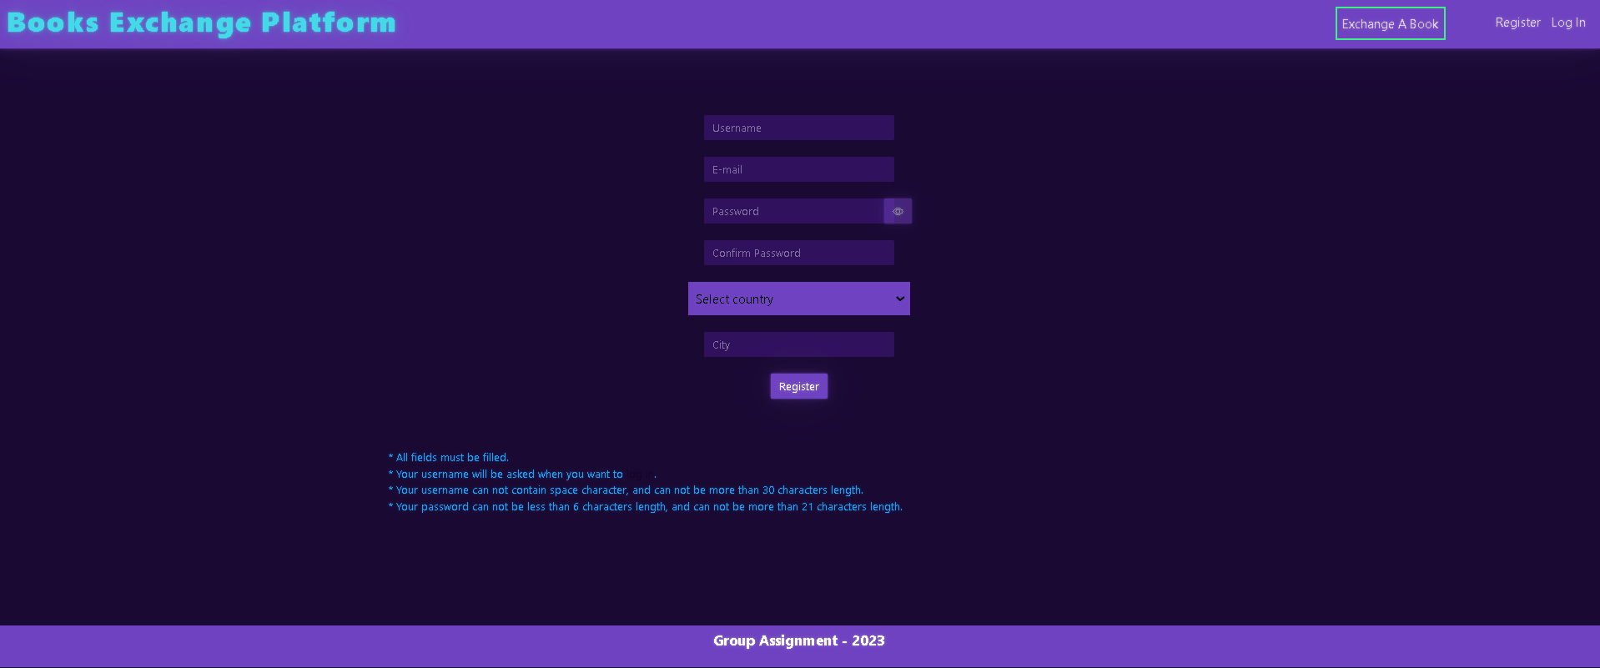

Below is a login screen that where users can login after creating an account.

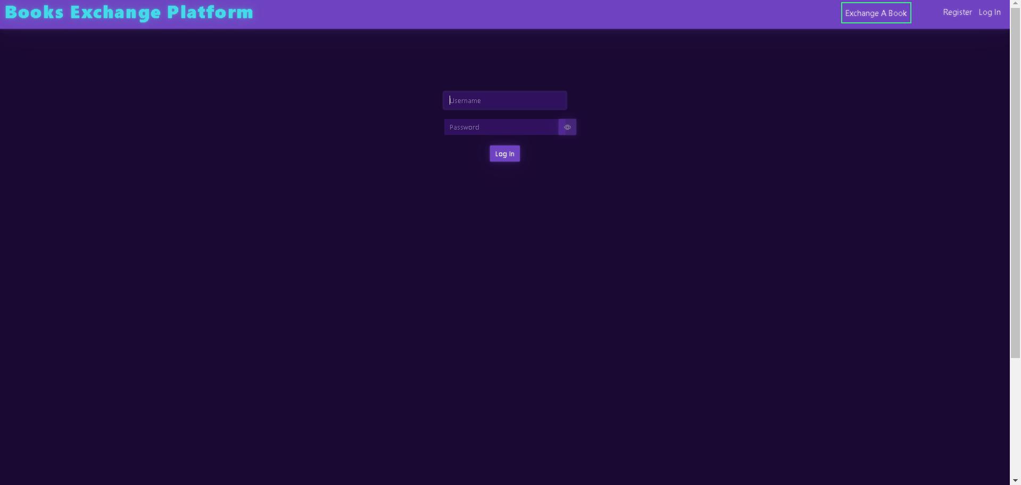

After login user can search a book and request for exchange.

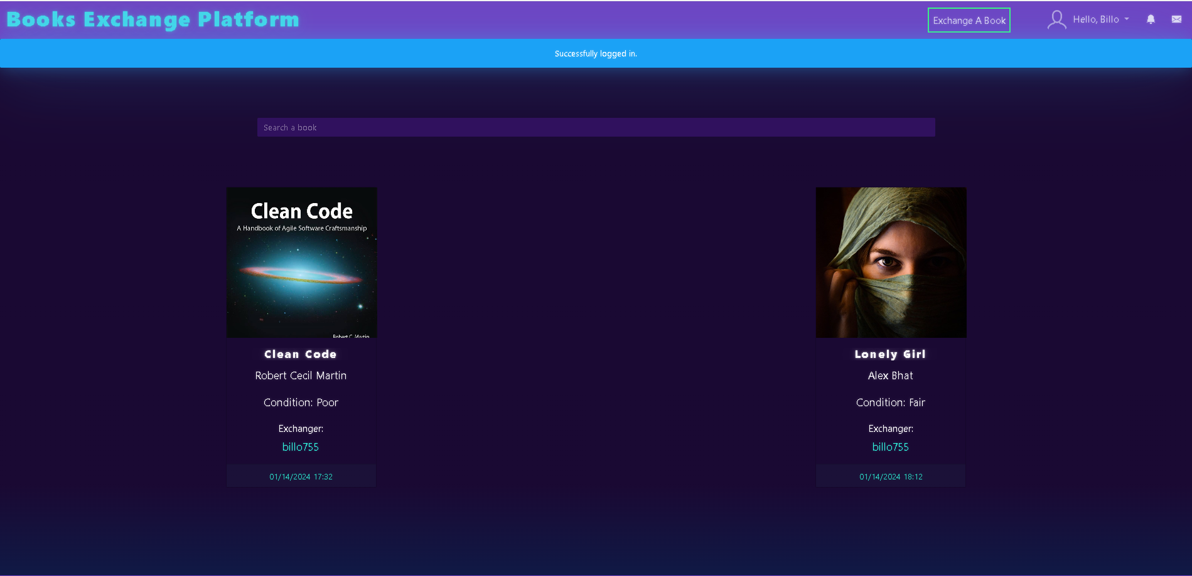

Below is a screen which shows the information about the user who posted the book.

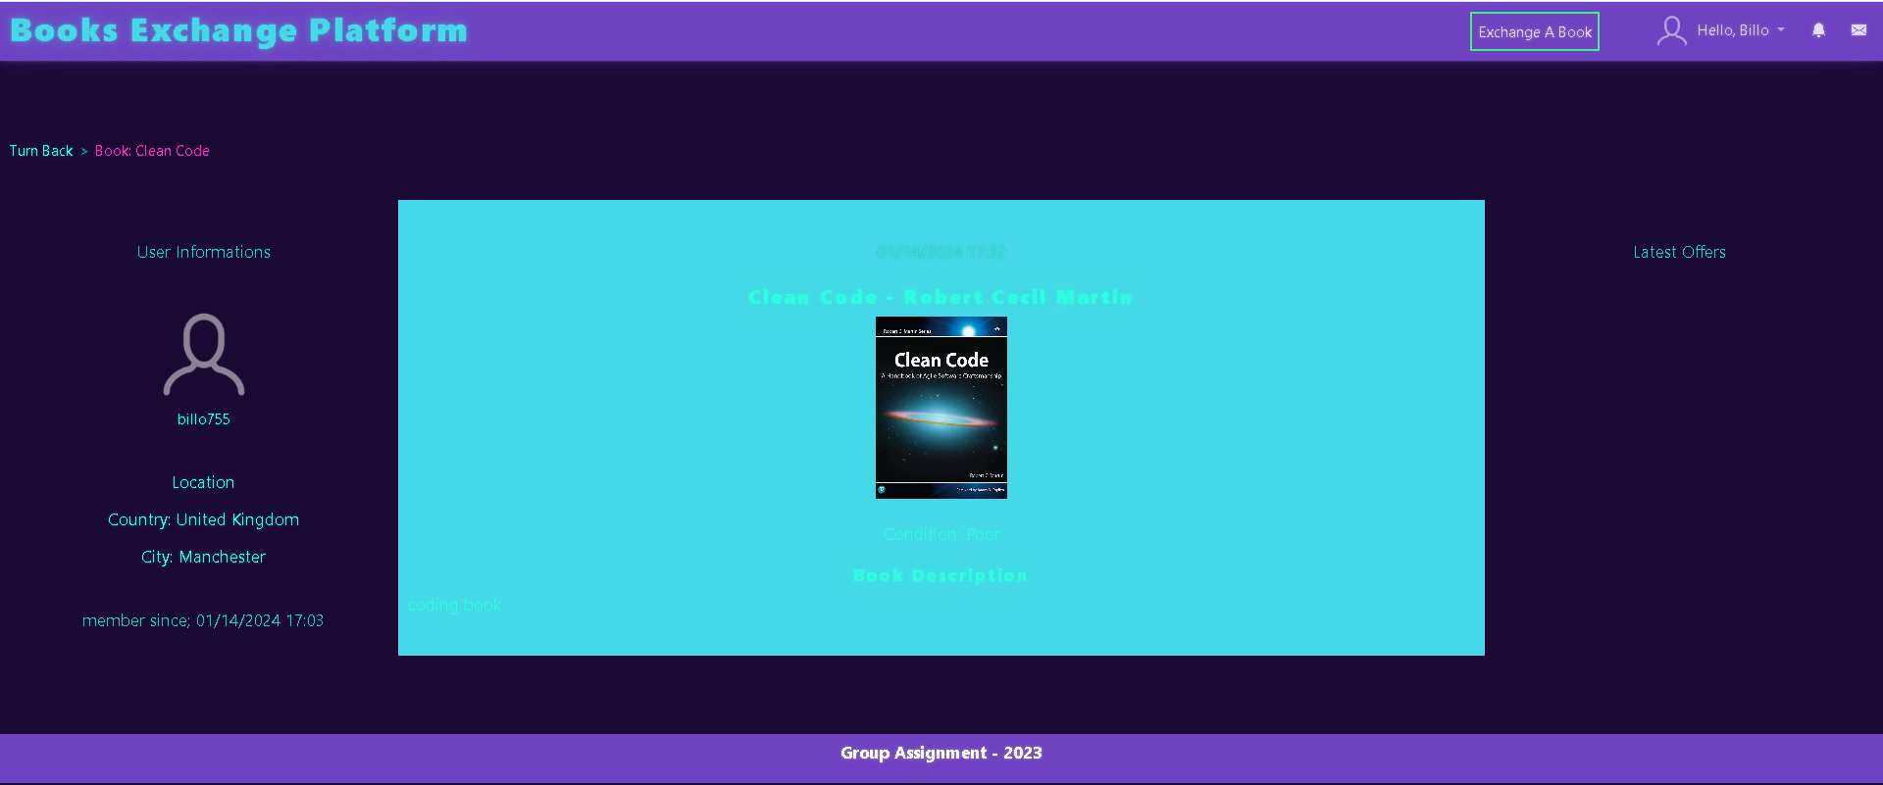

Lets exchange a book, below is a screen where user can add book for exchange

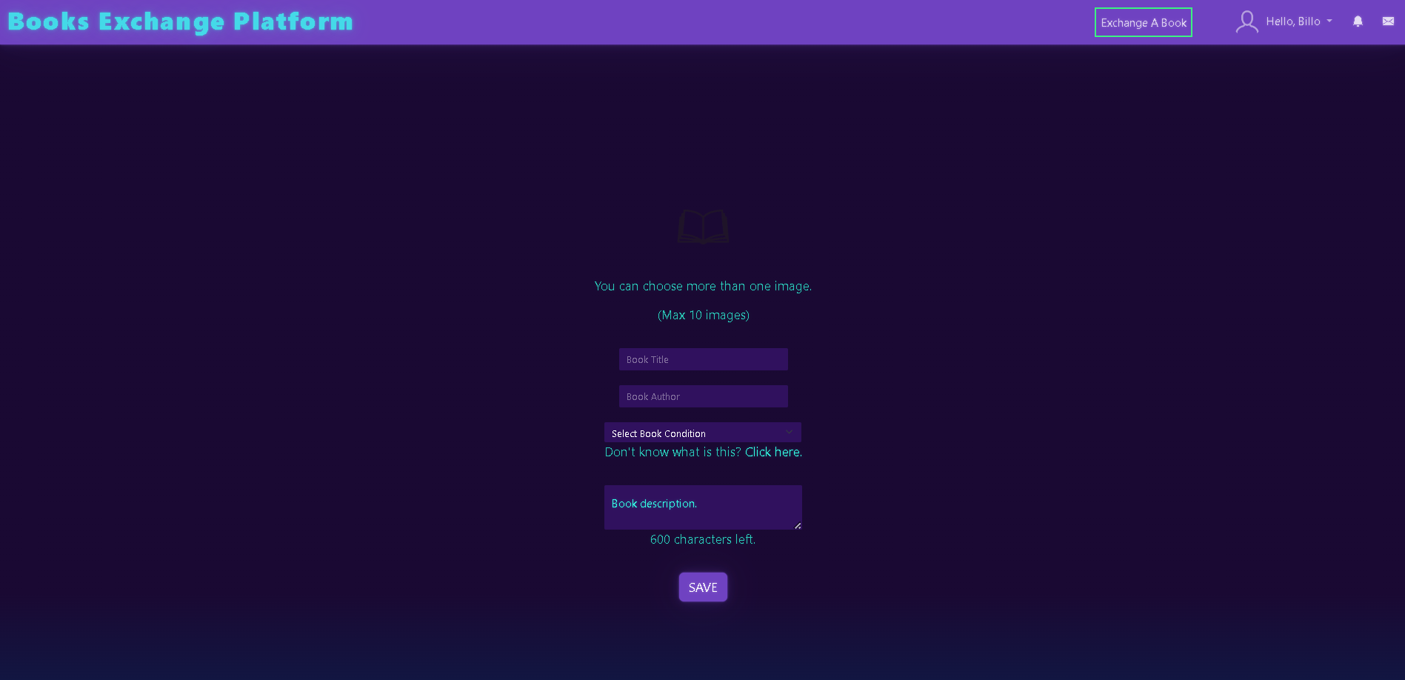

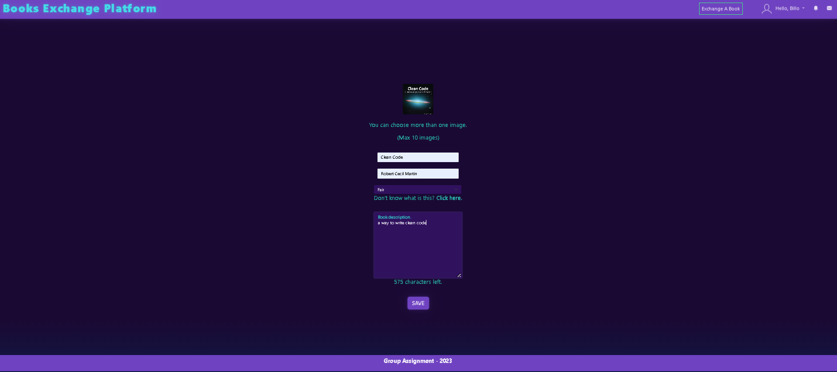

Below is a screen where user who has the book can offer a book.

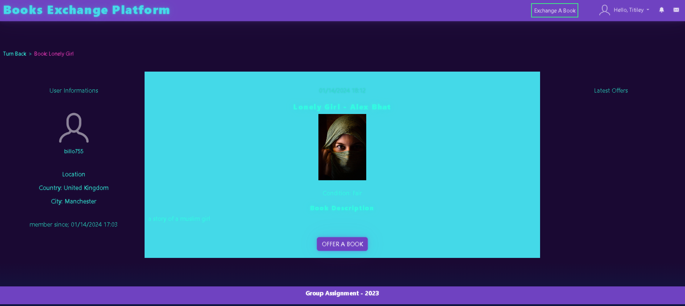

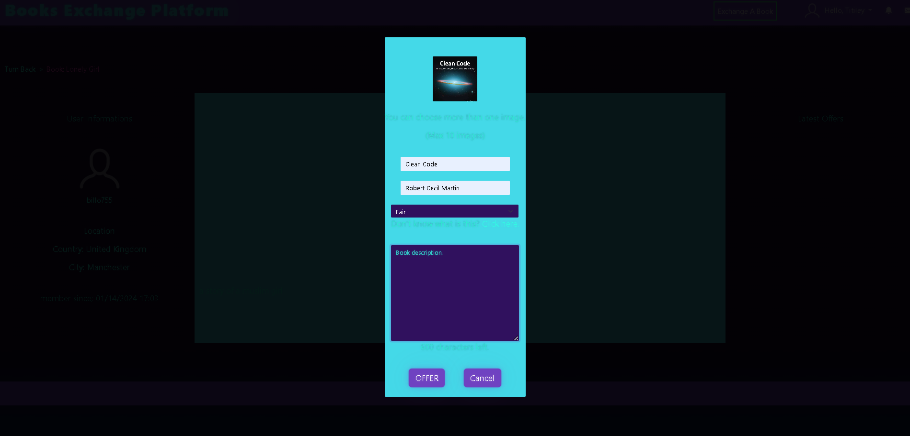

This screen shows the latest offers for the book available.

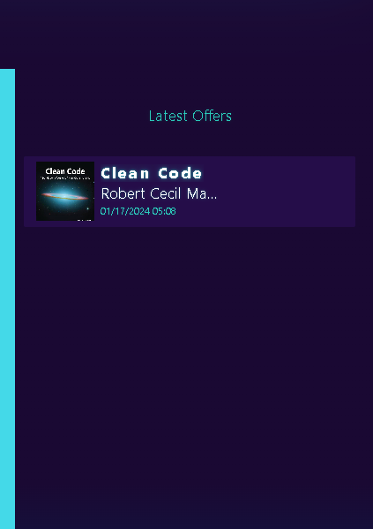

Below is a screen which shoes how a user gets notification for an offer.

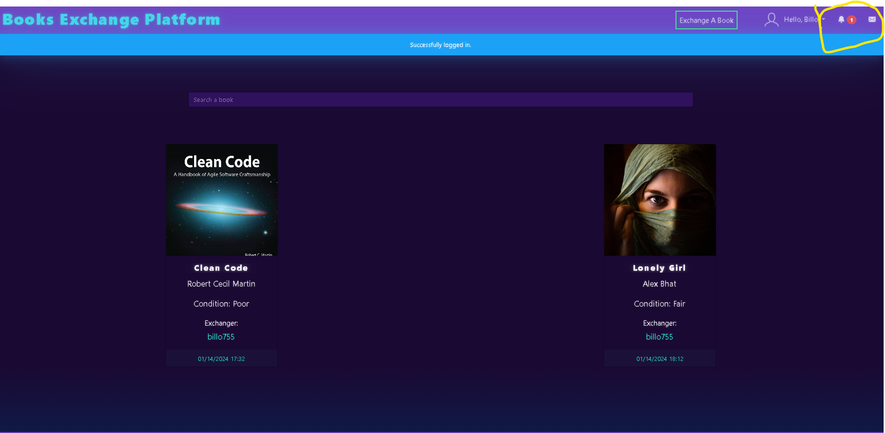

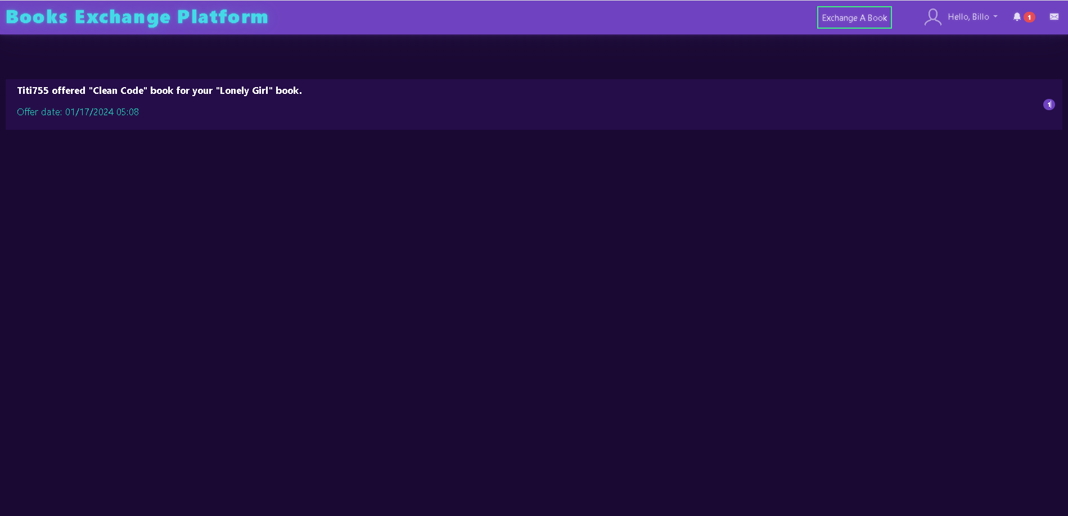

After clicking the offer, a user can accept pr decline the offer as shown in the below screen.

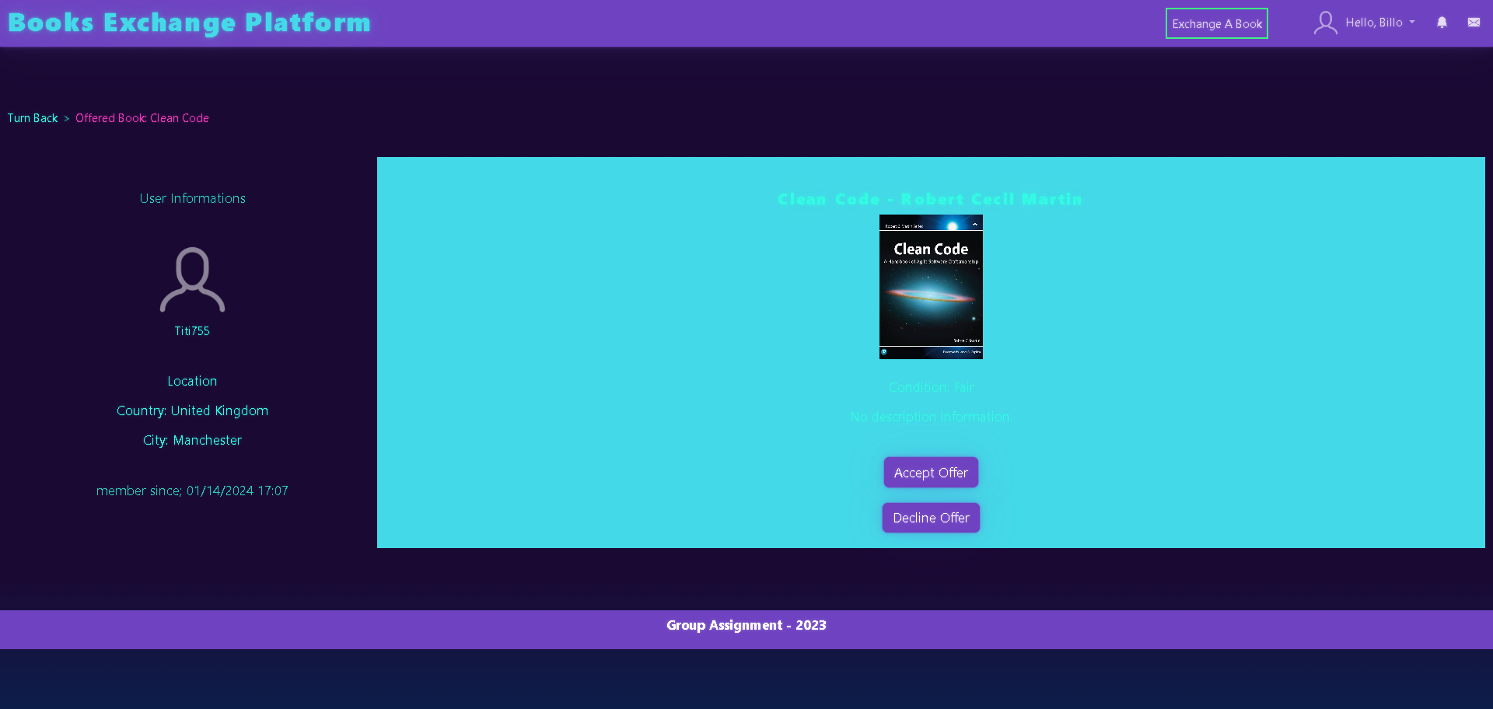

After accepting an offer, a user gets the detail of the exchange in the message

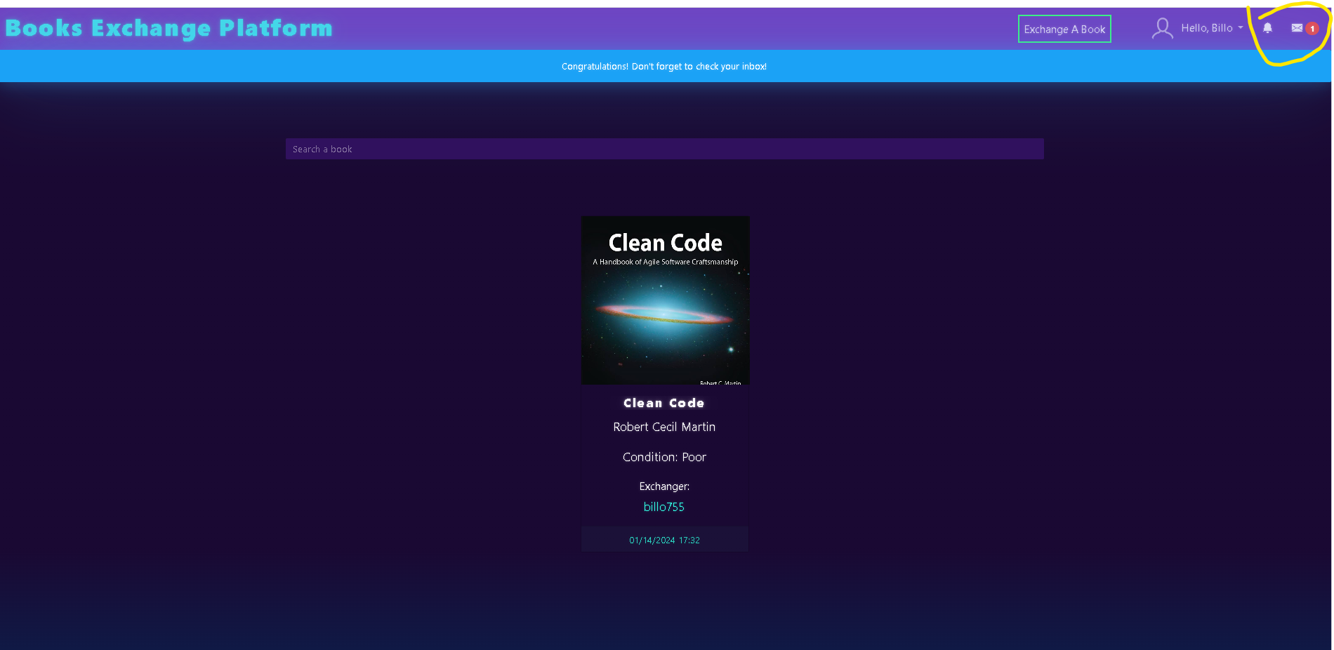

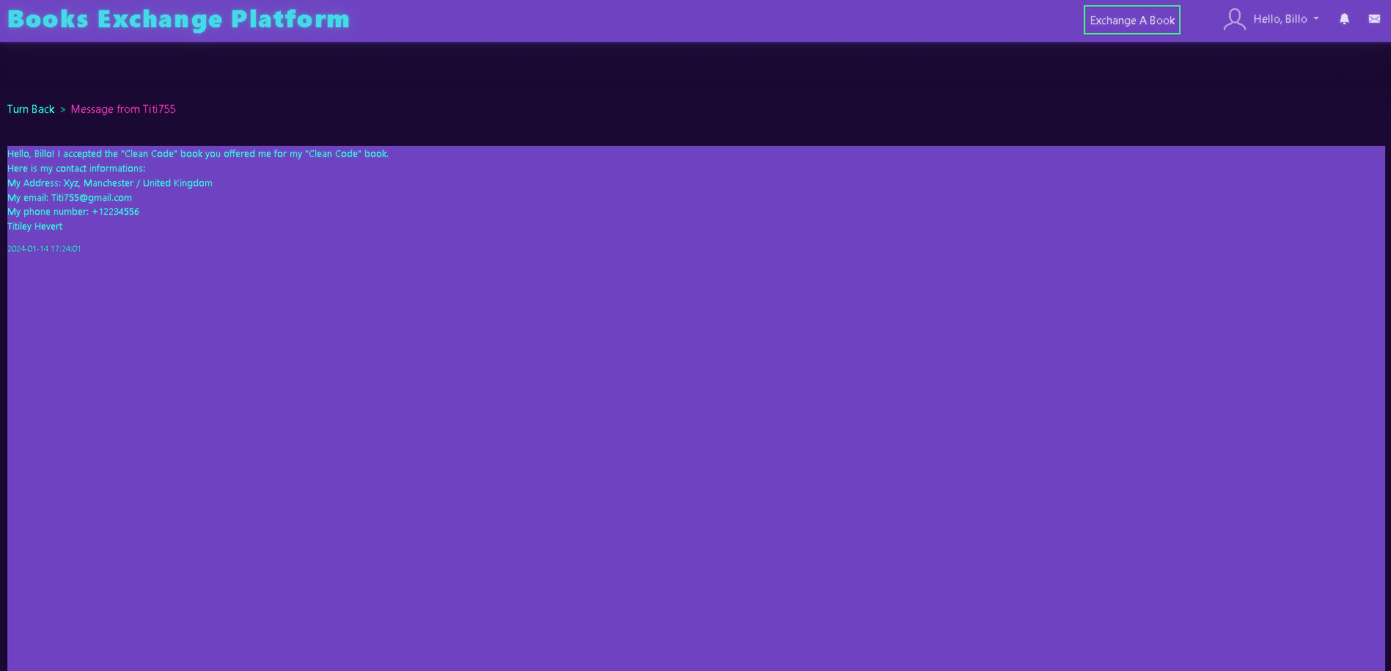

Below is a screen where user can set his/her profile and delete the details.

Everything is placed according to the rules

* You won’t be able to exchange books with individuals if you miss any field above.
* You will get auto messaged when you accept any offer or when your offer accepted (after you fill all "None" fields).
* Your username will be asked when you want to log in.
* Your username will be shown on the books you want to exchange or you offered (not your first name or last name).
* Your username can not contain space character, and cannot be more than 30 characters length.
* You can change your password only if you type your current password first.
* Your password can not be less than 6 characters length, and cannot be more than 21 characters length.

For deletion, a warning is shown as

WARNING! This can't be undone.

* You may not recover this account when you delete.
* Once you delete your account;
* You’re all personal information’s,
* Your all books,
* All the book offers you received / sent,
* All the messages you received / sent
* will be permanently deleted.
* When you want to log in later, you will need to register a new account.

