MACHINE LEARNING LAB ASSIGNMENT
NAME – Ishan Kaushik
ROLL NO. – 2026KPAD1005
SUBJECT – MACHINE LEARNING LAB ASSIGNMENT
M.Tech, CSE [AI&DS] – 1st Semester
Topic: Movement Decoding using Machine Learning Classifiers

Movement Decoding
For this practical, I used the two signal columns in the CSV file to identify which class a signal belongs to. I divided each signal into 50 ms windows and calculated five features from every window. I then used six classifiers to predict the class.
I tested Logistic Regression (LR), Support Vector Machine (SVM), Gaussian Naive Bayes (NB), K-Nearest Neighbors (KNN), Decision Tree (DT), and Random Forest (RF). I compared their results using accuracy, precision, recall, F1-score, and confusion matrices.
I used Python with Pandas, NumPy, Matplotlib, and Scikit-learn. I wrote the windowing and feature calculation functions myself. Scikit-learn was used for scaling, PCA, splitting the data, training the classifiers, and calculating the evaluation metrics.

1. Importing Libraries and Loading the Dataset
I used Pandas to load the CSV file, NumPy for the numerical calculations, and Matplotlib to plot the signals and results. I also used Scikit-learn for the classifiers and preprocessing steps such as scaling and PCA.
Code:
import numpy as np
import pandas as pd
import matplotlib.pyplot as plt
import time
from sklearn.model_selection import train_test_split
from sklearn.preprocessing import StandardScaler
from sklearn.decomposition import PCA
from sklearn.linear_model import LogisticRegression
from sklearn.svm import SVC
from sklearn.naive_bayes import GaussianNB
from sklearn.neighbors import KNeighborsClassifier
from sklearn.tree import DecisionTreeClassifier
from sklearn.ensemble import RandomForestClassifier
from sklearn.metrics import accuracy_score, precision_score, recall_score, f1_score, confusion_matrix, ConfusionMatrixDisplay
data = pd.read_csv("one - one.csv")
print(data.shape)
print(data.head())
print(data.describe())
The file has 36,000 rows and three columns: Time, AI0 (Class 1), and AI0 (Class2). Both signal columns contain 36,000 samples. I checked the first few rows and the summary statistics before starting the feature extraction.
Output:
Dataset shape: (36000, 3)
First rows:
Time AI0 (Class 1) AI0 (Class2)
0 1 0.005048 0.004848
1 2 0.005018 0.004862
2 3 0.005029 0.004851
3 4 0.005060 0.004826
4 5 0.005093 0.004818
Summary:
Time AI0 (Class 1) AI0 (Class2)
count 36000.000000 36000.000000 36000.000000
mean 18000.500000 0.004826 0.004939
std 10392.449182 0.000092 0.000277
min 1.000000 0.004198 0.002809
25% 9000.750000 0.004789 0.004876
50% 18000.500000 0.004818 0.004954
75% 27000.250000 0.004867 0.005015
max 36000.000000 0.005411 0.006902
The signal data is stored in a CSV file, so I loaded it using read_csv(). The filename used in my code is one - one.csv.

2. Preparing the Two Signal Classes
I converted the Time values into milliseconds by dividing them by 2. I also stored the two signal columns in separate arrays. Each class has 36,000 samples.
Code:
time_ms = data["Time"].values / 2
class1 = data["AI0 (Class 1)"].values
class2 = data["AI0 (Class2)"].values
print(f"Samples in Class 1: {len(class1)}")
print(f"Samples in Class 2: {len(class2)}")
Output:
Samples in Class 1: 36000
Samples in Class 2: 36000

3. Visualizing the Raw Signals
I first plotted both signals together to see how their amplitudes change over time. After that, I plotted each signal separately so I could look at the two patterns more clearly.
Code:
plt.figure(figsize=(14,5))
plt.plot(time_ms, class1, label="Class 1", color="blue", linewidth=0.6)
plt.plot(time_ms, class2, label="Class 2", color="teal", linewidth=0.6, alpha=0.7)
plt.xlabel("Time (ms)")
plt.ylabel("Amplitude")
plt.title("Raw Signals of Class 1 and Class 2")
plt.legend()
plt.grid(True)
plt.show()
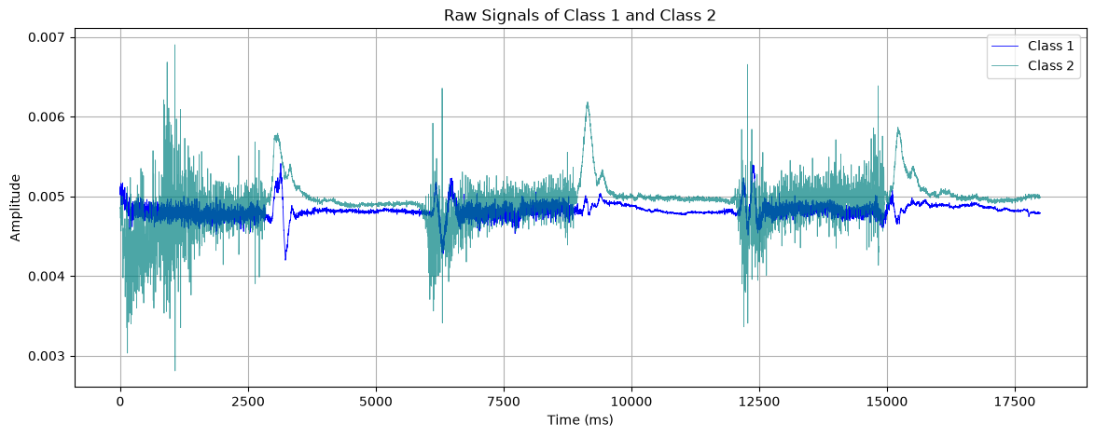
Code:
fig, ax = plt.subplots(2, 1, figsize=(14,7), sharex=True)
ax[0].plot(time_ms, class1, color="teal", linewidth=0.6)
ax[0].set_title("Class 1 Signal")
ax[0].set_ylabel("Amplitude")
ax[0].grid(True)
ax[1].plot(time_ms, class2, color="darkorange", linewidth=0.6)
ax[1].set_title("Class 2 Signal")
ax[1].set_xlabel("Time (ms)")
ax[1].set_ylabel("Amplitude")
ax[1].grid(True)
plt.tight_layout()
plt.show()
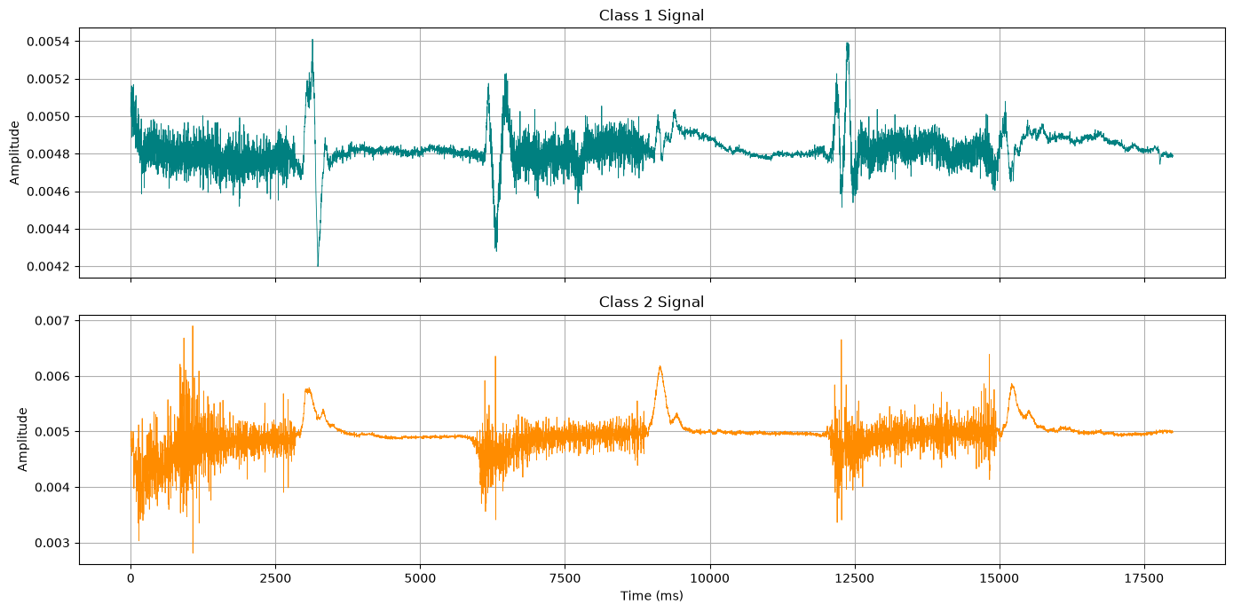
I also zoomed in on the first 500 ms. The vertical dashed lines mark every 50 ms and show how the signals are divided into windows.
Code:
plt.figure(figsize=(14,5))
plt.plot(time_ms[:1000], class1[:1000], label="Class 1", color="purple")
plt.plot(time_ms[:1000], class2[:1000], label="Class 2", color="coral")
for i in range(0, 501, 50):
plt.axvline(i, color="gray", linestyle="--", linewidth=0.7)
plt.xlabel("Time (ms)")
plt.ylabel("Amplitude")
plt.title("First 500 ms of Signals with 50 ms Windows")
plt.legend()
plt.grid(True)
plt.show()
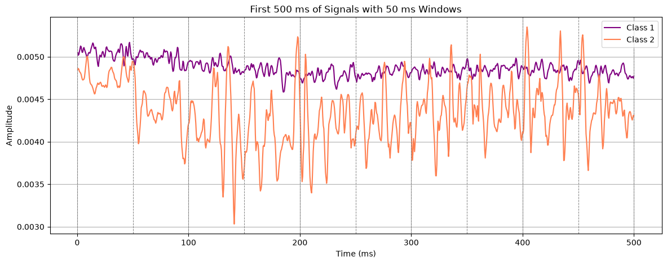
.

4. Dividing Signals into 50 ms Windows
The assignment asks us to use a 50 ms window. In the notebook, I used fs = 2 samples per millisecond, so each window contains 100 samples. Since each signal has 36,000 samples, it gives 360 non-overlapping windows per class.
Window size = fs × window duration = 2 × 50 = 100 samples.
Code:
fs = 2
window_ms = 50
window_size = fs * window_ms
print(f"Window size: {window_size} samples")
print(f"Number of windows per class: {len(class1)//window_size}")
Output:
Window size: 100 samples
Number of windows per class: 360

5. Extracting Features from Each Window
For each 100-sample window, I calculated five features: mean, variance, standard deviation, mean absolute value (MAV), and zero-crossing count. These values describe the signal level and how much it changes within that window.
Mean = (1/N) × Σxᵢ
Variance = (1/N) × Σ(xᵢ − Mean)²
Standard Deviation = √Variance
Mean Absolute Value (MAV) = (1/N) × Σ|xᵢ|
Zero Crossing Count = number of adjacent samples that change sign after subtracting the window mean.
In my function, a zero crossing is counted when two neighbouring samples fall on opposite sides of that window's mean.
Code:
def findMean(x):
total = 0
for i in range(len(x)):
total = total + x[i]
return total / len(x)
def findVariance(x):
m = findMean(x)
total = 0
for i in range(len(x)):
total = total + (x[i] - m) ** 2
return total / len(x)
def findStd(x):
return findVariance(x) ** 0.5
def findMAV(x):
total = 0
for i in range(len(x)):
total = total + abs(x[i])
return total / len(x)
def findZeroCrossing(x):
m = findMean(x)
count = 0
for i in range(1, len(x)):
if (x[i-1] - m) * (x[i] - m) < 0:
count = count + 1
return count
The extractFeatures() function takes one window at a time, calculates the five features, and adds the class label to the end of the row.
Code:
def extractFeatures(signal, window_size, label):
features = []
n = len(signal) // window_size
for w in range(n):
x = signal[w*window_size:(w+1)*window_size]
features.append([
findMean(x), findVariance(x), findStd(x),
findMAV(x), findZeroCrossing(x), label
])
return features

6. Creating the Feature Dataset
I assigned label 0 to the Class 1 windows and label 1 to the Class 2 windows. I then joined both feature lists into one DataFrame with five feature columns and one label column.
Code:
f1 = extractFeatures(class1, window_size, 0)
f2 = extractFeatures(class2, window_size, 1)
df = pd.DataFrame(
f1 + f2,
columns=["Mean", "Variance", "Std", "MAV", "ZeroCrossing", "Label"]
)
print(df.shape)
print(df.head())
print(df.tail())
print(df["Label"].value_counts())
Output:
Feature dataset shape: (720, 6)
First rows:
Mean Variance Std MAV ZeroCrossing Label
0 0.005049 3.760553e-09 0.000061 0.005049 16 0
1 0.004976 5.026821e-09 0.000071 0.004976 13 0
2 0.004894 3.540336e-09 0.000060 0.004894 13 0
3 0.004829 5.796981e-09 0.000076 0.004829 11 0
4 0.004787 4.623876e-09 0.000068 0.004787 16 0
Last rows:
Mean Variance Std MAV ZeroCrossing Label
715 0.005001 1.275940e-10 0.000011 0.005001 11 1
716 0.005002 1.306894e-10 0.000011 0.005002 15 1
717 0.005009 1.319018e-10 0.000011 0.005009 19 1
718 0.005005 8.586416e-11 0.000009 0.005005 8 1
719 0.004995 1.521513e-10 0.000012 0.004995 10 1
Label distribution:
0 360
1 360
The feature dataset has 720 rows and 6 columns. There are 360 rows for each label, so both classes have the same number of windows.

7. Visualizing the Extracted Features
I plotted each feature against the window number to see how its values change for the two classes. I also made boxplots to compare the feature values of Class 1 and Class 2.
Code:
feature_names = ["Mean", "Variance", "Std", "MAV", "ZeroCrossing"]
fig, ax = plt.subplots(5, 1, figsize=(14,14), sharex=True)
for i in range(5):
ax[i].plot(df[df["Label"]==0][feature_names[i]].values, label="Class 1")
ax[i].plot(df[df["Label"]==1][feature_names[i]].values, label="Class 2")
ax[i].set_ylabel(feature_names[i])
ax[i].legend()
ax[i].grid(True)
ax[4].set_xlabel("Window Number")
plt.suptitle("Extracted Features per 50 ms Window")
plt.tight_layout()
plt.show()
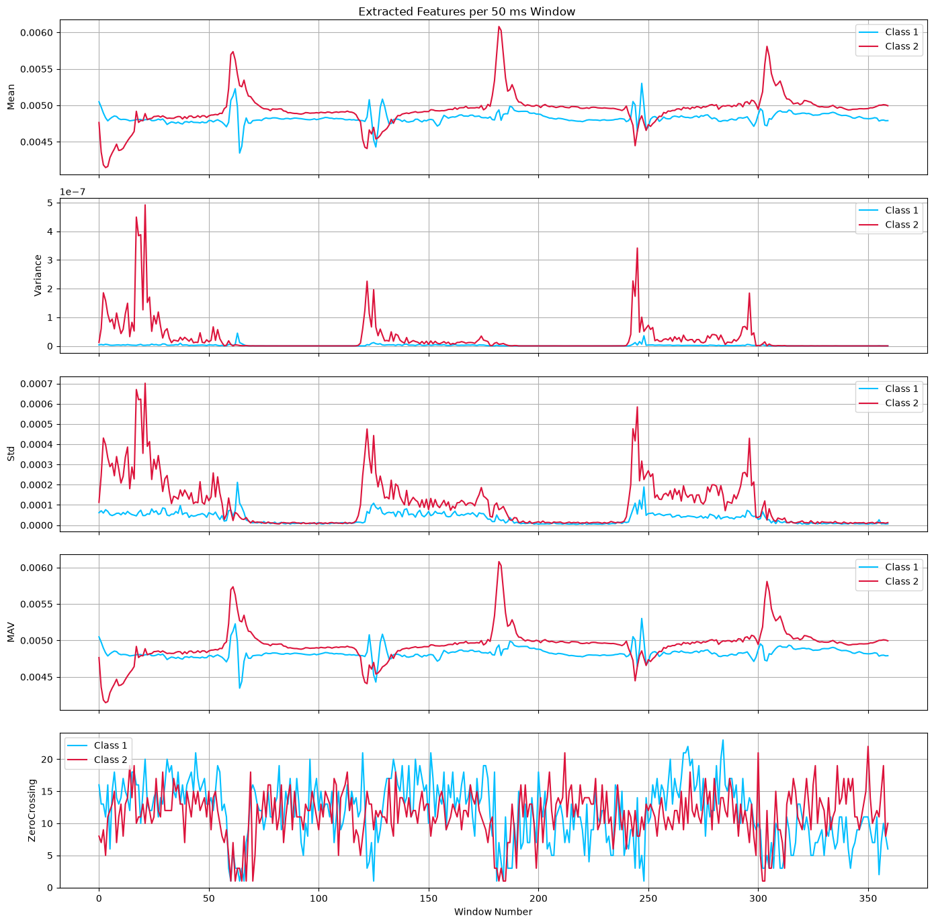
Code:
fig, ax = plt.subplots(1, 5, figsize=(20,4))
for i in range(5):
ax[i].boxplot([
df[df["Label"]==0][feature_names[i]],
df[df["Label"]==1][feature_names[i]]
])
ax[i].set_xticks([1, 2])
ax[i].set_xticklabels(["Class 1", "Class 2"])
ax[i].set_title(feature_names[i])
plt.tight_layout()
plt.show()
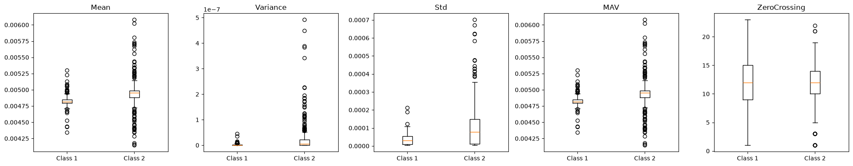

8. Feature Scaling
The five extracted features have different numerical ranges. I used StandardScaler to put them on a similar scale before applying PCA and training the classifiers.
Standardization: X_scaled = (X − μ) / σ
Code:
X = df[feature_names].values
y = df["Label"].values
scaler = StandardScaler()
X_scaled = scaler.fit_transform(X)
print(X_scaled.shape)
Output:
(720, 5)

9. Principal Component Analysis (PCA)
I used PCA to reduce the five scaled features to fewer components. First, I checked how much variance each component explains. I then kept three components for training the classifiers.
Code:
pca_full = PCA()
pca_full.fit(X_scaled)
print("Explained variance ratio:", pca_full.explained_variance_ratio_)
print("Cumulative variance:", np.cumsum(pca_full.explained_variance_ratio_))
Output:
Explained variance ratio:
[0.4957951 0.31456278 0.16871825 0.02092387 0. ]
Cumulative variance:
[0.4957951 0.81035788 0.97907613 1. 1. ]
Code:
plt.figure(figsize=(8,5))
plt.bar(range(1,6), pca_full.explained_variance_ratio_, label="Individual")
plt.plot(range(1,6), np.cumsum(pca_full.explained_variance_ratio_), marker="o", label="Cumulative")
plt.xlabel("Principal Component")
plt.ylabel("Explained Variance Ratio")
plt.title("PCA Explained Variance")
plt.legend()
plt.grid(True)
plt.show()
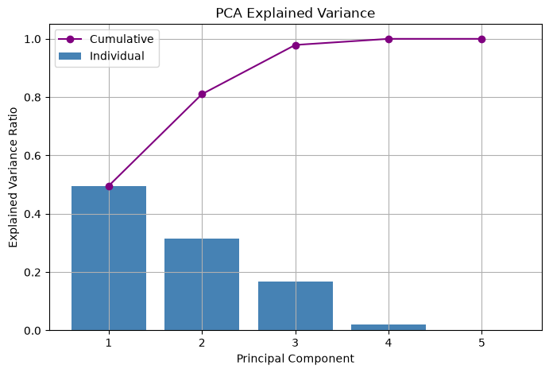
Code:
pca = PCA(n_components=3)
X_pca = pca.fit_transform(X_scaled)
print(X_pca.shape)
print("Variance kept with 3 components:", sum(pca.explained_variance_ratio_))
Output:
(720, 3)
Variance kept with 3 components: 0.9790761303594033
The three components retain about 97.91% of the total variance. After PCA, each sample has three values instead of the original five features.
Code:
plt.figure(figsize=(8,6))
plt.scatter(X_pca[y==0,0], X_pca[y==0,1], label="Class 1", alpha=0.6)
plt.scatter(X_pca[y==1,0], X_pca[y==1,1], label="Class 2", alpha=0.6)
plt.xlabel("PC1")
plt.ylabel("PC2")
plt.title("PCA of Extracted Features")
plt.legend()
plt.grid(True)
plt.show()
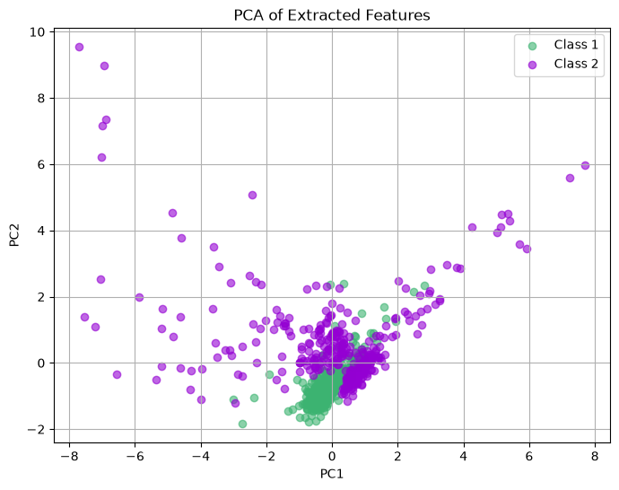

10. Training and Testing Split
I split the PCA-transformed data into training and testing sets. I used 80% of the data for training and 20% for testing. random_state=42 makes the split repeatable, and stratify=y keeps the class proportions similar in both sets.
Code:
X_train, X_test, y_train, y_test = train_test_split(
X_pca, y, test_size=0.2, random_state=42, stratify=y
)
print("Train size:", X_train.shape)
print("Test size:", X_test.shape)
Output:
Train size: (576, 3)
Test size: (144, 3)

11. Defining the Six Classifiers
I created the six classifiers with the settings shown below. Each model uses the same training data, and its predictions are checked on the same test data.
Code:
models = {
"LR": LogisticRegression(),
"SVM": SVC(kernel="rbf"),
"NB": GaussianNB(),
"KNN": KNeighborsClassifier(n_neighbors=5),
"DT": DecisionTreeClassifier(random_state=42),
"RF": RandomForestClassifier(n_estimators=100, random_state=42)
}
- LR: Logistic Regression classifier.
- SVM: Support Vector Machine using an RBF kernel.
- NB: Gaussian Naive Bayes classifier.
- KNN: K-Nearest Neighbors with 5 neighbors.
- DT: Decision Tree classifier with random_state=42.
- RF: Random Forest with 100 trees and random_state=42.

12. Training, Evaluation Metrics and Computational Cost
For each classifier, I trained the model on the training set and predicted the labels for the test set. I then calculated accuracy, precision, recall, and F1-score. The Classroom task also asks for computational cost, so I added a timer around model fitting using time.perf_counter().
The notebook already imports time, but the original classifier loop did not use it. I added the timer to record how long each model takes to fit.
Code:
results = []
predictions = {}
training_times = {}
for name in models:
model = models[name]
start_time = time.perf_counter()
model.fit(X_train, y_train)
training_times[name] = time.perf_counter() - start_time
y_pred = model.predict(X_test)
predictions[name] = y_pred
acc = accuracy_score(y_test, y_pred)
pre = precision_score(y_test, y_pred)
rec = recall_score(y_test, y_pred)
f1s = f1_score(y_test, y_pred)
results.append([name, acc, pre, rec, f1s, training_times[name]])
print(
f"{name} -> Accuracy: {acc:.4f}, Precision: {pre:.4f}, "
f"Recall: {rec:.4f}, F1: {f1s:.4f}, "
f"Training Time: {training_times[name]:.6f} s"
)
res = pd.DataFrame(
results,
columns=["Model", "Accuracy", "Precision", "Recall", "F1", "Training Time (s)"]
)
print(res)
The classification scores below are from the notebook. I also ran the same classifier setup with the training-time measurement added. These timings are from one run, so they may be different on another computer or when the system is busy.
Output:
LR -> Accuracy: 0.8611, Precision: 0.8939, Recall: 0.8194, F1: 0.8551
SVM -> Accuracy: 0.8958, Precision: 0.9130, Recall: 0.8750, F1: 0.8936
NB -> Accuracy: 0.7431, Precision: 0.9268, Recall: 0.5278, F1: 0.6726
KNN -> Accuracy: 0.8750, Precision: 0.8750, Recall: 0.8750, F1: 0.8750
DT -> Accuracy: 0.8819, Precision: 0.8986, Recall: 0.8611, F1: 0.8794
RF -> Accuracy: 0.8958, Precision: 0.8904, Recall: 0.9028, F1: 0.8966
One-run training times (seconds):
LR: 0.003265
SVM: 0.004292
NB: 0.000569
KNN: 0.000947
DT: 0.002099
RF: 0.110480
From these results, SVM and Random Forest have the highest accuracy, at about 89.58%. Random Forest has the highest recall and F1-score, while SVM has the highest precision. Gaussian Naive Bayes has the lowest accuracy and recall, although its precision is high.

13. Confusion Matrices
A confusion matrix shows how many samples were classified correctly and incorrectly. The rows show the actual classes and the columns show the predicted classes. Here, label 0 means Class 1 and label 1 means Class 2.
These are the confusion matrices calculated from the test-set predictions:
Output:
LR:
[[65 7]
[13 59]]
SVM:
[[66 6]
[ 9 63]]
NB:
[[69 3]
[34 38]]
KNN:
[[63 9]
[ 9 63]]
DT:
[[65 7]
[10 62]]
RF:
[[64 8]
[ 7 65]]
I have placed all six confusion matrices together so their results can be compared in one figure.
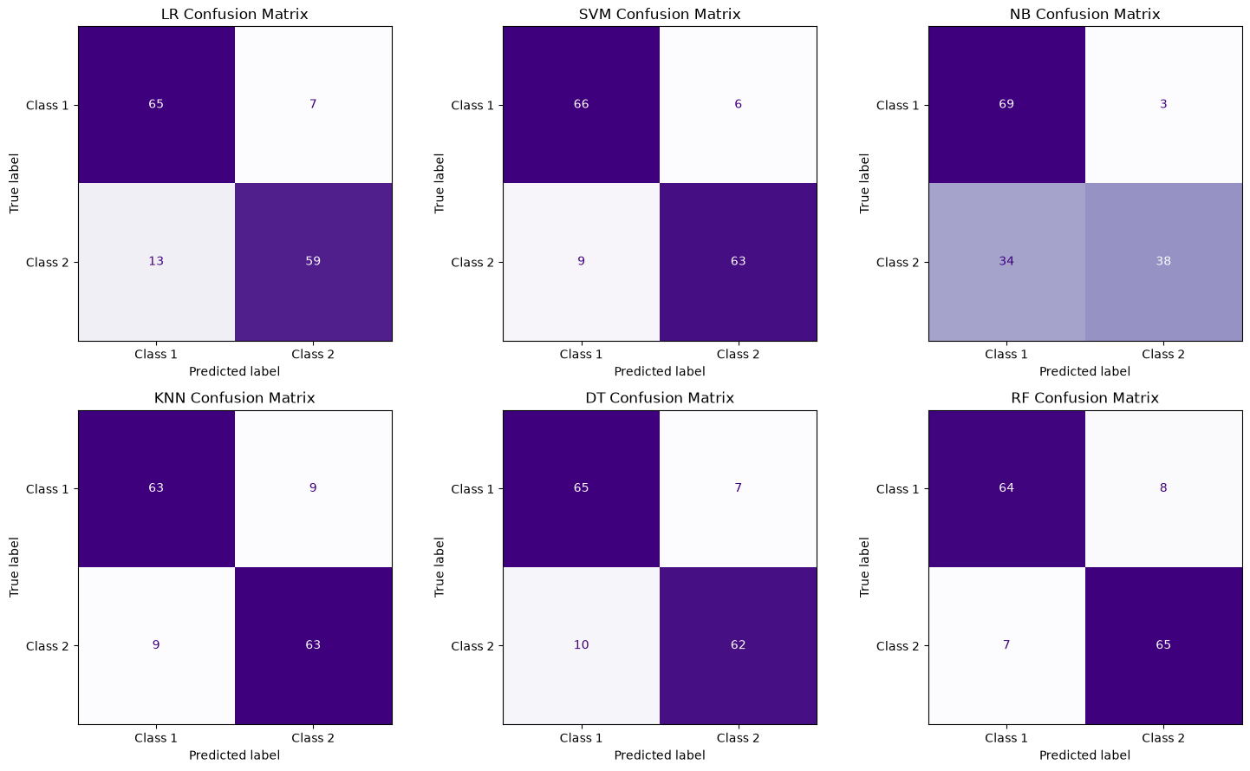

14. Comparing the Classifiers
This bar chart shows the accuracy, precision, recall, and F1-score of all six classifiers side by side.
Code:
x = np.arange(len(res))
w = 0.2
plt.figure(figsize=(12,6))
plt.bar(x - 1.5*w, res["Accuracy"], w, label="Accuracy")
plt.bar(x - 0.5*w, res["Precision"], w, label="Precision")
plt.bar(x + 0.5*w, res["Recall"], w, label="Recall")
plt.bar(x + 1.5*w, res["F1"], w, label="F1")
plt.xticks(x, res["Model"])
plt.ylabel("Score")
plt.ylim(0, 1.1)
plt.title("Comparison of Classifiers")
plt.legend()
plt.grid(axis="y")
plt.show()
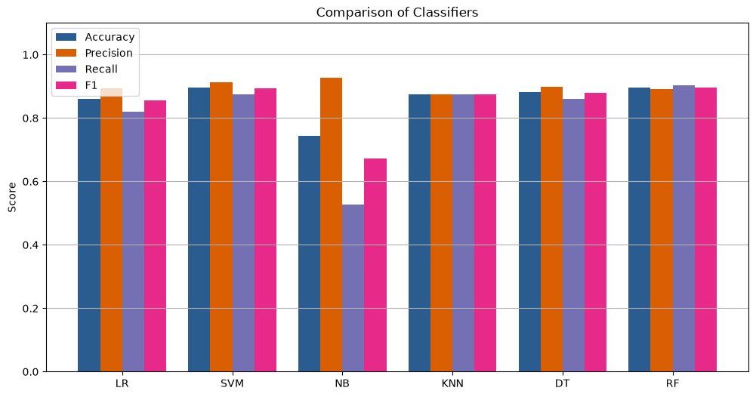

15. Conclusion
For this assignment, I used two recorded signal classes to create a movement-decoding dataset. Each signal had 36,000 samples. I divided both signals into non-overlapping 50 ms windows and calculated five features from every window. This gave me 720 feature rows, with 360 rows from each class.
I standardized the five features and then applied PCA. I kept three principal components, which together explain about 97.91% of the variance. I used an 80:20 stratified split and trained all six classifiers on the resulting data.
In my results, SVM and Random Forest both reached 89.58% accuracy. Random Forest had the highest recall (0.9028) and F1-score (0.8966), while SVM had the highest precision (0.9130). Gaussian Naive Bayes had the lowest accuracy (0.7431). The confusion matrices show the errors made by each classifier for the two classes.
I also measured the time taken by each model's fit() call. In this run, Random Forest took the longest to train and Gaussian Naive Bayes took the least time. The timing can change depending on the computer and its current workload.

Implementation Notes
One thing to note is that my notebook applies StandardScaler and PCA before splitting the data. Because of this, the test data also affects the preprocessing step. For a stricter evaluation, I should split the data first, fit the scaler and PCA only on the training set, and then use them to transform the test set. The results in this report are kept the same as the current notebook.
The original notebook imports time but does not measure the training time inside the classifier loop. I added a timer around model.fit() to cover the computational-cost part of the Classroom task. The updated timed loop should also be run in the notebook so the notebook and this report show the same results.

Coding Implementation for reference:
https://github.com/Ishan10123/ML-Algos-/blob/main/MLassignment.ipynb

