MACHINE LEARNING LAB ASSIGNMENT
NAME – Ishan Kaushik
ROLL NO. – 2026KPAD1005
SUBJECT – MACHINE LEARNING LAB ASSIGNMENT
M.Tech, CSE [AI&DS] – 1st Semester
Topic: Linear Regression

Linear Regression
Linear Regression is a supervised learning method used to predict a numerical value. It finds a straight line that shows the relationship between an input and an output. In this practical, I implemented Linear Regression using Python and Gradient Descent.
ŷ = wx + b
Here, x is the input, ŷ is the predicted value, w is the weight and b is the bias.

1. Importing Libraries and Loading the Dataset
Pandas is used to read the dataset, NumPy performs calculations, and Matplotlib is used to draw graphs.
import pandas as pd
import numpy as np
import matplotlib.pyplot as plt
train_data = pd.read_csv("train_data.csv")
X = train_data["x"].values
Y = train_data["y"].values
The dataset contains 97 rows and two columns, x and y. The scatter plot shows the original data points.
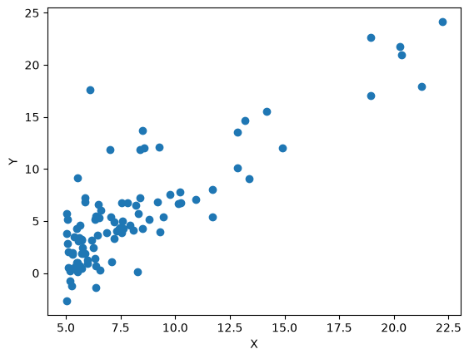

2. Loss Function
Loss measures the squared error for one data point. In this practical, the first data point is used to calculate the loss when the weight and bias are zero.
w = 0
b = 0
y_pred = w * X[0] + b
loss = (y_pred - Y[0]) ** 2
print("Loss:", loss)
Output:
Loss: 309.478464

3. Cost Function
The cost function measures the average squared error over all data points, divided by two. The aim is to find weight and bias values that reduce this cost.
J(w, b) = (1 / 2m) Σ(ŷᵢ − yᵢ)²
def cost_function(X, Y, w, b):
y_pred = w * X + b
return np.sum((y_pred - Y) ** 2) / (2 * len(X))
print("Cost at w=0, b=0:", cost_function(X, Y, 0, 0))
print("Cost at w=2, b=1:", cost_function(X, Y, 2, 1))
Output:
Cost at w=0, b=0: 32.072733877455676
Cost at w=2, b=1: 75.20338497891959

4. Calculating Gradients
Gradients show how the cost changes when the weight and bias change. They are used to update these values during Gradient Descent.
dw = (1 / m) Σ((ŷᵢ − yᵢ)xᵢ)
db = (1 / m) Σ(ŷᵢ − yᵢ)
def gradient(X, Y, w, b):
y_pred = w * X + b
error = y_pred - Y
dw = np.sum(error * X) / len(X)
db = np.sum(error) / len(X)
return dw, db
w = 0
b = 0
dw, db = gradient(X, Y, w, b)
print("dw =", dw)
print("db =", db)
Output:
dw = -65.32884974555671
db = -5.839135051546393

5. Cost Function vs Weight
This graph shows how the cost changes for different weight values while the bias stays at zero. The lowest point gives the weight with the smallest cost under this condition.
w_values = np.linspace(-1, 3, 100)
cost_values = [cost_function(X, Y, w, 0) for w in w_values]
plt.plot(w_values, cost_values)
plt.xlabel("Weight (w)")
plt.ylabel("Cost J(w, b)")
plt.title("Cost Function vs Weight")
plt.grid()
plt.show()
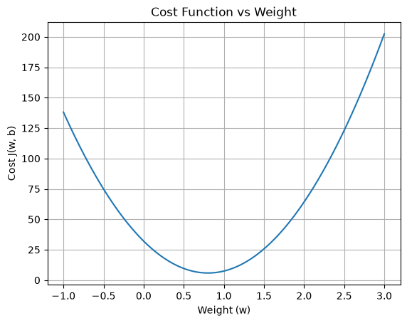

6. Gradient Descent
Gradient Descent updates the weight and bias repeatedly to reduce the cost. The learning rate controls the size of each update.
w = w − α(dw) b = b − α(db)
w = 0
b = 0
alpha = 0.01
iterations = 1000
cost_history = []
for i in range(iterations):
dw, db = gradient(X, Y, w, b)
w = w - alpha * dw
b = b - alpha * db
cost_history.append(cost_function(X, Y, w, b))
print("Weight:", w)
print("Bias:", b)
print("Final cost:", cost_history[-1])
Output:
Weight: 1.1272942024281842
Bias: -3.241402144274422
Final cost: 4.515955503078914
plt.plot(cost_history)
plt.xlabel("Iterations")
plt.ylabel("Cost")
plt.title("Cost Reduction during Gradient Descent")
plt.grid()
plt.show()
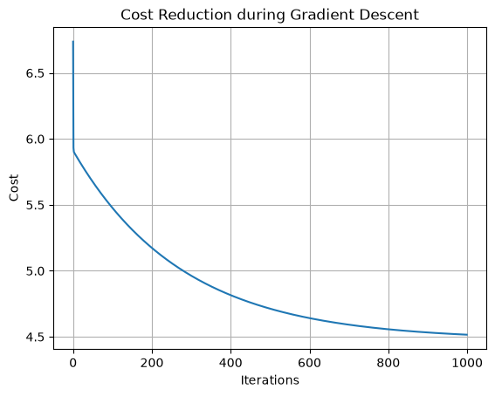

7. Learning Rate Selection
I tested six learning rates and compared the final cost after 1,000 iterations for each value. Among the tested values, the learning rate with the lowest final cost was selected.
learning_rates = [0.001, 0.003, 0.005, 0.01, 0.015, 0.02]
final_costs = []
for lr in learning_rates:
w_test = 0
b_test = 0
for i in range(1000):
dw, db = gradient(X, Y, w_test, b_test)
w_test = w_test - lr * dw
b_test = b_test - lr * db
final_costs.append(cost_function(X, Y, w_test, b_test))
print("Learning rates:", learning_rates)
print("Final costs:", final_costs)
Output:
Learning rates: [0.001, 0.003, 0.005, 0.01, 0.015, 0.02]
Final costs: [5.480269332020323, 4.964695258134313, 4.714002349533667, 4.515955503078914, 4.483372590612986, 4.478020743321126]
plt.plot(learning_rates, final_costs, marker="o")
plt.xlabel("Learning Rate")
plt.ylabel("Final Cost")
plt.title("Learning Rate vs Final Cost")
plt.grid()
plt.show()
best_index = np.argmin(final_costs)
best_alpha = learning_rates[best_index]
print("Best learning rate:", best_alpha)
print("Lowest final cost:", final_costs[best_index])
Output:
Best learning rate: 0.02
Lowest final cost: 4.478020743321126
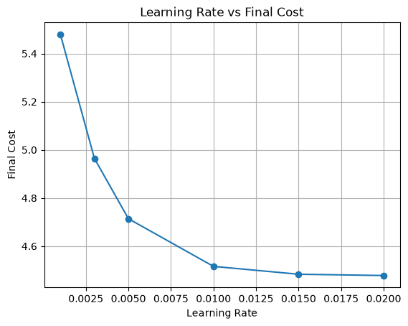

8. Training with the Selected Learning Rate
The model is trained again from w = 0 and b = 0 using the selected learning rate of 0.02.
w = 0
b = 0
alpha = best_alpha
for i in range(1000):
dw, db = gradient(X, Y, w, b)
w = w - alpha * dw
b = b - alpha * db
print("Weight:", w)
print("Bias:", b)
print("Final cost:", cost_function(X, Y, w, b))
Output:
Weight: 1.1822480052540145
Bias: -3.7884192615511796
Final cost: 4.478020743321126

9. Actual and Predicted Values
The trained weight and bias are used to predict the output for each input value.
y_pred = w * X + b
prediction_table = pd.DataFrame({
"X": X,
"Actual Y": Y,
"Predicted Y": y_pred
})
display(prediction_table.round(3))
The prediction output contains 97 rows. Some values shown in the notebook are:
Row 0: X = 6.110, Actual Y = 17.592, Predicted Y = 3.435
Row 1: X = 5.528, Actual Y = 9.130, Predicted Y = 2.747
Row 2: X = 8.519, Actual Y = 13.662, Predicted Y = 6.283
Row 3: X = 7.003, Actual Y = 11.854, Predicted Y = 4.491
Row 4: X = 5.860, Actual Y = 6.823, Predicted Y = 3.139
Row 92: X = 5.871, Actual Y = 7.203, Predicted Y = 3.152
Row 93: X = 5.305, Actual Y = 1.987, Predicted Y = 2.484
Row 94: X = 8.293, Actual Y = 0.145, Predicted Y = 6.016
Row 95: X = 13.394, Actual Y = 9.055, Predicted Y = 12.047
Row 96: X = 5.437, Actual Y = 0.617, Predicted Y = 2.639

10. Plotting the Regression Line
The scatter plot shows the original data points, and the red line shows the predictions made by the trained model.
x_line = np.sort(X)
plt.scatter(X, Y)
plt.plot(x_line, w * x_line + b, color="red")
plt.xlabel("X")
plt.ylabel("Y")
plt.title("Linear Regression")
plt.show()
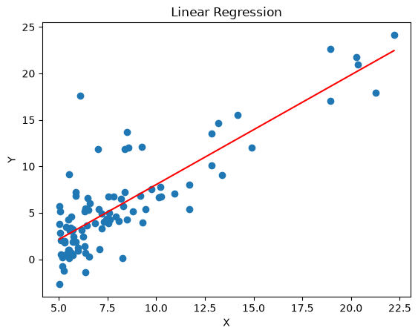

11. Model Evaluation
The model is evaluated using MSE, MAE, RMSE and R². These values help compare predicted values with actual values.
MSE = (1 / m) Σ(yᵢ − ŷᵢ)²
mse = np.mean((Y - y_pred) ** 2)
mae = np.mean(np.abs(Y - y_pred))
rmse = np.sqrt(mse)
r2 = 1 - np.sum((Y - y_pred) ** 2) / np.sum((Y - np.mean(Y)) ** 2)
print("MSE:", mse)
print("MAE:", mae)
print("RMSE:", rmse)
print("R2 Score:", r2)
Output:
MSE: 8.956041486642253
MAE: 2.2009382333439533
RMSE: 2.9926646131236043
R2 Score: 0.7019617122928004
The R² score is about 0.702, so the model explains around 70.2% of the variation in the target values for this dataset.

Conclusion
In this practical, I implemented Linear Regression using the cost function, gradients and Gradient Descent. I compared different learning rates and selected 0.02 because it gave the lowest final cost among the tested values. The final model achieved an R² score of about 0.702.
Reference link of my practical: https://github.com/Ishan10123/ML-Algos-/blob/main/Linear_Regression_using_Maths.ipynb

