MACHINE LEARNING LAB ASSIGNMENT
NAME – Ishan Kaushik
ROLL NO. – 2026KPAD1005
SUBJECT – MACHINE LEARNING LAB ASSIGNMENT
M.Tech, CSE [AI&DS] – 1st Semester
Topic: Logistic Regression
Introduction to Logistic Regression & Multivariate Logistic Regression
Logistic Regression:
Logistic Regression is a supervised machine learning algorithm mainly used for classification. It predicts the probability that an input belongs to a binary class (0 or 1) using the Sigmoid function.
Multivariate Logistic Regression:
Multivariate Logistic Regression uses two or more input features. In this assignment, the features are x1 and x2. Their weighted combination is converted into a probability, which is then classified as 0 or 1.
Implementation overview:
Part A implements multivariate Logistic Regression using Gradient Descent. Part B maps the same two features into polynomial features and trains the model with L2 Regularization to learn a nonlinear decision boundary.
PART A: Multivariate Logistic Regression
1. Load Dataset and Inspect Data
What we are performing:
We load LogR.csv using Pandas and inspect the first rows, dataset shape, column data types, and descriptive statistics.
Why we are performing this step:
This helps us understand the available observations, input columns, target column, and feature ranges before training.
Code:
import pandas as pd
import numpy as np
import matplotlib.pyplot as plt
df = pd.read_csv("LogR.csv")
display(df.head())
print("Dataset shape:", df.shape)
df.info()
display(df.describe())

Dataset preview:
Index | x1 | x2 | Output
0 | 34.623660 | 78.024693 | 0
1 | 30.286711 | 43.894998 | 0
2 | 35.847409 | 72.902198 | 0
3 | 60.182599 | 86.308552 | 1
4 | 79.032736 | 75.344376 | 1

Dataset shape: (100, 4)
RangeIndex: 100 entries, 0 to 99
Columns: Unnamed: 0, x1, x2, Output
Non-null values: 100 in each column
Data types: float64(3), int64(1)
Memory usage: 3.3 KB

Descriptive statistics:
Statistic | Unnamed: 0 | x1 | x2 | Output
count | 100 | 100 | 100 | 100
mean | 49.5000 | 65.6443 | 66.2220 | 0.6000
std | 29.0115 | 19.4582 | 18.5828 | 0.4924
min | 0 | 30.0588 | 30.6033 | 0
25% | 24.7500 | 50.9195 | 48.1792 | 0
50% | 49.5000 | 67.0330 | 67.6824 | 1
75% | 74.2500 | 80.2125 | 79.3606 | 1
max | 99 | 99.8279 | 98.8694 | 1

The CSV contains an index-like column named Unnamed: 0. The model uses only x1 and x2 as input features and Output as the target.
2. Visualize the Dataset
What we are performing:
We create a scatter plot using x1 and x2 and color the points according to the Output class.
Why we are performing this step:
The plot gives a visual view of how the two classes are distributed before model training.
plt.scatter(df["x1"], df["x2"], c=df["Output"])
plt.xlabel("x1")
plt.ylabel("x2")
plt.title("Logistic Regression Dataset")
plt.colorbar(label="Output")
plt.show()

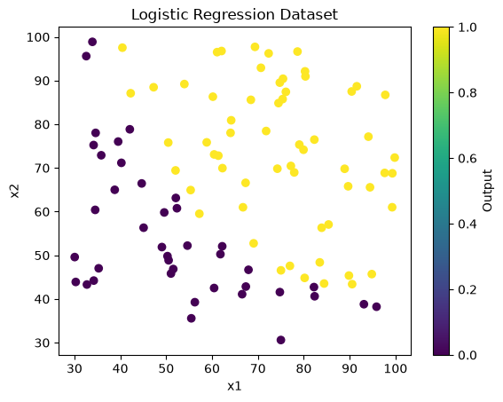
Figure 1. Original Logistic Regression dataset: x1 and x2 colored by Output.
3. Multivariate Logistic Regression and Feature Scaling
The model uses two features, x1 and x2, to calculate a linear score and convert it into a probability.
z = w₁x₁ + w₂x₂ + b
ŷ = 1 / (1 + e⁻ᶻ)
Feature Scaling
Standardization brings the input features to a similar scale. Each feature is transformed using its mean and standard deviation.
x_scaled = (x − μ) / σ
Here, μ is the feature mean and σ is its standard deviation. Scaling helps Gradient Descent converge more efficiently.
X = df[["x1", "x2"]].values
y = df["Output"].values
mean = np.mean(X, axis=0)
std = np.std(X, axis=0)
X_scaled = (X - mean) / std
print("X shape:", X_scaled.shape)
print("y shape:", y.shape)
print("Scaled mean:", np.mean(X_scaled, axis=0))
print("Scaled standard deviation:", np.std(X_scaled, axis=0))

X shape: (100, 2)
y shape: (100,)
Scaled mean: [-7.66053887e-17 1.14575016e-15]
Scaled standard deviation: [1. 1.]

4. Sigmoid Function and Initial Parameters
What we are performing:
We define the Sigmoid function, test it with a few values, and initialize the two weights and bias to zero. We then calculate the initial probabilities.
Why we are performing this step:
The Sigmoid function maps a real-valued score to a probability between 0 and 1. With zero weights and bias, the initial probability for each observation is 0.5.
σ(z) = 1 / (1 + e⁻ᶻ)
def sigmoid(z):
return 1 / (1 + np.exp(-z))
z = np.array([-10, -2, 0, 2, 10])
print("Sigmoid values:", sigmoid(z))
w = np.zeros(2)
b = 0
y_hat = sigmoid(np.dot(X_scaled, w) + b)
print("Initial weights:", w)
print("Initial bias:", b)
print("First 10 probabilities:", y_hat[:10])

Sigmoid values: [4.53978687e-05 1.19202922e-01 5.00000000e-01 8.80797078e-01 9.99954602e-01]
Initial weights: [0. 0.]
Initial bias: 0
First 10 probabilities: [0.5 0.5 0.5 0.5 0.5 0.5 0.5 0.5 0.5 0.5]

5. Binary Cross-Entropy Cost Function
What we are performing:
We implement Binary Cross-Entropy, also called Log Loss, to measure the difference between actual labels and predicted probabilities.
Why we are performing this step:
The cost function provides the value that Gradient Descent tries to minimize. The probabilities are clipped slightly to avoid taking the logarithm of zero.
J(w,b) = −(1/m) Σ [yᵢ log(ŷᵢ) + (1 − yᵢ) log(1 − ŷᵢ)]
def cost_function(y, y_hat):
m = len(y)
epsilon = 1e-15
y_hat = np.clip(y_hat, epsilon, 1 - epsilon)
cost = -np.sum(
y * np.log(y_hat) +
(1 - y) * np.log(1 - y_hat)
) / m
return cost
print("Initial Cost:", cost_function(y, y_hat))

Initial Cost: 0.6931471805599453

6. Gradient Calculation
What we are performing:
We calculate the gradients of the cost with respect to each weight and the bias.
Why we are performing this step:
The gradients show the direction in which the parameters should move to reduce the cost.
dw = Xᵀ(ŷ − y) / m
db = Σ(ŷᵢ − yᵢ) / m
def gradient(X, y, y_hat):
m = len(y)
error = y_hat - y
dw = np.dot(X.T, error) / m
db = np.sum(error) / m
return dw, db
dw, db = gradient(X_scaled, y, y_hat)
print("dw:", dw)
print("db:", db)

dw: [-0.28122914 -0.25098615]
db: -0.1

7. Gradient Descent Function
What we are performing:
We define one reusable training function. It initializes the weights and bias, calculates predictions and gradients, updates the parameters, and stores the cost after each iteration.
Why we are performing this step:
The same function is used for both parts of the assignment. In Part A, reg_lambda is zero, so no regularization penalty is applied. In Part B, reg_lambda is set to one to apply L2 Regularization.
wⱼ = wⱼ − α dwⱼ b = b − α db
def train_model(X, y, alpha, iterations, reg_lambda=0):
m = len(y)
w = np.zeros(X.shape[1])
b = 0
cost_history = []
for i in range(iterations):
y_hat = sigmoid(np.dot(X, w) + b)
dw, db = gradient(X, y, y_hat)
dw = dw + (reg_lambda / m) * w
w = w - alpha * dw
b = b - alpha * db
y_hat = sigmoid(np.dot(X, w) + b)
cost = cost_function(y, y_hat)
cost += (reg_lambda / (2 * m)) * np.sum(w ** 2)
cost_history.append(cost)
return w, b, cost_history

The parameter reg_lambda controls the L2 penalty. When it is 0, the function performs ordinary Logistic Regression. When it is 1, the regularization term is included in the cost and weight gradient.
8. Learning Rate Selection
What we are performing:
We test learning rates 0.001, 0.01, 0.05, 0.1, and 0.2. Each value is used for 1,000 iterations, and the final cost is recorded.
Why we are performing this step:
Comparing the final costs helps us choose a learning rate that gives a lower cost among the tested values.
learning_rates = [0.001, 0.01, 0.05, 0.1, 0.2]
final_costs = []
for lr in learning_rates:
_, _, history = train_model(
X_scaled, y, lr, 1000
)
final_costs.append(history[-1])
plt.plot(learning_rates, final_costs, marker="o")
plt.xlabel("Learning Rate")
plt.ylabel("Final Cost")
plt.title("Learning Rate vs Final Cost")
plt.grid()
plt.show()
best_index = np.argmin(final_costs)
best_alpha = learning_rates[best_index]
print("Best learning rate:", best_alpha)
print("Lowest final cost:", final_costs[best_index])

Learning rates: [0.001, 0.01, 0.05, 0.1, 0.2]
Final costs: [0.5725494034, 0.3118023105, 0.2244317157, 0.2105175841, 0.2049106008]
Best learning rate: 0.2
Lowest final cost: 0.20491060083873847

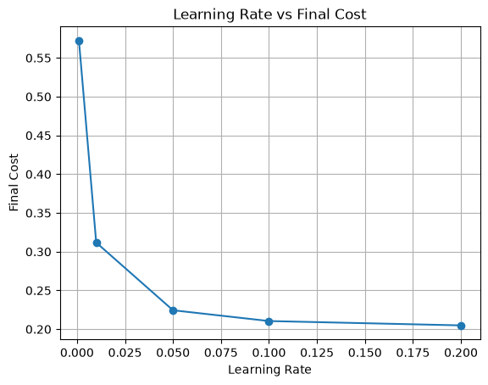
Figure 2. Final cost for each tested learning rate.
9. Final Model Training
What we are performing:
We train the final linear Logistic Regression model using the selected learning rate of 0.2 for 10,000 iterations.
Why we are performing this step:
This provides the final learned weights, bias, and cost that are used for prediction and evaluation.
w, b, cost_history = train_model(
X_scaled, y, best_alpha, 10000
)
print("Final Weights:", w)
print("Final Bias:", b)
print("Final Cost:", cost_history[-1])

Final Weights: [3.99277605 3.72512532]
Final Bias: 1.7184440743267346
Final Cost: 0.2034977015902713

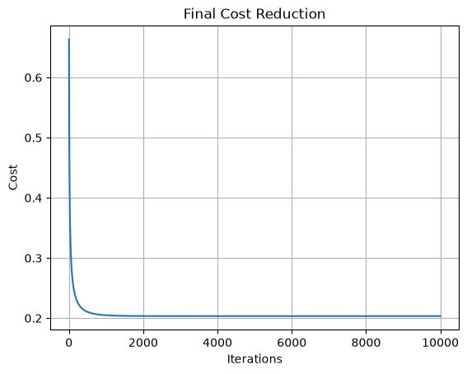
Figure 3. Cost reduction during final Gradient Descent training.
10. Prediction and Classification
What we are performing:
The trained model first calculates probabilities. We then convert probabilities into class labels using a threshold of 0.5.
Why we are performing this step:
This step converts probability estimates into the final binary predictions, 0 or 1.
ŷ_class = 1 if ŷ ≥ 0.5; otherwise ŷ_class = 0
z = np.dot(X_scaled, w) + b
y_prob = sigmoid(z)
print("First 10 actual values:", y[:10])
print("First 10 probabilities:", y_prob[:10].round(4))
y_pred = (y_prob >= 0.5).astype(int)
print("First 10 actual values:", y[:10])
print("First 10 predicted values:", y_pred[:10])
prediction_table = pd.DataFrame({
"x1": X[:, 0],
"x2": X[:, 1],
"Actual Output": y,
"Predicted Probability": y_prob,
"Predicted Output": y_pred
})
display(prediction_table.round(4))

First 10 actual values: [0. 0. 0. 1. 1. 0. 1. 1. 1. 1.]
First 10 probabilities: [0.091 0. 0.0439 0.9904 0.9982 0.0108 0.999 0.4232 0.9997 0.7354]
First 10 predicted values: [0 0 0 1 1 0 1 0 1 1]

Prediction table sample:
x1 | x2 | Actual | Probability | Predicted
34.6237 | 78.0247 | 0 | 0.0910 | 0
30.2867 | 43.8950 | 0 | 0.0000 | 0
35.8474 | 72.9022 | 0 | 0.0439 | 0
60.1826 | 86.3086 | 1 | 0.9904 | 1
79.0327 | 75.3444 | 1 | 0.9982 | 1
... | ... | ... | ... | ...
83.4892 | 48.3803 | 1 | 0.8586 | 1
42.2617 | 87.1039 | 1 | 0.7509 | 1
99.3150 | 68.7754 | 1 | 0.9999 | 1
55.3400 | 64.9319 | 1 | 0.3393 | 0
74.7759 | 89.5298 | 1 | 0.9998 | 1

11. Model Evaluation and Confusion Matrix
We calculate training accuracy, precision, recall, and F1-score. The confusion matrix shows the number of correct and incorrect predictions for each class.
Accuracy = (TP + TN) / (TP + TN + FP + FN) × 100
Precision = TP / (TP + FP)
Recall = TP / (TP + FN)
F1 = 2 × Precision × Recall / (Precision + Recall)
correct = np.sum(y == y_pred)
accuracy = (correct / len(y)) * 100
print("Correct predictions:", correct)
print("Total predictions:", len(y))
print("Accuracy:", accuracy, "%")
TP = np.sum((y == 1) & (y_pred == 1))
TN = np.sum((y == 0) & (y_pred == 0))
FP = np.sum((y == 0) & (y_pred == 1))
FN = np.sum((y == 1) & (y_pred == 0))
conf_matrix = np.array([
[TN, FP],
[FN, TP]
])
print("Confusion Matrix:")
print(conf_matrix)
precision = TP / (TP + FP) if TP + FP > 0 else 0
recall = TP / (TP + FN) if TP + FN > 0 else 0
f1 = (2 * precision * recall / (precision + recall)
if precision + recall > 0 else 0)
print("Precision:", precision)
print("Recall:", recall)
print("F1 Score:", f1)

Correct predictions: 89
Total predictions: 100
Training Accuracy: 89.0 %
Confusion Matrix:
[[34 6]
[ 5 55]]
Precision: 0.9016393443
Recall: 0.9166666667
F1 Score: 0.9090909091

In the confusion matrix, TN = 34, FP = 6, FN = 5, and TP = 55.
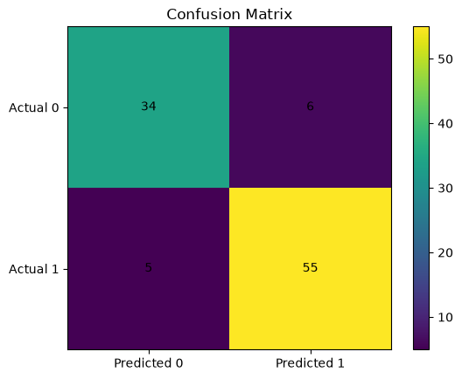
Figure 4. Confusion matrix for the linear Logistic Regression model.
12. Linear Decision Boundary
What we are performing:
We plot the learned decision boundary over the scaled data points.
Why we are performing this step:
At the decision boundary, the predicted probability is 0.5. For two input features, the boundary is a straight line.
w₁x₁ + w₂x₂ + b = 0
x1 = X_scaled[:, 0]
x2 = X_scaled[:, 1]
x1_values = np.linspace(x1.min(), x1.max(), 100)
if w[1] != 0:
x2_values = -(w[0] * x1_values + b) / w[1]
plt.scatter(x1[y == 0], x2[y == 0], label="Output 0")
plt.scatter(x1[y == 1], x2[y == 1], label="Output 1")
plt.plot(x1_values, x2_values, color="red",
label="Decision Boundary")
plt.xlabel("x1 (scaled)")
plt.ylabel("x2 (scaled)")
plt.title("Logistic Regression Decision Boundary")
plt.legend()
plt.grid()
plt.show()

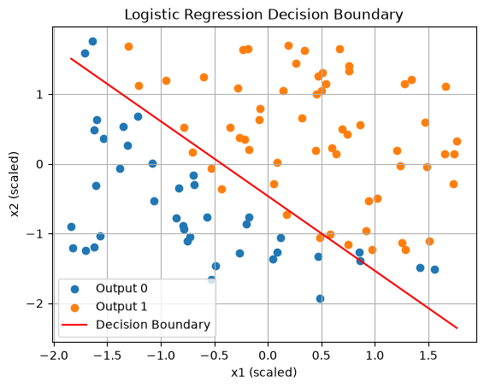
Figure 5. Linear decision boundary for the two scaled input features.

PART B: Polynomial Logistic Regression with L2 Regularization
In Part B, we use polynomial feature mapping to create additional features from x1 and x2. We then reuse the same training function with L2 Regularization to learn a nonlinear decision boundary.
13. Polynomial Feature Mapping
What we are performing:
We transform the two scaled input features into polynomial terms up to degree 6.
Why we are performing this step:
The additional terms allow Logistic Regression to learn a nonlinear decision boundary instead of only a straight line.
def map_feature(X, degree=6):
x1 = X[:, 0]
x2 = X[:, 1]
mapped_features = []
for i in range(1, degree + 1):
for j in range(i + 1):
mapped_features.append(x1 ** (i - j) * x2 ** j)
return np.column_stack(mapped_features)
X_poly = map_feature(X_scaled, degree=6)
print("Original features:", X_scaled.shape)
print("Polynomial features:", X_poly.shape)

Original features: (100, 2)
Polynomial features: (100, 27)

The degree-6 mapping creates 27 features: 2 + 3 + 4 + 5 + 6 + 7 = 27.
14. L2 Regularization
L2 Regularization adds a penalty to the cost function to discourage very large weights. The bias is not regularized.
J(w,b) = J_BCE + (λ / 2m) Σ wⱼ²
dw = Xᵀ(ŷ − y) / m + (λ / m)w
db = Σ(ŷᵢ − yᵢ) / m
The existing train_model() function applies these two regularization terms when reg_lambda is greater than zero. We use λ = 1 for the polynomial model.
15. Training the Polynomial Model
What we are performing:
We reuse train_model() with the 27 polynomial features, learning rate 0.01, 10,000 iterations, and reg_lambda = 1.
Why we are performing this step:
This trains the polynomial Logistic Regression model while including the L2 penalty in the cost and weight gradient.
w_poly, b_poly, cost_history_poly = train_model(
X_poly,
y,
alpha=0.01,
iterations=10000,
reg_lambda=1
)
print("Final Weights:", w_poly)
print("Final Bias:", b_poly)
print("Final Cost:", cost_history_poly[-1])

Final Weights (27 values):
[ 1.20654690 0.96691333 0.09049410 -0.93108328 0.24647462 0.81200921
0.21548571 0.50245265 0.59977879 -0.11802898 -0.41394491 0.21458346
-0.57686232 0.08218001 0.70362693 0.22976258 0.06157596 0.25620462
0.15649579 0.84999262 -0.41969095 0.01883869 -0.13942859 -0.00127487
-0.12514359 -0.03852875 -0.46804458]
Final Bias: 1.7851623134602872
Final Cost: 0.1302998968264627

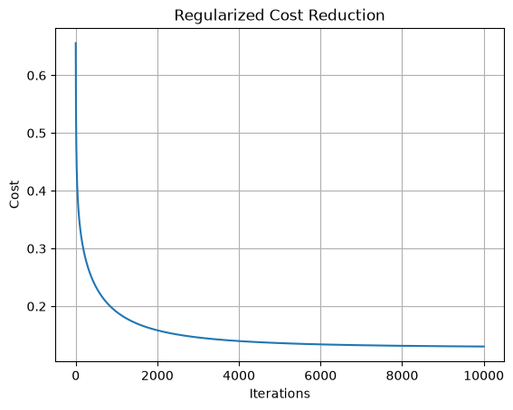
Figure 6. Regularized cost reduction during polynomial model training.
16. Nonlinear Decision Boundary
What we are performing:
We create a grid over the scaled feature space, map each grid point to the same degree-6 polynomial features, and calculate its predicted probability.
Why we are performing this step:
The contour at probability 0.5 shows the nonlinear boundary learned by the polynomial Logistic Regression model.
x1_values = np.linspace(X_scaled[:, 0].min(), X_scaled[:, 0].max(), 200)
x2_values = np.linspace(X_scaled[:, 1].min(), X_scaled[:, 1].max(), 200)
xx, yy = np.meshgrid(x1_values, x2_values)
grid = np.column_stack((xx.ravel(), yy.ravel()))
grid_poly = map_feature(grid, degree=6)
probabilities = sigmoid(np.dot(grid_poly, w_poly) + b_poly)
Z = probabilities.reshape(xx.shape)
plt.scatter(X_scaled[y == 0, 0], X_scaled[y == 0, 1], label="Output 0")
plt.scatter(X_scaled[y == 1, 0], X_scaled[y == 1, 1], label="Output 1")
plt.contour(xx, yy, Z, levels=[0.5], colors="red")
plt.xlabel("x1 (scaled)")
plt.ylabel("x2 (scaled)")
plt.title("Polynomial Logistic Regression Decision Boundary")
plt.legend()
plt.grid()
plt.show()

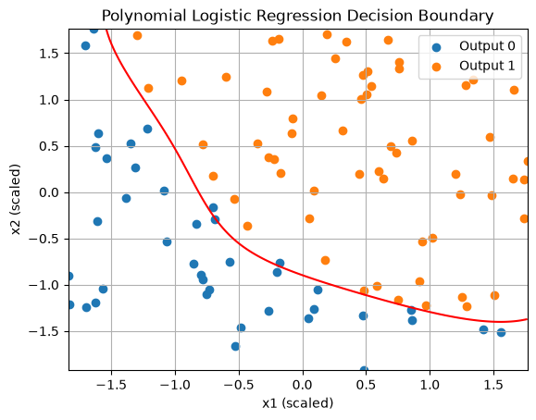
Figure 7. Nonlinear decision boundary learned from polynomial features.
17. Polynomial Predictions
What we are performing:
We calculate probabilities from the polynomial model and classify them using the same 0.5 threshold. The notebook displays the first 20 predictions.
Why we are performing this step:
The prediction table allows us to compare each actual output with its predicted probability and predicted class.
y_poly_prob = sigmoid(np.dot(X_poly, w_poly) + b_poly)
y_poly_pred = (y_poly_prob >= 0.5).astype(int)
prediction_table_poly = pd.DataFrame({
"Actual Output": y,
"Predicted Probability": y_poly_prob,
"Predicted Output": y_poly_pred
})
display(prediction_table_poly.head(20).round(4))

Row | Actual Output | Predicted Probability | Predicted Output
0 | 0 | 0.0000 | 0
1 | 0 | 0.0000 | 0
2 | 0 | 0.0000 | 0
3 | 1 | 0.9892 | 1
4 | 1 | 0.9668 | 1
5 | 0 | 0.0173 | 0
6 | 1 | 0.9998 | 1
7 | 1 | 0.6061 | 1
8 | 1 | 0.9949 | 1
9 | 1 | 0.7304 | 1
10 | 0 | 0.0180 | 0
11 | 0 | 0.0000 | 0
12 | 1 | 0.9811 | 1
13 | 1 | 0.9998 | 1
14 | 0 | 0.0048 | 0
15 | 1 | 0.9966 | 1
16 | 1 | 0.7666 | 1
17 | 0 | 0.2877 | 0
18 | 1 | 0.9990 | 1
19 | 1 | 0.7859 | 1

18. Polynomial Model Evaluation
We calculate the confusion matrix, training accuracy, precision, recall, and F1-score for the polynomial model.
TP = np.sum((y == 1) & (y_poly_pred == 1))
TN = np.sum((y == 0) & (y_poly_pred == 0))
FP = np.sum((y == 0) & (y_poly_pred == 1))
FN = np.sum((y == 1) & (y_poly_pred == 0))
conf_matrix_poly = np.array([
[TN, FP],
[FN, TP]
])
accuracy_poly = (TP + TN) / len(y) * 100
precision_poly = TP / (TP + FP) if TP + FP > 0 else 0
recall_poly = TP / (TP + FN) if TP + FN > 0 else 0
f1_poly = (
2 * precision_poly * recall_poly / (precision_poly + recall_poly)
if precision_poly + recall_poly > 0 else 0
)
print("Confusion Matrix:")
print(conf_matrix_poly)
print("Training Accuracy:", accuracy_poly, "%")
print("Precision:", precision_poly)
print("Recall:", recall_poly)
print("F1 Score:", f1_poly)

Confusion Matrix:
[[38 2]
[ 0 60]]
Training Accuracy: 98.0 %
Precision: 0.9677419355
Recall: 1.0
F1 Score: 0.9836065574

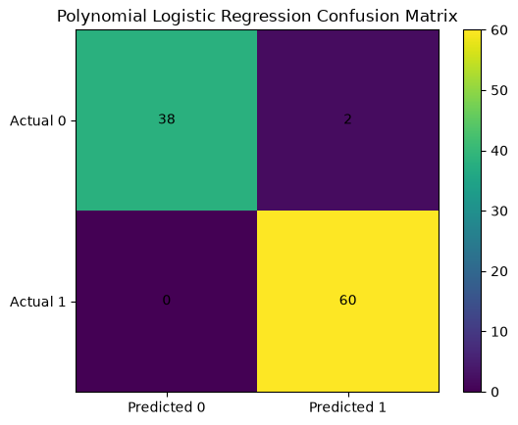
Figure 8. Confusion matrix for polynomial Logistic Regression with L2 Regularization.
19. Conclusion and Summary
In this assignment, Logistic Regression was implemented from scratch using NumPy, Pandas, and Matplotlib. No machine learning library was used for model training.
Part A: Multivariate Logistic Regression
- The dataset contains 100 observations, two input features (x1 and x2), and a binary target (Output).
- Feature standardization gave the two input features approximately zero mean and unit standard deviation.
- The learning-rate experiment selected 0.2 as the lowest-cost option among the five tested values.
- The final linear model reached a cost of 0.2035 and 89.0% training accuracy.
Part B: Polynomial Logistic Regression with L2 Regularization
- Degree-6 polynomial mapping converted the two original features into 27 features.
- L2 Regularization with λ = 1 was applied through the reusable training function.
- The final regularized cost was 0.1303, and training accuracy was 98.0%.
- The polynomial model produced a nonlinear decision boundary.
The reported accuracy values are training accuracy because the models were evaluated on the same 100 observations used for training. The higher polynomial training accuracy does not by itself establish better performance on unseen data.
Final Results
Metric | Part A: Linear Model | Part B: Polynomial + L2
Input features | 2 | 27
Learning rate | 0.2 | 0.01
Iterations | 10,000 | 10,000
Regularization λ | 0 | 1
Final cost | 0.2035 | 0.1303
Confusion matrix | [[34, 6], [5, 55]] | [[38, 2], [0, 60]]
Training accuracy | 89.0% | 98.0%
Precision | 0.9016 | 0.9677
Recall | 0.9167 | 1.0000
F1-score | 0.9091 | 0.9836

Repository / Code Reference:
https://github.com/Ishan10123/Machine-Learning-Assignments

