MACHINE LEARNING LAB ASSIGNMENT
NAME – Ishan Kaushik
ROLL NO. – 2026KPAD1005
SUBJECT – MACHINE LEARNING LAB ASSIGNMENT
M.Tech, CSE [AI&DS] – 1st Semester
Topic: Decision Tree

Decision Tree
A Decision Tree is a supervised learning algorithm used for classification and regression. It makes decisions by splitting data into smaller groups based on feature values. In this practical, I implemented a categorical classification tree from scratch using Python, without using Scikit-learn.
The target variable is Edible, and the input features are Cap color, Stalk shape, and Solitary. The tree selects features by measuring how much each split reduces class impurity.
Entropy: H(S) = −Σ pᵢ log₂(pᵢ)
Gini Impurity: Gini(S) = 1 − Σ pᵢ²
Information Gain = Parent Entropy − Weighted Entropy
Gini Reduction = Parent Gini − Weighted Gini

1. Importing Libraries and Loading the Dataset
Pandas is used to read and inspect the dataset, NumPy performs the mathematical calculations, and Matplotlib creates the graphs.
import pandas as pd
import numpy as np
import matplotlib.pyplot as plt
df = pd.read_csv("mushroom_problem_identification.csv")
df.head()
The first five observations displayed by the notebook are:
Output:
Cap color Stalk shape Solitary Edible
Brown Tapering Yes 1
Brown Enlarging Yes 1
Brown Tapering No 0
Brown Enlarging No 0
Brown Tapering Yes 1

2. Inspecting the Dataset
Before training the tree, I check the dataset dimensions, column names, data types, missing values, and duplicate rows. These checks help identify basic data-quality issues.
print("Dataset shape:", df.shape)
print("Columns:", df.columns.tolist())
df.info()
print("\nMissing values:")
print(df.isnull().sum())
print("\nDuplicate rows:", df.duplicated().sum())
Output:
Dataset shape: (10, 4)
Columns: ['Cap color', 'Stalk shape', 'Solitary', 'Edible']
All 10 rows contain values in each column.
Missing values: 0 in each column
Duplicate rows: 3
The dataset contains 10 observations and 4 columns. It has no missing values, but it contains 3 duplicate rows. The original dataset is kept unchanged for the main mathematical calculations.

3. Selecting Features and Target
The three input features are Cap color, Stalk shape, and Solitary. Edible is the target variable with two classes, 0 and 1. Cross-tabulations show the class counts for each feature category.
features = ["Cap color", "Stalk shape", "Solitary"]
target = "Edible"
X = df[features]
y = df[target]
print("Features:", features)
print("Target:", target)
print("\nTarget distribution:")
print(y.value_counts().sort_index())
for feature in features:
print("\n", feature)
print(pd.crosstab(df[feature], df[target]))
Output:
Target distribution:
Edible
0 5
1 5
Cap color (Edible 0 / 1):
Brown: 3 / 4
Red: 2 / 1
Stalk shape (Edible 0 / 1):
Enlarging: 3 / 2
Tapering: 2 / 3
Solitary (Edible 0 / 1):
No: 4 / 1
Yes: 1 / 4
The target is balanced, with five observations from each class. All input features are categorical, so feature scaling is not required for this implementation.

4. Entropy
Entropy measures class uncertainty. A dataset with equally represented classes has higher entropy, while a dataset containing only one class has entropy zero.
H(S) = −Σ pᵢ log₂(pᵢ)
def entropy(labels):
counts = np.unique(labels, return_counts=True)[1]
probabilities = counts / len(labels)
return -np.sum(probabilities * np.log2(probabilities))
print("Dataset Entropy:", entropy(y))
Output:
Dataset Entropy: 1.0
The entropy is 1.0 because the dataset has five examples of class 0 and five examples of class 1.

5. Gini Impurity
Gini Impurity is another way to measure how mixed the classes are in a dataset. A pure group has a Gini value of zero.
Gini(S) = 1 − Σ pᵢ²
def gini(labels):
counts = np.unique(labels, return_counts=True)[1]
probabilities = counts / len(labels)
return 1 - np.sum(probabilities ** 2)
print("Dataset Gini Impurity:", gini(y))
Output:
Dataset Gini Impurity: 0.5
The initial Gini Impurity is 0.5, which matches a balanced binary target.

6. Evaluating Feature Splits
A feature split divides the data into groups based on its categories. I calculate the weighted Entropy and weighted Gini Impurity by multiplying each group impurity by its share of the observations.
Weighted Impurity = Σ (Nᵢ / N) × Impurity(Sᵢ)
def split_impurities(data, feature, target):
weighted_entropy = 0
weighted_gini = 0
for value in data[feature].unique():
subset = data[data[feature] == value]
weight = len(subset) / len(data)
weighted_entropy += weight * entropy(subset[target])
weighted_gini += weight * gini(subset[target])
return weighted_entropy, weighted_gini
Information Gain is the reduction in Entropy after a split. Gini Reduction is the reduction in Gini Impurity. The following code compares these values for all three features.
Information Gain = Parent Entropy − Weighted Entropy
Gini Reduction = Parent Gini − Weighted Gini
parent_entropy = entropy(y)
parent_gini = gini(y)
results = []
for feature in features:
weighted_entropy, weighted_gini = split_impurities(
df, feature, target
)
results.append({
"Feature": feature,
"Weighted Entropy": weighted_entropy,
"Information Gain": parent_entropy - weighted_entropy,
"Weighted Gini": weighted_gini,
"Gini Reduction": parent_gini - weighted_gini
})
scores = pd.DataFrame(results)
display(scores.round(4))
Output:
Feature: Cap color
Weighted Entropy: 0.9651
Information Gain: 0.0349
Weighted Gini: 0.4762
Gini Reduction: 0.0238
Feature: Stalk shape
Weighted Entropy: 0.9710
Information Gain: 0.0290
Weighted Gini: 0.4800
Gini Reduction: 0.0200
Feature: Solitary
Weighted Entropy: 0.7219
Information Gain: 0.2781
Weighted Gini: 0.3200
Gini Reduction: 0.1800
Solitary has the highest Information Gain and Gini Reduction. Both measures indicate that it is the most useful first split for this dataset.
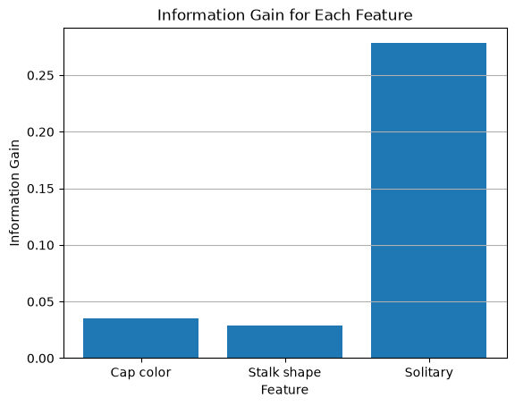
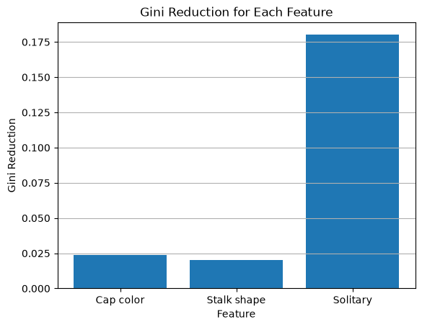

7. Selecting the Root Feature
The root is the first decision node of the tree. I select the feature with the highest Information Gain and examine the class distribution in each branch.
best_feature = scores.loc[
scores["Information Gain"].idxmax(), "Feature"
]
print("Best root feature:", best_feature)
print("Information Gain:", scores["Information Gain"].max())
for value in df[best_feature].unique():
subset = df[df[best_feature] == value]
print("\nSolitary =", value)
print("Rows:", len(subset))
print("Class counts:")
print(subset[target].value_counts().sort_index())
print("Entropy:", round(entropy(subset[target]), 4))
print("Gini:", round(gini(subset[target]), 4))
Output:
Best root feature: Solitary
Information Gain: 0.2780719051126377
Solitary = Yes
Rows: 5
Class counts: 0 = 1, 1 = 4
Entropy: 0.7219
Gini: 0.32
Solitary = No
Rows: 5
Class counts: 0 = 4, 1 = 1
Entropy: 0.7219
Gini: 0.32

8. Building the Decision Tree Using Information Gain
I build the tree recursively. At every node, the feature with the highest Information Gain is selected. The process stops when a subset contains a single class or when no features remain. The tree is stored as nested Python dictionaries.
def information_gain(data, feature, target):
weighted_entropy, weighted_gini = split_impurities(
data, feature, target
)
return entropy(data[target]) - weighted_entropy
def build_tree(data, features, target):
labels = data[target]
if labels.nunique() == 1:
return int(labels.iloc[0])
if len(features) == 0:
return int(labels.mode()[0])
gains = [
information_gain(data, feature, target)
for feature in features
]
best_feature = features[np.argmax(gains)]
tree = {best_feature: {}}
remaining_features = [
feature for feature in features
if feature != best_feature
]
for value in data[best_feature].unique():
subset = data[data[best_feature] == value]
tree[best_feature][value] = build_tree(
subset, remaining_features, target
)
return tree
tree = build_tree(df, features, target)
print(tree)
Output:
{'Solitary': {'Yes': {'Cap color': {'Brown': 1, 'Red': 0}}, 'No': {'Cap color': {'Brown': 0, 'Red': {'Stalk shape': {'Enlarging': 0, 'Tapering': 1}}}}}}
The tree begins with Solitary. For Solitary = Yes, Cap color separates the labels. For Solitary = No, Cap color is checked first, and Stalk shape is used for the remaining Red branch.
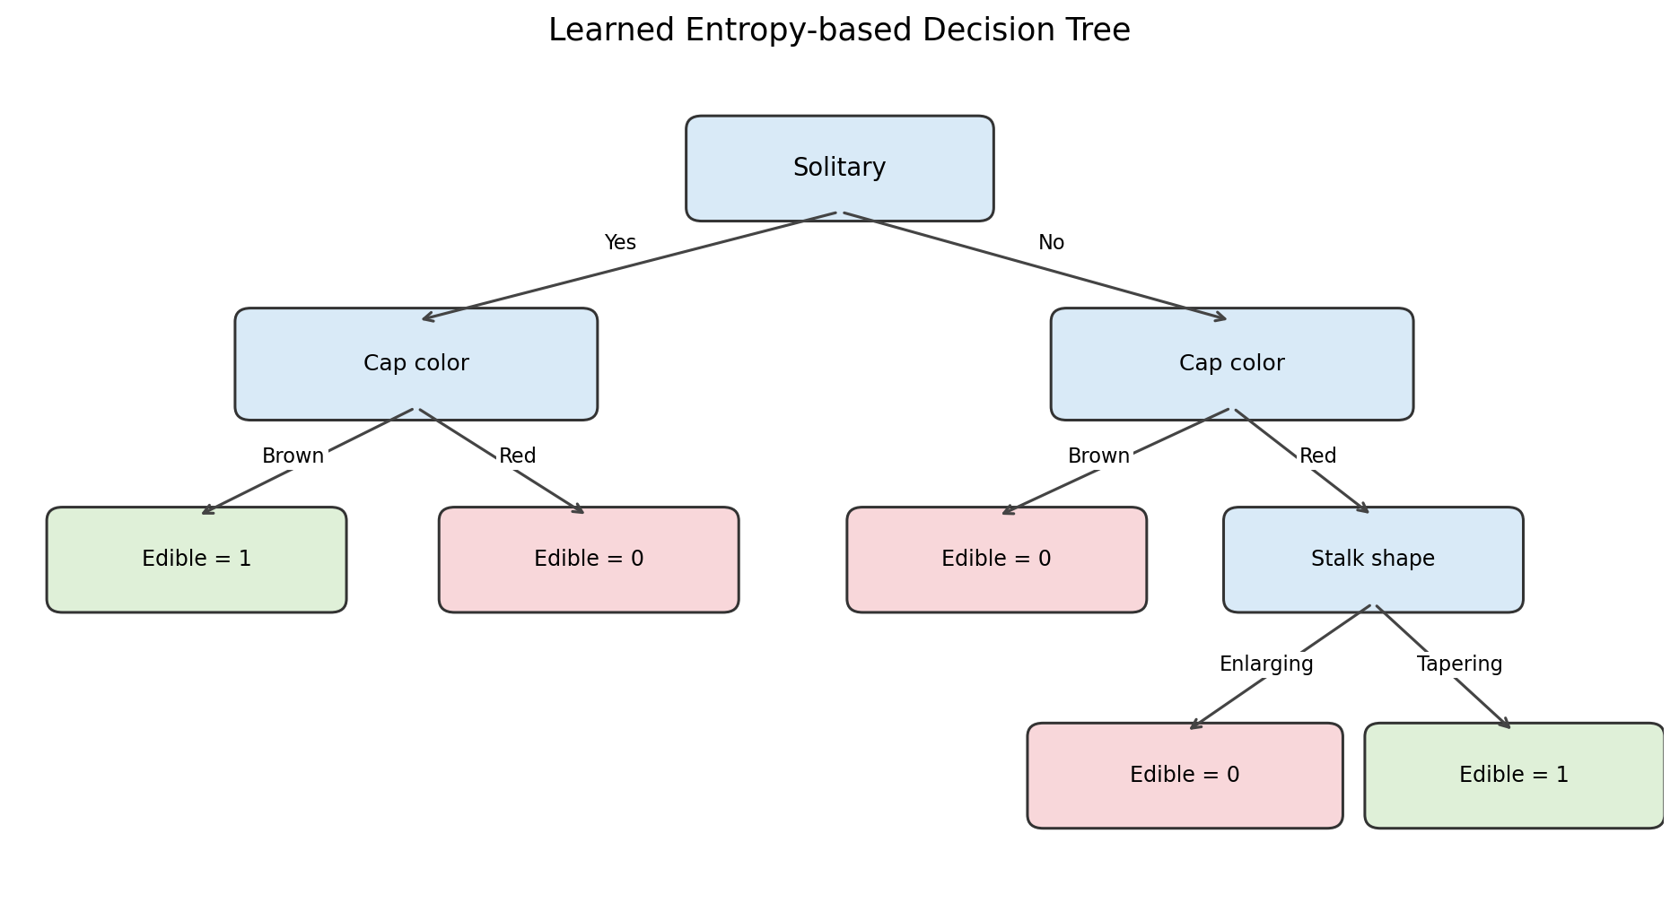

9. Prediction and Training Accuracy
The prediction function follows the tree branches using a row’s feature values. Once it reaches a leaf, it returns the predicted class. I then compare predictions with the actual labels.
def predict(tree, sample, default=0):
if not isinstance(tree, dict):
return tree
feature = next(iter(tree))
value = sample[feature]
if value not in tree[feature]:
return default
return predict(tree[feature][value], sample, default)
y_actual = df[target].values
y_pred = np.array([predict(tree, row) for _, row in df.iterrows()])
print("Actual values:", y_actual)
print("Predicted values:", y_pred)
Output:
Actual values: [1 1 0 0 1 0 0 1 1 0]
Predicted values: [1 1 0 0 1 0 0 1 1 0]
correct = np.sum(y_actual == y_pred)
accuracy = correct / len(y_actual) * 100
print("Correct predictions:", correct)
print("Total predictions:", len(y_actual))
print("Accuracy:", accuracy, "%")
Output:
Correct predictions: 10
Total predictions: 10
Accuracy: 100.0 %
This is training accuracy because the tree was built and evaluated on the same 10 observations. It does not show how the tree will perform on unseen data.

10. Confusion Matrix
The confusion matrix compares actual classes with predicted classes. It contains True Negatives (TN), False Positives (FP), False Negatives (FN), and True Positives (TP).
Confusion Matrix = [[TN, FP], [FN, TP]]
TP = np.sum((y_actual == 1) & (y_pred == 1))
TN = np.sum((y_actual == 0) & (y_pred == 0))
FP = np.sum((y_actual == 0) & (y_pred == 1))
FN = np.sum((y_actual == 1) & (y_pred == 0))
conf_matrix = np.array([
[TN, FP],
[FN, TP]
])
print("Confusion Matrix:")
print(conf_matrix)
Output:
Confusion Matrix:
[[5 0]
[0 5]]
plt.imshow(conf_matrix)
plt.colorbar()
plt.xticks([0, 1], ["Predicted 0", "Predicted 1"])
plt.yticks([0, 1], ["Actual 0", "Actual 1"])
for i in range(2):
for j in range(2):
plt.text(j, i, conf_matrix[i, j],
ha="center", va="center")
plt.title("Decision Tree Confusion Matrix")
plt.show()
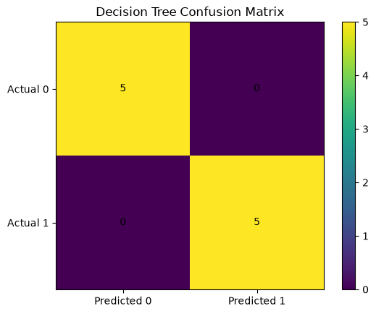

11. Building the Decision Tree Using Gini Reduction
I also build a second tree using Gini Reduction to select each split. This allows me to compare a Gini-based tree with the Entropy-based tree. Both use the same input features and target.
def gini_reduction(data, feature, target):
_, weighted_gini = split_impurities(data, feature, target)
return gini(data[target]) - weighted_gini
def build_gini_tree(data, features, target):
labels = data[target]
if labels.nunique() == 1:
return int(labels.iloc[0])
if len(features) == 0:
return int(labels.mode()[0])
reductions = [
gini_reduction(data, feature, target)
for feature in features
]
best_feature = features[np.argmax(reductions)]
tree = {best_feature: {}}
remaining_features = [
feature for feature in features
if feature != best_feature
]
for value in data[best_feature].unique():
subset = data[data[best_feature] == value]
tree[best_feature][value] = build_gini_tree(
subset, remaining_features, target
)
return tree
gini_tree = build_gini_tree(df, features, target)
print("Gini-based Decision Tree:")
print(gini_tree)
Output:
Gini-based Decision Tree:
{'Solitary': {'Yes': {'Cap color': {'Brown': 1, 'Red': 0}}, 'No': {'Cap color': {'Brown': 0, 'Red': {'Stalk shape': {'Enlarging': 0, 'Tapering': 1}}}}}}
y_pred_gini = np.array([
predict(gini_tree, row)
for _, row in df.iterrows()
])
accuracy_entropy = np.mean(y_actual == y_pred) * 100
accuracy_gini = np.mean(y_actual == y_pred_gini) * 100
print("Entropy-based accuracy:", accuracy_entropy, "%")
print("Gini-based accuracy:", accuracy_gini, "%")
Output:
Entropy-based accuracy: 100.0 %
Gini-based accuracy: 100.0 %
Both trees have the same structure and both achieve 100% training accuracy on the original dataset.

12. Train/Test Evaluation and Overfitting
To check performance beyond the original training rows, I remove duplicate rows for a separate evaluation, shuffle the remaining data, and create a 70/30 split. The tree is trained only on the training subset.
df_eval = df.drop_duplicates().reset_index(drop=True)
np.random.seed(42)
indices = np.random.permutation(len(df_eval))
split = int(0.7 * len(df_eval))
train_df = df_eval.iloc[indices[:split]]
test_df = df_eval.iloc[indices[split:]]
print("Training rows:", len(train_df))
print("Testing rows:", len(test_df))
Output:
Training rows: 4
Testing rows: 3
tree_test = build_tree(train_df, features, target)
print("Training tree:")
print(tree_test)
train_actual = train_df[target].values
test_actual = test_df[target].values
train_pred = np.array([
predict(tree_test, row) for _, row in train_df.iterrows()
])
test_pred = np.array([
predict(tree_test, row) for _, row in test_df.iterrows()
])
train_accuracy = np.mean(train_actual == train_pred) * 100
test_accuracy = np.mean(test_actual == test_pred) * 100
print("Training accuracy:", train_accuracy, "%")
print("Testing accuracy:", test_accuracy, "%")
Output:
Training tree: {'Solitary': {'Yes': 1, 'No': 0}}
Training accuracy: 100.0 %
Testing accuracy: 33.33333333333333 %
The training accuracy is 100%, but the testing accuracy is 33.33%. This is a warning sign that the tree does not generalize well on this particular split. However, only four training rows and three testing rows are available, so these values are not a reliable estimate of real-world performance.

13. Controlling Tree Depth
A depth limit prevents the tree from adding more decision levels once it reaches the selected maximum depth. If the limit is reached before the subset becomes pure, the majority class is returned.
def build_tree_depth(data, features, target, max_depth, depth=0):
labels = data[target]
if labels.nunique() == 1:
return int(labels.iloc[0])
if depth >= max_depth or len(features) == 0:
return int(labels.mode()[0])
gains = [
information_gain(data, feature, target)
for feature in features
]
best_feature = features[np.argmax(gains)]
tree = {best_feature: {}}
remaining_features = [
feature for feature in features
if feature != best_feature
]
for value in data[best_feature].unique():
subset = data[data[best_feature] == value]
tree[best_feature][value] = build_tree_depth(
subset, remaining_features, target,
max_depth, depth + 1
)
return tree
I compare maximum depths of 1, 2, and 3. Each tree is trained on the same training subset and evaluated on the same testing subset.
depths = [1, 2, 3]
results = []
default_class = int(train_df[target].mode()[0])
for depth in depths:
tree_d = build_tree_depth(
train_df, features, target, max_depth=depth
)
train_pred_d = np.array([
predict(tree_d, row, default_class)
for _, row in train_df.iterrows()
])
test_pred_d = np.array([
predict(tree_d, row, default_class)
for _, row in test_df.iterrows()
])
train_acc = np.mean(train_df[target].values == train_pred_d) * 100
test_acc = np.mean(test_df[target].values == test_pred_d) * 100
results.append({
"Max Depth": depth,
"Training Accuracy": train_acc,
"Testing Accuracy": test_acc
})
depth_results = pd.DataFrame(results)
display(depth_results)
Output:
Max Depth 1: Training Accuracy 100.0%, Testing Accuracy 33.3333%
Max Depth 2: Training Accuracy 100.0%, Testing Accuracy 33.3333%
Max Depth 3: Training Accuracy 100.0%, Testing Accuracy 33.3333%
For this particular split, all tested depths produce the same accuracy. The small training subset allows the root feature Solitary to classify its four training rows, so deeper limits do not change the results.
plt.plot(
depth_results["Max Depth"],
depth_results["Training Accuracy"],
marker="o", label="Training Accuracy"
)
plt.plot(
depth_results["Max Depth"],
depth_results["Testing Accuracy"],
marker="o", label="Testing Accuracy"
)
plt.xlabel("Maximum Tree Depth")
plt.ylabel("Accuracy (%)")
plt.title("Tree Depth vs Accuracy")
plt.xticks(depths)
plt.legend()
plt.grid()
plt.show()
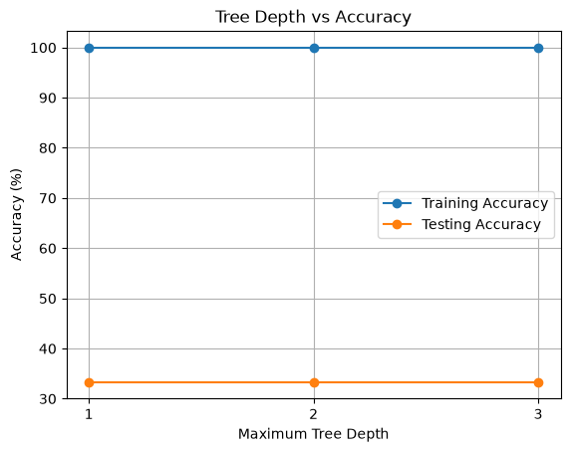

Conclusion
In this practical, I implemented a Decision Tree from scratch using Pandas, NumPy, and Matplotlib without using Scikit-learn. I calculated Entropy, Gini Impurity, Information Gain, and Gini Reduction to compare the input features and select splits.
The feature Solitary had the highest Information Gain and Gini Reduction, so it was selected as the root. The Entropy-based and Gini-based trees produced the same structure and achieved 100% training accuracy on the original 10 rows.
For a separate evaluation, I removed duplicates and split the seven unique observations into four training rows and three testing rows. The training accuracy was 100%, while the testing accuracy was 33.33%. This shows that accuracy on the training data alone is not enough. Because the dataset is very small, more data would be needed to evaluate how well the tree predicts unseen observations.

Reference link of complete implementation: https://github.com/Ishan10123/ML-Algos-/blob/main/Decision_Tree%20(1).ipynb

