**ANDROID ASSIGNMENT**

**ON**

**Accessing Internal and External Storage**

**By-Ishan Pandey**

**Reg No.- 11703590**

**Section- KM042**

**Roll No. 04**

**Dept. of Computer Science and Engineering**

**Lovely Professional University**

**1. Introduction**

The assignment given to me consists of creating an Android Application that depicts the usage and access to the Android System’s external and internal storage. I created an application that consists both the modules separately. In first module the user can write into an already created file that is “int.txt” and can display what is written into the file. As the device is not rooted, we cannot go to the actual location of the file but we can display the content on the android studio using **View-> Tool Windows -> Device File Explorer.**

**2. Working Screenshots**

**2.1 The Splash Screen:** The first screen consists of a simple splash screen with a progress bar at the bottom.



**2.2 The MainActivity:** The MainActivity consists of the 2 modules, the first one is the Internal Storage and the second one is the External Storage. The MainActivity consists of a Fragment that is replaced by the other 2 on the click of the respective button.

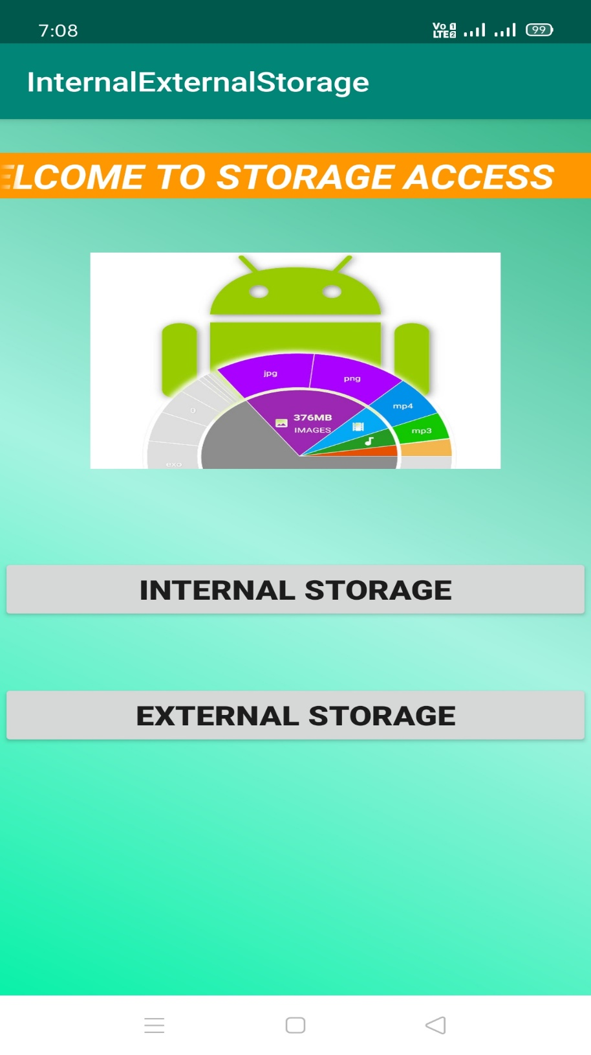

**2.3 The Internal Storage:** This module consists of a EditText to get the content that is to be written in the file and it also shows what is written in the file. The 2 buttons are used to store and retrieve the file data. The data is stored in an existing file “int.txt”.

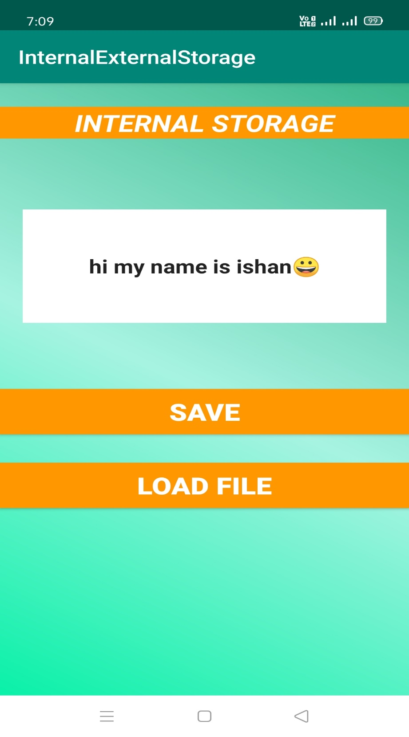 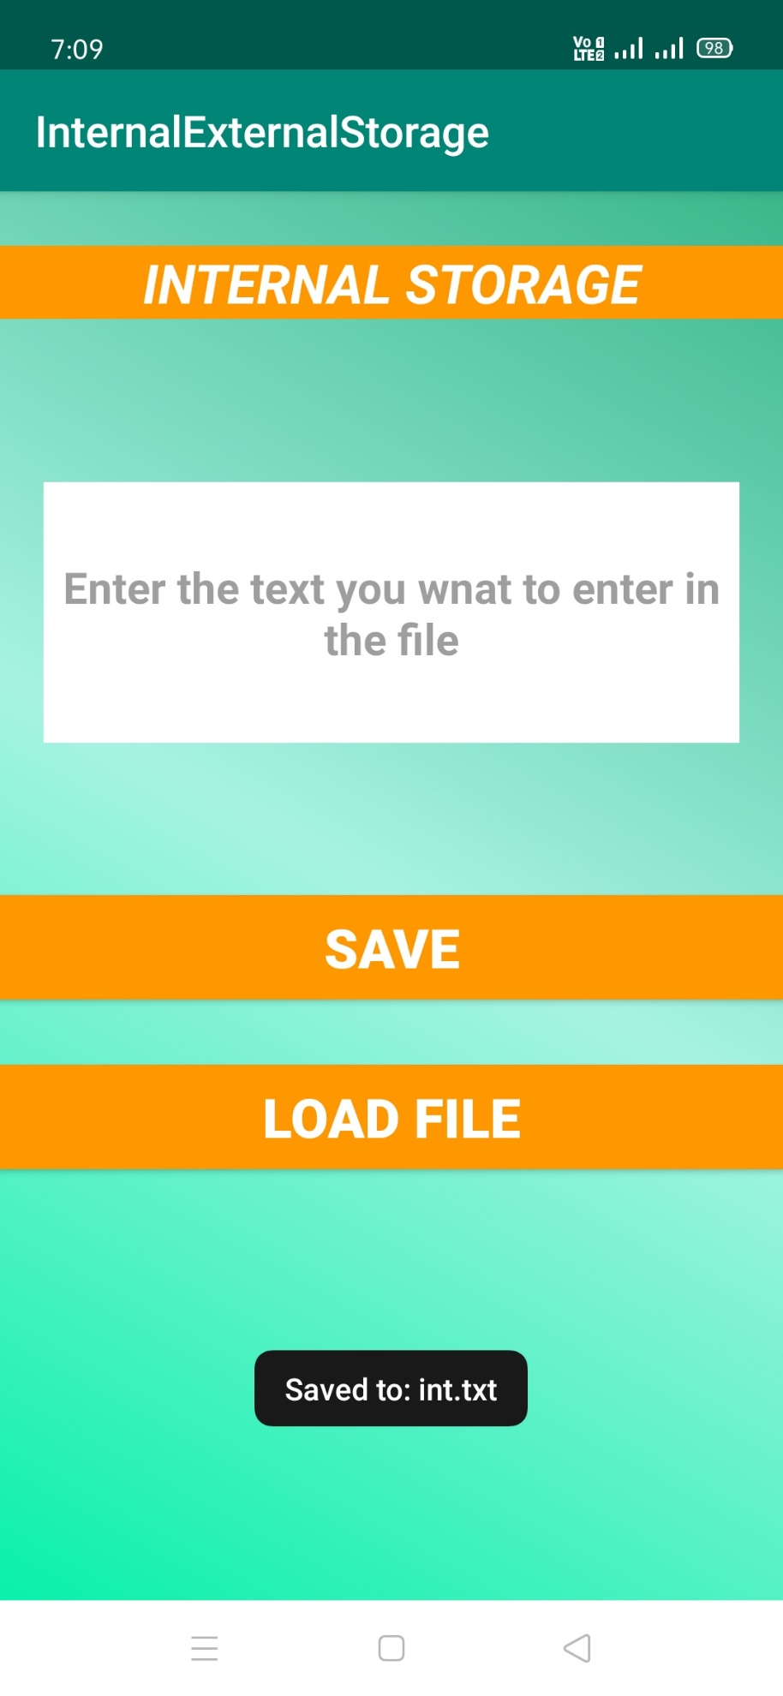

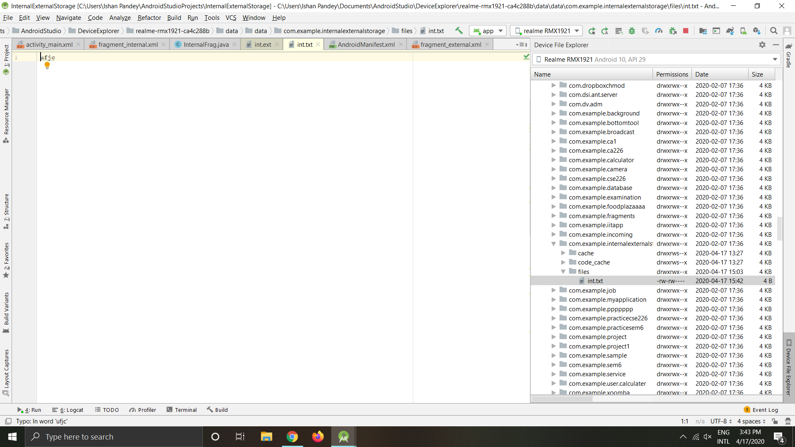**–**

**2.4 The External Storage:** This module is used to store the data in the external storage of the device. It consists of 2 EditText and 2 Buttons. The first EditText is to take the name of the file that you want to create and the second is used to enter the content into the file. The first button is to store the data and the second button is to retrieve the data. The device is not rooted so we cannot see where the file is being physically created but we can get the data ofit.

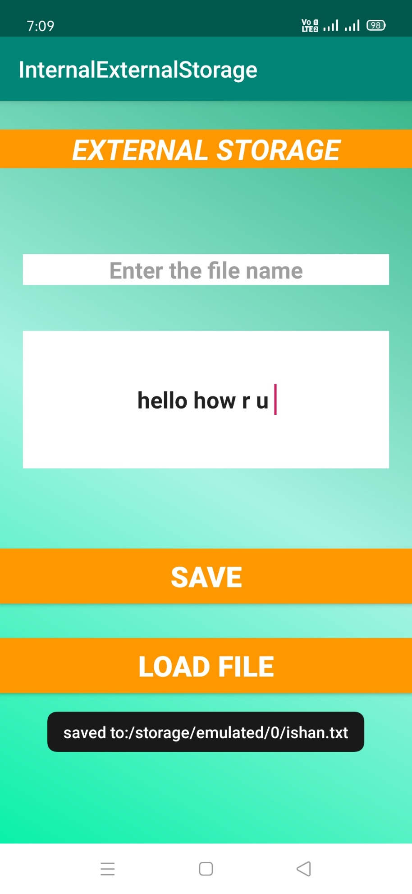

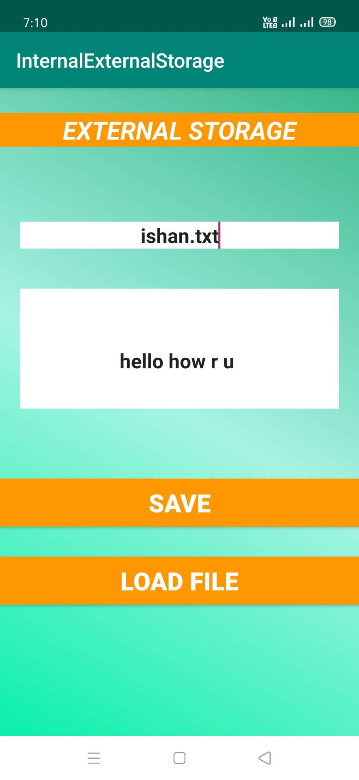

**3. Uses**

This application can be used to store data into a file both externally and internally in the Android System and can also be used to retrieve the data at any-time. It can also create files with any extension in the External Storage module.

**4. Conclusion**

In the last we can conclude that this application can create files and read it in the external storage and can write into the internal storage file using all the basic concepts and views of Android Studio.

**5. References**

**5.1 https://youtube.com**

**5.2 https://stackoverflow.com**

**5.3 https://www.javapoint.com**

**5.4 https://www.google.com**

**5.5 https://android.stackexchange.com**