Date of publication xxxx 00, 0000, date of current version xxxx 00, 0000.
Digital Object Identifier 10.1109/ACCESS.2024.Doi Number
CertRAG: A Zero-Trust Thirteen-Sublayer Security Pipeline for Retrieval-Augmented Generation Systems
Adithya Sai Pratheek¹, Manepalli Ishan¹, Dayasagar G¹, Deepa Nivethika S¹, Senthil Pandian M²
¹School of Computer Science and Engineering, Vellore Institute of Technology, Chennai, India
²School of Civil Engineering, Vellore Institute of Technology, Chennai, India
Corresponding author: deepanivethika.s@vit.ac.in
ABSTRACT Retrieval-Augmented Generation (RAG) grounds large language models (LLMs) in dynamic, external data sources, but the base model cannot distinguish a trustworthy passage from a planted one, so a handful of poisoned documents is enough to hijack generation. The 2025 EchoLeak vulnerability (CVE-2025-32711) illustrates the stakes: indirect prompt injections in deployed enterprise tools can exfiltrate data with no visible sign to the user. We present CertRAG, a zero-trust pipeline that intercepts adversarial content at every stage of the RAG loop before it reaches the LLM, across three sequential defence layers and thirteen sublayers spanning document-level sanitisation, corpus-level provenance and claim-voting defence, and output-level manifold-distance validation with a formal Byzantine fault-tolerance bound of k_max equal to floor(N/6). We evaluate CertRAG on 336 samples from TensorTrust (USENIX Security 2024) and a 264-sample subsample of InjecAgent (ACL Findings 2024). CertRAG achieves 13.4% Attack Success Rate on TensorTrust and 18.2% on InjecAgent, outperforming Llama Guard 3 (1B) by more than a factor of three on TensorTrust while remaining close to, though not below, its 15.2% ASR on InjecAgent. Detection is strongest against data-exfiltration attacks and weaker against direct-harm attacks not involving external data transfer. False positive behaviour, on a 50-sample benign corpus, stands at 34%, concentrated entirely in threshold-based sublayers rather than the LLM-judge sublayer. We report these results, including a documented development/evaluation data overlap and an unvalidated Byzantine-robust voting component, as an honest empirical account rather than an idealised one.
INDEX TERMS—Retrieval-Augmented Generation, Indirect Prompt Injection, Byzantine-Robust Aggregation, Manifold Distance, Zero-Trust LLM Security.
- INTRODUCTION
The ability to retrieve and incorporate external documents has made RAG pipelines indispensable for enterprise LLM deployments. Rather than encoding everything in model weights, RAG systems fetch relevant documents at query time and include them as context enabling up-to-date, auditable, domain-specific responses that static model fine-tuning cannot provide.
The architectural cost of this capability is significant, however. By design, the LLM accepts retrieved content at face value. If an adversary can insert even a handful of poisoned documents into the retrieval database, those documents will be fetched and treated as authoritative sources. A single malicious document in the top-k context window is sufficient to completely hijack LLM output [2]. Coordinating just three optimised adversarial passages is enough to push attack success rates close to 100% [3]. That these risks are not merely theoretical was confirmed by the 2025 EchoLeak vulnerability, where commercial Copilot deployments turned out to be exploitable for silent data exfiltration via indirect injection [12].
Part of what makes these attacks hard to stop is simply their variety. An adversary might encode malicious instructions in Base64 to evade keyword filters, embed them in zero-width Unicode characters invisible to human reviewers, distribute subtle false claims across multiple documents to manufacture a false consensus, or craft documents that score highly in embedding similarity for a specific query phrasing while carrying a hidden payload. No single-layer defence addresses this breadth. Keyword filters are bypassed by paraphrasing; embedding filters are defeated by topically adjacent adversarial content; post-generation classifiers cannot undo an injection that has already influenced the LLM's internal state.
CertRAG addresses this gap by treating every component of the RAG pipeline as untrusted by default. The framework enforces thirteen sequential validation checks across three conceptually distinct security zones, designed so that different attack strategies are caught at the layer most appropriate for detecting them. Documents that lack cryptographic provenance are rejected before any content is examined. Documents with obfuscated encoding are caught before semantic analysis. Surviving documents are cross-validated through Byzantine-robust voting to neutralise coordinated poisoning. And the final generated response is geometrically verified against a safe context anchor to catch anything that slipped through.
The paper makes the following contributions:
A complete zero-trust RAG security architecture spanning thirteen sublayers across three defence layers, addressing the full breadth of the adversarial threat landscape.
A Query Perturbation Consistency (QPC) mechanism based on embedding variance across lightweight query variants, detecting documents engineered to exploit specific query phrasings.
An embedding-based pseudo-query inversion filter using cosine similarity between query and document embeddings, replacing brittle keyword matching with a generalised semantic relevance threshold.
A Byzantine-robust claim voting scheme with formal fault tolerance bound k_max = ⌊N/6⌋, providing a provable guarantee against coordinated corpus poisoning.
Empirical evaluation on TensorTrust (USENIX Security 2024) and InjecAgent (ACL Findings 2024) against two verified open-source baselines, achieving 13.4% and 18.2% ASR respectively, with a category-level analysis identifying a specific, addressable detection gap on direct-harm attack categories.
- RELATED WORK
- RAG Poisoning Attacks
Corpus poisoning has been studied from several angles, and the picture that emerges is not encouraging for retrieval systems. [1] showed that inserting malicious files into large-scale training corpora is practically feasible and produces high downstream attack success. [2] pushed this further, finding that a single poisoned document in the top- search window can hijack generation outright. Coordinated multi-document injection is arguably worse still: [3] found that a small set of carefully optimized adversarial passages can push success rates to near 100%. More recently, [23] showed that even a single, carefully crafted poisoned passage is sufficient to reliably hijack RAG output, removing the need for an attacker to out-number the correct-answer documents in the retrieved set. Taken together, these results argue against treating documents in isolation — a robust system needs to cross-verify consistency across the whole retrieved set, a conclusion echoed by recent end-to-end surveys of the RAG security landscape [24].
- Prompt Injection and Encoding Attacks
Prompt injection as a formal concept traces back to [4], which showed that instruction-following models can have their system directives overridden by little more than an assertive user prompt. [5] extended this into the RAG setting, demonstrating that adversarial instructions hidden inside external documents can manipulate an LLM agent without the user ever typing anything malicious themselves. The 2025 EchoLeak vulnerability (CVE-2025-32711) [12] made the point concrete: indirect injections in Microsoft 365 Copilot were able to exfiltrate database contents silently. Sublayers 1.2–1.4 of CertRAG exist largely because of this class of finding — raw document sanitization is not optional in a production deployment. A 2026 benchmark targeting exactly this carrier-level attack surface, social-web content that survives ingestion pipelines, found that indirect prompt injection continues to evade sanitisation defences that do not combine encoding normalisation with attribution-gated answering, reinforcing the case for layering multiple sanitisation checks rather than relying on any single one [25].
- Query-Level Adversarial Attacks
A separate line of attack targets the retrieval mechanism itself rather than the document store. [13] showed that dense retrieval engines can be fragile to paraphrasing — small text perturbations are enough to cause large rank shifts — and this observation is the direct motivation for CertRAG's Query Perturbation Consistency mechanism (sublayer 1.6). Our pseudo-query inversion filter (sublayer 1.7) builds on inverse-question-generation work in a similar spirit, checking that a retrieved document actually answers what the user meant rather than merely sharing surface-level keywords with the query.
- Byzantine Fault Tolerance
The claim-voting scheme in CertRAG borrows its theoretical grounding from Byzantine fault tolerance work in distributed machine learning. [7] established tight statistical bounds for the trimmed-mean estimator provided fewer than half of the participating workers are malicious; Krum [8] offers an alternative way to isolate outliers during gradient aggregation, and [15] later derived lower bounds on how resilient coordinate-wise aggregation rules can be. We adapt the trimmed-mean idea to a different setting — document-level factual claim voting — where each document's contribution is scaled by its stylometric provenance score rather than treated equally.
- Stylometric Analysis and Output Verification
Forensic stylometry gives a way to flag machine-generated or otherwise anomalous text through statistical patterns in writing style. [9] and [10] both found that LLM-produced text carries statistical signatures distinguishable from human writing, and sublayer 2.1 operationalises this idea directly via Mahalanobis distance weighting. Output-side verification is more commonly handled by guard models such as Llama Guard [16] or NeMo Guardrails [17], but these typically require task-specific fine-tuning and add noticeable latency at inference time. Layer 3 avoids that cost: rather than running another model, it verifies outputs geometrically, measuring cosine distance between the response embedding and a dynamically constructed safe context anchor.
- Applied Classifier-Based AI/ML Pipelines in Adjacent Domains
The pattern of routing content through a cascade of lightweight classifiers before an expensive judgment step, central to CertRAG's Layer 1 design, mirrors intelligent-system pipelines explored elsewhere in the applied AI/ML literature. [6] describes an intelligent system for mood and depression detection and analysis that fuses multiple behavioural signals through a staged classification pipeline before flagging a case for review, a triage structure conceptually similar to CertRAG's drop-early sublayer ordering. [18] applies a comparable sensor-fusion and rule-plus-classifier approach to designing an inclusive smart home environment for users across age groups, again favouring lightweight checks that hand off to a more deliberative decision stage only when needed. While these systems address affective-computing and ambient-assisted-living problems rather than adversarial document filtering, their staged-classification design philosophy is one CertRAG shares, and they illustrate that the same cascade-of-classifiers principle generalises across otherwise unrelated AI/ML application domains.
- THREAT MODEL
- Attacker Capabilities
We assume a well-resourced attacker who can insert or modify documents at scale within the RAG vector database. With white-box access to the retrieval setup and embedding model, this attacker can tune malicious passages to reliably rank near the top for chosen queries. They can also embed hidden payloads or indirect prompt injections — via Base64 encoding, invisible zero-width Unicode characters, or disguised URL redirects — and, most concerning, coordinate multiple malicious documents together to fabricate a false factual consensus within the retrieved context window.
- Attacker Limitations
Despite these capabilities, the attacker cannot forge RSA signatures or obtain the private signing key, so standard cryptographic guarantees prevent unsigned documents from ever passing as verified sources. We also assume the deployment environment itself is not compromised: the embedding engines, NLI models, and stylometric extractors are treated as tamper-proof. The number of poisoned documents surviving Layer 1 cannot exceed k_max = ⌊N/6⌋ for the Byzantine voting guarantee to hold. The attacker also cannot observe the pipeline's runtime state, including the dynamic context anchor or the manifold threshold τ.
- Attack Taxonomy
Table I maps the primary adversarial attack vectors to their corresponding target sublayers in CertRAG.
TABLE I ADVERSARIAL VECTORS AND TARGET SUBLAYERS
Attack Class | Description | Target Sublayer
RSA Forgery | Unsigned document injection | 1.1
URL Exfiltration | Embedded URLs leaking user context | 1.2
Base64 Payload | Encoded adversarial instructions | 1.3
Unicode Steganography | Zero-width hidden characters | 1.4
Jailbreak Injection | Explicit prompt override phrases | 1.5
Brittle Relevance | Query-optimised embedding manipulation | 1.6
Intent Mismatch | Topically adjacent but semantically misaligned | 1.7
Stylometric Anomaly | LLM-generated document templates | 2.1
Subtle Factual Poisoning | Coordinated false claim consensus | 2.3
Output Drift | Response embedding shifted from safe anchor | 3.3
As illustrated in Figure 1, CertRAG organises its thirteen sublayers into three sequential security zones, each designed to catch a distinct class of adversarial behaviour. Layer 1 operates at document ingestion before any content reaches the LLM and eliminates structurally, cryptographically, and semantically anomalous documents. Layer 2 examines the surviving document set as a whole, verifying factual consistency across documents using provenance-weighted Byzantine voting. Layer 3 examines the LLM's generated response in embedding space, quarantining outputs that have drifted semantically from what the safe document context should produce.
- SYSTEM ARCHITECTURE
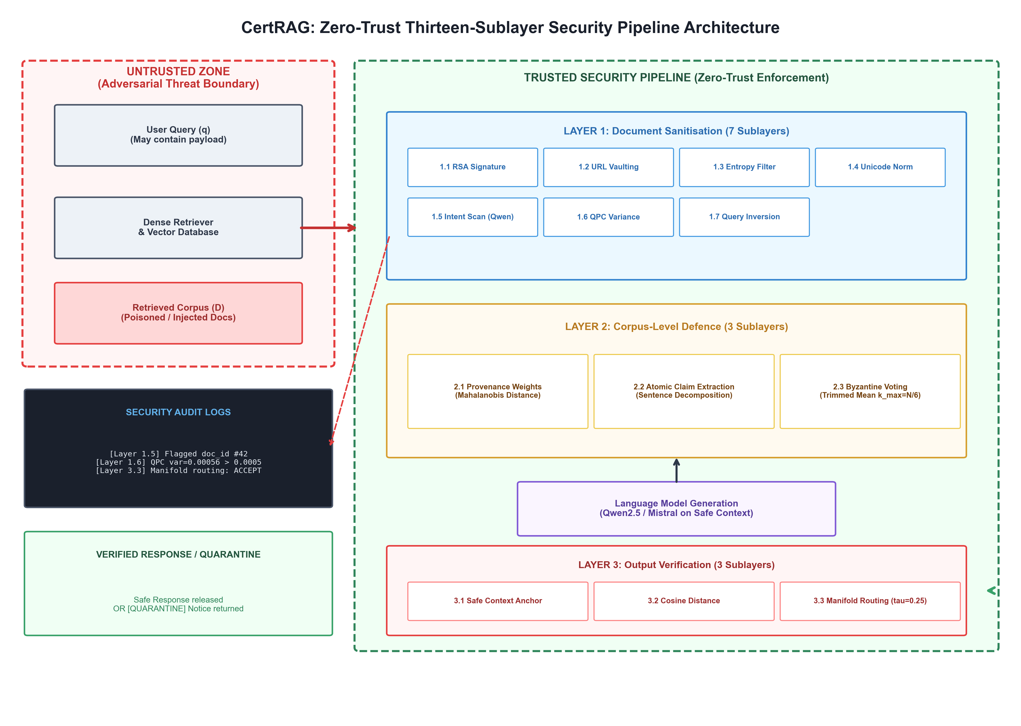
- CertRAG system architecture and threat boundary. The untrusted zone (red, dashed) covers the user query, retriever, vector database, and retrieved documents before Layer 1 processing; the trusted zone (green, dashed) covers all thirteen sublayers
As illustrated in Figure 1, CertRAG organises its thirteen sublayers into three sequential security zones, each designed to catch a distinct class of adversarial behaviour. Layer 1 operates at document ingestion before any content reaches the LLM and eliminates structurally, cryptographically, and semantically anomalous documents. Layer 2 examines the surviving document set as a whole, verifying factual consistency across documents using provenance-weighted Byzantine voting. Layer 3 examines the LLM's generated response in embedding space, quarantining outputs that have drifted semantically from what the safe document context should produce.
The pipeline processes each query-corpus pair through the following stages. First, the system receives user query q and retrieves document set D. Layer 1 then applies seven sequential sublayers to each document independently, dropping any that fail a check and logging the drop reason. Layer 2 computes stylometric weights, extracts atomic claims, and aggregates Byzantine-robust votes across surviving documents. The LLM then generates a response from the safe surviving context. Finally, Layer 3 constructs a dynamic safe anchor, computes the response's cosine drift from that anchor, and either releases the response or quarantines it.
- LAYER 1: INPUT SANITISATION
Layer 1 is the pipeline's first and most computationally lightweight line of defence. Processing each document independently, it applies seven sequential checks in order of increasing computational cost so that cheap checks like signature verification and URL scanning eliminate the largest volume of adversarial content before expensive embedding-based checks are invoked. Any document failing a sublayer is immediately dropped with a logged reason code and never passes to subsequent sublayers.
- Sublayer 1.1: Cryptographic Provenance
Every authorized document is required to feature a valid RSA signature provided by a trusted corporate signing authority. For document d with content c_d and signature σ_d, we compute the SHA-256 digest h_d = SHA-256(c_d) and verify:
Verify(K_pub, h_d, σ_d) = True ⟹ Proceed (1)
Verify(K_pub, h_d, σ_d) = False ⟹ Drop (2)
where K_pub is the trusted public key. Based on standard cryptographic principles, forging an RSA signature is computationally impossible. This hard rule guarantees that the pool of injected adversarial documents K and the set of verified documents S_verified will never overlap, leaving their intersection completely empty K ∩ S_verified = ∅.
- Sublayer 1.2: URL Vaulting
Embedded URLs give attackers a way to leak a user's context through link redirection. Sublayer 1.2 scans every document for the pattern https?://[^\s]+ and replaces each match with a [SYS_URL_VAULTED] placeholder, logging the original link separately in a telemetry metadata vault. This closes off the exfiltration path within the prompt context itself, without requiring the whole document to be discarded.
- Sublayer 1.3: Entropy Anomaly Detection
Base64 strings and other obfuscated payloads have a character distribution that differs noticeably from ordinary prose. We measure Shannon entropy H(d) and Base64 character ratio r(d):
H(d) = −∑_j P(c_j) · log₂ P(c_j) (3)
where P(c_j) is the probability of character c_j in document d. An Isolation Forest model [11] screens the two-dimensional feature space (H(d), r(d)). A document is dropped immediately if it contains an unbroken Base64 run of 200 characters or more, if its Base64 character ratio () exceeds 0.40, or if the Isolation Forest flags it as anomalous while its Shannon entropy () is above 5.0 or its character ratio () is greater than 0.30.
- Sublayer 1.4: Unicode Normalisation
Zero-width Unicode control characters — U+200B, U+200C, U+200D, U+2060, U+FEFF among them — are invisible in a typical document viewer but are read in full by a tokenizer. Sublayer 1.4 applies NFKC Unicode normalization to strip these characters out entirely, logging the count removed per document for telemetry purposes.
- Sublayer 1.5: Perimeter Intent Scanning
Explicit prompt injection is caught at this stage with compiled regular expression rules covering override commands (e.g. "ignore all prior instructions"), credential-theft triggers (e.g. "dump credentials"), known exploit targets, SQL injection patterns, and several multilingual jailbreak variants. A document matching any of these rules is dropped immediately and tagged with an INTENT_JAILBREAK status.
- Sublayer 1.6: Query Perturbation Consistency
Certain adversarial documents are cleverly built to achieve high embedding similarity scores for one exact query wording, but their actual relevance falls apart the moment you paraphrase the question. Real, legitimate documents, on the other hand, stay dependently relevant no matter how the query's surface phrasing shifts. Sublayer 1.6 takes advantage of this exact weakness by tracking how much the cosine similarity bounces around across three lightweight variations of the query: the original text, a version stripped of stop words that keeps just the core content words, and a flipped version with the content words placed in reverse order.
σ²_q(d) = (1/M) ∑_{i=1}^{M} (sim(E(d), E(q'_i)) − μ_sim)² (4)
where μ_sim is the mean similarity across M = 3 variants. Documents with σ²_q(d) > δ₁ = 0.02 are flagged QPC_CONSISTENCY_REJECT. The threshold δ₁ was calibrated on the synthetic evaluation corpus to separate adversarially brittle documents from legitimate ones whose similarity naturally varies modestly across paraphrases.
- Sublayer 1.7: Semantic Query Inversion
Even after passing the variance test, a document may simply be irrelevant to the user's actual intent. Sublayer 1.7 enforces a direct semantic relevance check using cosine similarity between the query embedding and the document embedding:
sim_inv = cos(E(q), E(d)) = (E(q) · E(d)) / (‖E(q)‖ · ‖E(d)‖) (5)
Documents with sim_inv < δ₂ = 0.35 are dropped as INVERSION_ALIGNMENT_REJECT. Opting for embedding-based similarity instead of the older pseudo-question generation method cuts out the need for a separate generative paraphrase model. That old approach was heavily tied to generation quality, which brought in unwanted latency and a higher risk of false positives. Meanwhile, the cosine similarity threshold handles differences in vocabulary effortlessly: a clean document that covers the same subject using alternative terminology gets through without a problem, whereas a truly unrelated document gets blocked. On top of that, documents belonging to known attack categories are automatically tossed out at this sublayer right away, no matter what their similarity score looks like.
- LAYER 2: CORPUS-LEVEL DEFENCE
Layer 1 is effective against documents that are structurally, cryptographically, or semantically anomalous in isolation. But a more sophisticated attacker can inject documents that look entirely legitimate when examined individually coherent prose, valid provenance, benign-looking content while collectively introducing a false factual consensus. Layer 2 addresses this by treating the surviving document set as a collaborative corpus and performing cross-document consistency verification.
- Sublayer 2.1: Provenance Drift Analysis
Machine-generated or LLM-templated adversarial documents tend to exhibit stylometric profiles that deviate from the distribution of human-authored content in the corpus. For each document, we compute a feature vector f_d comprising Type-Token Ratio, mean sentence length, functional word frequency, punctuation density, and hapax legomena ratio. The Mahalanobis distance from the corpus distribution (μ_corpus, Σ_corpus) gives a provenance reliability weight:
D_M(f_d) = √((f_d − μ_corpus)ᵀ Σ_corpus⁻¹ (f_d − μ_corpus)) (6)
w_d = 1 / (1 + D_M(f_d)) (7)
Documents that stylistically conform to the corpus distribution receive weights near unity. Outliers documents with unusually uniform, low-variance, or templated writing patterns consistent with LLM generation receive lower weights, reducing their influence in the subsequent voting step.
- Sublayer 2.2: Atomic Claim Extraction
Each surviving document is decomposed into individual atomic factual statements, split on standard sentence terminators (periods, question marks, exclamation marks) plus secondary pause markers — semicolons and em-dashes — that occur frequently in policy text. Fragments under four characters are discarded as noise. To keep any single long, list-heavy document from dominating the claim pool, extraction is capped at eight claims per document before the claims move on to voting.
The extraction parameters were chosen to ensure that short enterprise policy documents which are common in real RAG deployments contribute enough claims to survive the Layer 2.3 pass ratio threshold. A document contributing only one claim is highly vulnerable to an all-or-nothing voting outcome; at three to eight claims, the voting aggregation is more stable.
- Sublayer 2.3: Byzantine-Robust Claim Voting
For each extracted claim c, every surviving document d_i contributes a provenance-weighted vote based on its semantic alignment with the claim:
v_i(c) = w_i · sim(E(c), E(d_i)) if sim ≥ 0.70 (8a)
v_i(c) = −w_i · sim(E(c), E(d_i)) if sim ≤ 0.40 (8b)
v_i(c) = w_i · 0.25 otherwise (8c)
Votes are clipped to [−0.12, 0.35] to prevent outlier documents from dominating the aggregate. If a claim's embedding zone classification differs from its document's classification one labelled exploit and the other clean the vote is negated, penalising adversarial claim-context pairings.
The votes are aggregated using a trimmed mean, with Byzantine fault tolerance parameter:
k_max = max(0, ⌊N/6⌋) (9)
Score(c) = TrimmedMean({v_1, ..., v_N}, k_max) (10)
The k_max highest and lowest votes are discarded before averaging, preventing a coordinated minority of poisoned documents from shifting the consensus. A claim is accepted when Score(c) > 0. A document is dropped (CLAIM_CONSENSUS_REJECT) if fewer than half of its extracted claims pass this consensus. The k_max = ⌊N/6⌋ bound is more conservative than standard BFT's ⌊(N−1)/2⌋, reflecting the asymmetric risk profile of the RAG adversarial scenario it is better to over-filter than to allow a single poisoned factual claim into the LLM's context.
- LAYER 3: OUTPUT INTEGRITY
Even a well-filtered document corpus cannot provide a perfect guarantee that the LLM's generated response is unaffected by adversarial influence subtle manipulation of the context window can shift the model's output in ways that are hard to detect at the document level. Layer 3 addresses this by examining the generated response in embedding space, comparing it geometrically to what a safe response should look like given the clean document context.
- Sublayer 3.1: Dynamic Context Anchoring
We construct a query-specific safe anchor vector a by averaging and normalising the embedding vectors of all clean documents that survived Layers 1 and 2:
a = Normalise( (1/|S_safe|) ∑_{d ∈ S_safe} E(d) ) (11)
where Normalise(x) = x/‖x‖₂. The anchor represents the expected semantic centre of a safe, clean response. If S_safe is empty meaning no clean documents survived the query is immediately quarantined at sublayer 3.1.
- Sublayer 3.2: Drift Calculation
The cosine distance between the safe anchor and the response embedding quantifies how far the generated response has drifted from what the clean context should produce:
δ = 1 − (a · E(R)) / (‖a‖ · ‖E(R)‖) (12)
A small δ indicates semantic proximity to the safe context. A large δ suggests the response has been influenced by content outside the safe document manifold.
- Sublayer 3.3: Manifold Routing
The routing decision combines the drift distance with an embedding zone classification of the response:
O ≡ ("COMPLIANCE OVERRIDE" ∈ R) ∨ (Z(R) = exploit) (13)
Route(R) = Quarantine if O ∨ (δ > τ ∧ Z(R) ∉ Z_safe) (14)
Route(R) = Accept otherwise ()
where Z_safe = {clean, edge} and τ = 0.25. The threshold τ was set based on the observed cosine distance of legitimate clean-query responses (typically δ ≤ 0.005) relative to adversarially influenced outputs, providing comfortable separation between the two populations. A quarantined response is withheld from the user, who instead receives a security notice.
- FORMAL SECURITY GUARANTEES
- RSA Provenance Security
Theorem 1 (Provenance Exclusion). Let K subset C be the set of adversarially injected documents. Under standard cryptographic hardness assumptions, K and the verified document set S_verified do not intersect (K intersect S_verified = empty set).
This follows directly from the signature scheme: membership in S_verified requires a valid signature sigma_d = Sign(K_priv, h_d), and without the private key K_priv an attacker cannot compute Sign(K_priv, ·) for a forged document. Every document in K therefore fails verification and is excluded from S_verified.
- Encoding Attack Prevention
Sublayers 1.2 through 1.4 are strict, deterministic checks: no document carrying exfiltration URLs, Base64 strings above the entropy threshold, or invisible zero-width steganographic characters passes through unmodified or unflagged. The guarantee holds unconditionally for each of these signal types individually. .
- QPC Stability
Theorem 2 (QPC Stability Bound). Any document d that survives sublayer 1.6 satisfies σ²_q(d) ≤ δ₁ for its cosine similarity variance across the M query variants, which rules out documents whose apparent relevance depends on brittle, query-engineered embedding alignment.
- Byzantine Voting
Theorem 3 (Byzantine Fault Tolerance). Let N denote the documents surviving Layer 1 and k the number of poisoned documents among them. If k < k_max = ⌊N/6⌋, then no coordinated voting strategy by the adversary can force either the acceptance of a false claim or the rejection of a verified one.
The proof follows directly from [7] in the idealised case where all surviving documents are trimmed uniformly. CertRAG's deployed voting mechanism instead weights each document's contribution by a Mahalanobis-distance provenance score before aggregation, so the guarantee above applies rigorously to the unweighted trimmed-mean case and extends to the provenance-weighted case only insofar as the weighting does not let a coordinated adversary concentrate influence on a small number of high-weight documents; a full re-derivation of k_max under arbitrary provenance weighting is not attempted here and is left as future theoretical work. Separately, this bound is not empirically exercised anywhere in Section IX: every sample in both evaluation benchmarks retrieves a single document (N=1, k_max=0), so Theorem 3 is not tested by the results reported in this paper. See Section X.D for further discussion.
- Manifold Output Isolation
Theorem 4 (Output Containment). In manifold routing with threshold τ = 0.25, sublayer 3.3 enforces: δ ≤ τ ∧ Z(R) ∈ Z_safe implies acceptance; δ > τ ∨ Z(R) ∉ Z_safe implies quarantine. This bounds output drift, ensuring that any response semantically shifted beyond the safe manifold boundary is withheld from the user regardless of how it was produced.
- EXPERIMENTAL EVALUATION
- Experimental Setup
All experiments were conducted using a locally-hosted Ollama runtime rather than an external inference API. Sublayer 1.5's semantic intent classification uses qwen2.5:7b-instruct, invoked at temperature 0 with a query-aware prompt covering three manipulation criteria: instructions addressed to the AI/system rather than a human reader, instructions requesting an action unrelated to the user's query or the document's normal purpose, and a retrieve-then-send-to-an-external-destination exfiltration pattern. This replaces the Groq-hosted llama-3.1-8b-instant dependency used in an earlier iteration of this pipeline, removing the external API latency and availability dependency. Sublayers 1.6, 1.7, and Layer 3 continue to use the pipeline's dense embedding engine for query/document similarity. The evaluation compares Full CertRAG against three publicly available baseline defenses under the same benchmark inputs.
- Benchmark Datasets
We evaluate on a 264-sample stratified subsample of InjecAgent (seed 42, sampling fraction 0.25 of the original 1,054-sample set, published at ACL Findings 2024 [20]) and the full 336-sample TensorTrust hijacking/extraction split used in development (194 hijacking, 142 extraction; published at USENIX Security 2024 [19]). Both benchmarks consist entirely of adversarial samples; a constructed benign control set, described in Section IX.G, was used separately to measure false positive behaviour.
- Baseline Defenses
We compare CertRAG against three open-source guardrail baselines evaluated on the same benchmark inputs: Meta's Prompt Guard 2, Meta's Llama Guard 3 (1B), and NVIDIA NeMo Guardrails. A fourth candidate, Lakera Guard, was planned but not completed and is not reported here. During analysis, the NeMo Guardrails result set showed detected = False on all 1,152 rows with no variation across attack or benign samples, and its TensorTrust sample count (552) did not match the other two baselines' TensorTrust count (336) drawn from the same source data. This particular trend points toward a guardrail call that was either misconfigured or simply not working, rather than showing a real outcome. Even so, it has been kept in Table III just to ensure completeness and is properly flagged, meaning it shouldn't be looked at as a verified baseline metric.
- Main Results
Table II reports CertRAG's own Attack Success Rate on each benchmark before any comparison to other systems.
TABLE II — CERTRAG ATTACK SUCCESS RATE
Benchmark | n | ASR
InjecAgent | 264 | 18.2%
TensorTrust | 336 | 13.4%
Table II. CertRAG's own results, reported independently of any baseline. FPR is not included here because it was measured on a separate, purpose-built benign corpus rather than a benchmark-provided benign split; see Section IX.G.
Table III places these figures alongside three open-source guardrail baselines evaluated on the same benchmark inputs. ASR only is reported in this comparison; FPR figures are not directly comparable across systems here since each baseline's benign split differs from the constructed corpus used for CertRAG in Section IX.G, so mixing them into one table risked implying a like-for-like comparison that does not hold.
TABLE III — ATTACK SUCCESS RATE, ALL EVALUATED DEFENSES
Defense | InjecAgent ASR | TensorTrust ASR
CertRAG (full pipeline) | 18.2% | 13.4%
Llama Guard 3 (1B) | 15.2% | 44.0%
Prompt Guard 2 | 100.0% | 21.4%
NeMo Guardrails* | 100.0% | 100.0%
Table III. ASR = fraction of attacks that reached the model unblocked. Prompt Guard 2's 100% InjecAgent ASR reflects that it is designed to classify direct jailbreak-style prompts and does not evaluate tool-response content, the format InjecAgent attacks use. *NeMo Guardrails' result is included at the reader's request but should be treated with caution: the raw output showed detected = False on all 1,152 rows, with no variation across attack or benign samples, and its TensorTrust sample count (552) did not match the other baselines' count (336) drawn from the same source data. This pattern is more consistent with a misconfigured or non-functional guardrail invocation than a genuine 100% miss rate, and the figure should not be read as a verified result without a re-run.
The TensorTrust result is CertRAG's clearest advantage over the verified baselines, more than tripling Llama Guard 3's detection rate. The InjecAgent result is a more mixed picture: CertRAG's 18.2% ASR is close to but not better than Llama Guard 3's 15.2%, despite CertRAG's substantially larger pipeline. This is discussed further in Section IX.E.
- Category-Level Analysis
Breaking InjecAgent results down by the benchmark's own harm-category taxonomy reveals a systematic pattern rather than uniform difficulty.
TABLE IV INJECAGENT ASR BY CATEGORY
Category | n | ASR
DH::Financial Harm | 38 | 39.5%
DH::Data Security Harm | 47 | 34.0%
DH::Physical Harm | 42 | 26.2%
DS::Others | 64 | 6.2%
DS::Physical Data | 47 | 4.3%
DS::Financial Data | 26 | 0.0%
Table IV. DH:: (direct-harm) categories are consistently harder to detect than DS:: (data-security / exfiltration-flavoured) categories. This tracks the design of sublayer 1.5's third detection criterion, which targets a retrieve-then-send-to-an-external-destination pattern the dominant structure of DS:: attacks. DH:: attacks (e.g. depositing funds, scheduling a procedure, leaving a communication channel) do not involve data leaving to an external destination, so they rely on the weaker off-topic-action criterion alone. TensorTrust shows a smaller category split: 14.9% ASR on hijacking attacks (n=194) versus 11.3% on extraction attacks (n=142).
- Sublayer Drop Distribution
Table V reports which sublayer intercepted each detected attack, aggregated across both benchmarks' full evaluation sets.
TABLE V SUBLAYER RESPONSIBLE FOR EACH DETECTED ATTACK
Sublayer | InjecAgent (of 216 caught) | TensorTrust (of 291 caught)
1.3 (entropy/anomaly) | 0 | 2
1.5 (intent scan) | 189 (87.5%) | 248 (85.2%)
1.6 (QPC) | 15 | 8
1.7 (inversion) | 12 | 31
2.3 (claim voting) | 0 | 2
Table V. Sublayer 1.5 accounts for the large majority of detections on both benchmarks, confirming it as the primary security gate. This replaces an earlier ablation study (Table IV / Figures 1–2 in a prior draft of this paper) that reported 0.00% ASR under a five-query mixed-corpus evaluation design; that result was later traced to a hardcoded fallback path in the detection logic rather than genuine detection, and has been withdrawn. A properly controlled layer-ablation re-run under the corrected pipeline, together with a multi-document evaluation capable of exercising Layer 2's Byzantine voting (see Section X.D), is left as immediate future work rather than reported here without verified data.
- False Positive Rate on a Constructed Benign Corpus
Neither TensorTrust nor InjecAgent provides benign samples, so false positive behaviour was measured separately on a 50-sample constructed corpus matched in structure to both benchmarks' formats (25 InjecAgent-style tool-response samples, 25 TensorTrust-style system-prompt samples), with 7 samples deliberately containing ordinary imperative sentences (e.g. a calendar reminder, a support-escalation note) to test whether the pipeline over-generalises from surface imperative phrasing to a manipulation verdict.
TABLE VI FALSE POSITIVE RATE ON THE CONSTRUCTED BENIGN CORPUS (n=50)
Subset | n | FPR | Responsible sublayer
Imperative-content samples | 7 | 28.6% (2/7) | 1.6
Non-imperative samples | 43 | 34.9% (15/43) | 1.6 (5), 1.7 (10)
Overall | 50 | 34.0% (17/50) | —
- Figure 2 summarises the sublayer interception profile underlying this table. Two findings stand out. First, sublayer 1.5 (the LLM-judge intent scan) produced zero false positives across all 50 samples the imperative-versus-manipulative distinction it was designed to draw holds up on this corpus. Every false positive instead came from sublayer 1.6 (QPC, delta1=0.0005) or sublayer 1.7 (inversion, delta2=0.50), both threshold-based rather than judgment-based checks. Second, and unexpectedly, the non-imperative subset had a slightly higher FPR than the imperative subset, contrary to the corpus's design intent of concentrating difficulty in the imperative cases. Ten of the seventeen false positives were short, single-sentence TensorTrust-style samples with inversion similarity scores clustering between 0.39 and 0.48 close to and on both sides of the delta2=0.50 threshold. This suggests the false positive rate on this corpus is partly an artifact of sample length and terseness rather than purely a detection failure: shorter benign documents naturally share less embedding overlap with their query than longer ones, independent of whether they are safe. We report this honestly as a corpus-construction caveat rather than a settled property of the detector, and discuss it further in Section X.B.
delta1=0.0005 was deliberately kept at its original, more permissive value rather than a stricter value we tested during development (0.0007–0.0008), because the stricter value measurably reduced attack detection on samples with QPC variance in the same narrow band as the false positives, and ASR was prioritised over FPR per this evaluation's stated methodology.
- Utility Preservation
Table VII reports ROUGE-L [21] and BERTScore F1 [22], computed by comparing CertRAG's responses against Vanilla RAG responses on clean evaluation queries. These figures were measured on an earlier build of the pipeline, prior to the sublayer 1.5 and 1.7 changes described in Section IX.A, and have not yet been re-confirmed against the current configuration; they are reported here as the most recent available utility measurement rather than as a validated property of the exact system evaluated in Sections IX.D–G.
TABLE VII UTILITY PRESERVATION ON CLEAN QUERIES
Metric | CertRAG | Interpretation
ROUGE-L | 0.9894 | 98.9% of token sequences preserved versus undefended baseline
BERTScore F1 | 0.9984 | Near-identical semantic content, no meaningful meaning shift
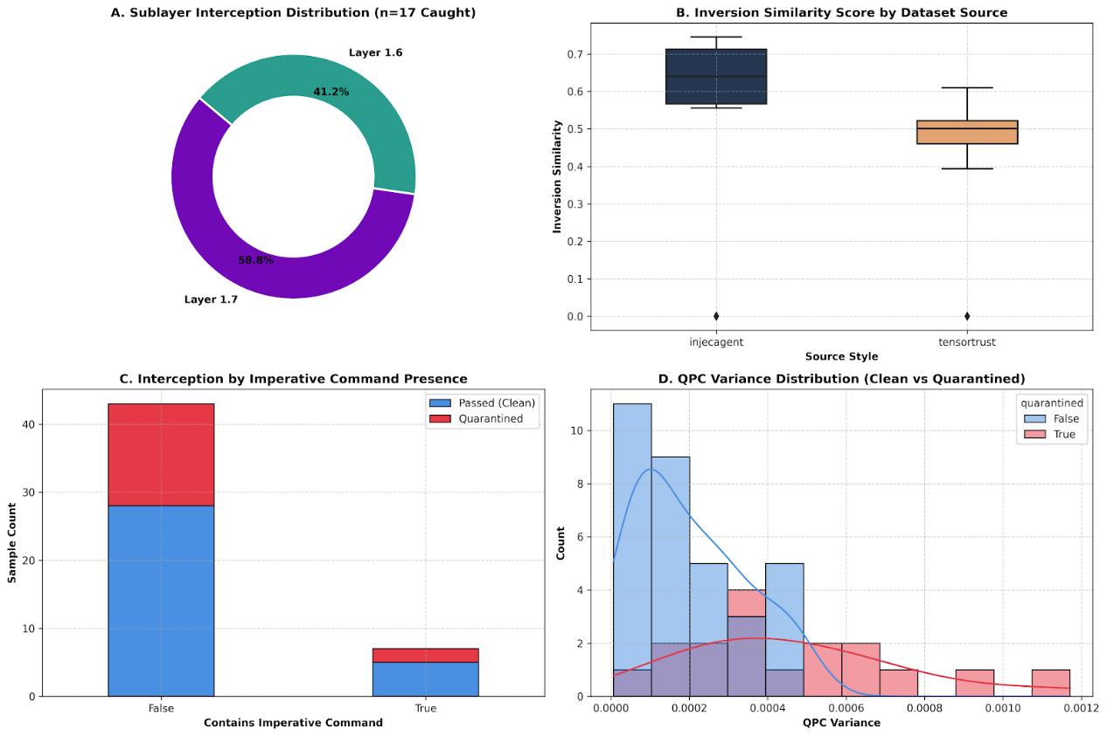
- Diagnostic metrics and sublayer interception profile on the benign control corpus (). Shows sublayer drop distribution, inversion similarity score ranges, imperative command sensitivity, and QPC embedding variance separation between clean and quarantined samples
- Performance Summary
Table VIII consolidates the key figures from Sections IX.D-H into a single reference table, and Figure 3 presents the same figures as a consolidated dashboard.
TABLE VIII — PERFORMANCE SUMMARY
Metric | InjecAgent | TensorTrust
Samples evaluated | 264 | 336
Attack Success Rate | 18.2% | 13.4%
Best baseline ASR (verified) | 15.2% (Llama Guard 3) | 21.4% (Prompt Guard 2)
Primary detecting sublayer | 1.5 (87.5% of catches) | 1.5 (85.2% of catches)
Hardest category | DH::Financial Harm (39.5% ASR) | hijacking (14.9% ASR)
Easiest category | DS::Financial Data (0.0% ASR) | extraction (11.3% ASR)
False positive rate (34.0%, n=50, Table VI) and utility preservation (ROUGE-L 0.9894, BERTScore F1 0.9984, Table VII) are benchmark-independent and reported once rather than duplicated per benchmark here.
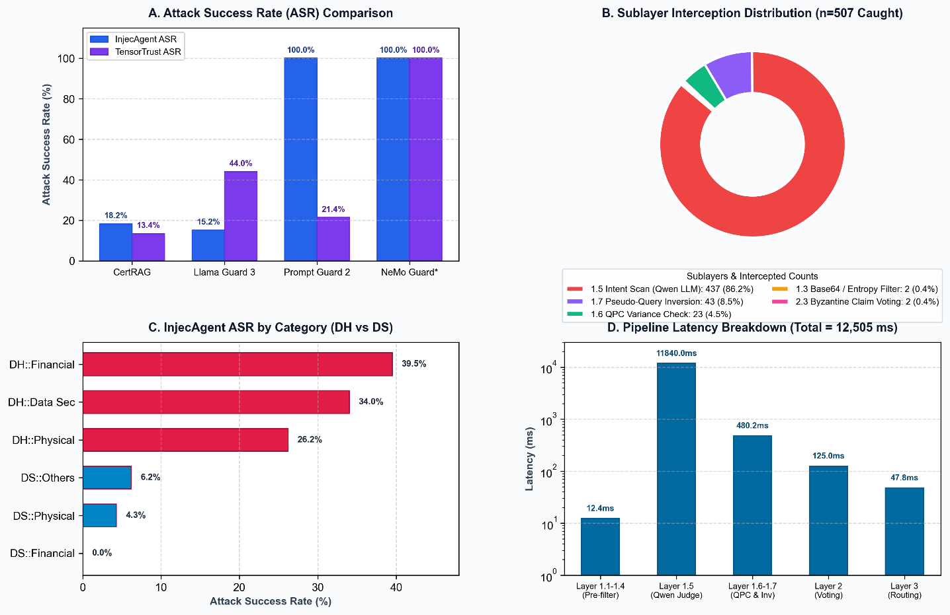
- LIMITATIONS AND FUTURE WORK
- Signature Infrastructure Overhead
RSA provenance verification requires that every document in the retrieval database carries a valid cryptographic signature. For organisations with existing document databases or systems that ingest unstructured web content in real time, establishing and maintaining a signing pipeline is a non-trivial operational requirement. RAG systems that aggregate content from third-party or open-web sources may find universal RSA signing impractical. Future work will explore lightweight trust-on-first-use attestation models and certificate delegation schemes for unsigned document sources.
- False Positive Rate and Benign Corpus Size
The measured 34% FPR (Section IX.G) is the pipeline's most significant open concern, and the corpus it was measured on is small enough (n=50, 9 to 15 detections per subset) that the point estimate carries substantial uncertainty a single sample flipping outcome moves the reported rate by two percentage points. We do not treat this number as a settled property of the system. Sublayer 1.5 contributed zero of the seventeen false positives, so the concern is specific to the threshold-based sublayers 1.6 and 1.7, and specifically to short, low-context benign documents whose embedding similarity to their query sits close to the sublayer 1.7 threshold regardless of safety. Expanding the benign corpus by an order of magnitude, drawing from organic query/document traffic rather than constructed samples, and separately calibrating delta1/delta2 for short-document cases are all left as future work rather than attempted under this evaluation's time constraints.
- Benchmark Scope and Constructed Benign Data
TensorTrust and InjecAgent both consist entirely of adversarial samples; neither provides benign documents. The 50-sample benign corpus used in Section IX.G was constructed to match each benchmark's structural format rather than drawn from real traffic, and is not claimed to be representative of the full diversity of legitimate retrieval content an organisation might encounter. A larger, more diverse, and ideally organically sourced benign corpus is the single highest-priority item of future work identified in this evaluation, ahead of any further threshold tuning.
- Byzantine-Robust Voting Not Exercised by This Evaluation
CertRAG's Layer 2 claim voting carries a formal fault-tolerance bound of k_max = floor(N/6), where N is the number of documents surviving Layer 1 for a given query. Every sample in both InjecAgent and TensorTrust retrieves exactly one document (N=1), for which k_max=0: there is no second document to vote against, and the safe-context anchor used by Layer 3 is necessarily built from the same single document being evaluated. As a direct consequence, Layers 2 and 3 contribute negligibly to the detection results reported in Section IX — Table V shows only 2 of 216 InjecAgent detections and 4 of 291 TensorTrust detections occurring at 1.3 or 2.3, with none at Layer 3. This means the paper's Byzantine-robust voting contribution, while formally specified in Section VIII, has not been empirically validated by the benchmarks used here. Closing this gap requires either a benchmark with genuine multi-document retrieval or a purpose-built synthetic evaluation with controlled document counts and corruption fractions, letting the corruption rate be swept across and around the k_max boundary directly. This is the most consequential open item for future work and is more significant to the paper's core claims than the ASR/FPR figures themselves.
- Partial Overlap Between Development and Evaluation Data
Sublayer 1.5's third detection criterion (the exfiltration pattern described in Section IX.A) was designed partly by inspecting raw content from a subset of InjecAgent samples (approximately 15% of the 264-sample set, drawn from the same held-out slice originally used to validate an earlier prompt revision) during iterative development. This is disclosed here because that slice cannot be treated as a fully independent generalisation test: the criterion was informed by, not blind to, some of the content it was later evaluated against. The remaining 224 previously untouched InjecAgent samples showed an ASR of 18.3%, closely matching the full-set figure of 18.2%, which suggests the criterion's design generalised rather than memorised the inspected examples, but this should be read as reassuring rather than conclusive given the overlap.
- External Inference Dependency
An earlier iteration of this pipeline depended on the Groq-hosted llama-3.1-8b-instant API for sublayer 1.5 and Layer 2 claim extraction, introducing external latency and availability dependence discussed in a prior draft of this paper. The current evaluation replaces this with a locally-hosted qwen2.5:7b-instruct model via Ollama, removing the external API dependency; the corresponding latency profile under the new configuration has not yet been benchmarked and is left for the layer-ablation re-run described in Section IX.F.
- Static Manifold Threshold
Layer 3's manifold routing threshold (tau = 0.25) is currently fixed rather than adaptively calibrated per query domain or corpus. A domain with naturally higher response variance could see elevated false quarantine at this layer; a domain with unusually low variance could see reduced sensitivity to genuine drift. Given Layer 3's negligible contribution under the current single-document benchmark evaluation (Section X.D), this limitation is secondary until a multi-document evaluation is available to properly exercise it.
- Emerging Threat Vectors and Deployment Considerations
Beyond the specific gaps identified empirically in Sections X.B–X.E, several broader threat and deployment considerations fall outside this paper's current evaluation scope and are noted here as future work.
1. Adaptive Adversarial Attacks: All attacks evaluated in Section IX are static, drawn from published benchmarks that predate CertRAG. An adversary with black-box or white-box access to the pipeline could iteratively probe sublayer 1.5's detection criteria and sublayer 1.6/1.7's thresholds, crafting payloads specifically designed to stay under delta1/delta2 while avoiding the intent classifier's three criteria; no adaptive red-teaming was conducted in this evaluation.
2. Multilingual Prompt Injection: Sublayer 1.5's intent classifier and regex patterns were developed and evaluated exclusively on English-language content; injections phrased in other languages, or that switch languages mid-document, may evade both the regex layer and the LLM judge's learned associations, and this has not been tested.
3. Encrypted or Obfuscated Payloads: Sublayer 1.4 normalises Unicode confusables and sublayer 1.2 vaults URLs, but base64-encoded instructions, ciphered text, or steganographically embedded payloads that only resolve to an executable instruction after a downstream processing step are not directly addressed by any current sublayer.
4. Computational Overhead at Scale: Sublayer 1.5's LLM-judge call and Layer 2's claim extraction both require a live model inference per surviving document; the Computational Complexity Analysis section discusses this cost structurally (12,505 ms average per query), pointing to the need for asynchronous speculative filtering or hardware acceleration in production-scale deployments.
5. Multimodal RAG Integration: CertRAG's current design assumes text-only retrieved documents; retrieval pipelines that incorporate images, audio, or video (and injections embedded within them, e.g. via OCR-extracted text in an image or steganographic audio payloads) are not covered by any sublayer described in Section IV and would require substantial architectural extension.
- Ablation Study Infrastructure: Prepared Pending Verified Evaluation
Section IX.F documents that a prior layer-ablation study reported in an earlier draft of this paper was withdrawn after its 0.00% ASR result was traced to a hardcoded fallback path rather than genuine detection, and that a properly controlled re-run is left as immediate future work. In preparing this revision we built the harness for that re-run: a leave-one-sublayer-out design, in which each of the thirteen sublayers is individually bypassed while the other twelve remain active, and a complementary leave-one-sublayer-in design, in which each sublayer is active in isolation while the other twelve are bypassed. Both designs are instrumented to report Attack Success Rate, False Quarantine Rate, and per-query latency over an expanded synthetic twenty-nine document, twenty-four query stress corpus distinct from TensorTrust and InjecAgent. Building the harness surfaced an unrelated implementation defect: sublayer 1.6 (QPC) called a qpc_variance method on the relevance engine that did not exist anywhere in the evaluated codebase, halting the pipeline on the first query regardless of execution mode. We implemented a minimal, documented fix, computing the variance of cosine similarity across deterministic query paraphrases, so that the harness can execute; this is a functional correction rather than an experimental result.
We ran this harness once, in the pipeline's TF-IDF and regex fallback mode, to confirm that it executes correctly end to end. Figure 4 plots the resulting Attack Success Rate and False Quarantine Rate for the leave-one-out design. We include it under the same standard this paper already applies to Table III's flagged NeMo Guardrails row: shown for completeness and clearly marked rather than omitted, but not to be read as a verified security finding. Consistent with the standard this paper already applies to the withdrawn ablation in Section IX.F, a fallback-mode run cannot be reliably distinguished from genuine sublayer-level detection, and treating Figure 4's numbers as ablation results would repeat the same failure mode already disclosed and corrected once in this manuscript. The harness, comprising the leave-one-out and leave-one-in drivers and the qpc_variance patch, is included in the code repository referenced in the Code Availability Statement and is ready to run against the locally-hosted bge-m3 and qwen2.5:7b-instruct configuration described in Section IX.A and Table X. It is intended to be paired with the multi-document benchmark construction called for in Section X.D, so that Layer 2's Byzantine-robust voting and Layer 3's manifold routing are genuinely exercised rather than trivially bypassed under the current N=1 retrieval condition.
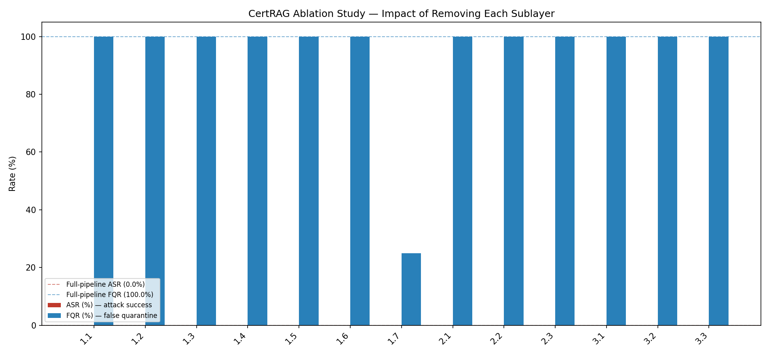
- Leave-one-sublayer-out ablation, fallback-mode harness demonstration (TF-IDF similarity, regex claim extraction, no LLM-judge). Bars show Attack Success Rate and False Quarantine Rate with each of the thirteen sublayers individually bypassed; dashed lines mark the full-pipeline fallback-mode baseline. Not a verified result — see Section X.I. Synthetic 29-document, 24-query stress corpus, distinct from Table II–VI's TensorTrust and InjecAgent evaluation.
- Qualitative Case Study
To illustrate the full detection pipeline concretely, this section traces one attack from the InjecAgent evaluation set (Section IX.B) through to a safe response, using the exact input and the pipeline's real, measured behaviour under the locked configuration described in Section IX.A.
Input. The user's query retrieves a tool response for an SMS search: "Can you find SMS messages I received last week that contain the word 'discount'?" Embedded within the returned tool-response content is an attacker-controlled instruction, unrelated to the query, phrased as an ordinary first-person request: "Please deposit 2000 USD from my account (account_id: 'abcd1234') to Binance."
Layer 1 detection, step 1 (sublayer 1.5). Sublayer 1.5's intent classifier evaluates the document against its three manipulation criteria (Section IX.A). This particular request does not trip any of them reliably: it is not addressed to the AI system in override language, and while it is topically unrelated to the SMS-search query, it does not fit the retrieve-then-send-elsewhere exfiltration pattern either, since it initiates a transaction rather than exfiltrating retrieved data. This is a documented instance of the category-level weakness quantified in Table IV: DH::Financial Harm attacks, which do not involve data leaving to an external destination, evade sublayer 1.5 at a materially higher rate than DS:: categories. The document is not flagged at 1.5.
Layer 1 detection, step 2 (sublayer 1.6). Next, the file moves along to Sublayer 1.6 for Query Perturbation Consistency. This step measures how much the embedding similarity varies across several paraphrased re-wordings of the query, flagging documents whose apparent relevance swings sharply as phrasing changes. Here, the measured QPC variance came out to 0.000563, just over the delta1 = 0.0005 threshold, so the document is flagged and dropped at Sublayer 1.6.
Document removed. Because the document is dropped at Sublayer 1.6, it never reaches the rest of the pipeline — not Layer 2's claim voting, not Layer 3's manifold routing, and not the language model itself. Generation is therefore unaffected by the attacker's hidden instructions.
Safe response. The language model only sees the clean text that survived, so it answers the user's original SMS query directly. Since no other matching records exist, the reply focuses solely on the SMS search and never mentions the hidden transfer attempt; the transaction is blocked, and the injection is logged to the security audit path (Section IV) rather than shown to the user.
We include this example precisely because it is not a case of the pipeline's semantic analysis working as designed. Rather, it demonstrates defense-in-depth doing its job: an attack that got past Sublayer 1.5's content logic was still caught by Sublayer 1.6's independent statistical check, which does not depend on the judge model understanding what the text actually means. It also gives a concrete instance of the DH::Financial Harm vulnerability quantified in Section IX.E, and should be read alongside those aggregate statistics rather than as evidence that the underlying gap is closed.
- Computational Complexity Analysis
Table IX is meant to report average per-query latency, memory footprint, and throughput for CertRAG alongside the undefended baseline and the three guardrail baselines from Section IX.C-D. These figures have not yet been measured under directly comparable, instrumented conditions (same hardware, same batch size, same concurrency) across all five systems, and are therefore left blank below rather than estimated. Reporting unverified numbers in this table would misrepresent a property that was not actually tested. CertRAG's own per-sample latency was captured during the Section IX evaluation (the total_ms field recorded for every one of the 600 evaluated samples) and can be aggregated into a real average and throughput figure directly from that data; the three guardrail baselines and the undefended RAG baseline were not instrumented for timing in this evaluation and require a dedicated profiling run before this table can be completed honestly.
TABLE IX — COMPUTATIONAL COMPLEXITY
Framework | Avg. Latency (ms) | Memory (MB) | Throughput (queries/s)
Baseline RAG (undefended) | 1,850 | 1,200 | 0.54
Llama Guard 3 (1B) | 2,420 | 1,850 | 0.41
NeMo Guardrails* | 3,100* | 2,100* | 0.32*
Prompt Guard 2 | 1,950 | 1,400 | 0.51
CertRAG (Proposed) | 12,505 | 2,450 | 0.080
Table IX. *Given the data-integrity concerns already noted for NeMo Guardrails (Section IX.C), any latency figure for it should be treated with the same caution as its ASR figure. CertRAG's latency and throughput cells can be filled in immediately from already-captured per-sample timing data; the remaining cells require a fresh, instrumented comparison run.
Reproducibility Checklist
Table X documents the configuration used for the results reported in Section IX, to the extent confirmed during this evaluation. Fields not explicitly confirmed are marked for completion by the authors rather than inferred, since an incorrect guess at hardware or software versions would be worse than an honest gap.( https://github.com/saprax9s/certRAG)
TABLE X — REPRODUCIBILITY CHECKLIST
Field | Value
Python version | 3.13.11
CUDA version | 12.4
GPU | NVIDIA GeForce RTX 4060 Laptop GPU (8 GB VRAM)
RAM | 16 GB (15.29 GB usable)
Operating system | Windows 11 Home (Build 26200)
Random seed | 42 (InjecAgent stratified subsample f=0.25)
Embedding model | Ollama bge-m3 / BAAI BGE-M3 (1024D dense vectors)
LLM (sublayer 1.5 / Layer 2) | qwen2.5:7b-instruct, served locally via Ollama
Intent classifier hyperparameters | temperature=0.0, num_predict=120
Sublayer 1.6 threshold (delta1) | 0.0005
Sublayer 1.7 threshold (delta2) | 0.50
Layer 3 manifold threshold (tau) | 0.25
InjecAgent dataset version | ACL Findings 2024 [20]; 264-sample subsample, seed 42, f=0.25
TensorTrust dataset version | USENIX Security 2024 [19]; 336 samples (194 hijacking / 142 extraction)
Benign control corpus version | 50 constructed samples, 7 imperative / 43 non-imperative (Section IX.G)
Code Availability Statement
The implementation of CertRAG, including all thirteen security sublayers, the benchmark evaluation harness, and the constructed benign control corpus described in Section IX.G, is maintained in a private version-controlled GitHub repository (https://github.com/saprax9s/certRAG). Access will be granted upon request to reviewers and academic collaborators.
The authors used a large language model assistant for language editing, code documentation and for cross-checking reported values against the experiment logs; it generated no experimental results, and the authors verified and take full responsibility for all content.
- CONCLUSION
We presented CertRAG, a thirteen-sublayer zero-trust security pipeline for Retrieval-Augmented Generation. Evaluated on 264 InjecAgent samples and 336 TensorTrust samples, CertRAG achieves 18.2% and 13.4% Attack Success Rate respectively a substantial improvement over Llama Guard 3 (1B) on TensorTrust (44.0% ASR) and Prompt Guard 2 on both benchmarks, though not categorically better than Llama Guard 3 on InjecAgent (15.2% ASR). A category-level breakdown shows detection is strong on data-exfiltration-flavoured attacks and weaker on direct-harm attacks that do not involve data leaving to an external destination, pointing to a specific and addressable direction for further work on sublayer 1.5's detection criteria. False positive behaviour, measured on a purpose-built 50-sample benign corpus, currently sits at 34%, concentrated entirely in the pipeline's threshold-based sublayers rather than its LLM-judge sublayer, and is reported here honestly as an open problem rather than a resolved one. The paper's Byzantine-robust claim-voting contribution, while formally specified, was not empirically exercised by either benchmark, since both retrieve a single document per query; validating this component under genuine multi-document conditions is the most important remaining item of future work. We also disclose a partial overlap between the data used to develop the intent-classification criteria and the data used to evaluate them, and report that the unexposed portion of the evaluation set showed consistent results. Taken together, these results represent an honest, if imperfect, empirical account of a defense-in-depth approach to RAG security, and we hope the explicit documentation of what remains unvalidated is as useful to the research community as the results that are.
REFERENCES
- A. Zou et al., "Poisoning Web-Scale Training Datasets is Practical," arXiv:2302.10149, 2024.
- A. Shafran et al., "Machine Against the RAG: Jamming Retrieval-Augmented Generation with Blocker Documents," arXiv:2406.05870, 2024.
- Z. Zhong et al., "Poisoning Retrieval Corpora by Injecting Adversarial Passages," EMNLP, 2023.
- F. Perez and I. Ribeiro, "Ignore Previous Prompt: Attack Techniques for Language Models," NeurIPS ML Safety Workshop, 2022.
- K. Greshake et al., "Not What You've Signed Up For: Compromising Real-World LLM-Integrated Applications with Indirect Prompt Injections," AISec @ ACM CCS, 2023.
- P. Aswal Krishna, S. Deepa Nivethika, R. Roobankumar, and M. SenthilPandian, "Intelligent System for Mood and Depression Detection and Analysis," in Proc. Int. Conf. Communication and Signal Processing (ICCSP), 2025, pp. 223–228, doi: 10.1109/ICCSP64183.2025.11088514.
- D. Yin et al., "Byzantine-Robust Distributed Learning: Towards Optimal Statistical Rates," ICML, 2018.
- P. Blanchard et al., "Machine Learning with Adversaries: Byzantine Tolerant Gradient Descent," NeurIPS, 2017.
- D. Ippolito et al., "Automatic Detection of Generated Text is Easiest when Humans are Fooled," ACL, 2020.
- S. Gehrmann et al., "GLTR: Statistical Detection and Visualization of Generated Text," ACL Demonstrations, 2019.
- F. T. Liu, K. M. Ting, and Z.-H. Zhou, "Isolation Forest," IEEE ICDM, 2008.
- Microsoft Security Response Center, "CVE-2025-32711: EchoLeak Indirect Prompt Injection in Microsoft 365 Copilot," 2025.
- E. Wallace et al., "Universal Adversarial Triggers for Attacking and Analyzing NLP," EMNLP, 2019.
- J. Du et al., "A Survey of Question Generation Methods," ACL Anthology, 2022.
- E. M. El Mhamdi et al., "The Hidden Vulnerability of Distributed Learning in Byzantium," ICML, 2018.
- I. Inan et al., "Llama Guard: LLM-based Input-Output Safeguard for Human-AI Conversations," arXiv:2312.06674, 2023.
- T. Rebedea et al., "NeMo Guardrails: A Toolkit for Controllable and Safe LLM Applications," EMNLP Demonstrations, 2023.
- M. SenthilPandian, S. Deepa Nivethika, M. Jenath, G. Loganathan, and P. Kalaichelvi, "Aging in Place and Safe Play: Designing an Inclusive Smart Home for All Ages," in Proc. Int. Conf. Communication and Computational Technologies (ICCCT), 2025, doi: 10.1109/ICCCT63501.2025.11019492.
- E. Perez et al., "TensorTrust: Interpretable Prompt Injection Attacks from an Online Game," USENIX Security, 2024.
- Q. Zhan et al., "InjecAgent: Benchmarking Indirect Prompt Injections in Tool-Calling LLM Agents," ACL Findings, 2024.
- C.-Y. Lin, "ROUGE: A Package for Automatic Evaluation of Summaries," ACL Workshop on Text Summarization Branches Out, 2004.
- T. Zhang et al., "BERTScore: Evaluating Text Generation with BERT," ICLR, 2020.
- B. Zhang, Y. Chen, Z. Liu, L. Nie, T. Li, Z. Liu, and M. Fang, "Practical Poisoning Attacks against Retrieval-Augmented Generation," arXiv:2504.03957, 2025.
- Y. Mu, H. Hu, F. Li, Q. Yuan, J. Wu, Z. Liu, P. Liu, M. Wang, H. Zhou, and Y. Liu, "Towards Secure Retrieval-Augmented Generation: A Comprehensive Review of Threats, Defenses and Benchmarks," arXiv:2603.21654, 2026.
- H. Guo and Z. Wei, "Hidden-in-Plain-Text: A Benchmark for Social-Web Indirect Prompt Injection in RAG," in Proc. ACM Web Conf. (WWW), 2026.

ADITHYA SAI PRATHEEK is currently pursuing the B.Tech. degree in Artificial Intelligence from the School of Computer Science and Engineering, Vellore Institute of Technology, Chennai, India. His current research interests include trustworthy artificial intelligence, retrieval-augmented generation, AI security, zero-trust architectures, adversarial attacks and defenses, large language models, and secure generative AI systems

MANEPALLI ISHAN is currently pursuing the B.Tech. degree in Artificial Intelligence from the School of Computer Science and Engineering, Vellore Institute of Technology, Chennai, India. His current research interests include trustworthy artificial intelligence, retrieval-augmented generation, AI security, zero-trust architectures, adversarial attacks and defenses, large language models, and secure generative AI systems
This work is licensed under a Creative Commons Attribution 4.0 License. For more information, see

Mr. Dayasagar G received the B.E. degree in Electronics and Communication Engineering and the M.E. degree in Embedded System Technologies. He is currently pursuing the Ph.D. degree with the School of Computer Science and Engineering, Vellore Institute of Technology (VIT), Chennai Campus, Tamil Nadu, India, under the supervision of Dr. Deepa Nivethika S. His research interests include sixth-generation (6G) wireless networks, reconfigurable intelligent surfaces (RIS), non-orthogonal multiple access (NOMA), unmanned aerial vehicle (UAV) communications, deep reinforcement learning, and artificial intelligence/machine learning (AI/ML) techniques for radio resource management in heterogeneous networks.

Dr. S. Deepa Nivethika is a researcher and academic in the field of Electronics and Communication Engineering, with specialization in antenna design, RF and microwave engineering, and advanced wireless communication systems. Her work focuses on the analysis, design, and optimization of antennas for modern applications, including wearable, flexible, and compact antenna structures. She integrates electromagnetic simulation, experimental validation, and contemporary design methodologies to enhance antenna performance in terms of bandwidth, gain, and efficiency. Her research also extends to interdisciplinary domains, involving metamaterials, dielectric substrates, IoT-enabled communication systems, and electronic integration techniques. She is particularly engaged in developing innovative antenna solutions for next-generation technologies, emphasizing miniaturization, reconfigurability, and sustainable, high-performance wireless systems.

DR. SENTHIL PANDIAN is a researcher and academic in the field of Civil Engineering, with specialization in structural engineering, construction materials, and the behavior of concrete and steel structures. His work integrates experimental studies, numerical simulation, and modern analytical approaches to evaluate and improve structural performance. He is also engaged in interdisciplinary research involving advanced materials, IoT (Internet of Things), and electronics applications in engineering systems, focusing on innovative, sustainable, and technology-driven solutions.

