

MID-TERM PROJECT

OF

"Movie Ticket Booking System"

IN
“DEPARTMENT OF COMPUTER SCIENCE AND ENGINEERING”

SUBMITTED IN PARTIAL FULFILLMENT OF THE DEGREE
OF

BE(CSE)

Under the Guidance of: Submitted By:
Name: Name: Ishan
Designation: Assistant Professor University ID No.: 2211981175
Department: CSE

Chitkara University, Himachal Pradesh

Acknowledgement

I would like to express my sincere gratitude to several individuals and organizations for supporting me throughout the completion of my project.
First, I wish to express my sincere gratitude to my mentor for his enthusiasm, patience, insightful comments, helpful information, practical advice, and unceasing ideas that have helped me tremendously at all times in my project. His immense knowledge, profound experience, and professional expertise in Java-based web development and backend systems has enabled me to complete this project successfully. Without his support and guidance, this project would not have been possible. I am also thankful to our respected faculty and all department members for loving inspiration and timely guidance.
I also wish to express my sincere thanks to the Department of Computer Science & Information Technology of CHITKARA UNIVERSITY for accepting this project. The resources, infrastructure, and academic environment provided by the university have been instrumental in the successful completion of this work. Thanks for all your encouragement!

Preface
In today's fast-paced and technology-driven world, digital services have become an integral part of everyday life. With the rapid advancement of the internet and mobile technologies, people increasingly rely on digital platforms for entertainment, communication, shopping, and leisure. Among these, the entertainment industry has witnessed a significant transformation, particularly in the way audiences access cinema and book movie tickets. The traditional process of standing in long queues at theatre counters has become largely obsolete, giving way to modern, fast, and user-friendly online ticket booking systems.
The Movie Ticket Booking System is designed to address these evolving needs by providing an efficient and convenient platform for customers to browse movies, check show timings, select seats interactively, and confirm bookings from the comfort of their homes. The system aims to enhance the overall user experience by offering a smooth interface, real-time seat availability, secure payment options, and instant booking confirmation. Additionally, it assists theatre administrators in managing movie schedules, seat availability, and booking records through a centralized digital platform.
This project leverages modern enterprise-level web technologies to build a scalable, reliable, and efficient system. Java and Spring Boot are used for backend development, MySQL for database management, and HTML5, CSS3, JavaScript for the frontend interface. Spring Security ensures secure user authentication and role-based access control, while REST APIs enable seamless communication between system components.
This report presents a comprehensive overview of the entire system, covering various stages of development including system design, requirement analysis, implementation, testing, and performance evaluation. It also highlights the key features, challenges faced during development, and the solutions implemented to overcome them. Overall, the project demonstrates how modern Java-based web technology can be effectively utilized to build practical, real-world applications that improve convenience and user satisfaction in the cinema industry.

Table of Contents
S.NO. | Content | Page No.
1. | Introduction
2. | Feasibility Study
3. | Requirement Analysis
4. | Modules completed till data
5. | Detailed Analysis of Individual Module
6. | Design
7. | Coding
8. | Testing
9. | Bibliography and References

- INTRODUCTION TO PROJECT
The Movie Ticket Booking System is a web-based application designed to provide an efficient platform that connects customers with cinema theatres through a single integrated system. In recent years, the rapid advancement of information technology and widespread internet access have significantly transformed the way people access entertainment services. Traditional ticket purchasing methods such as standing in long queues at theatre counters have been largely replaced by online ticket booking systems. This project addresses the growing demand for fast, convenient, and user-friendly digital ticket reservation solutions.
The primary objective of this system is to allow users to browse movies, check show timings, select seats, and book tickets anytime from anywhere. As users open the application, they are presented with options to Login or Register. New users can sign up to receive credentials and access the complete system.
After registration, the user can log in using their credentials. The system supports role-based access: regular users can browse movies and book tickets, while administrators have complete control over the platform including managing movies, theatres, and users.
Once logged in, the user is redirected to the home page where they can view currently running and upcoming movies, check theatre locations, view show schedules, and access their booking history.
The user can select a movie and choose from available shows and theatres. An interactive seating layout allows them to select preferred seats visually, check real-time availability, and proceed to booking confirmation.
Users can complete the booking by selecting their preferred seats and confirming the reservation. A digital ticket is generated upon successful booking. The system also supports ticket cancellation and booking history for user reference.
Users can choose to pay via available payment options including simulated online payment gateways. After booking confirmation, a digital ticket is generated and made available for download or display at the theatre.
All activities are monitored by the administrator through the admin panel. The admin can manage movies, theatres, show schedules, seat availability, user accounts, and review all booking transactions. The admin handles cancellations or issues and maintains organized records of daily transactions.

- FEASIBILITY STUDY
A feasibility study is an important step in system development that helps determine whether a proposed project is practical, beneficial, and achievable within given constraints. It evaluates different aspects of the system to ensure that the project is viable before full-scale development begins.
For the development of the Movie Ticket Booking System, a detailed feasibility analysis has been conducted. The system has been evaluated based on four major categories of feasibility: Operational, Technical, Economic, and Schedule feasibility.

- Operational Feasibility: Operational feasibility determines how well the proposed system will function in the real-world environment and whether it will meet user requirements effectively. The Movie Ticket Booking System is designed with a user-friendly interface that allows customers to easily browse movies, check show timings, select seats interactively, and complete bookings with minimal steps.
The system is highly beneficial for both users and theatre management. Customers save time and effort by booking from anywhere, while theatre owners can manage schedules and reduce overbooking errors. The application is simple to use, requires minimal training, and significantly improves operational efficiency, making it operationally feasible.
- Technical Feasibility: Technical feasibility evaluates whether the current technology and resources are sufficient to develop and implement the system. The Movie Ticket Booking System is built using modern enterprise technologies such as Java and Spring Boot for the backend, HTML5/CSS3/JavaScript for the frontend, and MySQL for database management.
These technologies are widely used, reliable, and capable of handling real-time seat availability and multiple simultaneous users. Spring Security provides robust authentication and authorization. Since the required technical expertise and tools are available, the project is technically feasible.
- Schedule Feasibility: Schedule feasibility determines whether the project can be completed within the given time frame. The development of the Movie Ticket Booking System follows a structured timeline including requirement analysis, system design, frontend and backend development, database integration, testing, and documentation.
- Economic Feasibility: Economic feasibility analyzes the cost-effectiveness of the project by comparing development costs with expected benefits. The development of this system primarily requires open-source tools and frameworks such as Java, Spring Boot, MySQL, and standard web technologies, keeping infrastructure costs minimal.
The benefits include streamlined ticket booking processes, reduced manual errors, improved customer experience, and scalability for future expansion. Since the expected benefits outweigh the costs involved, the project is economically feasible.

- REQUIREMENT AND ANALYSIS
3.1 Software Requirement Specification
A software requirements specification (SRS) is a detailed description of a software system to be developed with its functional and non-functional requirements. The SRS for the Movie Ticket Booking System covers use cases such as movie browsing, seat selection, booking confirmation, payment processing, and admin-level system management. It is developed based on identified needs of users, theatre management, and administrators.
3.1.1 Data Gathering: Data gathering for the Movie Ticket Booking System involved analysis of existing platforms such as BookMyShow and PVR Cinemas, review of research papers on online reservation systems, and study of user requirements including movie browsing, real-time seat selection, secure payment, and digital ticket generation.
3.1.2 Software Process Model: A waterfall development model is used for the Movie Ticket Booking System following the SDLC. Development proceeds in phases — requirement analysis, system design, backend development (Java/Spring Boot), frontend development (HTML/CSS/JS), database integration (MySQL), testing, and documentation. Each phase must be completed before the next begins, ensuring structured progress.
3.2 HARDWARE REQUIREMENTS
- Processor: Intel i5 / Ryzen 5 or higher
- RAM: Minimum 8 GB
- Disk Space: 20 GB minimum available storage
- Network: Stable Internet Connection
- Display: 1366 x 768 or Higher Resolution
3.3 SOFTWARE REQUIREMENT
- Operating System: Windows 10/11 / Linux / macOS | IDE: IntelliJ IDEA / Eclipse / VS Code
- Framework: Spring Boot | Database: MySQL Server | Build Tool: Maven / Gradle | API Testing: Postman | Browser: Google Chrome / Firefox

- MODULES TILL DATE COMPLETED
During the development of the Movie Ticket Booking System, several important modules have been successfully designed and implemented. These modules form the foundation of the system and ensure smooth functionality for both users and administrators. The following modules have been completed so far:

User Authentication Module

This module allows users to register and log in securely to the application. Spring Security is used for authentication and authorization, ensuring only authorized users can access protected features. Role-based access control distinguishes between regular users and administrators, providing each with appropriate system access.

Movie Management Module

This module allows administrators to add, update, and remove movies from the system. Users can browse currently running and upcoming movies and view movie details such as title, genre, duration, language, and rating. The module provides an attractive and informative movie listing interface for users to make informed booking decisions.

Theatre & Show Management Module

This module manages theatre information and show schedules. Administrators can configure theatres, add show timings, and update seat availability. Users can view available theatres, show schedules, and select their preferred show date and time for a selected movie.

Seat Selection Module

The seat selection module provides users with an interactive seating layout for the selected show. Users can view real-time seat availability, select preferred seats, and temporarily reserve them. The system implements seat locking mechanisms to prevent double booking during simultaneous user reservations.

Ticket Booking & Confirmation Module

This module handles the complete ticket booking process including seat reservation, booking confirmation, and digital ticket generation. Users receive a booking confirmation with complete ticket details. The system also supports booking history and ticket cancellation features for user convenience.

Admin Panel Module

The admin module provides administrators with complete control over the entire system. Admins can manage movies, theatres, show schedules, user accounts, and bookings. The admin panel includes monitoring capabilities for occupancy rates, revenue tracking, and peak show time analysis.

Payment Processing Module

This module handles secure payment processing for ticket bookings. It supports simulated transactions and can be integrated with standard digital payment gateways. Users receive instant confirmation upon successful payment, and the booking record is automatically updated in the database.

- Detailed Analysis of Individual Modules
The Movie Ticket Booking System is composed of multiple modules, each designed to perform specific functions within the system. A detailed analysis of each module helps in understanding its role, functionality, inputs, outputs, and overall contribution to the system.
- User Authentication Module
Description:
This module handles user registration and login functionality using Spring Security with role-based access control.
Input:
User details: email, password, full name, and role.
Process:
- Validate user credentials against database
- Encrypt passwords using BCrypt
- Assign role-based access (USER / ADMIN) and manage sessions
Output:
- Login/signup confirmation and session initiation
- Redirect to user dashboard or admin panel based on role

- Movie Management Module
Description:
This module manages movie listings for admin and displays them to users.
Input:
Movie details: title, genre, language, duration, rating, poster.
Process:
- Admin adds/updates/removes movies via admin panel
- System fetches and displays categorized movie listings
- Filters by running/upcoming status
Output:
- Movie listings with details displayed to users
Analysis:
Provides users with complete and current movie information, improving engagement and enabling informed booking decisions.

- Restaurant & Menu Display Module
Theatre & Show Management Module
Description:
Manages theatre information and show schedules for all movies.
Input:
Theatre name, location, screen info, show timings, seat capacity.
- Process:
- Admin configures theatres and assigns show timings
System updates real-time seat availability per show
- Output:
Available theatres and shows listed for the selected movie
Analysis:
Centralizes show management and provides users with accurate real-time schedule information to facilitate booking decisions.
- Seat Selection Module
Description:
Core module providing interactive, real-time seat selection for a chosen show.
Input:
Selected show details and number of seats required.
Process:
- Fetches real-time seat availability from database
- Renders interactive seating layout with seat status
- Temporarily locks selected seats to prevent double booking
Output:
- Selected and temporarily locked seats for booking confirmation
Analysis:
The most critical module for user experience. Real-time seat locking ensures conflict-free reservations, especially during high-demand shows.

- Ticket Booking & Confirmation Module
Description:
Handles complete booking lifecycle: reservation, confirmation, and digital ticket generation.
Input:
Selected seats, show details, user info, and payment confirmation.
Process:
- Confirms seat reservation upon successful payment
- Stores booking record with all details in database

Output:
Digital ticket with booking ID, show details, seat numbers
Analysis:
Eliminates physical counters by providing immediate digital confirmation. Reduces manual errors and improves user convenience significantly.
- Payment Processing Module
Description:
Handles secure online payment processing for ticket bookings.
Input:
Booking amount and payment transaction details.
Process:
- Initiates payment for the total booking amount
- Verifies transaction via simulated or integrated payment gateway
- Updates booking status and seat reservation in database
Output:
Payment success/failure confirmation and booking status update
Analysis:
Ensures secure and reliable transactions. Integration with digital payment gateways enhances user trust and system credibility.
- Admin Panel Module
Description:
Provides complete centralized administrative control over the entire system.
Input:
Admin credentials and management inputs (movies, shows, users).
Process:
- Manage movies, theatres, shows, and seat configurations
- Monitor all bookings and manage user accounts
Output:
Updated system records, booking analytics, revenue reports
Analysis:
Centralizes system management and enhances operational efficiency. Real-time monitoring prevents errors and ensures high system reliability.
- Booking History & Cancellation Module
Description:
Allows users to view past/upcoming bookings and request cancellations.
Input:
User ID for history retrieval; Booking ID for cancellation.

Process:
- Fetches booking records from database for the user
- Processes cancellations and releases locked seats
- Notifies user of cancellation confirmation
Output:
Booking history list and cancellation confirmation message
Analysis:
Improves user experience through transparency and flexibility. Cancellation management releases seats for other users, maximizing occupancy.
- Notification Module
Description:
Sends booking confirmations, cancellation alerts, and updates to users.
Input:
Booking/cancellation events and system triggers.
Process:
- Generates notification based on booking or system events
- Sends via email or in-app notification channel
Output:
Booking confirmation, cancellation, and reminder messages
Analysis:
Keeps users informed about their bookings and upcoming shows, improving customer engagement and overall satisfaction.

- Design

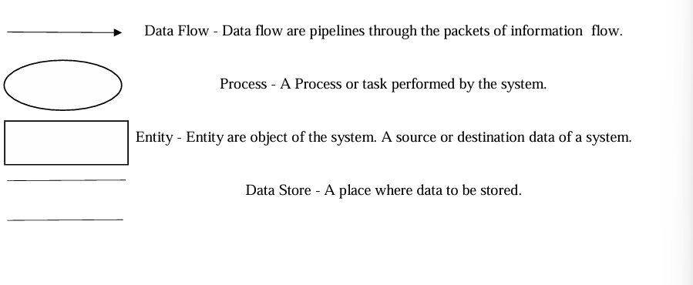
CONTEXT LEVEL DFD:
The context level data flow diagram (DFD) describes the complete Movie Ticket Booking System. The Level 0 DFD illustrates the two primary actors: the Customer (User) and the Administrator. The customer interacts with the system to browse movies, select shows, choose seats, book tickets, and process payments. The administrator manages movies, theatres, show schedules, seat availability, user accounts, and booking records. The central MySQL database processes and stores all system data.

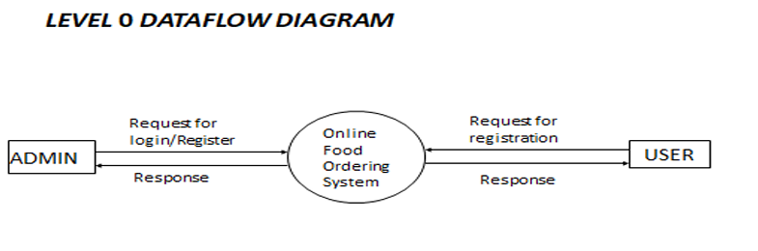

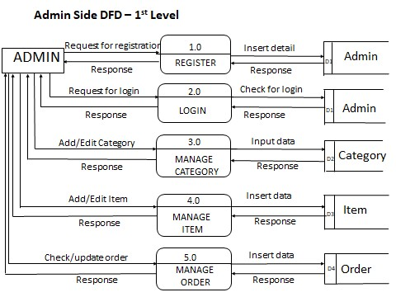

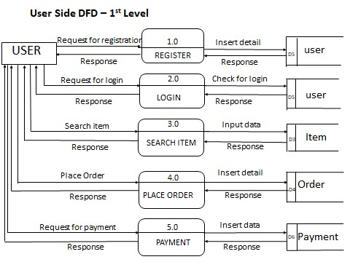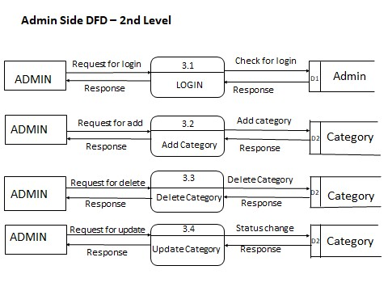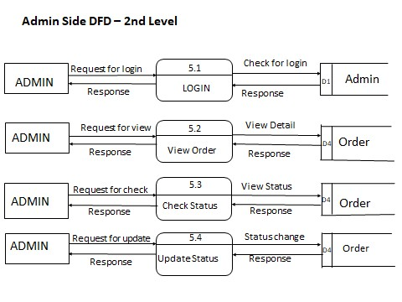

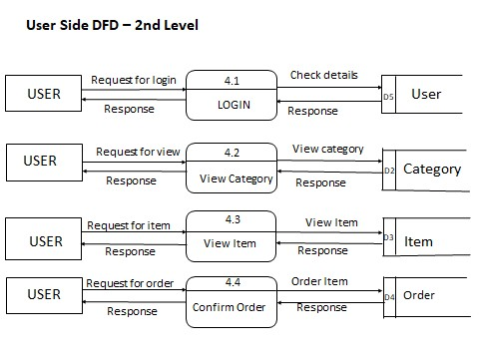

SYSTEM DESIGN
ER Diagram

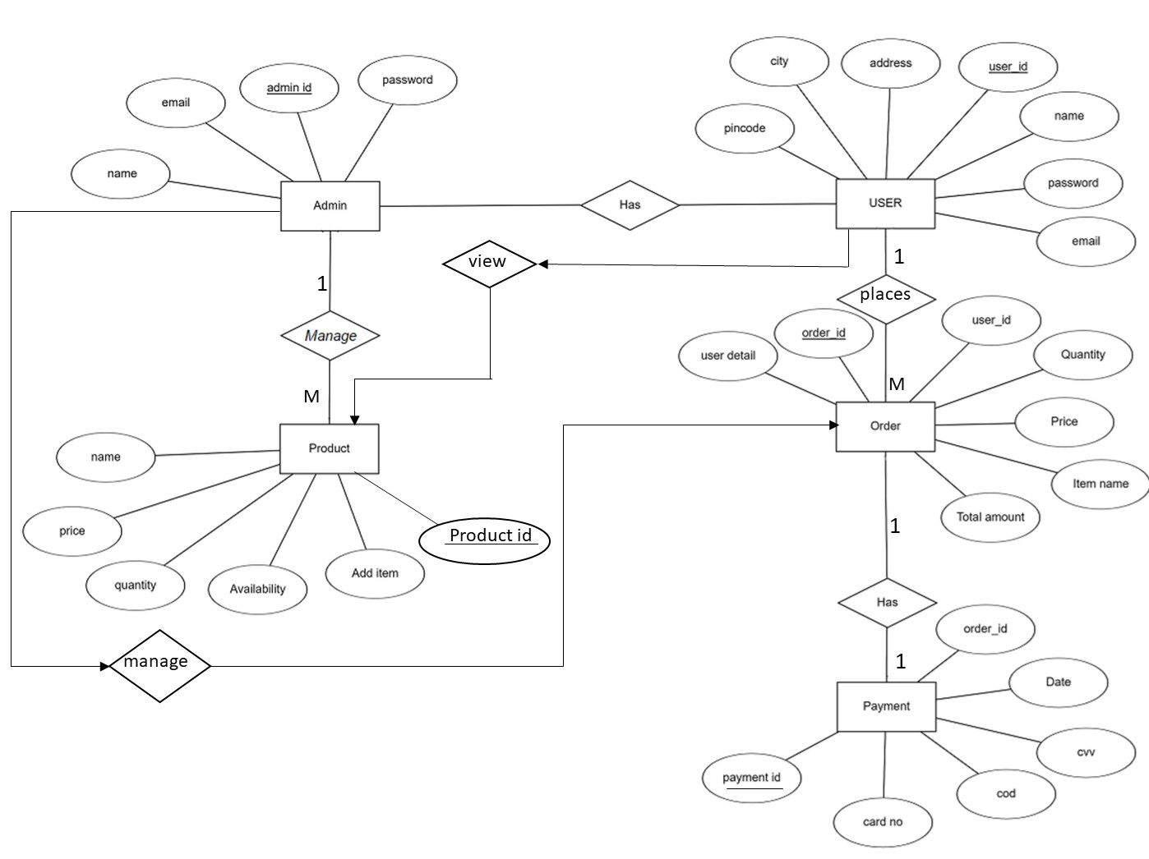

- CODING

- Testing
Testing is a crucial phase in the software development lifecycle that ensures the system works as expected and is free from errors. It helps in identifying bugs, validating functionality, and improving the overall quality and performance of the system. For the Movie Ticket Booking System, comprehensive test cases were designed and executed to verify each module including authentication, movie management, seat selection, booking, payment processing, and the admin panel.
Types of Testing Performed
- Unit Testing: Each module (User Authentication, Movie Management, Seat Selection, Ticket Booking, Payment, Admin Panel) was tested individually using JUnit to ensure isolated correctness.
- Integration Testing: Interactions between modules were tested — e.g., seat selection to booking confirmation, payment processing to booking record updates, and admin actions to system state changes.
- System Testing: The complete system was tested end-to-end to validate the full movie browsing to ticket booking workflow including all edge cases.
- User Acceptance Testing (UAT): Tested from the user's perspective to ensure the interface and booking flow meets expected requirements and provides a smooth experience.
.
Test cases table

Test Case ID | Module | Test Scenario | Input | Expected Output | Actual Output | Status
TC01 | Authentication | Valid Login | Correct email & password | User logged In successfully | Same as expected | Pass
TC02 | Authentication | Invalid Login | Wrong password | Error message displayed | Same as expected | Pass
TC03 | Registration | New User Signup | Valid user details | Account created successfully | Same as expected | Pass
TC04 | Profile | Update Profile | Change address | Profile updated | Same as expected | Pass
TC05 | Menu | View Restaurants | Click menu | List of restaurants displayed | Same as expected | Pass
TC06 | Cart | Add Item to Cart | Select food item | Item added to cart | Same as expected | Pass
TC07 | Cart | Remove Item | Remove item | Item removed | Same as expected | Pass
TC08 | Order | Place Order | Valid cart items | Order placed successfully | Same as expected | Pass
TC09 | Payment | Successful Payment | Valid payment details | Payment success message | Same as expected | Not completed

- Bibliography and References
- Journals
- Title: A Study on Online Movie Ticket Booking Systems
Author: S. Kumar, P. Singh
Year of Publication: 2022
Page No.: 34–48
- Title: Real-Time Seat Reservation in Online Booking Systems
Author: R. Sharma, A. Verma
Year of Publication: 2021
Page No.: 78–85
- Books
- Title: Software Engineering: A Practitioner's Approach
Author: Roger S. Pressman
Publication: McGraw-Hill
Edition: 7th Edition
- Title: Spring Boot in Action
Author: Craig Walls
Publication: Manning Publications
Edition: 2nd Edition
- Title: Java: The Complete Reference
Author: Herbert Schildt
Publication: McGraw-Hill
Edition: 12th Edition
- Websites
- https://docs.oracle.com/en/java/
- https://spring.io/projects/spring-boot
- https://dev.mysql.com/doc/
- https://spring.io/guides
- https://maven.apache.org/guides/
- https://restfulapi.net/
- https://github.com/
- https://stackoverflow.com/
- https://stackoverflow.com

