**10/7/2016**

**COMP-229-006**

**Submitted To: Prof – Tom Tsiliopoulos**

**Team Members: Ishan Sharma (#300856455)**

**Solanky Thareja (#300869859)**



Table of Contents

1. **Website Description ……………………………………………………………………………………….2**
2. **Game Structure Description…………………………………………………………………………….3**
3. **Wireframe……………………………………………………………………………………………………….3**
4. **Game Tracker PART-B……………………………………………………………………………………...4**
5. **GitHub And Azure Links…………………………………………………………………………………...4**
6. **website description**



The website “Tournament Hits” is a Game Tracker website which tracks the progress of top teams of four different leagues of four different sports. The reason we choose the name “Tournament hits” because our website allows user to track the scores of top teams in the world.

* Our website tracks 4 different games for each calendar week.
* Our website will also measure how many points were scored and how many points were allowed (or lost) for each team and how many spectators watched each game.
* All the four leagues appear on the main page of the website.
* Our website has database of scores up to four weeks including the ongoing week.
* Each time user clicks on particular week, the score of teams will be shown accordingly.
* Anonymous user can only see the last updated scores that has been updated in our website database.
* Any user can register anytime to modify the scores and view his own scores on website.
* Our typography and color would include shades of black, gray and blue.

1. **game structure description**

**Four Games**

* Basketball
* Football
* Hockey
* Volleyball
* Teams in Basketball: Toronto Raptors & Miami Heats.
* Teams in Football: Toronto FC & DC United
* Teams in Hockey: Toronto Maple Leafs & Ottawa Senators
* Teams in Volleyball: Canada & Russia

1. **wireframe**

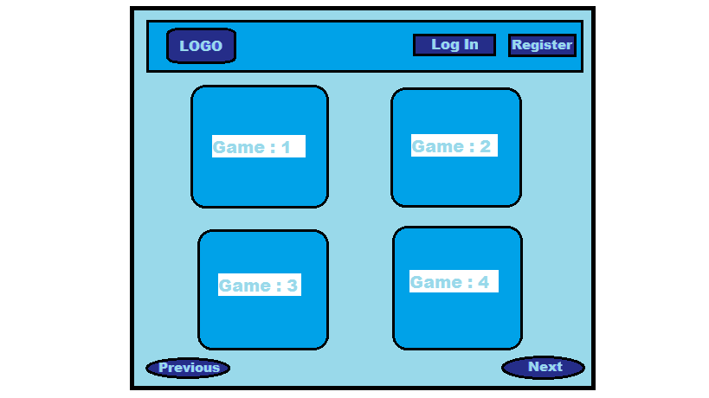

1. **Game tracker part-b**

* **Main Game Tracking Page Setup**

**Main Game Tracking Page** will display the **weekly statistics** of each game. Each game will track **two teams** and our web application will record which team won the game. Our Web App will also measure how many points were **scored** and how many points were **allowed** (or lost) for each team and how many **spectators** watched each game. The weekly results will be recorded in a database using appropriate tables and relations.

Our main game tracking page setup includes a football game tracked between Toronto FC and DC United with the number of spectators in their game.

The game is tracked in four different weeks between Week12 to Week15.

* **Database Structure Setup**

We made a database on the local server, and on that database, four tables were produced (one for each week). All the necessary fields were put into the table.

We used both hand-written queries system and design view available in visual studio to produce tables.

Database connection was set up with the web application by using the models.

We used LINQ, SQL and created queries to build our tables for each particular week. We formatted our site structure using CSS properties in accordance to bootstrap and fontawesome.

1. **github and azure link**

* GitHub Link: <https://github.com/Ishan2996/COMP-229-006-Project-1-GameTracker>
* Azure Link To Website: <http://comp-229-006-gametracker.azurewebsites.net>