**10/7/2016**

**COMP-229-006**

**Submitted To: Prof – Tom Tsiliopoulos**

**Team Members: Ishan Sharma (#300856455)**

**Solanky Thareja (#300869859)**



Table of Contents

1. **Website Description ……………………………………………………………………………………….2**
2. **Game Structure Description…………………………………………………………………………….3**
3. **Wireframe……………………………………………………………………………………………………….3**
4. **GitHub And Azure Links…………………………………………………………………………………...4**
5. **website description**



The website “Tournament Hits” is a Game Tracker website which tracks the progress of top teams of four different leagues of four different sports. The reason we choose the name “Tournament hits” because our website allows user to track the scores of top teams in the world.

* Our website tracks 4 different games for each calendar week.
* Our website will also measure how many points were scored and how many points were allowed (or lost) for each team and how many spectators watched each game.
* All the four leagues appear on the main page of the website.
* Our website has database of scores up to four weeks including the ongoing week.
* Each time user clicks on particular week, the score of teams will be shown accordingly.
* Anonymous user can only see the last updated scores that has been updated in our website database.
* Any user can register anytime to modify the scores and view his own scores on website.
* Our typography and color would include shades of black, gray and blue.

1. **game structure description**

**Four Games**

* Basketball
* Football
* Hockey
* Volleyball
* Teams in Basketball: Toronto Raptors & Miami Heats.
* Teams in Football: Toronto FC & DC United
* Teams in Hockey: Toronto Maple Leafs & Ottawa Senators
* Teams in Volleyball: Canada & Russia

1. **wireframe**

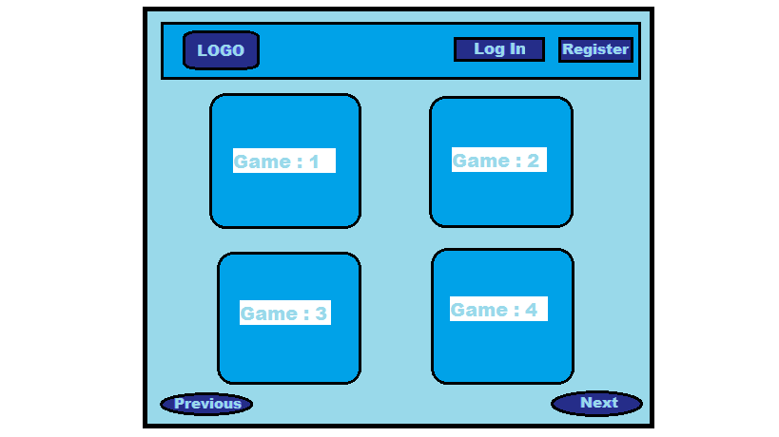

1. **github and azure link**

* GitHub Link: <https://github.com/Ishan2996/COMP-229-006-Project-1>
* Azure Link: <http://comp229-006-project-1.azurewebsites.net/>