**ASP.Net Practical : 4-15**

Practical : 4

## Aim : Design a web form to allow user to enter following details in his Resume using Web Server Controls. Set validations using properties. When data is submitted it must be viewed in the panel below the form. Fields of Resume are FirstName, Surname, Gender, Address, City, Pincode, Phone, Qualification (Diploma, Bachelor, Master), Specialization subject, Percentage.

Resume.aspx

<%@ Page Language="vb" AutoEventWireup="false" CodeBehind="Resume.aspx.vb" Inherits="Practical_4._Resume" %>

<!DOCTYPE html PUBLIC "-//W3C//DTD XHTML 1.0 Transitional//EN" "http://www.w3.org/TR/xhtml1/DTD/xhtml1-transitional.dtd">

<html xmlns="http://www.w3.org/1999/xhtml">

<head runat="server">

<title></title>

</head>

<body>

<form id="form1" runat="server">

<p>

First Name:

<asp:TextBox ID="txtFname" runat="server" MaxLength="15"></asp:TextBox>

</p>

<p>

<asp:Label ID="Label2" runat="server" Text="Surname : "></asp:Label>

<asp:TextBox ID="txtLname" runat="server"></asp:TextBox>

</p>

<p>

Gender: <asp:RadioButton ID="rdoMale" runat="server" GroupName="gender" Text="Male" />

<asp:RadioButton ID="rdoFemale" runat="server" GroupName="gender" Text="Female" />

</p>

<p>

Address: <asp:TextBox ID="txtAddress" runat="server" TextMode="MultiLine"/>

</p>

<p>

City:

<asp:DropDownList ID="drpCity" runat="server">

<asp:ListItem ID="drpListGandhinagar" runat="server">Gandhinagar</asp:ListItem>

<asp:ListItem ID="drpListAhmedabad" runat="server">Ahmedabad</asp:ListItem>

<asp:ListItem ID="drpListSurat" runat="server">Surat</asp:ListItem>

<asp:ListItem ID="drpListRajkot" runat="server">Rajkot</asp:ListItem>

</asp:DropDownList>

</p>

<p>

Pincode: <asp:TextBox ID="txtPincode" runat="server" />

</p>

<p>

Phone: <asp:TextBox ID="txtPhone" runat="server" MaxLength="10"

/>

</p>

<p>

Qualification: <asp:RadioButton ID="radDiploma" runat="server" GroupName="qualification" Text="Diploma"/>

<asp:RadioButton ID="radDegree" runat="server" GroupName="qualification" Text="Degree"/>

<asp:RadioButton ID="radMasters" runat="server" GroupName="qualification" Text="Masters"/>

</p>

<p>

Specialization Subject: <asp:TextBox ID="txtSpeSub" runat="server"/>

</p>

<p>

Percentage: <asp:TextBox ID="txtPercentage" runat="server" />

</p>

<p>

<asp:Button ID="submitButton" runat="server" Text="Submit" />

</p>

<asp:Panel ID="resultPanel" runat="server">

First Name : <asp:Label ID="lblFname" runat="server" Text="" />

<br />

Surname : <asp:Label ID="lblLName" runat="server" Text="" />

<br />

Gender: <asp:Label ID="lblGender" runat="server" Text="" />

<br />

Address :

<asp:Label ID="lblAddress" runat="server" Text="" />

<br />

City : <asp:Label ID="lblCity" runat="server" Text="" />

<br />

Pincode : <asp:Label ID="lblPincode" runat="server" Text="" />

<br />

Phone : <asp:Label ID="lblPhone" runat="server" Text="" />

<br />

Qualification :

<asp:Label ID="lblQualification" runat="server" Text=""></asp:Label>

<br />

Specialization Subject : <asp:Label ID="lblSpeSubject" runat="server" Text="" />

<br />

Percentage : <asp:Label ID="lblPercentage" runat="server" Text="" />

<br />

</asp:Panel>

</form>

</body>

</html>

Resume.aspx.vb

Public Class _Resume

Inherits System.Web.UI.Page

Protected Sub Page_Load(ByVal sender As Object, ByVal e As System.EventArgs) Handles Me.Load

resultPanel.Visible = False

End Sub

Protected Sub submitButton_Click(ByVal sender As Object, ByVal e As EventArgs) Handles submitButton.Click

resultPanel.Visible = "True"

lblFname.Text = txtFname.Text

lblLName.Text = txtLname.Text

If rdoMale.Checked = True Then

lblGender.Text = rdoMale.Text

Else

lblGender.Text = rdoFemale.Text

End If

lblAddress.Text = txtAddress.Text

lblCity.Text = drpCity.Text

lblPincode.Text = txtPincode.Text

lblPhone.Text = txtPhone.Text

If radDiploma.Checked = True Then

lblQualification.Text = "Diploma"

ElseIf radDegree.Checked = True Then

lblQualification.Text = "Degree"

Else

lblQualification.Text = "Masters"

End If

lblSpeSubject.Text = txtSpeSub.Text

lblPercentage.Text = txtPercentage.Text

End Sub

End Class

Result :

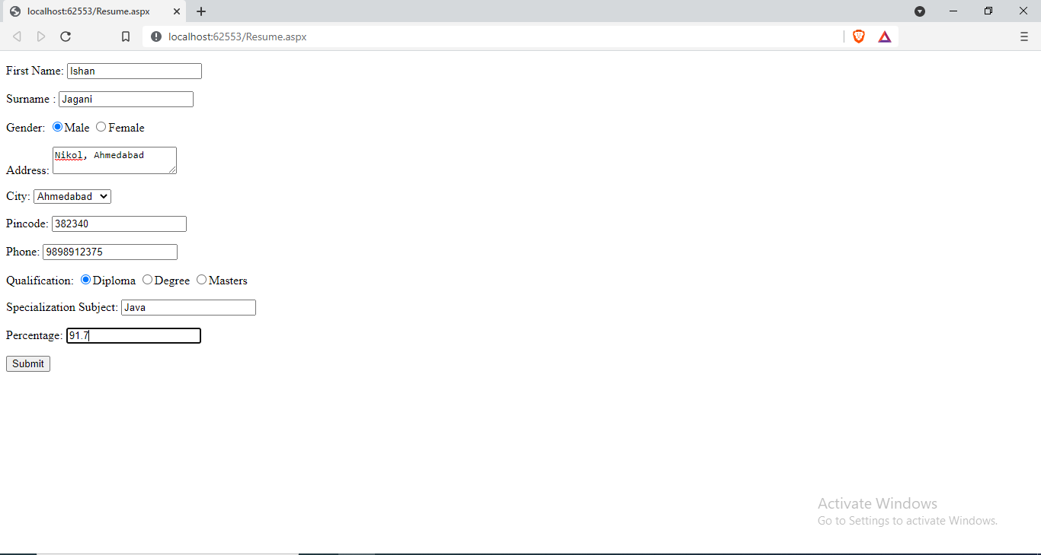

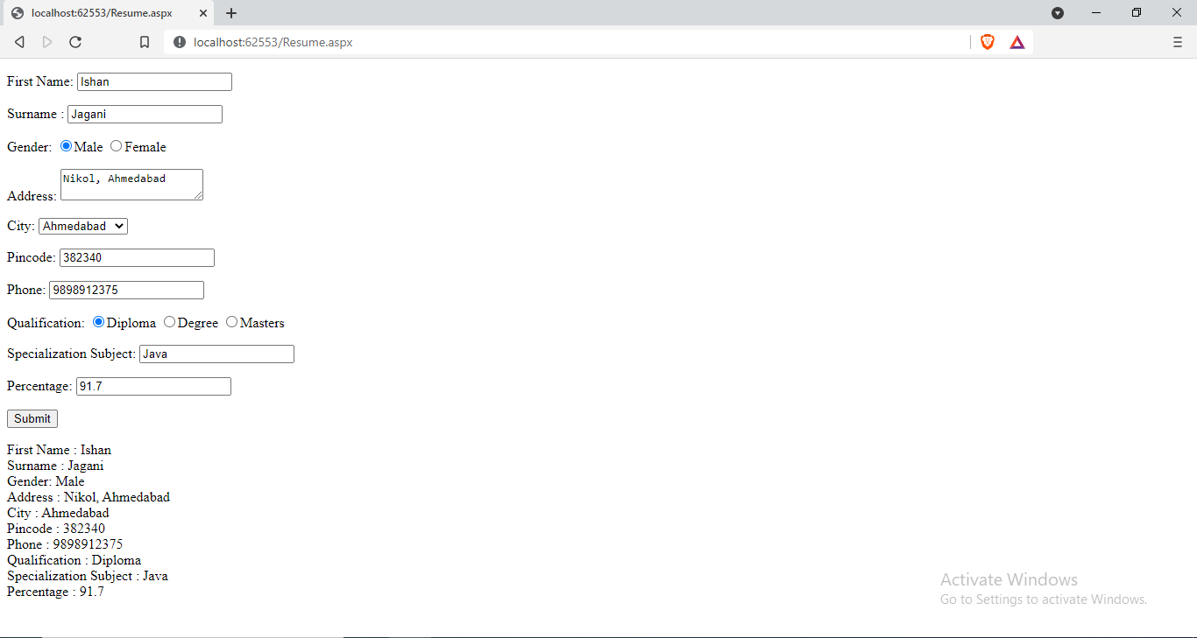

|  |  |  |  |
| --- | --- | --- | --- |
| Start Date | End/Sign Date | Faculty Sign | Remarks/Grade |
|  |  |  |  |

Practical : 5

## Aim : Create a web form where user enters following marks. ASP.NET, JAVA, ISS, Project (All out of 100). When user submits the marks, numeric value validation must be done. On entering marks, the grade should be displayed in message box .

Result.aspx

<%@ Page Language="vb" AutoEventWireup="false" CodeBehind="WebForm1.aspx.vb" Inherits="Practical_5.WebForm1" %>

<!DOCTYPE html PUBLIC "-//W3C//DTD XHTML 1.0 Transitional//EN" "http://www.w3.org/TR/xhtml1/DTD/xhtml1-transitional.dtd">

<html xmlns="http://www.w3.org/1999/xhtml">

<head runat="server">

<title></title>

<style type="text/css">

.style1

{

width: 302px;

}

</style>

</head>

<body>

<form id="marksheetForm" runat="server">

<div>

<table style="width:100%;">

<tr>

<td class="style1">

Asp.net </td>

<td>

<asp:TextBox ID="txtAsp" runat="server"></asp:TextBox>

</td>

<td>

<asp:Label ID="lblASP" runat="server" Text=""></asp:Label>

</td>

</tr>

<tr>

<td class="style1">

Java</td>

<td>

<asp:TextBox ID="txtJava" runat="server"></asp:TextBox>

</td>

<td>

<asp:Label ID="lblJava" runat="server" Text=""></asp:Label>

</td>

</tr>

<tr>

<td class="style1">

ICN</td>

<td>

<asp:TextBox ID="txtIcn" runat="server"></asp:TextBox>

</td>

<td>

<asp:Label ID="lblIcn" runat="server" Text=""></asp:Label>

</td>

</tr>

<tr>

<td class="style1">

ENS</td>

<td>

<asp:TextBox ID="txtEns" runat="server"></asp:TextBox>

</td>

<td>

<asp:Label ID="lblEns" runat="server" Text=""></asp:Label>

</td>

</tr>

<tr>

<td></td>

<td>

<asp:Button ID="viewResultBtn" runat="server" Text="Submit" Width="126px" />

</td>

<td></td>

</tr>

</table>

</div>

</form>

</body>

</html>

Result.aspx.vb

Public Class WebForm1

Inherits System.Web.UI.Page

Protected Sub Page_Load(ByVal sender As Object, ByVal e As System.EventArgs) Handles Me.Load

End Sub

Private Function getMyGrade(ByVal p1 As String) As String

If p1 > 90 And p1 <= 100 Then

Return "AA"

ElseIf p1 > 80 And p1 <= 90 Then

Return "AB"

ElseIf p1 > 70 And p1 <= 80 Then

Return "BB"

ElseIf p1 > 60 And p1 <= 70 Then

Return "BC"

ElseIf p1 > 50 And p1 <= 60 Then

Return "CC"

ElseIf p1 > 40 And p1 <= 50 Then

Return "DD"

Else

Return "Fail"

End If

End Function

Protected Sub viewResultBtn_Click(ByVal sender As Object, ByVal e As EventArgs) Handles viewResultBtn.Click

lblASP.Text = getMyGrade(txtAsp.Text)

lblJava.Text = getMyGrade(txtJava.Text)

lblIcn.Text = getMyGrade(txtIcn.Text)

lblEns.Text = getMyGrade(txtEns.Text)

End Sub

End Class

Result :

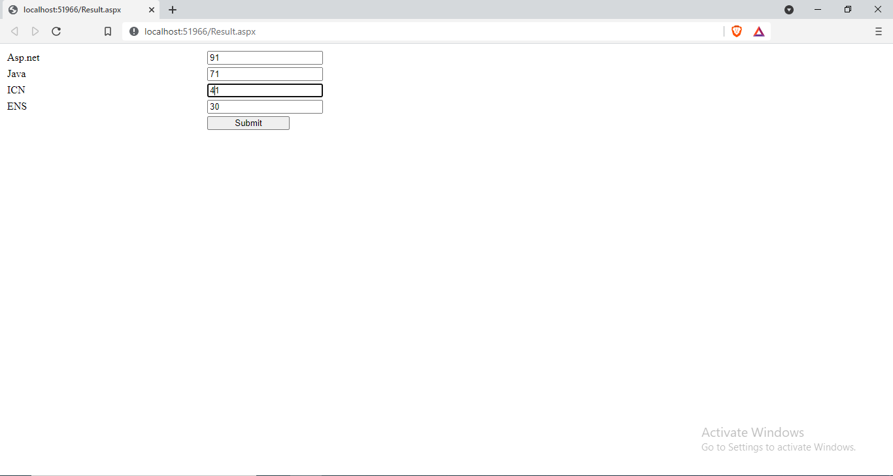

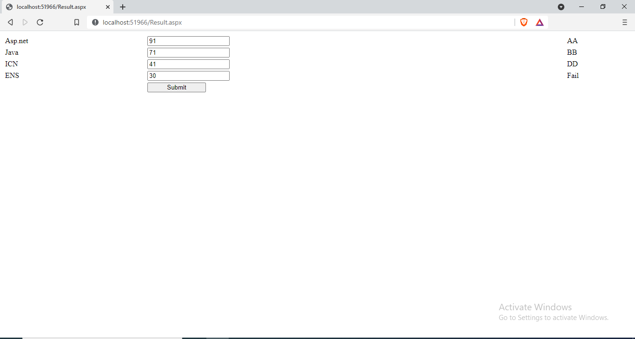

|  |  |  |  |
| --- | --- | --- | --- |
| Start Date | End/Sign Date | Faculty Sign | Remarks/Grade |
|  |  |  |  |

Practical: 6

## Aim : Create a Simple Calculator with Validation and Details

Calculator.aspx

<%@ Page Language="vb" AutoEventWireup="false" CodeBehind="Calculator.aspx.vb" Inherits="Practical_06.Calculator" %>

<!DOCTYPE html PUBLIC "-//W3C//DTD XHTML 1.0 Transitional//EN" "http://www.w3.org/TR/xhtml1/DTD/xhtml1-transitional.dtd">

<html xmlns="http://www.w3.org/1999/xhtml">

<head runat="server">

<title></title>

</head>

<body>

<form id="form1" runat="server">

<div>

<asp:TextBox ID="tbA" runat="server" />

<asp:RequiredFieldValidator ID="rfvA" runat="server" ControlToValidate="tbA" ErrorMessage="Enter A" ForeColor="Red" />

<asp:RangeValidator ID="rnvA" runat="server" ControlToValidate="tbA" ErrorMessage="Invalid Value" Type="Double" MinimumValue="0.0" MaximumValue="65536.0" ForeColor="Red" />

<asp:TextBox ID="tbB" runat="server" />

<asp:RequiredFieldValidator ID="rfvB" runat="server" ControlToValidate="tbB" ErrorMessage="Enter B" ForeColor="Red" />

<asp:RangeValidator ID="rnvB" runat="server" ControlToValidate="tbB" ErrorMessage="Invalid Value" Type="Double" MinimumValue="0.0" MaximumValue="65536.0" ForeColor="Red" />

<asp:DropDownList ID="drpOp" runat="server">

<asp:ListItem>+</asp:ListItem>

<asp:ListItem>-</asp:ListItem>

<asp:ListItem>*</asp:ListItem>

<asp:ListItem>/</asp:ListItem>

<asp:ListItem>%</asp:ListItem>

</asp:DropDownList>

<asp:Button ID="btnCalculate" runat="server" Text="Calculate" />

<asp:Label ID="lblAnswer" runat="server" />

</div>

</form>

</body>

</html>

Calculator.aspx.vb

Public Class Calculator

Inherits System.Web.UI.Page

Protected Sub Page_Load(ByVal sender As Object, ByVal e As System.EventArgs) Handles Me.Load

End Sub

Protected Sub btnCalculate_Click(ByVal sender As Object, ByVal e As EventArgs) Handles btnCalculate.Click

If CInt(tbB.Text) = 0 Then

Response.Write("Cannot Divided by 0")

ElseIf drpOp.Text = "+" Then

lblAnswer.Text = CDbl(tbA.Text) + CDbl(tbB.Text)

ElseIf drpOp.Text = "-" Then

lblAnswer.Text = CDbl(tbA.Text) - CDbl(tbB.Text)

ElseIf drpOp.Text = "*" Then

lblAnswer.Text = CDbl(tbA.Text) * CDbl(tbB.Text)

ElseIf drpOp.Text = "/" Then

lblAnswer.Text = CDbl(tbA.Text) / CDbl(tbB.Text)

ElseIf drpOp.Text = "%" Then

lblAnswer.Text = CDbl(tbA.Text) Mod CDbl(tbB.Text)

End If

End Sub

End Class

Output :

Addition:



Subtraction:



Multiplication:



Division:



Modulo:



Errors :

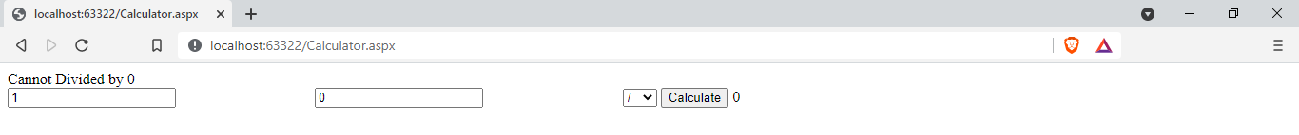



|  |  |  |  |
| --- | --- | --- | --- |
| Start Date | End/Sign Date | Faculty Sign | Remarks/Grade |
|  |  |  |  |

Practical – 7

## Aim : Create a web page using the concept of cascading style sheets in ASP.NET.

CSSDemo.aspx

<%@ Page Language="vb" AutoEventWireup="false" CodeBehind="CSSDemo.aspx.vb" Inherits="Practical_07.WebForm1" %>

<!DOCTYPE html PUBLIC "-//W3C//DTD XHTML 1.0 Transitional//EN" "http://www.w3.org/TR/xhtml1/DTD/xhtml1-transitional.dtd">

<html xmlns="http://www.w3.org/1999/xhtml">

<head runat="server">

<title>CSS Declaration Demo</title>

<link rel="Stylesheet" type="text/css" href="CSSDemo.css" />

<style type="text/css">

h1

{

color:Lime;

}

</style>

</head>

<body>

<form id="form1" runat="server">

<div>

<input type="text" style="background-color:Purple;border:2px solid white;" placeholder="inline CSS" />

<h1> Internal CSS </h1>

</div>

</form>

</body>

</html>

CSSDemo.css

body

{

background-color: Gray;

}

div

{

background-color: Red;

}

Output :

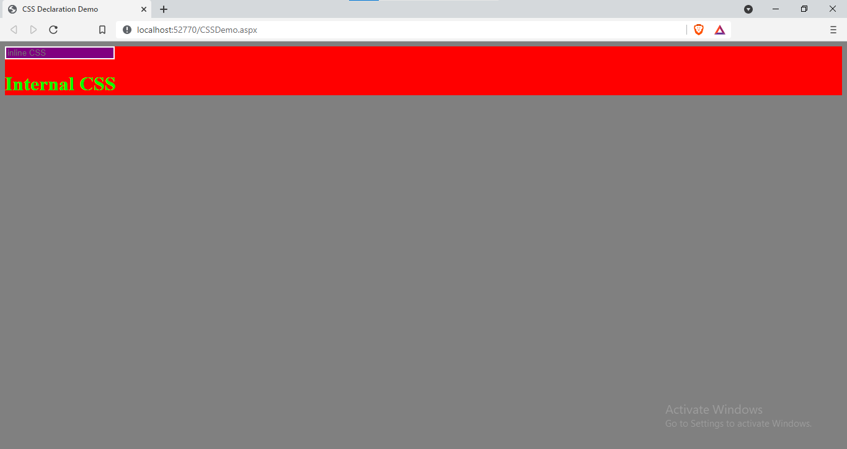

|  |  |  |  |
| --- | --- | --- | --- |
| Start Date | End/Sign Date | Faculty Sign | Remarks/Grade |
|  |  |  |  |

Practical – 8

## Aim : Create a web page using the concept of Theme & Skin in ASP.NET.

ThemeAndSkin.aspx

<%@ Page Theme="MyTheme" Language="vb" AutoEventWireup="false" CodeBehind="ThemeAndSkin.aspx.vb" Inherits="Practical_08.ThemeAndSkin" %>

<!DOCTYPE html PUBLIC "-//W3C//DTD XHTML 1.0 Transitional//EN" "http://www.w3.org/TR/xhtml1/DTD/xhtml1-transitional.dtd">

<html xmlns="http://www.w3.org/1999/xhtml">

<head runat="server">

<title></title>

</head>

<body>

<form id="form1" runat="server">

<p>

<asp:TextBox ID="TextBox1" runat="server"></asp:TextBox>

</p>

<p>

<asp:TextBox ID="TextBox2" runat="server"></asp:TextBox>

</p>

<asp:RadioButton ID="RadioButton1" GroupName="bool" runat="server" Text="Yes" />

<asp:RadioButton ID="RadioButton2" GroupName="bool" runat="server" Text="No" />

<br />

<asp:Button ID="Button1" runat="server" Text="Button" />

</form>

</body>

</html>

Controls.skin

<asp:TextBox runat="server" BackColor="Black" ForeColor="White" />

<asp:RadioButton runat="server" ForeColor="Purple" />

<asp:Button runat="server" BackColor="Black" ForeColor="Cyan" />

Output:

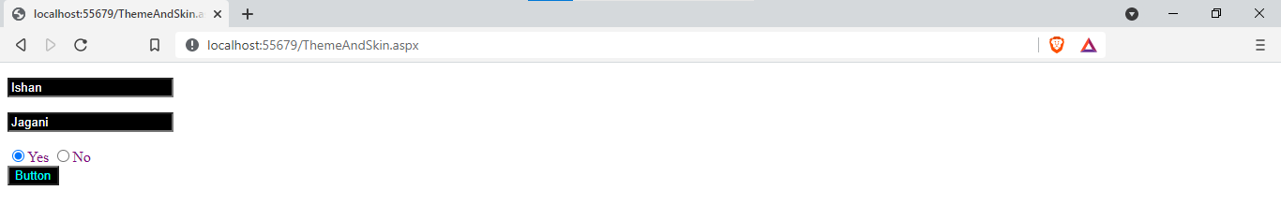

|  |  |  |  |
| --- | --- | --- | --- |
| Start Date | End/Sign Date | Faculty Sign | Remarks/Grade |
|  |  |  |  |

Practical : 9

## Aim : Create Home page of your website using master page concept.

HeaderFooter.Master

<%@ Master Language="VB" AutoEventWireup="false" CodeBehind="HeaderFooter.master.vb" Inherits="Practical_09.HeaderFooter" %>

<!DOCTYPE html PUBLIC "-//W3C//DTD XHTML 1.0 Transitional//EN" "http://www.w3.org/TR/xhtml1/DTD/xhtml1-transitional.dtd">

<html xmlns="http://www.w3.org/1999/xhtml">

<head id="Head1" runat="server">

<title>Milk Prism</title>

<style type="text/css">

#header{

color: #247BA0;

text-align: center;

font-size: 20px;

}

#nav{

background-color:Blue;

padding: 5px;

}

li a {

color: #F1FAEE;

font-size: 30px;

column-width: 5%;

}

li

{

display: inline;

padding-left: 2px;

column-width: 20px;

}

a{

text-decoration: none;

margin-left:20px

}

li a:hover{

background-color: #F3FFBD;

color: #FF1654;

padding:1%;

}

#footer{

background-color: #C7EFCF;

text-align:center;

padding-bottom: 5%;

font-size: 20px;

}

#con{

border:double;

border-color:Fuchsia;

}

</style>

<asp:ContentPlaceHolder ID="head" runat="server">

</asp:ContentPlaceHolder>

</head>

<!DOCTYPE html>

<body>

<header id="header">

<h1>MilkPrism</h1>

</header>

<nav id="nav">

<ul>

<li><a href="home.aspx">Find Us</a></li>

<li><a href="#">Contact Us</a></li>

<li><a href="#">Login</a></li>

<li><a href="#">Sign Up</a></li>

</ul>

</nav>

<div id="con">

<asp:ContentPlaceHolder ID="ContentPlaceHolder1" runat="server">

</asp:ContentPlaceHolder>

</div>

<footer id="footer">

insta : milkprism

fb : milkprism

</footer>

</body>

</html>

Home.aspx

<%@ Page Title="" Language="vb" AutoEventWireup="false" MasterPageFile="~/HeaderFooter.Master" CodeBehind="Home.aspx.vb" Inherits="Practical_09.Home" %>

<asp:Content ID="Content1" ContentPlaceHolderID="head" runat="server">

</asp:Content>

<asp:Content ID="Content2" ContentPlaceHolderID="ContentPlaceHolder1" runat="server">

<h1>Home Page</h1>

</asp:Content>

Output :

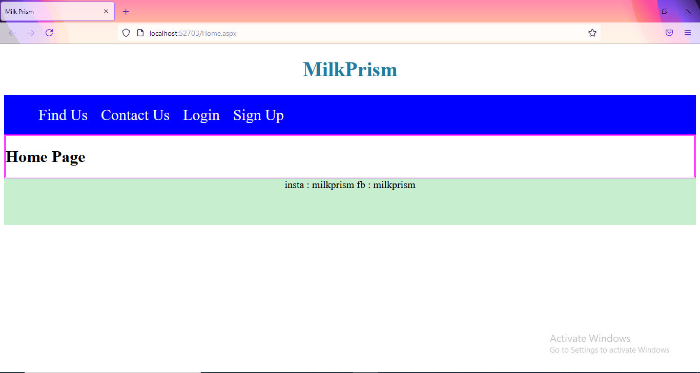

|  |  |  |  |
| --- | --- | --- | --- |
| Start Date | End/Sign Date | Faculty Sign | Remarks/Grade |
|  |  |  |  |

Practical : 10

## Aim : Create a simple web application to illustrate the concept of nesting master page in ASP.NET.

Master.Master

<%@ Master Language="VB" AutoEventWireup="false" CodeBehind="Master.master.vb" Inherits="Practical_10.Master" %>

<!DOCTYPE html PUBLIC "-//W3C//DTD XHTML 1.0 Transitional//EN" "http://www.w3.org/TR/xhtml1/DTD/xhtml1-transitional.dtd">

<html xmlns="http://www.w3.org/1999/xhtml">

<head runat="server">

<title></title>

<asp:ContentPlaceHolder ID="head" runat="server">

</asp:ContentPlaceHolder>

</head>

<body>

<form id="form1" runat="server">

<div>

<table cellpadding="50px" style="border:3px Solid Red;">

<tr>

<td colspan="2" align="center">

Header Part

</td>

</tr>

<tr>

<td width="20%" colspan="2">

&nbsp<asp:ContentPlaceHolder ID="ContentPlaceHolder1" runat="server">

</asp:ContentPlaceHolder>

</td>

</tr>

<tr>

<td colspan="2" align="center">

Footer Part

</td>

</tr>

</table>

</div>

</form>

</body>

</html>

SideBar.master

<%@ Master Language="VB" MasterPageFile="~/Master.Master" AutoEventWireup="false" CodeBehind="SideBar.master.vb" Inherits="Practical_10.SideBar" %>

<asp:Content ID="Content1" ContentPlaceHolderID="head" runat="server">

</asp:Content>

<asp:Content ID="Content2" ContentPlaceHolderID="ContentPlaceHolder1" runat="server">

<table width="60%" style="border:2px dotted blue;">

<tr>

<td width="40%">Sidebar</td>

<td><asp:ContentPlaceHolder ID="cph" runat="server"></asp:ContentPlaceHolder></td>

</tr>

</table>

</asp:Content>

Shops.aspx

<%@ Page Title="" Language="vb" AutoEventWireup="false" MasterPageFile="~/SideBar.master" CodeBehind="Shops.aspx.vb" Inherits="Practical_10.Shops" %>

<asp:Content ID="Content1" ContentPlaceHolderID="cph" runat="server">

Krishna Dairy

<br />

Kandhenu Dairy

<br />

Amul

<br />

Sumul

<br />

Havemor Eatery

</asp:Content>

Output :

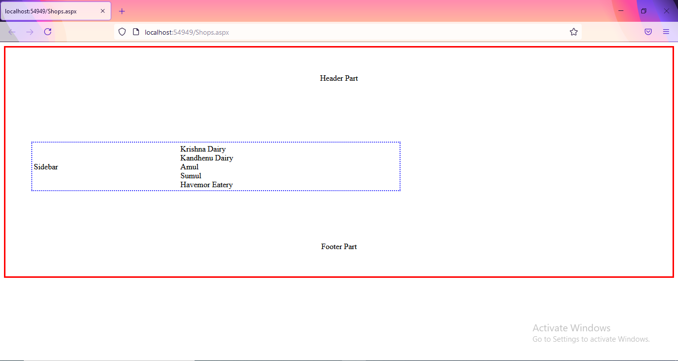

|  |  |  |  |
| --- | --- | --- | --- |
| Start Date | End/Sign Date | Faculty Sign | Remarks/Grade |
|  |  |  |  |

Practical : 11

## Aim: Develop a web page to implement the concept of state management using Cookies.

WebForm1.aspx

<%@ Page Language="vb" AutoEventWireup="false" CodeBehind="WebForm1.aspx.vb" Inherits="Practical_11.WebForm1" %>

<!DOCTYPE html PUBLIC "-//W3C//DTD XHTML 1.0 Transitional//EN" "http://www.w3.org/TR/xhtml1/DTD/xhtml1-transitional.dtd">

<html xmlns="http://www.w3.org/1999/xhtml">

<head runat="server">

<title></title>

</head>

<body>

<form id="form1" runat="server">

<div>

<asp:Button ID="btn1" runat="server" Text="Write to Cookies" />

</div>

</form>

</body>

</html>

WebForm1.aspx.vb

Public Class WebForm1

Inherits System.Web.UI.Page

Protected Sub Page_Load(ByVal sender As Object, ByVal e As System.EventArgs) Handles Me.Load

End Sub

Protected Sub btn1_Click(ByVal sender As Object, ByVal e As EventArgs) Handles btn1.Click

Dim ck As New HttpCookie("MyCookie")

ck.Values.Add("Username", "Ishan")

ck.Expires = Now.AddMonths(2)

Response.Cookies.Add(ck)

Response.Redirect("WebForm2.aspx")

End Sub

End Class

WebForm2.aspx.vb

Public Class WebForm2

Inherits System.Web.UI.Page

Protected Sub Page_Load(ByVal sender As Object, ByVal e As System.EventArgs) Handles Me.Load

Response.Write("Welcome " & Request.Cookies("myCookie").Values("Username"))

End Sub

End Class

Output :

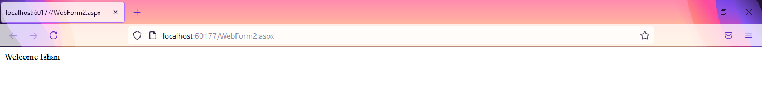

|  |  |  |  |
| --- | --- | --- | --- |
| Start Date | End/Sign Date | Faculty Sign | Remarks/Grade |
|  |  |  |  |

Practical : 12

## Aim: Develop a web page to implement the concept of state management using Session and Application.

First.aspx

<%@ Page Language="vb" AutoEventWireup="false" CodeBehind="First.aspx.vb" Inherits="Practical_12.First" %>

<!DOCTYPE html PUBLIC "-//W3C//DTD XHTML 1.0 Transitional//EN" "http://www.w3.org/TR/xhtml1/DTD/xhtml1-transitional.dtd">

<html xmlns="http://www.w3.org/1999/xhtml">

<head runat="server">

<title></title>

</head>

<body>

<form id="form1" runat="server">

<div>

<asp:TextBox ID="tb1" runat="server"></asp:TextBox>

<asp:Button ID="Button1" runat="server" Text="Login" />

</div>

</form>

</body>

</html>

First.aspx.vb

Public Class First

Inherits System.Web.UI.Page

Protected Sub Page_Load(ByVal sender As Object, ByVal e As System.EventArgs) Handles Me.Load

End Sub

Protected Sub Button1_Click(ByVal sender As Object, ByVal e As EventArgs) Handles Button1.Click

Session("username") = tb1.Text

Application("lastuser") = tb1.Text

Response.Redirect("Second.aspx")

End Sub

End Class

Second.aspx.vb

Public Class Second

Inherits System.Web.UI.Page

Protected Sub Page_Load(ByVal sender As Object, ByVal e As System.EventArgs) Handles Me.Load

Response.Write("Welcome : " & Session("username"))

Response.Write("<br />Last Logged User : " & Application("lastuser"))

End Sub

End Class

Output :



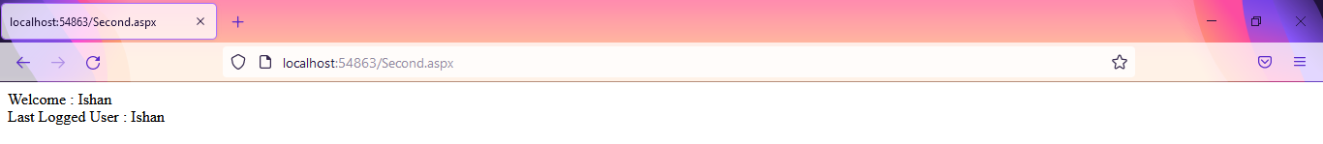

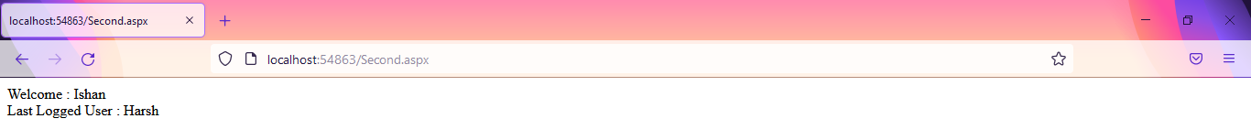

|  |  |  |  |
| --- | --- | --- | --- |
| Start Date | End/sign Date | Faculty Sign | Remarks/Grade |
|  |  |  |  |

Practical : 13

## Aim: Develop a web page to implement the concept of state management using ViewState and QueryString.

First.aspx

<%@ Page Language="vb" AutoEventWireup="false" CodeBehind="First.aspx.vb" Inherits="Practical_13.First" %>

<!DOCTYPE html PUBLIC "-//W3C//DTD XHTML 1.0 Transitional//EN" "http://www.w3.org/TR/xhtml1/DTD/xhtml1-transitional.dtd">

<html xmlns="http://www.w3.org/1999/xhtml">

<head runat="server">

<title></title>

</head>

<body>

<form id="form1" runat="server">

<div>

First Name

<asp:TextBox ID="tb1" runat="server" />

&nbsp;

Last Name

<asp:TextBox ID="tb2" runat="server" />

<br />

<br />

<asp:Button ID="btn" runat="server" Text="Click Me" />

<br />

<a href="Second.aspx?word1=abcd...&word2=xyz">Click Here</a>

<br />

<asp:HyperLink ID="hl1" runat="server" NavigateUrl="~/Second.aspx?word1=Baburao&word2=Apte" Text="FullName Here" />

</div>

</form>

</body>

</html>

First.aspx.vb

Public Class First

Inherits System.Web.UI.Page

Protected Sub Page_Load(ByVal sender As Object, ByVal e As System.EventArgs) Handles Me.Load

End Sub

Protected Sub btn_Click(ByVal sender As Object, ByVal e As EventArgs) Handles btn.Click

Response.Redirect("Second.aspx?word1=" & tb1.Text & "&word2=" & tb2.Text)

End Sub

End Class

Second.aspx

<%@ Page Language="vb" AutoEventWireup="false" CodeBehind="Second.aspx.vb" Inherits="Practical_13.Second" %>

<!DOCTYPE html PUBLIC "-//W3C//DTD XHTML 1.0 Transitional//EN" "http://www.w3.org/TR/xhtml1/DTD/xhtml1-transitional.dtd">

<html xmlns="http://www.w3.org/1999/xhtml">

<head runat="server">

<title></title>

</head>

<body>

<form id="form1" runat="server">

<div>

Welcome To Home Page.

</div>

</form>

</body>

</html>

Second.aspx.vb

Public Class Second

Inherits System.Web.UI.Page

Protected Sub Page_Load(ByVal sender As Object, ByVal e As System.EventArgs) Handles Me.Load

Response.Write("Welcome, " & Request.QueryString("word1"))

Response.Write(" " & Request.QueryString("word2"))

End Sub

End Class

Output :

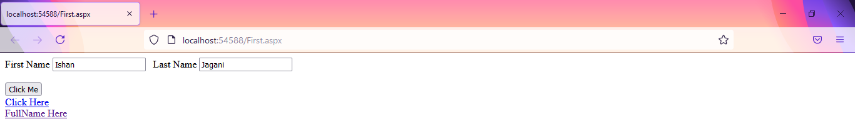

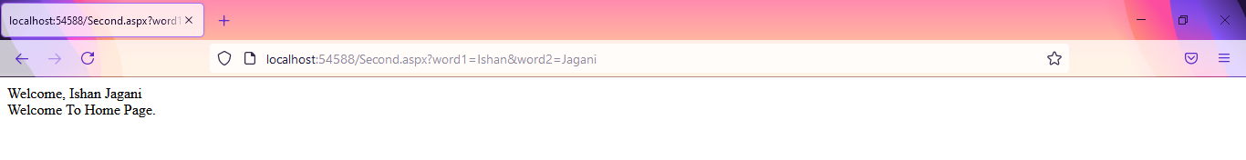

Using a tag :

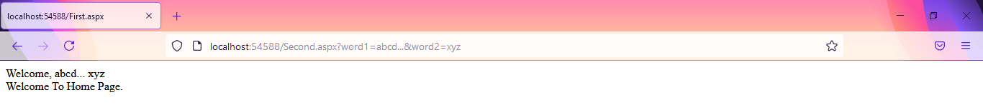

Using HyperLink tag :

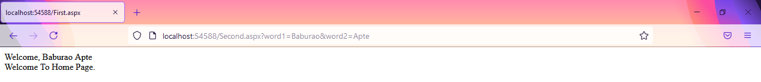

|  |  |  |  |
| --- | --- | --- | --- |
| Start Date | End/Sign Date | Faculty Sign | Remarks/Grade |
|  |  |  |  |

Practical : 14

## Aim: Create a web application using **Global.asax** file which will count the number of visitors on web page.

Home.aspx

<%@ Page Language="vb" AutoEventWireup="false" CodeBehind="Home.aspx.vb" Inherits="Practical_14.Home" %>

<!DOCTYPE html PUBLIC "-//W3C//DTD XHTML 1.0 Transitional//EN" "http://www.w3.org/TR/xhtml1/DTD/xhtml1-transitional.dtd">

<html xmlns="http://www.w3.org/1999/xhtml">

<head runat="server">

<title></title>

</head>

<body>

<form id="form1" runat="server">

<div>

</div>

</form>

</body>

</html>

Home.aspx.vb

Public Class Home

Inherits System.Web.UI.Page

Protected Sub Page_Load(ByVal sender As Object, ByVal e As System.EventArgs) Handles Me.Load

Session.Timeout = 1

Response.Write("Total Visitors : " & Application("visitor"))

Response.Write("<br />Total Online : " & Application("online"))

End Sub

End Class

Global.asax.vb

Imports System.Web.SessionState

Public Class Global_asax

Inherits System.Web.HttpApplication

Sub Application_Start(ByVal sender As Object, ByVal e As EventArgs)

Application("visitor") = 0

Application("online") = 0

End Sub

Sub Session_Start(ByVal sender As Object, ByVal e As EventArgs)

Application("visitor") += 1

Application("online") += 1

End Sub

Sub Application_BeginRequest(ByVal sender As Object, ByVal e As EventArgs)

End Sub

Sub Application_AuthenticateRequest(ByVal sender As Object, ByVal e As EventArgs)

End Sub

Sub Application_Error(ByVal sender As Object, ByVal e As EventArgs)

End Sub

Sub Session_End(ByVal sender As Object, ByVal e As EventArgs)

Application("online") -= 1

End Sub

Sub Application_End(ByVal sender As Object, ByVal e As EventArgs)

End Sub

End Class

Output :

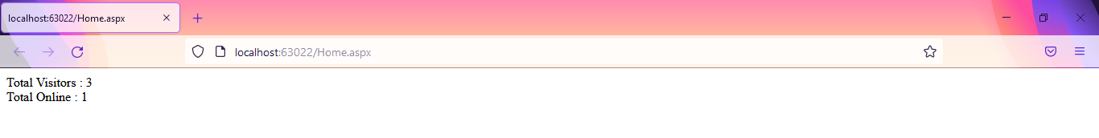

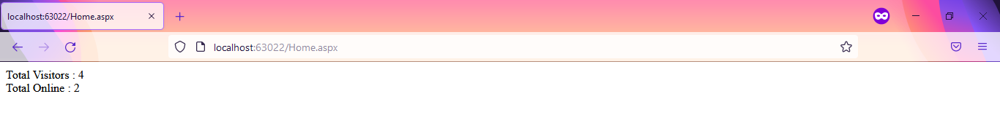

|  |  |  |  |
| --- | --- | --- | --- |
| Start Date | End/sign Date | Faculty Sign | Remarks/Grade |
|  |  |  |  |

Practical : 15

## Aim: Use various tags in Web.config file for ASP.NET configuration.

Home.aspx

<%@ Page Language="vb" AutoEventWireup="false" CodeBehind="Home.aspx.vb" Inherits="Practical_15.Home" %>

<!DOCTYPE html PUBLIC "-//W3C//DTD XHTML 1.0 Transitional//EN" "http://www.w3.org/TR/xhtml1/DTD/xhtml1-transitional.dtd">

<html xmlns="http://www.w3.org/1999/xhtml">

<head runat="server">

<title></title>

</head>

<body>

<form id="form1" runat="server">

<div>

<asp:TextBox ID="TextBox1" runat="server"></asp:TextBox>

</div>

</form>

</body>

</html>

Home.aspx.vb

Public Class Home

Inherits System.Web.UI.Page

Protected Sub Page_Load(ByVal sender As Object, ByVal e As System.EventArgs) Handles Me.Load

Response.Write(ConfigurationManager.AppSettings("Title"))

Response.Write("</br>Website Version : " & ConfigurationManager.AppSettings("Version"))

End Sub

End Class

Web.config

<?xml version="1.0"?>

<configuration>

<system.web>

<pages theme="Green" />

<compilation debug="true" strict="false" explicit="true" targetFramework="4.0" />

</system.web>

<appSettings>

<add key="Version" value="3.2.0"/>

<add key="Title" value="My Name is Ishan"/>

</appSettings>

</configuration>

Green.skin

<asp:TextBox runat="server" BackColor="Green" ForeColor="White" />

Output :

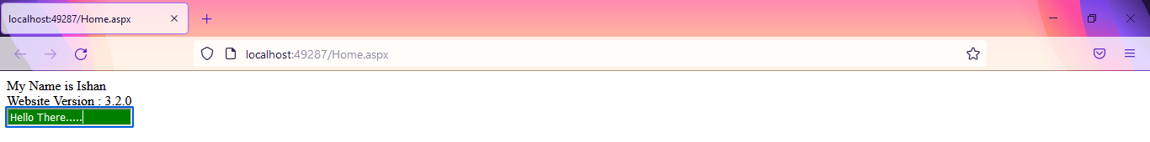

|  |  |  |  |
| --- | --- | --- | --- |
| Start Date | End/Sign Date | Faculty Sign | Remarks/Grade |
|  |  |  |  |