BRANDEIS UNIVERSITY

WALTHAM, MA. 02254-9110

DEPARTMENT OF COMPUTER SCIENCE PHONE: 781-736-2709
TJX/Feldberg Chair in Computer Science FAX: 781-736-2741
jamesp@cs.brandeis.edu

July 31, 2017

To: The KVPY Office

Re: Ishan Agarwal as Visiting Researcher

To Whom It May Concern:
This letter is to confirm that Ishan Agarwal, a student at IISc UG Programme, worked as a Summer Intern with my group in the Computer Science Department, at Brandeis University, Waltham, for June and July 2017. By way of background, I currently hold the TJX Feldberg Chair in Computer Science at Brandeis University, where I am Chair of the Program in Linguistics, Director of the MA Program in Computational Linguistics, and also direct the Laboratory for Linguistics and Computation. My areas of research include computational semantics, temporal reasoning, lexical semantics, spatial reasoning, and linguistic annotation for machine learning.

Mr. Agarwal worked on a particularly difficult problem in computational linguistics involving the automatic extraction of lexical knowledge from large language resources. The acquisition of semantic knowledge associated with words is an incredibly important but difficult task: natural language processing applications require significant knowledge of words to adequately process and effectively carry out their stated goal program. Mr. Agarwal has been working specifically to extract Qualia Structure for words from a lexical resource known as WordNet. His work has involved meeting with me weekly over the summer, to familiarize himself with the formal and theoretical model he has been using, as well as meeting regularly with my senior Research Scientist, Dr. Marc Verhagen, who has supervised Mr. Agarwal’s programming progress. The results of his work are extremely interesting and encouraging for further exploration in this area. He focused on identifying one particular semantic qualia relation, known as the Telic Role, by using some fairly direct and even naïve methods over the hierarchical strtucture of WordNet, as well as parsing the glosses of WordNet entries. The results were a 77% F-measure on the algorithm, which is extremely good. Mr. Agarwal has also made some suggestions for how to improve this score, which are both intriguing and tractable.

In sum, I have been very pleased with Mr. Agarwal’s contribution to the lab and his research over the summer.

Sincerely,
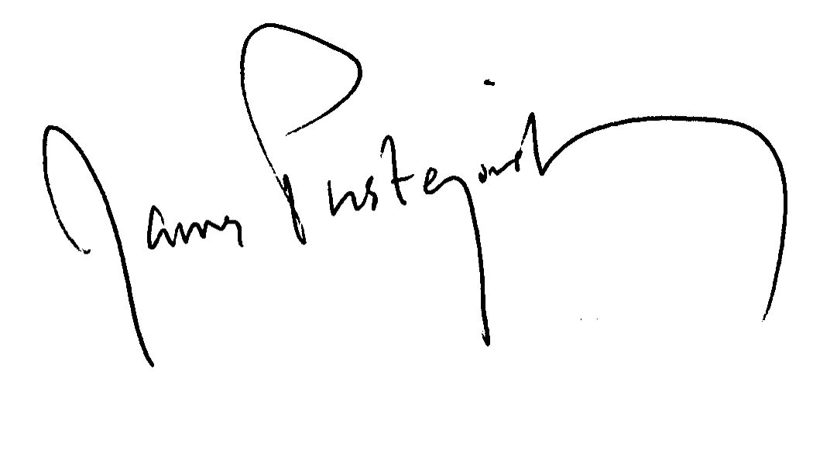
Professor James Pustejovsky
TJX Feldberg Chair in Computer Science
Department of Computer Science
Chair, Language and Linguistics Program
Chair, Computational Linguistics MA Program

