**Project Overview**

1. **“Vision”**

**General Vision**

The general vision of the system key features is to allow the manager keep track of the warehouse stock in detail. Keeping track allows the manager to plan in advance and optimise the processes for major decision-making as the system can output a summary of how the warehouse is operating.

**Core Project’s Requirements**

* Record incoming and outgoing stock
* Categorize the stock in relation to their type
* Search and display available stock
* Search and display stock in accordance to price range and quantity
* Summary Report of incoming and outgoing stock
* Data stored encryption
* Login authentication encryption/decryption
* Unsuccessful login – system locked
* Provide stock item alerts for below threshold limit

**Main Constraints**

* System to be implemented in C++ and to run on Linux OS
* Simple textual “menu-select” style of user interface

**Business Case**

**What is this system that you are to build?**

The system which we are creating is a Warehouse Management tool which will enhance efficiency of work operations and at the same time keeping track of stock inventory details.

**Who will it serve?**

The system will serve the operators in the warehouse incorporating several daily routine processes into “main” processes, thus further aiding the long-term plans of the company to create a streamlined process for the management of their warehouse.

**What will it do for them?**

It will speed up many warehouse operations. Operators will be able to keep track of incoming and outgoing stocks, search for stock by prices/categories and quantity in ascending or descending order. It will also be able to display a summary of stocks according to day, week or month at one glance. The system will have a tight security feature to safeguard the company details by using 2FA login process and verification. Also, the system can send out alerts when the stocks fall below a certain threshold set by the company.

1. **Initial Use-Case Model**
2. **Project Plan**

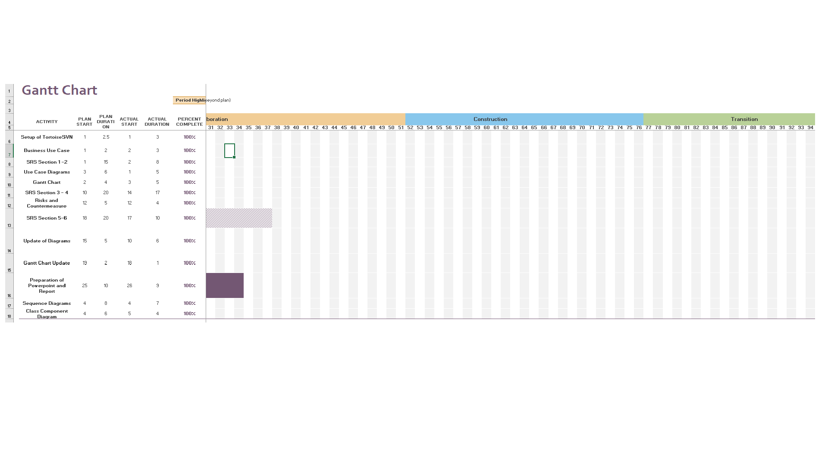

**Roles and Responsibilities**

|  |  |  |  |
| --- | --- | --- | --- |
| Team Number: <A4> | | | |
|  | **Student Name** | **Role** | **Artefacts** |
| 1 | Ishan Ali | Manager | SRS Report |
| 2 | Deddy | Designer / Tester | Use Cases, Domain Model |
| 3 | Jun Kiat | Lead Programmer | SRS Report |
| 4 | V Prathyaksha | Integration / Programmer | SRS Report |
| 5 | Ken | Designer / Tester | Use Cases, Domain Model |
| 6 | Reynard Tan | Intergration / Documenter | Business Case Process |

**Risk Analysis and Counter Measures**

|  |  |  |  |  |  |
| --- | --- | --- | --- | --- | --- |
|  | **Impact Type** | **Risk Seriousness (%)** | **Likelihood of Occurrence (%)** | **WBS**  **(affected work / task)** | **Risk Description** |
| 1 | Budget | 80% | 5% | 1.3, 2.2 | Employees demand a higher salary |
| 2 | Project Progression | 85% | 40% | All | A member of the project group gets into an accident affecting the completion deadline. |
| 3 | Successful task completion | 70% | 20% | All | Project requirements are not defined properly due to insufficient planning. |
| 4 | Project workflow | 60% | 40% | All | Project is unable to advance successfully due to data being lost |
| 5 | Project duration | 50% | 30% | 2, 3 | Effort and time needed for extra features of product is greater than expected |
| 6 | Deadline | 50% | 10% | 4.5, 2.1 | Product prototype is rejected by test users and may require rework. |
| 7 | Product Testing | 40% | 70% | 3 | Bad estimation of workflow may cause delays and troubles, and may lead to significant re-planning |

(Possible) Reduction in Risk Seriousness (%)

|  |  |  |  |
| --- | --- | --- | --- |
|  | **Risk Description** | **Proposed Mgmt Plan** | **(Possible) Reduction in Risk Seriousness (%)** |
| 1 | Group member left the group | Plan 1 : Distribute the workload of that particular member across the team | -50% |
| Plan 2 : Reduce requirements | -40% |
| 2 | A member of the project group gets into an accident affecting the completion deadline. | Hold frequent group meetings so that the group members are aware of all the tasks and is able to take over the role. | -50% |
| 3 | Project requirements are not defined properly due to insufficient planning. | Define functional requirements in detail and review them thoroughly | -70% |
| 4 | Teammate’s computer crashed and his work is not versioned | Backup work frequently on two different sites and use versioning tool. | -90% |
| 5 | Effort and time needed for extra features of product is greater than expected | Workflow should be planned for completing required and critical features, and do the extra features if there is time remaining | -40% |
| 6 | Product prototype is rejected by test users and may require rework. | Organize frequent user testing to test the product prototype, and use input to improve on the product | -50% |
| 7 | Bad estimation of workflow may cause delays and troubles, and may lead to significant re-planning | Establish the time needed for each task with entire team and apply some leeway in case the task takes longer than anticipated. Also, receive updates from team about their individual work progress to adjust appropriately | -40% |

**Design Artefacts – Use Cases (Iteration 1)**

**General**

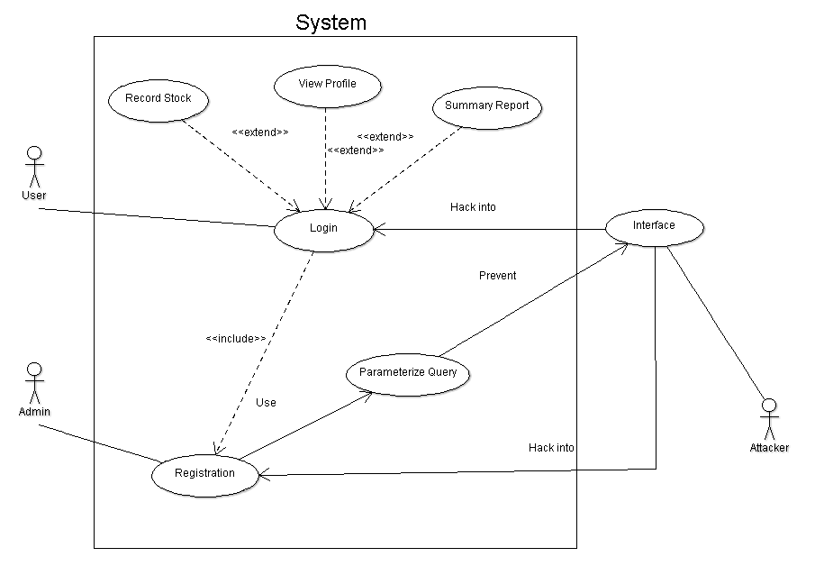

**Design Artefacts – Use Cases (Iteration 1)**

**Login**

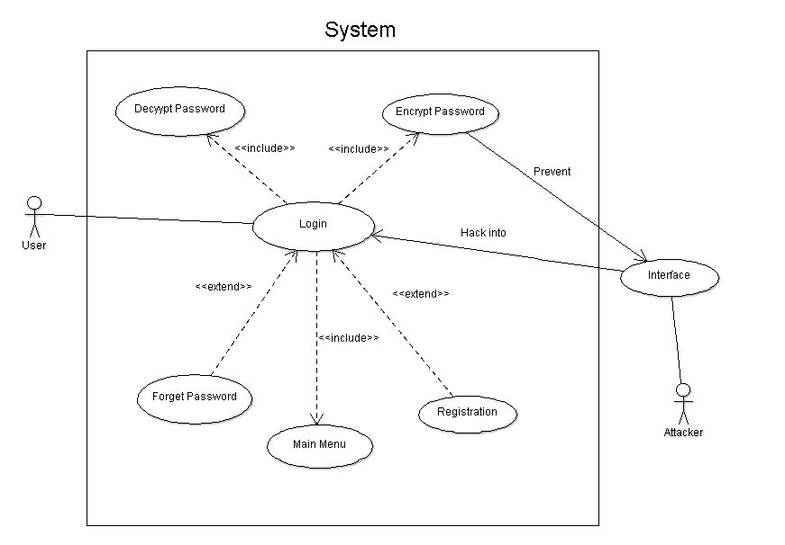

**Design Artefacts – Use Cases (Iteration 1)**

**Stock**

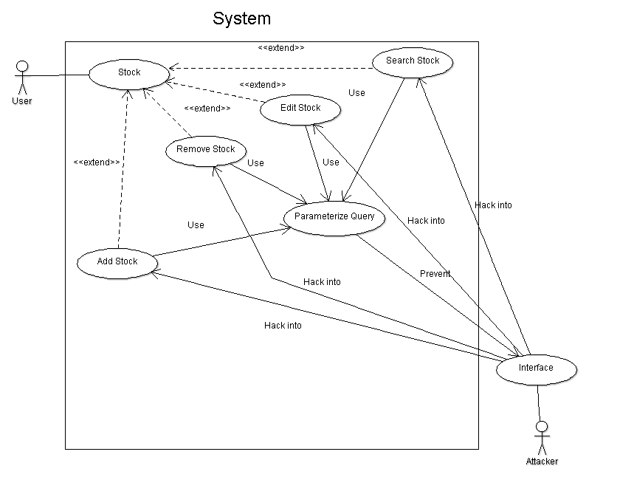

**Design Artefacts – Use Cases (Iteration 1)**

**Summary**

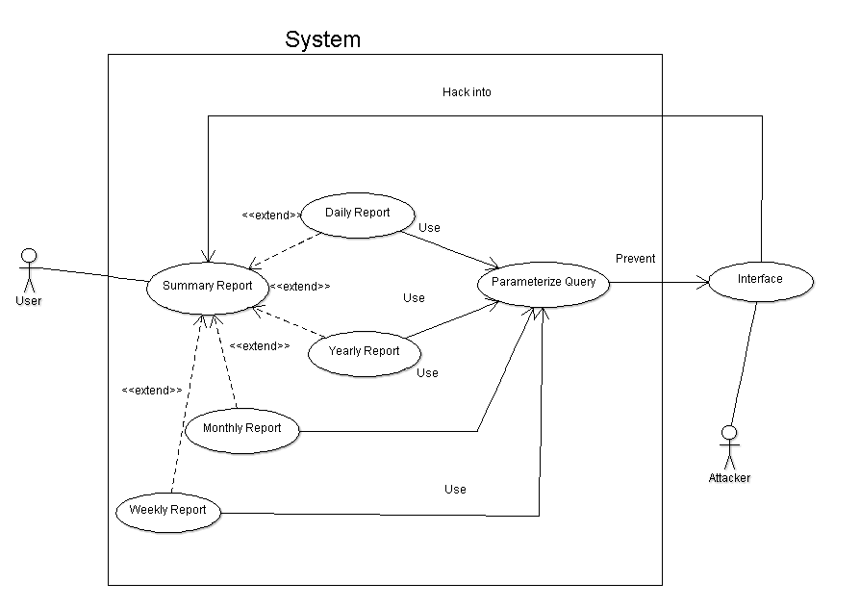

**Design Artefacts – Use Cases (Iteration 2)**

**Summary**

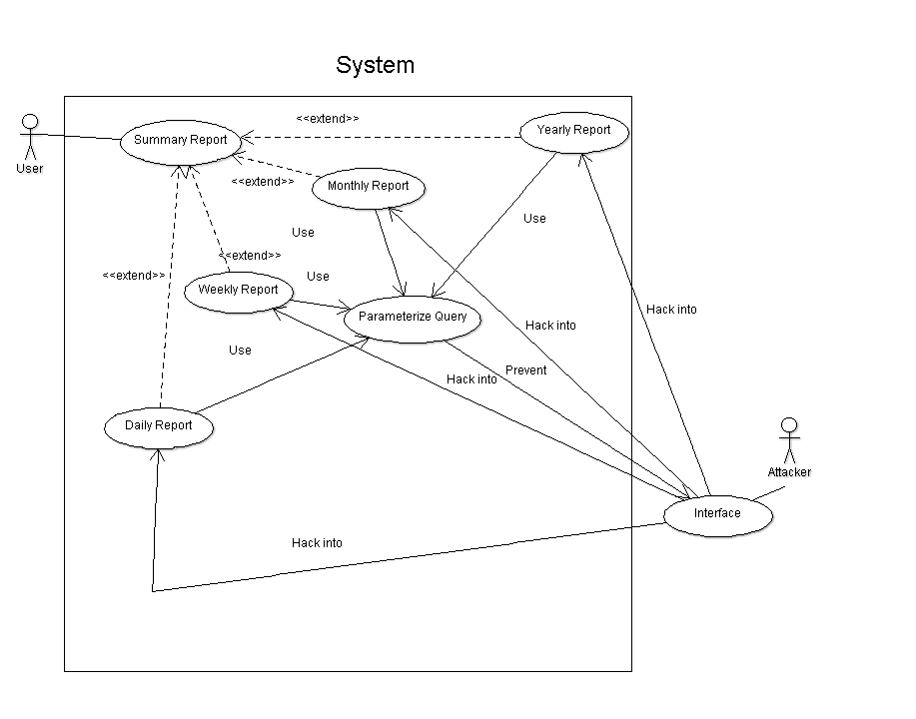

**Design Artefacts – Activity Workflows (Iteration 1)**

**Login**

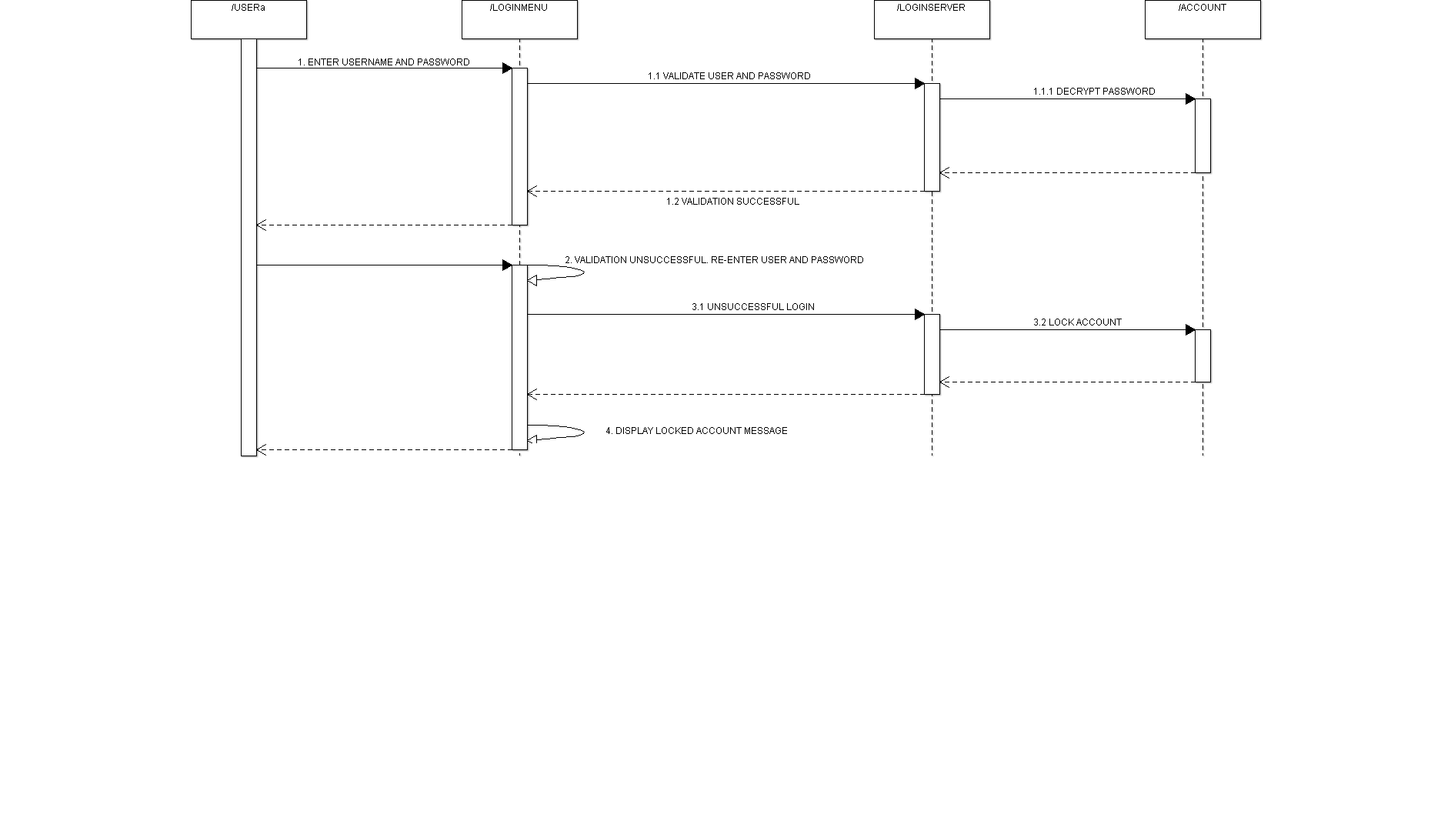

**Design Artefacts – Activity Workflows (Iteration 1)**

**Stock**

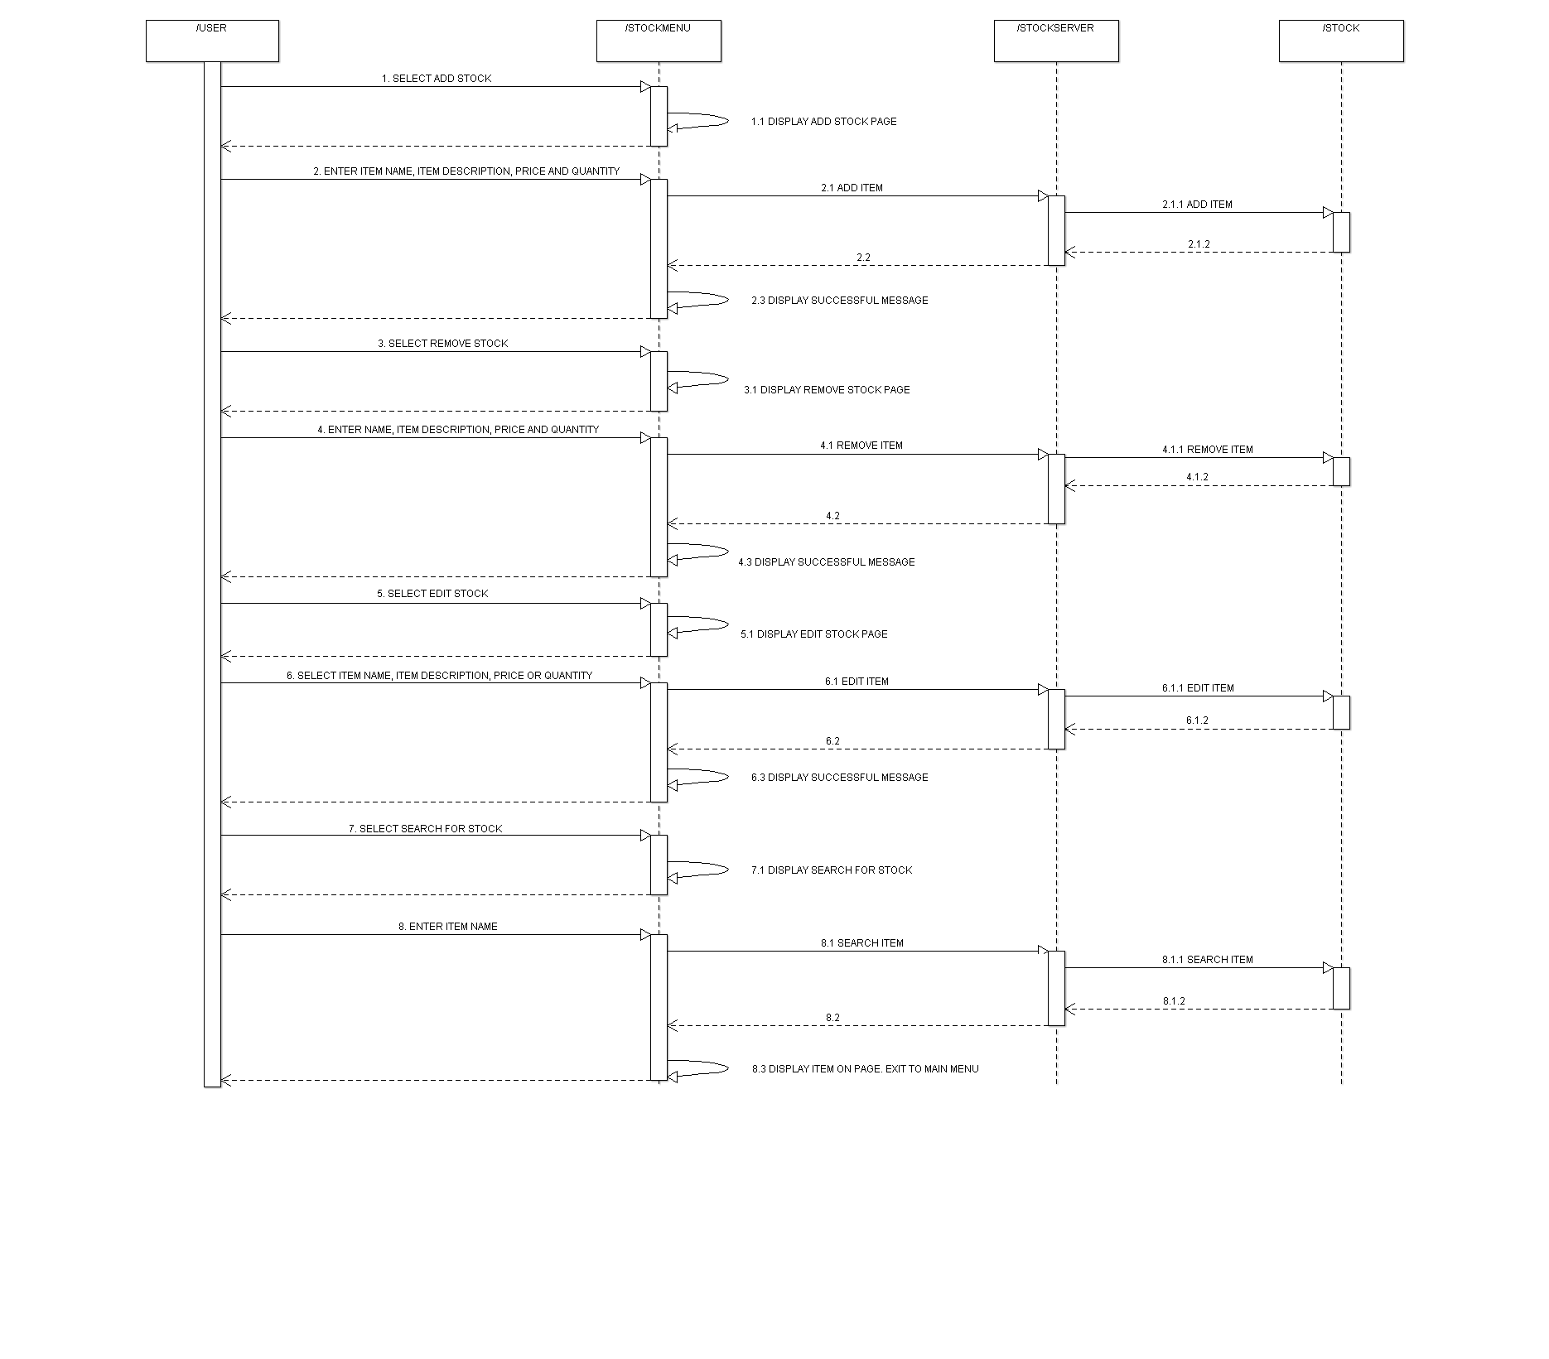

**Design Artefacts – Activity Workflows (Iteration 1)**

**Summary Report**

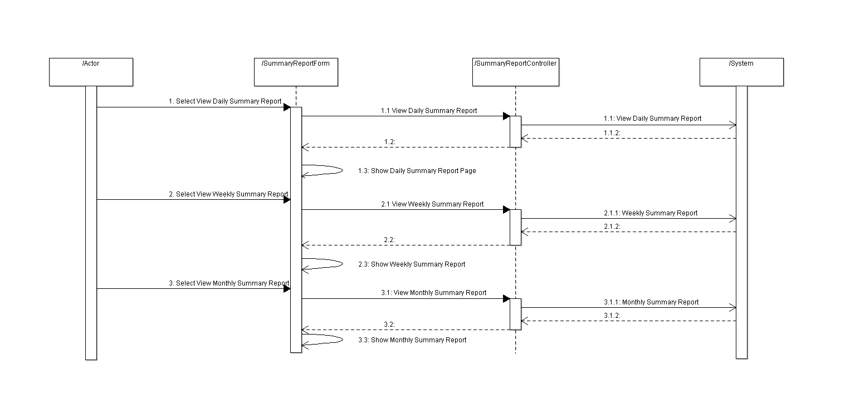

**Design Artefacts – Component Diagrams (Iteration 1)**

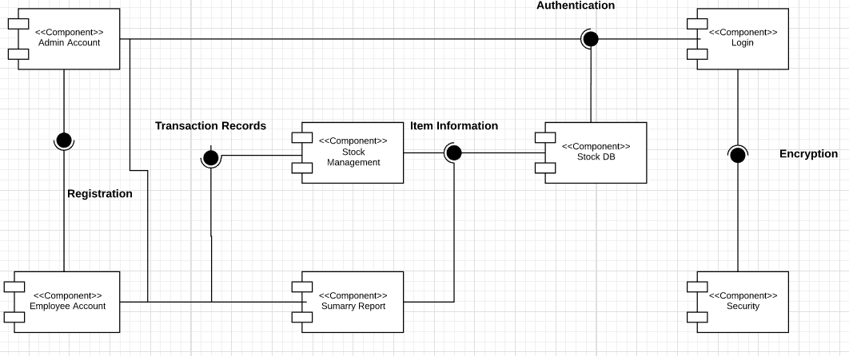

**Design Artefacts – Class Diagrams (Iteration 1)**

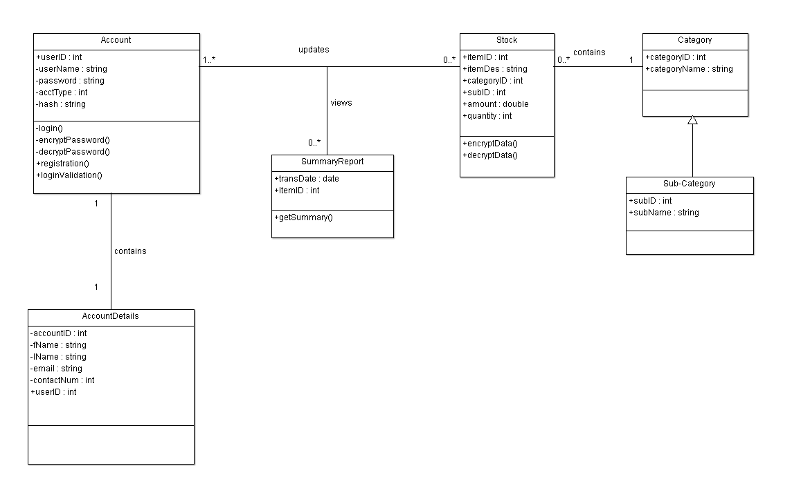

**Design Artefacts – Class Diagrams (Iteration 2)**

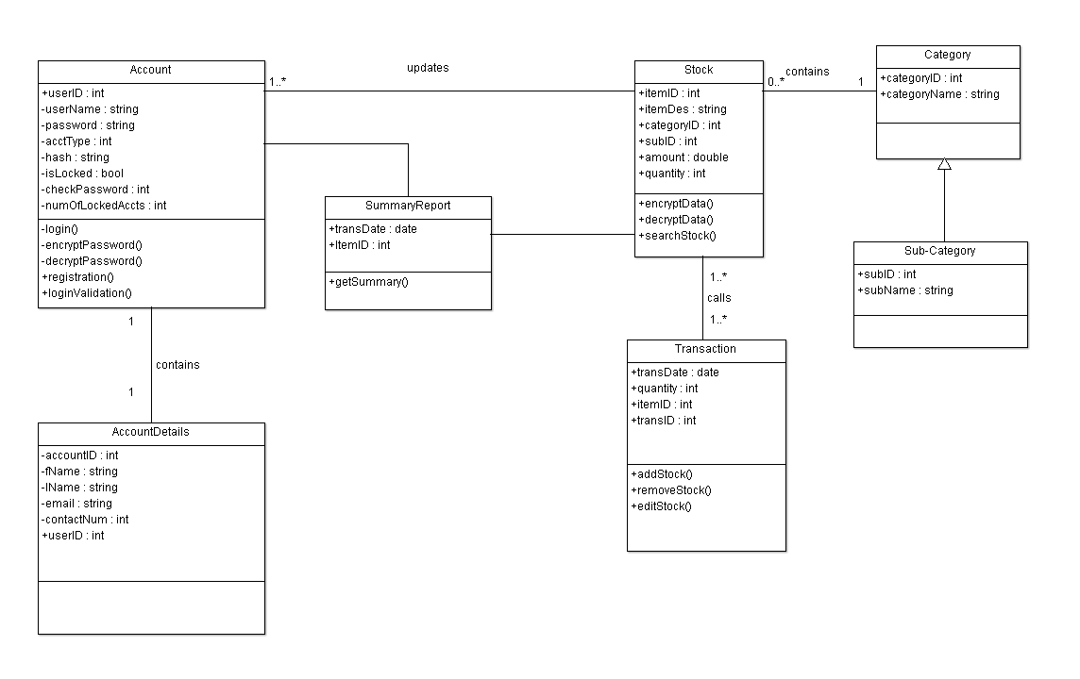

**Appendix A – Formal Meeting Records**

Inception Phase – Iteration 1

MEETING MINUTES

System Development Team A-4

??, ?? February 2018

12:00pm

SIM Block B, Level 3

**PRESENT:** Ishan Ali, Deddy Zul, Reynard Tan, Pipi, Kent Wong

ABSENT: NIL

1. CALL TO ORDER/OPENING REMARKS

Meeting called to order at 12:00pm by Team Leader Ishan Ali.

First meet up for the team.

2. APPROVAL OF THE MINUTES FROM ??

Inaugural meeting.

3. Roles assignment to members by Team Leader, Ishan Ali

Ishan gave a warm welcome to the team members and asked members to state their strengths and weaknesses. This was to ensure that the components of the projects could be distributed fairly and equally. The team members then voiced out their strength and weaknesses. The roles were decided as below.

Team member Ji Kiat stated that he will be the Lead Programmer for this iteration. He said that he would be able to identify key components of the project and would try to solve them in the most efficient way possible. The group came to a consensus on his roles and responsibilities.

Team members Deddy and Kent pushed to take on the role of a Designer and Tester. They stated that they feel more confident in creating the diagrams and test cases as compared to programming. They asserted that they would try their best to identify the key features that would be needed to be designed and implemented. The group thus came to a consensus on their roles and responsibilities.

Team member Ishan said that he would take on the role of Project Manager. He was confident that he would be able to distribute the tasks and arrange meetings reasonably. He would be the overseer of the progress regarding this system. Major decisions would also have to be discussed with and decided by him. The team approved of this delegation.

Team member V Prathyaksha stated that she would work together with team member Reynard to take on the role of a Systems Integrator. She would also take on an additional role of being a Programmer. She asserted that she would e able to provide assistance to team member Ji Kiat to identify the risks and deploy corrective action if and when they happen. The team approved of this role delegation.

Team member Reynard will take on the dual-role of a Systems Integrator and a Documenter. He would assist Team member V Prathyaksha in Systems Integration and noting down any documentation related components of this program. The group came to a consensus on his roles and responsibilities.

**Task:** N/A

4. Key Milestones/Tasks by Team Leader, Ishan Ali

Team leader Ishan outlined the key milestones that the group must meet within the stipulated timeline. He stressed of the need to adhere to deadlines and asserted the key dates that the team should take note. He also outlined key tasks that each team member in their roles should work on and the deadlines for them. He tasked himself to create a Gantt chart documenting the predicted duration and actual duration needed for the tasks of each team member. An update on the progress made is to be presented the to team members during the next meeting. Ishan accepted this action and will present the chart during the next meeting.

Team members Deddy and Kent proposed that each of the members draft an rough guide of their tasks and show it to the project manager at the next meeting. V Prathyaksha and Reynard concurred to produce a first draft of the business use case and Software Requirements Specification by the next meeting. Ji Kiat discussed details regarding the drafting of the UML diagrams.

**MOTION** to accept proposal for first drafts of member’s tasks, seconded and passed.

**Task:** Gantt Chart to be done by Ishan by ?? February 2018

5. Allocation of time needed for each task by Project Manager, Ishan Ali

Ishan briefly went through with the members of the team on the amount of time they needed to complete their tasks:

Diagrams by Designer/Tester (Deddy and Kent) - ?? man hours

SRS/Business Use Case/ Gantt Charts (Ishan, Reynard, Ji Kiat, V Prathyaksha) - ?? man hours

6. Outline of tasks to be done by individual members by Team Leader, Ishan Ali

a. Avenue of communications by Team Member, Kent

Ji Kiat noted that we would be doing most of our tasks individually majority of the time. The team members should be able to communicate with each other effectively. Ji Kiat suggested that we could use video conferencing programs such as Skype to aid us in communicating efficiently during the team’s individual work phases.

**MOTION** to use Skype as primary means of online communication between members; seconded and passed.

Ishan stated that we would be using a software versioning program for our work. A consensus should then be reached to use the same program within the team to ensure consistency and render assistance should problems arise. He suggested that all members use TortoiseSVN for this reason. He stated that he will setup a repository for use by all members by the next meeting.

**MOTION** to accept TortoiseSVN as our main version control system; seconded and passed.

|  |  |  |  |  |  |
| --- | --- | --- | --- | --- | --- |
| **S/N** | **Action Items** | **Urgency**  **(Low/Normal/Urgent)** | **Status** | **Who** | **Due By** |
| 1 | Gantt  Chart for Project | Normal |  | Ishan, Kent | Next meeting  ?? Feb 2018 |
| 2 | Business Use Case | Urgent |  | Reynard | Next meeting  ?? Feb 2018 |
| 3 | Software Requirements Specification – Section 1.1 – 2.0 | Urgent |  | Ji Kiat, Deddy | Next meeting  ?? Feb 2018 |
| 4 | Class Diagram | Urgent |  | Deddy, Kent | Next meeting  ?? Feb 2018 |
| 5 | Use Case Diagram | Urgent |  | Deddy, Kent | Next meeting  ?? Feb 2018 |
| 6 | Setup of SVN for team | Urgent |  | Ishan | Next meeting  ?? Feb 2018 |

7. New Actions

8. AGENDA FOR NEXT MEETING

Ishan proposed that all members of the team present the following in the next meeting, seconded by V Prathyaksha:

* Progress of action items from previous meeting
* Difficulties faced
* Additional requirements needed
* Delays if any
* Additional work done if any

All members agreed on the above items for presentation next meeting.

9. ADJOURNMENT

Meeting was adjournment at ??:?? p.m.

10. NEXT MEETING

Next meeting will be at ??:?? p.m. , ??, ?? February 2018.

# Appendix B - Individual Work Diaries

Team Member 1: Ishan Ali

Inception Phase - Iteration 1

**Create Software Requirements Specifications 2.1-2.7**

**Time Required:(4.5 hours)**

**Date:??**

**Difficulties faced:** Understanding certain concepts mentioned in SRS and to clarify the doubts.

* Identify Purpose of Warehouse System (30 mins)
* Define the vision/scope of the system (1hr)
* Create Business case (30 mins)
* Identify features of the product (1hr)
* Identify risks and counter measures (2.5hrs)

Elaboration Phase - Iteration 1

**Create Software Requirements Specifications 2.1-3**

**Time Required: (7 hours)**

**Date: ??**

**Difficulties faced: Nil**

**Sub-tasks:**

* Identify design and implementation constraints(1hr)
* Ensure that system vision/scope is complete. (1hr)
* Create critical high level requirements(1hr)
* Define constraints (1hr)
* Define basic system objectives(2hr)
* Identify user classes and characteristics(2hr)

Elaboration Phase - Iteration 2

**Create Software Requirements Specification – Section 5.0 – 6.0()**

**Time Required:(4 hours)**

**Date: ??**

**Difficulties faced: Nil**

**Sub-tasks:**

* Add non-functional requirements such as performance, security and software quality attributes. (1hr)
* Identify more relevant risks and countermeasures(1hr)
* Create PowerPoint for presentation(2hr)

Team Member 2 : Goh Ji Kiat

Inception Phase - Iteration

**Task: Create SRS 1.1 – 1.**

**Date: 7 – 8 Feb**

**Time Spent: 2.5 hours**

**Difficulties faced: NIL**

**Sub-tasks:**

* Identify the purpose of the system (15 mins)
* Define the scope of the system (30 mins)
* Create product perspective (15 mins)
* Identify the features of the product (1h)
* Discuss with teammates (30 mins)

Elaboration Phase - Iteration 1

**Task:** Create SRS 5.0 – 5.4

**Date:** 7 – 9 Feb

**Time Spent:** 3 hours

**Difficulties:** NIL

**Sub-tasks:**

* Identify non-functional requirements (performance, safety, security and software) (1h)
* Assist teammate in other parts of SRS (2h)

Elaboration Phase - Iteration 2

**Task: Create Use Case and Component Diagrams**

**Date: 5 – 9 Feb**

**Time Spent: 7 hours**

**Difficulties: Not familiar with Component Diagram, spent some time to research and consult**

**Sub-tasks:**

* Create each Use Case according to the requirements (2h)
* Amending the Use Case diagrams with teammates (1h)
* Create Component diagram according to other diagrams (3h)
* Amending Component diagram with teammates (1h)

# Appendix C - Evidence of using VCS (Version Control Software)

Version Control Software used: TortoiseSVN

Screenshot #1 - Contents in the VCS's **Root Folder** containing all **Repository Project Files**

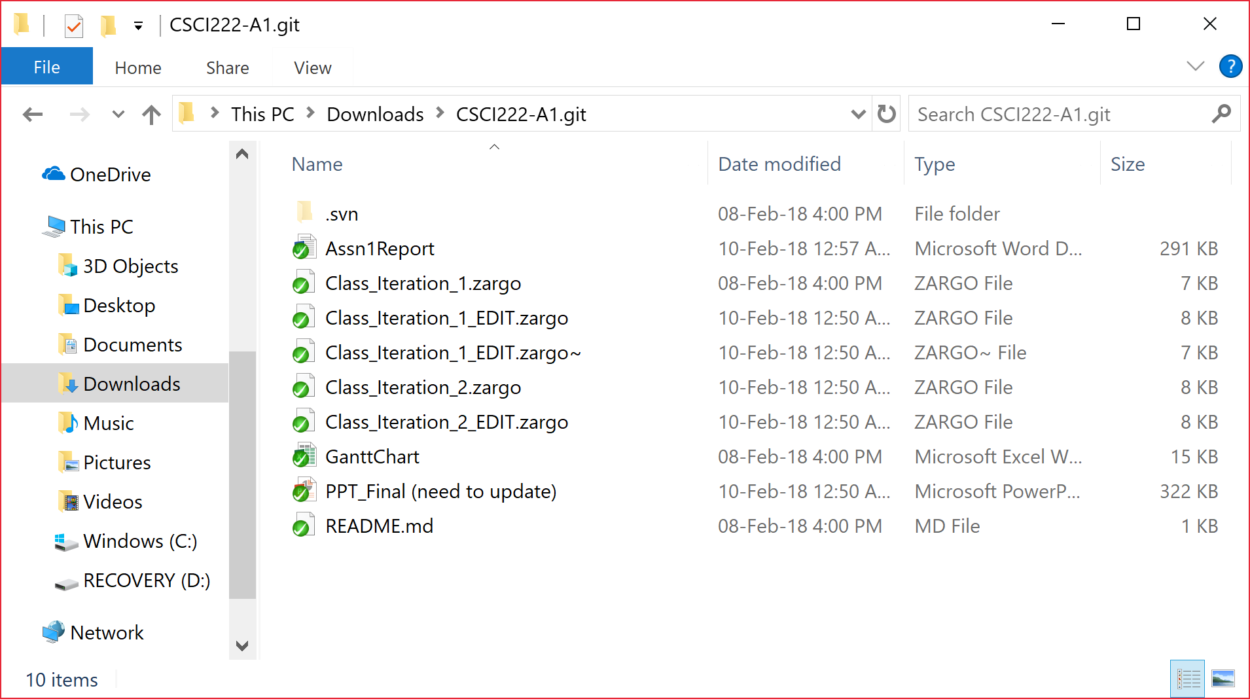

Screenshot #2 - VCS's listing of all the **latest source files currently being managed**

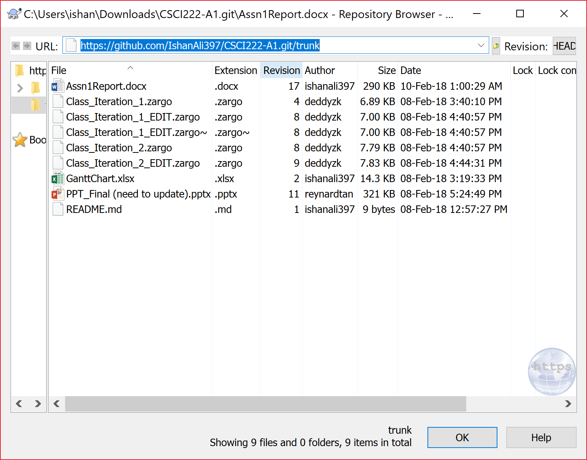

Team Member 3: Reynard Tan

Inception Phase: Iteration 1

**Task: Write Up a Business Use Case**

**Date:**

**Time Spent: 3 hours**

**Difficulties Faced: Nil**

**Sub-Tasks:**

* Understanding the purpose of the system that the client wishes for
* Identifying what the client wants
* Determining any additional requirements
* Defining the key points
* Elaboration of the key points

Elaboration Phase: Iteration 1

**Task: Complete the Risks and Counter Measures**

**Date:**

**Time Spent: 4 hours**

**Difficulties faced: Identifying risk and determining if risk proposed were realistic and relevant to the project**

**Remedial Actions Taken: Consulting with teammates to remove risks that were unrealistic or irrelevant to the project**

**Sub-tasks:**

* Identifying any potential risks
* Classifying how serious the risk is
* Classify how likely the risk is to occur
* Classify which workflow will likely be affected
* Elaborating on the risk itself
* Outline counter measures to minimize risk
* Identifying the reduction of the risk seriousness
* Verifying if the risk identified and the counter measures implemented is realistic and relevant to the project