CSCI222 Assignment 1 Report
Team Number: <A4>

 | Student Number | Name | Email Address
1 | 5562351 | Ishan Ali | Tel : 93212348  Email : ishan397@hotmail.com
2 | 5921776 | Goh Ji Kiat | jkpingster@gmail.com
3 | 5283048 | V Prathyaksha | prathyakshavenkatachari@gmail.com
4 | 5655651 | Deddy | deddyzk@gmail.com
5 | 5562971 | Reynard Tan | reynardtanjiewei@gmail.com
6 | 5656539 | Kent Wong | wyh.kent@yahoo.com

TABLE OF CONTENTS

Project Overview
Initial Use-Case Model
Project Plan
Roles & Responsibilities
Risk analysis and counter measures
(Possible) Countermeasures

Design Artefacts

Appendix A – Formal Meeting Minutes

Appendix B – Individual Work Diary

Appendix C- Evidence of using VCS (Version Control Software)

Project Overview

- “Vision”

System’s key features

The system allows the manager to keep track of the stock level in the warehouse in detail. When this is achieved, it will allow the manager to optimise processes, minimising bottlenecking, and plan for future projects with all the formation available now at his fingertips.

Core Project’s Requirements

- Record incoming and outgoing stock
- Categorize the stock in relation to their type
- Search and display available stock
- Search and display stock in accordance to price range and quantity
- Summary Report of incoming and outgoing stock
- Data stored encryption
- Login authentication encryption/decryption
- Unsuccessful login – system locked
- Provide stock item alerts for below threshold limit

Main Constraints
- System to be implemented in C++ and to run on Linux OS
- Simple textual “menu-select” style of user interface

Business Case

The system which we are creating is a Warehouse Management tool which will enhance the efficiency of most work operations and at the same time keep track of stock inventory details.

This system will help the operators in the warehouse incorporate several daily routine processes into “main” processes, thus further aiding the long-term plans of the company to create a streamlined process for the management of their warehouse.

It will also hasten many warehouse operations. Operators will now be able to keep track of incoming and outgoing stocks, search for stock by prices/categories and quantity in ascending or descending order. It will also be able to display a summary of stocks according to day, week or month at a glance. The system will have tight security features to safeguard the company details by using 2FA login process and verification. Also, the system can send out alerts when the stocks fall below a certain threshold set by the company.
- Initial Use-Case Model

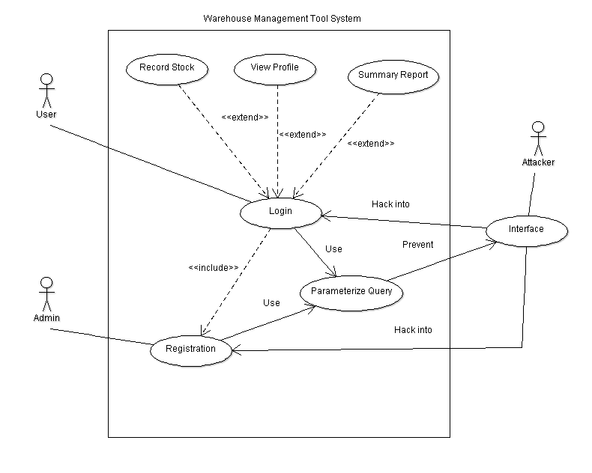
To access the Warehouse Management Tool, they have to login into the system first. The login function will then use a parameterized query to prevent unauthorized access or attacks. If an employee account is to be created, an admin will register that account. Once validating the employee’s credentials, the employee has the option to record any change in stock or view a summary report. The view profile function allows the employee to view his own credentials.

- Project Plan

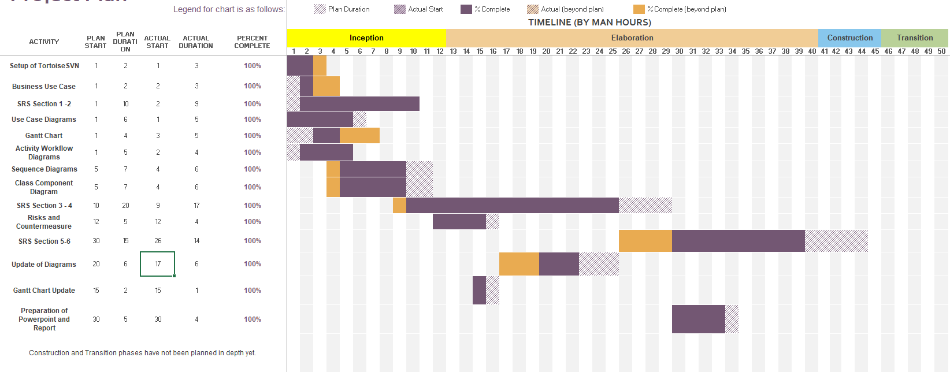

Roles and Responsibilities

Team Number: <A4>
 | Student Name | Role | Artefacts
1 | Ishan Ali | Manager | SRS Report, Business Case Process
2 | Deddy | Designer / Tester | Use Cases, Domain Model
3 | Jun Kiat | Lead Programmer | SRS Report
4 | V Prathyaksha | Integration / Programmer | SRS Report
5 | Kent Wong | Designer / Tester | Use Cases
6 | Reynard Tan | Intergration / Documenter | Business Case Process

Risk Analysis and Counter Measures
 | Impact Type | Risk Seriousness (%) | Likelihood of Occurrence (%) | WBS  (affected work / task) | Risk Description
1 | Budget | 80% | 5% | 1.3, 2.2 | Employees demand a higher salary
2 | Project Progression | 85% | 40% | All | A member of the project group gets into an accident affecting the completion deadline.
3 | Successful task completion | 70% | 20% | All | Project requirements are not defined properly due to insufficient planning.
4 | Project workflow | 60% | 40% | All | Project is unable to to the next stage due to data being lost
5 | Project duration | 50% | 30% | 2, 3 | Effort and time needed for additional features of product is greater than expected
6 | Deadline | 50% | 10% | 4.5, 2.1 | Product prototype is rejected by test users and may require rework.
7 | Product Testing | 40% | 70% | 3 | Bad estimation of workflow may cause delays and troubles, and may lead to significant re-planning

(Possible) Countermeasures

 | Risk Description | Proposed Mgmt Plan | (Possible) Reduction in Risk Seriousness (%)
1 | Group member left the group | Plan 1 : Distribute the workload of that particular member across the team | -50%
1 | Group member left the group | Plan 2 : Reduce requirements | -40%
2 | A member of the project group gets into an accident affecting the completion deadline. | Hold frequent group meetings so that the group members are aware of all the tasks and is able to take over the role. | -50%
3 | Project requirements are not defined properly due to insufficient planning. | Define functional requirements in detail and review them thoroughly | -70%
4 | Teammate’s computer crashed and his work is not versioned | Backup work frequently on two different sites and use versioning tool. | -90%
5 | Effort and time needed for extra features of product is greater than expected | Workflow should be planned for completing required and critical features, and do the extra features if there is time remaining | -40%
6 | Product prototype is rejected by test users and may require rework. | Organize frequent user testing to test the product prototype, and use input to improve on the product | -50%
7 | Bad estimation of workflow may cause delays and troubles, and may lead to significant re-planning | Establish the time needed for each task with entire team and apply some leeway in case the task takes longer than anticipated. Also, receive updates from team about their individual work progress to adjust appropriately | -40%

Design Artefacts – Use Cases (Iteration 1)
General
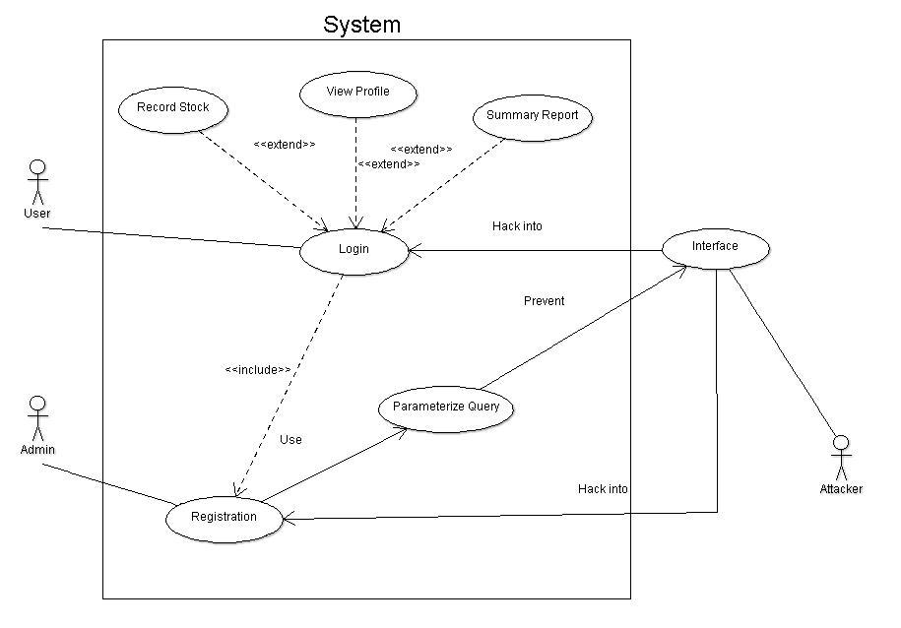
Design Artefacts – Use Cases (Iteration 1)
Login
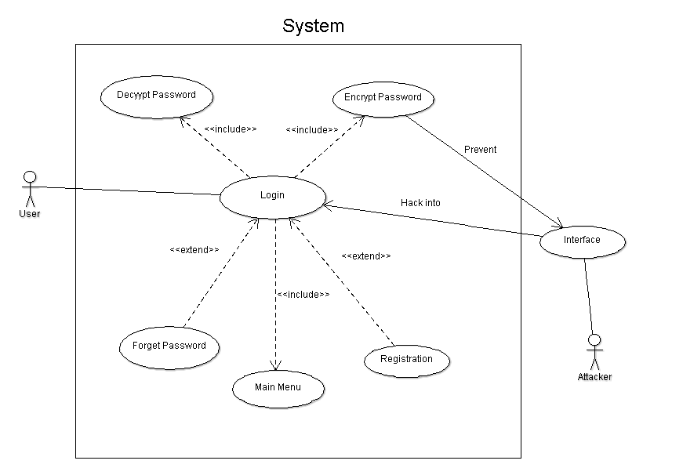

Design Artefacts – Use Cases (Iteration 1)
Stock
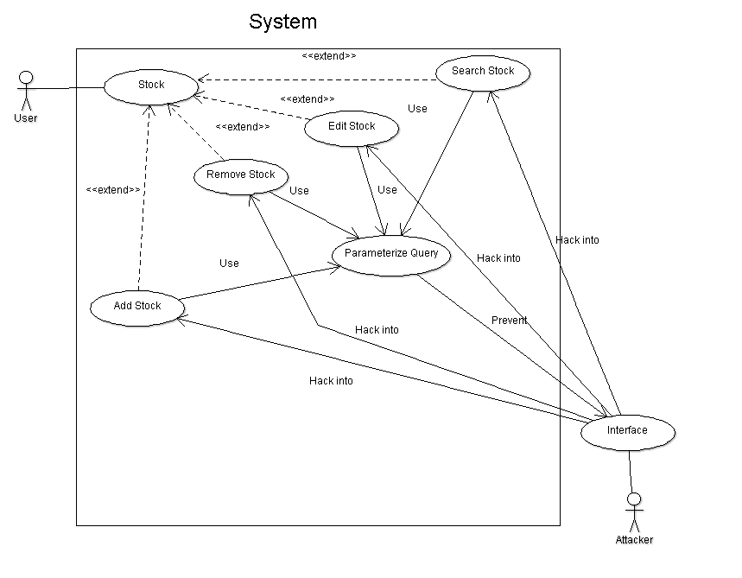
Design Artefacts – Use Cases (Iteration 1)
Summary
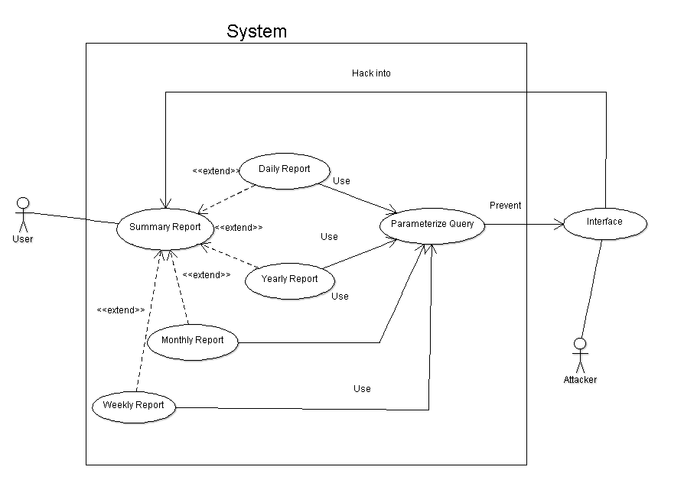

Design Artefacts – Use Cases (Iteration 2)
Summary
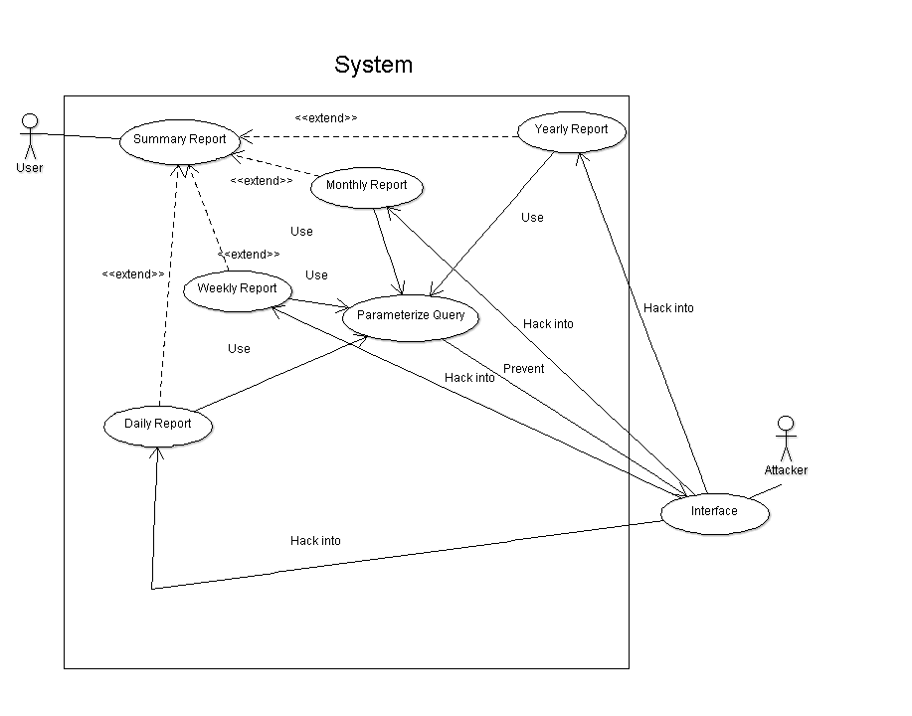
Design Artefacts – Activity Workflows (Iteration 1)
Login
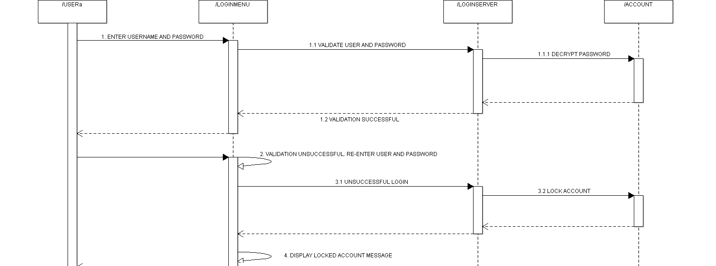

Design Artefacts – Activity Workflows (Iteration 1)
Stock
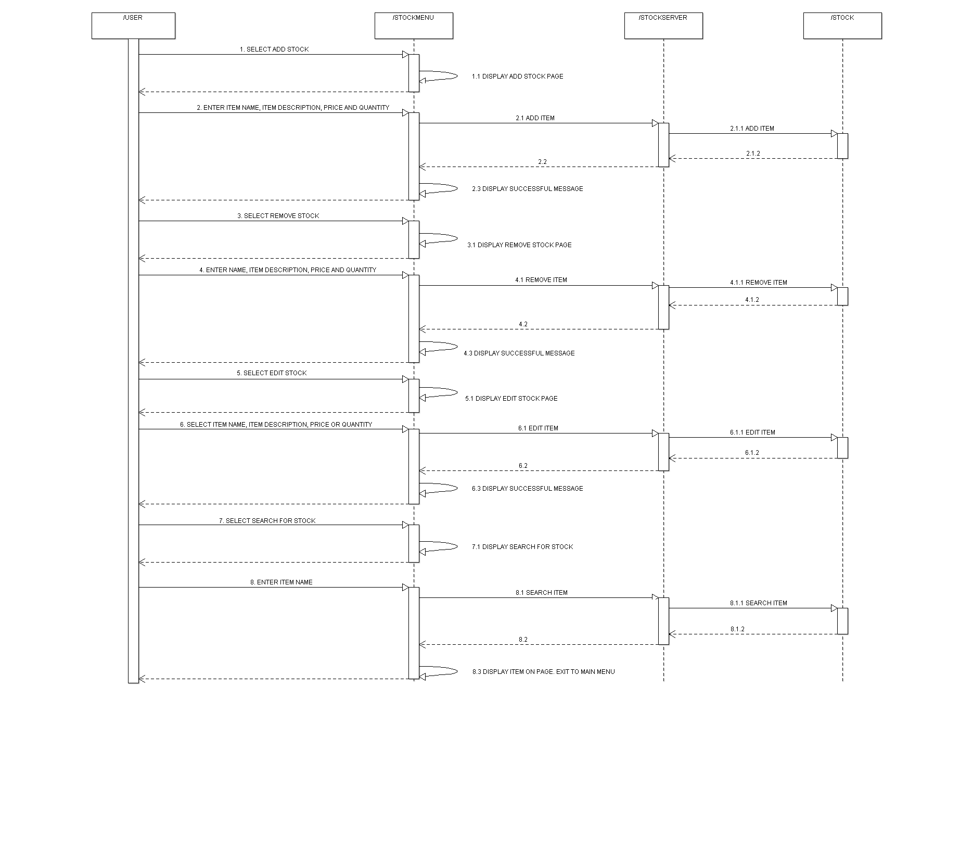

Design Artefacts – Activity Workflows (Iteration 1)
Summary Report
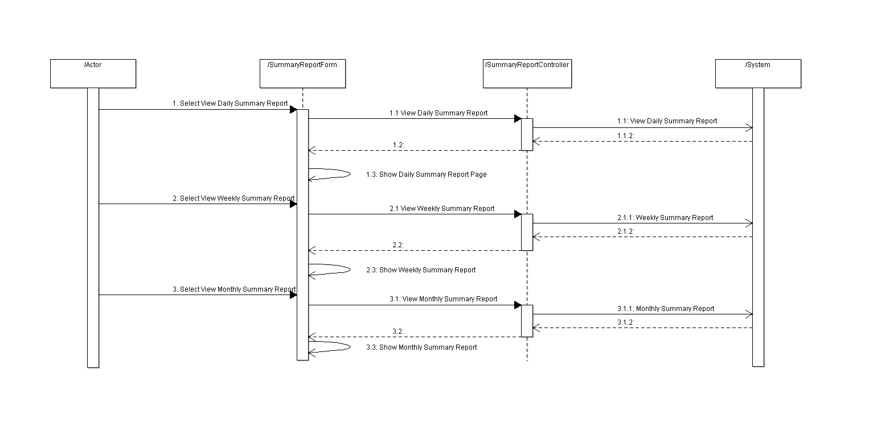

Design Artefacts – Component Diagrams (Iteration 1)
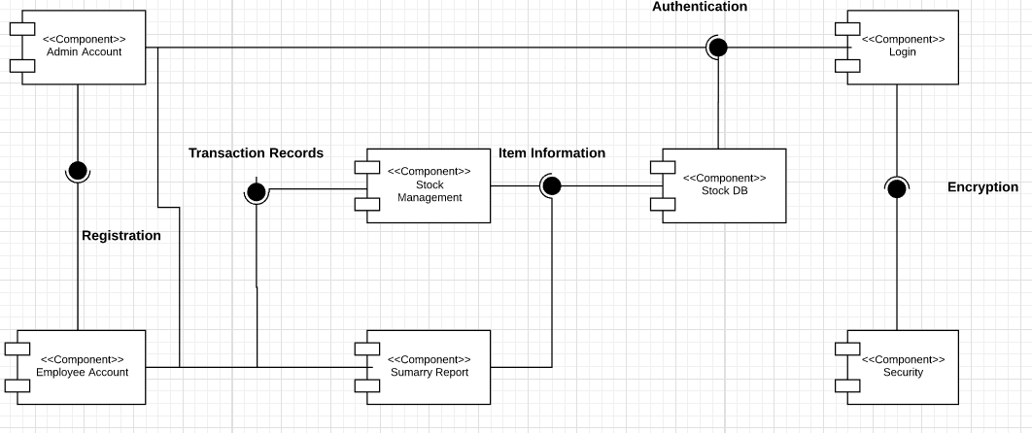

Design Artefacts – Class Diagrams (Iteration 1)

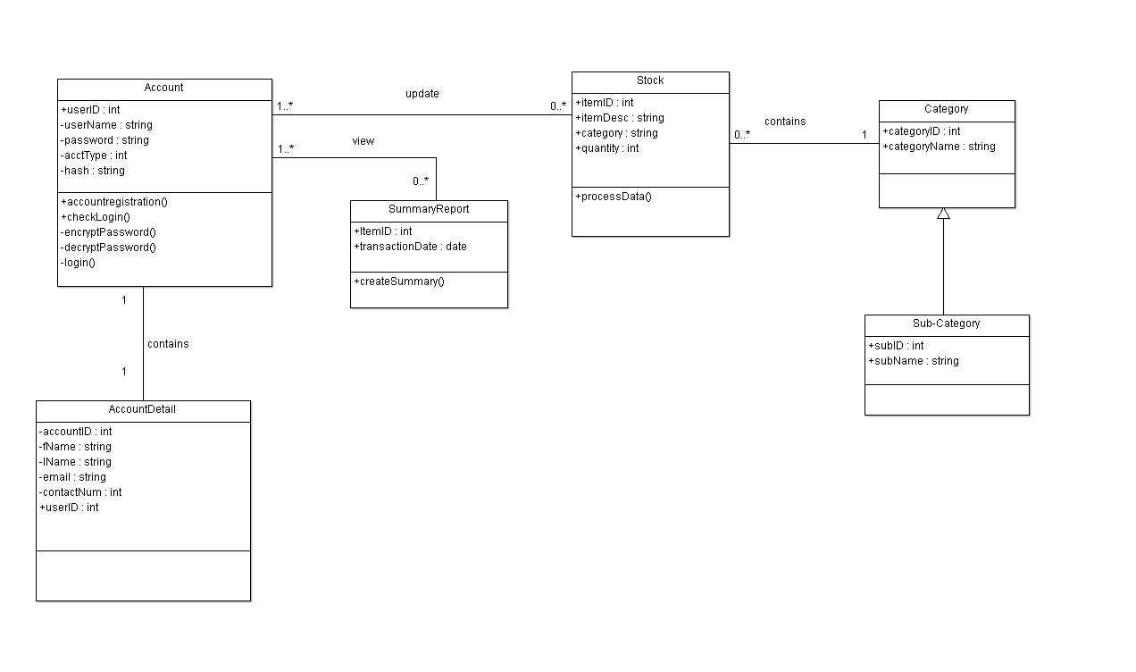

Design Artefacts – Class Diagrams (Iteration 2)
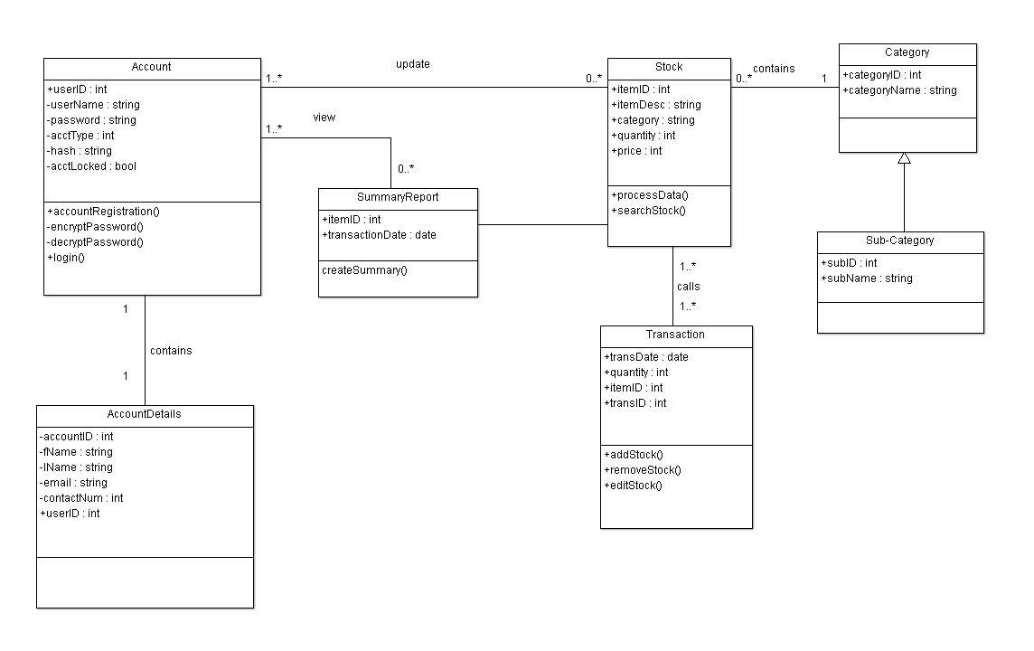

Appendix A – Formal Meeting Records

Inception Phase – Iteration 1

MEETING MINUTES
System Development Team A-4
1st February 2018
12:00pm
SIM Block B, Level 3
PRESENT: Ishan, Deddy, Reynard, Prathyaksha, Kent, Ji Kiat
ABSENT: NIL

1. CALL TO ORDER/OPENING REMARKS
Meeting called to order at 12:00pm by Team Leader Ishan Ali.
First meet up for the team.

2. APPROVAL OF THE MINUTES FROM N/A
No approval for inaugural meeting. (No prior meetings)

3. Roles assignment to members by Team Leader, Ishan Ali
Ishan gave a warm welcome to the team members and asked members to state their strengths and weaknesses. This was to ensure that the components of the projects could be distributed fairly and equally. The team members then voiced out their strength and weaknesses. The roles were decided as below.
Team member Ji Kiat stated that he will be the Lead Programmer for this iteration. He said that he would be able to identify key components of the project and would try to solve them in the most efficient way possible. The group came to a consensus on his roles and responsibilities.
Team members Deddy and Kent pushed to take on the role of a Designer and Tester. They stated that they feel more confident in creating the diagrams and test cases as compared to programming. They asserted that they would try their best to identify the key features that would be needed to be designed and implemented. The group thus came to a consensus on their roles and responsibilities.
Team member Ishan said that he would take on the role of Project Manager. He was confident that he would be able to distribute the tasks and arrange meetings reasonably. He would be the overseer of the progress regarding this system.
Major decisions would also have to be discussed with and decided by him. The team approved of this delegation.
Team member V Prathyaksha stated that she would work together with team member Reynard to take on the role of a Systems Integrator. She would also take on an additional role of being a Programmer. She asserted that she would e able to provide assistance to team member Ji Kiat to identify the risks and deploy corrective action if and when they happen. The team approved of this role delegation.
Team member Reynard will take on the dual-role of a Systems Integrator and a Documenter. He would assist team member V Prathyaksha in Systems Integration and noting down any documentation related components of this program. The group came to a consensus on his roles and responsibilities.
Task: N/A

4. Key Milestones/Tasks by Team Leader, Ishan Ali
Team leader Ishan outlined the key milestones that the group must meet within the stipulated timeline. He stressed of the need to adhere to deadlines and asserted the key dates that the team should take note. He also outlined key tasks that each team member in their roles should work on and the deadlines for them. He tasked himself to create a Gantt chart documenting the predicted duration and actual duration needed for the tasks of each team member. An update on the progress made is to be presented the to team members during the next meeting. Ishan accepted this action and will present the chart during the next meeting.
Team members Deddy and Kent proposed that each of the members draft a rough guide of their tasks and show it to the project manager at the next meeting. Prathyaksha and Reynard echoed their sentiments and agreed to produce a first draft of the business use case and Software Requirements Specification by the next meeting. Ji Kiat discussed details regarding the drafting of the UML diagrams.
MOTION to accept proposal for first drafts of member’s tasks, seconded and passed.
Task: Gantt Chart to be done by Ishan by 2nd February 2018

5. Allocation of time needed for each task by Project Manager, Ishan Ali
Ishan briefly went through with the members of the team on the amount of time they needed to complete their tasks:
Diagrams by Designer/Tester (Deddy and Kent) - 20 man hours
SRS/Business Use Case/ Gantt Charts (Ishan, Reynard, Ji Kiat, Prathyaksha) – 30 man hours

6. Outline of tasks to be done by individual members by Team Leader, Ishan Ali
a. Avenue of communications by Team Member, Ji Kiat
Ji Kiat noted that we would be doing most of our tasks individually majority of the time. The team members should hence be able to communicate with each other effectively. Ji Kiat suggested that we could use video conferencing programs such as Skype to aid us in communicating efficiently during the team’s individual work phases.
MOTION to use Skype as primary means of online communication between members; seconded and passed.
b. Software Versioning Program suggestion by Team Member, Reynard
Reynard stated that we would be using a software versioning program for our work. A consensus should then be reached to use the same program within the team to ensure consistency and render assistance should problems arise. He suggested that all members use TortoiseSVN for this reason. He stated that he will setup a repository for use by all members by the next meeting.
MOTION to accept TortoiseSVN as the team’s main version control system; seconded and passed.

7. New Actions
S/N | Action Items | Urgency (Low/Normal/Urgent) | Status | Who | Due By
1 | Gantt  Chart for Project | Normal |  | Ishan, Kent | 2nd Feb 2018
2 | Business Use Case | Urgent |  | Reynard | 3rd Feb 2018
3 | Software Requirements Specification – Section 1.1 – 2.0 | Urgent |  | Ji Kiat, Deddy | 5th Feb 2018
4 | Class Diagram | Urgent |  | Deddy, Kent | 4th Feb 2018
5 | Use Case Diagram | Urgent |  | Deddy, Kent | 3rd Feb 2018
6 | Setup of SVN for team | Urgent |  | Ishan | 2nd Feb 2018

8. Agenda for next meeting
Ishan proposed that all members of the team present the following in the next meeting, seconded by Prathyaksha:
- Progress of action items from previous meeting
- Difficulties faced
- Additional requirements needed
- Delays if any
- Additional work done if any
All members agreed on the above items for presentation next meeting.

9. ADJOURNMENT
Meeting was adjourned at 2:00 p.m.

10. NEXT MEETING
Next meeting will be at 12:00 p.m., 5th February 2018.

Elaboration Phase – Iteration 1

MEETING MINUTES
System Development Team A-4
5th February 2018
12:00 pm
SIM Block B, Level 5
PRESENT: Ishan, Deddy, Reynard, Prathyaksha, Kent, Ji Kiat
ABSENT: NIL

1. CALL TO ORDER/OPENING REMARKS
Meeting called to order at 12:00 pm by Team Leader Ishan Ali.

2. APPROVAL OF THE MINUTES FROM 1st February 2018
MOTION: To approve minutes from 1st February 2018; Approved and seconded by all team members.

3. Review of Current Progress of Project
Manager’s Report:
- Currently experienced no delays, team is on time for the delivery of the project.

- Project should be around half done for the conceptualisation phase.

- Team members should sound out on any difficulties faced to resolve them efficiently.

- SRS and UML Diagram will be of priority

4. Review of work done by team members
- Work Done for Class Diagrams

    - Have completed a first draft of the class diagram
    - Will add ‘Operations’ after today’s meeting
    - Identified the possible classes, settled on attribute types, established relationships between classes
    - Used lesser than allocated time

- Work Done for Business Use Case Report

    - Business use case has been completed
    - Encompassed possible business aspects
    - Used lesser than allocated time

- Work Done for Gantt Chart

- Gantt Charts has the various estimates of time required updated
- Actual time taken is to be entered after members are done with their individual tasks
- Used lesser than allocated time

- Work Done for SVN

    - Repository for the SVN has been setup and verified to be working
    - Members are to upload their individual parts onto the SVN, with a backup onto Google Drive.
    - Members are to try to remember to add comments when they edit something.

- Work Done for SRS

  - Essentially completed Sections 1 and 2.
  - Time allotted was ample.
  - Time was mostly spent acquiring the inputs from other members.
  - Predicted to spend more time for Section 3

5. Discussion of remaining tasks
- SRS Report

  - User Classes and Characteristics
    - Discussion held to identify key users and characteristics
    - Warehouse stock takers and administrators/record keepers have been identified as the 2 main users.
    - Warehouse stock takers are already familiar with the process of stock taking and require minimal training.
    - Administrators/record keepers collect weekly/monthly/annual reports from the stock taking program. Their interaction with the program will be minimal.
    - Reports should be succinct and readily available for the administrators/record keepers to be access.
    - Identification of further user classes is possible and not ruled out.

- Assumptions and Dependencies
- Key dependencies of the program and assumptions made have to be further researched into.

- System Features
  - Identification of use cases
  - Reference for the system features will be the activity flow charts.
  - UML diagrams will consist of the functional requirements.

- Class/ Use Case diagrams

- Completed business use case now provides an overall view on how the users will interact with the program.
- Key attributes identification and operations will be added in soon.
- The Activity Workflows can now be completed with reference made to the Business Use Case

- Component Diagram

  - Component diagram can be created once use case and class diagrams are amended.

- Risk and Countermeasures

  - Further risks and countermeasures will have to be identified.
  - Of these, software risks, preferably rational and applicable risks, to the program should be identified, along with corresponding countermeasures.

- Gantt Chart and RUP

- RUP will be represented using the Gantt Chart, will need to be integrated together.

6. New Actions
S/N | Action Items | Urgency (Low/Normal/Urgent) | Status | Who | Due By
1 | SRS – Section 2 – 4 | Normal |  | Ji Kiat, Deddy, Ishan | 8th Feb 2018
2 | Risks and Countermeasures | Urgent |  | Ishan | 7th Feb 2018
3 | SRS – Section 4 - 6 | Urgent |  | Ji Kiat, Deddy | 8th Feb 2018
4 | Updates to Class Diagram | Urgent |  | Reynard, Prathyaksha | 9th Feb 2018
5 | Use Case Diagrams, Sequence Diagrams, Component Diagrams | Urgent |  | Reynard, Prathyaksha | 8th Feb 2018
6 | Gantt Chart integration | Normal |  | Ishan, Kent | 9th Feb 2018

7. Allocation of time needed for each task
- Software Requirements Specifications - Section 2.0 – 4.0

- Members working on this section has said that they would need at least 20-man hours, giving the scope of the sections

- Risks and Countermeasures

- Would require roughly 5-man hours to complete

- 5-man hours will be allocated to this section. Work on the Gantt Chart and RUP will be done if task is completed ahead of time.

- Software Requirements Specification – Section 5.0 – 6.0

- Would require around 10-man hours to complete

- Update of Class Diagrams / Use Cases Diagrams

- Would need around 20-man hours to complete

- 20-man hours would provide sufficient turn-around time should any new requirements be identified.

- All work should be uploaded onto the SVN so that the team can avoid a scenario in which a team member is left waiting because his task is interlinked with another teammate’s.

8. Agenda for next meeting
Ishan proposed the team should provide updates pertaining to the following items at the next meeting:

- Progress of action items from this meeting

- Difficulties faced

- Additional requirements needed

- Delays if any

In addition, he proposed the team should discuss future phases of the project and finalise the elaboration phase of the project.

MOTION for peer cross checking; seconded and passed.

9. ADJOURNMENT
Meeting was adjourned at 6:00 p.m.

10. NEXT MEETING
Next meeting will be at 12:00 p.m., 9th February 2018.

Elaboration Phase – Iteration 2

MEETING MINUTES
System Development Team A-4
9th February 2018
12:00 pm
SIM Block B, Level 2
PRESENT: Ishan, Deddy, Reynard, Prathyaksha, Kent, Ji Kiat
ABSENT: NIL

1. CALL TO ORDER/OPENING REMARKS
Meeting called to order at 12:00pm by Team Leader Ishan Ali.

2. APPROVAL OF THE MINUTES FROM 5th February 2018
MOTION: To approve minutes from 5th February 2018; Approved and seconded by all team members.

3. Review of Current Progress of Project
Manager’s Report:
- Elaboration phase should be almost done judging from the files uploaded in the repository.

- There would not need to be another physical meeting if there are no hiccups in the remaining jobs.

4. Review of work done by team members
- Software Requirements Specifications - Section 2.0 – 4.0

  - has stated that all the above sections are done, and has been peer reviewed by

  - Allocated time was sufficient, completed 1 hour earlier

  - Previous inconveniences such as waiting on other team member’s diagrams or references were alleviated using SVN.

  - Incomplete sections from previous meeting has been completed.

  - Diagrams and references have been added

  - Extensive research was done regarding the limitations of the project, development and operating environment

Deddy stated that he will standardise the format of the SRS such that there are no misaligned sections in the document.

- Risks and Countermeasures

  - Identified further relevant risks for the project

  - Identified efficient countermeasures that are simple and cost effective if implemented.

- Software Requirements Specifications - Section 5.0 – 6.0

  - Added non-functional requirements to the SRS.

  - Research on the memory consumption and security concerns when the program is run on small scale applications were done.

  - Identified potential exploits and vulnerabilities in the software that would create chances for employees to abuse, potentially even leading to fraud.

  - Identified some software quality attributes such as being able to use on different OSes, reliability, robustness, extendibility and availability of the system

- Gantt Chart & RUP

  - Gantt Chart has been updated with regards to the RUP. It now shows the phases in accordance with the weeks that they were performed.

  - All members have updated their actual time used in the Gantt Chart

- Class Diagrams and Use Cases

- Class and Use Case Diagrams have been completed.

- Diagrams were uploaded onto the SVN and are awaiting the cross-checking phase for inconsistencies.

- The screenshots of the diagrams will be added to the report once checking is done.

- Sequence Diagrams

  - Sequence diagrams have been completed.

- Program compatible scenarios were added to the diagrams

- Diagrams were uploaded onto the SVN and are awaiting the cross-checking phase for inconsistencies.

- Component Diagram

- Component diagram has been completed.

- Diagrams were uploaded onto the SVN and are awaiting the cross-checking phase for inconsistencies.

5. Discussion of remaining tasks
- Compilation of Report

  - A PowerPoint presentation summarising what the team has accomplished will be done by Prathyaksha and Reynard.

  - Compilation of the report will be done by Deddy and Kent.

  - The PowerPoint presentation and the report will be uploaded to the SVN once they are finished.

6. New Actions

S/N | Action Items | Urgency (Low/Normal/Urgent) | Status | Who | Due By
1 | Compilation of report and PowerPoint presentation | Urgent |  | Everyone | Next meeting  10th Feb 2018

7. Allocation of time needed for each task
- Compilation of report and PowerPoint presentation – 5 man-hours

8. Agenda for next meeting
- Discussions on the construction phase.

9. ADJOURNMENT
Meeting was adjourned at 4:00 p.m.

10. NEXT MEETING
Next meeting will be at 12:00 p.m., 10th February 2018.

Appendix B - Individual Work Diaries

Team Member 1: Ishan Ali

Inception Phase - Iteration 1

Create Software Requirements Specifications 1.2-2.7
Time Required:(4.5 hours)
Date: 2 - 3 Feb
Difficulties faced: Understanding certain concepts mentioned in SRS and to clarify the doubts.
- Identify Product features (30 mins)
- Define the vision/scope of the system (1hr)
- Create Business case (30 mins)
- Identify features of the product (1hr)
- Identify risks and counter measures (2.5hrs)

Elaboration Phase - Iteration 1

Create Software Requirements Specifications 2.1-2.7
Time Required: (7 hours)
Date: 5-6 Feb
Difficulties faced: Nil
- Identify design and implementation constraints(1hr)
- Ensure that system vision/scope is complete. (1hr)
- Create critical high-level requirements(1hr)
- Define constraints of software (1hr)
- Define basic system objectives(2hr)
- Identify user classes and characteristics(2hr)

Elaboration Phase - Iteration 2

Create Software Requirements Specification – Section 5.0 – 6.0()
Time Required:(4 hours)
Date: 9 Feb
Difficulties faced: Nil

- Add non-functional requirements such as performance, security and software quality attributes. (1hr)
- Identify more relevant risks and countermeasures(1hr)
- Create PowerPoint for presentation(2hr)

Team Member 2 : Goh Ji Kiat

Inception Phase - Iteration 1
Task: Create SRS 1.1 – 1.4
Date: 1 – 2 Feb
Time Spent: 2.5 hours
Difficulties faced: NIL
Sub-tasks:
- Identify the purpose of the system (15 mins)
- Define the scope of the system (30 mins)
- Create product perspective (15 mins)
- Identify the features of the product (1h)
- Discuss with teammates (30 mins)
Elaboration Phase - Iteration 1
Task: Create SRS 5.0 – 5.4
Date: 4 – 5 Feb
Time Spent: 3 hours
Difficulties: NIL
Sub-tasks:
- Identify non-functional requirements (performance, safety, security and software) (1h)
- Assist teammate in other parts of SRS (2h)

Elaboration Phase - Iteration 2
Task: Create Use Case and Component Diagrams
Date: 7 – 9 Feb
Time Spent: 7 hours
Difficulties: Not familiar with Component Diagram, spent some time to research and consult
Sub-tasks:
- Create each Use Case according to the requirements (2h)
- Amending the Use Case diagrams with teammates (1h)
- Create Component diagram according to other diagrams (3h)
- Amending Component diagram with teammates (1h)

Team Member 3: Reynard Tan

Inception Phase: Iteration 1
Task: Write Up a Business Use Case
Date: 1 Feb
Time Spent: 3 hours
Difficulties Faced: Nil
Sub-Tasks:
- Understanding the purpose of the system that the client wishes for
- Identifying what the client wants
- Determining any additional requirements
- Defining the key points
- Elaboration of the key points

Elaboration Phase: Iteration 1
Task: Complete the Risks and Counter Measures
Date: 4 Feb
Time Spent: 4 hours
Difficulties faced: Identifying risk and determining if risk proposed were realistic and relevant to the project
Remedial Actions Taken: Consulting with teammates to remove risks that were unrealistic or irrelevant to the project
Sub-tasks:
- Identifying any potential risks
- Classifying how serious the risk is
- Classify how likely the risk is to occur
- Classify which workflow will likely be affected
- Elaborating on the risk itself
- Outline counter measures to minimize risk
- Identifying the reduction of the risk seriousness
- Verifying if the risk identified and the counter measures implemented is realistic and relevant to the project

Team Member 4: Kent Wong

Inception Phase - Iteration 1
Task: Set up repository
Date: 1 Feb
Time Spent: 3 hours
Difficulties faced: Github was our choice of repository. Some members had problems receiving the invite email to join the online repository.
Remedial Actions Taken: Resent the invite email a couple of times over a few days to make sure members could access the repository and upload/download our files from it.

Elaboration Phase - Iteration 1
Task: Plotting the Gantt Chart with regards to the RUP
Date: 3 Feb
Time Spent: 5 hours
Difficulties: NIL
Sub-tasks:
  - Figuring out how to plot the Gantt chart with the template given (1 hr 30 mins)
  - Identifying the activities done and the phase they fall under. (1 hr 30 mins)
  - Adding in new activities (1 hr)
  - Gathering information from other team members for addition into the Gantt chart (1 hr 30mins)

Elaboration Phase - Iteration 2
Task: Preparation of PowerPoint presentation and Report
Date: 10 Feb
Time Spent: 4 hours
Difficulties: NIL
Sub-tasks:
- Creation of the PowerPoint slides with the required information, diagrams (1 hr 30 mins)
- Combining various parts into the report (2 hr 30 mins)

Team Member 5: Deddy

Inception Phase - Iteration 1
Task: Class Diagram Iteration 1
Date: 1-2 Feb
Time Spent: 2 hours
Difficulties faced: Unsure of proper class diagram conventions and format.
Remedial Actions Taken: Did research on the correct conventions and formats.
Sub-tasks:
  - Discussion with group members (30 mins)
  - Creation with diagram with ArgoUML software (1hr 30 mins)

Elaboration Phase - Iteration 1
Task: SRS Section 2
Date: 2 - 4 Feb
Time Spent: 3 hours
Difficulties: NIL
Sub-tasks:
  - Research (30 mins)
  - Discussion with group members (30 mins)
  - Write SRS (1 hr)
  - Review and edit SRS (1 hr)
Task: SRS Section 3
Date: 4-6 Feb
Time Spent: 3 hours
Difficulties: NIL
Sub-tasks:
  - Research (30 mins)
  - Discussion with group members (30 mins)
  - Write SRS (1 hr)
  - Review and edit SRS (1 hr)

Elaboration Phase - Iteration 2
Task: SRS Section 4
Date: 4-6 Feb
Time Spent: 3 hours
Difficulties: NIL
Sub-tasks:
  - Research (30 mins)
  - Discussion with group members (30 mins)
  - Write SRS (1 hr)
  - Review and edit SRS (1 hr)
Task: Class Diagram Iteration 2
Date: 8-9 Feb
Time Spent: 2 hours
Difficulties faced: Unsure of proper class diagram conventions and format.
Remedial Actions Taken: Did research on the correct conventions and formats.
Sub-tasks:
  - Discussion with group members (30 mins)
  - Creation with diagram with ArgoUML software (1hr 30 mins)

Team Member 6: V Prathyaksha

Inception Phase - Iteration 1

Task: Check diagrams done by other group members
Date: 3 Feb
Time Spent: 6h
Sub-tasks:
- Check Use Case (2 hr)
- Check Activity Workflows (2 hr)
- Check Class Diagrams (2 hr)
Difficulties Faced: If one changes is to be made, other diagrams may be affected.
Remedial Actions Taken: Discuss during meetings, to respective members.

Appendix C - Evidence of using VCS (Version Control Software)

Version Control Software used: TortoiseSVN
Screenshot #1 - Contents in the VCS's Root Folder containing all Repository Project Files

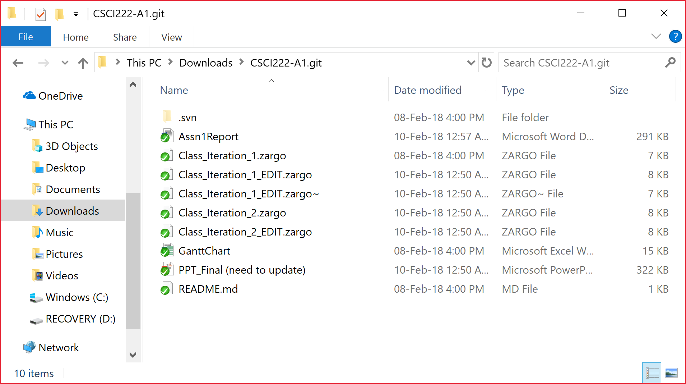

Screenshot #2 - VCS's listing of all the latest source files currently being managed

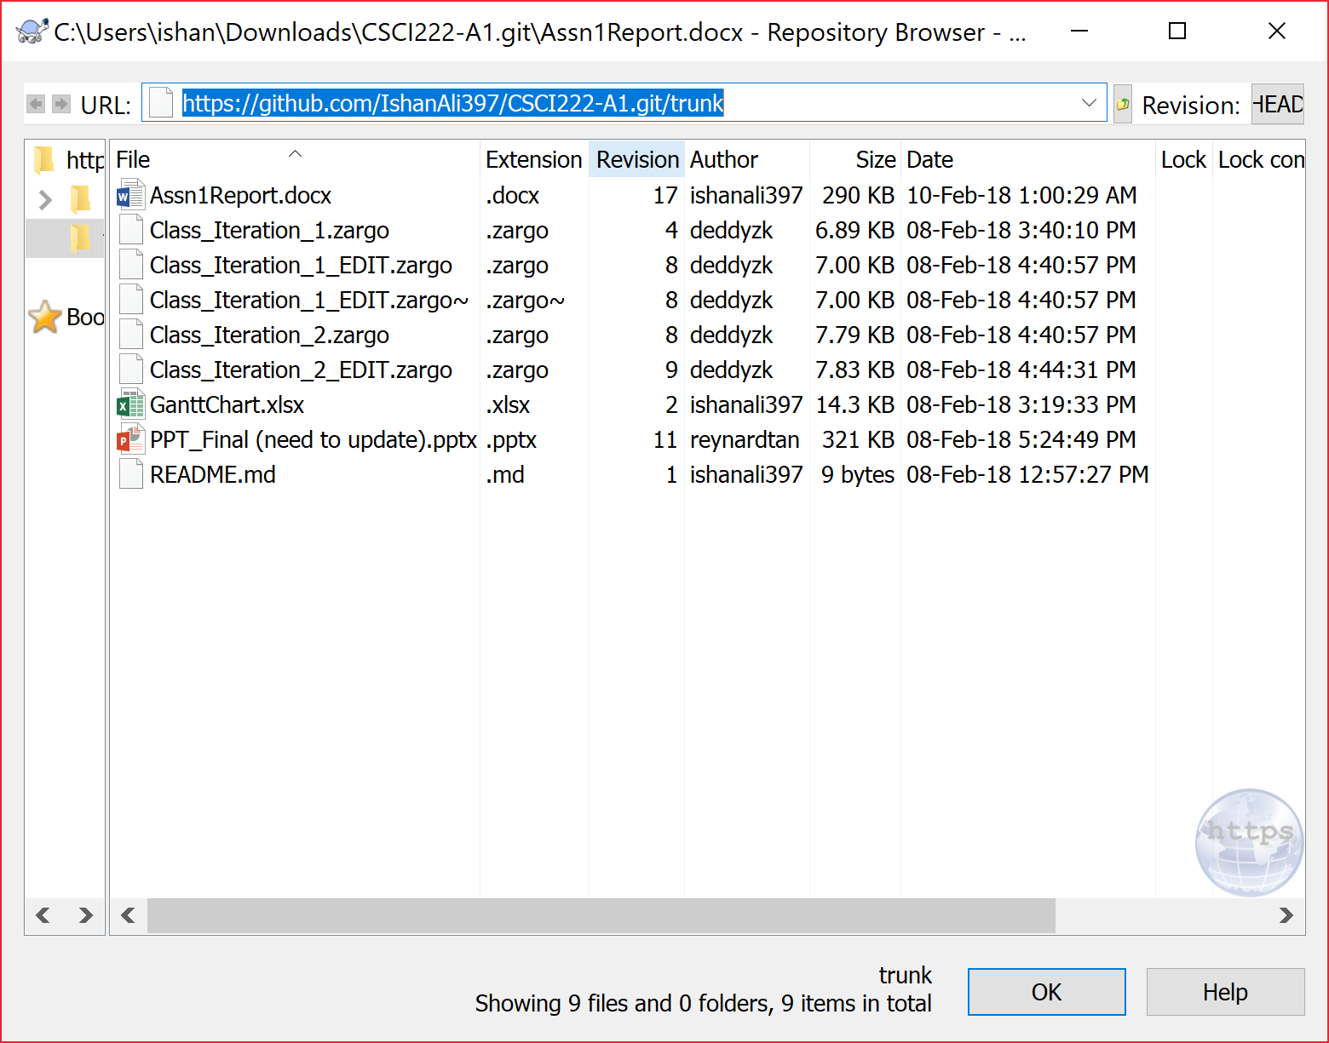

Screenshot #3 - Example using VCS's to check-out source files (it may be necessary to do >1 screen capture, depending on the software used)

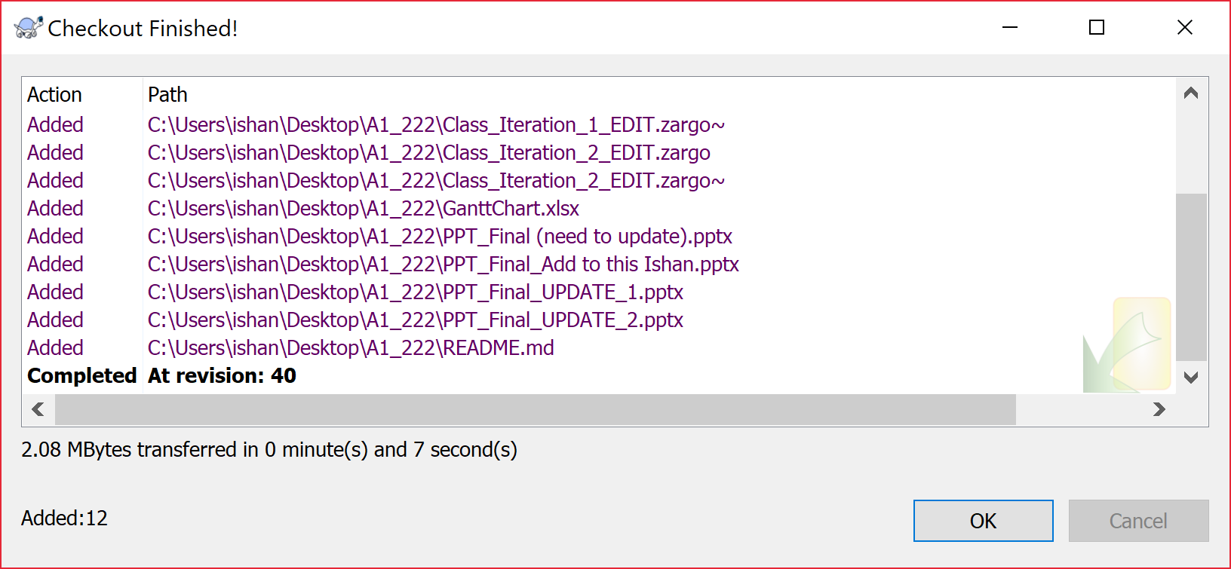

Screenshot #4 - Example using VCS's to check-in source files (it may be necessary to do >1 screen capture, depending on the software used)

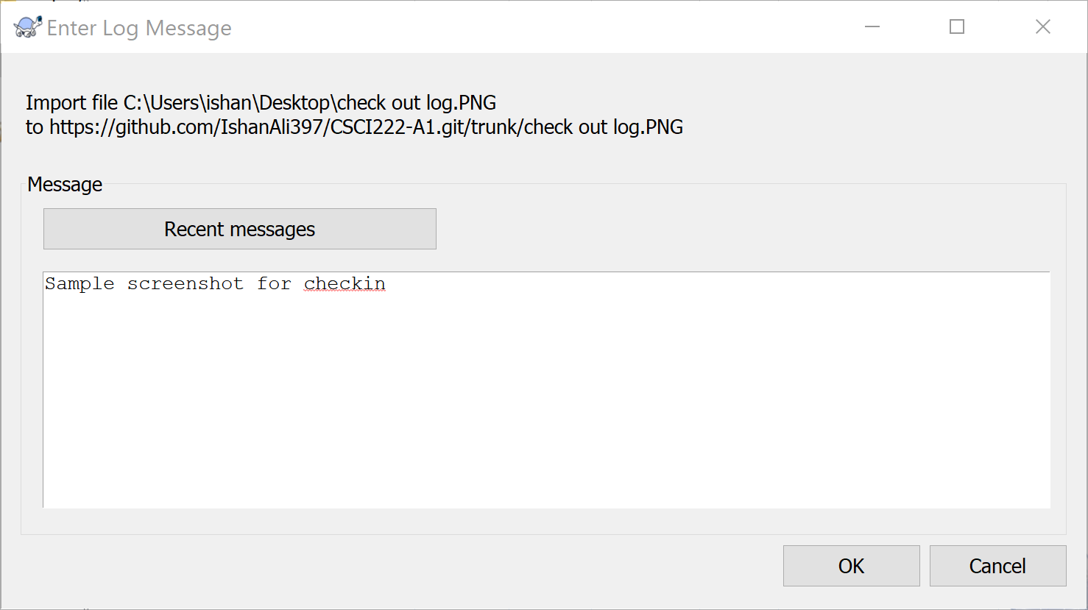

Screenshot #5 - Example using VCS's to display the change history / log
