CSCI222 Assignment 2 Report

|  |  |  |  |
| --- | --- | --- | --- |
| **Team Number: <A4>** | | | |
| **S/N** | **Student Number** | **Name** | **Email Address** |
| 1 | 5562351 | Ishan Ali | Tel : 93212348    Email : ishan397@hotmail.com |
| 2 | 5921776 | Goh Ji Kiat | jkpingster@gmail.com |
| 3 | 5283048 | V Prathyaksha | prathyakshavenkatachari@gmail.com |
| 4 | 5655651 | Deddy Zulkarnain | deddyzk@gmail.com |
| 5 | 5562971 | Reynard Tan | reynardtanjiewei@gmail.com |
| 6 | 5656539 | Kent Wong | wyh.kent@yahoo.com |

Table of Contents

Project Overview 4

A) "Vision" 4

System’s key features 4

Core Project’s Requirements 4

Main Constraints 4

Business Case 4

B) Initial Use-Case Model 5

C) Project Plan 5

Roles and Responsibility 6

Risk Analysis and Countermeasures 7

(Possible) Countermeasures 8

Design Artefacts - Use Cases (Iteration 1) 9

Design Artefacts - Use Cases (Iteration 2) 10

Design Artefacts - Activity Workflows (Iteration 1) 11

Design Artefacts - Activity Workflows (Iteration 2) 12

Design Artefacts - Component Diagrams (Iteration 1) 13

Design Artefacts - Component Diagrams (Iteration 2) 14

Design Artefacts - Class Diagrams (Iteration 1) 15

Design Artefacts - Class Diagrams (Iteration 2) 16

Design Artefacts - Sequence Diagrams (Iteration 1) 17

Design Artefacts - Sequence Diagrams (Iteration 2) 18

Design Artefacts - Deployment Diagrams (Iteration 1) 19

Design Artefacts - Deployment Diagrams (Iteration 2) 20

Design Artefacts - State Diagram (Iteration 1) 21

Design Artefacts - State Diagram (Iteration 2) 22

Test Plan Design 23

Appendix A - Formal Meeting Records 25

Construction Phase - Iteration 1 25

Construction Phase - Iteration 2 28

Transition Phase - Iteration 1 31

Transition Phase - Iteration 2 35

Appendix B - Individual Work Diaries 38

Appendix C - Evidence of using VCS (Version Control Software) 40

# Project Overview

## "Vision"

### System’s key features

The system allows the manager to keep track of the stock level in the warehouse in detail. When this is achieved, it will allow the manager to optimise processes, minimising bottlenecking, and plan for future projects with all the formation available now at his fingertips.

### Core Project’s Requirements

* Record incoming and outgoing stock
* Categorize the stock in relation to their type
* Search and display available stock
* Search and display stock in accordance to price range and quantity
* Summary Report of incoming and outgoing stock
* Data stored encryption
* Login authentication encryption/decryption
* Unsuccessful login – system locked
* Provide stock item alerts for below threshold limit

### Main Constraints

* System to be implemented in C++ and to run on Linux OS
* Simple textual “menu-select” style of user interface

### Business Case

The system which we are creating is a Warehouse Management tool which will enhance the efficiency of most work operations and at the same time keep track of stock inventory details.

This system will help the operators in the warehouse incorporate several daily routine processes into “main” processes, thus further aiding the long-term plans of the company to create a streamlined process for the management of their warehouse.

It will also hasten many warehouse operations. Operators will now be able to keep track of incoming and outgoing stocks, search for stock by prices/categories and quantity in ascending or descending order.

It will also be able to display a summary of stocks according to day, week or month at a glance. The system will have tight security features to safeguard the company details by using 2FA login process and verification. Also, the system can send out alerts when the stocks fall below a certain threshold set by the company.

## Initial Use-Case Model

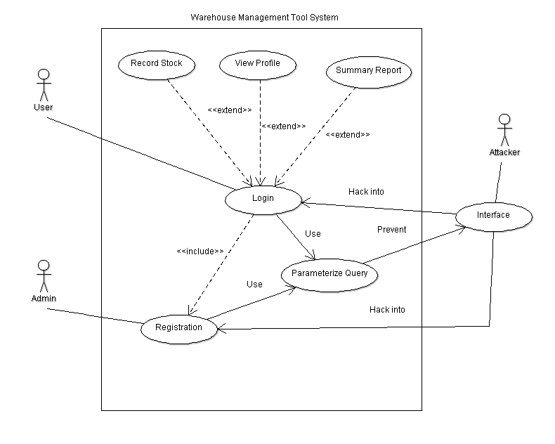

## Project Plan

PASTE GANTT CHART HERE

# Roles and Responsibility

|  |  |  |  |
| --- | --- | --- | --- |
| Team Number: <A4 > | | | |
|  | **Student Name** | **Role** | **Artefacts** |
| 1 | Ishan Ali | Manager | SRS Report, Business Case Process |
| 2 | Deddy Zulkarnain | Designer / Tester | Use Cases, Domain Model |
| 3 | V Prathyaksha | Integration / Programmer | SRS Report |
| 4 | Goh Ji Kiat | Lead Programmer | SRS Report |
| 5 | Kent Wong | Designer / Tester | Use Cases |
| 6 | Reynard Tan | Integration / Documenter | Business Case Process |

# Risk Analysis and Countermeasures

|  |  |  |  |  |  |
| --- | --- | --- | --- | --- | --- |
| **S/N** | **Impact Type** | **Risk Seriousness (%)** | **Likelihood of Occurrence (%)** | **WBS**  **(affected work / task)** | **Risk Description** |
| 1 | Budget | 80% | 5% | 1.3, 2.2 | Employees demand a higher salary |
| 2 | Project Progression | 85% | 40% | All | A member of the project group gets into an accident affecting the completion deadline. |
| 3 | Successful task completion | 70% | 20% | All | Project requirements are not defined clearly due to insufficient knowledge. |
| 4 | Project workflow | 60% | 40% | All | Team member’s computer crashed and his work is not versioned |
| 5 | Project duration | 50% | 30% | 2, 3 | Effort and time needed for additional features of product is greater than expected |
| 6 | Deadline | 50% | 10% | 4.5, 2.1 | Product prototype is rejected by test users and may require a rework. |
| 7 | Product Testing | 40% | 70% | 3 | Bad estimation of workflow may result in delays, leading to significant re-planning. |

## (Possible) Countermeasures

|  |  |  |  |
| --- | --- | --- | --- |
| **S/N** | **Risk Description** | **Proposed Management Plan** | **(Possible) Reduction in Risk Seriousness (%)** |
| 1 | Members demand a higher salary | Meet the member’s salary based on their contribution. Alternatively, explain why the member only deserves the salary they are getting now | -50% |
| 2 | A member of the project group gets into an accident affecting the completion deadline. | Hold frequent group meetings so that the group members are aware of all the tasks and are able to take over his/her role. | -50% |
| 3 | Project requirements are not defined clearly due to insufficient knowledge. | Define functional requirements in detail and review them thoroughly | -70% |
| 4 | Team member’s computer crashed and his work is not versioned | Backup work frequently on two different sites and use versioning software. | -90% |
| 5 | Effort and time needed for additional features of product is greater than expected | Workflow should be planned for completing required and critical features. Extra features should only be implemented if time permits. | -40% |
| 6 | Product prototype is rejected by test users and may require rework. | Organise frequent user testing to inspect the product prototype, and use input to improve on the product | -50% |
| 7 | Bad estimation of workflow may result in delays, leading to significant re-planning. | Discuss within the team the duration they would need for the completion of their individual task. From there, allow some buffer time in the case that the task would need a longer duration than expected. Timely, periodic updates from the team members would also assist in evaluating their progress. Adjustments can then be made on the fly to adapt according to their progress. | -40% |

# Design Artefacts - Use Cases (Iteration 1)

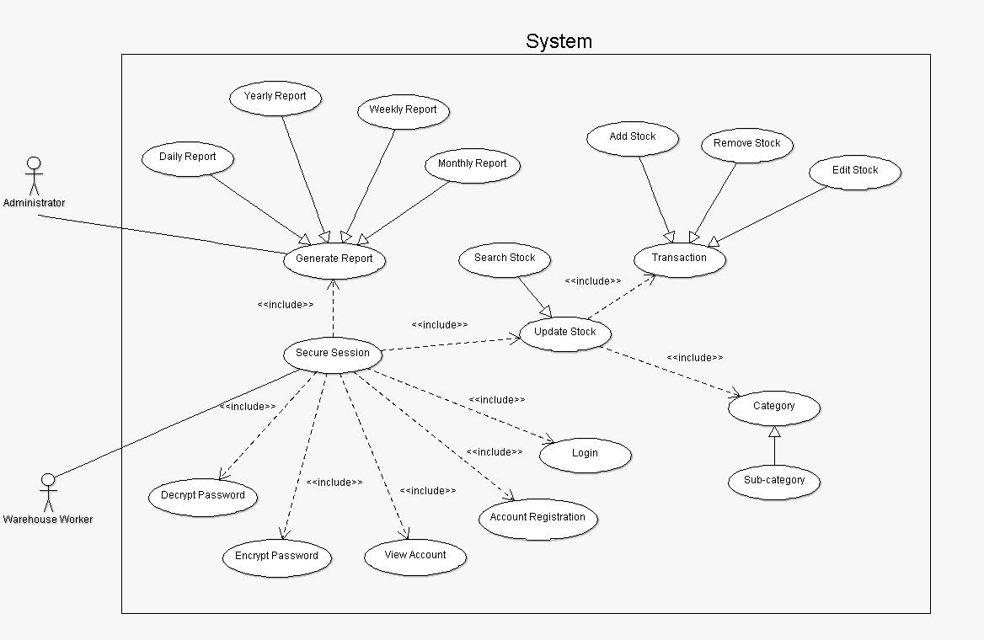

# Design Artefacts - Use Cases (Iteration 2)

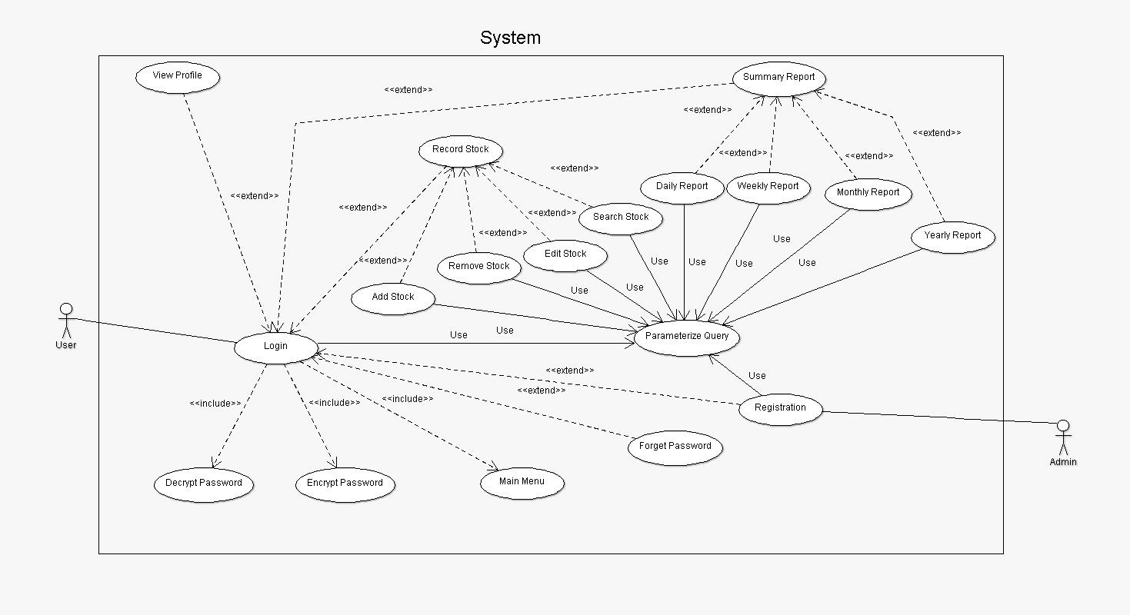

# Design Artefacts - Activity Workflows (Iteration 1)

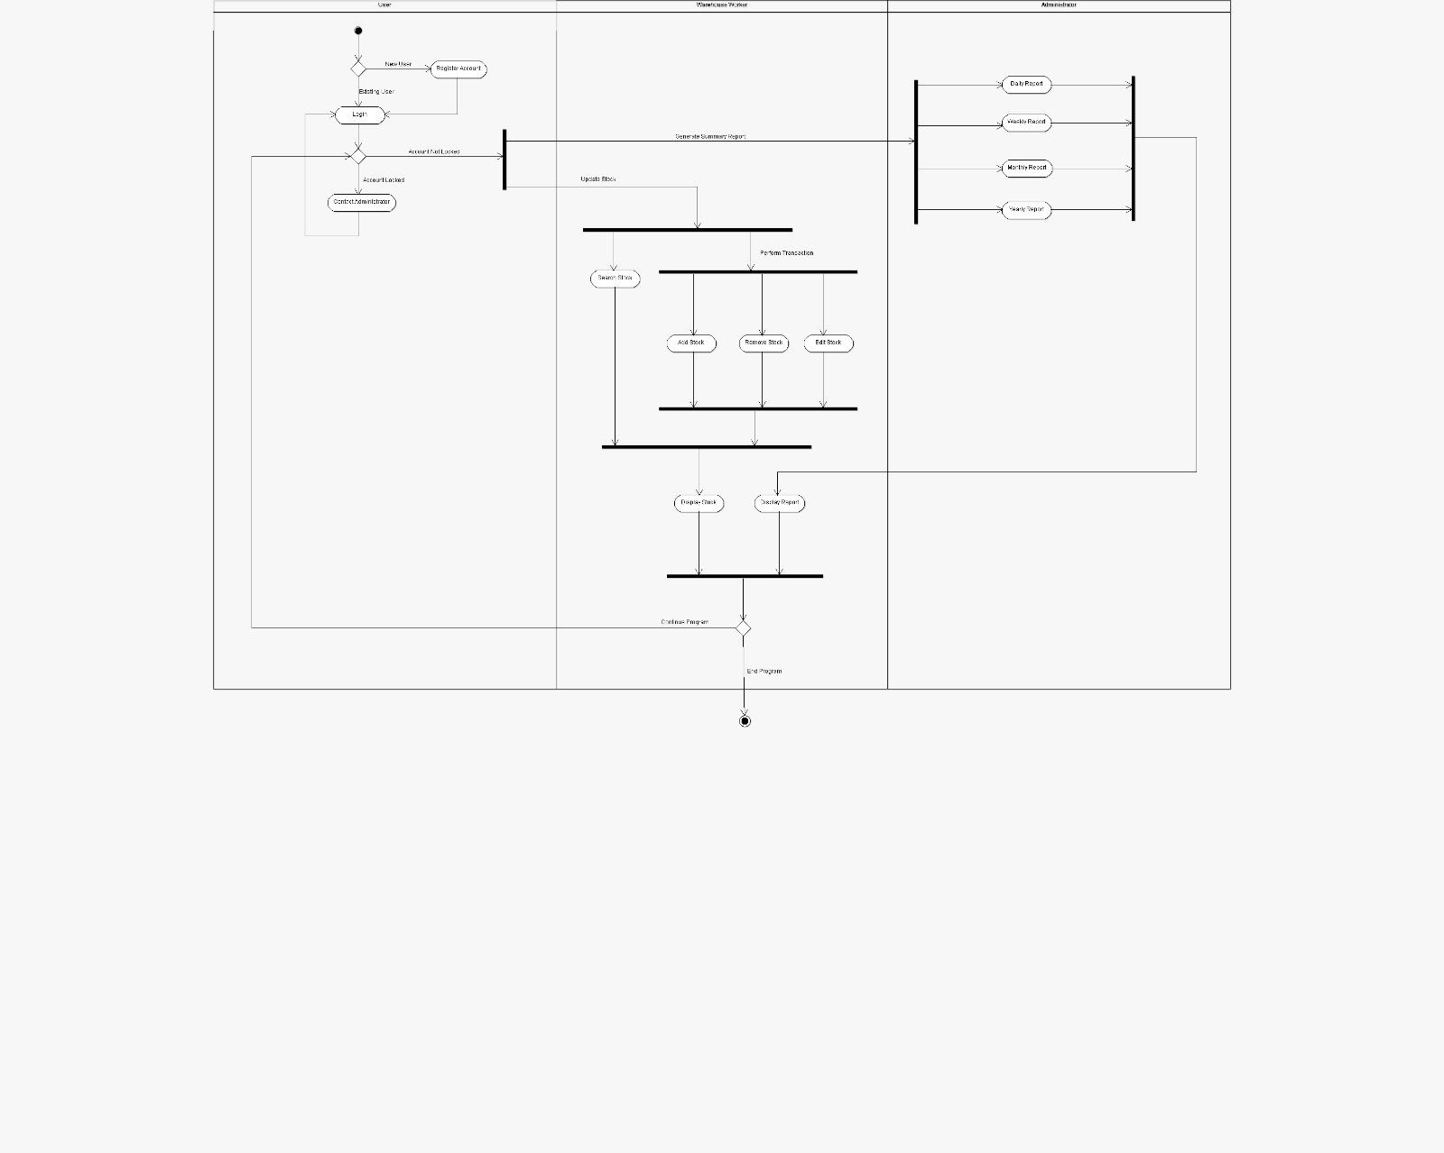

# Design Artefacts - Activity Workflows (Iteration 2) Deddy

# Design Artefacts - Component Diagrams (Iteration 1)

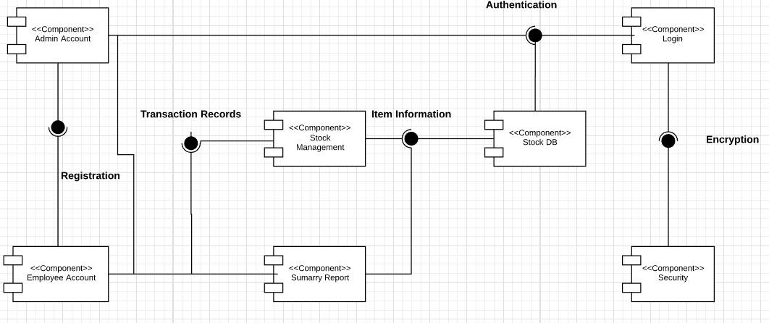

# Design Artefacts - Component Diagrams (Iteration 2)

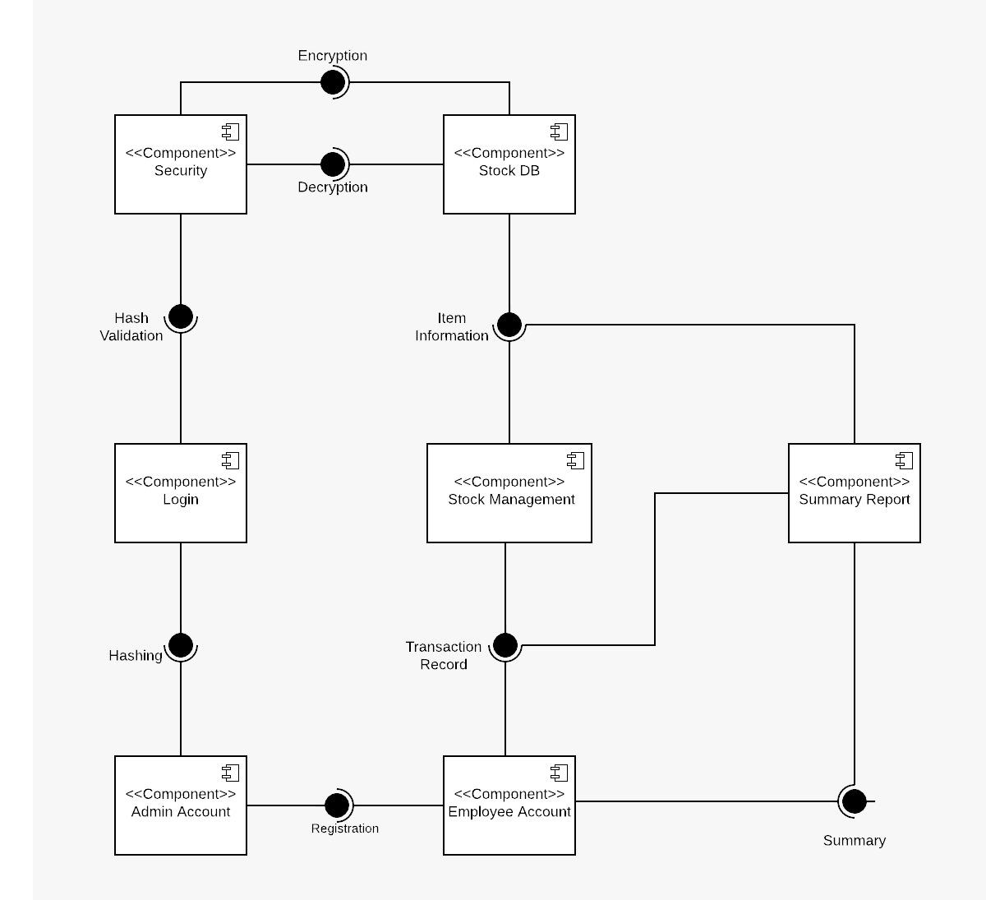

# Design Artefacts - Class Diagrams (Iteration 1) Deddy

# Design Artefacts - Class Diagrams (Iteration 2) Deddy

# Design Artefacts - Sequence Diagrams (Iteration 1) Reynard

# Design Artefacts - Sequence Diagrams (Iteration 2) Reynard

# Design Artefacts - Deployment Diagrams (Iteration 1)

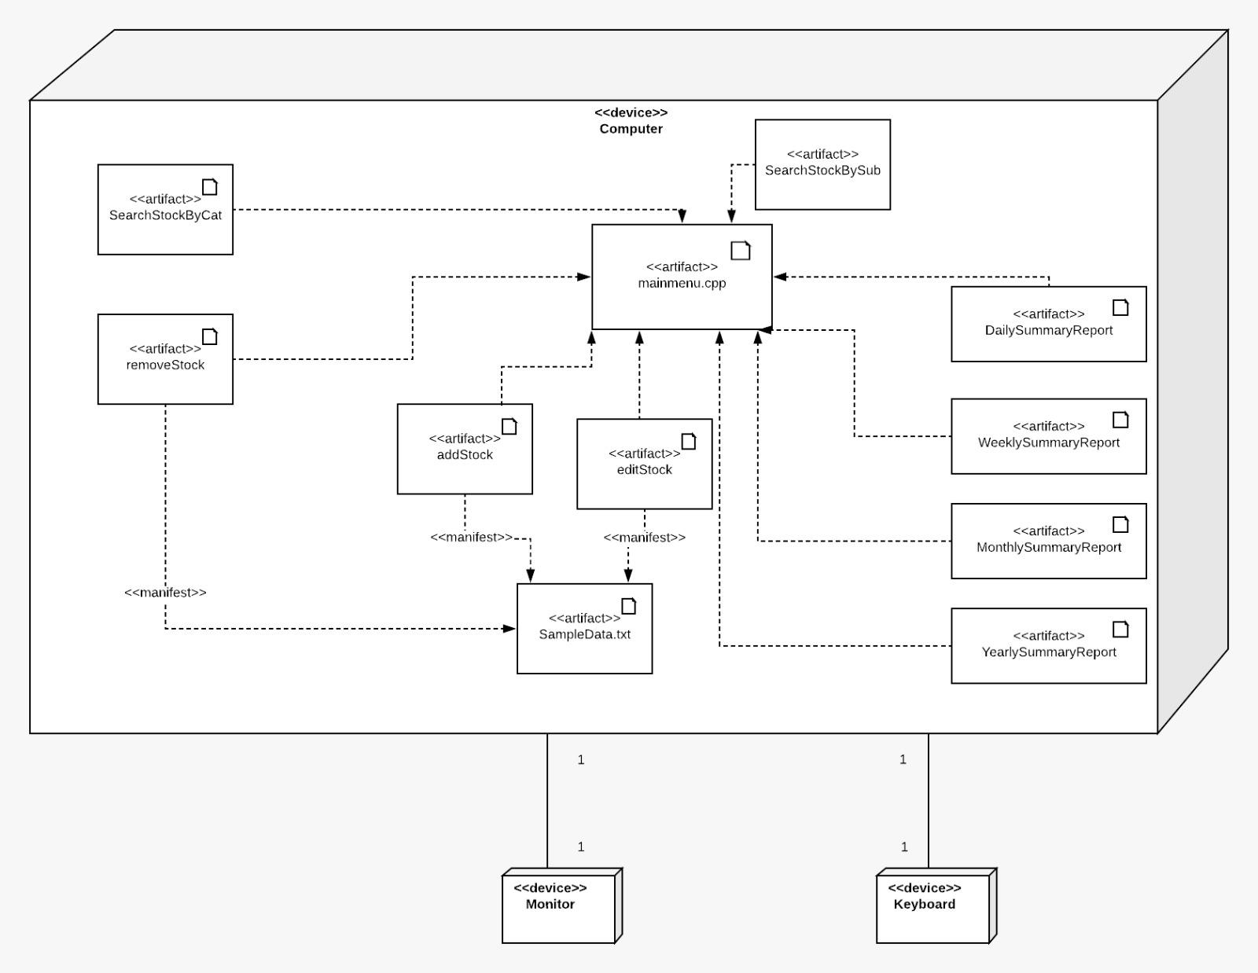

# Design Artefacts - Deployment Diagrams (Iteration 2)

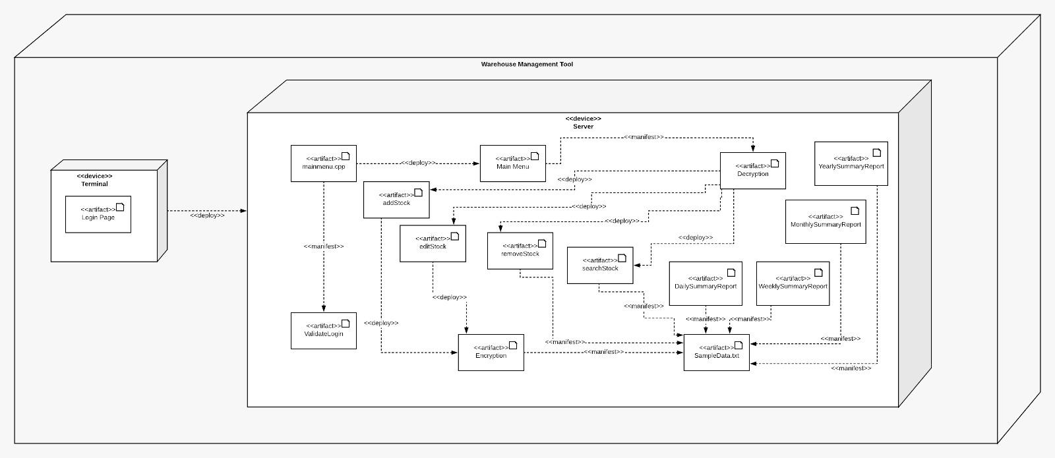

# Design Artefacts - State Diagram (Iteration 1) Reynard

# Design Artefacts - State Diagram (Iteration 2) Reynard

# Test Plan Design

Depending on your system's software architecture, there may be many different classes, with many different implemented methods(), whose functionalities need to be tested.

Your team should describe how they intend to test their functionalities to ensure the methods() work as designed.

Below table provides a sample structure, to organize your content. You can reuse this structure to cover as many other important methods() as necessary.

|  |  |  |  |  |
| --- | --- | --- | --- | --- |
| Test Plan for :  <Relate to fuctional requirement>  Club Membership Management - The system should allow the administrator to add new members | | | | |
| Test Case ID: | Description | Expected Outcome | Participating Program's Class & Method to be tested | Participating CPPUnit Test Program's Class & Method doing the testing |
| E.g.  CM-1 | E.g.  To test for adding a new member's name "John Anderson" | E.g.  System should output a message like "Member : John Anderson created successfully".  The last array slot in the member array should contain the string " John Anderson " | E.g.  Class Name : ManageMember  Method Name :  bool createNewMember (string name) | E.g.  CPPUnit Class Name : TestManageMember  Method Name :  void testCreateNewMember (string name) |
| E.g.  CM-2 | E.g.  To test for adding an **EXISTING DUPLICATE** member's name "John Anderson" | E.g.  System should output a message like "Error, member : John Anderson already exists".  The total no. of elements in the member array should remain the same | E.g.  Class Name : ManageMember  Method Name :  bool createNewMember (string name) | E.g.  CPPUnit Class Name : TestManageMember  Method Name :  void testAddingExistingMember (string name) |
|  |  |  |  |  |
|  |  |  |  |  |

# Appendix A - Formal Meeting Records

## Construction Phase - Iteration 1

**MINUTES**

**Systems Development Team A4**

**Monday, 12th February 2018**

**12:00 p.m.**

**SIM Block B, Level 2**

**PRESENT:** Ishan, Kent, Deddy, Ji Kiat, Reynard, Prathyaksha

**ABSENT:** NIL

**1. CALL TO ORDER/OPENING REMARKS**

Meeting called to order at 12:00 p.m. by Ishan

1. **APPROVAL OF THE MINUTES FROM 10th February 2018**

**MOTION:** To approve minutes from 10th February 2017; approved and seconded by all team members

1. **AGENDA**

- Distribution of tasks for Construction Phase

- Discuss and allocate time for tasks for construction phase and remaining diagrams

- Feedback of Assignment 1 presentation

- Summary of progress of project

- Progress updates from individual members

- Feedback from previous meeting

- Additional features, enhancements/improvements

1. **Summary of Overall Progress**

Deddy stated that we have completed most of the Elaboration phase for this project except some of the new diagrams which are part of the requirements for this assignment. Ideally, we should be having 3 iterations for Construction phase and 2 iterations for Transition phase.

1. **Discussion of Remaining Tasks**

- Suggestions for Task

o Ji Kiat and Deddy volunteered to work on the use case and class diagrams as we needed to make some updates to these diagrams as per feedback from our tutor. As an extra task they were also assigned to also construct the deployment diagram as well

o Ishan, Reynard & Prathyaksha agreed to work on the modules of the overall program. They will decide among themselves to split on who will be working on which part of the modules. If needed, they will request help from the rest of the team members. The rest of the team members agreed to this suggestion.

o Kent volunteered to help out with Deddy and Ji Kiat. He decided to work together with them on the deployment diagram and help enhance the component diagram.

- Ideas for Implementation

o Ishan suggested that we identify key variables and methods as they are being implemented so during the testing phase we can save time instead of re-identifying them.

1. **Allocation of Time for each Issue**

- Development of Add/Remove Stock

o Reynard & Pipi have prior experience in developing a add/remove function in a program so they should be able to complete it latest by 13th Feb 2018 (1 Day)

- Development of Edit and Search Stock will be done by Ishan & Reyard. They requested time till 14th Feb 2018 (2 Days)

- Kent will be developing the ‘Summary Report’ function by 14th Feb 2018 (2 Days)

o Deddy and Ji Kiat would need 1 full day to complete and update the diagrams (1 Day)

1. **New Actions**

|  |  |  |  |  |  |
| --- | --- | --- | --- | --- | --- |
| **S/N** | **Action Items** | **Urgency**  **(Low/Normal/Urgent)** | **Status** | **Who** | **Due By** |
| 1 | Development of Add/Remove Stock | Urgent |  | Reynard & Pipi | Next Meeting 14th Feb 2018 |
| 2 | Development of Edit and Search Stock | Normal |  | Ishan & Reynard | Next Meeting 14th Feb 2018 |
| 3 | Development of ‘Summary Report’ function | Normal |  | Kent | Next Meeting 14th Feb 2018 |
| 4 | Development/ update new/existing diagrams | Urgent |  | Ji Kiat, Deddy, Kent | 13th Feb 2018 |

**8. AGENDA FOR NEXT MEETING**

Mark proposed that all members of the team present the following in the next meeting, seconded by Jonathan

- Status of from previous meeting

- Difficulties faced

- Additional requirements needed

- Delays if any

- Additional work done if any

All members agreed on the above items for presentation next meeting.

**9. ADJOURNMENT**

Meeting was adjourned at 5 p.m.

**10. NEXT MEETING**

Next meeting will be on 12:30 p.m., Wednesday, 14th February 2017

## Construction Phase - Iteration 2

**MINUTES**

**Systems Development Team A-4**

**Wednesday, 14th February 2018**

**12:30 p.m.**

**SIM Block B, Level 2**

**PRESENT:** Ishan Ali, V Prathyaksha, Reynard Tan, Deddy Zulkarnain, Goh Ji Kiat, Kent Wong

**ABSENT:** NIL

**1. CALL TO ORDER/OPENING REMARKS**

Meeting called to order at 12:30 p.m. by Team Leader Ishan

1. **APPROVAL OF THE MINUTES FROM 12th February 2018**

**MOTION:** To approve minutes from 12th February 2018; approved and seconded by all team members

1. **AGENDA**

- Progress of action items from previous meeting

- Difficulties faced

- Additional requirements needed

- Delays if any

- Additional work done if any

1. **Summary of Overall Progress**

Ishan stated that barring any delays today, the team will be on track for developing test plans and testing of the program.

1. **Discussion of Remaining Tasks**

- Test Plans

o Prathyaksha stated that the critical functions and variables should be compiled into a “test case” document to make life easier for the tester when he is doing testing.

- Integration

o Reynard stated that the modules related to one another, like Add/Remove, Search/Edit functions should be also integrated together as they use the same storing methods.

- Encryption of Passwords

o Prathyaksha touched on the topic of encryption of passwords. She stated that the easiest implementation method was to add separators to the password. She will continue to explore other available methods and implement the one she feels is best fitted for the program.

1. **Review of Tasks from previous Meeting**

- Development of Add/Remove Stock

o Prathyaksha has stated that the development of the Add/Remove stock function is complete and is ready for testing and integration

o Reynard consolidated a list of important functions and variables that will need to be extensively tested so that they do not crash the system when run.

- Development of Edit and Search Stock

o Reynard stated that the development of the Edit and Search stock function is complete and is ready for testing and integration

o Ishan also said that the list of important functions and variables that will need to be extensively tested is also in the consolidated list.

- Developing the ‘Summary Report’ function

o Kent stated that he would require more time in the development of the ‘Summary Report’ function. The formatting of the data is currently all over the place and would take some time to organise into a legible format.

o He stated that he would need a few hours to figure out the formatting of the data onto the output screen.

1. **Allocation of Time for Tasks**

- Testing of the various modules

o Testing should be complete within 1-man day. This is contingent on whether a module fails a test case, thus requiring remedial action and delay in the time required.

o Testing should be done by the programmers of the module. Thereafter, it should be tested again by the tester as part of cross-checking.

- Completion of ‘Summary Report’ function

o Despite the challenges faced in formatting the output, it should be completed within half a day.

- Development of Track Stock

o Ji Kiat stated that he would need around half a day to complete the programming of this function

1. **New Actions**

|  |  |  |  |  |  |
| --- | --- | --- | --- | --- | --- |
| **S/N** | **Action Items** | **Urgency**  **(Low/Normal/Urgent)** | **Status** | **Who** | **Due By** |
| 1 | Testing of Add/Remove Stock | Normal |  | Prathyaksha, Reynard, Ishan, Ji Kiat | Next Meeting 16th Feb 2018 |
| 2 | Completion of ‘Summary Report’ function | Urgent |  | Kent | Next Meeting 16th Feb 2018 |
| 3 | Development of Track Stock | Normal |  | Ji Kiat, Deddy | Next Meeting 16th Feb 2018 |

**9. AGENDA FOR NEXT MEETING**

Ishan proposed that all members of the team present the following in the next meeting.

- Progress of action items from previous meeting

- Difficulties faced

- Additional requirements needed

- Delays if any

- Additional work done if any

All members agreed on the above items for presentation next meeting.

**10. ADJOURNMENT**

Meeting was adjourned at 5:30 p.m.

**11. NEXT MEETING**

Next meeting will be on 12:00 p.m., Friday, 24th February 2018

## Transition Phase - Iteration 1

**MINUTES**

**Systems Development Team A-4**

**Friday, 16th February 2018**

**12:00 p.m.**

**SIM Block B, Level 4**

**PRESENT:** Ishan Ali, V Prathyaksha, Reynard Tan, Deddy Zulkarnain, Goh Ji Kiat, Kent Wong

**ABSENT:** NIL

**1. CALL TO ORDER/OPENING REMARKS**

Meeting called to order at 12:00 p.m. by Ishan

1. **APPROVAL OF THE MINUTES FROM 16th February 2018**

**MOTION:** To approve minutes from 16th February 2018; approved and seconded by all team members

Minutes added into the repository

1. **AGENDA**

- Progress of action items from previous meeting

- Difficulties faced

- Additional requirements needed

- Suggestions for any additional features

1. **Summary of Overall Progress**

Deddy and Ji Kiat urged that we should be focusing on integrating the components together to ensure a working program can be produced. We also need to ensure that the program should be foolproof and error free. Thus, it can be stable and working under any test conditions.

1. **Discussion of Remaining Tasks**

- Testing and Integration

o Deddy and Ji Kiat stated that our main goal should be getting the program to integrate together and ensure a working version is produced.

o Pipeline for completion should be within the day.

- Vetting and fine tuning of SRS

o Ishan stated that we should all work on identifying sections in the SRS the requires enhancement/rectification and peer review them

- Diagrams

o Reyarnd stated that most of the diagrams are almost done and need some fine tuning to produce a final copy

o Ishan suggested that we should create additional diagrams to have a better understanding of the project.

1. **Review of Tasks from previous Meeting**

- Testing of Summary Report Module

o Kent stated that Summary Report Module still has some major issues and require some help from the rest of the members to solve it

o He also stated that other than the above problem, other modules of the program is working great and just need some minor fine tuning to make it foolproof.

- SRS Fine Tuning

o XXX stated that he has edited some sections of the SRS, namely 2.4 and 2.6

o XXX stated that he has also edited some sections, which include 4.2 and 1.2

o XXX stated that he edited sections 1.2 and 5.1

o XXX stated that he edited sections 5.2 and 6.0

o XXX stated that he edited sections 5.3 and the glossary

- Diagrams

o Ji Kiat stated that he has completed creating the diagrams and requests members to help peer review and vetthem

1. **Allocation of Time for Tasks**

o Integration of Application

§ Kent and Deddy stated that the Integration of the Application should take 1 man days unless a module fails to perform as expected during integration

o SRS Document

§ Prathyaksha stated we would need 0.5 man day to complete the vetting of SRS Document

o Diagrams

§ Reynard Ji Kiat stated that review by all members should take only 0.5 man day which includes the time for editing.

1. **New Actions**

|  |  |  |  |  |  |
| --- | --- | --- | --- | --- | --- |
| **S/N** | **Action Items** | **Urgency**  **(Low/Normal/Urgent)** | **Status** | **Who** | **Due By** |
| 1 | Integration of Application & Fine Tuning Summary Report Module | Urgent |  | All | Next Meeting 18th Feb 2018 |
| 2 | SRS Fine Tuning | Normal |  | All | Next Meeting |
| 3 | Review of Diagrams | Normal |  | All | Next Meeting |

**9. AGENDA FOR NEXT MEETING**

Ishan proposed that all members of the team present the following in the next meeting, seconded by Jonathan

- Progress of action items from previous meeting

- Difficulties faced

- Additional requirements needed

- Delays if any

- Additional work done if any

All members agreed on the above items for presentation next meeting.

**10. ADJOURNMENT**

Meeting was adjourned at 3.00pm.

**11. NEXT MEETING**

Next meeting will be on 1:30 p.m., Sunday, 18th February 2018

## Transition Phase - Iteration 2

**MINUTES**

**Systems Development Team A-4**

**Sunday, 18th February 2018**

**1:30 p.m.**

**Skype Meeting**

**PRESENT:** Ishan Ali, V Prathyaksha, Reynard Tan, Deddy Zulkarnain, Goh Ji Kiat, Kent Wong

**ABSENT:** NIL

**1. CALL TO ORDER/OPENING REMARKS**

Meeting called to order at 1:30 p.m. by Team Leader Ishan

1. **APPROVAL OF THE MINUTES FROM 16th February 2018**

**MOTION:** To approve minutes from 16th February 2018; approved and seconded by all team members

1. **AGENDA**

- Progress of action items from previous meeting

- Difficulties faced

- Additional requirements needed

- Delays if any

- Additional work done if any

1. **Summary of Overall Progress**

Ishan stated that the project should be 99% completed at this juncture, save for eleventh hour

everything should be complete at this stage, and we should be shipping out the product along with all documentation.

1. **Review of Tasks from previous Meeting**

- Integration of Application

o Prathyaksha stated that the application has been properly integrated and all modules are confirmed to be working

o Ji Kiat also stated that all modules of the program are working and have been completed.

- SRS Editing

o Deddy had confirmed that the SRS is updated and ready for perusal.

o Kent has also edited the formatting to be inline with the guidelines previously stated.

- Diagrams

o Reynard stated that he has reviewed the diagrams and found minor mistakes which were changed.

o Ji Kiat altered some of the class/variable names to be relevant with the program code.

- Others

o Ji Kiat stated that he had inserted comments on various parts of the program to aid in the maintenance of the code in future.

o Ishan stated that he has archived unofficial documents and diagrams in the SVN for future reference

**6. ADJOURNMENT**

Meeting was adjourned at 4:50 p.m.

**7. NEXT MEETING**

Will not be necessary unless some abnormalities surface.

Appendix B - Individual Work Diaries

Team Member 1 : Ishan Ali

* Construction Phase - Iteration 1
* **Development of the Add Stock function**
* **Time Required:(6 man hours)**
* **Date: 12th February 2018**
* **Difficulties faced:** Getting the vector to read the changes stored to the database
* Allocation of time
* - Creating the vector of vectors to store data from the “SampleData” text file (2 man hours)
* - Reading data from “Sample Data” text file to store into the vector (2 man hours)
* - Writing new stock data that user has input into the “SampleData” text file (1-man hour)
* - Getting the vector to read from database after stock changes (1-man hour)
* **Development of the Remove Stock function**
* **Time Required:(6 man hours)**
* **Date:**
* **Difficulties faced:**
* Trying to match the stock name against the vector of vector
* Writing of the new stock changes to the database
* Allocation of time
* - Matching of user input stock name against vector elements (4 man hours)
* - Removing of stock matching with the user input stock name and database ID (1-man hour)
* - Writing new stock vector to text file (1-man hour)

* Construction Phase - Iteration 2
* **Testing/integration of Add/Remove Stock**
* **Time Required:(12 man hours)**
* **Date: 14th February 2018**
* **Difficulties faced: -**
* Allocation of time
* - Creation of test plan design for Add/Remove stock (4hr)
* - Integration of Add/Remove stock to the main cpp file(4hr)
* - Testing of Add/Remove stock(4hr)

* Transition Phase - Iteration 1
* **Integration**
* **Time Required:(12 man hours)**
* **Date: 16th February 2018**
* **Difficulties faced: -**
* Allocation of time
* Integrating of Add Stock, Remove Stock, Edit Stock and Search Stock (12 man hours)
* Transition Phase - Iteration 2
* **Creation of SRS, Report and PowerPoint Presentation**
* **Time Required:(12 man hours)**
* **Date: 18th February 2018**
* **Difficulties faced: -**
* Allocation of time
* - Creation of SRS (4 Man Hours)
* - Creation of Report (4 Man Hours)
* Creation of PowerPoint Presentation (4 Man Hours)

Team Member 'N' : Xxxx Xxxx

Construction Phase - Iteration 1

* Copy and Paste your formal meeting minutes for Construction Phase, iteration 1 here.
* You can refer to Assn 1 Qn Paper, Appendix B, bullet point 5 for a summary of contents to be included.
* Note: this section can span as many pages as necessary

Construction Phase - Iteration 2

* Copy and Paste your formal meeting minutes for Construction Phase, iteration 2 here.
* You can refer to Assn 1 Qn Paper, Appendix B, bullet point 5 for a summary of contents to be included.
* Note: this section can span as many pages as necessary

Construction Phase - Iteration 3 (Optional)

* Copy and Paste your formal meeting minutes for Construction Phase, iteration 3 here.
* You can refer to Assn 1 Qn Paper, Appendix B, bullet point 5 for a summary of contents to be included.
* Note: this section can span as many pages as necessary

Transition Phase - Iteration 1

* Copy and Paste your formal meeting minutes for Transition Phase, iteration 1 here.
* You can refer to Assn 1 Qn Paper, Appendix B, bullet point 5 for a summary of contents to be included.
* Note: this section can span as many pages as necessary

Transition Phase - Iteration 2 (Optional)

* Copy and Paste your formal meeting minutes for Transition Phase, iteration 2 here.
* You can refer to Assn 1 Qn Paper, Appendix B, bullet point 5 for a summary of contents to be included.
* Note: this section can span as many pages as necessary

# Appendix C - Evidence of using VCS (Version Control Software)

Version Control Software used : (E.g. Netbeans subversion, TortiseSVN, etc)

Note 1 : The following screenshots can span as many pages as necessary

Note 2 : Please ensure that all the wordings / text in your screen shots are clearly visible

Screenshot #1 - Contents in the VCS's **Root Folder** containing all **Repository Project Files**

< Paste Screenshot #1 image here >

Screenshot #2 - VCS's listing of all the **latest source files currently being managed**

< Paste Screenshot #2 image here >

Screenshot #3 - Example using VCS's to **check-out source files** (it may be necessary to do >1 screen capture, depending on the software used)

< Paste Screenshot #3 image**(s)** here >

Screenshot #4 - Example using VCS's to **check-in source files** (it may be necessary to do >1 screen capture, depending on the software used)

< Paste Screenshot #4 image**(s)** here >

Screenshot #5 - Example using VCS's to **display the change history / log** (it may be necessary to do >1 screen capture, depending on the software used)

< Paste Screenshot #5 image**(s)** here >