Software Requirements Specification

for

<Warehouse Management (WM) Tool >

Prepared by <Team A-4>

<UOW>

<19 February 18>

Software Requirements Specification for Warehouse Management Tool Page ii

Table of Contents
Table of Contents .......................................................................................................................... |  |  | ii
Revision History ............................................................................................................................ |  |  | ii
1. | Introduction.............................................................................................................................. |  | 1
 | 1.1 | Purpose ............................................................................................................................................ | 1
 | 1.2 | Document Conventions.................................................................................................................... | 1
 | 1.3 | Intended Audience and Reading Suggestions.................................................................................. | 1
 | 1.4 | Project Scope ................................................................................................................................... | 2
 | 1.5 | References........................................................................................................................................ | 2
2. | Overall Description .................................................................................................................. |  | 3
 | 2.1 | Product Perspective ......................................................................................................................... | 3
 | 2.2 | Product Features .............................................................................................................................. | 3
 | 2.3 | User Classes and Characteristics ..................................................................................................... | 4
 | 2.4 | Operating Environment.................................................................................................................... | 5
 | 2.5 | Design and Implementation Constraints .......................................................................................... | 5
 | 2.6 | User Documentation ........................................................................................................................ | 5
 | 2.7 | Assumptions and Dependencies ...................................................................................................... | 5
3. | System Features........................................................................................................................ |  | 6
 | 3.1 | User Class 1 - Stock Taker................................................................................................................ | 6
 | 3.2 | User Class 2 – Warehouse Manager.................................................................................................. | 8
4. | External Interface Requirements ........................................................................................... |  | 10
 | 4.1 | User Interfaces ................................................................................................................................. | 10
 | 4.2 | Hardware Interfaces ......................................................................................................................... | 11
 | 4.3 | Software Interfaces .......................................................................................................................... | 11
 | 4.4 | Communications Interfaces ............................................................................................................. | 11
5. | Other Nonfunctional Requirements ....................................................................................... |  | 12
 | 5.1 | Performance Requirements.............................................................................................................. | 12
 | 5.2 | Safety Requirements ........................................................................................................................ | 12
 | 5.3 | Security Requirements ..................................................................................................................... | 12
 | 5.4 | Software Quality Attributes ............................................................................................................. | 12
6. Other Requirements.................................................................................................................... |  |  | 13
Appendix A: Glossary..................................................................................................................... |  |  | 13
Appendix B: Issues List.................................................................................................................. |  |  | 13

Revision History

Name | Date | Reason For Changes | Version
 | 19/02/2018

Software Requirements Specification for Warehouse Management Tool Page 1

1. Introduction

1.1 Purpose

The purpose of this document is to give a detailed description of the Warehouse Management (WM) Tool software. This document will illustrate the purpose and complete declaration of system. It will also explain system limitations, interactions and interface. This document will be proposed to a customer for his reference for developing the first version of the system.

1.2 Document Conventions

The document has been written in ‘Arial’ font size 12. Headers were written, with a numbering system, in ‘Times New Roman’ font size 18. Sub-headers were written with a number system, in ‘Times New Roman’ font size 14. Diagram descriptions were written in ‘Times New Roman’ font size 10.

1.3 Intended Audience and Reading Suggestions

The document is intended for developers, project managers, marketing staff, users, testers, and documentation writers. The rest of this document will illustrate the overall description, features, external interface requirements and non-functional requirements of the system.

The following reading sequences are recommended,

- For developers and testers, begin with the overview sections and proceed to system features, external interface requirements and other non-functional requirements.
- For project managers, marketing staff and users, begin with overview sections and proceed to system features.

Software Requirements Specification for Warehouse Management Tool Page 2

1.4 Project Scope

The Warehouse Management (WM) Tool is essential for streamlining process, long range planning and organization. It provides a better understanding of day-to-day operation with its summary information of how a warehouse is performing.
It is critical for the warehouse management to have an effective system in place for security, accuracy and availability.

1.5 References

[1] IEEE Software Engineering Standards Committee, “IEEE Std 830-1998, IEEE Recommended Practice for Software Requirements Specifications”, October 20, 1998.

[2] v00086,”1c Requirements”, unpublished.

Software Requirements Specification for Warehouse Management Tool Page 3

2. Overall Description

2.1 Product Perspective

This product is a new, self-contained product. It contains one part: The Warehouse Management (WM) Tool software. This software will be used to track and amend warehouse stock.
The software will need to be installed onto a personal computer (PC).
Since this is a data-centric product, it will need somewhere to store the data. Thus, a database will be used. The software will be able to add and modify data stored in this database.
Software
Database Server
Database
Warehouse Management (WM) Tool

Hardware

Personal Computer (PC)

Figure 1 – Block Diagram

2.2 Product Features

With this software, users will be allowed to view/search, add, remove or append/edit stock inventory. In addition, users will also be able to generate a summary report of the total incoming and outgoing stocks.
By selecting the desired category and sub-category, the user will be able to search for and display a particular stock.
Software Requirements Specification for Warehouse Management Tool Page 4

Additional search parameters namely of price range and quantity can also be selected to filter the search results.
Users will also have the ability to generate a variation of reports. The options available to the user are: Daily, weekly and monthly reports.

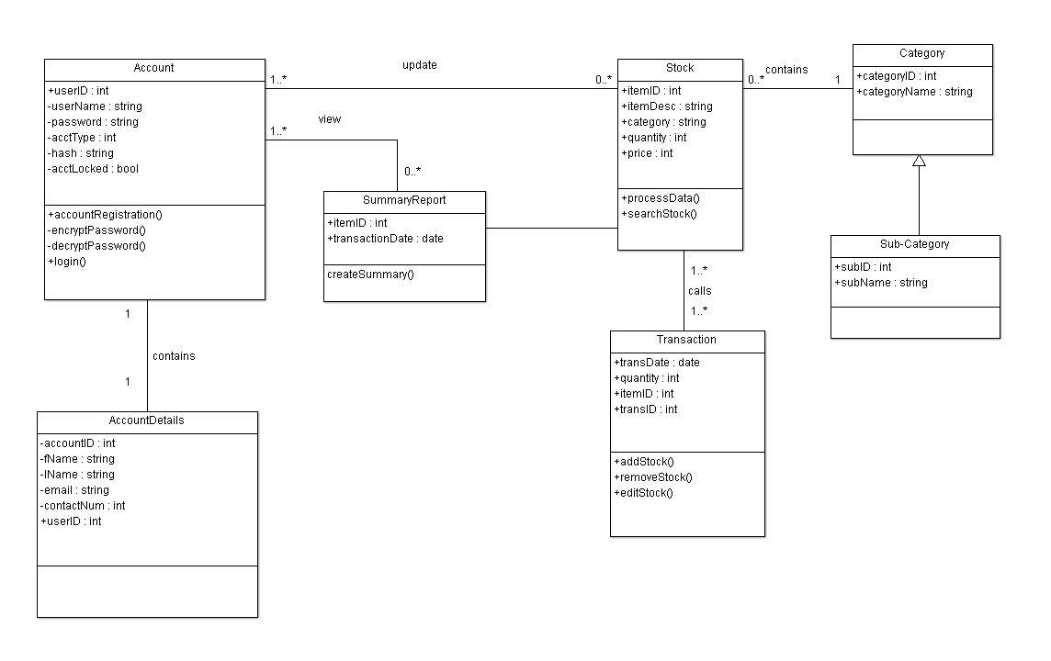
Figure 2 – Class Diagram

2.3 User Classes and Characteristics

There will be two types of users that will interact with this system: The Warehouse managers and the stock takers. Each type of user has different use for the system and thus has their own requirements.
The stock takers can only use the system to view, add, remove or append/edit stock inventory. This means that the stock takers must be able to search for specific stocks based on category and sub-category, quantity and price range. Stock takers will use this system the most.
Warehouse managers manage the overall total incoming and outgoing stock details and will only interact with the system to generate summary reports. Warehouse managers will only use
Software Requirements Specification for Warehouse Management Tool Page 5

this system at the end of a workday, end of the week and end of the month to generate these reports.

2.4 Operating Environment

The software will be running on Ubuntu 14.04 LTS operating system. Minimum hardware requirements to run this program are a single core CPU, with at least 1 GB of RAM and 120 GB HDD.

2.5 Design and Implementation Constraints

The system will be constrained by the capacity of the database. If the database is shared between multiple users, it may be forced to queue incoming requests and therefore increase the time taken to fetch data.

2.6 User Documentation

Two forms of user documentations will be provided: A user manual and video tutorials.
The User Manual will contain all important information for the user to make full use of the Warehouse Management Tool system. The manual will include a description of the system’s functions and capabilities, contingencies and alternate modes of operation, and step-by-step procedures for system access and use.
Video tutorials will include step-by-step description of the system’s functions and capabilities, contingencies and alternate modes of operation, and step-by-step procedures for system access and use.

2.7 Assumptions and Dependencies

An assumption made is that the software will always be used on PCs that have sufficient performance. If the PC does not meet the minimum requirements (see sub-section 2.4 Operating Environment) specified, there may be instances where the software does not work as intended.

Software Requirements Specification for Warehouse Management Tool Page 6

3. System Features

3.1 User Class 1 – Stock Taker

3.1.1 Add New Stock

3.1.1.1 Description and Priority
Queries user to input information regarding addition of stock into the system. Information may include stock quantity, item category, sub categories, etc. Information entered by user will then be stored into the database.
Priority – High.

3.1.1.2 Stimulus/Response Sequences
1. System displays “Add New Stock” option.
2. User selects ‘Add New Stock’ option.
3. System prompts user to input stock details.
4. User inputs the stock details.
5. System stores information in database

3.1.1.3 Functional Requirements
- Able to add records on incoming and outgoing stock easily

3.1.2 Remove Stock
3.1.2.1 Description and Priority
Queries user to input information regarding addition of stock into the system. Information may include stock quantity, item category, sub categories, etc. Information entered by user will then be stored into the database.
Priority - High.
Software Requirements Specification for Warehouse Management Tool Page 7

3.1.2.2 Stimulus/Response Sequences
1. System displays ‘Remove New Stock’ option.
2. User selects ‘Remove New Stock’ option.
3. System prompts user to input Item ID.
4. User inputs the Item ID.
5. System deleted stored information in database

3.1.2.3 Functional Requirements
1. Remove all of the stock in accordance to stock ID

3.1.3 Edit Stock Item

3.1.3.1 Description and Priority
Allows user to edit item ID, item description, item category, quantity, etc.
Priority – High.

3.1.3.2 Stimulus/Response Sequence
1. System displays ‘Edit Warehouse Stocks’ option
2. User selects ‘Edit Warehouse Stocks’ option
3. System prompts user to input Item ID.
4. User inputs the Item ID.
5. System displays an Edit Warehouse Stocks submenu
6. User selects from the following options:
- Item Description
- Item category
- Item sub-category
- Amount per unit
- Quantity of Stock

Software Requirements Specification for Warehouse Management Tool Page 8

7. User inputs changes to be made.
8. System stores changes in database.

3.1.3.3 Functional Requirements
1. Able to update incoming and outgoing stock easily

3.1.4 Search Stock Item

3.1.4.1 Description and Priority
Allows user to search for an item in the system database.
Priority – Medium.

3.1.4.2 Stimulus/Response Sequences
1. System displays ‘Search Stock’ option.
2. User selects ‘Search Stock’ option.
3. System prompts user to input Item ID.
4. User inputs the Item ID.
5. System displays stock information from database

3.1.4.3 Functional Requirements
1. Search and display based on category or sub-category
2. Search and display based on price range and quantity in ascending
or descending order
3.2 User Class 2 – Warehouse managers

3.2.1 Generate Summary Report

Software Requirements Specification for Warehouse Management Tool Page 9
3.2.1.1 Description and Priority
Generates a daily summary report.
Priority – High.

3.2.1.2 Stimulus/Response Sequence
1. System displays ‘Generate Summary Report’ option
2. User selects ‘Generate Summary Report’ option
3. System displays 4 options:
    - Generate Daily Report
    - Generate Weekly Report
    - Generate Monthly Report
    - Generate Yearly Report
4. User selects a report to generate
5. System prints out report

3.2.1.3 Functional Requirements
1. Display summary report based on daily, weekly, monthly or yearly

Software Requirements Specification for Warehouse Management Tool Page 10

4. External Interface Requirements

4.1 User Interfaces

Every user should see the login page upon opening the software, see figure 3.
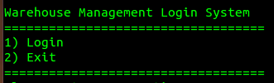
Figure 3 - Login Menu
If the user is an admin, you should see figure 4. After pressing option 1, you should see figure 5
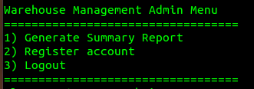
Figure 4 - Admin Menu
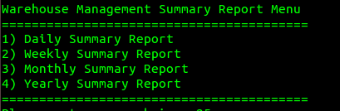
Figure 5 – Summary Report Menu

Software Requirements Specification for Warehouse Management Tool Page 11
If user is a worker, you should see figure 6. After pressing option 2, you should see figure 7
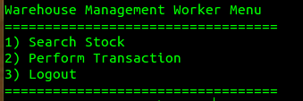
Figure 6 – Worker Menu
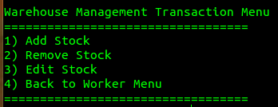
Figure 7 – Transaction Menu
4.2 Hardware Interfaces

The only hardware interface needed to control the software will be the keyboard. The keyboard will take in the user’s input for the software to operate.

4.3 Software Interfaces

The Warehouse Management Tool runs on the system terminal of Ubuntu 14.04 LTS OS. This tool communicates with a database in order to get information on the stock inventory. The communication between the software and the database will consist of both reading and writing.

4.4 Communications Interfaces

The communication between server and client in the Warehouse Management Tool requires a socket connection. In order not to lose any data in the event of power loss or other unforeseen circumstances, the data need to be backed up frequently at different offsite location.
Software Requirements Specification for Warehouse Management Tool Page 12

5. Other Nonfunctional Requirements

5.1 Performance Requirements

A read/write to the database should take no longer than 2 seconds under normal load condition. Under peak load conditions, it should take not more than 5 seconds.

5.2 Safety Requirements

This system will be up every day on high availability. Thus, the PC running this software might encounter hardware problems, software bugs or other unforeseen problems. Thus, the database should be backed-up on an external storage unit daily. In addition, with a UPS (Uninterruptible Power Source) installed into the system, the system will continue to run on emergency power if the main power source goes down.

5.3 Security Requirements

Data integrity must be of utmost importance. Via normal usage of the program, the data should not be corrupted or easily tampered with. The data must be stored in a secured and well-guarded medium.

5.4 Software Quality Attributes

The user interface of this system was designed with ease of use for the user in mind. Thus, it is presented and organized in a manner that is clear and easy for the user to navigate and understand. There will be system feedbacks when the user enters an invalid input to provide users with instructions.

Software Requirements Specification for Warehouse Management Tool Page 13

6. Other Requirements

Appendix A: Glossary

Term | Definition
OS | Operating System
PC | Personal Computer
RAM | Random Access Memory
CPU | Central Processing Unit
HDD | Hard Disk Drive
UPS | Uninterrupted Power Supply
Stock Taker | Someone who works in a warehouse and wants to use the software to track warehouse inventory
Warehouse Managers | Someone who manages a warehouse and wants to use the software to generate summary reports

Appendix B: Issues List

- NIL

