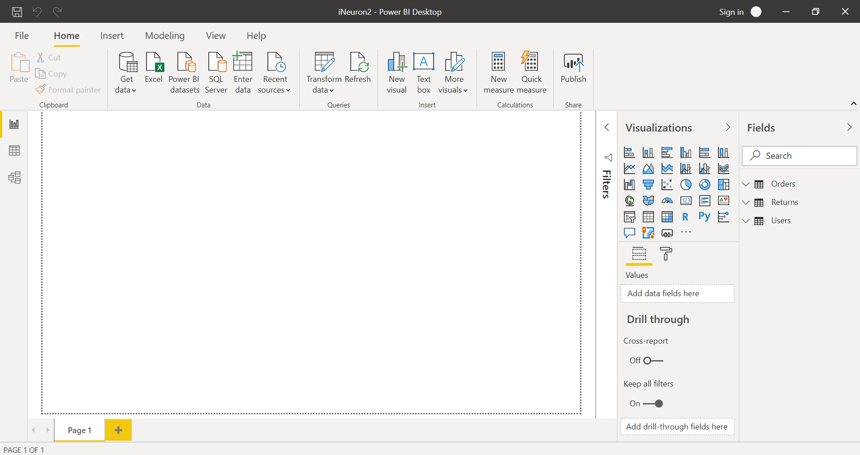

A. Report View

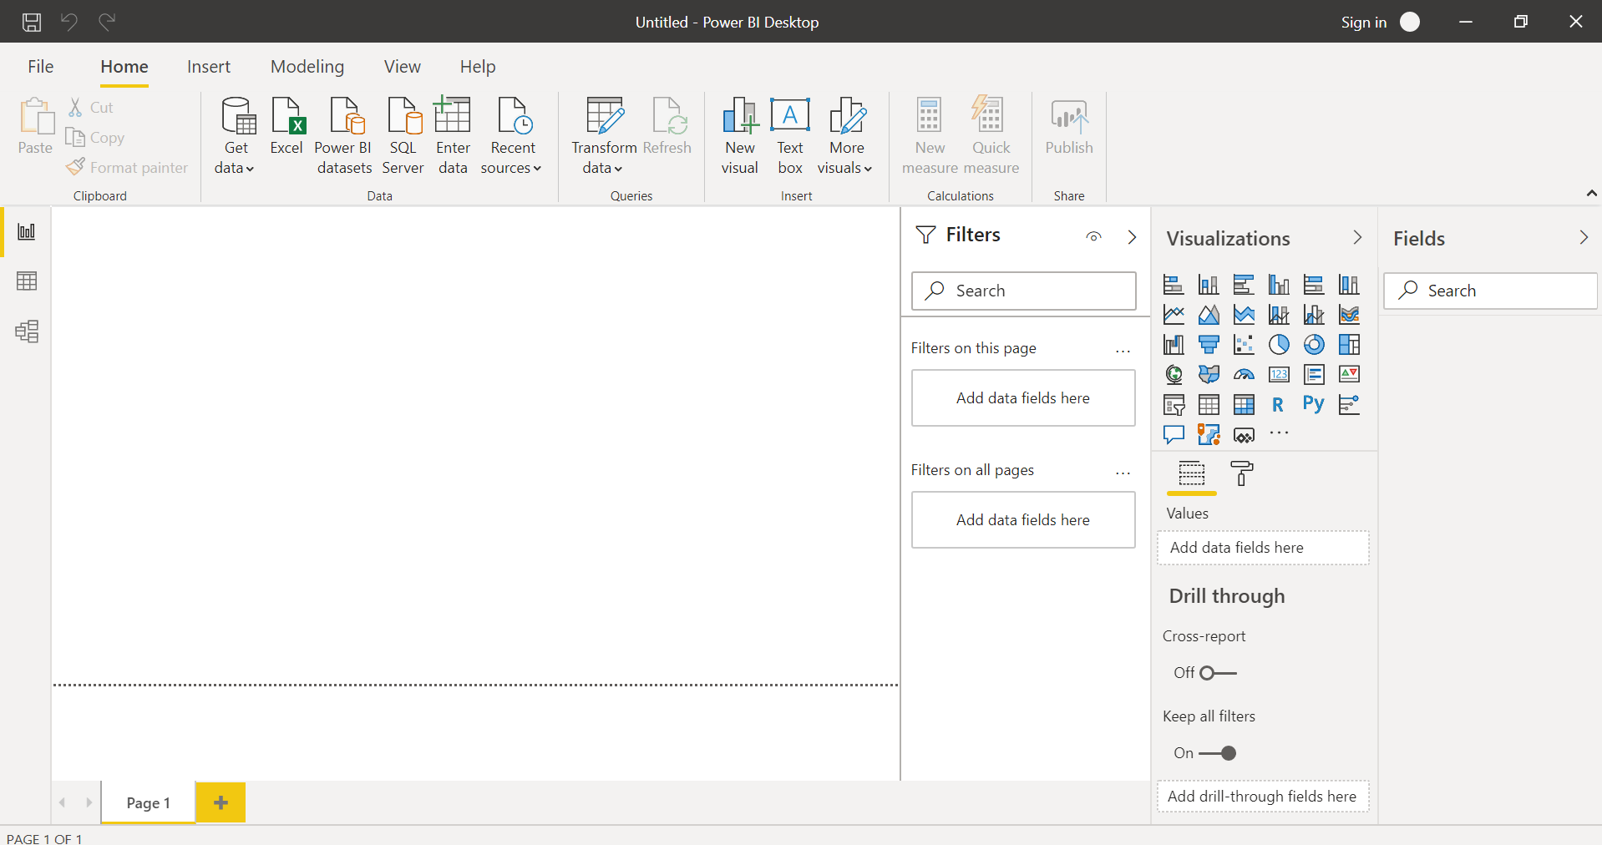

B. Data View

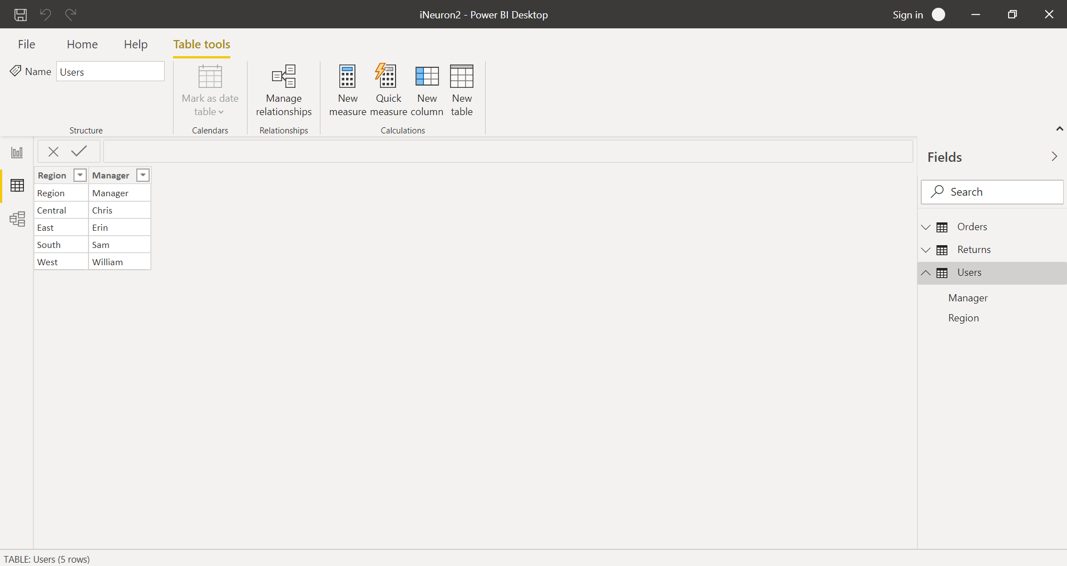

C. Model View

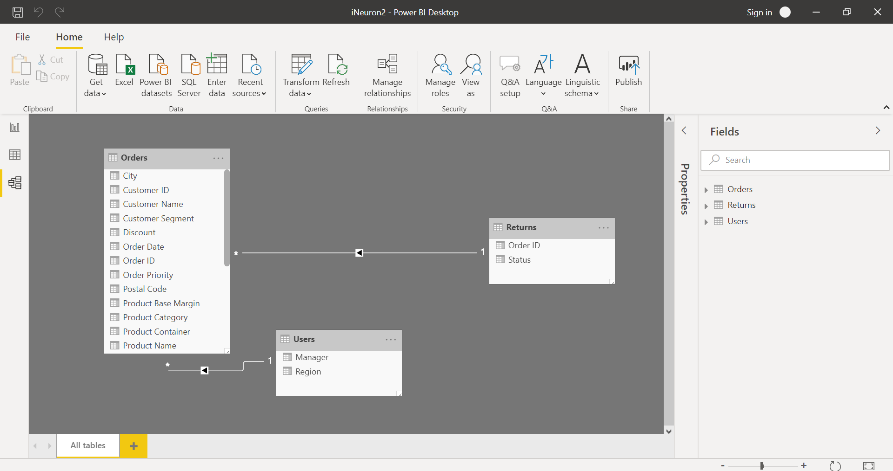

D. Power Query Editor

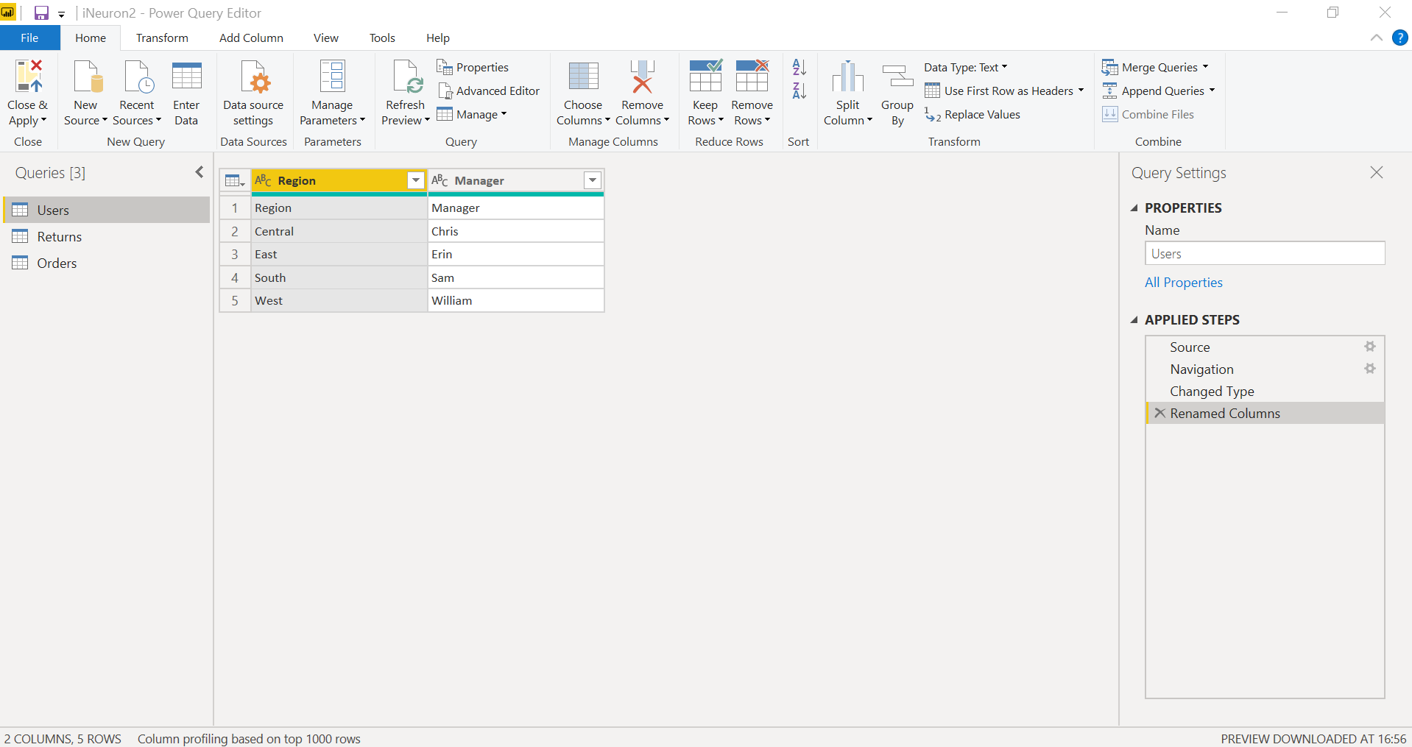

E. Advance Editor

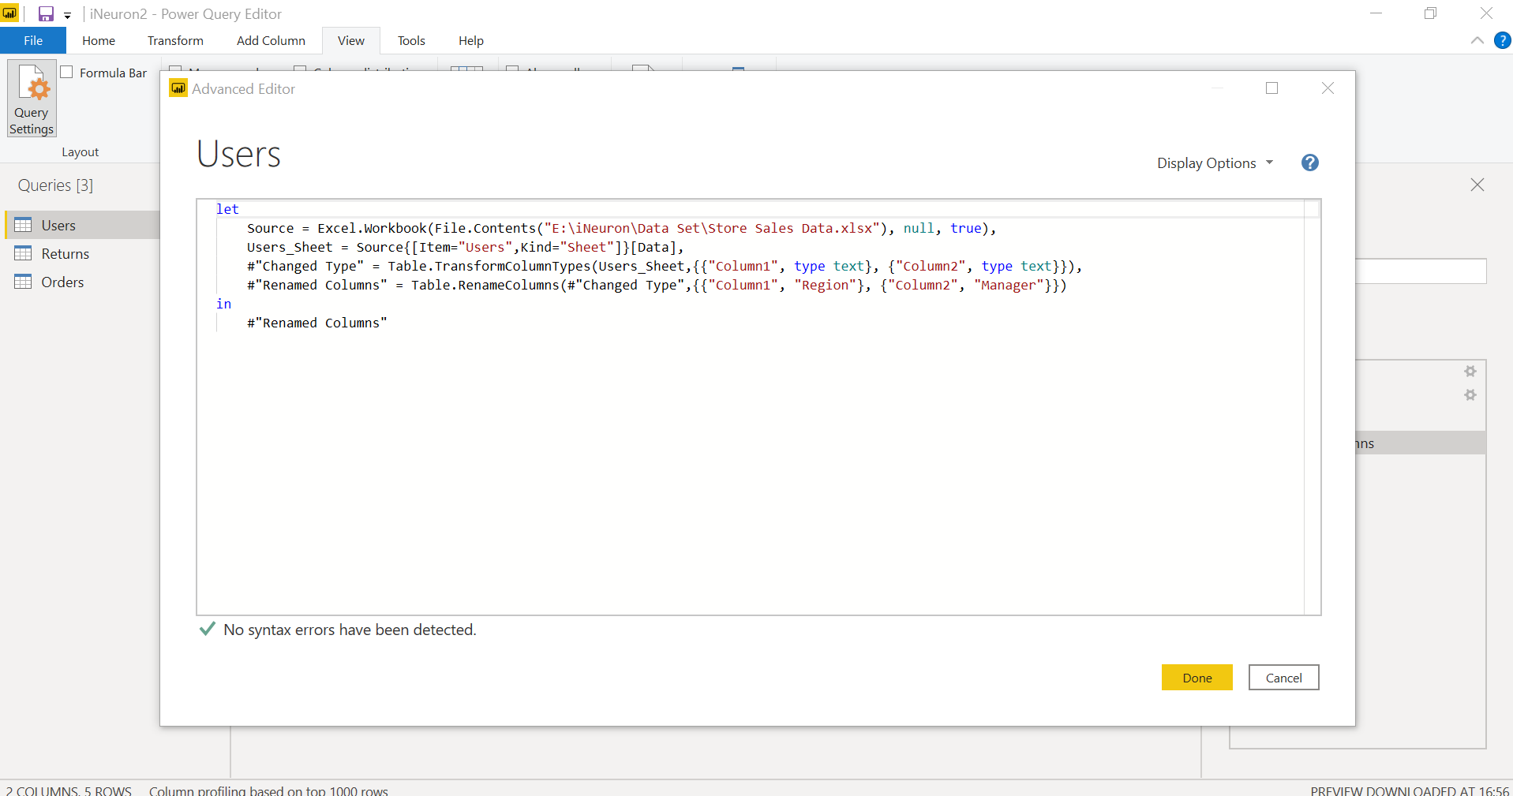

|  |  |  |
| --- | --- | --- |
| Power BI Desktop | Power BI Pro | Power BI Premium |
| Reports cannot be shared over cloud | Self-service and modern BI in the cloud | Enterprise BI, big data analytics, cloud and on-premises reporting |
| Used for editing and reporting on local machine. | Collaboration, publishing, sharing, and ad-hoc analysis | Advanced administration and deployment controls |
|  | Fully managed by Microsoft | Dedicated cloud compute and storage resources |
|  |  | Allows any user to consume Power BI content |
| Free | Rs 660 per user/month | Rs 3,30,190* |

* Monthly price per dedicated cloud compute and storage resource with annual subscription