**CASE STUDY**

**IMAGE SEGMENTATION USING LABELBOX TOOL**

**Business Impact**

**Model Accuracy: 90% Model File Size: 373 MB Training Dataset: 434 images**

**Customer Key Facts Problem Context**

Image segmentation is a very important challenge for any industry to label and track the object present on the scene with accurate boundary. It is a manual process wherein the annotator identifies the object by marking the boundaries for particular object covering each pixel as per the boundary region using the pencil sketch. e.g., car, person, etc. This is a tedious and time-consuming task for any annotator to draw irregular figures rather than bounding boxes, polyline, polygon, entity, point annotations.

However, by increasing the number of the training dataset, the time taken by the annotation reduces slowly.

Size: 30 + employees

Industry: Roadside traffic, Surveillance systems, CCTV footages

Location: Bangalore, Karnataka

**Challenges**

* Fully automated annotation and segmentation process is not supported in LabelBox tool
* Annotation on large size videos take more time due to more frames
* Proper marking of the boxes in some small size images
* Free version of this tool allows to add only 5 annotators per project

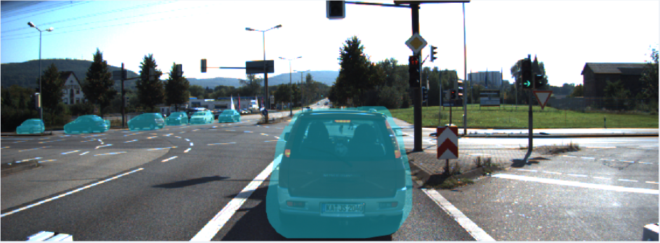

**Technologies Used**



LabelBox annotation tool

**Features**

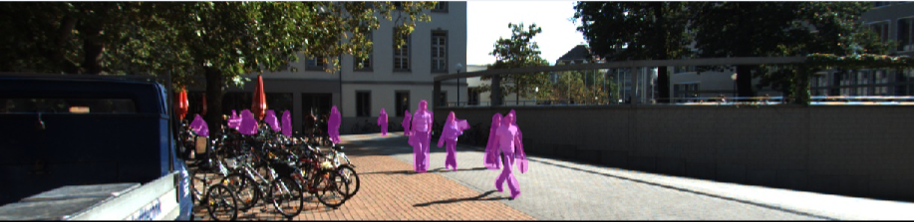

* Machine Learning powered 2D data labelling tool
* 3 times faster throughput than manual labelling
* Fast and ergonomic drawing tools
* Smooth workflow setup for easier project management
* Advanced built-in review tool for performing quality check
* Performs real-time productivity analysis for all the annotators
* Auto-scaling workforce to optimize the ML model with large training dataset
* Real-time insights

**Advantages**

* Helps to improve annotator productivity by increasing the training dataset
* Ensures high-quality annotations for our model
* Quality assurance at the pixel level
* Label the data in the way your model needs it
* Easily scalable to suit our labelling requirements
* End-to-end labelling solution

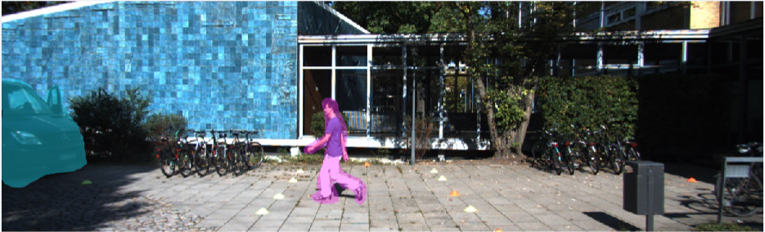

**Solution**

TPRI worked on image segmentation task using LabelBox tool to identify the accurate semantic segmentation results. This tool helps us in marking the objects in any shape like bounding box, polylines, polygon, point, entity, and segmentation. This will definitely help the surveillance departments, RTO, CCTV footages to use out method and identify any object. It will increase the productivity of tracking all the objects in an effective manner.

**Results**

* Model gives accuracy up to 90%
* Labelbox annotation tool is freely available for usage
* Easy to use solution
* Greater cost and time savings