## Time comparison

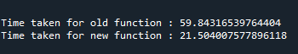

## Matching results



## Reason/s behind non-matching results

### Old function

The old function first removes the word with combination of alphabets and numbers

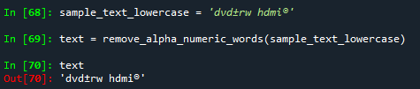

Then replaces any special characters with [space]

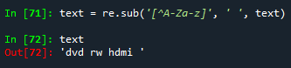

### New function

The new function directly removes all the words that do not satisfy ***isalpha()***

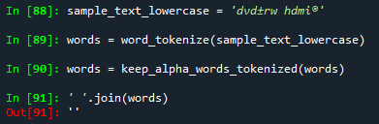

## Examples

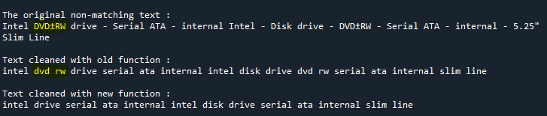

Here, the word DVD+RW was completely removed by new function.

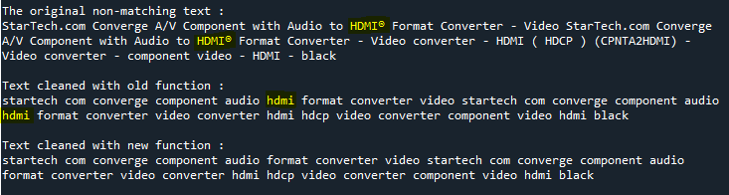

Here, the word HDMI(some special character) was completely removed by new function.