**The Old Fashion Way**

* **Group members**:
  + Ishan Gohil
  + Erik Hirschmann
  + Chengming Li
  + Nathan Mukooba
  + Kartik Sharma
* **Project Description**:

In a time of war and famine, our project attempts to resolve conflicts in a classy and respectable manner. Through our platform, we provide a lightweight browser application to allow users to bet and play pong against each other in a fast-paced and fun environment. Users can invite their friends and play the pong game in their free time. The theme of this project is pixel style. All the elements used in the project are pixeled, including the portrait of users, the pong game, the text, etc.

The technologies we used, including, HTML/CSS, EJS, Figma, NodeJS, PostgreSQL, and GitHub.

* **Project Tracker - GitHub project board**
  + Link: [The Old Fashion Way - Project Board](https://github.com/users/IshanGProjects/projects/5)

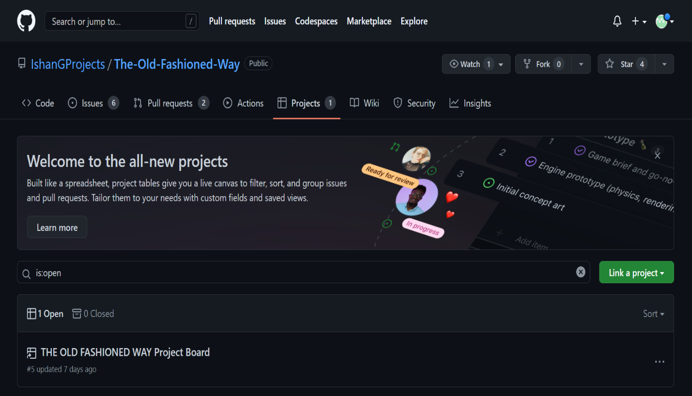

* **Video:**
  + Video Link:
* **VCS:**
  + [The Old Fashion Way – GitHub Repo](https://github.com/IshanGProjects/The-Old-Fashioned-Way)
* **Contributions:**

This should include the technologies worked on

Features that have contributed to

* + **Ishan Gohil:**
  + **Erik Hirschmann:**
  + **Chengming Li:**

I’ve been working on creating the profile page, main page, and leaderboard with the filter in this project. I also made the NodeJS function for the button linking to the profile and leaderboard pages. And the NodeJS function for the filter button inside of the leaderboard page is created by me. I also worked on writing the test plan. The technologies I’ve been working on are EJS and NodeJS for software development. Git bash is also used to control the development flow. **Nathan Mukooba:**

* + **Kartik Sharma:**
* **Use Case Diagram:**

* **Test results:**
  + **Test Case – Login/Register Page**

**Register Page:**

The user can create a unique identifier that allows him to sign onto the main page. The user needs to input their email address, username, password, and country to create a unique account.

Corner Case: the user will be told to sign into their account if the username has been used and is already defined in the database.

**Login Page:**

The user can log in to their account and will be led to the main page. The user needs to input the correct username and password to have access.

Corner Case: the user will be told to register an account if the username has not been found or is not defined in the database.

The user will be told to input the correct password for the account if the password does not match the password for this account in the database.

* + **Test Case – Main Page/ Leaderboard Page**

**Main page:**

The user can access the leaderboard page, his profile page, the pong game (two users needed), and the logout function.

The user has access to the leaderboard page by clicking the leaderboard button.

The user can access his profile page by clicking the first user’s profile button if only one user has logged in. The second user can also be logged in from the main page by clicking the user2 login button. After the second user has logged in, he also has access to his profile page.

If two users have logged in, they will have access to start the pong game by clicking the start button.

The user can log out from the account by clicking the logout button.

**Leaderboard Page:**

The user can access the leaderboard page from the main page. The leaderboard page will display the first ten users with the highest wins by default. The name, country, portrait, and total wins will be displayed on the page by default. The user can filter the leaderboard by coins via the COINS button.

If the login user or both users are on the leaderboard, their names will be colored light yellow and dark yellow.

The user can go back to the main page from the leaderboard page by clicking the BACK button.

* + **Test Case – Profile Page**

**Profile Page:**

The user can access the profile page from the main page. On the main page, users can see their portrait, name, country, battle records, and coins.

On the profile page, users can change their portrait by clicking the original portrait on the profile page. The page will be rendered to the “changeUrl” page and ask the user to provide a valid URL. An error will be thrown if the user inputs an invalid URL. On the “changeUrl” page, the user can go back to the profile page if they don’t want to the portrait.

* + **Test Case – Pong Game**

Pong Page:

* **Deployment: (Instructions)**