**SYNTHESIS OF TRI-METALLIC SULPHIDE AND IT’S CHARACTERISATION.**Name - Ishan Shrivastava  
Roll number – 210005021  
Marks scored out of 10 - /10  
BTP advisor – Prof. Rupesh S. Devan  
Comments by BTP advisor -

**Title:** Synergistic design and optimization of NiCoMnS4 nanostructures for high performance hybrid supercapacitor electrodes.

**Work done:** Literature review about NiCoMnS4 and its synthesis.

**Objective:** To synthesize NiCoMnS4 nanoparticles.

**Experiments performed: A) SYNTHESIS:**

* **10 ml DI water**
* **W = 9.31 mg**
* **0.8 m M Co(NO3)2.6H2**O
* **10 ml DI Water**
* **W = 19.97 mg**
* **6.4 m M**

**Na2S**

* **10 ml DI Water**
* **W = 8.03 mg**
* **0.8 m M**

**Mn (NO3)2.4H2O**

* **10 ml DI water**
* **W = 9.3 mg**
* **0.8 m M Ni(NO3)2.6H2O**

**Autoclave**

(T = 180 ℃; t = 12 hours)

**Furnace**

(5 times with DI Water; RPM = 4000; t = 5 minutes;

1 time with ethanol; RPM = 4000; t = 5 minutes)

**Centrifugation**

**Vacuum Drying**

(T = 80 ℃; t = 2 hours; Vacuum = -911 PV)

**Synthesis of NiCoMnS₄ nanostructures via Hydrothermal Method**

The NiCoMnS₄ nanostructures were synthesized through a hydrothermal process. Initially, four cleaned beakers were prepared, and 10 mL of deionized (DI) water was added to each using a dropper and a cleaned measuring cylinder. The respective masses of the precursor materials were then added to the beakers (weights taken are shown in Table 1.1 (NCMS 1)) .Cleaned magnetic stir bars were introduced to all four beakers, and the solutions were stirred using a magnetic stirrer for 5 minutes. Subsequently, the contents of all four beakers were combined dropwise into a single beaker while maintaining continuous stirring. The combined solution was stirred for an additional 5 minutes. The final mixture was then transferred to a cleaned Teflon liner (50 mL capacity) and sealed within a stainless steel autoclave. The autoclave was placed in an electric furnace, and the following parameters were maintained: ramp rate of 3 ℃/min, final temperature of 180 ℃, and reaction time of 12 hours. After 12 hours, the furnace was switched off, and the autoclave was allowed to cool to room temperature before opening. Upon opening, the NiCoMnS₄ powder was observed at the bottom of the Teflon liner, with a transparent fluid floating above it. The fluid was carefully removed using a dropper. The remaining solution was transferred to a cleaned centrifugation tube and subjected to centrifugation under the following conditions: 5 cycles with DI water at 4000 RPM for 5 minutes each, followed by 1 cycle with ethanol at 4000 RPM for 5 minutes. After centrifugation, the ethanol was discarded, and fresh ethanol was added. The solution was then collected in a cleaned petri dish, covered with aluminum foil with perforations to allow ethanol to evaporate, and subjected to vacuum drying at 80 ℃ for 2 hours under a vacuum of -900 PV. After drying, the heater was switched off, and the furnace was allowed to cool to room temperature before the sample was collected in a vial. Two additional samples were prepared under identical conditions using the same precursor ratios, but at a better yield. (Molarities were doubled(NCMS 2) and quadrupled(NCMS 3) respectively)

|  |  |  |
| --- | --- | --- |
|  | Molarity taken (m M) | Mass taken (mg) |
| Ni(NO3)2.6H2O | 0.8 | 9.3 |
| Co(NO3)2.6H2O | 0.8 | 9.31 |
| Mn(NO3)2.4H2O | 0.8 | 8.03 |
| Na2S | 6.4 | 19.97 |

Table 1.1

**B) XRD of the above three samples:**

The characterizations of samples were conducted using the X-ray diffraction. Diagram given below shows the XRD of our sample, the XRD peaks at 31.4°, 38.2°, 50.3° and 55.1° can be indexed to the 311, 400, 511 and 440 crystallographic plane families of cubic phase NiCo2S4 (JCPDS card no. 43-1477) or Co3S4 (JCPDS card no. 47-1738). Some impurity peaks are also present here. On literature reading it was found that it was of phases like Ni3S, NiCo2S4 etc.

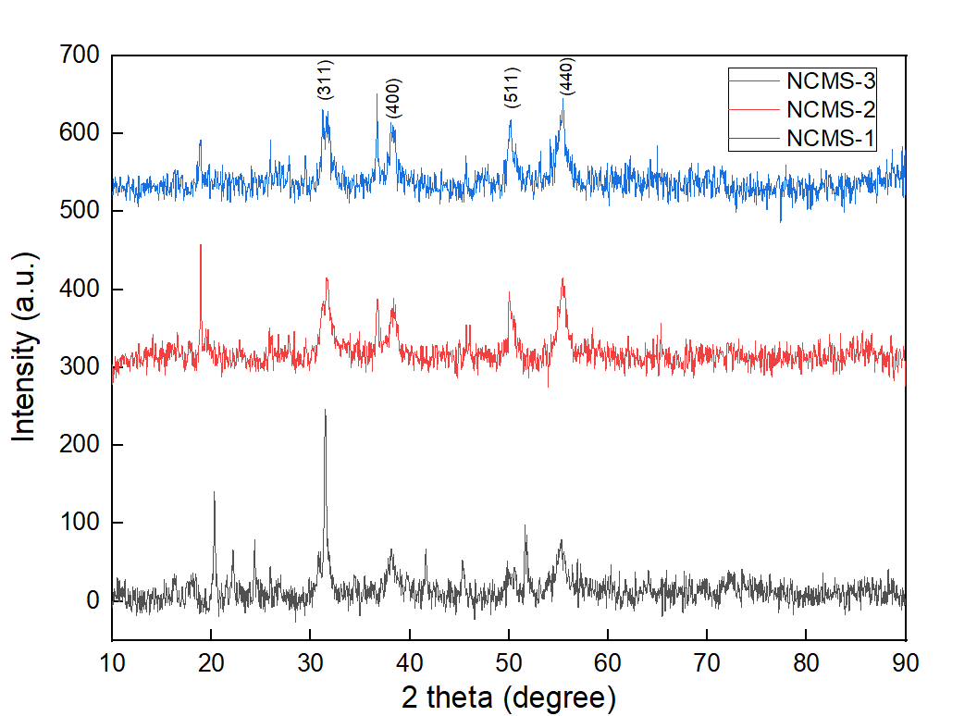

**Fig: XRD graph**

**Optimization:** Three additional samples were synthesized with varying molar ratios of Ni:Co:Mn:S to optimize the composition: 1:1:1.1:8 (NCMS-A), 1:1:1.2:8 (NCMS-B), and 1:1:1.5:8 (NCMS-C).  
  
**Future plan:** The recently synthesized NCMS-C samples (1:1:1.5:8) will undergo annealing to reduce impurity phases. Following the optimization of this process, the samples will be subjected to further characterization techniques, including Field Emission Scanning Electron Microscopy (FESEM), Cyclic Voltammetry (CV), Galvano static Charge-Discharge (GCD), X-ray Photoelectron Spectroscopy (XPS), and Electron Backscatter Diffraction (EBSD).

.

**Challenges faced:** Impurity phases being formed along with NCMS phase.  
  
**References:** <https://doi.org/10.1016/j.cej.2020.126928>