SUMMER TRAINING PROJECT REPORT
End-to-End Machine Learning Model with Monitoring, Containerization, CI/CD, and Cloud Deployment

Project Components
• Monitoring Script
• Machine Learning Prediction Model
• Docker Containerization
• Jenkins CI/CD Pipeline
• Docker Hub Image Publishing
• GitHub Source Code Publication
• Optional AWS Deployment
Prepared By: Ishan Rajpurohit
Department/Branch: CSE 2ND YEAR
Institute Name: Jodhpur Institute of Engineering and Technology
Submission Date: 25-05-2026

Certificate
This is to certify that this summer training project report titled “End-to-End Machine Learning Model with Monitoring, Containerization, CI/CD, and Cloud Deployment” is a bona fide record of the work carried out during the summer training period. The report includes the implementation of a monitoring script, machine learning prediction model, application containerization, Jenkins-based CI/CD pipeline, Docker Hub publishing, GitHub source code management, and optional AWS deployment.
Supervisor Signature: __________________________
Faculty/Project Guide: _________________________
Student Signature: _____________________________

Acknowledgement
I express my sincere gratitude to my faculty mentor, project guide, and institution for providing the opportunity to work on this summer training project. This project helped me gain practical exposure to machine learning, application monitoring, Docker containerization, continuous integration and delivery with Jenkins, Docker Hub image publishing, GitHub-based version control, and cloud deployment practices. I also acknowledge all learning resources and documentation referred to during the execution of this project.

Executive Summary
This project demonstrates a complete DevOps and machine learning workflow for a prediction application. The work begins with building a machine learning prediction model and a monitoring script to track execution or service health. The model application is then containerized using Docker, integrated into a Jenkins CI/CD pipeline, pushed to Docker Hub as an image, and stored on GitHub as a complete source repository. As an optional extension, the same solution can be deployed on AWS for cloud-based execution and monitoring. This document is designed in a professional format and includes step-by-step implementation guidance, placeholders for screenshots as proof of work, and complete source code sections for every major script.

Table of Contents
- 1. Introduction
- 2. Project Objectives
- 3. System Architecture
- 4. Tools and Technologies
- 5. Project Modules
- 6. Implementation Steps
- 7. Source Code
- 8. Screenshots and Proof of Work
- 9. Optional AWS Deployment
- 10. Challenges and Learnings
- 11. Outcome
- 12. Evaluation Scheme

1. Introduction
Modern DevOps environments involve continuous integration and continuous deployment (CI/CD) pipelines where software builds and deployments occur frequently. However, deployment failures due to configuration issues, high resource usage, failed test cases, dependency conflicts, and infrastructure instability can negatively impact software delivery.
This project focuses on developing an AI-powered deployment failure prediction system using machine learning techniques. The system predicts whether a deployment/build is likely to fail based on deployment metrics and historical build information.
The project combines machine learning, monitoring, automation, Docker containerization, Jenkins CI/CD pipelines, and dashboard visualization to create an industry-oriented AIOps solution.

2. Project Objectives
To develop a machine learning model for deployment failure prediction.
To analyze deployment metrics and build logs.
To create a deployment monitoring script for system resource tracking.
To containerize the application using Docker.
To automate workflow using Jenkins CI/CD pipeline.
To visualize deployment risk using a Streamlit dashboard.
To optionally deploy the application on cloud infrastructure.

3. System Architecture
Deployment Logs / Metrics
↓
Data Collection
↓
Machine Learning Model
↓
Deployment Risk Prediction
↓
Streamlit Dashboard
↓
Docker Containerization
↓
Jenkins CI/CD Pipeline
↓
Optional Cloud Deployment

4. Tools and Technologies
Component | Technology
Programming Language | Python
Machine Learning | Scikit-learn
Data Handling | Pandas, NumPy
Visualization | Matplotlib, Seaborn
Dashboard | Streamlit
Containerization | Docker
CI/CD | Jenkins
Version Control | GitHub
Monitoring | Python Monitoring Script

5. Project Modules
5.1 Deployment Failure Prediction Model
Machine learning models are trained using deployment metrics to predict build/deployment failures.
5.2 Streamlit Dashboard
A web dashboard allows users to enter deployment parameters and receive deployment risk predictions.
5.3 Monitoring Script
A monitoring script tracks:
- CPU usage
- Memory usage
- Resource spikes
- Warning alerts
5.4 Docker Containerization
The complete application is packaged into a Docker container for portability and deployment.
5.5 Jenkins CI/CD Pipeline
The Jenkins pipeline automates:
- Dependency installation
- Model training
- Docker image build
5.6 GitHub Repository Management
The project source code and documentation are maintained using GitHub.

6. Implementation Steps
Step 1: Generate and prepare deployment metrics dataset.
Step 2: Perform preprocessing and train machine learning models.
Step 3: Evaluate model performance using accuracy and confusion matrix.
Step 4: Save trained model using joblib.
Step 5: Develop Streamlit prediction dashboard.
Step 6: Create monitoring script for system resource tracking.
Step 7: Containerize project using Docker.
Step 8: Configure Jenkins pipeline for CI/CD automation.
Step 9: Push project to GitHub repository.
Step 10: (Optional) Deploy project using cloud infrastructure.

7. Source Code
The following subsections should contain the full source code of every important project component. Paste the exact final code used during implementation.
Recommended code files to include are listed below.

7.1 Machine Learning Training Script

import pandas as pd
import joblib
import seaborn as sns
import matplotlib.pyplot as plt

from sklearn.model_selection import train_test_split
from sklearn.ensemble import RandomForestClassifier, GradientBoostingClassifier
from sklearn.linear_model import LogisticRegression
from sklearn.metrics import accuracy_score, classification_report, confusion_matrix

print("Loading dataset...")

df = pd.read_csv('dataset/deployment_logs.csv')

print(df.head())

X = df.drop('status', axis=1)
y = df['status']

X_train, X_test, y_train, y_test = train_test_split(
X,
y,
test_size=0.2,
random_state=42
)

# Models
lr = LogisticRegression(max_iter=1000)
rf = RandomForestClassifier()
gb = GradientBoostingClassifier()

print("Training models...")

lr.fit(X_train, y_train)
rf.fit(X_train, y_train)
gb.fit(X_train, y_train)

# Predictions
lr_pred = lr.predict(X_test)
rf_pred = rf.predict(X_test)
gb_pred = gb.predict(X_test)

print("\nLogistic Regression Accuracy:", accuracy_score(y_test, lr_pred))
print("Random Forest Accuracy:", accuracy_score(y_test, rf_pred))
print("Gradient Boosting Accuracy:", accuracy_score(y_test, gb_pred))

print("\nClassification Report (Random Forest):")
print(classification_report(y_test, rf_pred))

cm = confusion_matrix(y_test, rf_pred)

plt.figure(figsize=(5,4))
sns.heatmap(cm, annot=True, fmt='d', cmap='Blues')
plt.title('Confusion Matrix')
plt.xlabel('Predicted')
plt.ylabel('Actual')
plt.savefig('confusion_matrix.png')

joblib.dump(rf, 'models/deployment_failure_model.pkl')

print("\nModel saved successfully.")
Purpose:
- Train ML models
- Evaluate performance
- Save trained model

7.2 Prediction Application Script

import streamlit as st
import numpy as np
import joblib

st.set_page_config(page_title="AI Deployment Failure Predictor")

st.title("AI Deployment Failure Predictor")

st.write("Predict whether a deployment/build may fail using ML.")

build_duration = st.slider("Build Duration (minutes)", 1, 60, 20)
error_count = st.slider("Error Count", 0, 20, 2)
failed_tests = st.slider("Failed Tests", 0, 15, 1)
cpu_usage = st.slider("CPU Usage (%)", 0, 100, 50)
memory_usage = st.slider("Memory Usage (%)", 0, 100, 50)
previous_status = st.selectbox("Previous Build Status", ["Success", "Failed"])
deployment_frequency = st.slider("Deployments Per Week", 1, 10, 3)

prev = 1 if previous_status == "Failed" else 0

model = joblib.load("../models/deployment_failure_model.pkl")

features = np.array([[
build_duration,
error_count,
failed_tests,
cpu_usage,
memory_usage,
prev,
deployment_frequency
]])

if st.button("Predict Deployment Risk"):
prediction = model.predict(features)[0]

if prediction == 1:
st.error("High Risk: Deployment Likely to Fail")
st.write("Suggestions:")
st.write("- Reduce failed test cases")
st.write("- Optimize CPU/memory usage")
st.write("- Fix dependency issues")
else:
st.success("Low Risk: Deployment Likely to Succeed")
Purpose:
- User input interface
- Deployment risk prediction
- Real-time analytics

7.3 Monitoring Script
import time
import random

print("Starting Monitoring Service...")

while True:
cpu = random.randint(20, 95)
memory = random.randint(30, 90)

print(f"CPU Usage: {cpu}% | Memory Usage: {memory}%")

if cpu > 85:
print("WARNING: High CPU usage detected!")

if memory > 80:
print("WARNING: High memory usage detected!")

time.sleep(5)
Purpose:
- CPU usage monitoring
- Memory usage monitoring
- Alert generation

7.4 requirements.txt
Contains all project dependencies:
- pandas
- numpy
- scikit-learn
- streamlit
- matplotlib
- seaborn
- joblib

7.5 Dockerfile
FROM python:3.10
WORKDIR /app
COPY . .
RUN pip install -r requirements.txt
EXPOSE 8501
CMD ["streamlit", "run", "app/app.py", "--server.address=0.0.0.0"]
Purpose:
- Containerize the application
- Create portable deployment environment

7.6 Jenkinsfile
pipeline {
agent any

stages {
stage('Clone Repository') {
steps {
git 'https://github.com/your-repo/project.git'
}
}

stage('Install Dependencies') {
steps {
sh 'pip install -r requirements.txt'
}
}

stage('Train Model') {
steps {
sh 'python train_model.py'
}
}

stage('Docker Build') {
steps {
sh 'docker build -t deployment-failure-predictor .'
}
}
}
}
Purpose:
- Automate CI/CD workflow
- Build Docker image
- Execute pipeline stages

7.7 GitHub Repository Structure
Folder structure with descriptions
[Paste Complete Source Code Here]

7.8 AWS Deployment Scripts/Commands
Optional deployment files and commands
[Paste Complete Source Code Here]

8. Screenshots and Proof of Work
This section should include screenshots of all major implementation stages as proof of execution and completion.
Add actual screenshots captured during your work, such as terminal outputs, model results, Docker build logs, Jenkins stages, Docker Hub repository, GitHub repository, and AWS deployment console.

8.1 Dataset Preparation / Model Training Output
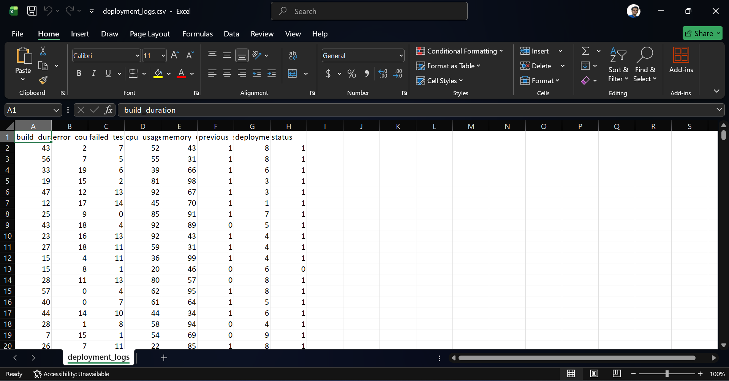

8.2 Prediction Result Output
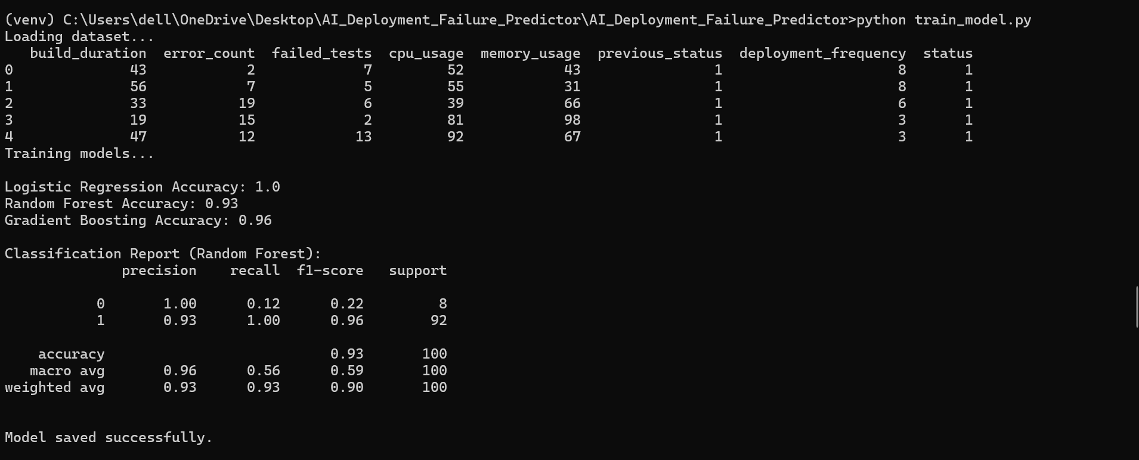

8.3 Monitoring Script Execution
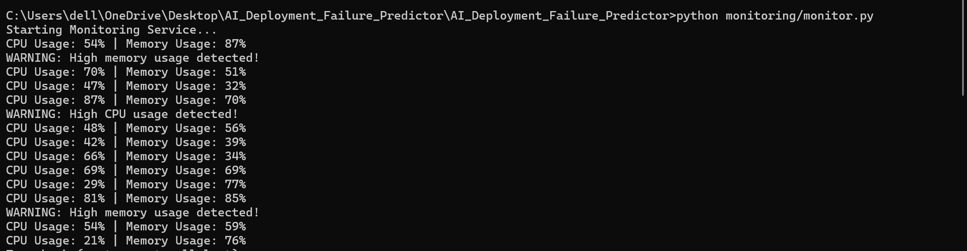

8.4 Dockerfile and Docker Build Output
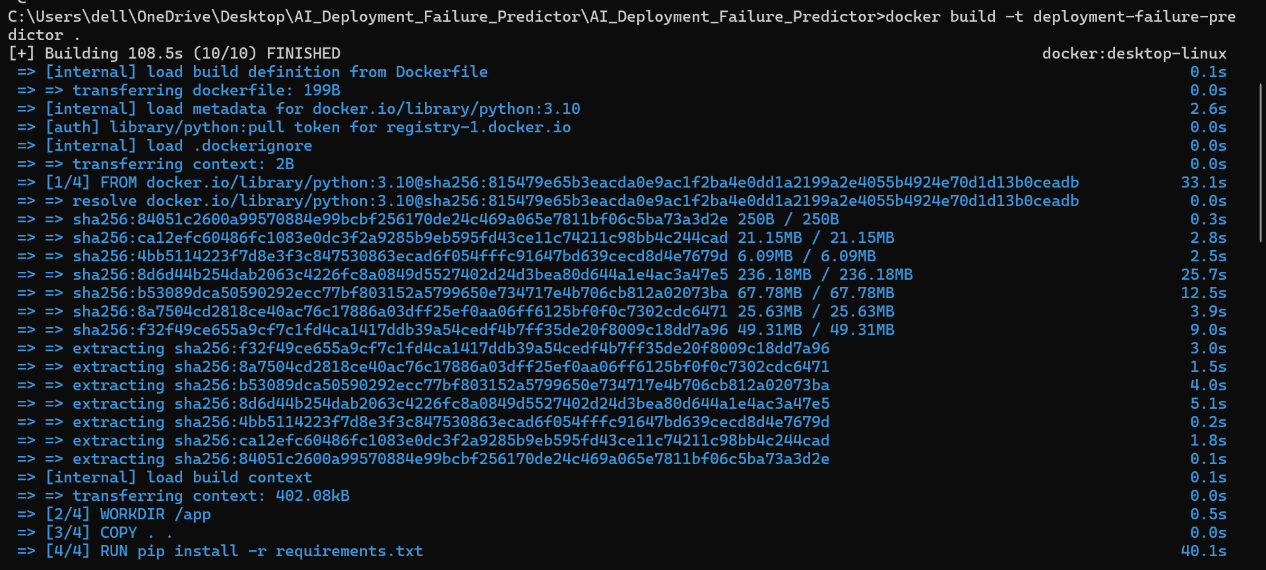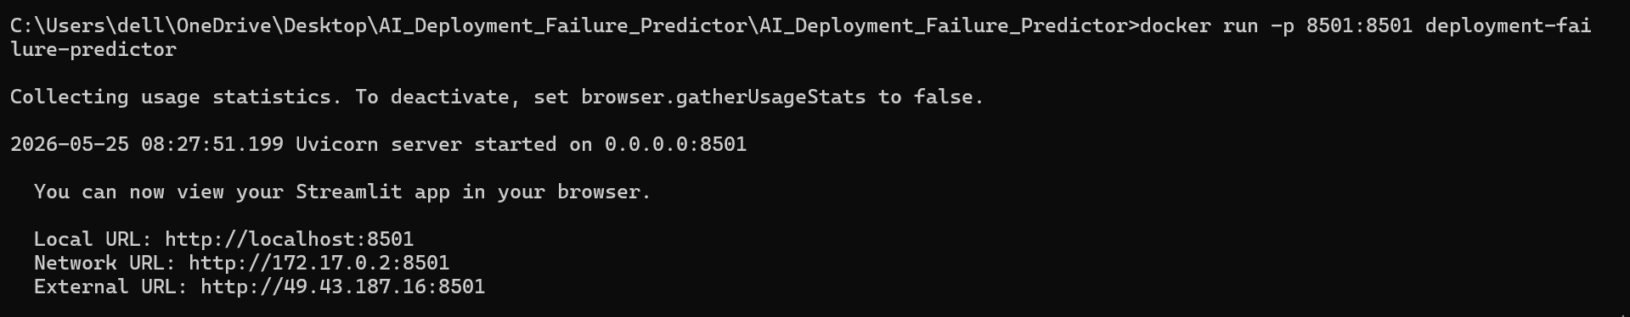

8.5 Local Container Run Output
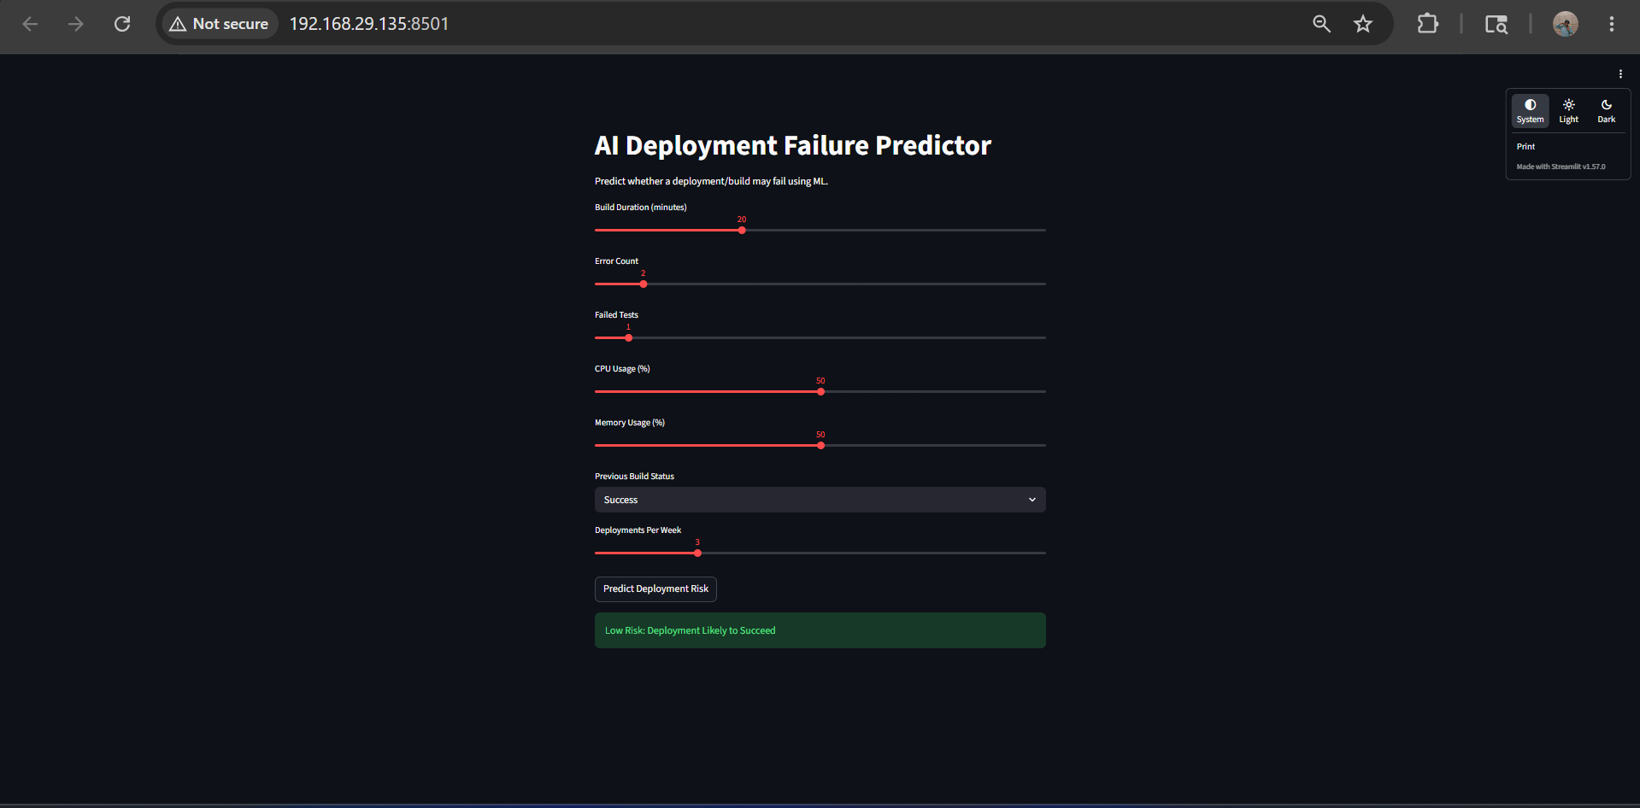

8.6 GitHub Repository Push Confirmation
[Insert Screenshot Here]
Caption: ________________________________________________
Description/Proof: _______________________________________

8.7 Jenkins Dashboard and Pipeline Stages
[Insert Screenshot Here]
Caption: ________________________________________________
Description/Proof: _______________________________________

8.8 Docker Hub Image Repository
[Insert Screenshot Here]
Caption: ________________________________________________
Description/Proof: _______________________________________

8.9 Optional AWS Deployment Screenshots
[Insert Screenshot Here]
Caption: ________________________________________________
Description/Proof: _______________________________________

9. Optional AWS Deployment
The optional deployment can be performed on AWS by launching an EC2 instance, installing Docker, pulling the published image from Docker Hub, and running the application container.
The monitoring script can either run within the same instance, as a separate container, or through scheduled execution using cron/systemd. Security groups, instance access, and environment variables should be configured properly.

10. Challenges and Learnings
Possible challenges in this project include dependency conflicts, model packaging issues, Jenkins plugin configuration, Docker authentication, webhook setup, and environment-specific runtime errors.
The project strengthens knowledge of ML workflow design, container lifecycle, CI/CD automation, source control discipline, and deployment readiness.
Challenges
- Creating realistic deployment dataset
- Managing model file paths
- Docker container configuration
- Streamlit integration
Learnings
- Machine learning workflow
- CI/CD automation
- Docker containerization
- Monitoring and analytics
- Streamlit dashboard development

11. Outcome
The final outcome is an AI-powered deployment failure prediction system integrated with DevOps and monitoring practices.
The project demonstrates:
- Machine learning implementation
- Dashboard development
- Monitoring automation
- Docker containerization
- Jenkins CI/CD integration

12. Conclusion
This project demonstrates how machine learning can be integrated with DevOps practices to improve deployment reliability and infrastructure monitoring. By analyzing deployment metrics and predicting deployment failures, the system helps reduce operational risks and supports proactive deployment management.
The integration of machine learning, Docker, Jenkins, monitoring scripts, and dashboard visualization makes the project industry-oriented and aligned with modern AIOps practices.

