SUPPORTING DOCUMENTS REPORT
Subject Code: ES-453 (7th Semester)
Design and Development of Interactive Data Visualisation Modules for a Solar PV Smart O&M Monitoring Portal
Submitted in partial fulfilment of the
Requirements for the award of
Degree of Bachelor of Technology in Information Technology

Submitted By:
Name of Student: Ishan Bhattacharya
Enrollment No.: 08514803123 (7I4)
Under the Guidance of:
Faculty Guide: ______________________
Industry Mentor: Mr. Manav Gupta, PV Doctor Pte. Ltd.
Head of Department: Prof. (Dr.) Amita Goel
SUBMITTED TO:
Department of Information Technology
MAHARAJA AGRASEN INSTITUTE OF TECHNOLOGY
GGSIPU, DELHI
Academic Session 2026–27

INDEX
Table of Contents:
1. Final Submission & Viva Document Checklist 1
2. Offer / Internship Agreement (ID number masked) 2
3. Internship Completion Certificate 8
4. NOC Status Note 9
5. Industry Mentor and Organisation Details 10
6. Declaration by Student 11
7. Work Evidence – Intern Task Tracker Extracts 12
8. Work Evidence – Portal Screenshots 16
Annexure:
1. Mid-Internship Verification Record 19
2. Weekly Logbooks (Appendix D) 20
3. Industry Mentor Feedback Form (Appendix F) 37
4. Student Feedback Form (Appendix G) 38
5. Course Exit Survey (Appendix H) 39
6. CO–PO/PSO Mapping (Appendix J) 40
7. SDG Mapping (Appendix K) 41

1. FINAL SUBMISSION & VIVA DOCUMENT CHECKLIST
MAHARAJA AGRASEN INSTITUTE OF TECHNOLOGY
DEPARTMENT OF INFORMATION TECHNOLOGY
FINAL SUBMISSION & VIVA DOCUMENT CHECKLIST
7th Semester – ES-453 | Academic Session 2026–27
Final Viva Window: 12–16 October 2026
Student Name: Ishan Bhattacharya Roll No.: 08514803123 Group: 7-I-4
Faculty Counsellor: ______________________________ Track: Industrial Internship
Industrial Internship
☑ Offer Letter
☑ Weekly Logbook (Appendix D)
☑ Completion Certificate
☑ Industry Mentor Feedback (Appendix F)
☑ Student Feedback (Appendix G)
☑ Course Exit Survey (Appendix H)
☑ Internship Report (Appendix I)
☑ CO–PO/PSO Mapping (Appendix J)
☑ SDG Mapping (Appendix K)
Research Internship
☐ Acceptance Letter
☐ Weekly Research Logbook (Appendix D)
☐ Completion Certificate
☐ Research Supervisor Feedback (Appendix F)
☐ Student Feedback (Appendix G)
☐ Course Exit Survey (Appendix H)
☐ Research Report (Appendix I)
☐ CO–PO/PSO Mapping (Appendix J)
☐ SDG Mapping (Appendix K)
SWAYAM / NPTEL
☐ Registration Proof
☐ Weekly Learning Logbook (Appendix D)
☐ Assignment / Quiz Records
☐ Final Certificate
☐ Grade Card
☐ Student Feedback (Appendix G)
☐ Course Exit Survey (Appendix H)
☐ Course Report (Appendix I)
☐ CO–PO/PSO Mapping (Appendix J)
☐ SDG Mapping (Appendix K)
Mandatory Requirements
☑ Training/course must be relevant to the branch of study.
☑ Weekly logbook/progress record must be maintained.
☑ Professional conduct, attendance and ethics must be maintained.
☑ Work/course must be mapped with relevant SDG(s), POs and PSOs.
☑ Report must follow Appendix I and be submitted as a verified Spiral Bound copy plus Word and PDF soft copies.
☑ Do not include confidential source code, proprietary datasets, credentials or restricted organizational information in the report.
SWAYAM/NPTEL: credits/marks are finalized only after verified successful completion evidence; Final Certificate and Grade Card are required.
Additional evidence, where applicable: GitHub/portfolio links, LinkedIn project showcase, publication, patent/IPR, or demo video.
Student Signature: ____________________ Date: 12 October 2026 Faculty Counsellor Verification: ____________________ Date: __________

2. OFFER / INTERNSHIP AGREEMENT
Internship Agreement between PV Doctor Pte. Ltd. and Ishan Bhattacharya, dated 4 May 2026 (6 pages). The personal identification number on page 2 has been masked.
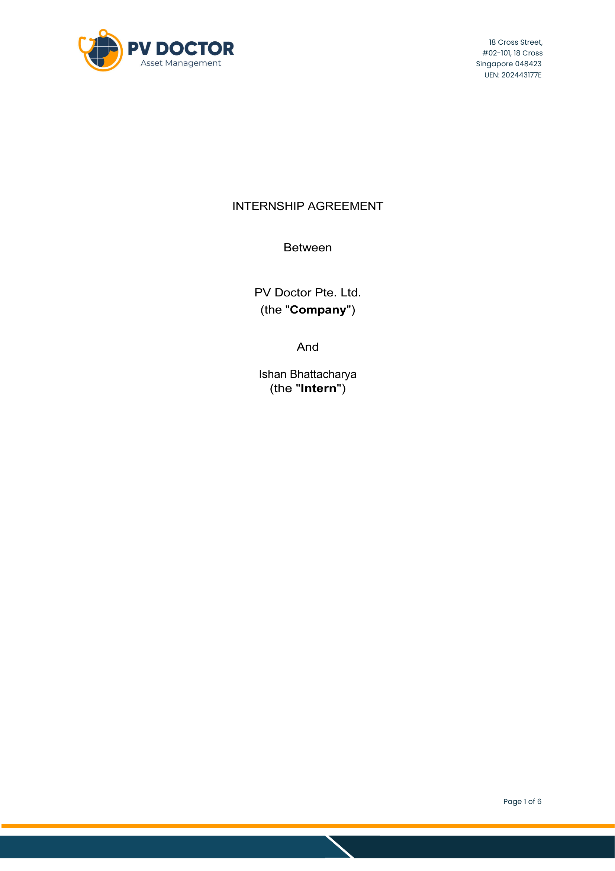

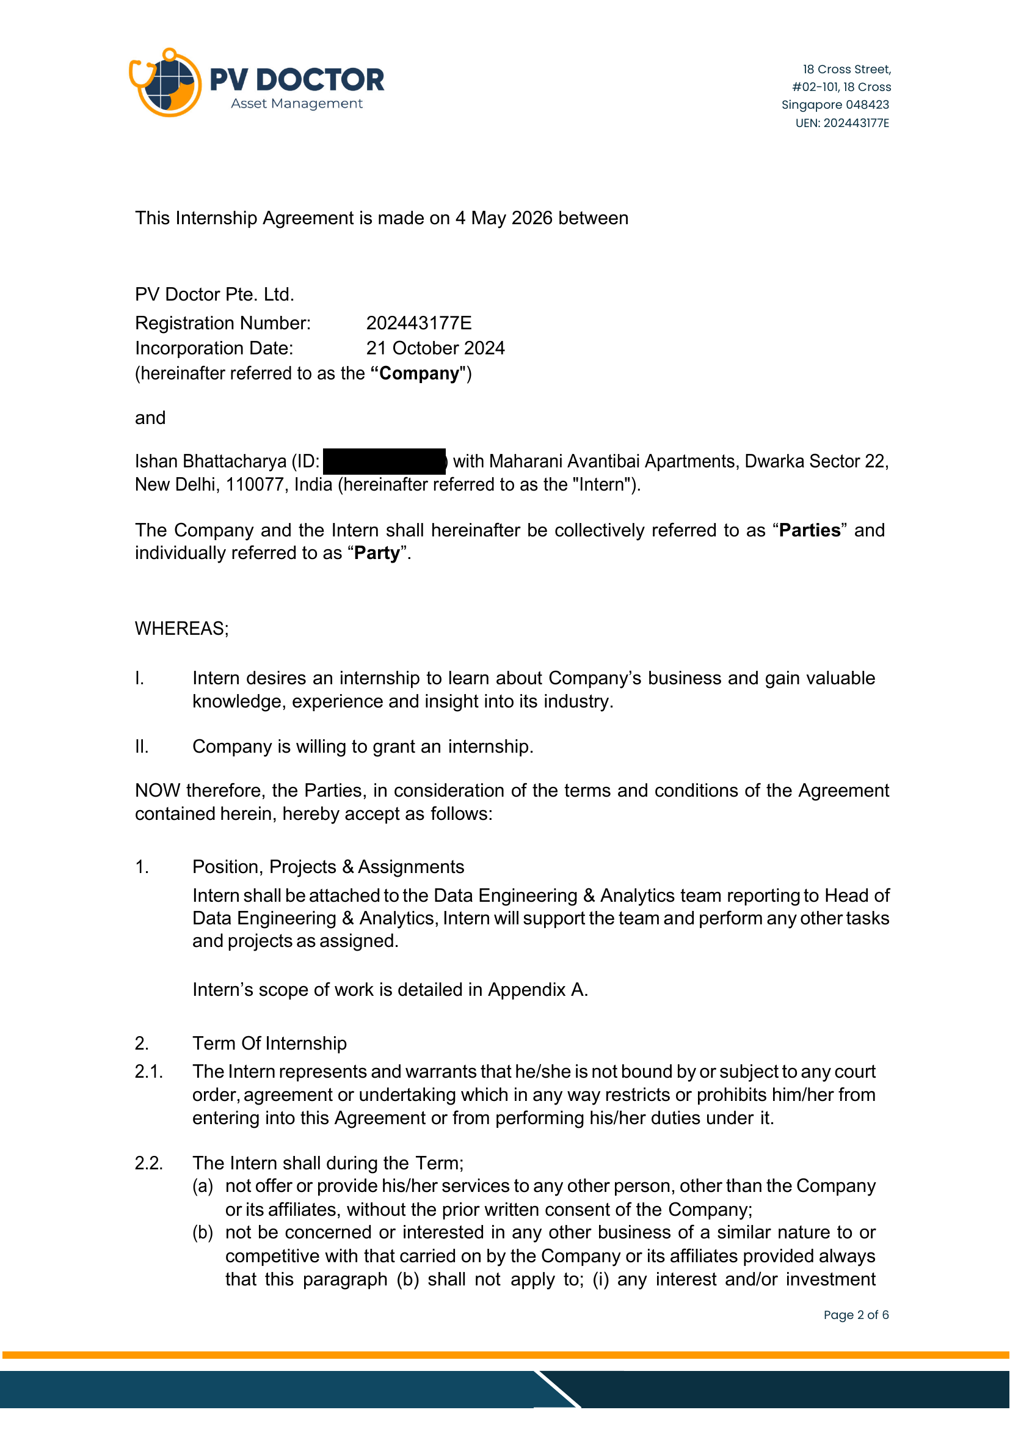

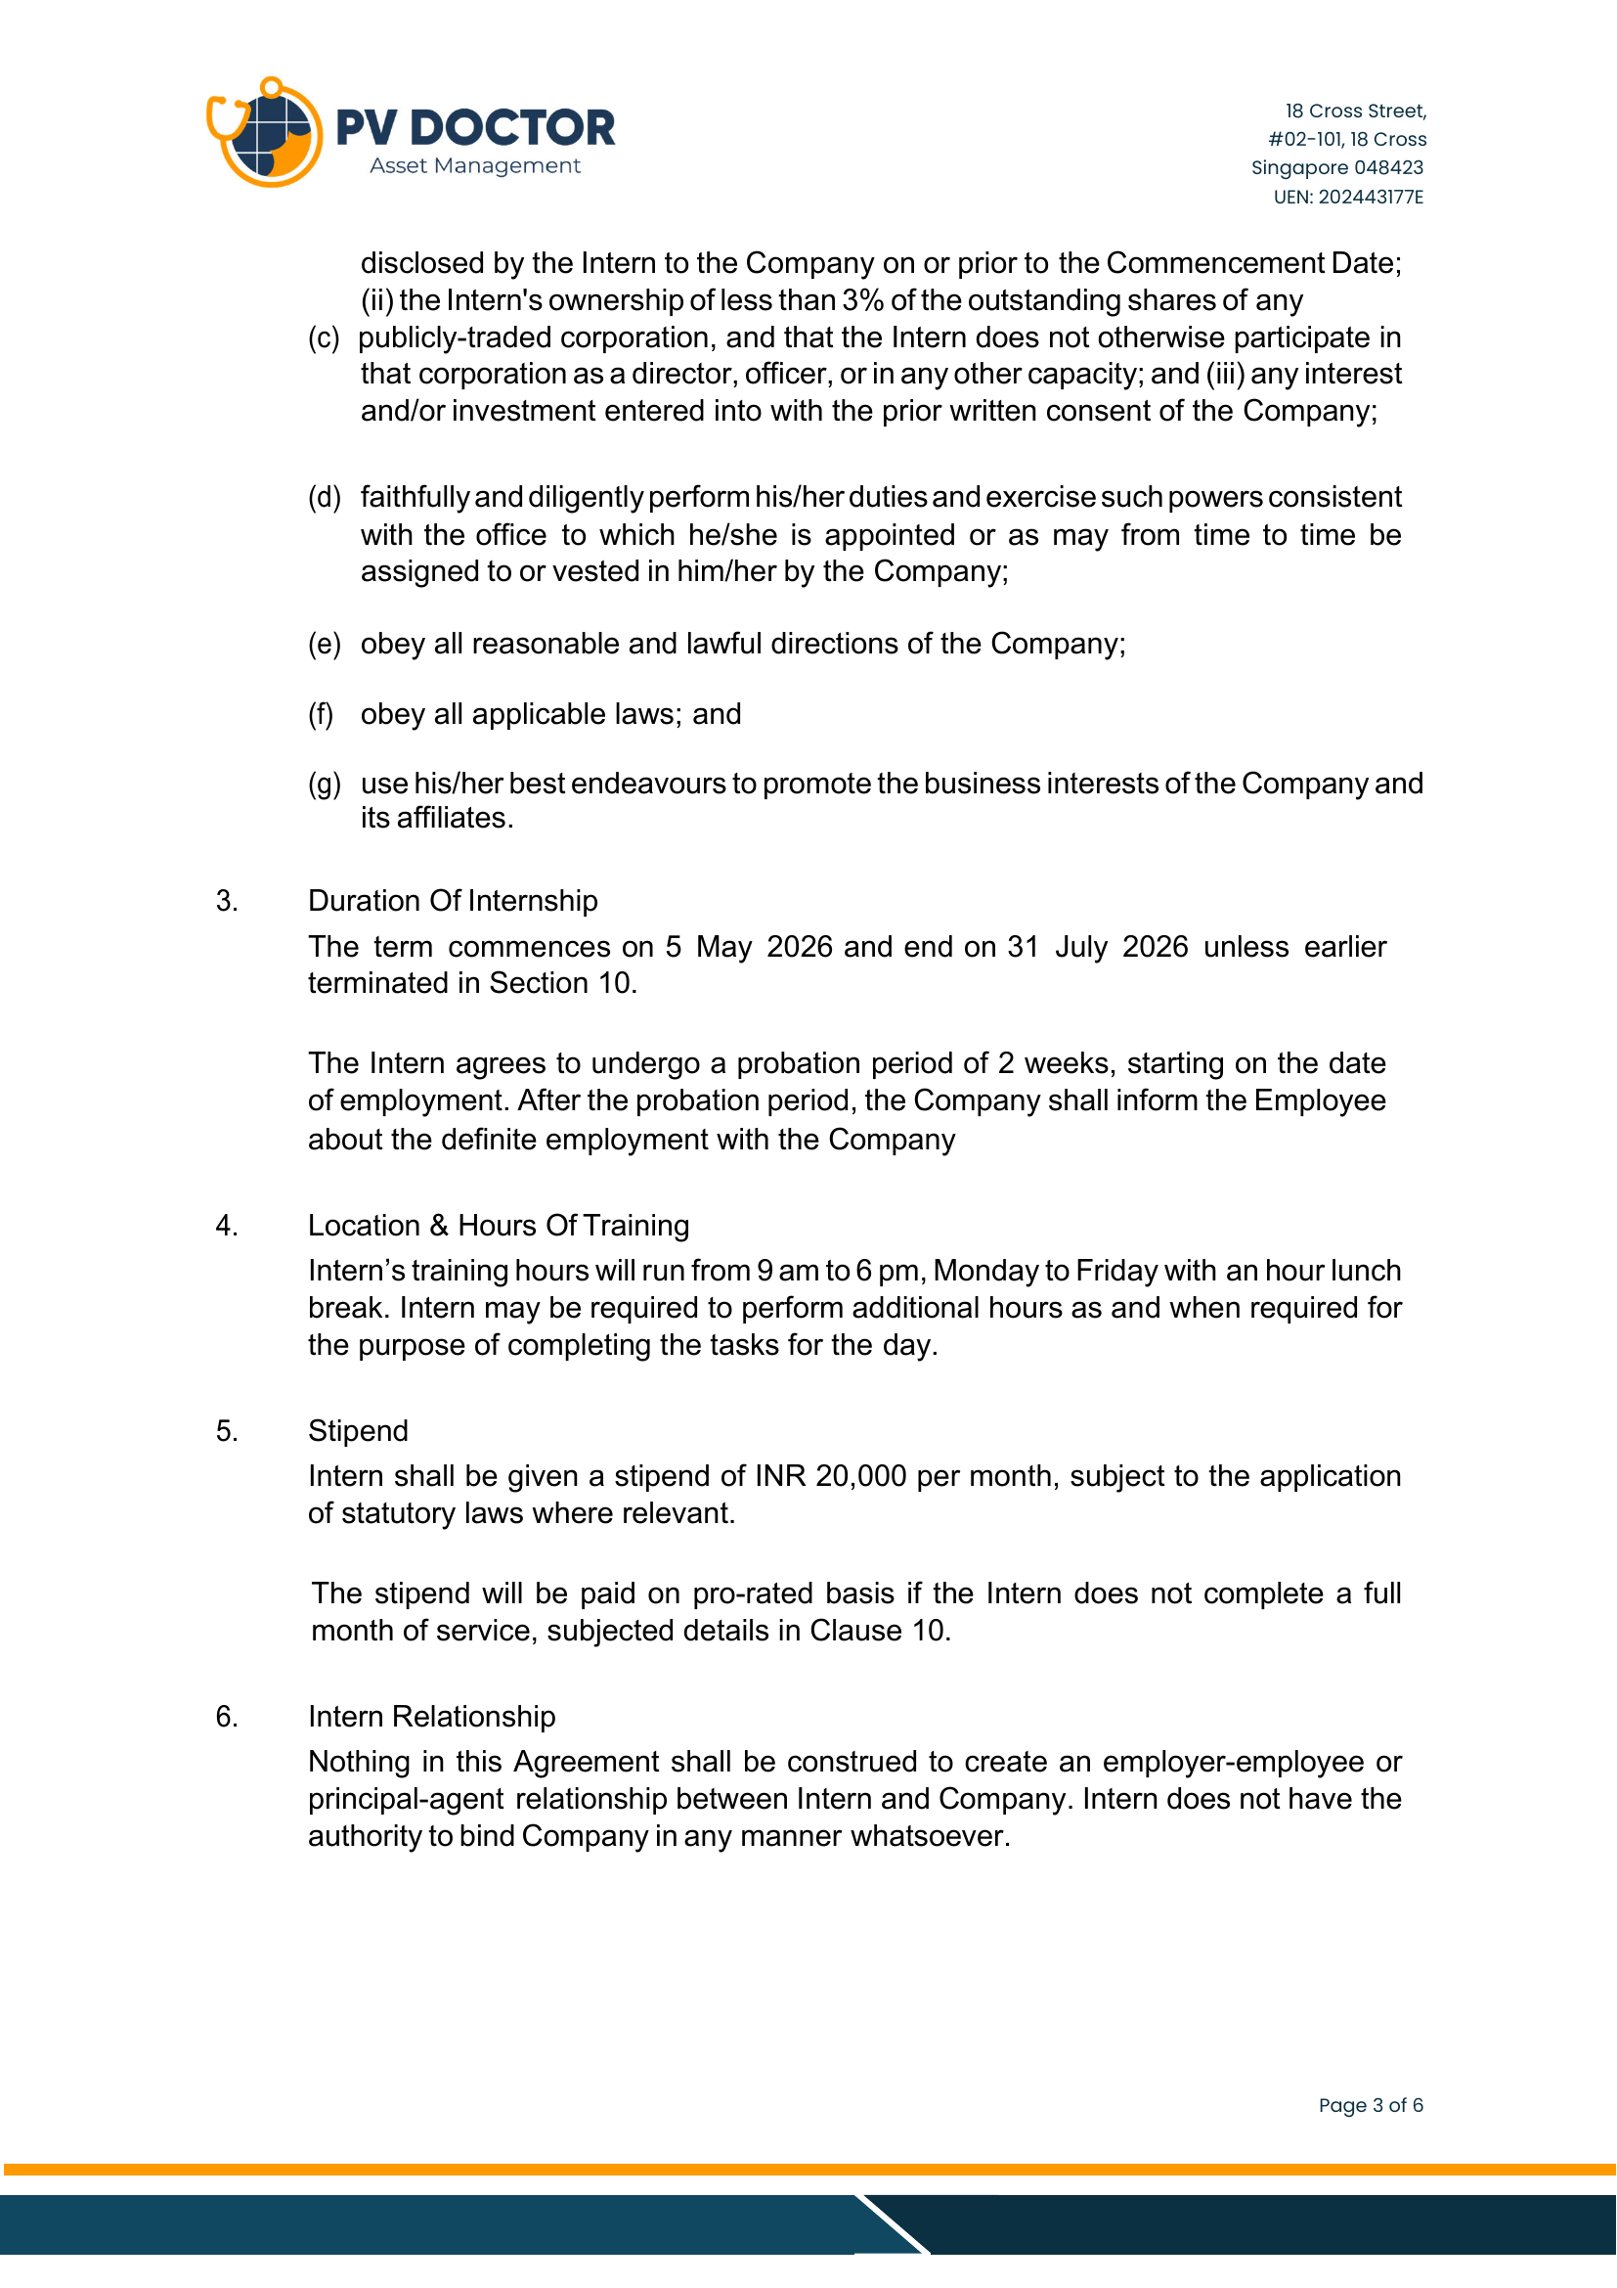

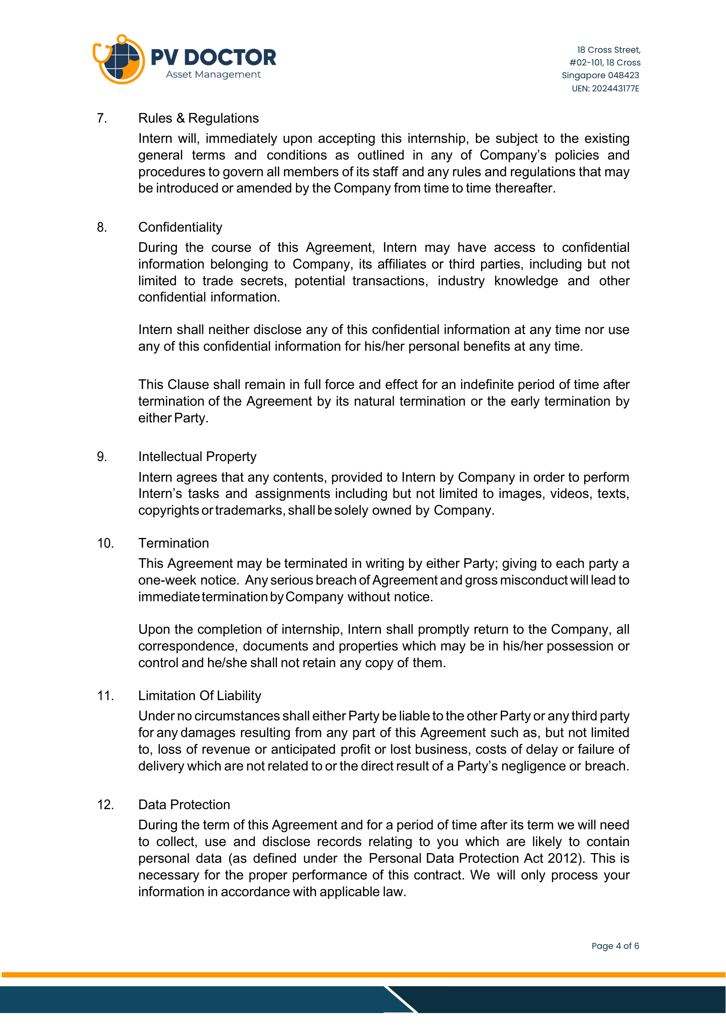

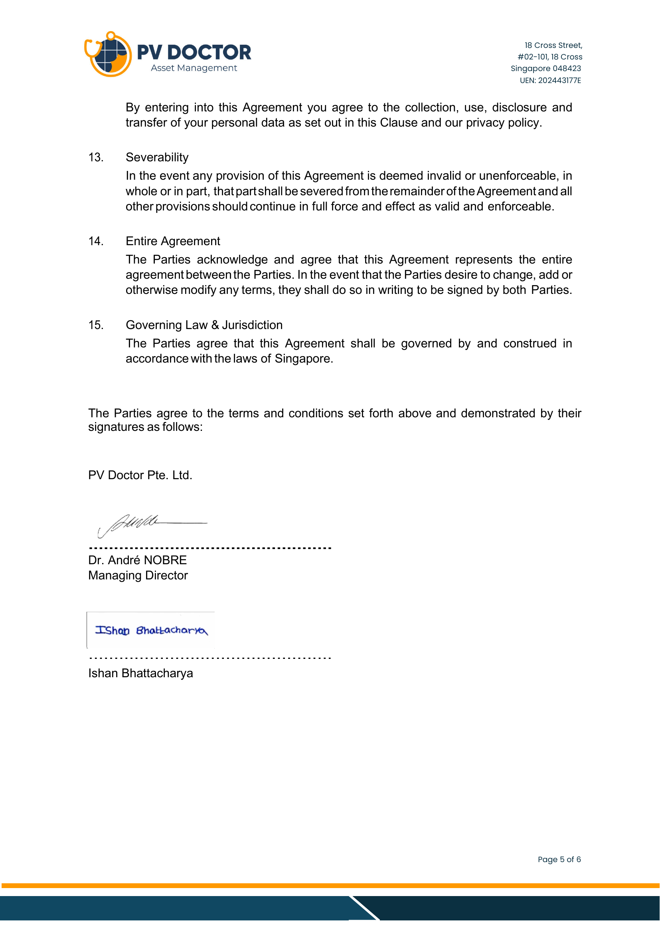

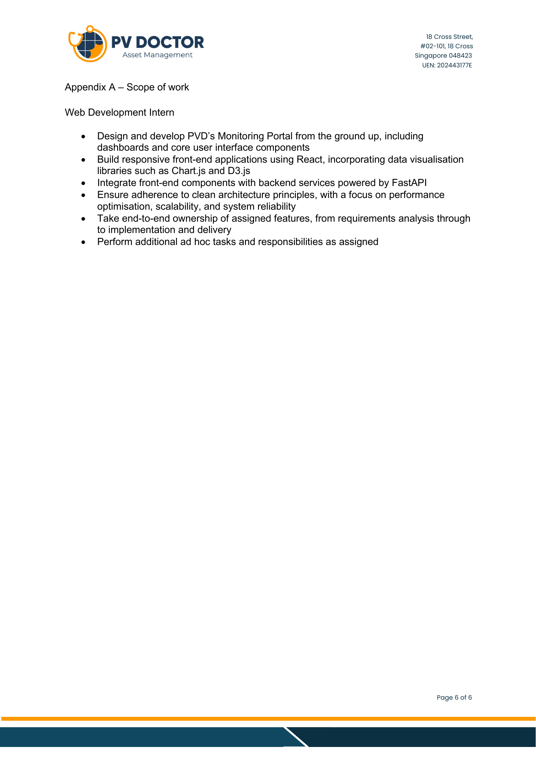

3. INTERNSHIP COMPLETION CERTIFICATE
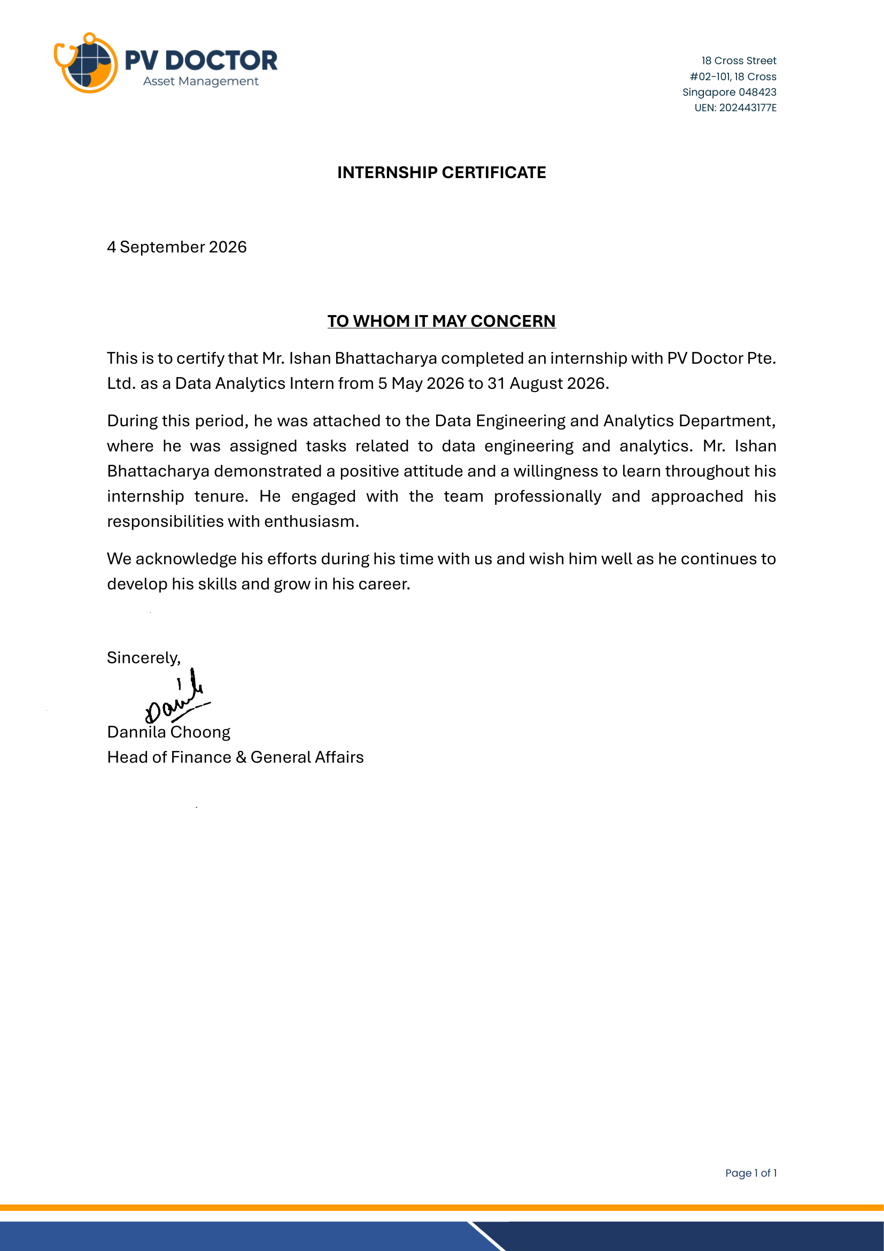

4. NOC STATUS NOTE
MAHARAJA AGRASEN INSTITUTE OF TECHNOLOGY
Department of Information Technology
NOC (No Objection Certificate) – Status Note

Student Name: Ishan Bhattacharya
Enrollment No.: 08514803123
Counselor Group: 7-I-4
Department: Information Technology

Regarding: NOC for Summer Internship/Training at PV Doctor (Singapore, Remote)

This internship was fully remote, and the company (PV Doctor) did not require or ask for a No Objection Certificate as part of onboarding. Hence, no NOC was obtained.

______________________________
Ishan Bhattacharya
08514803123

5. INDUSTRY MENTOR AND ORGANISATION DETAILS
Table 1: Mentor and organisation details
Particular | Details
Organisation | PV Doctor Pte. Ltd., 18 Cross Street, #02-101, Singapore 048423 (UEN 202443177E)
Website / Portal | www.pv.doctor | portal.pv.doctor
Department | Data Engineering & Analytics
Industry Mentor | Name: Mr. Manav Gupta  Designation: Head of Data Engineering & Analytics  E-mail / Phone: +91 97175 20052
HR / Administration contact | Ms. Dannila Choong, Head of Finance & General Affairs (signatory of the internship certificate)
Managing Director | Dr. André Nobre (signatory of the internship agreement)
Company contact (public) | SmartOM.IT@pv.doctor | WhatsApp +65 8896 0180
Student role | Data Analytics Intern – Web Development of the Smart O&M Monitoring Portal
Duration / Mode | 5 May 2026 to 31 August 2026 (17 weeks) – Remote
Stipend | INR 20,000 per month

6. DECLARATION
I hereby declare that the Training Report entitled "Design and Development of Interactive Data Visualisation Modules for a Solar PV Smart O&M Monitoring Portal" is an authentic record of my own work as requirements of 17 weeks Training during the period from 5 May 2026 to 31 August 2026 for the award of degree of B.Tech. (Information Technology), GGSIPU, under the guidance of Mr. Manav Gupta, Head of Data Engineering & Analytics, PV Doctor Pte. Ltd., Singapore.

Signature of Student: ______________________________
Name of Student: Ishan Bhattacharya
University Roll No.: 08514803123
Date: 12 October 2026

Certified that the above statement made by the student is correct to the best of our knowledge and belief.
Examined by:

1. ______________________________ 2. ______________________________
Industry Mentor / Research Supervisor Faculty Counsellor

Head of Department (Signature and Seal): ______________________________

7. WORK EVIDENCE – INTERN TASK TRACKER EXTRACTS
Daily entries submitted in PV Doctor's intern task tracker. Only the student's own rows are reproduced. Days without an entry (weekends, leave) are omitted.
Table 2: Task tracker – June 2026
Date | Day | Hrs | Task / activity description
01 Jun 2026 | Monday | 8 | Standardized Reset button CSS across the application; Removed unnecessary bottom legend section from Daily Generation; Removed Day / Month / Year labels from the UI; Updated period labels to CM, LT (Lifetime), and LY (Last Year); Fixed Playback tooltip behavior while paused; Added graph-consistent border styling to Playback; Added thousand separators for Playback values; Updated PR Evolution:; Matched Yield's color, shape, and filter behavior; Added comma-separated formatting in the subheading.
02 Jun 2026 | Tuesday | 0 | On leave.
03 Jun 2026 | Wednesday | 0 | On leave.
04 Jun 2026 | Thursday | 0 | On leave.
05 Jun 2026 | Friday | 8 | Fixed Daily Generation issue where CM + 2026 only displayed June; corrected period-selection logic; Fixed Hindsight view where only the last month of the selected year was visible; Applied the same visibility fix to Custom Date Range; Enhanced Irradiation vs Yield aggregation logic:; For custom ranges spanning multiple years but under 365 days, data now displays monthly aggregation with Month + Year labels; Restricted PR Evolution zooming to the X-axis only; Performed testing and validation of date-range, aggregation, and chart behavior fixes across affected modules.
08 Jun 2026 | Monday | 8 | Added multi-select functionality for Inverter MFM G2 filters; Implemented reset/clear filter action matching Plant Monitoring behavior; Updated filter UI to auto-adjust width based on selected text length; Reviewed and aligned G2 filter interactions with existing Plant Monitoring patterns; Fixed styling inconsistencies in G2 filter container and dropdown states; Investigated and corrected border rendering issues in G2 widgets/components.
09 Jun 2026 | Tuesday | 8 | Refined G2 grid layout to match Plant Monitoring's subtle grid appearance; Performed UI polish and responsive behavior testing for multi-select controls; Adjusted spacing and alignment of legends within PR Evolution charts; Increased separation between chart legends and graph area for improved readability; Conducted cross-screen validation of updated layouts and chart spacing; Performed regression testing to ensure filter updates did not impact existing monitoring views; Minor visual consistency fixes across G2 monitoring components.
10 Jun 2026 | Wednesday | 0 | On leave.
11 Jun 2026 | Thursday | 0 | On leave.
12 Jun 2026 | Friday | 0 | On leave.
15 Jun 2026 | Monday | 0 | On leave.
16 Jun 2026 | Tuesday | 8 | Fix Heatmap Today case (match COV); Fix date formats (Today, Yesterday, LT, Single Date → D); Remove filters when only one option exists; Single Year → show full range only, no extra filters; Custom Range (2 points) → default LT, keep dropdown; Single-day Custom Range → default 30D, keep dropdown; COV monthly data → fix X-axis (D); Remove divider lines in COV; Test all date/filter combinations.
17 Jun 2026 | Wednesday | 8 | Rotate Yield graph 180°; Fix Y-axis in Yield-PR graph; Increase spacing between legends and graph in PR Evolution; Increase Z-order for selected items in Yield-PR graph; Validate graph rendering after changes.
18 Jun 2026 | Thursday | 8 | Plant Monitoring → fix Y-axis (D); Apply Plant Monitoring subtle grid styling to Inverter MFM; Check/fix G2 border; Add multi-select filter in Inverter MFM; Add Reset button; Auto-adjust filter width based on text length; Attach G1/G2/G3 to Inverter & MFM filters; Test all filter combinations and reset behavior.
19 Jun 2026 | Friday | 8 | Updated Portfolio Overview reset functionality to fully reset component state along with selected filters; Fixed reset behavior to ensure map filters are also cleared and synchronized with UI state; Corrected decimal precision and rounding inconsistencies in Portfolio Overview metrics and values; Fixed decimal point formatting issues in Spatial Heatmap visualizations and tooltips; Added logic to hide sensitive/informational sections for demo account users; Validated filter reset flows across Portfolio Overview and map views; Performed UI consistency checks and regression testing for formatting and account-based visibility changes; Minor bug fixes and code cleanup related to state management and display formatting.
22 Jun 2026 | Monday | 8 | Added a Year/Day toggle in the Yield PR graph, allowing users to switch between yearly and daily views based on their analysis needs; Updated COV Graph visualization to dynamically adjust point sizes according to the selected toggle, improving readability and reducing visual clutter; Modified Spatial Heatmap deviation display to show values with 1 decimal place instead of 2, improving consistency and readability across the dashboard; Performed testing and validation to ensure graph interactions, filtering behavior, and data presentation remained accurate after the updates.
23 Jun 2026 | Tuesday | 8 | Refactored the Heatmap implementation to remove duplicate code and improve reusability across graph components; Consolidated common graph logic to reduce maintenance overhead and improve code structure; Fixed a UI issue in the Yield PR Graph where special symbols (+, ×, and *) were not visible under certain conditions; Testing to see if they still exist.
24 Jun 2026 | Wednesday | 8 | Worked on additional bug fixes and improvements for the Yield PR Graph; Reimplemented Heatmap Playback functionality and validated behavior; Continued refactoring of COV Graph and Stacked Bar Chart components to reduce duplicate code and move towards a shared implementation; Make pr, for bug fixes in the code. g1g2g3 pr not raised yet.
25 Jun 2026 | Thursday | 8 | Completed Refactored the CoV chart implementation for both Inverter and Meter monitoring pages; Refactored the Heatmap chart implementation for both Inverter and Meter monitoring pages; Refactored the Stacked Bar Chart (G2) implementation for both Inverter and Meter monitoring pages; Performed testing and validation of all refactored graph components to ensure functionality and data consistency; Addressed issues identified during testing and verified graph behavior across supported scenarios; Created and raised a Pull Request for the completed refactoring changes.
26 Jun 2026 | Friday | 8 | Worked on connecting System Information to the Period Filter; Updated monitoring.py to support custom access for System Information; Refactored the backend logic to ensure seamless integration with the Period Filter; Performed end-to-end testing across multiple sites to validate the implementation; Verified functionality and confirmed expected behavior across different user access levels; Fixed minor issues identified during testing and improved overall stability; Reviewed the implementation for edge cases and ensured compatibility with existing features; Cleaned up and optimized the related code for better readability and maintainability.
29 Jun 2026 | Monday | – | Fixed bugs in the filter logic and updated the fetch flow for a client site; Improved responsive layout for smaller screen sizes, especially the Overview page KPIs; Adjusted KPI breakpoints to improve screen space utilization; Performed testing across different screen sizes and verified the fixes; Fixed minor UI issues found during testing.

Table 3: Task tracker – August 2026
Date | Day | Hrs | Task / activity description
03 Aug 2026 | Monday | 4 | Fixed layout spacing and padding across the Spatial Heatmap container.
04 Aug 2026 | Tuesday | 4 | Implemented AC Power/Energy exclusivity in Raw Data and fixed Net PR corridor calculations.
05 Aug 2026 | Wednesday | 4 | Synchronized date handling across PR Evolution, Raw Data, and Spatial Heatmap.
06 Aug 2026 | Thursday | 4 | Fixed mixed-resolution granularity detection and completed the interactive Spatial Heatmap.
07 Aug 2026 | Friday | 4 | Added MFM-wise inverter dropdowns, improved legends, and implemented dynamic SolarGIS granularity.
10 Aug 2026 | Monday | 4 | Fixed graph scrollbar clipping and refined Spatial Heatmap statistics and PR Evolution filters.
11 Aug 2026 | Tuesday | 4 | Updated PR Evolution corridor and historical averages; aligned chart styling across monitoring views.
12 Aug 2026 | Wednesday | 4 | Integrated PR Evolution and Spatial Heatmap changes into staging.
13 Aug 2026 | Thursday | 4 | Added reference sensor support to Raw Data queries and improved scrollbar visibility.
14 Aug 2026 | Friday | 4 | Refined Spatial Heatmap scaling and tooltips; adjusted Generation chart and ranking layouts.
18 Aug 2026 | Tuesday | 4 | Implemented batched external reference sensor resolution and fixed Spatial Heatmap scrolling.
19 Aug 2026 | Wednesday | 4 | Fixed client-site raw data and reference sensor handling for multi-site sensor setups.
20 Aug 2026 | Thursday | 4 | Stabilized backend raw data routing and integrated the latest staging changes.
21 Aug 2026 | Friday | 4 | Added multi-orientation SolarGIS support and optimized parallel raw-data queries, caching, and heatmap labels.
24 Aug 2026 | Monday | 4 | Refactored the monitoring.py pull request, reducing the implementation from 700+ lines to 289 lines while retaining the required monitoring functionality.
25 Aug 2026 | Tuesday | 4 | Added tests for auth and files.py, along with additional test files covering contact, health, preference, and stats.

8. WORK EVIDENCE – PORTAL SCREENSHOTS
Screenshots from the public demo account of portal.pv.doctor (anonymised demo sites) showing modules developed during the internship.
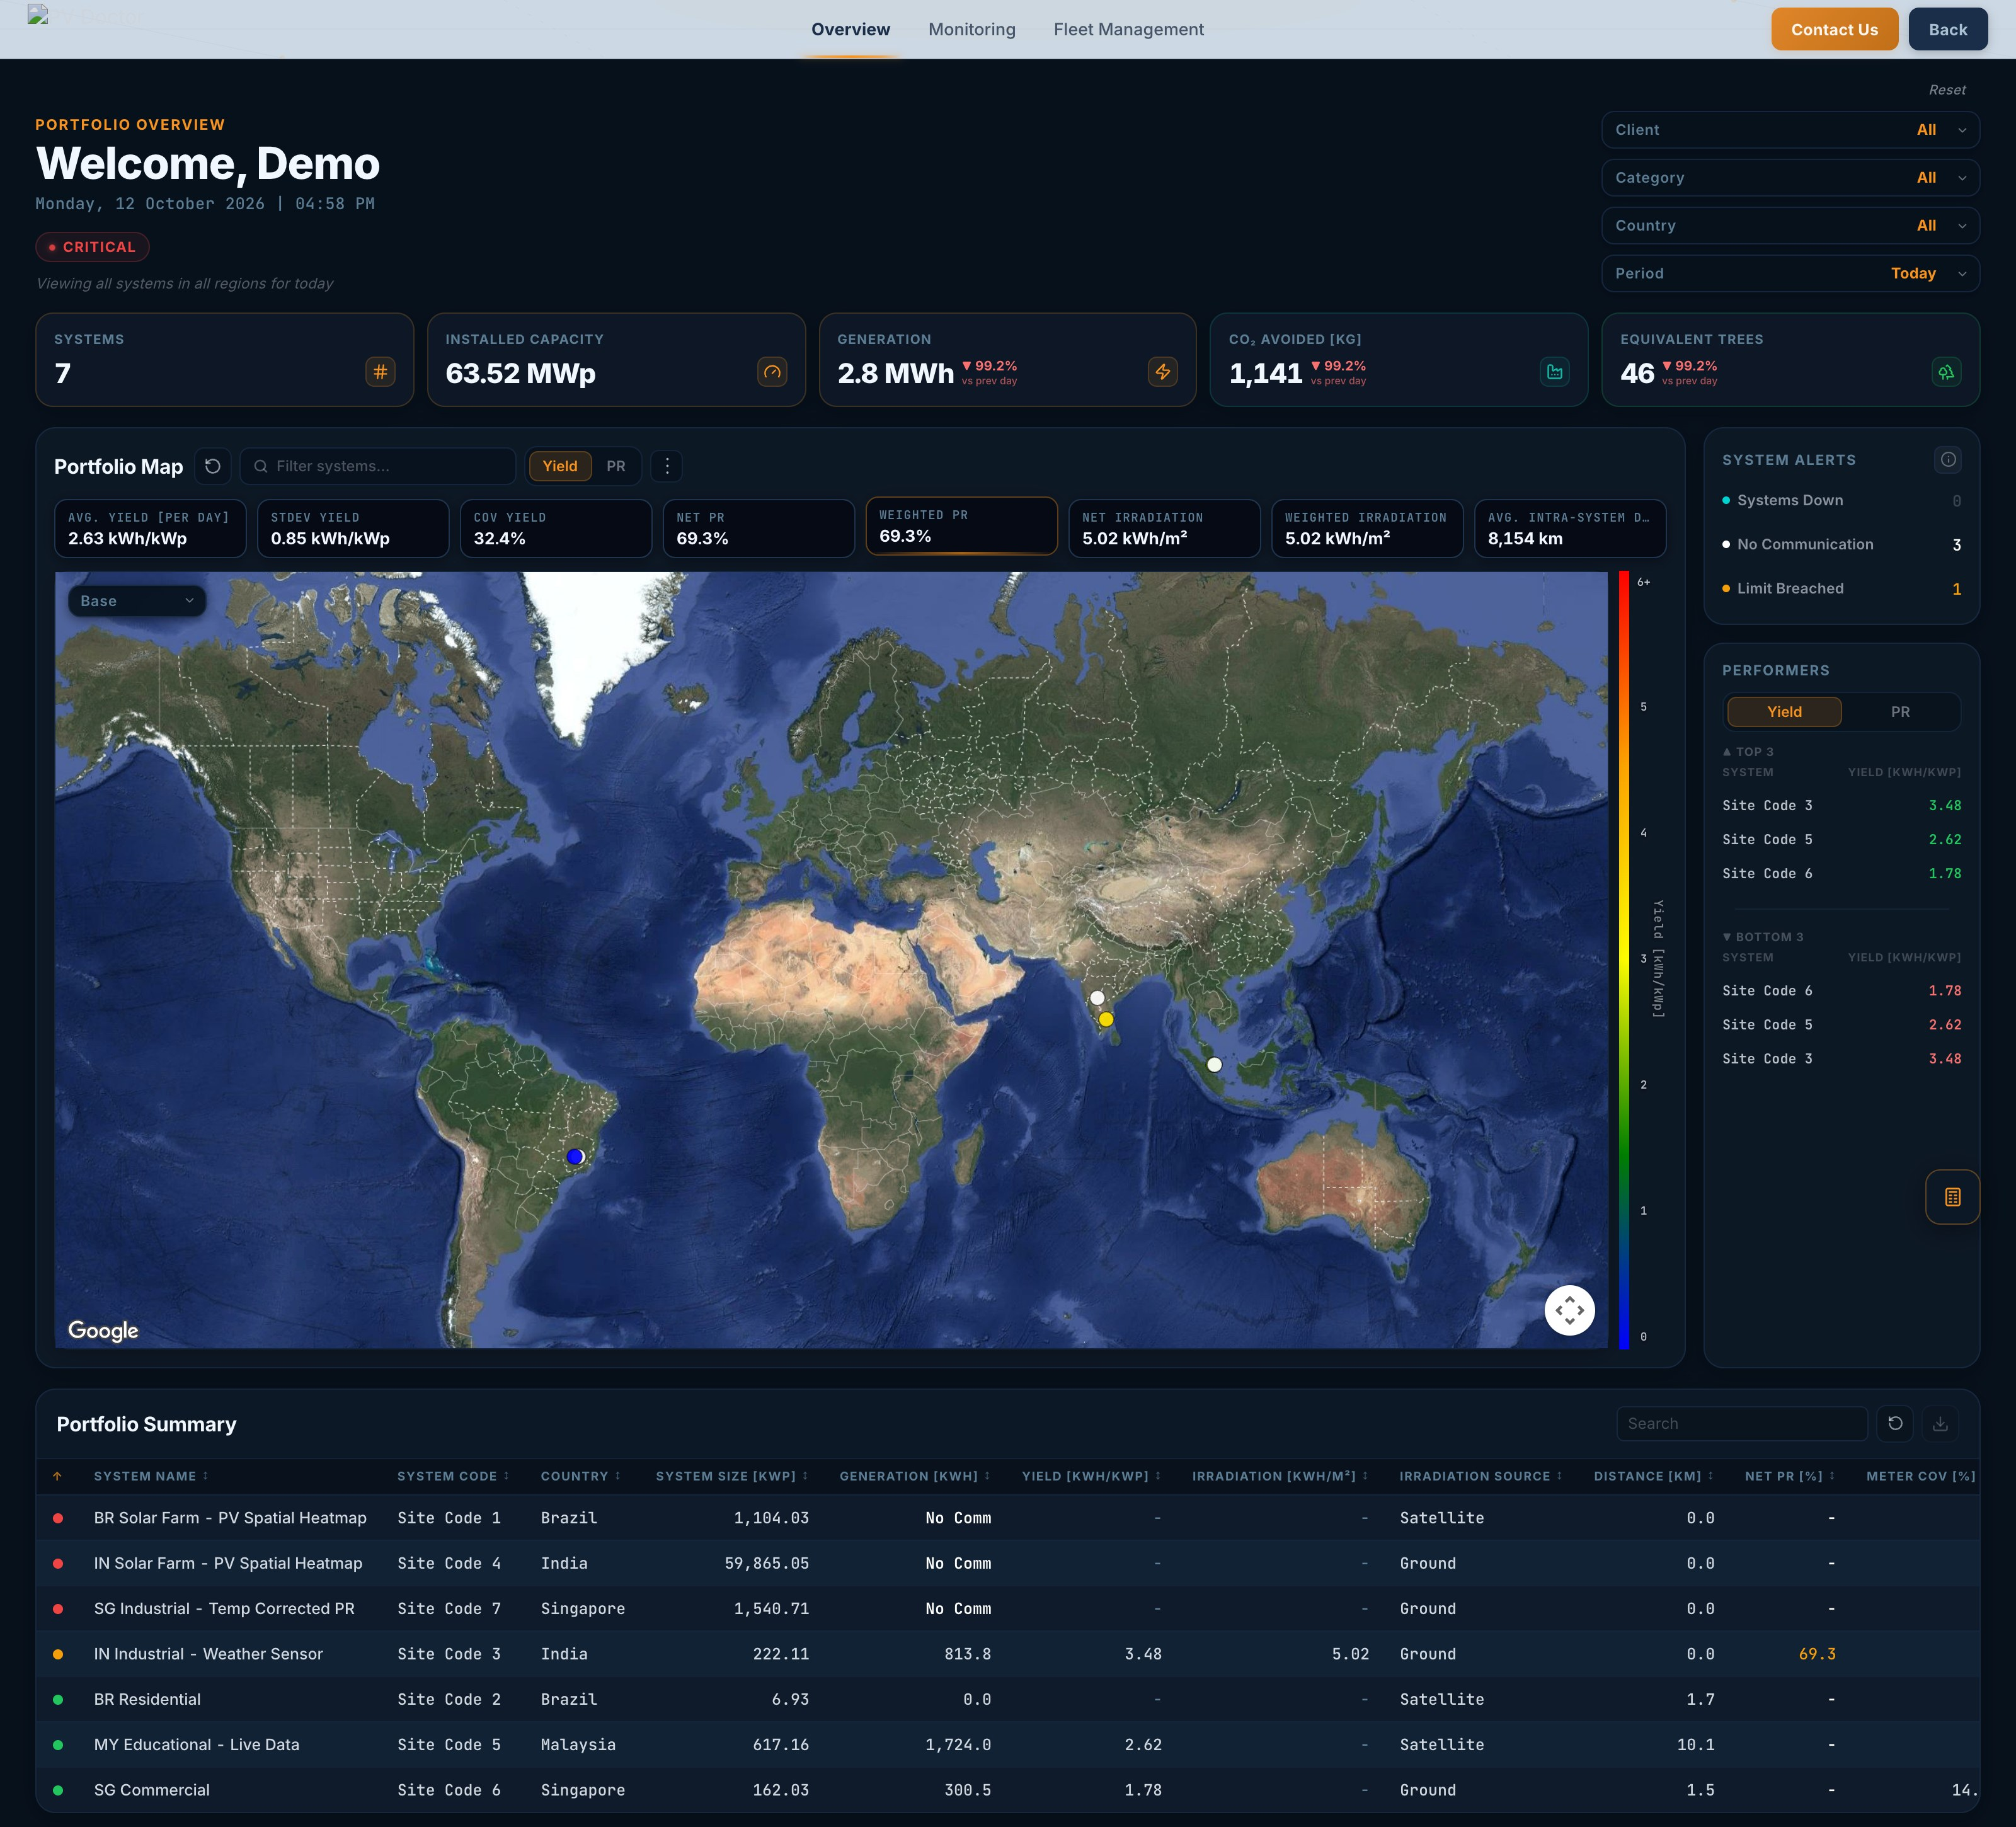
Figure 1: Portfolio Overview
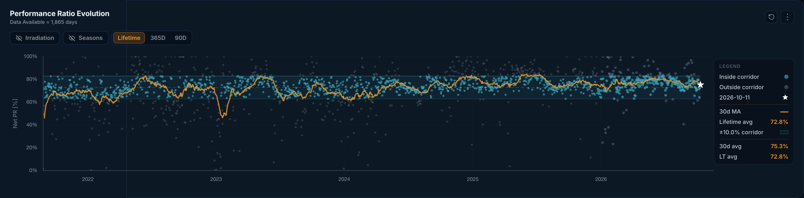
Figure 2: Performance Ratio Evolution with corridor
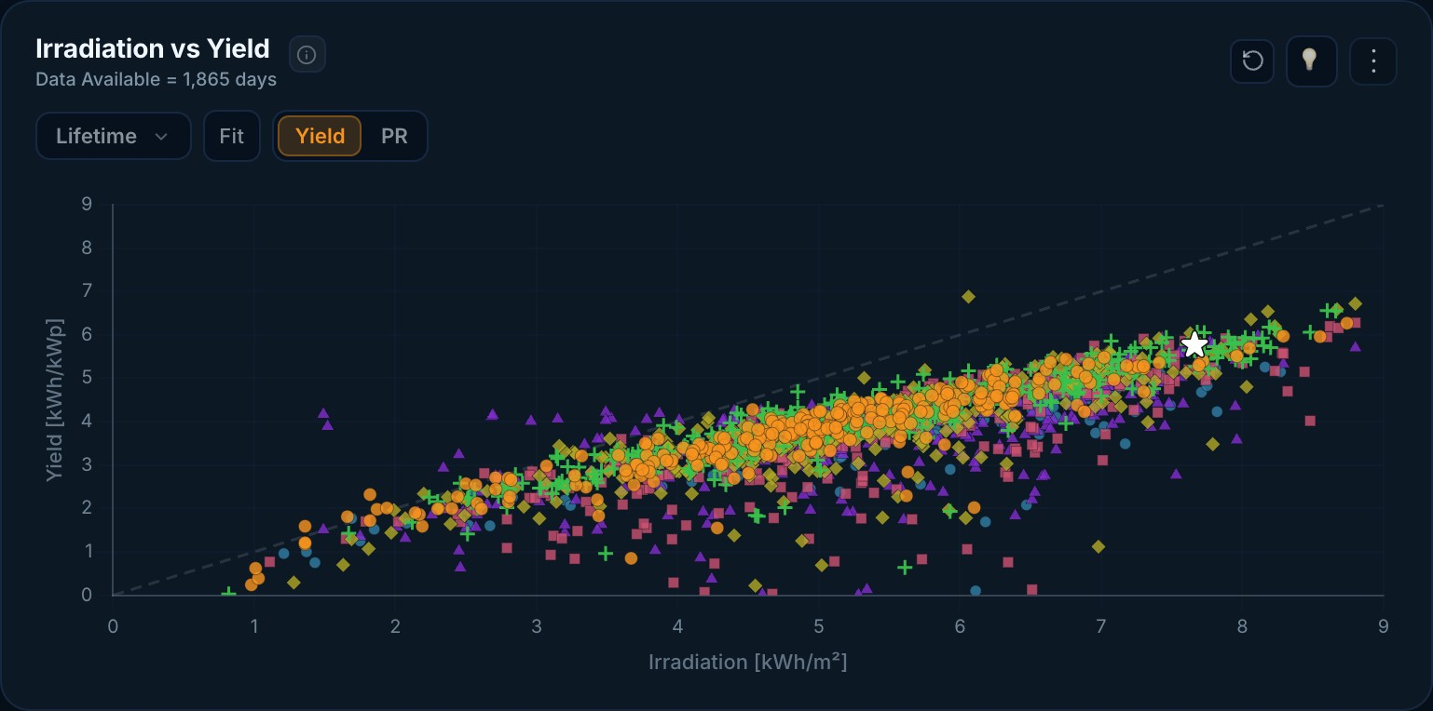
Figure 3: Irradiation vs Yield
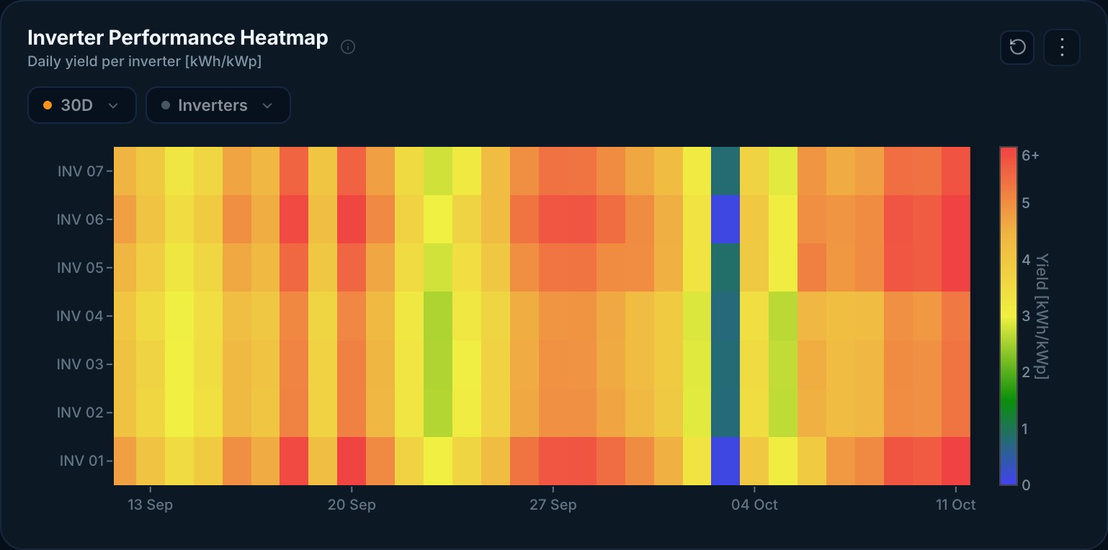
Figure 4: Inverter Performance Heatmap
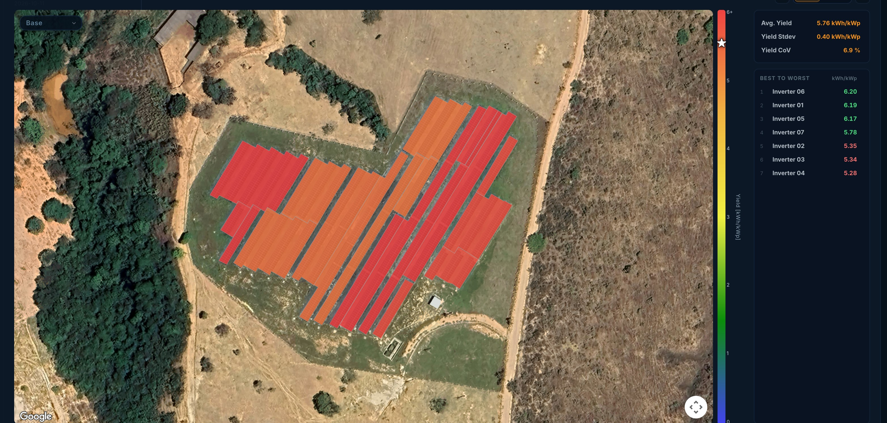
Figure 5: PV Spatial Heatmap (PV Healthscan)

ANNEXURE 1 – MID-INTERNSHIP VERIFICATION RECORD
MAHARAJA AGRASEN INSTITUTE OF TECHNOLOGY
DEPARTMENT OF INFORMATION TECHNOLOGY
MID-INTERNSHIP / RESEARCH VERIFICATION RECORD
7th Semester – ES-453 | Academic Session 2026–27
Student Information | Details | Industry / Research Information | Details
Name | Ishan Bhattacharya | Organization / Institution Name | PV Doctor Pte. Ltd.
Roll No. | 08514803123 | Contact Person (Mentor/HR/Supervisor) | Mr. Manav Gupta
Batch / Section | 7-I-4 (IT – AIML) | Designation | Head of Data Engineering & Analytics
Semester | 7th | Contact No. & Email | +91 97175 20052
Mid-Internship Verification
1. Is the student currently active and regular at the organization / institution?
☑ Yes (Active) ☐ No (Absenteeism / Dropped out) ☐ Not Yet Joined
2. Is the work environment physical or remote?
☐ On-Site / Office ☑ Remote / Work from Home ☐ Hybrid Model
3. Has the student maintained professional workplace decorum, punctuality, and followed the organization guidelines?
☐ Exemplary / Excellent ☐ Satisfactory (No issues) ☐ Unsatisfactory / Discipline Flagged
Details, if flagged: ______________________________________________________________________________
4. Is the student working on an applied module/project, or just tutorials?
☑ Project Execution Phase (Core Coding / Model Training / Deployment) ☐ Onboarding / Learning Phase (Basic Syntax, Documentation Reading)
5. Skill Validation: What specific core tools or technical modules are they working with this fortnight?
1. React / Next.js (TypeScript) 2. Chart.js & Plotly.js visualisation 3. FastAPI + SQL Server
Counsellor Remarks: ______________________________________________________________________________
Faculty Counsellor Signature: ______________________________ Date: __________________

ANNEXURE 2 – WEEKLY LOGBOOKS (APPENDIX D)
MAHARAJA AGRASEN INSTITUTE OF TECHNOLOGY
DEPARTMENT OF INFORMATION TECHNOLOGY
WEEKLY SUMMER INTERNSHIP / TRAINING REPORT
7th Semester – ES-453 | Academic Session 2026–27
Week No.: 1 Dates: From 05 May 2026 to 08 May 2026
Student Information | Details | Training / Course Information | Details
Name | Ishan Bhattacharya | Organization Name | PV Doctor Pte. Ltd.
Roll No. | 08514803123 | Contact Person (Mentor/HR) | Mr. Manav Gupta
Batch / Section | 7-I-4 (IT – AIML) | Designation | Head of Data Engineering & Analytics
Semester | 7th | Contact No. & Email | +91 97175 20052
Project / Domain Name | Web Development & Data Visualisation – Solar PV Smart O&M Monitoring Portal | Faculty Counsellor Name
A. Application of Technical Knowledge and Skills
☑ Applied classroom knowledge to assigned tasks
☑ Used industry-standard tools/software
☑ Completed assigned technical tasks successfully
☑ Learned new technical concepts/technologies
B. Problem Solving and Learning Ability
☑ Identified technical/operational problems
☑ Analyzed and proposed solutions
☑ Resolved assigned issues/tasks
☑ Acquired new knowledge or skills during the week
C. Professionalism, Teamwork, and Communication
☑ Maintained regular attendance and punctuality
☑ Worked effectively with team members
☑ Communicated effectively with mentor/supervisor
☑ Completed assigned work within deadlines
D. Internship Progress, Documentation, and Reflection
☑ Updated weekly logbook/documentation
☑ Submitted reports/records on time
☑ Reflected on learning outcomes achieved
☑ Defined objectives for the next week
Weekly Progress Summary (Brief)
Major Activities Completed: Onboarding to the Data Engineering & Analytics team; Jira and repository access; local setup of the Next.js frontend and FastAPI backend; study of PV KPIs. First chart fixes: download menu, zoom limits, tooltips, units.
Key Learning Outcomes Achieved: Architecture of a production Next.js + FastAPI portal; solar KPIs and their units; Chart.js configuration, zoom plugin and tooltip callbacks.
Plan for Next Week: Complete review comments on Plant Monitoring graphs; add year filters, regression line and playback.
Verification
Student Self-Validation: I certify completion of this week's modules honestly.
Student Signature: __________________________ Date: 08 May 2026
Industry Mentor / Research Supervisor Remarks: ______________________________________________________
Signature: _________________________________ Date: __________________
Annexure 2 – Weekly Logbooks – Week 2
MAHARAJA AGRASEN INSTITUTE OF TECHNOLOGY
DEPARTMENT OF INFORMATION TECHNOLOGY
WEEKLY SUMMER INTERNSHIP / TRAINING REPORT
7th Semester – ES-453 | Academic Session 2026–27
Week No.: 2 Dates: From 11 May 2026 to 15 May 2026
Student Information | Details | Training / Course Information | Details
Name | Ishan Bhattacharya | Organization Name | PV Doctor Pte. Ltd.
Roll No. | 08514803123 | Contact Person (Mentor/HR) | Mr. Manav Gupta
Batch / Section | 7-I-4 (IT – AIML) | Designation | Head of Data Engineering & Analytics
Semester | 7th | Contact No. & Email | +91 97175 20052
Project / Domain Name | Web Development & Data Visualisation – Solar PV Smart O&M Monitoring Portal | Faculty Counsellor Name
A. Application of Technical Knowledge and Skills
☑ Applied classroom knowledge to assigned tasks
☑ Used industry-standard tools/software
☑ Completed assigned technical tasks successfully
☑ Learned new technical concepts/technologies
B. Problem Solving and Learning Ability
☑ Identified technical/operational problems
☑ Analyzed and proposed solutions
☑ Resolved assigned issues/tasks
☑ Acquired new knowledge or skills during the week
C. Professionalism, Teamwork, and Communication
☑ Maintained regular attendance and punctuality
☑ Worked effectively with team members
☑ Communicated effectively with mentor/supervisor
☑ Completed assigned work within deadlines
D. Internship Progress, Documentation, and Reflection
☑ Updated weekly logbook/documentation
☑ Submitted reports/records on time
☑ Reflected on learning outcomes achieved
☑ Defined objectives for the next week
Weekly Progress Summary (Brief)
Major Activities Completed: Plant Monitoring chart revisions: tooltip styling, units and precision, year filter, regression line, yield playback and screenshot effect. Portfolio Overview: map auto-fit, download option, cleaner reset and search.
Key Learning Outcomes Achieved: Designing readable charts (units, precision, colour for time); handling canvas capture for screenshots and animated playback; working through review feedback in iterations.
Plan for Next Week: Make Inverter page consistent with Plant Monitoring; heatmap legend and threshold revisions.
Verification
Student Self-Validation: I certify completion of this week's modules honestly.
Student Signature: __________________________ Date: 15 May 2026
Industry Mentor / Research Supervisor Remarks: ______________________________________________________
Signature: _________________________________ Date: __________________
Annexure 2 – Weekly Logbooks – Week 3
MAHARAJA AGRASEN INSTITUTE OF TECHNOLOGY
DEPARTMENT OF INFORMATION TECHNOLOGY
WEEKLY SUMMER INTERNSHIP / TRAINING REPORT
7th Semester – ES-453 | Academic Session 2026–27
Week No.: 3 Dates: From 18 May 2026 to 22 May 2026
Student Information | Details | Training / Course Information | Details
Name | Ishan Bhattacharya | Organization Name | PV Doctor Pte. Ltd.
Roll No. | 08514803123 | Contact Person (Mentor/HR) | Mr. Manav Gupta
Batch / Section | 7-I-4 (IT – AIML) | Designation | Head of Data Engineering & Analytics
Semester | 7th | Contact No. & Email | +91 97175 20052
Project / Domain Name | Web Development & Data Visualisation – Solar PV Smart O&M Monitoring Portal | Faculty Counsellor Name
A. Application of Technical Knowledge and Skills
☑ Applied classroom knowledge to assigned tasks
☑ Used industry-standard tools/software
☑ Completed assigned technical tasks successfully
☑ Learned new technical concepts/technologies
B. Problem Solving and Learning Ability
☑ Identified technical/operational problems
☑ Analyzed and proposed solutions
☑ Resolved assigned issues/tasks
☑ Acquired new knowledge or skills during the week
C. Professionalism, Teamwork, and Communication
☑ Maintained regular attendance and punctuality
☑ Worked effectively with team members
☑ Communicated effectively with mentor/supervisor
☑ Completed assigned work within deadlines
D. Internship Progress, Documentation, and Reflection
☑ Updated weekly logbook/documentation
☑ Submitted reports/records on time
☑ Reflected on learning outcomes achieved
☑ Defined objectives for the next week
Weekly Progress Summary (Brief)
Major Activities Completed: Inverter page made consistent with Plant Monitoring; heatmap legend and threshold revisions; fixed PR Evolution layering, Daily Generation defaults, corridor lines and moving-average styling.
Key Learning Outcomes Achieved: Layering (z-order) and layout in Chart.js; corridor-based performance visualisation; QA of lifetime (LT) dashboards.
Plan for Next Week: Fix tooltip/map cut-offs and add Excel/PNG export for map overview.
Verification
Student Self-Validation: I certify completion of this week's modules honestly.
Student Signature: __________________________ Date: 22 May 2026
Industry Mentor / Research Supervisor Remarks: ______________________________________________________
Signature: _________________________________ Date: __________________
Annexure 2 – Weekly Logbooks – Week 4
MAHARAJA AGRASEN INSTITUTE OF TECHNOLOGY
DEPARTMENT OF INFORMATION TECHNOLOGY
WEEKLY SUMMER INTERNSHIP / TRAINING REPORT
7th Semester – ES-453 | Academic Session 2026–27
Week No.: 4 Dates: From 25 May 2026 to 29 May 2026
Student Information | Details | Training / Course Information | Details
Name | Ishan Bhattacharya | Organization Name | PV Doctor Pte. Ltd.
Roll No. | 08514803123 | Contact Person (Mentor/HR) | Mr. Manav Gupta
Batch / Section | 7-I-4 (IT – AIML) | Designation | Head of Data Engineering & Analytics
Semester | 7th | Contact No. & Email | +91 97175 20052
Project / Domain Name | Web Development & Data Visualisation – Solar PV Smart O&M Monitoring Portal | Faculty Counsellor Name
A. Application of Technical Knowledge and Skills
☑ Applied classroom knowledge to assigned tasks
☑ Used industry-standard tools/software
☑ Completed assigned technical tasks successfully
☑ Learned new technical concepts/technologies
B. Problem Solving and Learning Ability
☑ Identified technical/operational problems
☑ Analyzed and proposed solutions
☑ Resolved assigned issues/tasks
☑ Acquired new knowledge or skills during the week
C. Professionalism, Teamwork, and Communication
☑ Maintained regular attendance and punctuality
☑ Worked effectively with team members
☑ Communicated effectively with mentor/supervisor
☑ Completed assigned work within deadlines
D. Internship Progress, Documentation, and Reflection
☑ Updated weekly logbook/documentation
☑ Submitted reports/records on time
☑ Reflected on learning outcomes achieved
☑ Defined objectives for the next week
Weekly Progress Summary (Brief)
Major Activities Completed: Fixed tooltip and map cut-offs; default map shows whole portfolio; Excel and PNG export of the map overview; 'Data Available' indicator and consistent legends and hover behaviour.
Key Learning Outcomes Achieved: Google Maps bounds and viewport handling; client-side Excel generation with SheetJS; consistent UX conventions across a large app.
Plan for Next Week: Period-selection logic (CM, LT, LY) and Daily Generation fixes.
Verification
Student Self-Validation: I certify completion of this week's modules honestly.
Student Signature: __________________________ Date: 29 May 2026
Industry Mentor / Research Supervisor Remarks: ______________________________________________________
Signature: _________________________________ Date: __________________
Annexure 2 – Weekly Logbooks – Week 5
MAHARAJA AGRASEN INSTITUTE OF TECHNOLOGY
DEPARTMENT OF INFORMATION TECHNOLOGY
WEEKLY SUMMER INTERNSHIP / TRAINING REPORT
7th Semester – ES-453 | Academic Session 2026–27
Week No.: 5 Dates: From 01 June 2026 to 05 June 2026
Student Information | Details | Training / Course Information | Details
Name | Ishan Bhattacharya | Organization Name | PV Doctor Pte. Ltd.
Roll No. | 08514803123 | Contact Person (Mentor/HR) | Mr. Manav Gupta
Batch / Section | 7-I-4 (IT – AIML) | Designation | Head of Data Engineering & Analytics
Semester | 7th | Contact No. & Email | +91 97175 20052
Project / Domain Name | Web Development & Data Visualisation – Solar PV Smart O&M Monitoring Portal | Faculty Counsellor Name
A. Application of Technical Knowledge and Skills
☑ Applied classroom knowledge to assigned tasks
☑ Used industry-standard tools/software
☑ Completed assigned technical tasks successfully
☑ Learned new technical concepts/technologies
B. Problem Solving and Learning Ability
☑ Identified technical/operational problems
☑ Analyzed and proposed solutions
☑ Resolved assigned issues/tasks
☑ Acquired new knowledge or skills during the week
C. Professionalism, Teamwork, and Communication
☑ Maintained regular attendance and punctuality
☑ Worked effectively with team members
☑ Communicated effectively with mentor/supervisor
☑ Completed assigned work within deadlines
D. Internship Progress, Documentation, and Reflection
☑ Updated weekly logbook/documentation
☑ Submitted reports/records on time
☑ Reflected on learning outcomes achieved
☑ Defined objectives for the next week
Weekly Progress Summary (Brief)
Major Activities Completed: On leave 2–4 June. Standardised Reset button and period labels (CM, LT, LY); fixed month/year visibility bugs in Daily Generation and Hindsight; monthly aggregation for multi-year ranges.
Key Learning Outcomes Achieved: Date-range and aggregation edge cases; why period logic must be centralised; regression testing after logic changes.
Plan for Next Week: Multi-select filters for Inverter/MFM G2 graphs.
Verification
Student Self-Validation: I certify completion of this week's modules honestly.
Student Signature: __________________________ Date: 05 June 2026
Industry Mentor / Research Supervisor Remarks: ______________________________________________________
Signature: _________________________________ Date: __________________
Annexure 2 – Weekly Logbooks – Week 6
MAHARAJA AGRASEN INSTITUTE OF TECHNOLOGY
DEPARTMENT OF INFORMATION TECHNOLOGY
WEEKLY SUMMER INTERNSHIP / TRAINING REPORT
7th Semester – ES-453 | Academic Session 2026–27
Week No.: 6 Dates: From 08 June 2026 to 12 June 2026
Student Information | Details | Training / Course Information | Details
Name | Ishan Bhattacharya | Organization Name | PV Doctor Pte. Ltd.
Roll No. | 08514803123 | Contact Person (Mentor/HR) | Mr. Manav Gupta
Batch / Section | 7-I-4 (IT – AIML) | Designation | Head of Data Engineering & Analytics
Semester | 7th | Contact No. & Email | +91 97175 20052
Project / Domain Name | Web Development & Data Visualisation – Solar PV Smart O&M Monitoring Portal | Faculty Counsellor Name
A. Application of Technical Knowledge and Skills
☑ Applied classroom knowledge to assigned tasks
☑ Used industry-standard tools/software
☑ Completed assigned technical tasks successfully
☑ Learned new technical concepts/technologies
B. Problem Solving and Learning Ability
☑ Identified technical/operational problems
☑ Analyzed and proposed solutions
☑ Resolved assigned issues/tasks
☑ Acquired new knowledge or skills during the week
C. Professionalism, Teamwork, and Communication
☑ Maintained regular attendance and punctuality
☑ Worked effectively with team members
☑ Communicated effectively with mentor/supervisor
☑ Completed assigned work within deadlines
D. Internship Progress, Documentation, and Reflection
☑ Updated weekly logbook/documentation
☑ Submitted reports/records on time
☑ Reflected on learning outcomes achieved
☑ Defined objectives for the next week
Weekly Progress Summary (Brief)
Major Activities Completed: On leave 10–12 June. Added multi-select inverter/MFM filters with reset and auto-width; aligned G2 grid and border styling; regression testing of monitoring views.
Key Learning Outcomes Achieved: Building reusable multi-select dropdown components; keeping UI behaviour consistent across modules.
Plan for Next Week: Heatmap and CoV date/filter rules; Yield–PR graph fixes.
Verification
Student Self-Validation: I certify completion of this week's modules honestly.
Student Signature: __________________________ Date: 12 June 2026
Industry Mentor / Research Supervisor Remarks: ______________________________________________________
Signature: _________________________________ Date: __________________
Annexure 2 – Weekly Logbooks – Week 7
MAHARAJA AGRASEN INSTITUTE OF TECHNOLOGY
DEPARTMENT OF INFORMATION TECHNOLOGY
WEEKLY SUMMER INTERNSHIP / TRAINING REPORT
7th Semester – ES-453 | Academic Session 2026–27
Week No.: 7 Dates: From 15 June 2026 to 19 June 2026
Student Information | Details | Training / Course Information | Details
Name | Ishan Bhattacharya | Organization Name | PV Doctor Pte. Ltd.
Roll No. | 08514803123 | Contact Person (Mentor/HR) | Mr. Manav Gupta
Batch / Section | 7-I-4 (IT – AIML) | Designation | Head of Data Engineering & Analytics
Semester | 7th | Contact No. & Email | +91 97175 20052
Project / Domain Name | Web Development & Data Visualisation – Solar PV Smart O&M Monitoring Portal | Faculty Counsellor Name
A. Application of Technical Knowledge and Skills
☑ Applied classroom knowledge to assigned tasks
☑ Used industry-standard tools/software
☑ Completed assigned technical tasks successfully
☑ Learned new technical concepts/technologies
B. Problem Solving and Learning Ability
☑ Identified technical/operational problems
☑ Analyzed and proposed solutions
☑ Resolved assigned issues/tasks
☑ Acquired new knowledge or skills during the week
C. Professionalism, Teamwork, and Communication
☑ Maintained regular attendance and punctuality
☑ Worked effectively with team members
☑ Communicated effectively with mentor/supervisor
☑ Completed assigned work within deadlines
D. Internship Progress, Documentation, and Reflection
☑ Updated weekly logbook/documentation
☑ Submitted reports/records on time
☑ Reflected on learning outcomes achieved
☑ Defined objectives for the next week
Weekly Progress Summary (Brief)
Major Activities Completed: On leave 15 June. Defined date/filter rules for Heatmap and CoV; fixed Yield–PR axes and z-order; Portfolio Overview reset now clears map state; demo-account visibility rules.
Key Learning Outcomes Achieved: Rule tables for UI state; React state synchronisation between filters and map; role-based visibility for demo users.
Plan for Next Week: Year/Day toggle for Yield–PR; refactor duplicated chart code.
Verification
Student Self-Validation: I certify completion of this week's modules honestly.
Student Signature: __________________________ Date: 19 June 2026
Industry Mentor / Research Supervisor Remarks: ______________________________________________________
Signature: _________________________________ Date: __________________
Annexure 2 – Weekly Logbooks – Week 8
MAHARAJA AGRASEN INSTITUTE OF TECHNOLOGY
DEPARTMENT OF INFORMATION TECHNOLOGY
WEEKLY SUMMER INTERNSHIP / TRAINING REPORT
7th Semester – ES-453 | Academic Session 2026–27
Week No.: 8 Dates: From 22 June 2026 to 26 June 2026
Student Information | Details | Training / Course Information | Details
Name | Ishan Bhattacharya | Organization Name | PV Doctor Pte. Ltd.
Roll No. | 08514803123 | Contact Person (Mentor/HR) | Mr. Manav Gupta
Batch / Section | 7-I-4 (IT – AIML) | Designation | Head of Data Engineering & Analytics
Semester | 7th | Contact No. & Email | +91 97175 20052
Project / Domain Name | Web Development & Data Visualisation – Solar PV Smart O&M Monitoring Portal | Faculty Counsellor Name
A. Application of Technical Knowledge and Skills
☑ Applied classroom knowledge to assigned tasks
☑ Used industry-standard tools/software
☑ Completed assigned technical tasks successfully
☑ Learned new technical concepts/technologies
B. Problem Solving and Learning Ability
☑ Identified technical/operational problems
☑ Analyzed and proposed solutions
☑ Resolved assigned issues/tasks
☑ Acquired new knowledge or skills during the week
C. Professionalism, Teamwork, and Communication
☑ Maintained regular attendance and punctuality
☑ Worked effectively with team members
☑ Communicated effectively with mentor/supervisor
☑ Completed assigned work within deadlines
D. Internship Progress, Documentation, and Reflection
☑ Updated weekly logbook/documentation
☑ Submitted reports/records on time
☑ Reflected on learning outcomes achieved
☑ Defined objectives for the next week
Weekly Progress Summary (Brief)
Major Activities Completed: Year/Day toggle for Yield–PR; refactored Heatmap, CoV and Stacked Bar into shared components; connected System Information to the Period Filter with backend access changes.
Key Learning Outcomes Achieved: Refactoring to remove duplication without changing behaviour; backend changes in FastAPI; testing across user roles.
Plan for Next Week: Responsive layout for smaller screens; filter fixes for specific sites.
Verification
Student Self-Validation: I certify completion of this week's modules honestly.
Student Signature: __________________________ Date: 26 June 2026
Industry Mentor / Research Supervisor Remarks: ______________________________________________________
Signature: _________________________________ Date: __________________
Annexure 2 – Weekly Logbooks – Week 9
MAHARAJA AGRASEN INSTITUTE OF TECHNOLOGY
DEPARTMENT OF INFORMATION TECHNOLOGY
WEEKLY SUMMER INTERNSHIP / TRAINING REPORT
7th Semester – ES-453 | Academic Session 2026–27
Week No.: 9 Dates: From 29 June 2026 to 03 July 2026
Student Information | Details | Training / Course Information | Details
Name | Ishan Bhattacharya | Organization Name | PV Doctor Pte. Ltd.
Roll No. | 08514803123 | Contact Person (Mentor/HR) | Mr. Manav Gupta
Batch / Section | 7-I-4 (IT – AIML) | Designation | Head of Data Engineering & Analytics
Semester | 7th | Contact No. & Email | +91 97175 20052
Project / Domain Name | Web Development & Data Visualisation – Solar PV Smart O&M Monitoring Portal | Faculty Counsellor Name
A. Application of Technical Knowledge and Skills
☑ Applied classroom knowledge to assigned tasks
☑ Used industry-standard tools/software
☑ Completed assigned technical tasks successfully
☑ Learned new technical concepts/technologies
B. Problem Solving and Learning Ability
☑ Identified technical/operational problems
☑ Analyzed and proposed solutions
☑ Resolved assigned issues/tasks
☑ Acquired new knowledge or skills during the week
C. Professionalism, Teamwork, and Communication
☑ Maintained regular attendance and punctuality
☑ Worked effectively with team members
☑ Communicated effectively with mentor/supervisor
☑ Completed assigned work within deadlines
D. Internship Progress, Documentation, and Reflection
☑ Updated weekly logbook/documentation
☑ Submitted reports/records on time
☑ Reflected on learning outcomes achieved
☑ Defined objectives for the next week
Weekly Progress Summary (Brief)
Major Activities Completed: Fixed filter and data-fetch logic for a site with an unusual configuration; improved responsive layout and KPI breakpoints for smaller screens.
Key Learning Outcomes Achieved: Responsive design with CSS breakpoints; debugging data-dependent issues using a single site's data.
Plan for Next Week: Admin user-management view and exports.
Verification
Student Self-Validation: I certify completion of this week's modules honestly.
Student Signature: __________________________ Date: 03 July 2026
Industry Mentor / Research Supervisor Remarks: ______________________________________________________
Signature: _________________________________ Date: __________________
Annexure 2 – Weekly Logbooks – Week 10
MAHARAJA AGRASEN INSTITUTE OF TECHNOLOGY
DEPARTMENT OF INFORMATION TECHNOLOGY
WEEKLY SUMMER INTERNSHIP / TRAINING REPORT
7th Semester – ES-453 | Academic Session 2026–27
Week No.: 10 Dates: From 06 July 2026 to 10 July 2026
Student Information | Details | Training / Course Information | Details
Name | Ishan Bhattacharya | Organization Name | PV Doctor Pte. Ltd.
Roll No. | 08514803123 | Contact Person (Mentor/HR) | Mr. Manav Gupta
Batch / Section | 7-I-4 (IT – AIML) | Designation | Head of Data Engineering & Analytics
Semester | 7th | Contact No. & Email | +91 97175 20052
Project / Domain Name | Web Development & Data Visualisation – Solar PV Smart O&M Monitoring Portal | Faculty Counsellor Name
A. Application of Technical Knowledge and Skills
☑ Applied classroom knowledge to assigned tasks
☑ Used industry-standard tools/software
☑ Completed assigned technical tasks successfully
☑ Learned new technical concepts/technologies
B. Problem Solving and Learning Ability
☑ Identified technical/operational problems
☑ Analyzed and proposed solutions
☑ Resolved assigned issues/tasks
☑ Acquired new knowledge or skills during the week
C. Professionalism, Teamwork, and Communication
☑ Maintained regular attendance and punctuality
☑ Worked effectively with team members
☑ Communicated effectively with mentor/supervisor
☑ Completed assigned work within deadlines
D. Internship Progress, Documentation, and Reflection
☑ Updated weekly logbook/documentation
☑ Submitted reports/records on time
☑ Reflected on learning outcomes achieved
☑ Defined objectives for the next week
Weekly Progress Summary (Brief)
Major Activities Completed: Admin user-management view with user list and Excel export; prepared visuals for the public demo page.
Key Learning Outcomes Achieved: Role-based access in an admin interface; handling personal data carefully in exports.
Plan for Next Week: System Information page data table and exports.
Verification
Student Self-Validation: I certify completion of this week's modules honestly.
Student Signature: __________________________ Date: 10 July 2026
Industry Mentor / Research Supervisor Remarks: ______________________________________________________
Signature: _________________________________ Date: __________________
Annexure 2 – Weekly Logbooks – Week 11
MAHARAJA AGRASEN INSTITUTE OF TECHNOLOGY
DEPARTMENT OF INFORMATION TECHNOLOGY
WEEKLY SUMMER INTERNSHIP / TRAINING REPORT
7th Semester – ES-453 | Academic Session 2026–27
Week No.: 11 Dates: From 13 July 2026 to 17 July 2026
Student Information | Details | Training / Course Information | Details
Name | Ishan Bhattacharya | Organization Name | PV Doctor Pte. Ltd.
Roll No. | 08514803123 | Contact Person (Mentor/HR) | Mr. Manav Gupta
Batch / Section | 7-I-4 (IT – AIML) | Designation | Head of Data Engineering & Analytics
Semester | 7th | Contact No. & Email | +91 97175 20052
Project / Domain Name | Web Development & Data Visualisation – Solar PV Smart O&M Monitoring Portal | Faculty Counsellor Name
A. Application of Technical Knowledge and Skills
☑ Applied classroom knowledge to assigned tasks
☑ Used industry-standard tools/software
☑ Completed assigned technical tasks successfully
☑ Learned new technical concepts/technologies
B. Problem Solving and Learning Ability
☑ Identified technical/operational problems
☑ Analyzed and proposed solutions
☑ Resolved assigned issues/tasks
☑ Acquired new knowledge or skills during the week
C. Professionalism, Teamwork, and Communication
☑ Maintained regular attendance and punctuality
☑ Worked effectively with team members
☑ Communicated effectively with mentor/supervisor
☑ Completed assigned work within deadlines
D. Internship Progress, Documentation, and Reflection
☑ Updated weekly logbook/documentation
☑ Submitted reports/records on time
☑ Reflected on learning outcomes achieved
☑ Defined objectives for the next week
Weekly Progress Summary (Brief)
Major Activities Completed: System Information page: sensor, meter and inverter time series with consistent names, units and Excel export.
Key Learning Outcomes Achieved: Working with multi-source time series and units; designing export formats engineers can use directly.
Plan for Next Week: Alarm and system-alert views.
Verification
Student Self-Validation: I certify completion of this week's modules honestly.
Student Signature: __________________________ Date: 17 July 2026
Industry Mentor / Research Supervisor Remarks: ______________________________________________________
Signature: _________________________________ Date: __________________
Annexure 2 – Weekly Logbooks – Week 12
MAHARAJA AGRASEN INSTITUTE OF TECHNOLOGY
DEPARTMENT OF INFORMATION TECHNOLOGY
WEEKLY SUMMER INTERNSHIP / TRAINING REPORT
7th Semester – ES-453 | Academic Session 2026–27
Week No.: 12 Dates: From 20 July 2026 to 24 July 2026
Student Information | Details | Training / Course Information | Details
Name | Ishan Bhattacharya | Organization Name | PV Doctor Pte. Ltd.
Roll No. | 08514803123 | Contact Person (Mentor/HR) | Mr. Manav Gupta
Batch / Section | 7-I-4 (IT – AIML) | Designation | Head of Data Engineering & Analytics
Semester | 7th | Contact No. & Email | +91 97175 20052
Project / Domain Name | Web Development & Data Visualisation – Solar PV Smart O&M Monitoring Portal | Faculty Counsellor Name
A. Application of Technical Knowledge and Skills
☑ Applied classroom knowledge to assigned tasks
☑ Used industry-standard tools/software
☑ Completed assigned technical tasks successfully
☑ Learned new technical concepts/technologies
B. Problem Solving and Learning Ability
☑ Identified technical/operational problems
☑ Analyzed and proposed solutions
☑ Resolved assigned issues/tasks
☑ Acquired new knowledge or skills during the week
C. Professionalism, Teamwork, and Communication
☑ Maintained regular attendance and punctuality
☑ Worked effectively with team members
☑ Communicated effectively with mentor/supervisor
☑ Completed assigned work within deadlines
D. Internship Progress, Documentation, and Reflection
☑ Updated weekly logbook/documentation
☑ Submitted reports/records on time
☑ Reflected on learning outcomes achieved
☑ Defined objectives for the next week
Weekly Progress Summary (Brief)
Major Activities Completed: Alarm views: severity colours, categories and recommended actions, consistent with the Portfolio Overview alert panel.
Key Learning Outcomes Achieved: How KPI-based alarms (e.g. PR corridor deviation) are generated and shown to O&M teams.
Plan for Next Week: Alarm History export; start PR Evolution corridor and Spatial Heatmap work.
Verification
Student Self-Validation: I certify completion of this week's modules honestly.
Student Signature: __________________________ Date: 24 July 2026
Industry Mentor / Research Supervisor Remarks: ______________________________________________________
Signature: _________________________________ Date: __________________
Annexure 2 – Weekly Logbooks – Week 13
MAHARAJA AGRASEN INSTITUTE OF TECHNOLOGY
DEPARTMENT OF INFORMATION TECHNOLOGY
WEEKLY SUMMER INTERNSHIP / TRAINING REPORT
7th Semester – ES-453 | Academic Session 2026–27
Week No.: 13 Dates: From 27 July 2026 to 31 July 2026
Student Information | Details | Training / Course Information | Details
Name | Ishan Bhattacharya | Organization Name | PV Doctor Pte. Ltd.
Roll No. | 08514803123 | Contact Person (Mentor/HR) | Mr. Manav Gupta
Batch / Section | 7-I-4 (IT – AIML) | Designation | Head of Data Engineering & Analytics
Semester | 7th | Contact No. & Email | +91 97175 20052
Project / Domain Name | Web Development & Data Visualisation – Solar PV Smart O&M Monitoring Portal | Faculty Counsellor Name
A. Application of Technical Knowledge and Skills
☑ Applied classroom knowledge to assigned tasks
☑ Used industry-standard tools/software
☑ Completed assigned technical tasks successfully
☑ Learned new technical concepts/technologies
B. Problem Solving and Learning Ability
☑ Identified technical/operational problems
☑ Analyzed and proposed solutions
☑ Resolved assigned issues/tasks
☑ Acquired new knowledge or skills during the week
C. Professionalism, Teamwork, and Communication
☑ Maintained regular attendance and punctuality
☑ Worked effectively with team members
☑ Communicated effectively with mentor/supervisor
☑ Completed assigned work within deadlines
D. Internship Progress, Documentation, and Reflection
☑ Updated weekly logbook/documentation
☑ Submitted reports/records on time
☑ Reflected on learning outcomes achieved
☑ Defined objectives for the next week
Weekly Progress Summary (Brief)
Major Activities Completed: Alarm History export; validated PR corridor-deviation alarms; planned Spatial Heatmap work. Internship extended into August (part-time).
Key Learning Outcomes Achieved: End-to-end flow from a KPI rule to an alarm record and export.
Plan for Next Week: Spatial Heatmap layout, Raw Data and PR corridor calculations (part-time from August).
Verification
Student Self-Validation: I certify completion of this week's modules honestly.
Student Signature: __________________________ Date: 31 July 2026
Industry Mentor / Research Supervisor Remarks: ______________________________________________________
Signature: _________________________________ Date: __________________
Annexure 2 – Weekly Logbooks – Week 14
MAHARAJA AGRASEN INSTITUTE OF TECHNOLOGY
DEPARTMENT OF INFORMATION TECHNOLOGY
WEEKLY SUMMER INTERNSHIP / TRAINING REPORT
7th Semester – ES-453 | Academic Session 2026–27
Week No.: 14 Dates: From 03 August 2026 to 07 August 2026
Student Information | Details | Training / Course Information | Details
Name | Ishan Bhattacharya | Organization Name | PV Doctor Pte. Ltd.
Roll No. | 08514803123 | Contact Person (Mentor/HR) | Mr. Manav Gupta
Batch / Section | 7-I-4 (IT – AIML) | Designation | Head of Data Engineering & Analytics
Semester | 7th | Contact No. & Email | +91 97175 20052
Project / Domain Name | Web Development & Data Visualisation – Solar PV Smart O&M Monitoring Portal | Faculty Counsellor Name
A. Application of Technical Knowledge and Skills
☑ Applied classroom knowledge to assigned tasks
☑ Used industry-standard tools/software
☑ Completed assigned technical tasks successfully
☑ Learned new technical concepts/technologies
B. Problem Solving and Learning Ability
☑ Identified technical/operational problems
☑ Analyzed and proposed solutions
☑ Resolved assigned issues/tasks
☑ Acquired new knowledge or skills during the week
C. Professionalism, Teamwork, and Communication
☑ Maintained regular attendance and punctuality
☑ Worked effectively with team members
☑ Communicated effectively with mentor/supervisor
☑ Completed assigned work within deadlines
D. Internship Progress, Documentation, and Reflection
☑ Updated weekly logbook/documentation
☑ Submitted reports/records on time
☑ Reflected on learning outcomes achieved
☑ Defined objectives for the next week
Weekly Progress Summary (Brief)
Major Activities Completed: Part-time (~4 h/day). Spatial Heatmap layout; AC power/energy handling in Raw Data; Net PR corridor fix; shared date handling; mixed-resolution data; dynamic SolarGIS granularity.
Key Learning Outcomes Achieved: Combining data series of different time resolutions; satellite irradiance (SolarGIS) as a reference.
Plan for Next Week: Spatial Heatmap statistics, PR Evolution filters and staging integration.
Verification
Student Self-Validation: I certify completion of this week's modules honestly.
Student Signature: __________________________ Date: 07 August 2026
Industry Mentor / Research Supervisor Remarks: ______________________________________________________
Signature: _________________________________ Date: __________________
Annexure 2 – Weekly Logbooks – Week 15
MAHARAJA AGRASEN INSTITUTE OF TECHNOLOGY
DEPARTMENT OF INFORMATION TECHNOLOGY
WEEKLY SUMMER INTERNSHIP / TRAINING REPORT
7th Semester – ES-453 | Academic Session 2026–27
Week No.: 15 Dates: From 10 August 2026 to 14 August 2026
Student Information | Details | Training / Course Information | Details
Name | Ishan Bhattacharya | Organization Name | PV Doctor Pte. Ltd.
Roll No. | 08514803123 | Contact Person (Mentor/HR) | Mr. Manav Gupta
Batch / Section | 7-I-4 (IT – AIML) | Designation | Head of Data Engineering & Analytics
Semester | 7th | Contact No. & Email | +91 97175 20052
Project / Domain Name | Web Development & Data Visualisation – Solar PV Smart O&M Monitoring Portal | Faculty Counsellor Name
A. Application of Technical Knowledge and Skills
☑ Applied classroom knowledge to assigned tasks
☑ Used industry-standard tools/software
☑ Completed assigned technical tasks successfully
☑ Learned new technical concepts/technologies
B. Problem Solving and Learning Ability
☑ Identified technical/operational problems
☑ Analyzed and proposed solutions
☑ Resolved assigned issues/tasks
☑ Acquired new knowledge or skills during the week
C. Professionalism, Teamwork, and Communication
☑ Maintained regular attendance and punctuality
☑ Worked effectively with team members
☑ Communicated effectively with mentor/supervisor
☑ Completed assigned work within deadlines
D. Internship Progress, Documentation, and Reflection
☑ Updated weekly logbook/documentation
☑ Submitted reports/records on time
☑ Reflected on learning outcomes achieved
☑ Defined objectives for the next week
Weekly Progress Summary (Brief)
Major Activities Completed: Spatial Heatmap statistics, ranking list and zoom fixes; PR Evolution corridor and historical averages; reference sensors in Raw Data; changes integrated into staging.
Key Learning Outcomes Achieved: Iterating on UX details from stakeholder review; integrating multiple feature branches into staging.
Plan for Next Week: Batched external reference sensor resolution; multi-site sensor setups.
Verification
Student Self-Validation: I certify completion of this week's modules honestly.
Student Signature: __________________________ Date: 14 August 2026
Industry Mentor / Research Supervisor Remarks: ______________________________________________________
Signature: _________________________________ Date: __________________
Annexure 2 – Weekly Logbooks – Week 16
MAHARAJA AGRASEN INSTITUTE OF TECHNOLOGY
DEPARTMENT OF INFORMATION TECHNOLOGY
WEEKLY SUMMER INTERNSHIP / TRAINING REPORT
7th Semester – ES-453 | Academic Session 2026–27
Week No.: 16 Dates: From 17 August 2026 to 21 August 2026
Student Information | Details | Training / Course Information | Details
Name | Ishan Bhattacharya | Organization Name | PV Doctor Pte. Ltd.
Roll No. | 08514803123 | Contact Person (Mentor/HR) | Mr. Manav Gupta
Batch / Section | 7-I-4 (IT – AIML) | Designation | Head of Data Engineering & Analytics
Semester | 7th | Contact No. & Email | +91 97175 20052
Project / Domain Name | Web Development & Data Visualisation – Solar PV Smart O&M Monitoring Portal | Faculty Counsellor Name
A. Application of Technical Knowledge and Skills
☑ Applied classroom knowledge to assigned tasks
☑ Used industry-standard tools/software
☑ Completed assigned technical tasks successfully
☑ Learned new technical concepts/technologies
B. Problem Solving and Learning Ability
☑ Identified technical/operational problems
☑ Analyzed and proposed solutions
☑ Resolved assigned issues/tasks
☑ Acquired new knowledge or skills during the week
C. Professionalism, Teamwork, and Communication
☑ Maintained regular attendance and punctuality
☑ Worked effectively with team members
☑ Communicated effectively with mentor/supervisor
☑ Completed assigned work within deadlines
D. Internship Progress, Documentation, and Reflection
☑ Updated weekly logbook/documentation
☑ Submitted reports/records on time
☑ Reflected on learning outcomes achieved
☑ Defined objectives for the next week
Weekly Progress Summary (Brief)
Major Activities Completed: Batched external reference-sensor resolution; multi-site sensor fixes; multi-orientation SolarGIS; parallel raw-data queries with caching.
Key Learning Outcomes Achieved: Query batching, parallelism and caching to reduce API latency; designing for sites that share sensors.
Plan for Next Week: Refactor monitoring.py pull request and add backend tests.
Verification
Student Self-Validation: I certify completion of this week's modules honestly.
Student Signature: __________________________ Date: 21 August 2026
Industry Mentor / Research Supervisor Remarks: ______________________________________________________
Signature: _________________________________ Date: __________________
Annexure 2 – Weekly Logbooks – Week 17
MAHARAJA AGRASEN INSTITUTE OF TECHNOLOGY
DEPARTMENT OF INFORMATION TECHNOLOGY
WEEKLY SUMMER INTERNSHIP / TRAINING REPORT
7th Semester – ES-453 | Academic Session 2026–27
Week No.: 17 Dates: From 24 August 2026 to 31 August 2026
Student Information | Details | Training / Course Information | Details
Name | Ishan Bhattacharya | Organization Name | PV Doctor Pte. Ltd.
Roll No. | 08514803123 | Contact Person (Mentor/HR) | Mr. Manav Gupta
Batch / Section | 7-I-4 (IT – AIML) | Designation | Head of Data Engineering & Analytics
Semester | 7th | Contact No. & Email | +91 97175 20052
Project / Domain Name | Web Development & Data Visualisation – Solar PV Smart O&M Monitoring Portal | Faculty Counsellor Name
A. Application of Technical Knowledge and Skills
☑ Applied classroom knowledge to assigned tasks
☑ Used industry-standard tools/software
☑ Completed assigned technical tasks successfully
☑ Learned new technical concepts/technologies
B. Problem Solving and Learning Ability
☑ Identified technical/operational problems
☑ Analyzed and proposed solutions
☑ Resolved assigned issues/tasks
☑ Acquired new knowledge or skills during the week
C. Professionalism, Teamwork, and Communication
☑ Maintained regular attendance and punctuality
☑ Worked effectively with team members
☑ Communicated effectively with mentor/supervisor
☑ Completed assigned work within deadlines
D. Internship Progress, Documentation, and Reflection
☑ Updated weekly logbook/documentation
☑ Submitted reports/records on time
☑ Reflected on learning outcomes achieved
☑ Defined objectives for the next week
Weekly Progress Summary (Brief)
Major Activities Completed: Refactored the monitoring pull request from 700+ to 289 lines; added automated API tests; analysed support-widget requirements; handover.
Key Learning Outcomes Achieved: Writing smaller, reviewable pull requests; writing automated API tests; documentation and handover.
Plan for Next Week: Internship completed – handover done.
Verification
Student Self-Validation: I certify completion of this week's modules honestly.
Student Signature: __________________________ Date: 31 August 2026
Industry Mentor / Research Supervisor Remarks: ______________________________________________________
Signature: _________________________________ Date: __________________

ANNEXURE 3 – INDUSTRY MENTOR FEEDBACK FORM (APPENDIX F)
MAHARAJA AGRASEN INSTITUTE OF TECHNOLOGY
7th Semester – ES-453 | Academic Session 2026–27
DEPARTMENT OF INFORMATION TECHNOLOGY
Employer Feedback Form
(Industry Mentor / Research Supervisor Feedback Form)
Academic Session 2026–27
Dear Industry Mentor / Research Supervisor,
Thank you for supporting our Programme by offering an Industrial Training placement. It represents an important part of our students’ professional training. To complete the process, we would appreciate it if you would complete this short assessment of the student.
Student Information / Industry Information
Student Information | Industry Information
Name: Ishan Bhattacharya | Organization Name: PV Doctor Pte. Ltd.
Roll No.: 08514803123 | Contact Person (Mentor/HR): Mr. Manav Gupta
Batch / Section: 7-I-4 (IT – AIML) | Designation: Head of Data Engineering & Analytics
Semester: 7th | Contact No. & Email: +91 97175 20052
Performance & Behavioural Assessment
Please check (✔) the box that best reflects the intern's traits during their tenure.
Evaluation Parameters | Excellent | Good | Satisfactory | Poor
Attendance & Punctuality | ☐ | ☐ | ☐ | ☐
Technical Agility (Ability to learn and apply new skills) | ☐ | ☐ | ☐ | ☐
Professional Decorum (Workplace ethics and discipline) | ☐ | ☐ | ☐ | ☐
Teamwork & Collaboration (Communication with peers) | ☐ | ☐ | ☐ | ☐
Quality of Output (Accuracy and completion of tasks) | ☐ | ☐ | ☐ | ☐
Final Validation & Comments
Parameter | Industry Mentor / Research Supervisor Response
Core Skills / Tools Used:
Overall Performance Grade: | ☐ Outstanding ☐ Good ☐ Average ☐ Poor
Internship Status: | ☐ Completed Successfully ☐ Unsuccessful / Terminated
Major Strengths:
Areas for Improvement:
Signature of Industry Mentor / Research Supervisor: __________________________ Date: __________________

ANNEXURE 4 – STUDENT FEEDBACK FORM (APPENDIX G)
MAHARAJA AGRASEN INSTITUTE OF TECHNOLOGY
7th Semester – ES-453 | Academic Session 2026–27
DEPARTMENT OF INFORMATION TECHNOLOGY
STUDENT FEEDBACK FORM: INTERNSHIP
Academic Session 2026–27
Student Information / Industry Information
Student Information | Industry Information
Name: Ishan Bhattacharya | Organization Name: PV Doctor Pte. Ltd.
Roll No.: 08514803123 | Contact Person (Mentor/HR): Mr. Manav Gupta
Batch / Section: 7-I-4 (IT – AIML) | Designation: Head of Data Engineering & Analytics
Semester: 7th | Contact No. & Email: +91 97175 20052
Experience Evaluation
Please check (✔) the box that best matches your experience.
S.No. | Evaluation Parameters | Excellent | Good | Satisfactory | Poor
1 | Work Environment & Facilities | ☐ | ☑ | ☐ | ☐
2 | Support from Industry Mentor / Research Supervisor | ☑ | ☐ | ☐ | ☐
3 | Technical Learning & Exposure | ☑ | ☐ | ☐ | ☐
4 | Relevance to Your Branch | ☑ | ☐ | ☐ | ☐
Key Learnings & Comments
Parameter | Student Response
Core Skills / Tools Learned: | 1. React / Next.js with TypeScript 2. Chart.js & Plotly.js data visualisation 3. FastAPI & SQL Server
Recommend to Juniors? | ☑ Yes ☐ No
Brief Comments / Feedback: | Worked remotely with the Data Engineering & Analytics team on a production solar-monitoring portal used by clients in over 20 countries. Every feature went through code review and staging, which taught me to write maintainable code and to test edge cases thoroughly.
Student's Signature: ______________________________ Date: 12 October 2026

ANNEXURE 5 – COURSE EXIT SURVEY (APPENDIX H)
MAHARAJA AGRASEN INSTITUTE OF TECHNOLOGY
DEPARTMENT OF INFORMATION TECHNOLOGY
COURSE EXIT SURVEY
Academic Session: 2026-27
Course: Summer Training Report - 2 (ES-453) | Semester: 7th Semester
Please rate your level of skills and knowledge for each course outcome.
Rating Scale: 1 - Lowest, 2 - Low, 3 - Moderate, 4 - High, 5 - Highest
CO / Bloom Level | Course Exit Survey Statement | Rating
ES-453.1  L2 - Understand | Your ability to understand real-world IT problems, processes, and requirements encountered during internship or training. | □ 1 □ 2 □ 3 ☑ 4 □ 5
ES-453.2  L3 - Apply | Your ability to apply appropriate technologies, tools, platforms, or frameworks to assigned real-world tasks or problems. | □ 1 □ 2 □ 3 □ 4 ☑ 5
ES-453.3  L4 - Analyze | Your ability to analyze technical problems, results, and alternative approaches while working on real-world internship or training tasks. | □ 1 □ 2 □ 3 ☑ 4 □ 5
ES-453.4  L5 - Evaluate | Your ability to evaluate the effectiveness of the work or solution developed and communicate your technical learning through a comprehensive report, presentation, and viva. | □ 1 □ 2 □ 3 ☑ 4 □ 5
Suggestion(s) to improve the course:
Share the report templates and evidence checklist at the start of the summer so weekly logbooks can be signed as the internship progresses.
A short mid-internship review with the faculty counsellor would help remote interns align their work with the course outcomes early.
Name of the Student: Ishan Bhattacharya Enrollment No.: 08514803123
Signature: ____________________________ Date: 12 October 2026

ANNEXURE 6 – CO–PO/PSO MAPPING (APPENDIX J)
MAHARAJA AGRASEN INSTITUTE OF TECHNOLOGY
DEPARTMENT OF INFORMATION TECHNOLOGY
CO–PO & PSO MAPPING
7th Semester – ES453 | Academic Session 2026–27
(To be submitted by the student and evaluated by the Faculty Counsellor)
Particulars | Details
Student Name | Ishan Bhattacharya
Roll Number | 08514803123
Programme / Branch | B.Tech. / Information Technology
Semester | 7th
Type of Training | ☑ Industrial Internship ☐ Research Project ☐ SWAYAM/NPTEL Course
Training Duration & Mode | 5 May 2026 to 31 August 2026 (17 weeks) – Remote / Work from Home
Project Title / Course Name | Design and Development of Interactive Data Visualisation Modules for a Solar PV Smart O&M Monitoring Portal
Faculty Counsellor
COURSE OUTCOMES (COs) For 7th Semester ES453
CO # | Course Outcome Statement
CO1 | Analyze and understand real-world IT problems through internship tasks or case studies.
CO2 | Design or assist in implementing solutions using specific technologies such as AI/ML, Web Development, Cloud, or Networking.
CO3 | Use tools, platforms, or frameworks relevant to the internship domain efficiently.
CO4 | Prepare comprehensive technical reports and presentations adhering to professional standards.
CO–PO MAPPING MATRIX For 7th Semester ES453
Map each Course Outcome (CO) to Program Outcomes (POs) on a scale of: 1 = Low / Slight Correlation, 2 = Medium / Moderate Correlation, 3 = High / Substantial Correlation, or – = No Correlation.
COs | PO1 | PO2 | PO3 | PO4 | PO5 | PO6 | PO7 | PO8 | PO9 | PO10 | PO11
CO1 | 3 | 3 | 1 | 2 | 2 | - | - | - | - | - | 2
CO2 | 3 | 3 | 2 | 2 | 3 | - | - | - | 1 | - | 2
CO3 | 2 | 2 | - | 1 | 3 | - | - | - | - | - | 2
CO4 | - | - | - | - | - | - | - | 2 | 3 | 3 | 2
Average | 2.7 | 2.7 | 2 | 2.5 | 2.5 | - | - | 2 | 2.5 | 3 | 2
CO–PSO MAPPING MATRIX
Map each Course Outcome (CO) to Program Specific Outcomes (PSOs):
COs | PSO1 | PSO2 | PSO3
CO1 | 2 | 2 | 1
CO2 | 2 | 3 | 2
CO3 | 3 | 2 | 2
CO4 | - | 1 | 2
Average | 2.7 | 2.0 | 1.8
Student Signature: ______________________ Date: 12 October 2026 Signature of Faculty Counsellor: __________________ Date: _______________

ANNEXURE 7 – SDG MAPPING (APPENDIX K)
MAHARAJA AGRASEN INSTITUTE OF TECHNOLOGY
DEPARTMENT OF INFORMATION TECHNOLOGY
SUSTAINABLE DEVELOPMENT GOALS (SDG) MAPPING
7 Semester – ES453 | Academic Session 2026–27
(To be submitted by the student and verified by the Faculty Counsellor)
Particulars | Details
Student Name | Ishan Bhattacharya
Roll Number | 08514803123
Programme / Branch | B.Tech. / Information Technology
Semester | 7
Type of Training | ☑ Industrial Internship ☐ Research Project ☐ SWAYAM/NPTEL Course
Training Duration & Mode | 5 May – 31 Aug 2026 (17 weeks), Remote
Project Title / Course Name | Design and Development of Interactive Data Visualisation Modules for a Solar PV Smart O&M Monitoring Portal
Organization / Institution | PV Doctor Pte. Ltd., Singapore
Faculty Counsellor
Identify the Sustainable Development Goal(s) relevant to your project/course work and state the specific technical contribution or application.
Select (✓) | Sustainable Development Goal (SDG) | Technical Justification / Practical Application in Project
☐ | SDG 1: No Poverty
☐ | SDG 2: Zero Hunger
☐ | SDG 3: Good Health and Well-being
☐ | SDG 4: Quality Education
☐ | SDG 5: Gender Equality
☐ | SDG 6: Clean Water and Sanitation
☑ | SDG 7: Affordable and Clean Energy | Built PR, yield, CoV and Spatial Heatmap analytics that help operators find under-performing PV plants and inverters faster, raising clean-energy output.
☐ | SDG 8: Decent Work and Economic Growth
☑ | SDG 9: Industry, Innovation and Infrastructure | Contributed to scalable digital infrastructure for renewable-energy asset management (Next.js + FastAPI portal, shared components, optimised queries, tests).
☐ | SDG 10: Reduced Inequalities
☐ | SDG 11: Sustainable Cities and Communities
☐ | SDG 12: Responsible Consumption and Production
☑ | SDG 13: Climate Action | Faster fault detection reduces lost solar generation replaced by fossil power; the portal reports CO₂ avoided per site.
☐ | SDG 14: Life Below Water
☐ | SDG 15: Life on Land
☐ | SDG 16: Peace, Justice and Strong Institutions
☐ | SDG 17: Partnerships for the Goals
Student Signature: ______________________ Date: 12 October 2026 Faculty Counsellor Signature: _____________________ Date: ___________

