cu_logo

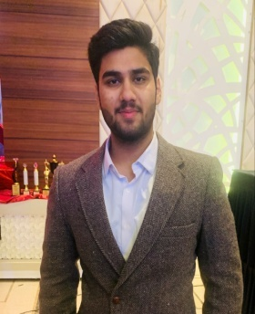

Ishan Dutt Sharma

House no-200,sector-8,Karnal,Haryana

+91-9991343499

ishanduttsharma.cse19@chitkarauniversity.edu.in

# EDUCATION:

|  |  |  |  |
| --- | --- | --- | --- |
| **Qualification/Degree** | **School/College** | **University or Board** | **Year** |
| B. E. (CSE) | Chitkara School of Engineering & Technology | Chitkara University | 2019-2023 |
| Class XII | St. Theresa’s Convent School | Central Board of Secondary Education | 2018-2019 |
| Class X | St. Theresa’s Convent School | Central Board of Secondary Education | 2016-17 |

**PROJECTS & TRAININGS:**

# Weather App

# Skills used- Html, css, Javascript.

# Gym Landing Website

# Skills used-Html, Css

# Laser Security System

# IOT

# ACHIEVEMENTS:

**Academic**

* Secured rank in various Olympiads
* Got scholarship at NTSE stage 1

# Cultural

* Part of Organizing Committee of Fest

# Sports

# District level Skating

**PROFESSIONAL SKILLS:**

* **Languages:** C,C++,Java, Html, Css.
* **DBMS:** MS**-**SQL Server

# Leadership Skills

# CO-CURRICULAR ACTIVITIES:

* Active NCC Cadet.
* Participated in various technical workshops organized.

# CERTIFICATIONS:

* Coding Ninjas Java Course

# PCAP Cyber Security.

# Course Era Complete HTML.