**SMS VOTING SYSTEM**

**ABSTRACT**

Voting is a right of every citizen in a democratic country. Establishment of government is based on citizen’s votes. The objective of this project is to overcome the drawbacks of conventional voting systems. Nowadays GSM (Global System For Mobile Communication) is one of the most widely used communication technology. In this system, voting system based on GSM technology is presented. This voting system is designed by integrating embedded system with mobile infrastructure. This system is able to provide enhanced voter authentication and mobility while maintaining voter privacy.

**LITERATURE SERVEY**

U. Rajkumar, H. Karunakaran, B.karthikeyan & M.venkatesh,(March 2012**)**

 A Secure Mobile Voting System Using Fingerprint.

The fingerprint shows the most promising future in real-worldapplications. Because of their uniqueness and consistency over time, fingerprintshave been used for identification and authentication purpose. However, there aresome challenges in using fingerprint in real-world application. We are interestedin designing and analyzing the Mobile voting system using fingerprint texture,which is the core in current modern approach for fingerprint analysis. As themobile phone become a part of the human, it is very convenient to use. We areusing the mobile phone for the purpose of voting. It helps the user to poll theirvote in spite of any location and also in short period of time. Keywords  Biometric, Fingerprint, Minutiae, Mobile phone. Elections allow the populace tochoose their representatives and express their preferences for how they will begoverned. Naturally, the integrity of the election process is fundamental to theintegrity of democracy itself. The election system must be sufficiently robust towithstand a variety of fraudulent behaviors and must be sufficiently transparentand comprehensible that voters and candidates can accept the results of anelection. Most of the countries in the world e-Voting system have been used. Dueto rapid growth of technology security problems are getting increased. So insteadof developing e-voting systems, also there is a lot research work is being done tomake these systems more secure

The MIT/Caltech researchers [1] “see a promising future for electronic voting, despite its problems today” (under a few conditions). They advocate using the methods currently in use which result in the lowest average numbers of “uncounted, unmarked, and spoiled ballots,” like in-precinct optical scanning. Their report even proposes a framework for a new voting system with a decentralized, modular design. Other researchers have done work in electronic voting; while they may not explicitly mention voting from remote poll sites, their work is nonetheless relevant to any effort at designing or implementing a remote poll site voting system.

Lorrie Cranor [2] could be classified, like the Caltech/MIT researchers, as a cautious optimist. She acknowledges the problems inherent in each kind of voting apparatus, but doesn't make an overt recommendation on her site for one technology over the rest. Some other academics, whom we did not study in class, like Peter Neumann who moderates the RISKS mailing list, are less optimistic. They agree mostly with the Caltech/MIT committee, but their papers focus on the immensity of the problem one faces when trying to design and implement a truly secure voting system. They often remind us of Ken Thompson's Turing acceptance speech and the fact that we really can't trust any code which we did not create ourselves. (And in reality, we cannot trust even code that we do write ourselves, since we almost always need a development toolchain written by someone else.) Therefore, they tend to be extremely suspicious of proprietary voting machines and their makers who insist that we should “just trust [them].”

Neumann [4] gives a list of suggestions for "generic voting criteria" which suggests that a voting system should be so hard to tamper with and so resistant to failure that no commercial system is likely to ever meet the requirements, and developing a suitable custom system would be extremely difficult and prohibitively expensive.

Rebecca Mercuri [3,7] invented the “Mercuri method” for electronic voting. A critical component of this method is very similar to the Caltech/MIT proposal: a voting machine must produce human-readable hardcopy paper results, which can be verified by the voter before the vote is cast, and manually recounted later if necessary. Her philosophy and Neumann's are very similar; in fact, they've written papers together on the subject.

David Chaum presents a very interesting scheme [5], whereby voters could get receipts for their votes. This receipt would allow them to know if their votes were included in the final tally or not, and to prove that they voted without revealing any information about how they voted. The security of this scheme depends on visual cryptography developed by Naor and Shamir, and on voters randomly choosing one of two pieces of paper. Mercuri and Neumann advocate the use of this technique in electronic voting systems.

Dr. Michael Shamos of CMU provides a sharp counterpoint [6] to Neumann and Mercuri's views. While his “Six Commandments” summary of requirements for a voting system is very similar to others' requirements, he's less afraid of the catastrophic failures and sweeping fraud made possible by imperfections in electronic voting machines actually occurring in a real election. Shamos is also much less impressed with paper ballots than are Neumann and Mercuri. He places a great deal of faith in decentralization to make fraud difficult to commit and easy to detect. Dr. Shamos even likes DRE machines. (We must take into account the fact that this paper was written ten years ago, long before the 2000 elections and before more modern mathematical results like Chaum's; some of Dr. Shamos' opinions may have changed since then. While Dr. Neumann's talk cited here is of similar age, his pessimism with regard to machines has had little reason for change.)

**INTRODUCTION**

Traditionally, in centralized or distributed places voting is conducted and the places are called voting booths in India. Traditional voting technologies include hand-counted paper ballots.

Paper based voting system results in various problems that include:

• Loss of votes through unclear or invalid ballot marks

• The Government has to call a day off which can incur huge losses

• Unacceptable percentage of lost, stolen or miscounted ballots

• The Government has to set voting booths at various places in a limited region for people to vote.

Also, for such process, the efficiency, reliability and security of the technologies involved are critical.

The aim of the project is to design an Electronic Voting Machine which maintains the voting record of all candidates through messages received as SMS or GPRS packets and also sends acknowledgement of task.[3]

Benefits of GSM based voting machine:

1. Increase in participation

GSM based voting system offers increased convenience to the voter, encourages more voters to cast their votes remotely, and increases the likelihood of participation for mobile voters.

2. Reduced costs

GSM based voting systems reduces the materials required for printing and distributing ballots.

3. Greater speed and accuracy placing and tallying votes

GSM based systems provide step-by-step processes that helps to minimize the number of miscast votes.

4. Greater accessibility for people with disabilities

GSM based systems allow citizens with disabilities to vote independently and privately.

5. Reduced time consumption

GSM based systems require very less time for citizens to register their votes and the results of the voting will be available immediately after voting process.

**BLOCK DIAGRAM**

LCD

GSM

Max-232

BUZZR

89S52 MICROCONTROLLER

**WORKING:**

We come across areas where we need to gather votes from a wide range of people through an SMS. The system consists of 89s52 microcontroller, LCD, MAX232, GSM and buzzer etc. This system is widely used in large scale dance, singing as well as other type of public voting competitions. Here we propose a system to handle this voting process using a microcontroller. Our system is designed to get casted votes using a gsm modem and transfer the data to a microcontroller for further processing. User casted votes are first received by the gsm modem. This data along with votes is sent to the microcontroller. The microcontroller now decodes the voting data. It considers only one vote from every unique phone number. Multiple voting is not allowed. The microcontroller counts every unique vote and displays the results of voting process on an LCD display. Buzzer is used for indication.

**HARDWARE TOOLS:**

**89S52 MICROCONTROLLER**

A **microcontroller** (sometimes abbreviated **µC**, **uC** or **MCU**) is a small computer on a single [integrated circuit](http://en.wikipedia.org/wiki/Integrated_circuit) containing a processor core, memory, and programmable [input/output](http://en.wikipedia.org/wiki/Input/output) peripherals. It is the control element in our project. 89S52 microcontroller is used in the project. It is an 8 bit microcontroller

**GSM**

* GSM, which stands for *G*lobal *S*ystem for *M*obile communications, reigns as the world’s most widely used cell phone technology. Cell phones use a cell phone service carrier’s GSM network by searching for cell phone towers in the nearby area

**MAX232**

* MAX232 is a driver IC which converts signals from an [RS-232](http://en.wikipedia.org/wiki/RS-232) serial port to signals suitable for use in [TTL](http://en.wikipedia.org/wiki/Transistor-transistor_logic) compatible digital logic circuits. The MAX232 is a dual driver/receiver and typically converts the RX, TX, CTS and RTS signals.
* The MAX232 is a low power dual driver/receiver featuring an onboard DC to DC converter, eliminating the need for ±12V power supplies. The device only requires a +5V power supply

**LCD**

* A liquid-crystal display (LCD) is a [flat panel display](http://en.wikipedia.org/wiki/Flat_panel_display), [electronic visual display](http://en.wikipedia.org/wiki/Electronic_visual_display), that uses the light modulating properties of [liquid crystals](http://en.wikipedia.org/wiki/Liquid_crystal). Liquid crystals do not emit light directly.
* We have used the 16 by 2 LCD that means that it can display the two lines containing 16 characters each. The Pixel Matrix is of 7 by 5 pixels that are each character can be displayed using 7 columns of the pixels and 5 rows of the pixels

**Power supply**

* The basic step in the designing of any system is to design the power supply required for that system. The steps involved in the designing of the power supply are as follows,
* 1) Determine the total current that the system sinks from the supply.
* 2) Determine the voltage rating required for the different components
* We require +5v supply voltage for our project so we used IC7805 regulator.

**Hardware description:**

1. **89S52 MICROCONTROLLER**

The AT89S52 is a low-power, high-performance CMOS 8-bit microcontroller with 8K bytes of in-system programmable Flash memory. The device is manufactured using Atmel’s high-density nonvolatile memory technology and is compatible with the industry-standard 80C51 instruction set and pinout. The on-chip Flash allows the program memory to be reprogrammed in-system or by a conventional nonvolatile memory pro-grammer. By combining a versatile 8-bit CPU with in-system programmable Flash on a monolithic chip, the Atmel AT89S52 is a powerful microcontroller, which provides a highly flexible and cost-effective solution to many, embedded control applications.

The AT89S52 provides the following standard features:

* 32 I/O lines,
* Watchdog timer,
* two data pointers,
* a full duplex serial port,
* on-chip oscillator, .
* A CPU (Central Processing Unit) 8 Bit.
* Four-port I / O, which each consist of eight bits
* the internal oscillator and timing circuits.
* Two timer / counters 16 bits
* Five interrupt lines (two fruits and three external interrupt internal interruptions).
* A serial port with full duplex UART (Universal Asynchronous Receiver Transmitter).
* Able to conduct the process of multiplication, division, and Boolean.
* the size of 8 KByte EPROM for program memory.
* Maximum speed execution of instructions per cycle is 0.5 s at 24 MHz clock frequency.If the microcontroller clock frequency used is 12 MHz, the speed is 1 s instructionexecution
* Internal ROM 4k
* Internal RAM of 128 bytes.
* Two external and three internal interrupt sources Oscillator and clock circuits.
* 16 bit PC &data pointer (DPTR)
* 8 bit program status word (PSW)
* 8 bit stack pointer (SP)
* 4 register banks, each containing 8 registers
* 80 bits of general purpose data memory
* 32 input/output pins arranged as four 8 bit ports: P0-P3 6
* Two 16 bit timer/counters: T0-T1

In addition, the AT89S52 is designed with static logic for operation down to zero frequency and supports two software selectable power saving modes. The Idle Mode stops the CPU while allowing the RAM, timer/counters, serial port, and interrupt system to continue functioning. The Power-down mode saves the RAM con-tents but freezes the oscillator, disabling all other chip functions until the next interrupt

**Pin diagram:**

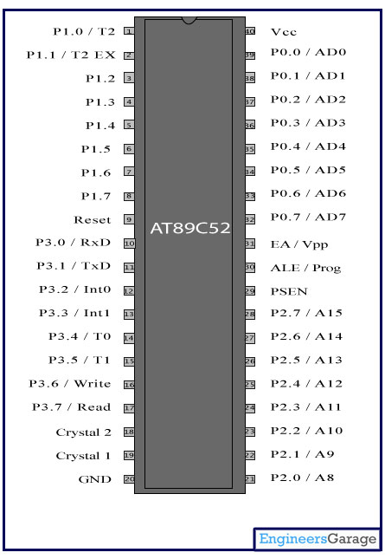

1. **GSM**

**GSM Module(SIM 900A)**

GSM was the most successful second generation cellular technology, but the need for higher data rates spawned new developments to enable data to be transferred at much higher rates.

The first system to make an impact on the market was GPRS. The letters GPRS stand for General Packet Radio System, GPRS technology enabled much higher data rates to be conveyed over a cellular network when compared to GSM that was voice centric.

GPRS technology became the first stepping-stone on the path between the second-generation GSM cellular technology and the 3G W-CDMA / UMTS system. With GPRS technology offering data services with data rates up to a maximum of 172 kbps, facilities such as web browsing and other services requiring data transfer became possible. Although some data could be transferred using GSM, the rate was too slow for real data applications.

* High Quality Product (Not hobby grade)
* Quad-Band GSM/GPRS 850/ 900/ 1800/ 1900 MHz
* Built in RS232 Level Converter (MAX3232)
* Configurable baud rate
* SMA connector with GSM L Type Antenna.
* Built in SIM Card holder.
* Built in Network Status LED
* Inbuilt Powerful TCP/IP protocol stack for internet data transfer over GPRS.
* Audio interface Connector Most Status & Controlling Pins are available at Connector
* Normal operation temperature: -20 °C to +55 °C
* Input Voltage: 5V-12V DC
* Quad-Band 850/ 900/ 1800/ 1900 MHz
* GPRS multi-slot class 10/8
* GPRS mobile station class B
* Compliant to GSM phase 2/2+ o Class 4 (2 W @850/ 900 MHz) o Class 1 (1 W @ 1800/1900MHz)
* Dimensions: 24\*24\*3mm
* Weight: 3.4g
* Control via AT commands (GSM 07.07 ,07.05 and SIMCOM enhanced AT Commands)
* Low power consumption: 1.0mA(sleep mode)
* Operation temperature: -40°C to +85 °C\ Specifications for Fax
* Group 3, class 1 Specifications for Data
* GPRS class 10: max. 85.6 kbps (downlink)
* PBCCH support
* Coding schemes CS 1, 2, 3, 4
* CSD up to 14.4 kbps , USSD , Non transparent mode
* PPP-stack Specifications for SMS via GSM/GPRS
* Point to point MO and MT SMS cell broadcast
* Text and PDU mode Software features
* 0710 MUX protocol
* embedded TCP/UDP protocol
* FTP/HTTP Special firmware , MMS
* Java (cooperate with IA solution) Embedded AT

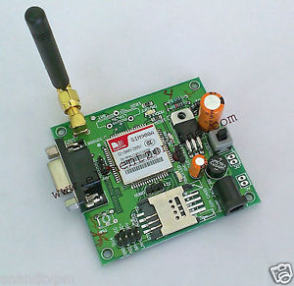

**GSM MODULE**

1. **MAX232**

**Logic Signal Voltage**

Serial RS-232 (V.24) communication works with voltages (between -15V ... -3V are used to transmit a binary '1' and +3V ... +15V to transmit a binary '0') which are not compatible with today's computer logic voltages. On the other hand, classic TTL computer logic operates between 0V ... +5V (roughly 0V ... +0.8V referred to as*low* for binary '0', +2V ... +5V for *high* binary '1' ). Modern low-power logic operates in the range of 0V ... +3.3V or even lower.

So, the maximum RS-232 signal levels are far too high for today's computer logic electronics, and the negative RS-232 voltage can't be grokked at all by the computer logic. Therefore, to receive serial data from an RS-232 interface the voltage has to be reduced, and the *0* and *1* voltage levels inverted. In the other direction (sending data from some logic over RS-232) the low logic voltage has to be "bumped up", and a negative voltage has to be generated, too.

RS-232 TTL Logic

-----------------------------------------------

-15V ... -3V <-> +2V ... +5V <-> 1 (idle state)

+3V ... +15V <-> 0V ... +0.8V <-> 0 (start bit)

All this can be done with conventional analog electronics, e.g. a particular power supply and a couple of [transistors](https://en.wikipedia.org/wiki/transistor) or the once popular 1488 (transmitter) and 1489 (receiver) ICs. However, since more than a decade it has become standard in amateur electronics to do the necessary signal level conversion with an integrated circuit (IC) from the MAX232 family (typically a MAX232A or some clone). In fact, it is hard to find some RS-232 circuitry in amateur electronics without a MAX232A or some clone.

We discuss the [[Serial\_Programming/RS-232\_Connections#Signal\_Bits | signal bits] in more detail later in this book.

[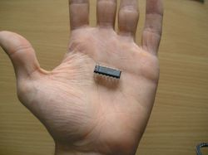](https://en.wikibooks.org/wiki/File:Max232_in_hand.jpg)

The MAX232 from [Maxim](http://www.maxim-ic.com/) was the first IC which in one package contains the necessary drivers (two) and receivers (also two), to adapt the RS-232 signal voltage levels to TTL logic. It became popular, because it just needs one voltage (+5V) and generates the necessary RS-232 voltage levels (approx. -10V and +10V) internally. This greatly simplified the design of circuitry. Circuitry designers no longer need to design and build a power supply with three voltages (e.g. -12V, +5V, and +12V), but could just provide one +5V power supply, e.g. with the help of a simple 78x05 voltage regulator.

The MAX232 has a successor, the MAX232**A**. The ICs are almost identical, however, the MAX232A is much more often used (and easier to get) than the original MAX232, and the MAX232A only needs external capacitors 1/10th the capacity of what the original MAX232 needs.

It should be noted that the MAX232(A) is just a driver/receiver. It does not generate the necessary RS-232 sequence of marks and spaces with the right timing, it does not decode the RS-232 signal, it does not provide a serial/parallel conversion. **All it does is to convert signal voltage levels**. Generating serial data with the right timing and decoding serial data has to be done by additional circuitry, e.g. by a [16550 UART](https://en.wikibooks.org/wiki/Serial_Programming:8250_UART_Programming) or one of these small micro controllers (e.g. [Atmel AVR](https://en.wikibooks.org/wiki/Atmel_AVR), [Microchip PIC](https://en.wikibooks.org/wiki/Embedded_Systems/PIC_Microcontroller)) getting more and more popular.

The MAX232 and MAX232A were once rather expensive ICs, but today they are cheap. It has also helped that many companies now produce clones (ie. [Sipex](http://www.sipex.com/products/interface.htm" \t "_blank)). These clones sometimes need different external circuitry, e.g. the capacities of the external capacitors vary. It is recommended to check the data sheet of the particular manufacturer of an IC instead of relying on Maxim's original data sheet.

The original manufacturer (and now some clone manufacturers, too) offers a large series of similar ICs, with different numbers of receivers and drivers, voltages, built-in or external capacitors, etc. E.g. The MAX232 and MAX232A need external capacitors for the internal voltage pump, while the MAX233 has these capacitors built-in. The MAX233 is also between three and ten times more expensive in electronic shops than the MAX232A because of its internal capacitors. It is also more difficult to get the MAX233 than the garden variety MAX232A.

A similar IC, the MAX3232 is nowadays available for low-power 3V logic.

**MAX232 DIP Package**

[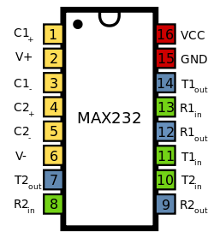](https://en.wikibooks.org/wiki/File:MAX232_Pinout.svg)

|  |  |  |  |  |  |
| --- | --- | --- | --- | --- | --- |
| **MAX232(A) DIP Package Pin Layout** | | | | | |
| **Nbr** | **Name** | **Purpose** | **Signal Voltage** | **Capacitor Value MAX232** | **Capacitor Value MAX232A** |
| 1 | C1+ | + connector for capacitor C1 | capacitor should stand at least 16V | 1µF | 100nF |
| 2 | V+ | output of voltage pump | +10V, capacitor should stand at least 16V | 1µF to VCC | 100nF to VCC |
| 3 | C1- | - connector for capacitor C1 | capacitor should stand at least 16V | 1µF | 100nF |
| 4 | C2+ | + connector for capacitor C2 | capacitor should stand at least 16V | 1µF | 100nF |
| 5 | C2- | - connector for capacitor C2 | capacitor should stand at least 16V | 1µF | 100nF |
| 6 | V- | output of voltage pump / inverter | -10V, capacitor should stand at least 16V | 1µF to GND | 100nF to GND |
| 7 | T2out | Driver 2 output | RS-232 |  |  |
| 8 | R2in | Receiver 2 input | RS-232 |  |  |
| 9 | R2out | Receiver 2 output | TTL |  |  |
| 10 | T2in | Driver 2 input | TTL |  |  |
| 11 | T1in | Driver 1 input | TTL |  |  |
| 12 | R1out | Receiver 1 output | TTL |  |  |
| 13 | R1in | Receiver 1 input | RS-232 |  |  |
| 14 | T1out | Driver 1 output | RS-232 |  |  |
| 15 | GND | Ground | 0V | 1µF to VCC | 100nF to VCC |
| 16 | VCC | Power supply | +5V | see above | see above |

V+(2) is also connected to VCC via a capacitor (C3). V-(6) is connected to GND via a capacitor (C4). And GND(15) and VCC(16) are also connected by a capacitor (C5), as close as possible to the pins.

### What is RS232?

The RS-232(X) is a communication cable, commonly used for transferring and receiving the serial data between two devices.  It supports both synchronous and asynchronous data transmissions. Many devices in the industrial environment are still using RS-232 communication cable. Rs-232 cable is used to identify the difference of two signal levels between logic 1 and logic 0. The logic 1 is represented by the -12V and logic 0 is represented the +12V.  The RS-232 cable works at different baud rates like 9600 bits/s, 2400bits/s, 4800bits/s etc. The RS-232 cable has two terminal devices namely Data Terminal Equipment and Data communication Equipment. Both device will sends and receives the signals. The  data terminal equipment is computer terminal and data communication Equipment is modems, or controllers etc.

[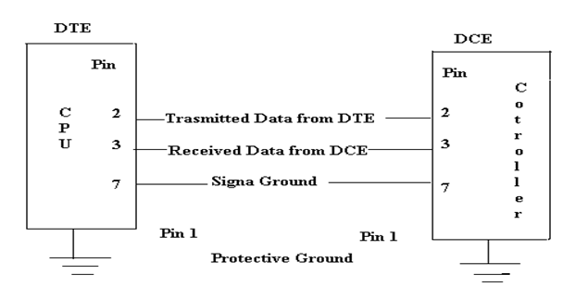](https://www.elprocus.com/wp-content/uploads/2013/06/The-General-RS-232-Communication-Diagram.png)

Now a day’s most of personal computers have two serial ports and one parallel port (RS232). These two types of ports are used for communicating with external devices and they work in different ways. The parallel port sends and receives the 8-bit data at a time over eight separate wires and this transfers the data very quickly, the parallel ports are typically used to connect a printer to a PC.

A serial port sends and receives one bit data at a time over one wire and it transfer data very slowly. The RS-232 stands for recommended slandered and 232 is a number X is indicates the latest version like RS-232c, RS232s.

The most commonly used type of serial cable connectors are 9-pin connector DB9 and 25-pin connector DB-25. Each of them may be male or female type. Now a days most of computers use DB9 connector for asynchronous data exchange. The maximum length of RS-232 cable is 50ft.

[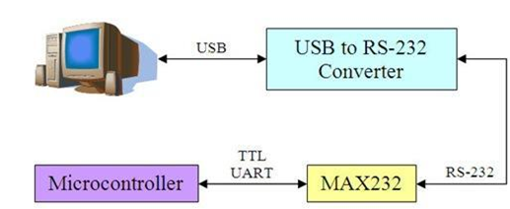](https://www.elprocus.com/wp-content/uploads/2013/06/RS-232-Communication-Cable.png)

Max 232 is an ic(integrated circuit) that converts TTL(Transistor Transistor logic) logic signal in to its equivalent RS-232c level signal and Rs-232c level to its equivalent TTL level signal.This ic is very important in case when we need to make connection and transfer data between devices that works on different wave forms.  
For example, Most of the microcontrollers 8051(89c51,89c52), PIC(16f877), AVR works on TTL logic wave form. These microcontrollers have a build in UART(Universal Synchronous-Asynchronous Receiver & Transmitter) which can send and receive serial data. Since they work on TTL level so they transmit and receive data on TTL wave from. Where as Standard PC(Personal Computers) works on RS-232 level wave form. Now if we need to transfer data from microcontroller to PC(Personal computer) we need to convert data from TTL to RS-232 level and if we want to send data from PC to microcontroller we have to convert data from Rs-232 to TTL. MAx-232 is solution to this problem. Their is wide range where we use max232 but its main purpose is explained above.

[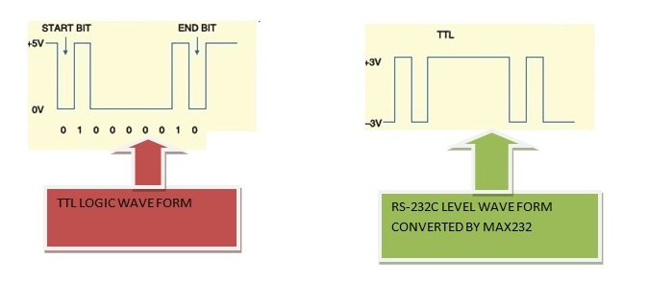](http://www.microcontroller-project.com/uploads/2/2/1/5/22159166/6962007_orig.jpg)

TTL vs RS-232 signal wave form

[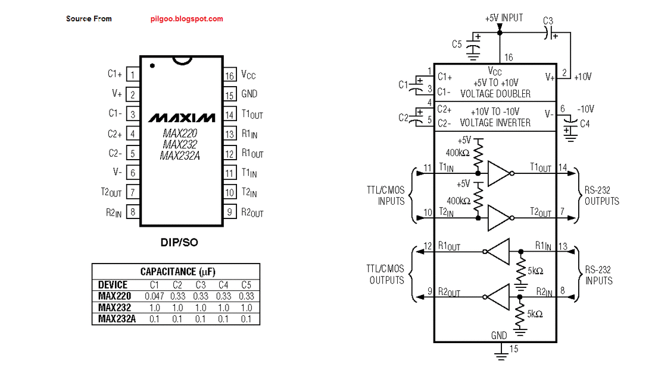](http://www.microcontroller-project.com/uploads/2/2/1/5/22159166/2625766_orig.gif)

MAX232 Pinout and Circuit Diagram

Pin names with Functions

MAx232 has 16 pins. It requires four external capacitors for its proper configuration Capacitors can range between 8uf to 10uf and are of upto 16v.

Pin names With functions are listed below. Suppose max-232 is connected to Pc or microcontroller.

PIN 1(C1+) Connect positive leg of a capacitor to it.

PIN 2(Vs+) Connect positive leg of a capacitor to it, and make negative leg of same capacitor ground.

PIN 3(C1-) Connect negative leg of a capacitor to it, whose positive leg is connected to Pin#1.

PIN 4(C2+) Connect positive leg of a capacitor to it.

PIN 5(C2-) Connect negative leg of a capacitor to it, whose positive leg is connected to Pin#4.

PIN 6(Vs-) Connect negative leg of a capacitor to it and apply 5 volts to positive leg of the same                             capacitor.

PIN 7(T2OUT)

Outputs the converted Transmitted signal. Signal is received from Pc or microcontroller etc at T1IN Pin.  Connect this pin to Pin#2 of DB-9 serial port of your PC or Rxd Pin of youe microcontroller, actually this pin transmits the transformed signal from TTL to RS-232 level or Rs-232 to TTL. Pin#2 of DB-9 port is Rxd(Rxd means This pin receives Transmitted Signal(data)).

PIN 8(R2IN)

This pin Receives transmitted signal from Pc or microcontroller etc. This pin receives signal transmitted from Txd pin. Connect this pin to Pin#3 of DB-9 port of your PC or Txd pin of microcontroller. Pin#3 of DB-9 port is Txd(Txd means This pin transmits data).

PIN 9(R2OUT)

Outputs the converted received signal. Signal is  recevied from Pc or microcontroller etc at R1In Pin. Connect this pin to your module Rxd pin which

receives the signal.

PIN 10(T2IN)

Receives the transmitted signal from pc or microcontroller etc. Signal is transmitted from txd pin. Connect this pin to your module Txd pin.

* PIN 11(T1IN)          Woks same as T1IN.
* PIN 12(R1OUT)      Works same as R2OUT.
* PIN 13(R1IN)          Works same as R2IN.
* PIN 14(T1OUT)      Works same as T2OUT.
* PIN 15(GND)          Ground this pin.
* PIN 16(vcc)             Apply 5 volts to this pin.

Max232 has two line drivers. You can make connections between four uarts at a time. Diagram below will clear you about line drivers, pin functions and connections. Data flow is clearly visible.

1. **LCD**

HOW 16x2 ALPHANUMERIC LCD WORKS ?

          LCD (Liquid Crystal Display) is used in all the electronics projects to display the status of the process. A 16x2 alphanumeric LCD is most widely used module of LCD nowadays. There are several others type of  LCD available in market also.

The reason for choosing LCD over other display component or devices is that it is

* Low cost
* Easily programmable
* Large number of display character etc.

16x2 LCD has 2 horizontal line which comprising a space of 16 displaying character. It has two type of register inbuilt that is

* Command Register
* Data Register.

[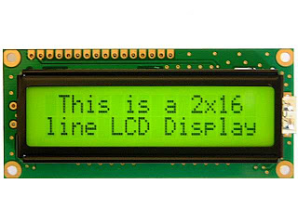](http://3.bp.blogspot.com/-hN2n9HggfCw/T2TOHEMIAsI/AAAAAAAAAAc/LrJ6uy2cNrs/s1600/lcd162b-yhy.jpg)

    Command register is used to insert a special command into the LCD. While Data register is used to insert a data into the LCD. Command is a special set of  data which is used to give the internal command to LCD like Clear screen, move to line 1 character 1, setting up the cursor etc.

**Pin Diagram of 16x2 LCD :**

[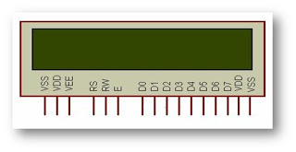](http://2.bp.blogspot.com/-RCDSxoj1p-o/T2TONmNyDhI/AAAAAAAAAAk/Cuea9cMqYis/s1600/lcd2.jpg)

16×2 LCD module is a very common type of LCD module that is used in embedded projects. It consists of 16 rows and 2 columns of 5×7 or 5×8 LCD dot matrices. It is available in a 16 pin package with back light ,contrast adjustment function and each dot matrix has 5×8 dot resolution. The pin numbers, their name and corresponding functions are shown in the table  below.

|  |  |  |
| --- | --- | --- |
| **Sr. No** | **Pin No.** | **Pin Description** |
| 1 | Pin 1 (GND) | This is a ground pin to apply a ground to LCD. |
| 2 | Pin 2 (VCC) | This is the supply voltage pin to apply voltage to LCD. |
| 3 | Pin 3 (VEE) | This is the pin for adjusting a contrast of  the LCD display by attaching a variable resistor in between VCC and GND. |
| 4 | Pin 4 (RS) | RS stands for Register Select. This pin is used to select command/data register.  If RS=0 then command register is selected.  If RS=1 then data register is selected. |
| 5 | Pin 5 (R/W) | R/W stands for Read/Write. This pin is used to select the operation Read/Write.  If R/W=0 then Write operation is performed.  If R/W=1 then Read operation is performed. |
| 6 | Pin 6 (EN) | En stand for Enable signal. A positive going pulse on this pin will perform a read/write function to the LCD. |
| 7 | Pin 7-14 (DB0-DB7) | This 8 pin is used as a Data pin of  LCD. |
| 8 | Pin 15 (LED+) | This pin is used with pin 16(LED-) to setting up the illumination of back light of LCD. This pin is connected with VCC. |
| 9 | Pin 16 (LEC-) | This pin is used with pin 15(LED+) to setting up the illumination of back light of LCD. This pin is connected with GND. |

VEE pin is meant for adjusting the contrast of the LCD display and the contrast can be adjusted by varying the voltage at this pin. This is done by connecting one end of a POT to the Vcc (5V), other end to the Ground and connecting the center terminal (wiper) of of the POT to the VEE pin.

The module has two built in registers namely data register and command register.  Data register is for placing the data to be displayed , and the command register is to place the commands. The 16×2 LCD module has a set of commands each meant for doing a particular job with the display. High logic at the RS pin will select the data register and  Low logic at the RS pin will select the command register. If we make the RS pin high and the put a data in the 8 bit data line (DB0 to DB7) , the LCD module will recognize it as a data to be displayed. If we make RS pin low and put a data on the data line, the module will recognize it as a command.

R/W pin is meant for selecting between read and write modes. High level at this pin enables read mode and low level at this pin enables write mode.

E pin is for enabling the module. A high to low transition at this pin will enable the module.

DB0 to DB7 are the data pins. The data to be displayed and the command  instructions are  placed on these pins.

LED+(positive) is the anode of the back light LED and this pin must be connected to Vcc through a suitable series current limiting resistor. LED-(negative) is the cathode of the back light LED and this pin must be connected to ground.

**Important commands codes for LCD :**

|  |  |  |
| --- | --- | --- |
| **Sr.No.** | **Hex Code** | **Command to LCD instruction Register** |
| 1 | 01 | Clear display screen |
| 2 | 02 | Return home |
| 3 | 04 | Decrement cursor (shift cursor to left) |
| 4 | 06 | Increment cursor (shift cursor to right) |
| 5 | 05 | Shift display right |
| 6 | 07 | Shift display left |
| 7 | 08 | Display off, cursor off |
| 8 | 0A | Display off, cursor on |
| 9 | 0C | Display on, cursor off |
| 10 | 0E | Display on, cursor blinking |
| 11 | 0F | Display on, cursor blinking |
| 12 | 10 | Shift cursor position to left |
| 13 | 14 | Shift cursor position to right |
| 14 | 18 | Shift the entire display to the left |
| 15 | 1C | Shift the entire display to the right |
| 16 | 80 | Force cursor to beginning to 1st line |
| 17 | C0 | Force cursor to beginning to 2nd line |
| 18 | 38 | 2 lines and 5x7 matrix |

1. **BUZZER**

Piezo buzzeris an electronic device commonly used to produce sound. Light weight, simple construction and low price make it usable in various applications like car/truck reversing indicator, computers, call bells etc. Piezo buzzer is based on the inverse principle of piezo electricity discovered in 1880 by Jacques and Pierre Curie. It is the phenomena of generating electricity when mechanical pressure is applied to certain materials and the vice versa is also true. Such materials are called piezo electric materials. Piezo electric materials are either naturally available or manmade. Piezoceramic is class of manmade material, which poses piezo electric effect and is widely used to make disc, the heart of piezo buzzer. When subjected to an alternating electric field they stretch or compress, in accordance with the frequency of the signal thereby producing sound.

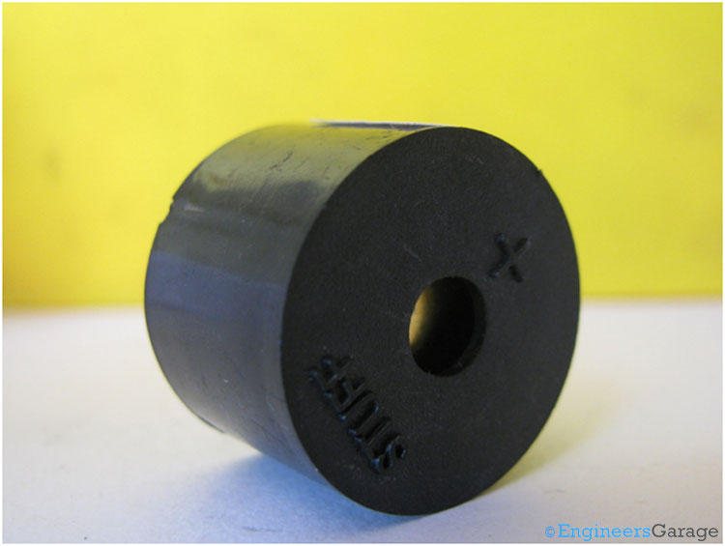

The above image shows a very commonly used piezo buzzer also called **piezo transducer** operating at DC voltage. Encapsulated in a cylindrical plastic coating, it has a hole on the top face for sound to propagate. A yellow metallic disc which plays an important role in the producing sound can be seen through the hole.

**SOFTWARE TOOLS:**

* Keil u vision 2(assembly language)
* Eagle 5.1.0 (for PCB and circuit design)
* Proteus (for simulation)

**ADVANTAGES**

* Reduced costs
* Increased participation and voting options
* Reduced Risk
* Reduced time Consumption
* Greater speed and accuracy placing and tallying votes

**APPLICATIONS**

* Allow your target audience to vote for different participants/ events via SMS.
* Audience can vote for any participant by sending SMS to a specified short code
* Add as many participants for voting service

**References**

[1]Douglas W. Jones, “Early Requirements for Mechanical Voting Systems”, International Workshop on Requirements Engineering for E-voting Systems, Aug. 31, 2009.

[2]. A. Drumea, P. Svasta, "Universal electronic module for industrial control based on system on chip device," 30th International Spring Seminar on Electronics Technology, ISSE 2007, Cluj-Napoca, Romania, pp. 232-235, May 2007.

[3]. A. Villafiorita, K. Weldemariam, and R. Tiella, “Development, Formal Verification, and Evaluation of an E-Voting System with VVPAT,” IEEE Transactions on Information Forensics and Security, vol. 4, no. 4, 2009.

[4]. S.Lavanya."Trusted secure electronic voting machine" International Conference on Nanoscience, Engineering and Technology (ICONSET), pp.505 – 507, 2011

[5]. D. Chaum , P. Y. Ryan and S. Schneider S. De Capitani di Vimercati , P. Syverson and D. Gollmann "A practical voter-verifiable election scheme", Proc. Comput. Security (ESORICS 2005), vol. 3679, pp. 118 -139, 2005.

[6]. Vaibhav Bhatia, Rahul Gupta, “A Novel Electronic Voting Machine Design with Voter Information Facility using Microcontroller” International Conference on Computing for Sustainable Global Development , pp: 311-313, March 5th- 7th

[7]. Kusam, P. Abrol and Devanand, “Digital Tampering Detection Techniques: A Review”, BIJIT-2009, July – December, 2009, Vol. 1 No. 2, ISSN 0973 – 5658.

[8]. V. Otsason, A. Varshavsky, A. LaMarca, E. de Lara, "Accurate GSM indoor localization," in Proceedings of the 7th International Conference on Ubiquitous Computing, pp.141-158, Tokyo, Japan, September 2005.

[9]. J. Cai, D.J. Goodman, “General Packet Radio Service in GSM", IEEE Communication magazine, October 1997.