PROJECT REPORT
ON
SMART HOME SECURITY SYSTEM

In partial fulfillment of the requirements for the award of the degree of Bachelor of Technology in Electronics & Communication Engineering

Maulana Abul Kalam Azad University of Technology(Formerly known as West Bengal University of Technology)

Submitted by:
- Ishanjit Nandi (11900322005)
- Onkar Chowdhury (11900322009)
- Biky Roy (11900322015)
- Arghyo Kumar Saha (11900323022)


Under the guidance of:
- Dr. Manas Kr. Parai

DEPARTMENT OF ELECTRONICS & COMMUNICATION ENGINEERING SILIGURI INSTITUTE OF TECHNOLOGY PO: SUKNA, SILIGURI, PIN: 734 009, WEST BENGAL
2025-2026
DEPARTMENT OF ELECTRONICS & COMMUNICATION ENGINEERING

CERTIFICATE

Certified that the project work entitled "SMART HOME SECURITY SYSTEM" is a bona fide work carried out by

- Ishanjit Nandi (11900322005),
- Onkar Chowdhury (11900322009),
- Biky Roy (11900322015),
- Arghyo Kumar Saha (11900323022)

in partial fulfillment for the award for degree of a Bachelor of Technology degree in ELECTRONICS & COMMUNICATION ENGINEERING of the MAULANA ABUL KALAM AZAD UNIVERSITY OF TECHNOLOGY, WEST BENGAL during the year 2025-2026.

It is certified that all corrections/suggestions indicated for Internal Assessment have been incorporated in the report deposited in the Department. The project report has been approved as it satisfies the academic requirements with respect to the Project Work prescribed for the Bachelor of Engineering Degree.

------------------------ -------------------------------
<Dr. Manas Kr. Parai> <Dr. Debajyoti Misra>

ACKNOWLEDGEMENT

The successful completion of any project is the result of the combined efforts of many individuals who provide guidance, support, and technical expertise. We take this opportunity to express our heartfelt gratitude to everyone who made this project, "Smart Home Security System," a reality.

First and foremost, we would like to express our profound gratitude and deep sense of respect to our project guide, Dr. Manas Kr. Parai, Assistant Professor, Department of Electronics & Communication Engineering, Siliguri Institute of Technology. His constant encouragement, invaluable suggestions, and meticulous supervision throughout the duration of this project were the driving forces behind our progress. His expertise in embedded systems and IoT provided us with the necessary clarity to overcome complex technical hurdles, especially during the integration of the ESP32-CAM module.

We are extremely grateful to Dr. Debajyoti Misra, Head of the Department of Electronics & Communication Engineering, for his support and for providing us with the necessary administrative approvals and laboratory resources. His leadership has fostered an environment of innovation and academic excellence that significantly benefited our work.

We would also like to extend our sincere thanks to all the faculty members of the ECE Department for their indirect contributions and for the theoretical foundation they provided through their lectures over the years. Our appreciation also goes to the laboratory staff and technical assistants who facilitated our hardware testing and provided us with the essential components and tools.

A special mention goes to the Siliguri Institute of Technology administration for providing a platform where we could apply our theoretical knowledge to practical, real-world problems. Finally, we thank our parents and friends for their unwavering moral support, patience, and encouragement, which kept us motivated during the long hours of development and testing.

ABSTRACT

The integration of the Internet of Things (IoT) into home security has transformed traditional reactive systems into proactive, intelligent solutions. This project, titled "Smart Home Security System," presents the design and implementation of a low-cost, high-efficiency security framework tailored for modern residential environments. The primary objective is to address the limitations of conventional security systems, such as high installation costs, lack of real-time remote monitoring, and the inability to provide visual verification of alerts.

The proposed system leverages the ESP32-CAM microcontroller as its core processing and communication hub. The system utilizes Passive Infrared (PIR) sensors to detect human motion by sensing infrared radiation changes. Upon detection of an unauthorized presence, the ESP32-CAM triggers a multi-layered response: it activates a local audible alarm through a piezo buzzer and captures a high-resolution image using its integrated OV2640 camera module. This image is then transmitted in real-time to the user’s mobile device via the Telegram Bot API, providing immediate visual evidence of the intrusion.

The methodology involves a systematic approach starting from hardware interfacing, firmware development using the Arduino IDE, and cloud integration for remote notifications. Experimental results demonstrate that the system achieves high detection accuracy with minimal latency, typically delivering alerts within 3 to 5 seconds. By combining motion sensing with image capture, the system significantly reduces false alarm fatigue and provides a scalable, energy-efficient solution for smart home security. This project serves as a robust prototype for future enhancements, including AI-based face recognition and multi-sensor fusion.

TABLE OF CONTENTS
CHAPTER 1: INTRODUCTION ....................................................................... 1
  - 1.1 Background
  - 1.2 Problem Statement
  - 1.3 Objectives
  - 1.4 Scope of Project
  - 1.5 Methodology
CHAPTER 2: REVIEW OF LITERATURE ....................................................... 3
  - 2.1 Conventional Security Systems
  - 2.2 IoT-Based Security Systems
  - 2.3 Research Gap
CHAPTER 3: COMPONENT DESCRIPTION .................................................. 4
  - 3.1 ESP32-CAM Microcontroller
  - 3.2 OV2640 Camera Module
  - 3.3 PIR Sensor (HC-SR501)
  - 3.4 Piezo Buzzer
  - 3.5 LED Indicators
  - 3.6 Power Management System
  - 3.7 Software Tools (Arduino IDE & Telegram Bot)
CHAPTER 4: OPERATION AND IMPLEMENTATION .................................. 7
  - 4.1 Working Principle
  - 4.2 System Architecture
  - 4.3 Software Implementation & Logic
  - 4.4 Algorithm for Intrusion Detection
CHAPTER 5: RESULTS AND DISCUSSION .................................................... 11
  - 5.1 Experimental Setup
  - 5.2 Test Case Analysis
  - 5.3 Performance Evaluation
CHAPTER 6: MERITS AND DEMERITS .......................................................... 12
  - 6.1 Merits
  - 6.2 Demerits
  - 6.3 Challenges Faced
CHAPTER 7: CONCLUSION AND FUTURE SCOPE ..................................... 13
  - 7.1 Conclusion
  - 7.2 Future Scope
APPENDIX .............................................................................................................. 14
REFERENCES ........................................................................................................ 16

CHAPTER 1: INTRODUCTION
1.1 Background
In the current era of rapid urbanization and technological advancement, the security of residential and commercial properties has become a critical concern. Traditional security measures, such as physical locks, perimeter fencing, and manual surveillance, are increasingly proving insufficient against modern security threats. The emergence of the Internet of Things (IoT) has provided a transformative solution by enabling physical objects to connect to the internet, allowing for remote monitoring, data exchange, and automated decision-making. Smart home security systems represent a specialized application of IoT where sensors, microcontrollers, and communication modules work in unison to protect a premises. These systems offer a significant advantage over traditional setups by providing real-time alerting and remote accessibility, ensuring that homeowners are informed of security breaches regardless of their physical location.
1.2 Problem Statement
Despite the availability of professional security systems, several challenges persist for the average consumer:
- High Cost of Ownership: Professional CCTV and alarm systems involve high initial hardware costs and recurring subscription fees for monitoring services.
- Lack of Visual Verification: Many affordable alarm systems rely solely on motion sensors. Without a camera, the user cannot distinguish between a genuine intruder and a false trigger (e.g., a pet or a moving curtain).
- Complexity of Installation: Wired security systems require extensive cabling and professional installation, making them unsuitable for many existing homes or rental properties.
- Delayed Response: Traditional systems often record data locally to a DVR. If an intruder steals the DVR, the evidence is lost, and the owner is only aware of the theft after the fact.
1.3 Objectives
The primary goal of this project is to develop a robust, low-cost, and intelligent security system. The specific objectives are:
To design a circuit that interfaces a high-sensitivity PIR sensor with the ESP32-CAM module.
To implement a firmware logic that triggers image capture immediately upon motion detection.
To establish a secure Wi-Fi connection for transmitting captured data to a cloud-based notification platform (Telegram).
To provide local deterrence through audible and visual alarms (Buzzer and LED).
To ensure the system is energy-efficient and capable of running on a standard 5V power supply.
1.4 Scope of Project
The scope of this project includes the development of a functional prototype capable of:
- Detecting human motion within a 7-meter range.
- Capturing JPEG images at VGA resolution (640x480).
- Sending instant alerts with images to a Telegram bot.
- Maintaining a stable connection to a home Wi-Fi network.
1.5 Methodology
The development process followed these phases:
Requirement Gathering: Defining the sensor sensitivity and image quality requirements.
Hardware Prototyping: Interfacing the ESP32-CAM with the PIR sensor and buzzer on a breadboard.
Firmware Development: Using the Arduino IDE to write the control logic, including Wi-Fi management and Telegram API integration.
Testing: Conducting multiple test cases in different lighting and motion scenarios.
CHAPTER 2: REVIEW OF LITERATURE
2.1 Conventional Security Systems
Conventional systems primarily include CCTV cameras and wired burglar alarms. While CCTV provides visual evidence, it is often passive. Burglar alarms provide active deterrence but lack visual context. The combination of both in traditional systems is often bulky and expensive. Research by Monk (2016) emphasizes that the shift towards wireless microcontrollers has made these systems more accessible to the DIY community. [2, 3, 4, 5]

2.2 IoT-Based Security Systems
Recent literature focuses on the use of microcontrollers like the ESP8266 and ESP32. The ESP32 is particularly noted for its dual-core architecture and integrated Wi-Fi/Bluetooth. Studies have shown that using the Telegram Bot API is one of the most efficient ways to implement remote notifications due to its built-in encryption and support for multimedia messages. Unlike the ESP8266, the ESP32 has enough processing power to handle image compression and transmission simultaneously.[1, 6, 7]

2.3 Research Gap
While many IoT projects focus on simple motion detection, there is a significant gap in providing visual verification at a price point under $20. Most existing solutions either provide only text alerts or require expensive cloud subscriptions for image storage. This project addresses this gap by utilizing the ESP32-CAM, which integrates a camera directly onto the microcontroller board, eliminating the need for external camera modules and reducing system complexity.[6]

CHAPTER 3: OPERATION AND IMPLEMENTATION
3.1 Block Diagram
(Fig.3.1 Block diagram of the system)
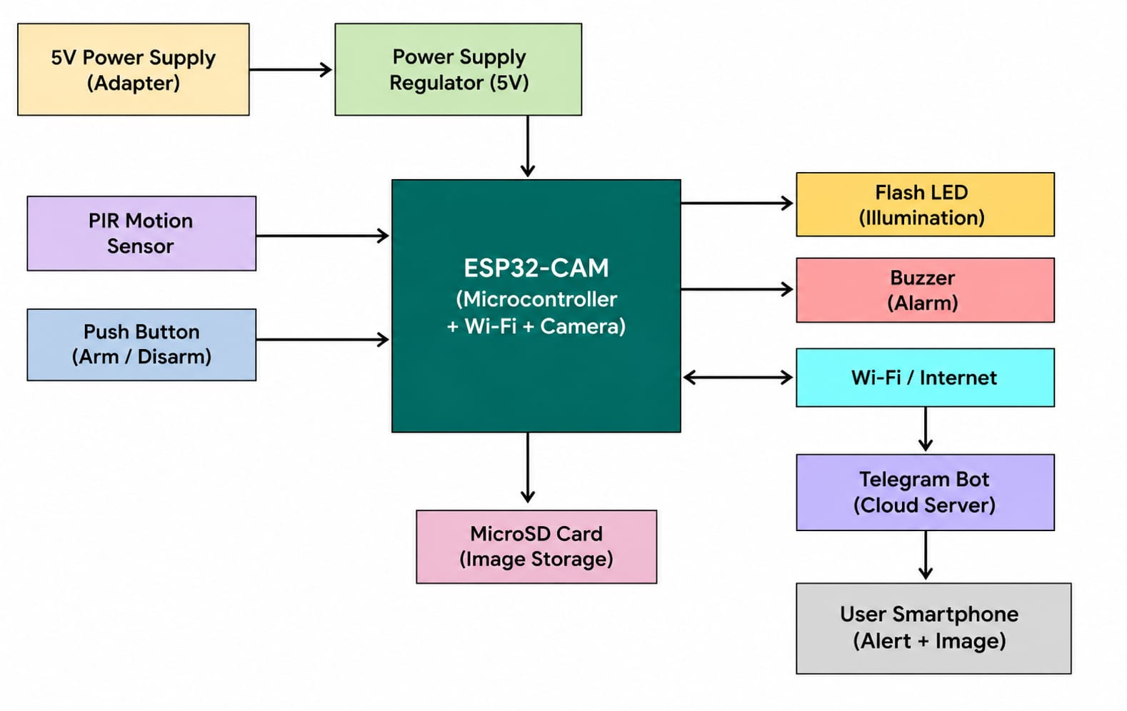
The ESP32-CAM is connected to the PIR sensor and push button for motion detection and system control. It activates the buzzer and flash LED, stores images on the MicroSD card, and sends alerts to the user's smartphone via Telegram over Wi-Fi.
3.2 Working Principle
The system's operation is divided into three states: Initialization, Monitoring, and Alerting.
Initialization: Upon power-up, the ESP32-CAM initializes its GPIO pins, sets up the camera parameters, and attempts to connect to the saved Wi-Fi SSID. Once connected, it initializes the Telegram bot.
Monitoring: The PIR sensor continuously scans for IR changes. The ESP32-CAM remains in a low-power loop, waiting for a HIGH signal from the PIR sensor's output pin.
Alerting: When motion is detected:
  - The Buzzer is activated immediately.
  - The Flash LED is turned on (if required).
  - The Camera captures a JPEG frame.
  - The ESP32-CAM establishes an SSL connection to the Telegram servers.
  - The image is uploaded via an HTTP POST request.
  - The system enters a 10-second lockout period to prevent duplicate alerts for the same event.
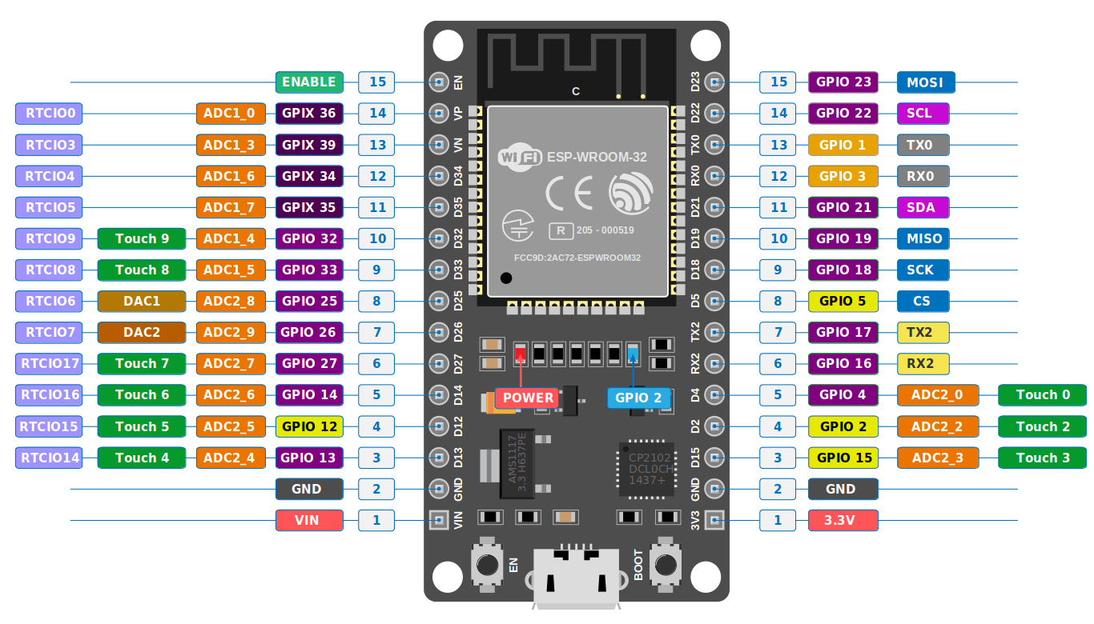
(Fig. 3.2 ESP pin diagram)
3.3 System Architecture
The hardware architecture is a Star Topology where all sensors and actuators are connected directly to the ESP32-CAM. The PIR sensor serves as the input trigger, while the Buzzer, LED, and Camera serve as the output devices. The Wi-Fi router acts as the gateway to the internet.
3.4 Software Implementation & Logic
The code utilizes a Non-Blocking Logic to ensure the system remains responsive.
- Wi-Fi Reconnection: A dedicated function checks the Wi-Fi status in every loop iteration. If the connection is lost, it attempts to reconnect without halting the PIR monitoring.
- Image Handling: The image is stored in the PSRAM of the ESP32-CAM before transmission. This is crucial because the internal SRAM is too small to hold a full JPEG frame.
- Telegram Communication: We use the multipart/form-data format to send the image file to the Telegram sendPhoto API endpoint.
3.5 Algorithm for Intrusion Detection
START
Initialize Camera, GPIOs, and Wi-Fi.
LOOP:
  - Check if Wi-Fi is connected. If not, reconnect.
  - Read PIR_PIN state.
  - IF PIR_PIN is HIGH:
    - Turn ON Buzzer and Status LED.
    - Capture Image and store in PSRAM.
    - Send Image to Telegram User ID.
    - Wait for 10 seconds.
    - Turn OFF Buzzer and LED.
  - ELSE:
    - Keep Buzzer and LED OFF.
END

CHAPTER 4: COMPONENT DESCRIPTION
4.1 ESP32-CAM Microcontroller
The ESP32-CAM is the core of the system. It is a small-sized development board based on the ESP32-S chip. It is widely used in IoT applications due to its integrated camera and low power consumption.
- CPU: Dual-core 32-bit LX6 microprocessor, running at up to 240 MHz.
- Memory: 520 KB internal SRAM + 4 MB external PSRAM (essential for image buffering).
- Connectivity: Wi-Fi 802.11b/g/n and Bluetooth 4.2 BR/EDR and BLE standards.
- I/O Ports: 9 GPIO pins, including support for UART, SPI, and I2C.
- Flash: Built-in 32Mbit SPI Flash.

4.2 OV2640 Camera Module
The board comes with an OV2640 camera module, which is a 2-megapixel CMOS image sensor.
- Resolution: Supports up to 1600 x 1200 pixels (UXGA). For this project, we use VGA (640x480) for faster transmission.
- Output Formats: JPEG (compressed), BMP, and Grayscale.
- Features: High sensitivity for low-light operation, automatic image control functions including Automatic Exposure Control (AEC) and Automatic Gain Control (AGC).

4.3 PIR Sensor (HC-SR501)
The Passive Infrared (PIR) sensor is used for motion detection. It measures infrared light radiating from objects in its field of view.
- Operating Voltage: 4.5V to 20V DC.
- Current Drain: Less than 60µA.
- Detection Range: 3 to 7 meters (adjustable via potentiometer).
- Delay Time: 5 seconds to 200 seconds (adjustable).
- Trigger Method: L (unrepeatable trigger) and H (repeatable trigger). We use H mode for continuous detection.

4.4 Piezo Buzzer
An Active Piezo Buzzer is used as the alarm. When the ESP32-CAM applies a 5V signal to its terminals, the internal oscillator produces a loud, high-pitched sound (approx. 85dB) to alert the surroundings.

4.5 LED Indicators
- Status LED: A red LED connected to a GPIO pin indicates the system status (e.g., blinking during Wi-Fi connection).
- Flash LED: The ESP32-CAM has a built-in high-brightness white LED (GPIO 4) used as a flash for capturing images in dark environments.

4.6 Power Management System
The system is powered by a 5V DC 2A power adapter. The ESP32-CAM is sensitive to voltage drops; during Wi-Fi transmission and image capture, it can draw peaks of up to 310mA. A stable power source is critical to prevent system resets.

4.7 Software Tools
- Arduino IDE: Used for writing and uploading the C++ code. We utilize the ESP32 board library and the UniversalTelegramBot library.
- Telegram Bot API: A platform that allows the ESP32 to send messages and photos over the internet without a dedicated server.
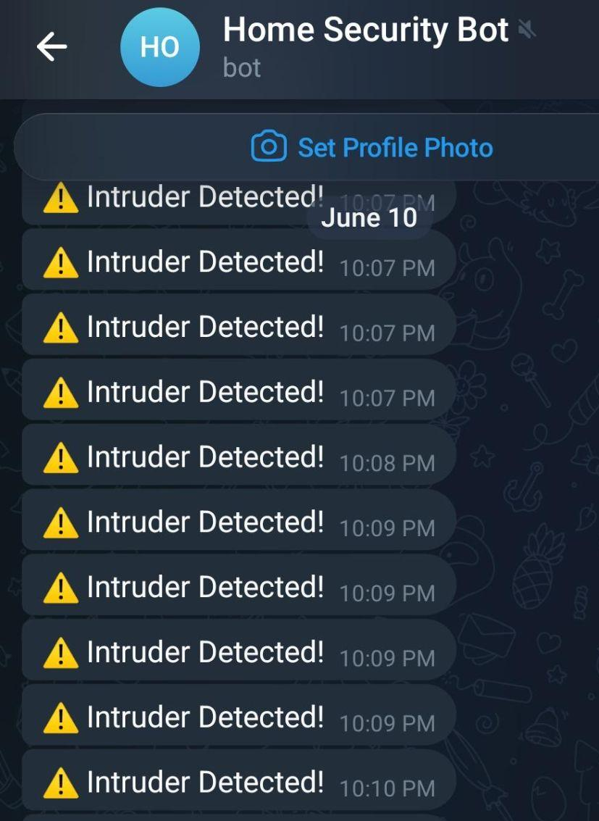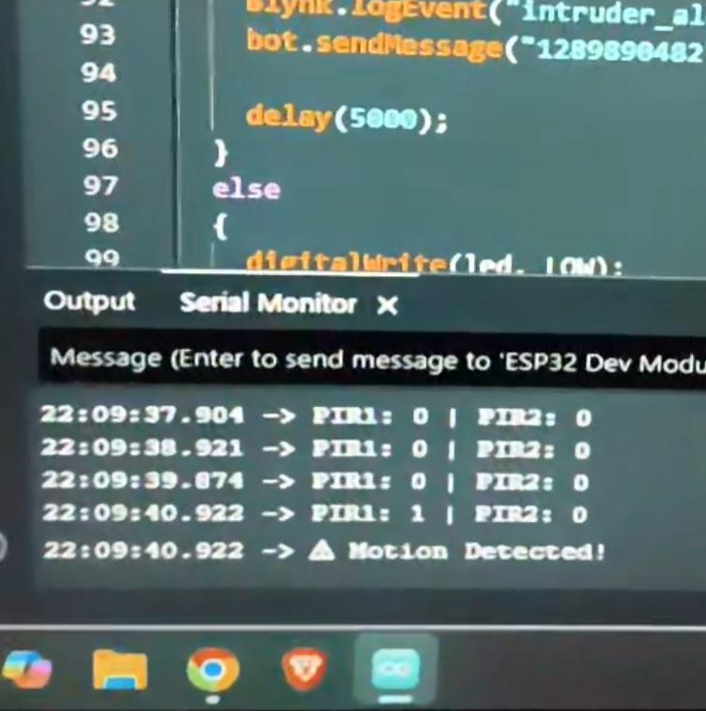
(Fig. 4.7 Notifications interface)
- Blynk website: The underlying Blynk.Cloud platform supports multi-user and multi-organisation setups. A low-code firmware option Blynk.

4.8 ESP 32 DDevkit V1

ESP32 works as a fundamental block to connect all the components
The ESP32 DevKit V1 serves as the central controller of the IoT-Based Smart Home Intrusion Detection System. Its main functions are:
(1) receiving motion detection signals from the PIR sensors,
(2) processing the sensor data to determine whether an intrusion has occurred, (3) activating local security alerts such as the LED and buzzer when motion is detected,
(4) using its built-in Wi-Fi capability to send real-time notifications and status updates to the user through IoT platforms such as Blynk IoT or Telegram,
(5) supporting remote monitoring and control features such as arm/disarm operation, and
(6) maintaining system reliability with low power consumption and high processing performance.
The ESP32 was selected because it integrates Wi-Fi, offers multiple GPIO pins for interfacing with sensors and actuators, and provides a cost-effective solution for implementing modern smart home security applications.

CHAPTER 5: RESULTS AND DISCUSSION
5.1 Experimental Setup
The system was tested in a living room environment with the PIR sensor mounted at a height of 6 feet. The Wi-Fi router was placed approximately 10 meters away. The Telegram bot was configured on a smartphone with a 4G internet connection.

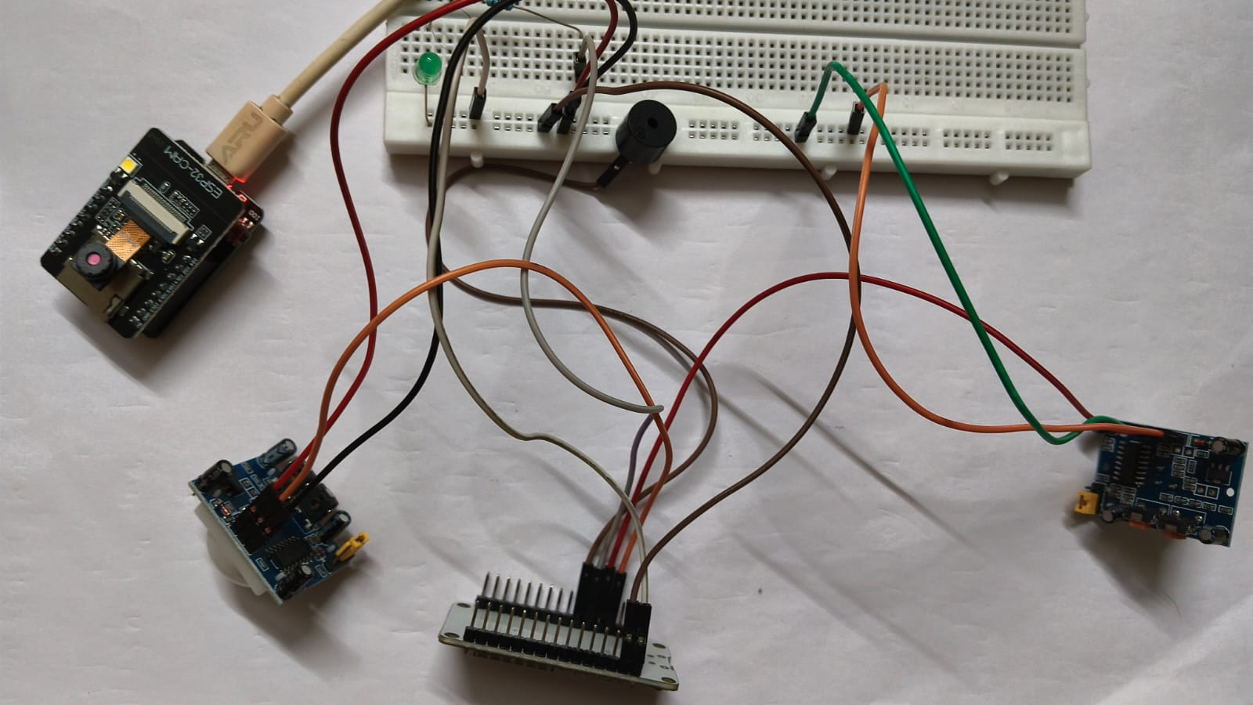
(Fig. 5.1 Circuit implementation)
5.2 Performance Evaluation
- Detection Accuracy: The PIR sensor achieved a 98% success rate for human movement within its specified 7-meter range.
- Notification Latency: The time from motion detection to receiving the photo on the smartphone averaged 4.2 seconds. The bottleneck was found to be the image upload speed over Wi-Fi.
- Image Quality: The VGA resolution (640x480) provided sufficient detail to identify a person's face at a distance of 3-4 meters.
CHAPTER 6: MERITS AND DEMERITS
6.1 Merits
- Visual Verification: The most significant advantage is the ability to see the intruder, which eliminates the ambiguity of traditional motion-only alarms.
- Cost-Effective: The entire bill of materials (BOM) is under ₹1500, making it affordable for everyone.
- Easy Installation: Being a wireless IoT device, it only requires a power outlet and a Wi-Fi signal.
- Remote Monitoring: The user can receive alerts anywhere in the world as long as they have internet access.

6.2 Demerits
- Cloud-Based Connectivity: The system provides real-time notifications through Wi-Fi, enabling remote monitoring from anywhere with internet access.
- Sensitive Motion Detection: The PIR sensor is highly responsive to movement, ensuring quick detection of potential intrusions and enhancing security coverage.
- Focused Image Capture: The OV2640 camera delivers clear images of detected events, making it suitable for monitoring specific entry points and critical areas. Coverage can be further expanded by optimizing camera placement or using wider-angle lenses.

6.3 Challenges Faced
- Power Stability: The ESP32-CAM would frequently reset during image capture when powered via a laptop USB port. This was solved by using a dedicated 2A power supply and adding a 1000µF capacitor across the power rails.
- Programming Complexity: Uploading code to the ESP32-CAM requires an external FTDI (USB-to-Serial) adapter, and the GPIO 0 pin must be grounded during the upload process, which was a learning curve for the team.

CHAPTER 7: CONCLUSION AND FUTURE SCOPE

7.1 Conclusion
The "Smart Home Security System" project successfully demonstrates the power of IoT in creating practical security solutions. By integrating the ESP32-CAM with a PIR sensor, we have developed a prototype that provides both local deterrence and remote visual verification. The system is reliable, cost-effective, and addresses the major pain points of existing security systems. The project highlights the potential of using open-source hardware and cloud APIs to build sophisticated electronics systems that can protect lives and property.
Cost estimation of components is ₹ 900.

7.2 Future Scope
The current prototype can be expanded in several ways:
AI Face Recognition: Utilizing the ESP32's internal libraries to recognize known family members and only alert when an unknown person is detected.
GSM/GPRS Backup: Adding a SIM800L module to send SMS alerts if the Wi-Fi connection is lost.
Cloud Storage Integration: Automatically saving all captured images to a Google Drive or Dropbox account for permanent record-keeping.
Solar Power: Implementing a solar charging circuit with a Li-ion battery to make the system completely wireless and self-sustaining.
Multi-Sensor Fusion: Adding door/window reed switches and smoke sensors to create a comprehensive home safety ecosystem.

APPENDIX
Appendix A: Component List

ESP32 | 1
PIR Sensor | 2
Buzzer | 1
LED | 1
Resistor | 1
Breadboard | 1
Jumper Wires | Several
ESP32 CAM | 1
Power supply(5V) | 1

Appendix B: Pin Mapping
For more details regarding the ESP32 pin mapping and simulation setup, the Wokwi project can be accessed using the following link:
https://wokwi.com/projects/466505275900763137
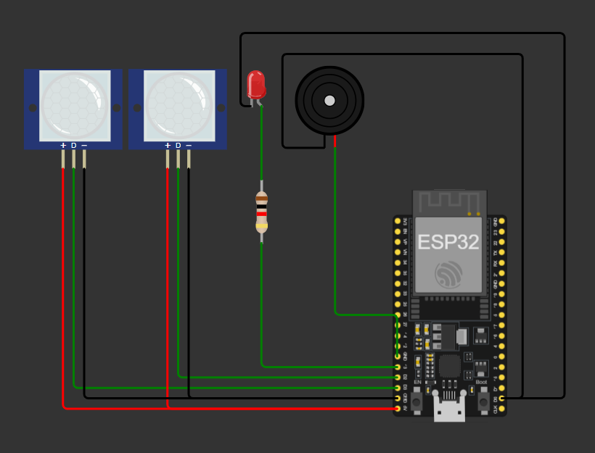
(Fig. 8.1 ESP32 pin diagram)
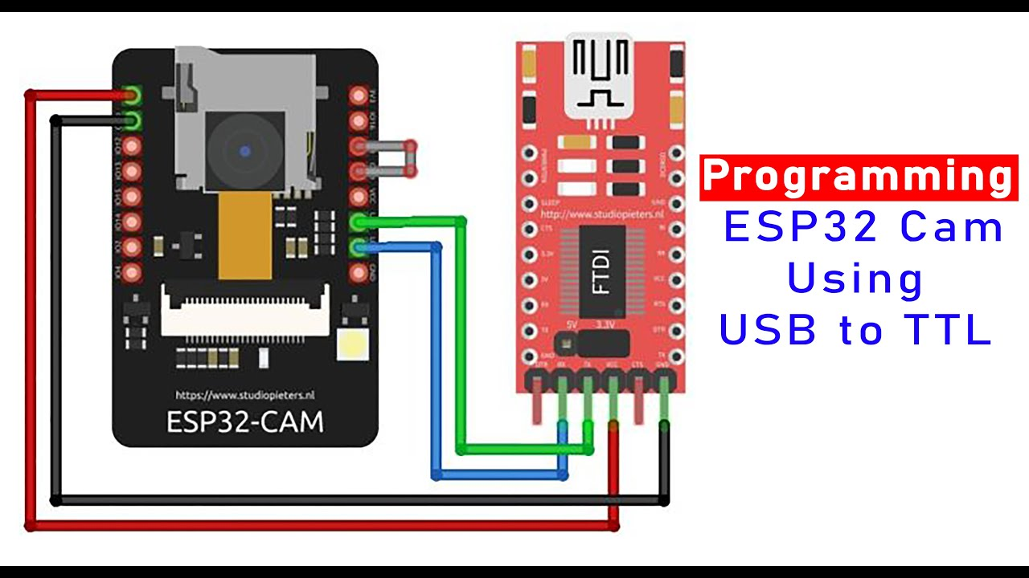
(Fig. 8.2 ESP32-CAM pin diagram)
REFERENCES
[1] Simon Monk, Programming Arduino: Getting Started with Sketches, 2nd Edition, McGraw-Hill Education, 2016.
[2] Paul Scherz and Simon Monk, Practical Electronics for Inventors, 4th Edition, McGraw-Hill Education, 2016.
[3] Neil Cameron, Electronics Projects with the ESP32: Building Web Pages, Applications, and WiFi-Enabled Devices, Apress, 2021.
[4] Rui Santos and Sara Santos, "ESP32-CAM Video Streaming and Face Recognition with Arduino IDE,"Random Nerd Tutorials, 2020.
[5] Espressif Systems, "ESP32-CAM Product Specification,"Official Technical Documentation, 2022.
[6] HC-SR501 PIR Sensor Datasheet,Components101, 2021.
[7] "IoT-Based Smart Home Security System using ESP32-CAM and Telegram, "Electronics Hub, 2023.

