**Ishan Patel**

**CIS 3207**

**PROJECT 2**

**Shell Project**

**Introduction:**

This is a simple shell creation with few built in functions. shell program should use the same style for running programs as the UNIX sh command. Using c libraries for linux and with the use of some of the Unix command we build our shell. There are parts of this lab that when combined together a shell can be formed. The following sections describe:

• Parsing and finding command names and parameter lists in the shell.

• finding the location of the file that contains the command.

• Executing the program for the command.

• Organizing shell program.

This program is set to run in Linux environment with c99 standard. It has a make file which simplifies and saves time in inputting long commands in the command prompt. Just open the command prompt in linux and go to the folder where you placed the files using the ‘cd’ command. Then enter in ‘make’ and then ‘./shell’.

Doing this would initiate your program and run to its completion.

**Testing the Shell and All the builtins:**

1. **Running the program using makefile**

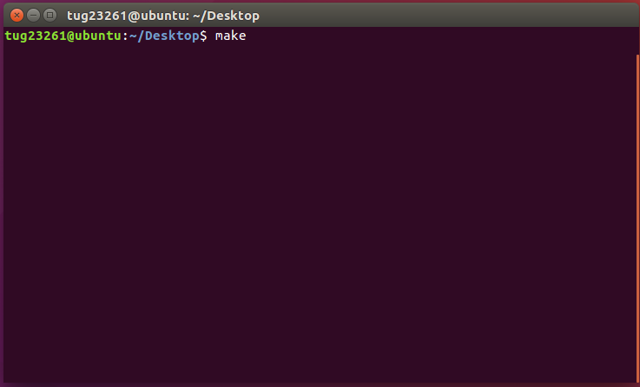

1. **Next step type in executable ‘./shell’**

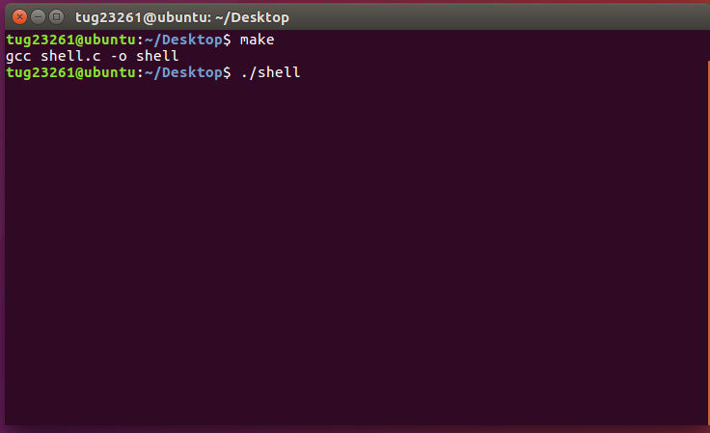

1. **Initiation of the shell (IshanShell)**

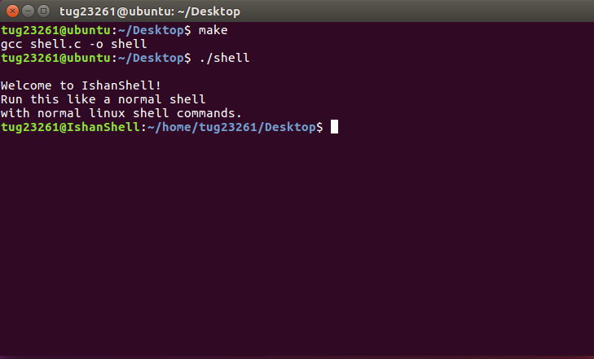

1. **Built in: DIR and its output**

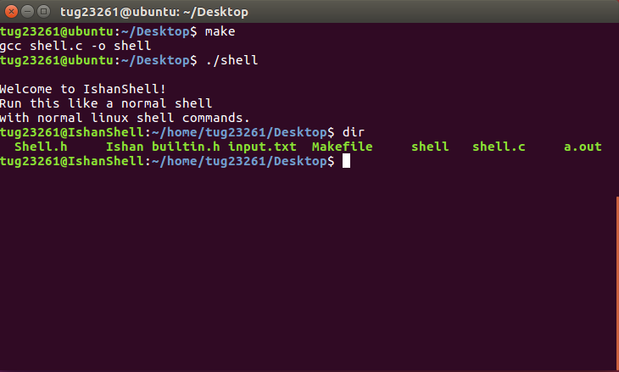

1. **Built in: CD and its output**

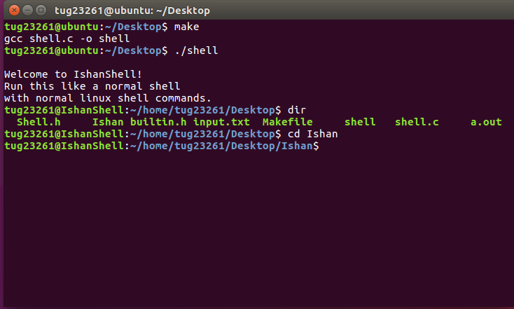

1. **Built in: echo and its output**

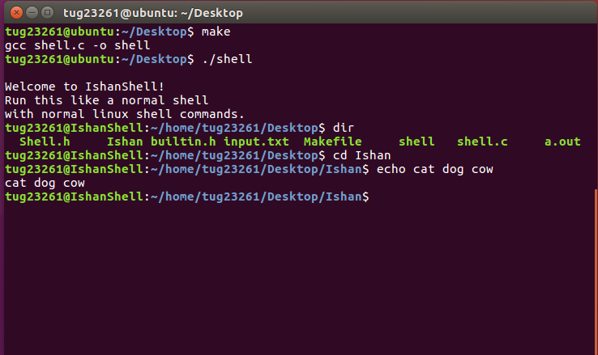

1. **Built in: clr and its output**

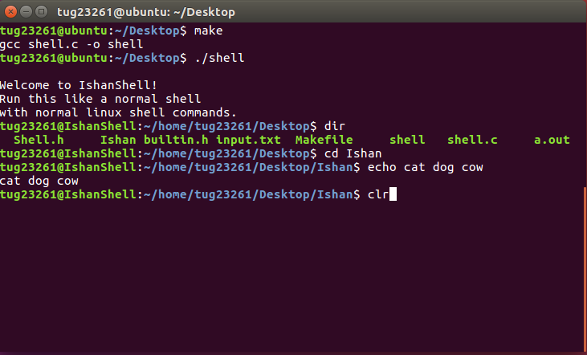

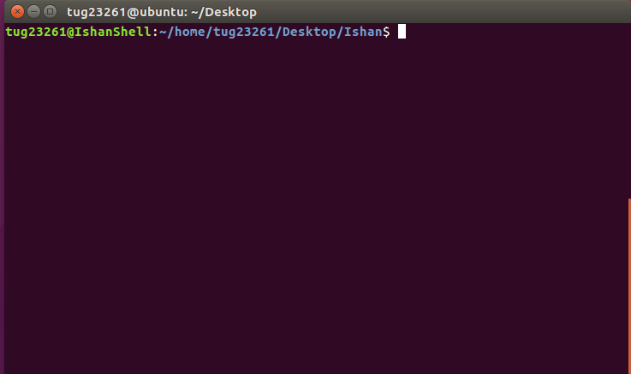

1. **Built in: pause and its output**

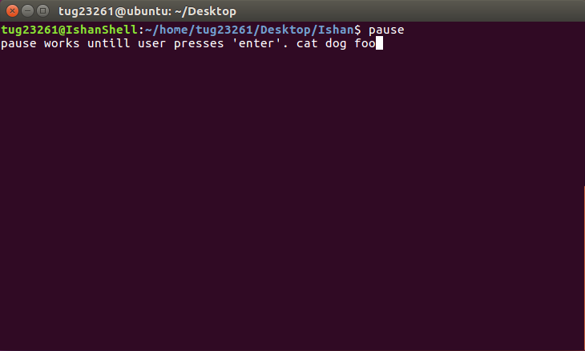

1. **Built in: help and its output**

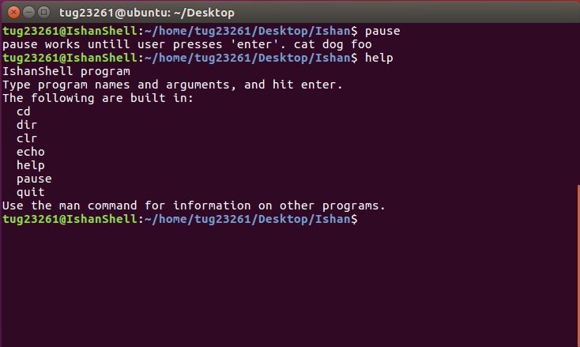

1. **Built in: environ and its output**

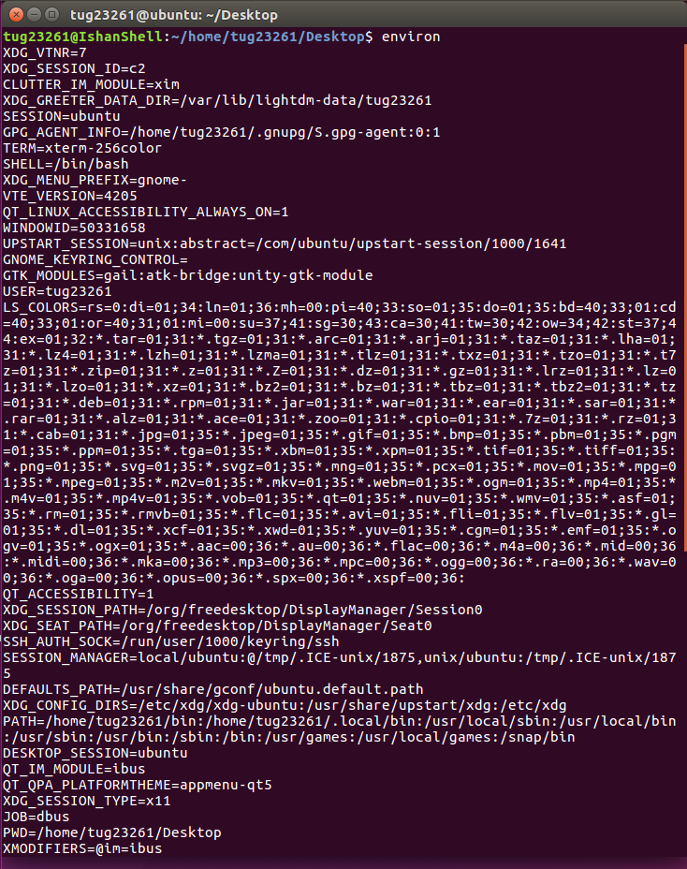

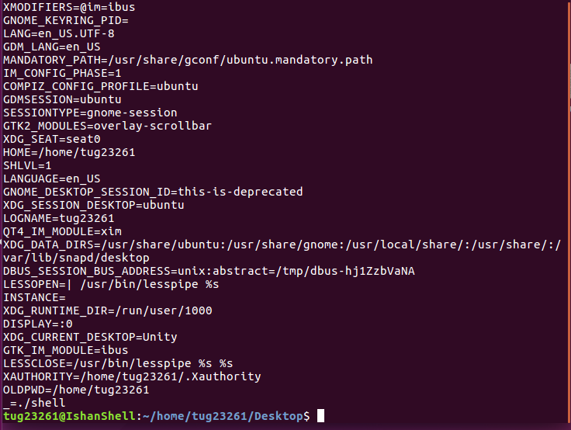

1. **Built in: quit and its output**

