**ASSIGNMENT**

**Q1.** How to create an empty and a full NumPy array?

**Code:**

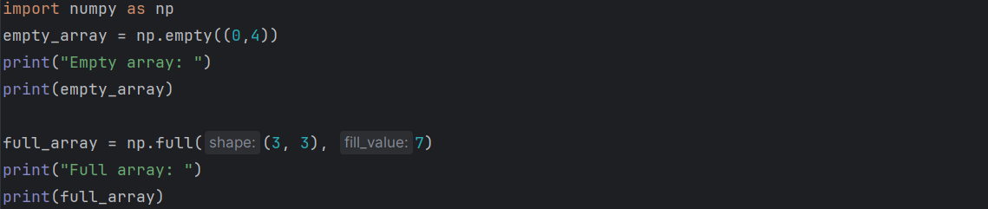

**Output:**

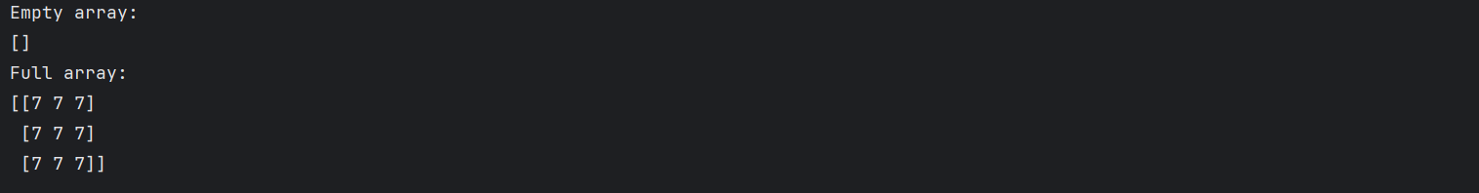

**Q2.** Create a Numpy array filled with all zeroes.

**Code:**



**Output:**



**Q3.** Create a Numpy array filled with all ones.

**Code:**



**Output:**



**Q4.** Combining a one and a two-dimensional NumPy Array.

**Code:**

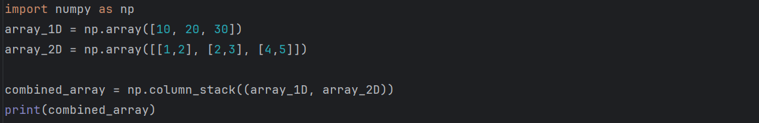

**Output:**



**Q5.** Create a Numpy array with random values.

**Code:**



**Output:**



**Q6.** Return a Matrix of random values from a Gaussian distribution.

**Code:**



**Output:**



**Q7.** How to convert a list and tuple into NumPy arrays?

**Code:**

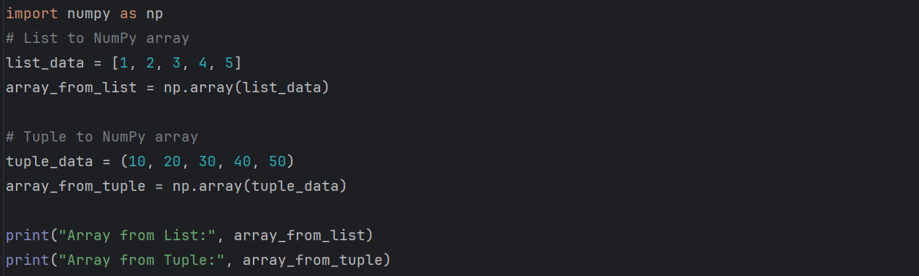

**Output:**

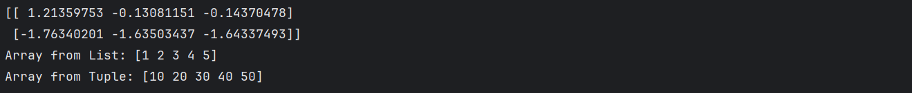

**Q8.** Ways to convert array of strings to array of floats’.

**Code:**

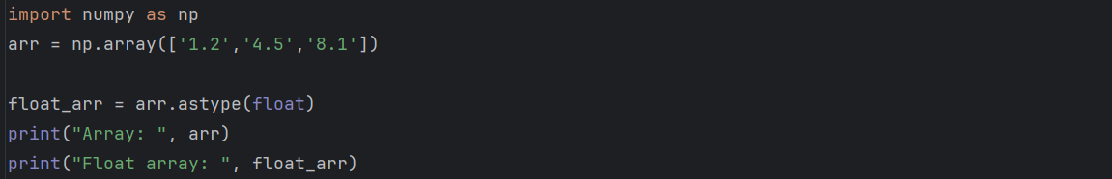

**Output:**



**Q9.** Get Random elements from Laplace distribution.

**Code:**



**Output:**



**Q10.** Generate Random Numbers from The Uniform Distribution using NumPy.

**Code:**



**Output:**

