Project Based Learning (PBL) Report
[Subject Name] ([Subject Code])
B.Tech (CSE), [III] Sem, Section F
AI RESUME ANALYZER
An NLP-Based System for Resume Scoring and Job Matching
Submitted by
Ishant Gupta (2502220100369)
Ishan Singh (2502220100368)
Krish Pratap Singh (2502220100409)
Under the supervision of
Ms. Himani Sharma
Assistant Professor,Department of CSE
Submitted to
Department of Computer Science and Engineering & Allied Branches
ITS Engineering College, Greater Noida
2026-27

Certificate
This is to certify that the Project Based Learning (PBL) report entitled “AI Resume Analyzer” has been successfully carried out by the following students of B.Tech (Computer Science & Engineering) as a part of the Project Based Learning during the academic session 2026–2027.
Submitted by:
- Name: Ishant Gupta Roll No.: 2502220100369
- Name: Ishan Singh Roll No.: 2502220100368
- Name: Krish Pratap Singh Roll No.: 2502220100409

The work has been completed under the guidance of Ms. Himani Sharma. The project is a part of continuous internal assessment under the PBL framework and reflects the students’ effort in applying theoretical knowledge to solve real-world problems.
To the best of our knowledge, this work is original and has not been submitted elsewhere for any other academic purpose.

Ms.Himani Sharma

Mapping of the Project to Sustainable Development Goals (SDGs)
Project Name | Problem Description | SDG No. : SDG Name
AI Resume Analyzer | Job seekers have no free, objective and explainable way to know how well a resume matches a job description, which skills are missing and what ATS-related mistakes it contains. | SDG 8: Decent Work and Economic Growth  SDG 4: Quality Education  SDG 9: Industry, Innovation and Infrastructure

Justification:
- SDG 8 (Decent Work and Economic Growth): the project supports the aim of productive employment for young people (targets 8.5 and 8.6). By showing a candidate why a resume is weak for a job, it helps fresh graduates present their skills better and reach the interview stage.
- SDG 4 (Quality Education): target 4.4 aims to increase the number of youth with skills relevant for employment. The missing-skills report tells students which skills the market asks for, so that they can plan their learning and projects.
- SDG 9 (Industry, Innovation and Infrastructure): the project applies NLP and machine-learning techniques to a practical recruitment problem, which supports the use of technology and innovation in industry (target 9.5).
- Equal access: the tool is free, runs locally and does not need a paid subscription, so students from any background can use the same quality of feedback.

Contents
Certificate
Mapping with SDG with Justification i
Contents ii
Abstract iii
Chapter 1: Problem Statement and Objectives 1
1.1 Background and Motivation 1
1.2 Problem Statement 1
1.3 Existing Systems and Their Limitations 2
1.4 Objectives 2
1.5 Scope of the Project 3
1.6 Software Development Approach 3
Chapter 2: Methodology / Design 4
2.1 Software Development Life Cycle 4
2.2 Requirement Analysis 4
2.3 System Architecture 5
2.4 Data Flow and Process Design 6
2.5 Algorithms and Scoring Model 7
2.6 Skill Taxonomy 9
2.7 Test Plan 10
Chapter 3: Implementation with Relevant Screenshots 11
3.1 Development Environment 11
3.2 Project Structure 11
3.3 Module Implementation 11
3.4 Sample Input Data 13
3.5 Execution and Output Screenshots 14
3.6 Challenges Faced and Solutions 15
Chapter 4: Results and Discussion 16
4.1 Experimental Setup 16
4.2 Test Cases and Verification 16
4.3 Scoring Results 16
4.4 Discussion 18
4.5 Observations 18
4.6 Limitations of the Results 19
Chapter 5: Conclusion 20
5.1 Conclusion 20
5.2 Limitations 20
5.3 Future Scope 20
References 22

Abstract
Recruiters receive hundreds of applications for a single opening and often spend only a few seconds on each resume. As a result, capable candidates are rejected because their resumes do not clearly show the skills a job requires, and the candidates receive no feedback about the reason. This project presents AI Resume Analyzer, a Python-based system that compares a resume with a job description and produces a score out of 100 together with specific suggestions for improvement.
The system extracts text, preprocesses it and then applies four measures. First, it finds the skills present in both documents using a taxonomy of 28 technical skills and reports matched and missing skills. Second, it measures the overall similarity of the two documents using TF-IDF vectors and cosine similarity. Third, it checks whether six standard resume sections are present. Fourth, it applies five ATS rules concerning contact details, length and quantified achievements. The final score is a weighted combination of these measures, with weights of 40%, 30%, 15% and 15%.
The prototype was implemented using Python and scikit-learn and tested with eight unit test cases, all of which passed, and with three sample resumes of different quality against a Machine Learning Engineer Intern job description. The resumes obtained final scores of 77.7, 24.9 and 3.2, which agrees with the expected ranking, and each report shows exactly which skills, sections or ATS rules caused the score. The project demonstrates that an open, explainable and low-cost tool can help students improve their resumes and supports SDG 8, SDG 4 and SDG 9.
Keywords: resume analysis, natural language processing, TF-IDF, cosine similarity, applicant tracking system, skill matching

CHAPTER 1
Problem Statement and Objectives

1.1 Background and Motivation
A resume is usually the first document through which a candidate is judged. For every job opening, a recruiter may receive hundreds of applications, and studies of hiring practice commonly report that the first screening of a resume lasts only a few seconds. In such a short time, a resume that does not clearly show the skills, projects and achievements required for the role is likely to be rejected, even when the candidate is capable. Most candidates, especially students and fresh graduates, never learn why their resume was rejected because employers rarely provide feedback.
To handle the volume of applications, many organisations use Applicant Tracking Systems (ATS). These systems parse a resume into text, look for keywords and rank candidates before a human reads anything. A resume that is well written for a human reader may still score poorly with an ATS because it uses unusual headings, omits contact details, or describes skills in words that differ from those in the job description. Candidates therefore need a simple way to check how well their resume matches a particular job and what exactly should be improved.
Recent progress in Natural Language Processing (NLP) and machine learning makes it possible to build such a tool at low cost. Techniques such as term weighting, vector-space similarity and rule-based information extraction can compare two documents objectively and consistently. This project, AI Resume Analyzer, applies these techniques to give a candidate an instant, explainable score and a list of concrete improvements.

1.2 Problem Statement
Job seekers have no easy, objective and free way to find out how well their resume matches a given job description, which skills are missing, and whether the resume follows basic ATS-friendly practices. Manual review by mentors is slow and subjective, and commercial resume checkers are paid, closed and do not explain how a score was reached. The problem addressed in this project is to design and implement a system that takes a resume and a job description as input and produces (i) a numerical match score out of 100, (ii) a list of matched and missing skills, and (iii) a list of structural and ATS-related issues in the resume.

1.3 Existing Systems and Their Limitations
The common approaches to resume screening and checking are compared with the proposed system in Table 1.1.
Table 1.1: Comparison of Resume Screening Approaches
Approach | Strengths | Limitations
Manual review by recruiter or mentor | Understands context and nuance | Slow, subjective, not scalable, no written feedback
Simple keyword search in ATS | Fast and easy to implement | Exact-word matching only; ignores overall similarity and resume structure
Paid online resume checkers | Polished interface and templates | Closed algorithms, subscription cost, score is not explained
Proposed AI Resume Analyzer | Open, explainable, combines skills, similarity, structure and ATS rules | Prototype works on plain text and a fixed skill taxonomy

1.4 Objectives
The objectives of the project are:
- To study how resumes are screened by recruiters and Applicant Tracking Systems.
- To extract skills and section information from resume text using NLP and rule-based techniques.
- To measure the similarity between a resume and a job description using TF-IDF vectors and cosine similarity.
- To check a resume against basic ATS rules such as contact details, length and quantified achievements.
- To combine these measures into one weighted score out of 100 that is easy to understand.
- To report matched skills, missing skills and specific suggestions so that the candidate can improve the resume.
- To test the system on resumes of different quality and verify that the scores rank them sensibly.

1.5 Scope of the Project

1.5.1 In Scope
- Comparison of one resume against one job description at a time.
- Detection of 28 technical skills grouped in four categories (languages, web, machine learning and tools).
- Detection of six standard resume sections and five ATS rules.
- A transparent scoring formula whose weights can be changed in the code.

1.5.2 Out of Scope
- Judging the truthfulness of the claims made in a resume.
- Scoring soft skills, writing quality or visual design of the resume.
- Large-scale ranking of thousands of candidates and integration with a company hiring portal.

1.6 Software Development Approach
As required by the PBL guidelines, the work followed all the phases of the software development life cycle: problem formulation (this chapter), design (next chapter), implementation and testing. An iterative approach was used. A first version contained only skill matching; TF-IDF similarity, section detection and ATS checks were added in later iterations, and every iteration was tested before the next one started.

CHAPTER 2
Methodology / Design

2.1 Software Development Life Cycle
The iterative waterfall model was followed. Each iteration passed through requirement analysis, design, coding and testing, and feedback from testing was used to correct the next iteration. This model was chosen because the requirements were clear at the start, but the scoring logic needed several refinements after seeing real outputs. Table 2.1 lists the activities carried out in every phase.
Table 2.1: Life-Cycle Phases and Activities
Phase | Activities carried out
Problem formulation | Studied resume screening practice, defined the problem statement, objectives and scope
Requirement analysis | Listed functional and non-functional requirements and the software needed
Design | Prepared architecture, data-flow diagram, flowchart, skill taxonomy and scoring formula
Implementation | Coded the analyzer in Python using scikit-learn and regular expressions
Testing | Wrote test cases, ran them on sample resumes, fixed defects and re-tested

2.2 Requirement Analysis

2.2.1 Functional Requirements
- The system shall accept the text of a resume and the text of a job description.
- The system shall identify the skills present in each document from the skill taxonomy.
- The system shall list matched skills (present in both) and missing skills (required by the job but absent from the resume).
- The system shall compute a TF-IDF cosine similarity between the two documents.
- The system shall detect which standard sections are present in the resume.
- The system shall apply ATS rules and list every issue found.
- The system shall display a final score out of 100 together with the individual component scores.

2.2.2 Non-Functional Requirements
- Performance: the analysis of one resume should finish within a second on an ordinary laptop.
- Explainability: every score must be traceable to a visible rule or formula, not to a hidden model.
- Portability: the system should run on Windows, Linux and macOS wherever Python is installed.
- Maintainability: skills, sections and weights should be stored as simple lists and constants that can be edited easily.
- Privacy: no resume text is sent to any external service; all processing is local.

2.2.3 Hardware and Software Requirements
Table 2.2: Hardware and Software Requirements
Item | Specification
Processor | Any dual-core processor or better
RAM | 4 GB minimum
Operating system | Windows 10/11, Linux or macOS
Programming language | Python 3.12
Libraries | scikit-learn 1.8.0 (TfidfVectorizer, cosine_similarity), re (regular expressions), json
Optional input libraries | pdfminer.six for PDF files and python-docx for DOCX files
Editor / tools | VS Code, Git for version control, Matplotlib for charts

2.3 System Architecture
The system is organised as a pipeline of small modules, as shown in Fig. 2.1. The resume and the job description enter through the input layer. Both are passed to the preprocessing module, which converts the text to lower case and removes unwanted symbols. The cleaned text then flows to three independent analysis modules: skill matching, TF-IDF similarity, and section with ATS checks. Their outputs are collected by the weighted scoring engine, which produces the final report.
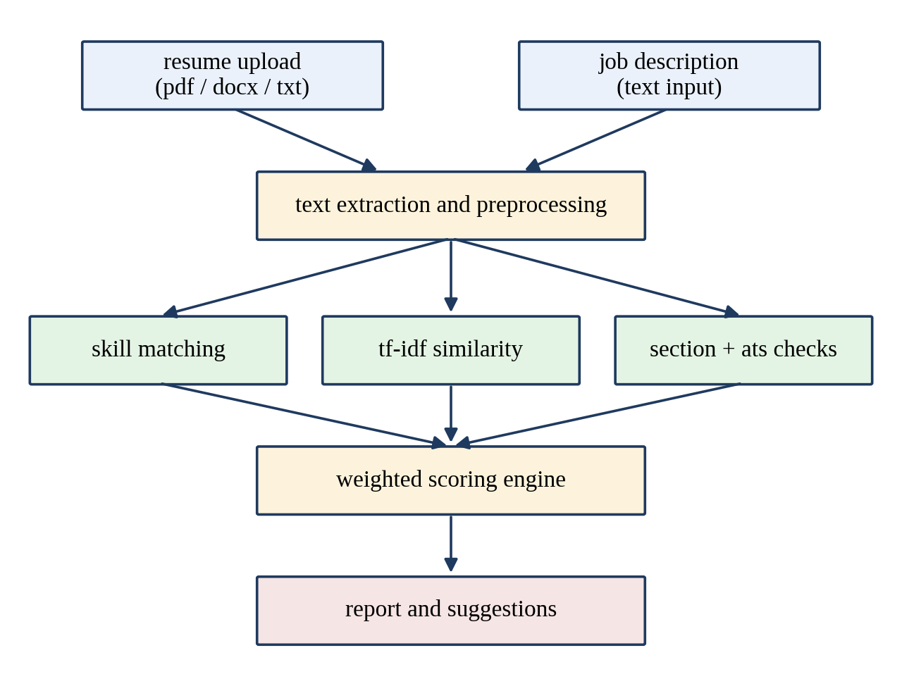
Fig. 2.1: System Architecture of the AI Resume Analyzer

2.3.1 Module Description
- Input layer: receives the resume and the job description. The prototype reads plain text; a PDF or DOCX file is first converted to text by a library and then follows the same path.
- Preprocessing: converts text to lower case and removes punctuation while keeping characters that matter in technical terms such as +, # and a full stop (for example c++ and node.js).
- Skill matching: searches both documents for the skills in the taxonomy and compares the two sets.
- TF-IDF similarity: represents both documents as weighted term vectors and finds the cosine of the angle between them.
- Section and ATS checks: looks for standard headings and applies the ATS rules.
- Scoring engine: combines the four component scores using fixed weights.
- Report generator: prints the final score, matched and missing skills and the list of issues.

2.4 Data Flow and Process Design
Fig. 2.2 shows the context-level data flow diagram. The only external entities are the user, who supplies the resume and job description and receives the score and report, and the skill taxonomy with rules, which is read by the system. Fig. 2.3 shows the step-by-step flow of the process.
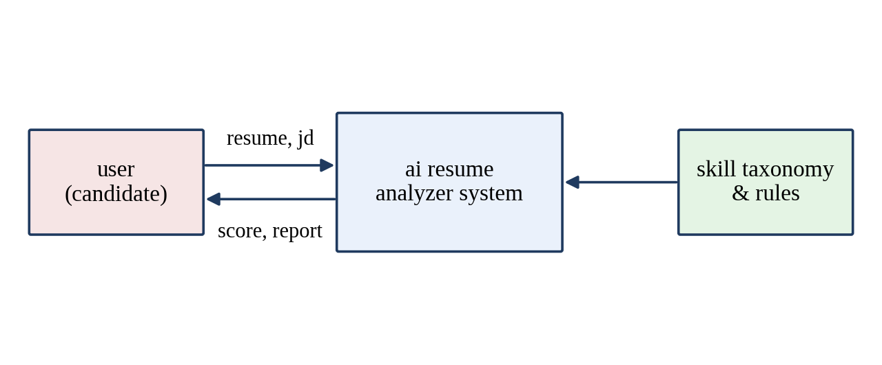
Fig. 2.2: Level-0 Data Flow Diagram
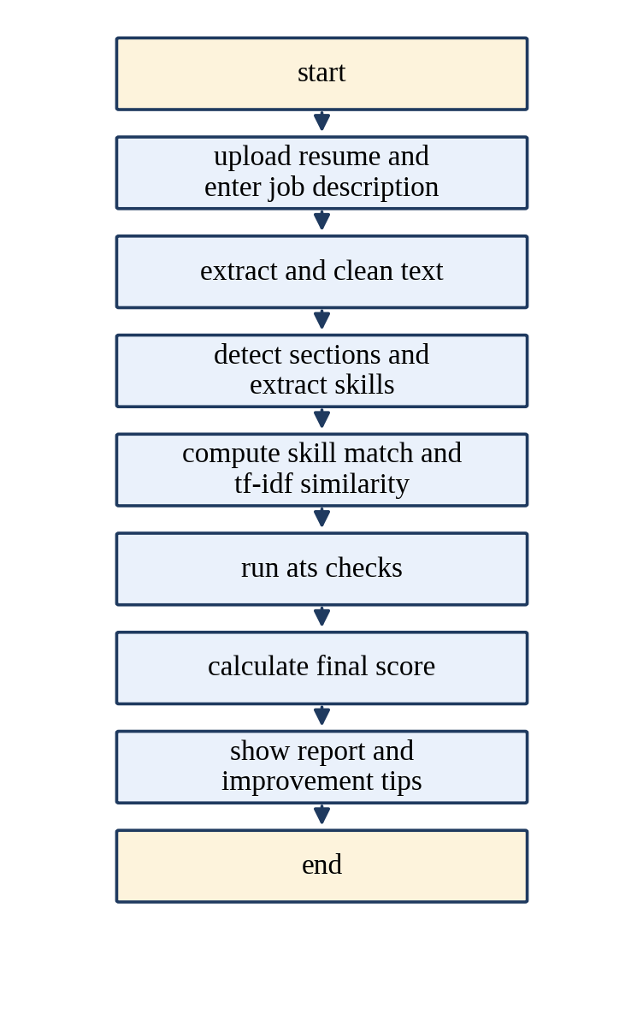
Fig. 2.3: Flowchart of the Analysis Process

2.5 Algorithms and Scoring Model

2.5.1 Skill Extraction
A taxonomy of 28 skills is stored in a dictionary with four categories. For every skill, a regular expression with boundaries is applied to the cleaned text so that a skill is accepted only when it appears as a complete token. This prevents a false match such as java inside javascript. Hyphens are converted to spaces on both sides so that scikit-learn is recognised whichever way it is written. The skill score is the percentage of the skills required by the job description that are present in the resume:
Skill Score = (number of matched skills / number of skills in the job description) × 100

2.5.2 TF-IDF and Cosine Similarity
Skill matching alone ignores the rest of the vocabulary, such as the words used to describe responsibilities. To capture this, both documents are converted into TF-IDF vectors. Term frequency (TF) counts how often a term occurs in a document, and inverse document frequency (IDF) reduces the weight of terms that occur in many documents. Single words and pairs of words (unigrams and bigrams) are used, and common English stop words are removed. The similarity of the resume vector A and the job vector B is the cosine of the angle between them:
cosine(A, B) = (A · B) / (|A| × |B|)
The value lies between 0 (no common terms) and 1 (identical term weights) and is multiplied by 100 to give the similarity score. Because a resume and a job advertisement are written differently, even a very good resume does not reach a value near 100, so this component is given a lower weight than the skill score.

2.5.3 Section Detection and ATS Rules
Six standard sections are searched at the start of lines: education, experience, projects, skills, certifications and summary. The section score is the percentage of these sections found. In addition, five ATS rules are applied, each of which produces a readable issue message when it fails (Table 2.3). The ATS score starts at 100 and loses 20 points for every issue.
Table 2.3: ATS Rules Applied by the System
No. | Rule | Issue reported when rule fails
1 | Resume contains an e-mail address | email address missing
2 | Resume contains a phone number | phone number missing
3 | Length is at least 150 words | resume too short (< 150 words)
4 | Length is at most 900 words | resume too long (> 900 words)
5 | Contains numbers such as percentages or counts | no quantified achievements found

2.5.4 Weighted Final Score
The four component scores are combined by the weights in Table 2.4. Skills receive the largest weight because they are what recruiters search for first. Similarity receives the second largest weight, and structure and ATS compliance share the remaining weight equally.
Final Score = 0.40 × Skill + 0.30 × Similarity + 0.15 × Section + 0.15 × ATS
Table 2.4: Weights of the Scoring Components
Component | Weight | What it measures
Skill match | 40% | Coverage of the skills required by the job
TF-IDF similarity | 30% | Overall textual closeness to the job description
Section score | 15% | Presence of standard resume sections
ATS score | 15% | Contact details, length and quantified achievements

2.6 Skill Taxonomy
The taxonomy used in the prototype is shown in Table 2.5. It is stored as a Python dictionary, so new skills or categories can be added without changing the program logic.
Table 2.5: Skill Taxonomy Used by the Analyzer
Category | Skills | Count
Languages | python, java, c++, javascript, sql | 5
Web | html, css, react, flask, django, node.js, rest api | 7
Machine learning / AI | machine learning, deep learning, nlp, tensorflow, pytorch, scikit-learn, pandas, numpy, computer vision | 9
Tools | git, docker, aws, linux, mongodb, mysql, power bi | 7
Total |  | 28

2.7 Test Plan
Testing was planned at two levels. At unit level, each function (skill extraction, similarity, section detection and ATS checking) was tested with small inputs whose correct output is known in advance. At system level, three resumes of different quality were analysed against one job description, and the ranking produced by the final score was compared with the expected ranking. The test cases and their results are given in Chapter 4.

CHAPTER 3
Implementation with Relevant Screenshots

3.1 Development Environment
The system was developed in Python 3.12 on a Linux machine. The scikit-learn library (version 1.8.0) provides TfidfVectorizer and cosine_similarity, and the built-in re module provides regular expressions. Matplotlib was used to draw the comparison chart in Chapter 4. All source files were kept under version control with Git.

3.2 Project Structure
The project has a small structure so that it is easy to read and extend:
ai-resume-analyzer/
|-- analyzer.py # core engine: skills, TF-IDF, sections, ATS, scoring
|-- run.py # reads the sample files, calls analyze(), saves results
|-- data/
| |-- jd.txt # job description (Machine Learning Engineer Intern)
| |-- resume_a.txt # strong resume
| |-- resume_b.txt # average resume
| |-- resume_c.txt # weak resume
| |-- results.json # scores written by run.py

3.3 Module Implementation

3.3.1 Taxonomy, Preprocessing and Skill Extraction
The skill taxonomy and the section list are defined as constants at the top of analyzer.py. The function clean() prepares the text and find_skills() returns the skills found in it.
SKILLS = {
"languages": ["python", "java", "c++", "javascript", "sql"],
"web": ["html", "css", "react", "flask", "django", "node.js", "rest api"],
"ml_ai": ["machine learning", "deep learning", "nlp", "tensorflow", "pytorch",
"scikit-learn", "pandas", "numpy", "computer vision"],
"tools": ["git", "docker", "aws", "linux", "mongodb", "mysql", "power bi"],
}
ALL_SKILLS = [s for group in SKILLS.values() for s in group]
SECTIONS = ["education", "experience", "projects", "skills",
"certifications", "summary"]

def clean(text):
text = text.lower()
return re.sub(r"[^a-z0-9+#.\s]", " ", text)

def find_skills(text):
t = " " + clean(text) + " "
found = []
for s in ALL_SKILLS:
pat = r"(?<![a-z0-9])" + re.escape(s.replace("-", " ")) + r"(?![a-z0-9])"
if re.search(pat, t):
found.append(s)
return found

def detect_sections(text):
low = text.lower()
return [s for s in SECTIONS if re.search(r"^\s*" + s, low, re.M)]

3.3.2 TF-IDF Similarity
TfidfVectorizer is configured to remove English stop words and to use both single words and two-word phrases. The resume and the job description are transformed together, so that the IDF values are computed on both documents, and the cosine similarity of the two rows is returned.
def tfidf_similarity(resume, jd):
vec = TfidfVectorizer(stop_words="english", ngram_range=(1, 2))
m = vec.fit_transform([clean(resume), clean(jd)])
return float(cosine_similarity(m[0], m[1])[0][0])

3.3.3 ATS Checks
Every rule of Table 2.3 is written as a short condition. Regular expressions are used to find an e-mail address, a phone number and numeric evidence such as percentages.
def ats_checks(text):
issues = []
if not re.search(r"[\w.]+@[\w.]+\.\w+", text):
issues.append("email address missing")
if not re.search(r"\+?\d[\d\s-]{8,}", text):
issues.append("phone number missing")
n = len(text.split())
if n < 150: issues.append("resume too short (< 150 words)")
if n > 900: issues.append("resume too long (> 900 words)")
quant = r"\d+%|\d+\+|\d+ (users|students|records|projects)"
if not re.search(quant, text.lower()):
issues.append("no quantified achievements found")
return issues

3.3.4 Scoring and Report
The function analyze() ties the modules together. It finds the skills of both documents, builds the matched and missing lists, computes the four component scores and combines them with the weights of Table 2.4. It returns a dictionary, which run.py prints and saves as JSON.
def analyze(resume, jd):
r_sk, j_sk = set(find_skills(resume)), set(find_skills(jd))
matched = sorted(r_sk & j_sk)
missing = sorted(j_sk - r_sk)
skill_score = 100 * len(matched) / len(j_sk) if j_sk else 0
sim = 100 * tfidf_similarity(resume, jd)
secs = detect_sections(resume)
sec_score = 100 * len(secs) / len(SECTIONS)
issues = ats_checks(resume)
ats_score = max(0, 100 - 20 * len(issues))
final = 0.40 * skill_score + 0.30 * sim + 0.15 * sec_score + 0.15 * ats_score
return dict(skill_score=round(skill_score, 1), similarity=round(sim, 1),
section_score=round(sec_score, 1), ats_score=ats_score,
final=round(final, 1), matched=matched, missing=missing,
sections=secs, issues=issues, words=len(resume.split()))

3.4 Sample Input Data
A job description for a Machine Learning Engineer Intern was written. It asks for Python and SQL, machine learning, NLP and deep learning with PyTorch or TensorFlow, pandas, numpy and scikit-learn, Flask or REST API development, Git, Docker, Linux and, as an advantage, AWS. Fifteen taxonomy skills are present in this description. Three sample resumes were prepared to represent different levels of quality, as described in Table 3.1.
Table 3.1: Sample Resumes Used for Evaluation
Resume | Description | Words
A | Complete resume with summary, education, skills, experience with quantified results, projects and certifications | 150
B | Short resume with a few basic skills, no phone number, no measurable achievements and generic experience | 68
C | Generic paragraph with no section headings, no contact details and no specific skills | 52

All three resumes are fictional and were written only for this project; they do not belong to real persons.

3.5 Execution and Output Screenshots
The program was executed for each resume and the output was captured from the terminal. Fig. 3.1 shows the report for the strong resume. The report lists the final score, the four component scores, the matched skills, the missing skills and the ATS issues, if any.
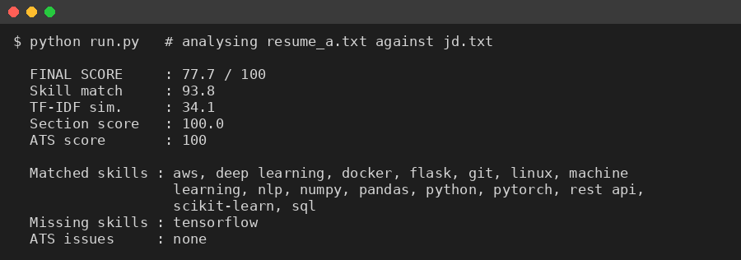
Fig. 3.1: Output of the Analyzer for Resume A
Fig. 3.2 shows the output for the average resume. The report correctly shows that only two required skills are present and gives the two ATS issues that should be fixed first.
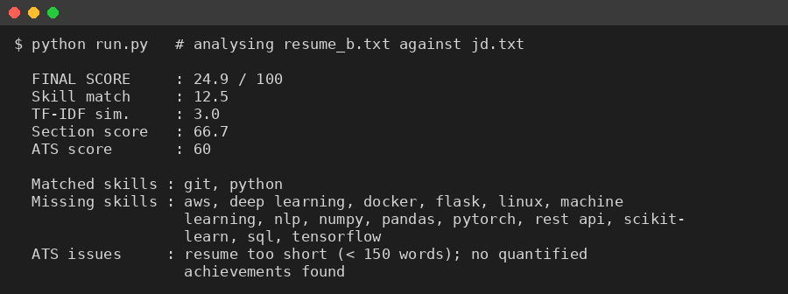
Fig. 3.2: Output of the Analyzer for Resume B
Fig. 3.3 shows the output for the weak resume. No skills are matched, no section is detected and four ATS issues are reported.
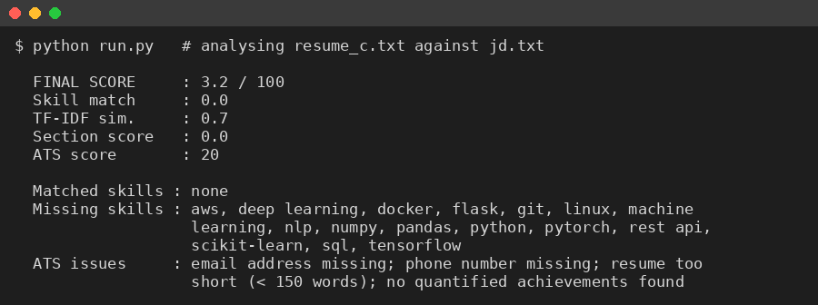
Fig. 3.3: Output of the Analyzer for Resume C

3.6 Challenges Faced and Solutions
Three defects were found during development and were fixed before the final tests.
- Hyphenated skill names: the first version removed all punctuation, so scikit-learn became scikit learn and was never matched. The fix was to convert hyphens in skill names to spaces before matching. After the fix the skill score of the strong resume rose from 93.3 to 93.8 and the similarity, section and ATS scores stayed unchanged.
- Partial matches: searching a skill with a plain substring test would match java inside javascript. Regular expressions with look-around boundaries were used so that only complete tokens are matched.
- Single-letter skill: the language r was initially included in the taxonomy, but after cleaning the text it could match isolated letters. It was removed from the list to avoid false matches.

CHAPTER 4
Results and Discussion

4.1 Experimental Setup
The analyzer was run on the three sample resumes of Table 3.1 against the job description described in Section 3.4. The same weights of Table 2.4 were used in all runs. The numbers reported in this chapter are the actual outputs produced by the program and were not edited by hand.

4.2 Test Cases and Verification
Eight test cases were prepared to check the individual functions. The expected and actual results are listed in Table 4.1, and all the test cases passed.
Table 4.1: Unit Test Cases and Results
ID | Test description | Expected result | Actual result | Status
T1 | Resume with no e-mail address is checked | Issue 'email address missing' reported | Issue reported | Pass
T2 | Job description compared with itself | Similarity of 100 | 100.0 | Pass
T3 | Skill in the job but not in resume (tensorflow) | Listed among missing skills | Listed as missing | Pass
T4 | Text contains 'Scikit-Learn' in mixed case | scikit-learn is detected | Detected | Pass
T5 | Empty resume is analysed | No crash; very low score | No error; final score 3.0 | Pass
T6 | Text contains only 'javascript' | java is not detected | Only javascript detected | Pass
T7 | Headings written in capital letters | Sections still detected | education and skills detected | Pass
T8 | Two identical skill lists are compared | Similarity above 0.99 | Above 0.99 | Pass

4.3 Scoring Results
Table 4.2 gives the component scores and the final score of each resume, and Fig. 4.1 shows the same values as a bar chart.
Table 4.2: Scores Obtained for the Sample Resumes
Resume | Skill match | TF-IDF similarity | Section score | ATS score | Final score
A | 93.8 | 34.1 | 100 | 100 | 77.7
B | 12.5 | 3 | 66.7 | 60 | 24.9
C | 0 | 0.7 | 0 | 20 | 3.2

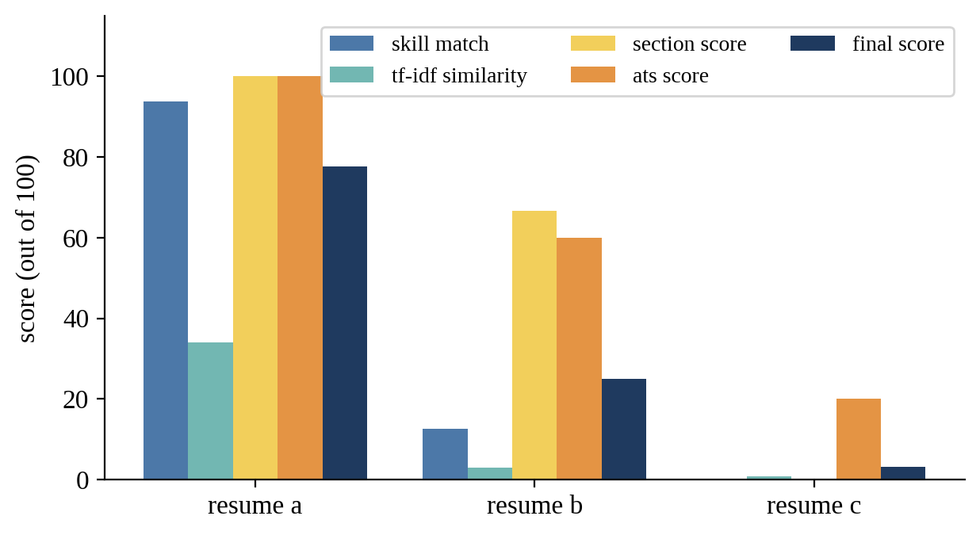
Fig. 4.1: Component and Final Scores of the Three Resumes
Table 4.3: Matched and Missing Skills
Resume | Matched skills | Missing skills
A | 15 of 15: aws, deep learning, docker, flask, git, linux, machine learning, nlp, numpy, pandas, python, pytorch, rest api, scikit-learn, sql | tensorflow
B | 2 of 15: git, python | aws, deep learning, docker, flask, linux, machine learning, nlp, numpy, pandas, pytorch, rest api, scikit-learn, sql, tensorflow
C | 0 of 15: none | aws, deep learning, docker, flask, git, linux, machine learning, nlp, numpy, pandas, python, pytorch, rest api, scikit-learn, sql, tensorflow

4.4 Discussion

4.4.1 Resume A (Strong Resume)
Resume A obtained the highest final score of 77.7. It matched 15 of the 15 required skills, so its skill score is 93.8; only tensorflow was missing. All six sections were detected and none of the ATS rules failed. The TF-IDF similarity is only 34.1, even though the resume is very close to the job, which confirms the expectation of Section 2.5.2 that a resume and an advertisement use different wording. This is why the similarity component carries a smaller weight than the skill component.

4.4.2 Resume B (Average Resume)
Resume B obtained 24.9. It has the basic skills python and git but lacks all the machine learning skills required by the job, which gives a skill score of 12.5. Two of the six sections (certifications and summary) are missing, and the ATS check reports that the resume is shorter than 150 words and has no quantified achievements. The report therefore points to clear actions: add machine learning projects, add a summary, and state results with numbers.

4.4.3 Resume C (Weak Resume)
Resume C obtained 3.2. None of the skills required by the job appear in it, no section heading is present, and four ATS rules fail, including missing e-mail and phone number. A human reader would also consider this resume unsuitable, so the score agrees with human judgement.

4.5 Observations
- The final scores rank the resumes in the expected order (A, then B, then C), with large gaps between the three levels.
- The skill score is the most discriminating component, while the similarity score separates the resumes only weakly in absolute terms.
- The report is explainable: every point lost can be traced to a missing skill, a missing section or a failed ATS rule.
- The analysis of a resume takes a small fraction of a second on an ordinary laptop, which satisfies the performance requirement.

4.6 Limitations of the Results
The evaluation used only three fictional resumes and one job description. The results show that the system behaves sensibly and that the scoring logic works as designed, but they do not measure accuracy on real hiring data. A proper validation would need a larger set of real resumes, labelled by recruiters, and a statistical comparison of the system's ranking with the recruiters' ranking.

CHAPTER 5
Conclusion

5.1 Conclusion
This project designed and implemented AI Resume Analyzer, a Python system that compares a resume with a job description and produces a score out of 100, together with matched skills, missing skills and ATS-related issues. The system combines four measures: skill coverage, TF-IDF cosine similarity, section completeness and ATS compliance. The weights are visible in the code, so a user can see exactly how a score is formed.
The tests showed that all eight unit test cases passed and that the three sample resumes were ranked in the expected order with final scores of 77.7, 24.9 and 3.2. The project covered the complete life cycle from problem formulation to testing and gave practical experience in NLP techniques, regular expressions, scikit-learn and report writing.

5.2 Limitations
- Skills are recognised only if they are in the fixed taxonomy of 28 entries; synonyms and spelling variants such as 'ML' for machine learning are not understood.
- TF-IDF measures word overlap, not meaning, so two texts with the same idea in different words may get a low similarity.
- The prototype processes plain text; layout, tables and images in a PDF are not interpreted.
- The weights were chosen from reasoning and not learned from hiring data.

5.3 Future Scope
- Add PDF and DOCX upload with a web interface built in Flask or Streamlit.
- Replace TF-IDF by sentence embeddings (for example a transformer model) to capture meaning and synonyms.
- Use Named Entity Recognition to extract names, organisations, dates and degrees automatically.
- Learn the component weights from a labelled dataset of resumes and hiring decisions.
- Generate automatic rewriting suggestions for weak bullet points and a rank list for many candidates against one job.
- Add a check for biased or gendered wording and an option to hide personal details during screening.

References
[1] G. Salton and C. Buckley, "Term-weighting approaches in automatic text retrieval," Information Processing & Management, vol. 24, no. 5, pp. 513–523, 1988.
[2] C. D. Manning, P. Raghavan and H. Schütze, Introduction to Information Retrieval. Cambridge, U.K.: Cambridge University Press, 2008.
[3] F. Pedregosa et al., "Scikit-learn: Machine learning in Python," Journal of Machine Learning Research, vol. 12, pp. 2825–2830, 2011.
[4] D. Jurafsky and J. H. Martin, Speech and Language Processing, 3rd ed. (draft). Stanford University, 2024. [Online]. Available: https://web.stanford.edu/~jurafsky/slp3/
[5] scikit-learn developers, "TfidfVectorizer," scikit-learn documentation. [Online]. Available: https://scikit-learn.org/stable/modules/generated/sklearn.feature_extraction.text.TfidfVectorizer.html
[6] Python Software Foundation, "re — Regular expression operations," Python 3 documentation. [Online]. Available: https://docs.python.org/3/library/re.html
[7] I. Sommerville, Software Engineering, 10th ed. Harlow, U.K.: Pearson, 2015.
[8] R. S. Pressman and B. R. Maxim, Software Engineering: A Practitioner's Approach, 8th ed. New York, NY, USA: McGraw-Hill, 2014.
[9] United Nations, "Transforming our world: the 2030 Agenda for Sustainable Development," Resolution A/RES/70/1, 2015.

