**WHEELS**

* Using Mecanum wheels -> 2 or 4 wheels
* 3 things needed:
  + Motor (directly drives the movement of the wheels)
  + Motor Driver (between the microcontroller and the motor**)**
  + Microcontroller (Sends signals to the motor driver, which then controls the motors based on PC input)
* Motor : N20 Micro Geared Motor (*4)
* Motor Driver : L298N Motor Driver Dual Chanel (*2)

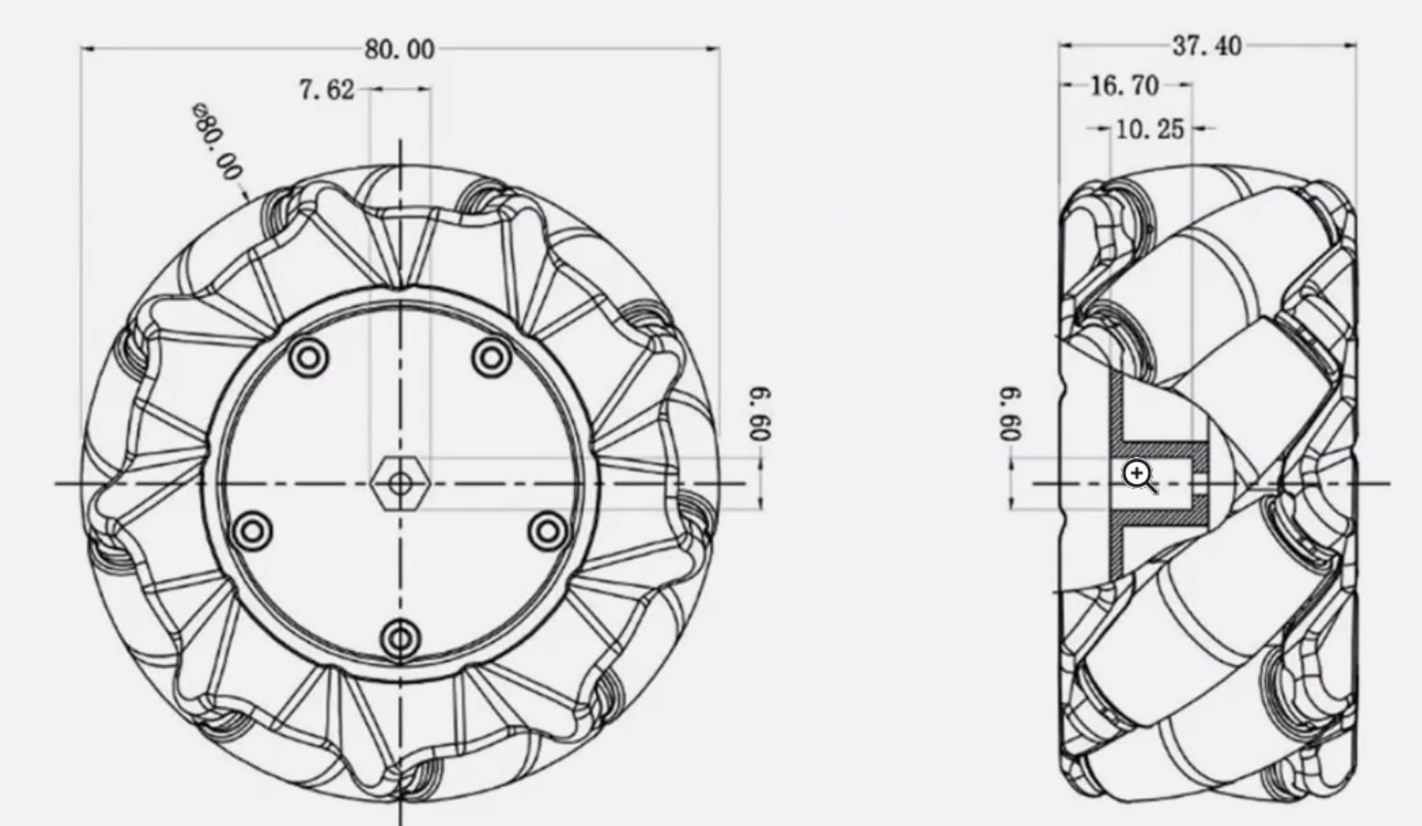

**WHERE TO BUY STUFF**

* <https://www.walmart.com/ip/Mecanum-Wheel-Smart-Robot-Car-Parts-Accessories-OmniDirectional-DIY-Toy-Components-48mm-1-Pair/10654567854?wmlspartner=wlpa&selectedSellerId=102516168>
* <https://www.amazon.com/JUZITAO-Motor-3V-6V-Gearbox-Motorfor/dp/B0CQ7WLZF9/ref=sr_1_6?dib=eyJ2IjoiMSJ9.xDSYQWV64jRZuTitsYuIoh5Ne45LEvKhJOZzAABS8P96TkjpnoPzTLA51kb3o4_m5I1S7GG3n9SPFAZSGSX3Nq04MUNblZSpDGSI7F5RX9pKqbT62ZtfQJuU3m9Va7NJ3DusmntxOi0qeSKu9whi9ElaGZl8rx7aMVEg96NiFNrmlyNSTxkWib-Iv3BooR9T9uEKDPKcCN_FKimEttDqIg2WXD4bXguyfg5pxbm3XFkvczsFxI8uT8nUcFKEPiXuE68MyBTdG_UNTFJRfrmuhtM6mZ74Z3nFnoR32iJ9PUs.uNamHgfGHBGsKVS9nc_1fGK2IZUNV1seQWJGYrFGkCU&dib_tag=se&keywords=n20+motor&qid=1726521688&sr=8-6>
* <https://www.digikey.com/en/products/detail/texas-instruments/DRV8833PW/4251165>