Chapter 1
Introduction
1.1 Introduction
Developers frequently search for reusable code snippets and UI implementations while building applications. There is a need for a centralized platform that combines visual previews with reusable source code, allowing developers to discover, understand, reuse, and collaborate on code efficiently. The platform should also support intelligent search, community interaction, AI-assisted code understanding, and premium developer features within a scalable microservices architecture.
Modern software development depends heavily on reusing proven solutions. Developers often use repository platforms to access source code, online editors to experiment with front-end components, community forums to solve technical problems, and visual-design platforms to find interface inspiration. GitHub supports code search and language-aware syntax highlighting, while CodePen provides an online editor for creating and demonstrating web-based code. These platforms are useful, but developers may still need to move between several sources to find both the visual appearance of a component and its implementation. GitHub Code Search, CodePen
Visual-design platforms such as Dribbble help designers and developers discover layouts, colour schemes, component styles, and interaction ideas. However, visual previews alone do not provide the corresponding source code needed to implement a similar component. Similarly, code repositories may contain valuable source files but do not always provide an immediate visual explanation of the final user interface. This separation between visual inspiration and reusable implementation creates additional effort during development. Dribbble
CodeCanvas is proposed as a visual code-sharing platform that addresses this gap. It enables developers to upload code snippets together with screenshots or UI previews. A user can search for snippets by keyword, programming language, framework, category, and tags, then view the preview image and source code in one place. The platform also supports likes, comments, bookmarks, follows, sharing, and fork/remix functionality. These features encourage developers to learn from existing work, adapt reusable components, and contribute improved versions to the community.
The platform uses a microservices architecture based on Spring Boot and Spring Cloud. Independent services handle user management, snippet management, search, notifications, payments, and AI features. Apache Kafka supports event-driven communication for operations such as search indexing, activity updates, and notifications. Kafka is designed for publishing, storing, and processing streams of events, which makes it suitable for asynchronous communication between services. Apache Kafka Documentation
PostgreSQL stores structured application data, Redis supports caching of frequently accessed information, and Elasticsearch provides full-text search across code snippets and tags. Elasticsearch indexes analysed text fields to return relevant results for search queries, while Spring Boot supports the development of stand-alone, production-grade Spring applications. Elasticsearch Full-Text Search, Spring Boot Documentation
CodeCanvas also includes AI-powered code explanations, automatic tag generation, code summaries, and similar-snippet recommendations. Premium membership plans provide access to premium AI features through secure Razorpay payment integration. Through the combination of visual previews, source-code sharing, intelligent search, community interaction, and scalable backend services, CodeCanvas aims to improve developer productivity and knowledge sharing.

1.2 Objective
The primary objective of CodeCanvas is to provide a centralized platform where developers can visually discover, share, and collaborate on reusable code snippets.
The project aims to:
Simplify code discovery using visual previews.
Enable developers to upload reusable code snippets with screenshots.
Provide intelligent search using Elasticsearch.
Support collaboration through likes, comments, bookmarks, and code forking.
Enhance productivity using AI-powered code explanations and automatic tag generation.
Offer premium subscription features through secure payment integration.
Demonstrate enterprise-level software architecture using Spring Boot Microservices.

1.3 End Users
Primary Users
Frontend Developers
Backend Developers
Full Stack Developers
Students and Learners
Open Source Contributors
Freelance Developers

Secondary Users
Recruiters reviewing developer portfolios
Organizations sharing reusable UI components
Technical trainers and mentors

Administrator
The administrator manages the overall platform by monitoring users, moderating content, managing premium memberships, viewing analytics, and maintaining platform integrity.

1.4 Project Scope

User Registration and Authentication
Role-Based Authorization
Developer Profiles
Code Snippet Upload
Screenshot Upload using Cloudinary
Syntax Highlighting
Categories and Tags
Full-Text Search
Like, Comment and Bookmark
Fork and Remix Code Snippets
Real-Time Notifications
AI Code Explanation
AI Tag Generation
Premium Membership
Razorpay Payment Gateway
Admin Dashboard
Docker Deployment

Chapter 2
Literature Review
Developers commonly rely on repository platforms, question-and-answer communities, visual-design galleries, and online code editors to discover reusable implementation ideas. These platforms provide valuable but different forms of support. The proposed CodeCanvas platform is motivated by the need to combine visual understanding of a component with its reusable source code, structured discovery, and community collaboration.
GitHub is a major repository-based platform for storing, managing, and discovering source code. Its code-search capabilities support advanced syntax and qualifiers for locating code across repositories, files, languages, and symbols. GitHub also supports language-aware code search and syntax highlighting. However, repository-oriented search is generally organized around projects and files, which can make it difficult for a developer to quickly evaluate the visual result of a small UI component. GitHub Code Search, GitHub language support
Stack Overflow provides a community-driven question-and-answer model through which developers share technical knowledge and code examples. Its guidance encourages questions to include relevant source code and allows users to ask and answer questions. This model is useful for solving specific programming problems, but the content is primarily organised around questions and answers rather than visually presented, reusable components. Stack Overflow Help Center
Visual design platforms address the inspiration side of the problem. Dribbble enables designers to share work, build portfolios, and discover design inspiration. Its visual focus helps developers and designers understand interface styles, layouts, and trends, but a visual design alone does not normally provide the complete underlying implementation required for direct reuse. Dribbble for Designers, Dribbble Design Inspiration
Online coding platforms such as CodePen bring source code and visible output closer together. CodePen describes itself as an online code editor and supports web-development tools such as Sass, Vue, TypeScript, and Prettier. It is especially useful for creating and demonstrating small front-end experiments. However, CodeCanvas extends this idea by providing developer profiles, categories, tags, follow relationships, bookmarks, comments, forking, premium AI features, and structured search across a dedicated code-sharing community. CodePen About, CodePen Online Editor
Research on code search demonstrates the importance of matching natural-language intent with relevant source code. Gu, Zhang, and Kim proposed DeepCS, which represents code and natural-language descriptions in a shared representation space for code retrieval. Their work shows that semantic relationships are important when developers search beyond exact keywords or file names. Gu, Zhang, and Kim, Deep Code Search
The CodeSearchNet Challenge further established a benchmark for semantic code search by releasing a code corpus, natural-language queries, and expert relevance annotations. This work supports the use of richer search approaches for retrieving useful code snippets from large collections. CodeCanvas applies this direction through keyword search, programming-language filters, framework filters, category filters, tags, and Elasticsearch-based full-text indexing. Husain et al., CodeSearchNet Challenge
Cambronero et al. evaluated choices used in deep-learning approaches to code search, showing that representation and evaluation choices materially affect retrieval quality. This supports the need for CodeCanvas to maintain clear snippet metadata such as title, description, programming language, framework, category, and tags, alongside the source code itself. Cambronero et al., When Deep Learning Met Code Search
The reviewed platforms and research demonstrate that code repositories, visual galleries, online editors, community discussion sites, and semantic search systems each solve part of the developer-discovery problem. CodeCanvas brings these capabilities together by associating code snippets with screenshots or UI previews, enabling structured search and social interaction, and supporting reuse through fork/remix functionality. Its microservices architecture, Kafka-based event communication, PostgreSQL, Redis, Elasticsearch, Cloudinary, Razorpay, and AI-supported features are intended to provide a scalable platform for visual code discovery and collaboration.

Chapter 3
Methodology and Techniques
3.1 Architecture and Technology Stack
To support scalability and maintainability, the platform is built using a microservices architecture powered by Spring Boot and Spring Cloud. Core functionalities are divided into independent services such as User Service, Post Service, Search Service, Notification Service, and Recommendation Service. Apache Kafka is used for event-driven communication between services, ensuring efficient asynchronous processing of tasks such as search indexing, notifications, and activity updates.
Frontend
React.js
HTML5
CSS3
Tailwind CSS
Backend
Java 21
Spring Boot
Spring Security
Spring Cloud Gateway
Spring Data JPA
Microservices
User Service
Snippet Service
Search Service
Notification Service
Payment Service
AI Service
Database
PostgreSQL
Search Engine
Elasticsearch
Cache
Redis
Messaging
Apache Kafka
AI
Google Gemini API
Image Storage
Cloudinary
Payment Gateway
Razorpay
Deployment
Docker
Development Tools
IntelliJ IDEA
VS Code
Postman
Git
GitHub
Jira

3.2 Database Design
PostgreSQL serves as the primary database for structured application data, while Redis is used for caching frequently accessed information. Elasticsearch enables fast and efficient full-text search capabilities across code snippets and tags.
Database Entities and Attributes
Entity | Attributes
roles | role_id UUID pk; role_name VARCHAR(30)
users | user_id UUID pk; role_id UUID fk; full_name VARCHAR(100); username VARCHAR(50); email VARCHAR(255); password VARCHAR(255); profile_image VARCHAR(500); bio TEXT; created_at TIMESTAMP; updated_at TIMESTAMP; last_login TIMESTAMP
snippets | snippet_id UUID pk; user_id UUID fk; title VARCHAR(150); description TEXT; language VARCHAR(50); framework VARCHAR(50); code TEXT; preview_image_url VARCHAR(500); visibility VARCHAR(20); views INTEGER; created_at TIMESTAMP; updated_by TIMESTAMP; updated_at TIMESTAMP
categories | category_name VARCHAR(50); category_id UUID pk
tags | tag_name VARCHAR(50); tag_id UUID pk
snippet_category | id UUID pk; snippet_id UUID fk; category_id UUID fk
snippet_tag | id UUID pk; snippet_id UUID fk; tag_id UUID fk
follows | follow_id UUID pk; follower_id UUID fk; following_id UUID fk
notifications | notification_id UUID pk; user_id UUID fk; notification_type VARCHAR(30); title VARCHAR(100); message TEXT; is_read BOOLEAN; created_at TIMESTAMP
ai_history | history_id UUID pk; user_id UUID fk; snippet_id UUID fk; feature_used VARCHAR(50); generated_output TEXT; created_at TIMESTAMP
comments | comment_id UUID pk; snippet_id UUID fk; user_id UUID fk; content TEXT; created_at TIMESTAMP
likes | like_id UUID pk; snippet_id UUID fk; user_id UUID fk; created_at TIMESTAMP
bookmarks | bookmark_id UUID pk; snippet_id UUID fk; user_id UUID fk; created_at TIMESTAMP
premium_plans | plan_id UUID pk; plan_name VARCHAR(50); description TEXT; duration INTEGER; price DECIMAL(10,2)
subscriptions | user_id UUID fk; subscription_id UUID pk; plan_id UUID fk; start_date TIMESTAMP; end_date TIMESTAMP; subscription_status VARCHAR(20)
payments | payment_id UUID pk; subscription_id UUID fk; amount DECIMAL(10,2); payment_method VARCHAR(10); transaction_id VARCHAR(30); razorpay_payment_id VARCHAR(150); payment_status VARCHAR(20); payment_date TIMESTAMP
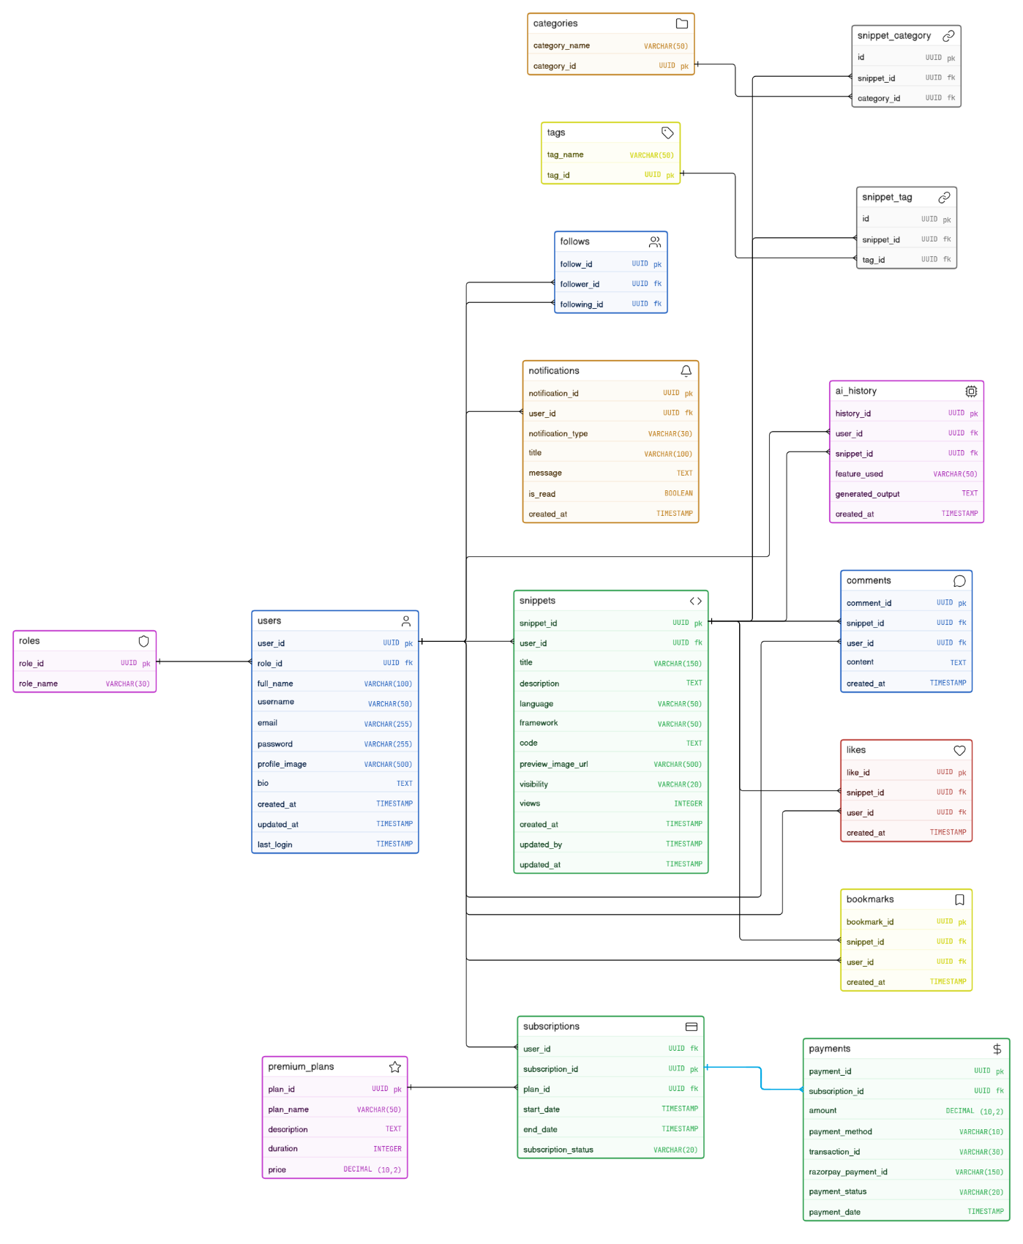
Fig. 1 CodeCanvas ER Diagram

3.3 User Flow Design
The user flow covers authentication, dashboard navigation, search, snippet details and actions, upload, profile, bookmarks, notifications, premium subscription, and administration.
Fig. 2 CodeCanvas User Flow Diagram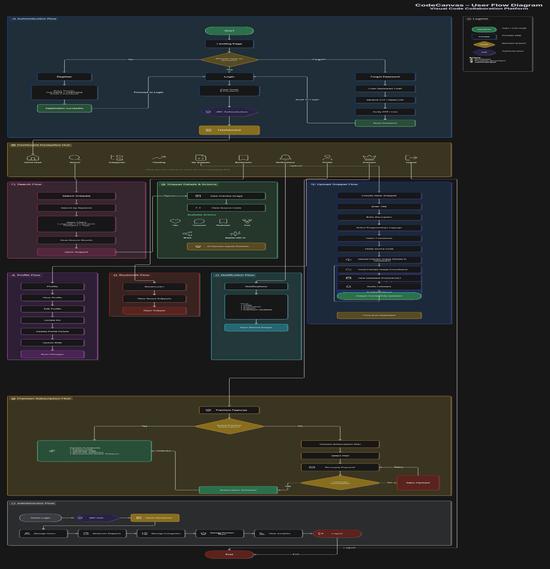
Chapter 4
Implementation
4.1 Feature List
User Management
Registration
Login
JWT Authentication
Role-Based Authorization
Forgot Password
User Profile Management
Code Snippet Management
Upload Code Snippets
Edit/Delete Snippets
Cloudinary Image Upload
Syntax Highlighting
Tags and Categories
Fork & Remix
Search & Discovery
Elasticsearch Search
Filter by Language
Filter by Framework
Tag Search
Trending Snippets
Community
Like
Comment
Bookmark
Follow Developers
Share Snippets
Notifications
Real-Time \Notifications
Like Notifications
Comment Notifications
Follow Notifications
AI Features
Code Explanation
Automatic Tag Generation
Code Summary
Similar Snippet Recommendation
Premium Features
Membership Plans
Razorpay Integration
Premium Badge
Premium AI Features
Administration
User Management
Content Moderation
Analytics Dashboard
Premium Management

4.2 Software Requirement Specification
Functional Requirements
Users shall register and log in securely.
Users shall upload code snippets with screenshots.
Users shall search snippets using keywords, tags, frameworks, and programming languages.
Users shall like, comment, bookmark, and fork snippets.
Premium users shall access AI-powered features.
Administrators shall manage users and content.
The system shall send real-time notifications.
Non-Functional Requirements
Responsive web interface.
Secure authentication using JWT.
Scalable microservices architecture.
Fast search using Elasticsearch.
Improved performance through Redis caching.
Reliable asynchronous communication using Kafka.
Secure payment processing.
Modular and maintainable codebase.

4.3 Primary Use Cases
Developer
Register Account
Login
Manage Profile
Upload Code Snippet
Upload Screenshot
Search Snippets
View Snippet
Like Snippet
Comment on Snippet
Bookmark Snippet
Fork Snippet
View Notifications
Subscribe to Premium
Use AI Features
Administrator
Login
Manage Users
Moderate Content
Manage Premium Memberships
View Reports and Analytics

Chapter 5
Results
CodeCanvas Screenshot Space

Chapter 6
Conclusion
6.1 Conclusion
The project demonstrates modern software engineering principles including microservices architecture, event-driven systems, distributed communication, caching, search optimization, and real-time application development. CodeCanvas aims to improve developer productivity by creating a centralized platform that combines visual learning, code discovery, collaboration, and reusable software components in a scalable and industry-relevant solution.
6.2 Future Enhancement
CodeCanvas can be enhanced by introducing a secure live-code preview environment. Instead of relying only on uploaded screenshots, developers could run supported front-end snippets in an isolated sandbox and view the output directly within the platform. This would improve understanding of component behaviour and enable users to test reusable code before forking or adapting it.
The search and recommendation system can be improved by using user activity such as searches, likes, bookmarks, follows, comments, and fork history. This would allow the platform to recommend relevant snippets, developers, categories, and tags based on individual interests. Semantic search can also be added to improve discovery when users describe a requirement in natural language rather than using exact keywords.
Future versions can provide deeper integration with external development platforms. Developers could import snippets from GitHub repositories, export remixed snippets to repositories, and maintain version history for code changes. Support for licences, attribution, and fork relationships can further improve responsible reuse of shared code.
Additional enhancements may include a mobile application, multi-language support, enhanced content moderation, reporting mechanisms, developer analytics, real-time collaborative editing, and richer dashboard visualisations. These improvements would help CodeCanvas grow into a more complete platform for code discovery, learning, collaboration, and reusable software development.

Chapter 7
References
- GitHub. GitHub Code Search. https://github.com/features/code-search
- GitHub. GitHub Language Support. https://docs.github.com/en/get-started/learning-about-github/github-language-support
- Stack Overflow. What Topics Can I Ask About Here? https://stackoverflow.com/help/on-topic
- CodePen. About CodePen. https://codepen.io/about
- Dribbble. Join the World’s Best Creative Community. https://dribbble.com/for-designers
- Gu, X., Zhang, H., and Kim, S. Deep Code Search. Paper
- Husain, H., Wu, H.-H., Gazit, T., Allamanis, M., and Brockschmidt, M. CodeSearchNet Challenge: Evaluating the State of Semantic Code Search. arXiv
- Cambronero, J., Li, H., Kim, S., Sen, K., and Chandra, S. When Deep Learning Met Code Search. arXiv
- Spring. Spring Boot Documentation. https://docs.spring.io/spring-boot
- Apache Kafka. Introduction. https://kafka.apache.org/documentation
- Elastic. Full-Text Search. https://www.elastic.co/docs/solutions/search/full-text
- PostgreSQL Global Development Group. PostgreSQL Documentation. https://www.postgresql.org/docs
- Redis. Redis Documentation. https://redis.io/docs/latest

