Freight Elevator Model

DEVS Specification and Experimentation Plan
This section provides the Part II specification deliverable for the Freight Elevator model. It contains: (1) the model organization and coupling scheme, (2) DEVS Graph definitions for the atomic models, (3) formal atomic DEVS specifications, and (4) an incremental experimentation framework.

Model Organization and Coupling Scheme

Model hierarchy (2–4 levels, ≥3 atomic models)
The Freight Elevator model is organized into the following hierarchy:
- Top coupled model: FreightElevatorTop
- Atomic: ECall
- Coupled: ElevatorCoupled
- Atomic: EControl
- Atomic: EVehicle

Ports and message types
A floor request is an integer floor number. A travel time command is an integer time value computed as |target_floor − current_floor| (1 time unit per floor).
Models
Model | Type | Input ports (type) | Output ports (type)
FreightElevatorTop | Coupled | inside_call:int, outside_call:int | floor:int
ElevatorCoupled | Coupled | acall:int | floor:int
ECall | Atomic | inside_call:int, outside_call:int | call_gen:int
EControl | Atomic | acall:int, fback:int | timem:int, floor:int
EVehicle | Atomic | in:int | out:int
Message types and semantics
Message | Type | Used on ports | Meaning / notes
floor_request | int | inside_call, outside_call, call_gen, acall | Requested destination floor number.
travel_time | int | timem, in, out, fback | Travel time in time units (1 unit per floor); value = |target_floor − current_floor|.
serviced_floor | int | floor | Floor number reached; emitted when the elevator completes the travel.

Coupling relations (EIC / IC / EOC)

Coupled model: ElevatorCoupled
EIC:
• (ElevatorCoupled.acall → EControl.acall)
IC:
• (EControl.timem → EVehicle.in)
• (EVehicle.out → EControl.fback)
EOC:
• (EControl.floor → ElevatorCoupled.floor)

Top coupled model: FreightElevatorTop
EIC:
• (FreightElevatorTop.inside_call → ECall.inside_call)
• (FreightElevatorTop.outside_call → ECall.outside_call)
IC:
• (ECall.call_gen → ElevatorCoupled.acall)
EOC:
• (ElevatorCoupled.floor → FreightElevatorTop.floor)

Coupled-model formal specification (DN form)
The coupled models are specified using the standard DEVS coupled model form:
DN = < X, Y, M, EIC, EOC, IC, SELECT >
SELECT is used as a tie-breaker if two submodels are imminent at the same simulation time.

ElevatorCoupled:
• X = { acall }
• Y = { floor }
• M = { EControl, EVehicle }
• EIC = { (ElevatorCoupled.acall, EControl.acall) }
• IC = { (EControl.timem, EVehicle.in), (EVehicle.out, EControl.fback) }
• EOC = { (EControl.floor, ElevatorCoupled.floor) }
• SELECT({EControl, EVehicle}) = EVehicle (vehicle completion has priority)

FreightElevatorTop:
• X = { inside_call, outside_call }
• Y = { floor }
• M = { ECall, ElevatorCoupled }
• EIC = { (inside_call, ECall.inside_call), (outside_call, ECall.outside_call) }
• IC = { (ECall.call_gen, ElevatorCoupled.acall) }
• EOC = { (ElevatorCoupled.floor, FreightElevatorTop.floor) }
• SELECT({ECall, ElevatorCoupled}) = ECall (resolve call selection first)

Atomic Models in DEVS Graph Modeler
For each atomic model, a DEVS Graph was created using the DEVS Graph Modeler.

ECall DEVS Graph
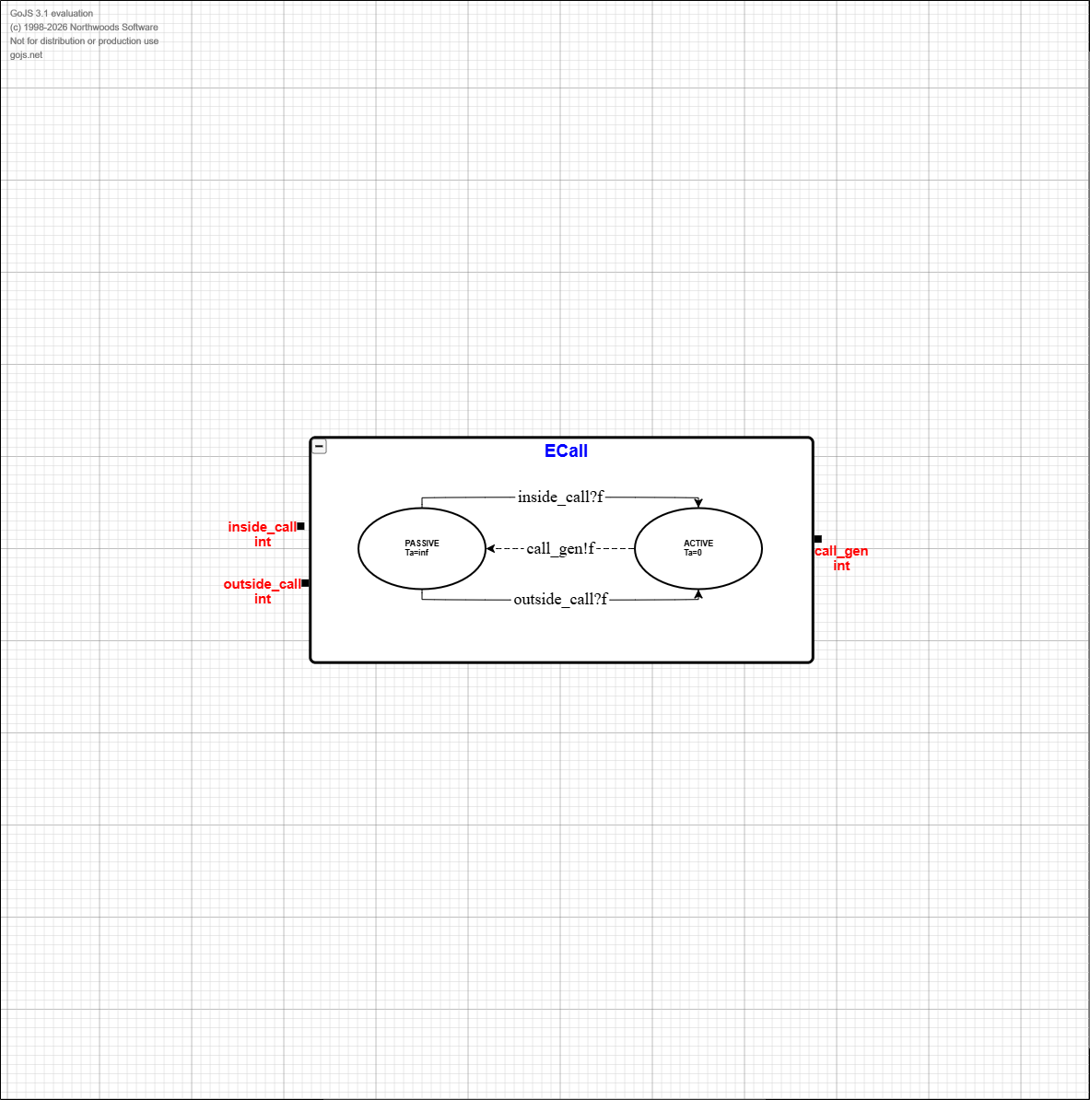

EControl DEVS Graph
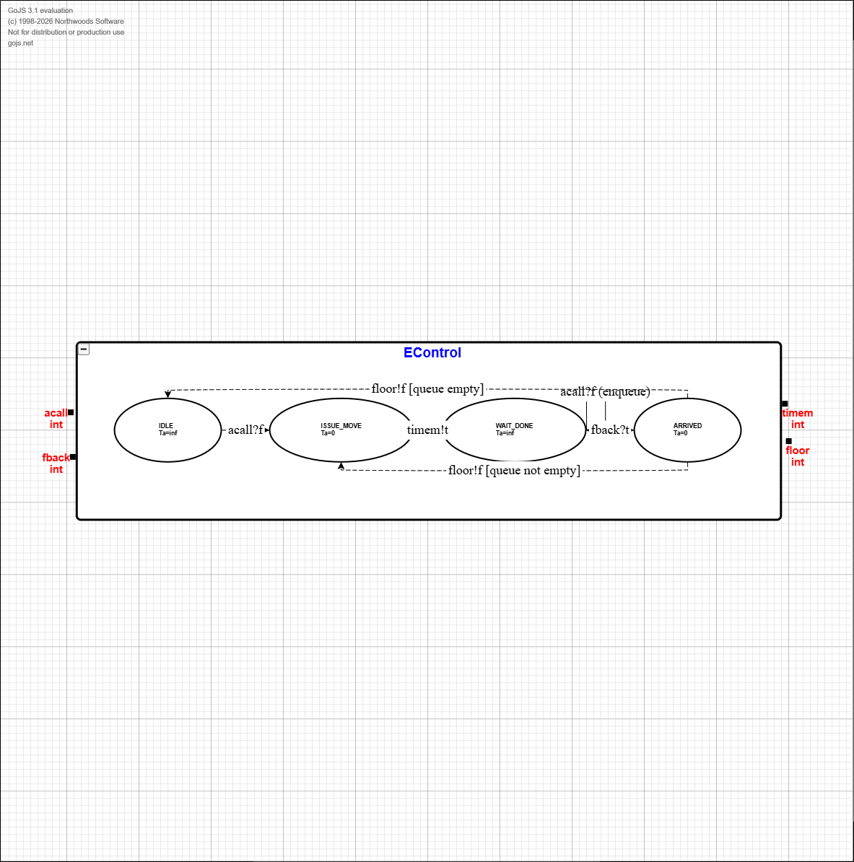

EVehicle DEVS Graph
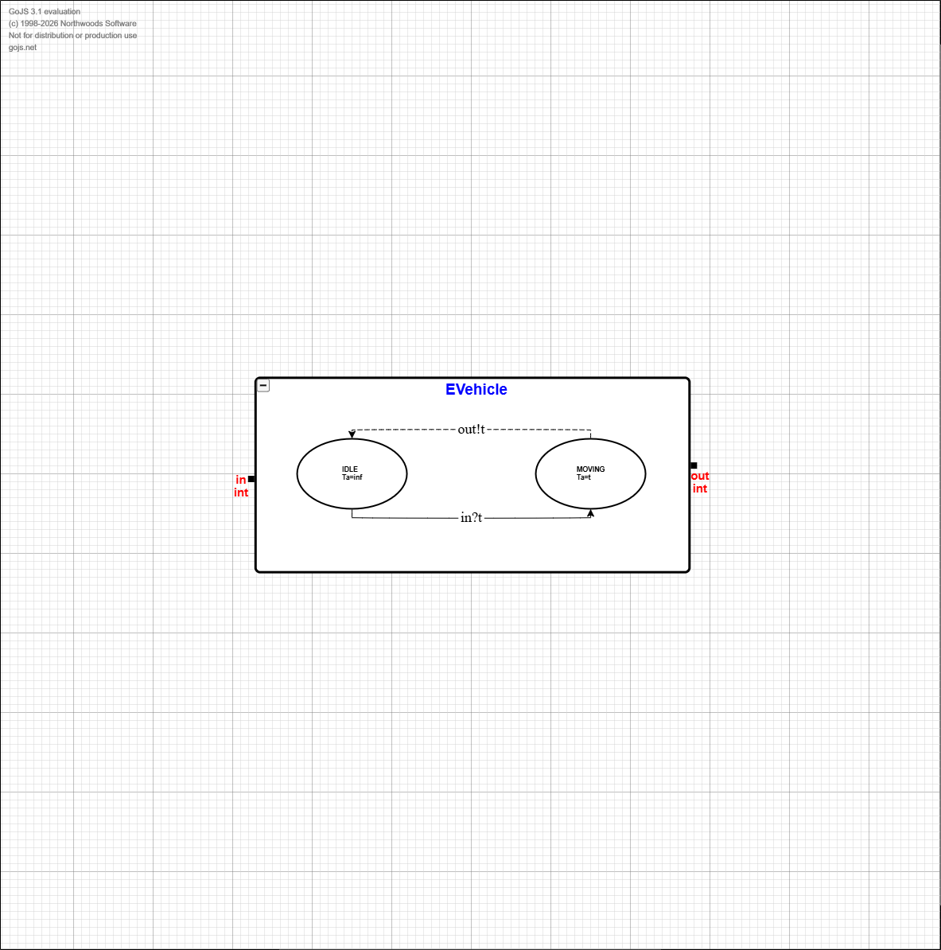

Formal Atomic DEVS Specifications
Each atomic model is specified in the form:
M = < X, S, Y, δint, δext, λ, ta >

ECall (Call router)
X = { inside_call:int, outside_call:int }
Y = { call_gen:int }
S = { phase ∈ {PASSIVE, ACTIVE}, pending_call:int or ⊥ }
ta(PASSIVE)=∞, ta(ACTIVE)=0
λ(ACTIVE) outputs call_gen = pending_call
δint(ACTIVE) = PASSIVE (clear pending_call)
δext:
• If an inside_call arrives (at any time): set pending_call = inside_call, phase=ACTIVE
• Else if only an outside_call arrives: set pending_call = outside_call, phase=ACTIVE
Tie rule if both arrive simultaneously: inside_call has priority over outside_call.

EVehicle (Travel delay)
X = { in:int } // travel time command
Y = { out:int } // completion feedback
S = { phase ∈ {IDLE, MOVING}, travel_time:int }
ta(IDLE)=∞, ta(MOVING)=travel_time
λ(MOVING) outputs out = travel_time
δint(MOVING) = IDLE
δext:
• If in arrives when IDLE: set travel_time=in and phase=MOVING
• If in arrives when MOVING: ignore (controller should not issue a new command while moving).

EControl (Scheduler/controller)
X = { acall:int, fback:int }
Y = { timem:int, floor:int }
S = { phase ∈ {IDLE, ISSUE_MOVE, WAIT_DONE, ARRIVED}, current_floor:int, target_floor:int, queue: list<int> }
ta(IDLE)=∞, ta(WAIT_DONE)=∞, ta(ISSUE_MOVE)=0, ta(ARRIVED)=0
λ(ISSUE_MOVE) outputs timem = |target_floor − current_floor|
λ(ARRIVED) outputs floor = target_floor
δint:
• ISSUE_MOVE → WAIT_DONE
• ARRIVED updates current_floor=target_floor and either:
– if queue empty: → IDLE
– else: pop next target_floor and → ISSUE_MOVE
δext:
• On acall: if phase is IDLE, set target_floor=acall and phase=ISSUE_MOVE; else append acall to queue.
• On fback (any completion message) when WAIT_DONE: set phase=ARRIVED.
Note: This controller intentionally uses FIFO scheduling and avoids updating current_floor until a completion feedback (fback) is received.

Experimentation Framework

Atomic model experiments
Experiment ID | Model | Inputs (time:port=value) | Expected output | Purpose
A1 | ECall | t=0:inside_call=2 | t=0:call_gen=2 | Basic inside call forwarding
A2 | ECall | t=0:outside_call=3 | t=0:call_gen=3 | Basic outside call forwarding
A3 | ECall | t=0:inside_call=2 and outside_call=3 | t=0:call_gen=2 only | Simultaneous calls, inside priority
A4 | EVehicle | t=0:in=3 | t=3:out=3 | Delay behavior
A5 | EControl | t=0:acall=3; t=2:fback=2 | t=0:timem=2; t=2:floor=3 | Single request: compute travel time, then report arrival on feedback
A6 | EControl | t=0:acall=4; t=1:acall=2; t=3:fback=3; t=5:fback=2 | t=0:timem=3; t=3:floor=4 and timem=2; t=5:floor=2 | Queued call while moving (FIFO). Second call enqueued during WAIT_DONE

Coupled and integration experiments
The following experiments validate the coupled model and then the full top model:
Experiment ID | Model | Inputs (time:port=value) | Expected output | Purpose
C1 | ElevatorCoupled | t=0:acall=3 (start at floor 1) | timem emitted at t=0; floor=3 emitted at t=2 | Single request end-to-end
C2 | ElevatorCoupled | t=0:acall=3, t=1:acall=2 | floor=3 then floor=2 (FIFO) | Queue behavior
T1 | FreightElevatorTop | t=0:inside_call=3 | floor=3 at expected arrival time | Top-level inside call
T2 | FreightElevatorTop | t=0:outside_call=4, t=0:inside_call=2 | inside call served first | Inside priority at top input

