SYSC4906G Discrete Event Modeling

Assignment 1: Freight Elevator Model
Repo URL: IshaqNour/FreightElevatorModel

Ishaq Nour 101235384

DEVS Specification and Experimentation Plan

Model Organization and Coupling Scheme

Model hierarchy
The Freight Elevator model is organized into the following hierarchy:
- Top coupled model: FreightElevatorTop
- Atomic: ECall
- Coupled: ElevatorCoupled
- Atomic: EControl
- Atomic: EVehicle

Ports and message types
Models
Model | Type | Input ports (type) | Output ports (type)
FreightElevatorTop | Coupled | inside_call:int, outside_call:int | floor:int
ElevatorCoupled | Coupled | acall:int | floor:int
ECall | Atomic | inside_call:int, outside_call:int | call_gen:int
EControl | Atomic | acall:int, fback:int | timem:int, floor:int
EVehicle | Atomic | in:int | out:int
Message types and semantics
Message | Type | Used on ports | Meaning / notes
floor_request | int | inside_call, outside_call, call_gen, acall | Requested destination floor number.
travel_time | int | timem, in, out, fback | Travel time in time units (1 unit per floor); value = |target_floor − current_floor|.
serviced_floor | int | floor | Floor number reached; emitted when the elevator completes the travel.

Coupling relations (EIC / IC / EOC)

Coupled model: ElevatorCoupled
EIC:
• (ElevatorCoupled.acall → EControl.acall)
IC:
• (EControl.timem → EVehicle.in)
• (EVehicle.out → EControl.fback)
EOC:
• (EControl.floor → ElevatorCoupled.floor)

Top coupled model: FreightElevatorTop
EIC:
• (FreightElevatorTop.inside_call → ECall.inside_call)
• (FreightElevatorTop.outside_call → ECall.outside_call)
IC:
• (ECall.call_gen → ElevatorCoupled.acall)
EOC:
• (ElevatorCoupled.floor → FreightElevatorTop.floor)

Coupled-model formal specification (DN form)
The coupled models are specified using the standard DEVS coupled model form:
DN = < X, Y, M, EIC, EOC, IC, SELECT >
SELECT is used as a tie-breaker if two submodels are imminent at the same simulation time.

ElevatorCoupled:
• X = { acall }
• Y = { floor }
• M = { EControl, EVehicle }
• EIC = { (ElevatorCoupled.acall, EControl.acall) }
• IC = { (EControl.timem, EVehicle.in), (EVehicle.out, EControl.fback) }
• EOC = { (EControl.floor, ElevatorCoupled.floor) }
• SELECT({EControl, EVehicle}) = EVehicle (vehicle completion has priority)

FreightElevatorTop:
• X = { inside_call, outside_call }
• Y = { floor }
• M = { ECall, ElevatorCoupled }
• EIC = { (inside_call, ECall.inside_call), (outside_call, ECall.outside_call) }
• IC = { (ECall.call_gen, ElevatorCoupled.acall) }
• EOC = { (ElevatorCoupled.floor, FreightElevatorTop.floor) }
• SELECT({ECall, ElevatorCoupled}) = ECall (resolve call selection first)

Atomic Models in DEVS Graph Modeler
For each atomic model, a DEVS Graph was created using the DEVS Graph Modeler.

ECall DEVS Graph
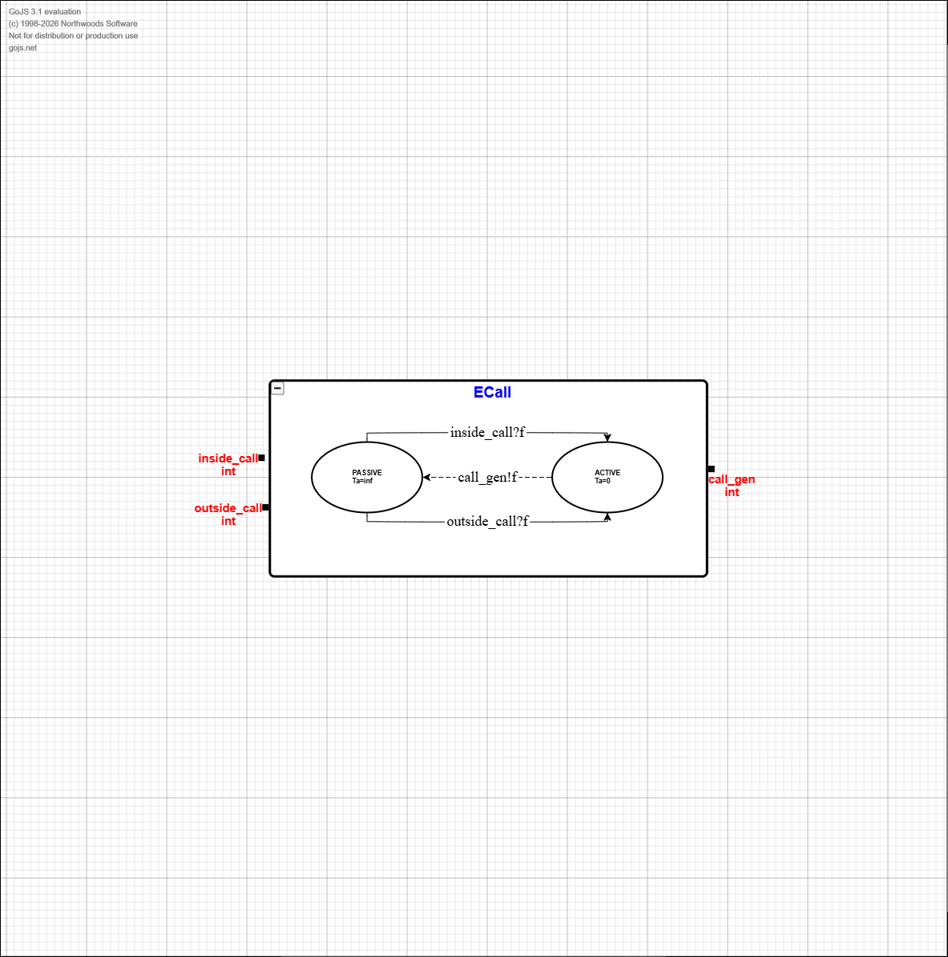

EControl DEVS Graph
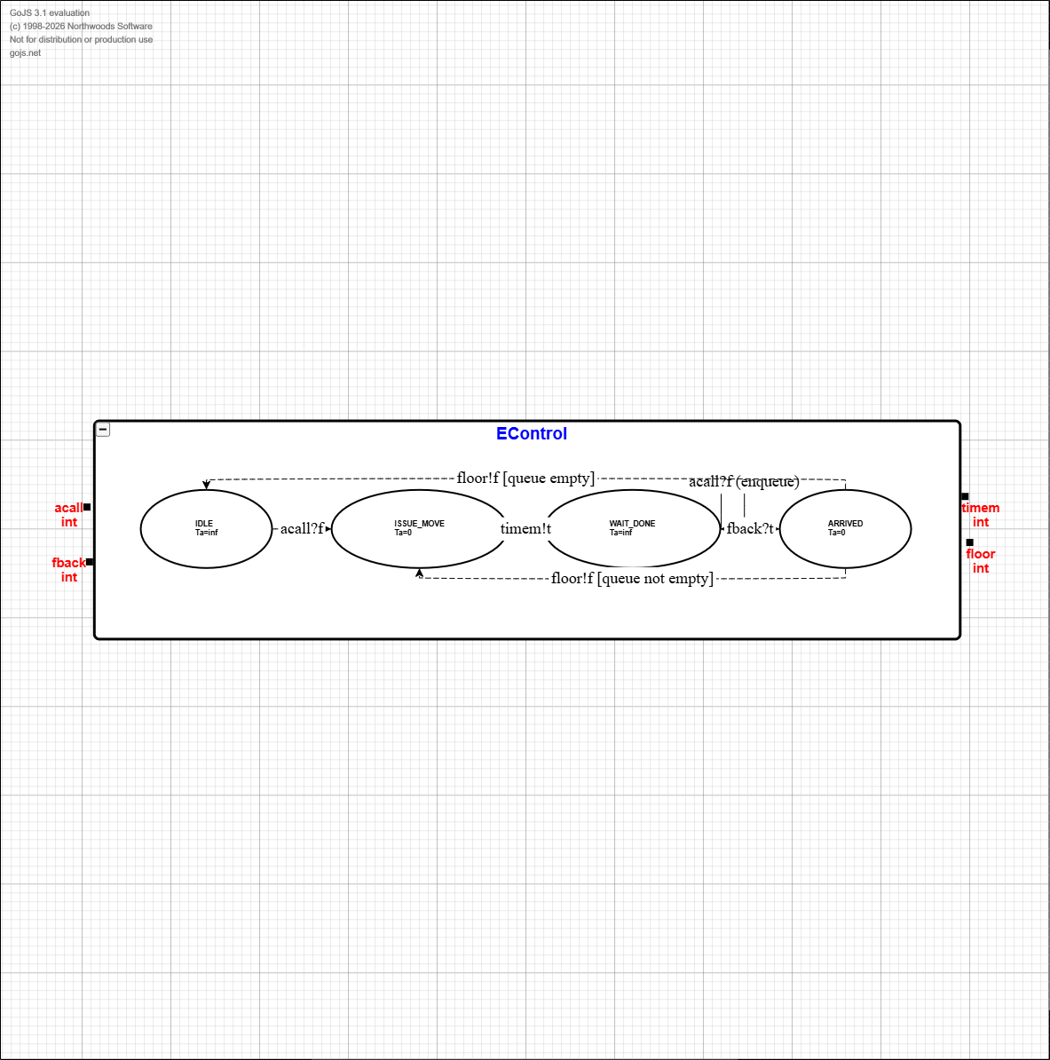

EVehicle DEVS Graph
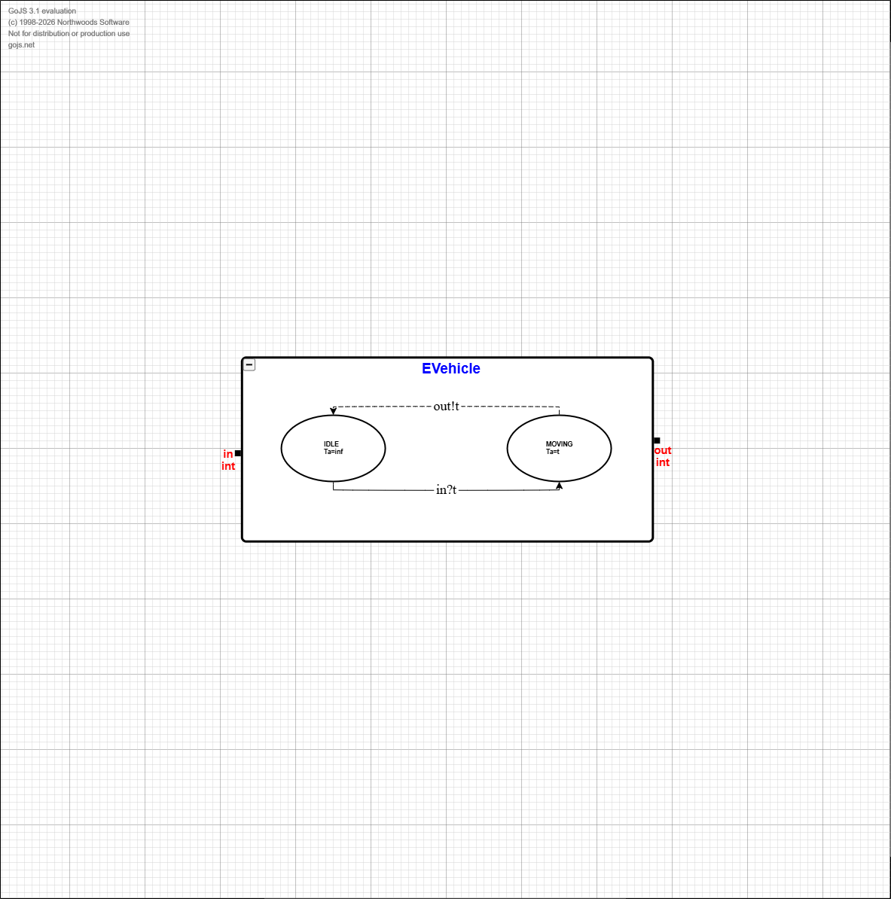

Formal Atomic DEVS Specifications
Each atomic model is specified in the form:
M = < X, S, Y, δint, δext, λ, ta >

ECall (Call router)
X = { inside_call:int, outside_call:int }
Y = { call_gen:int }
S = { phase ∈ {PASSIVE, ACTIVE}, pending_call:int or ⊥ }
ta(PASSIVE)=∞, ta(ACTIVE)=0
λ(ACTIVE) outputs call_gen = pending_call
δint(ACTIVE) = PASSIVE (clear pending_call)
δext:
• If an inside_call arrives (at any time): set pending_call = inside_call, phase=ACTIVE
• Else if only an outside_call arrives: set pending_call = outside_call, phase=ACTIVE
Tie rule if both arrive simultaneously: inside_call has priority over outside_call.

EVehicle (Travel delay)
X = { in:int } // travel time command
Y = { out:int } // completion feedback
S = { phase ∈ {IDLE, MOVING}, travel_time:int }
ta(IDLE)=∞, ta(MOVING)=travel_time
λ(MOVING) outputs out = travel_time
δint(MOVING) = IDLE
δext:
• If in arrives when IDLE: set travel_time=in and phase=MOVING
• If in arrives when MOVING: ignore (controller should not issue a new command while moving).

EControl (Scheduler/controller)
X = { acall:int, fback:int }
Y = { timem:int, floor:int }
S = { phase ∈ {IDLE, ISSUE_MOVE, WAIT_DONE, ARRIVED}, current_floor:int, target_floor:int, queue: list<int> }
ta(IDLE)=∞, ta(WAIT_DONE)=∞, ta(ISSUE_MOVE)=0, ta(ARRIVED)=0
λ(ISSUE_MOVE) outputs timem = |target_floor − current_floor|
λ(ARRIVED) outputs floor = target_floor
δint:
• ISSUE_MOVE → WAIT_DONE
• ARRIVED updates current_floor=target_floor and either:
– if queue empty: → IDLE
– else: pop next target_floor and → ISSUE_MOVE
δext:
• On acall: if phase is IDLE, set target_floor=acall and phase=ISSUE_MOVE; else append acall to queue.
• On fback (any completion message) when WAIT_DONE: set phase=ARRIVED.
Note: This controller intentionally uses FIFO scheduling and avoids updating current_floor until a completion feedback (fback) is received.

Experimentation Framework

Atomic model experiments
The following experiments validate the atomic model
Experiment ID | Model | Inputs (time:port=value) | Expected output | Purpose
A1 | ECall | inside_call: 11→3, 18→2, 20→3, 45→3  outside_call: 0→0 (empty) | call_gen: 0→0, 11→3, 18→2, 20→3, 45→3 | Basic inside call forwarding
A2 | ECall | inside_call: 0→0 (empty)  outside_call: 5→2, 11→1, 15→2, 25→1, 45→2 | call_gen: 0→0, 5→2, 11→1, 15→2, 25→1, 45→2 | Basic outside call forwarding
A3 | ECall | inside_call: 11→3, 18→2, 20→3, 45→3  outside_call: 5→2, 11→1, 15→2, 25→1, 45→2 | call_gen: 5→2, 11→3, 15→2, 18→2, 20→3, 25→1, 45→3 | Simultaneous calls, inside priority
A4 | EVehicle | in: 0→2 | out: 2→2 | Delay behavior
A5 | EControl | acall: 0→3  fback: 2→2 | timem: 0→2  floor: 2→3 | Single request: compute travel time, then report arrival on feedback
A6 | EControl | acall: 0→4, 1→2  fback: 3→3, 5→2 | timem: 0→3, 3→2  floor: 3→4, 5→2 | Queued call while moving (FIFO). Second call enqueued during WAIT_DONE

Coupled and integration experiments
The following experiments validate the coupled model and then the full top model:
Experiment ID | Model | Inputs (time:port=value) | Expected output | Purpose
C1 | ElevatorCoupled | acall: 5→2, 10→3, 15.5→1, 20→1, 23→2, 25→3, 27.0167→1, 29.5→2, 34→1, 36→3 | floor: 6→2, 11→3, 17.5→1, 20→1, 24→2, 26→3, 29.0167→1, 30.5→2, 35→1, 38→3 | Single request end-to-end
C2 | ElevatorCoupled | acall: 0→4, 1→2, 2→5 | floor: 3→4, 5→2, 8→5 | Queue behavior
T1 | FreightElevatorTop | inside_call: 15→1, 21→3, 25→1, 30→1, 39→1, 54→2  outside_call: 0→0 (empty) | floor: 1→0, 16→1, 23→3, 27→1, 30→1, 39→1, 55→2 | Top-level inside call
T2 | FreightElevatorTop | inside_call: 15→1, 21→3, 25→1, 30→1, 39→1, 54→2  outside_call: 12→3, 18→2, 21→2, 28→3, 35→2, 44→3, 57→1, 65→2, 70→3, 75→1 | floor: 14→3, 17→1, 19→2, 22→3, 27→1, 30→3, 32→1, 36→2, 40→1, 46→3, 55→2, 58→1, 66→2, 71→3, 77→1 | Inside priority at top input

Cadmium Implementation and Experiment Results

Atomic model experiments

Experiment A1 — ECall: inside call forwarding
This experiment validates that an inside call is forwarded immediately to the controller interface port (call_gen) with no delay.

Input events | Observed output events
From input_data/ecall_inside.txt and input_data/empty_outside.txt:  t=0: outside_call=0  t=11: inside_call=3  t=18: inside_call=2  t=20: inside_call=3  t=45: inside_call=3 | From simulation_results/A1_ecall.csv:  t=0: call_gen=0  t=11: call_gen=3  t=18: call_gen=2  t=20: call_gen=3  t=45: call_gen=3

Experiment A2 — ECall: outside call forwarding
This experiment validates that an outside call is forwarded immediately to call_gen with no delay.
Input events | Observed output events
From input_data/empty_inside.txt and input_data/ecall_outside.txt:  t=0: inside_call=0  t=5: outside_call=2  t=11: outside_call=1  t=15: outside_call=2  t=25: outside_call=1  t=45: outside_call=2 | From simulation_results/A2_ecall.csv:  t=0: call_gen=0  t=5: call_gen=2  t=11: call_gen=1  t=15: call_gen=2  t=25: call_gen=1  t=45: call_gen=2

Experiment A3 — ECall: simultaneous inside/outside calls (inside priority)
This experiment validates the priority rule when calls arrive simultaneously: the inside call is served, and the outside call at the same time is ignored.
Input events | Observed output events
From input_data/ecall_inside.txt and input_data/ecall_outside.txt:  t=5: outside_call=2  t=11: inside_call=3  t=11: outside_call=1  t=15: outside_call=2  t=18: inside_call=2  t=20: inside_call=3  t=25: outside_call=1  t=45: inside_call=3  t=45: outside_call=2 | From simulation_results/A3_ecall.csv:  t=5: call_gen=2  t=11: call_gen=3  t=15: call_gen=2  t=18: call_gen=2  t=20: call_gen=3  t=25: call_gen=1  t=45: call_gen=3

Experiment A4 — EVehicle: delay behavior
This experiment validates that EVehicle delays its output by exactly the travel-time value received on its input.
Input events | Observed output events
From input_data/evehicle_single_in.txt:  t=0: in=2 | From simulation_results/A4_evehicle.csv:  t=2: out=2

Experiment A5 — EControl: single request (compute travel time, then report arrival)
The controller computes travel time immediately (timem) and waits for vehicle feedback (fback). When feedback arrives, it outputs the target floor.
Input events | Observed output events
From input_data/econtrol_single_calls.txt and input_data/econtrol_single_fback.txt:  t=0: acall=3  t=2: fback=2 | From simulation_results/A5_econtrol.csv:  t=0: timem=2  t=2: floor=3

Experiment A6 — EControl: queued calls while moving (FIFO)
This experiment validates FIFO queuing: a second call arriving while moving is queued, then serviced after the first arrival.
Input events | Observed output events
From input_data/econtrol_queue_calls.txt and input_data/econtrol_queue_fback.txt:  t=0: acall=4  t=1: acall=2  t=3: fback=3  t=5: fback=2 | From simulation_results/A6_econtrol.csv:  t=0: timem=3  t=3: timem=2  t=3: floor=4  t=5: floor=2

Coupled and integration experiments

Experiment C1 — ElevatorCoupled: single request end-to-end
This coupled-model experiment validates the end-to-end behaviour of EControl + EVehicle: a call produces a floor output after the computed travel delay.
Input events | Observed output events
From input_data/elevator_calls_test.txt:  t=5: acall=2  t=10: acall=3  t=15.5: acall=1  t=20: acall=1  t=23: acall=2  t=25: acall=3  t=27.0167: acall=1  t=29.5: acall=2  t=34: acall=1  t=36: acall=3 | From simulation_results/C1_elevator.csv:  t=5: timem=1  t=6: floor=2  t=10: timem=1  t=11: floor=3  t=15.5: timem=2  t=17.5: floor=1  t=20: timem=0  t=20: floor=1  t=23: timem=1  t=24: floor=2  t=25: timem=1  t=26: floor=3  t=27.0167: timem=2  t=29.0167: floor=1  t=29.5: timem=1  t=30.5: floor=2  t=34: timem=1  t=35: floor=1  t=36: timem=2  t=38: floor=3

Experiment C2 — ElevatorCoupled: queue behaviour (FIFO)
This experiment validates FIFO service at the coupled level: floors are emitted in the same order that calls are accepted.
Input events | Observed output events
From input_data/elevator_queue_calls.txt:  t=0: acall=4  t=1: acall=2  t=2: acall=5 | From simulation_results/C2_elevator.csv:  t=0: timem=3  t=3: timem=2  t=3: floor=4  t=5: timem=3  t=5: floor=2  t=8: floor=5

Experiment T1 — FreightElevatorTop: top-level inside call
This top-level experiment validates that an inside call reaches the controller and produces a floor output after the expected travel delay.
Input events | Observed output events
From input_data/fe_inside_calls.txt and input_data/empty_outside.txt:  t=0: outside_call=0  t=15: inside_call=1  t=21: inside_call=3  t=25: inside_call=1  t=30: inside_call=1  t=39: inside_call=1  t=54: inside_call=2 | From simulation_results/T1_top.csv:  t=1: floor=0  t=16: floor=1  t=23: floor=3  t=27: floor=1  t=30: floor=1  t=39: floor=1  t=55: floor=2

Experiment T2 — FreightElevatorTop: inside priority at top input (simultaneous calls)
This experiment validates inside-call priority at the top model input: when calls arrive simultaneously, the inside call is selected.
Input events | Observed output events
From input_data/fe_inside_calls.txt and input_data/fe_outside_calls.txt:  t=12: outside_call=3  t=15: inside_call=1  t=18: outside_call=2  t=21: inside_call=3  t=21: outside_call=2  t=25: inside_call=1  t=28: outside_call=3  t=30: inside_call=1  t=35: outside_call=2  t=39: inside_call=1  t=44: outside_call=3  t=54: inside_call=2  t=57: outside_call=1  t=65: outside_call=2  t=70: outside_call=3  t=75: outside_call=1 | From simulation_results/T2_top.csv:  t=14: floor=3  t=17: floor=1  t=19: floor=2  t=22: floor=3  t=27: floor=1  t=30: floor=3  t=32: floor=1  t=36: floor=2  t=40: floor=1  t=46: floor=3  t=55: floor=2  t=58: floor=1  t=66: floor=2  t=71: floor=3  t=77: floor=1

