SYSC 5104: Methodologies for Discrete Event
Modelling and Simulation
Instructor: Dr. Gabriel A. Wainer
2D Heat Diffusion Using DEVS and CELL-DEVS
ASSIGNMENT 2
Ishaq Nour
Student ID : 101235384
Repo URL : IshaqNour/HeatDiffusionModel
27/03/2026

Conceptual Model
The model is a wrapped 10 x 10 temperature grid. Each cell stores one temperature value. In a normal step, a cell updates from its local 3 x 3 Moore neighborhood, including itself, so the rule stays simple and local.
The coupled structure adds one Cell-DEVS surface and two DEVS trigger generators. The HeatGenerator is coupled to cells (2,2) and (5,5), while the ColdGenerator is coupled to cells (2,8) and (8,8). When one of those source cells gets a trigger, that source update is used for that step instead of the regular averaging rule.
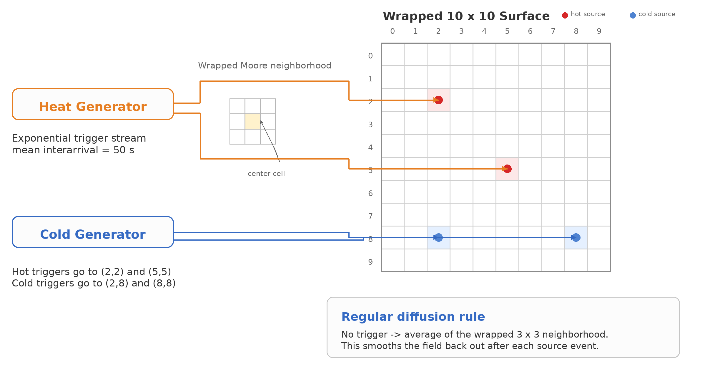
Figure 1. Conceptual view of the wrapped 10 x 10 heat-diffusion setup. Two DEVS generators feed the hot and cold source cells, and the regular cell rule uses the wrapped Moore neighborhood average when no trigger arrives.
In the base scenario every cell starts at 24.0. Hot events sample from Uniform[24,40] and cold events sample from Uniform[-10,15]. The wrapped boundary matters because activity can keep moving across opposite edges instead of stopping at the border.

Formal Cell-DEVS and DEVS Specification

Model Organization and Coupling Scheme
The model hierarchy is as follows:
- Top coupled model: HeatDiffusionTop
- Coupled Cell-DEVS model: HeatSurfaceCoupled
- Atomic Cell-DEVS model: HeatDiffusionCell(i,j), for every cell in the 10 x 10 wrapped grid
- Atomic DEVS models: HeatGenerator and ColdGenerator

Ports and message types
Model | Type | Input ports | Output ports
HeatDiffusionTop | Coupled
HeatSurfaceCoupled | Coupled Cell-DEVS | inputHeat:int, inputCold:int
HeatDiffusionCell(i,j) | inputHeat:int, inputCold:int, and neighboring HeatDiffusionState messages  state updates of type HeatDiffusionState | neighbor_state:double; source trigger on selected hot/cold cells | state_out:double
HeatGenerator | Atomic DEVS |  | out:int
ColdGenerator | Atomic DEVS |  | out:int

Message semantics
Message | Type | Used on ports | Meaning
heat_trigger | int | HeatGenerator.out, inputHeat | Trigger token for the hot-source cells. The arrival of the event matters more than the payload value.
cold_trigger | int | cell_state  HeatDiffusionState  neighboring cell state propagation  Cell state object exchanged through the Cell-DEVS grid; it stores one scalar field temperature:double. | Trigger token for the cold-source cells.
EIC  IC | double | neighbor_state, state_out | Scalar temperature exchanged among neighboring cells during diffusion.

Coupling relations (EIC / IC / EOC)

HeatSurfaceCoupled
- EIC = { (inputHeat, HeatCell(2,2).inputHeat), (inputHeat, HeatCell(5,5).inputHeat), (inputCold, HeatCell(2,8).inputCold), (inputCold, HeatCell(8,8).inputCold) }
- IC = { (HeatCell(a,b).state_out, HeatCell(i,j).neighbor_state) | (a,b) belongs to the wrapped Moore neighborhood N(i,j) }
- EOC = empty set. The cell-space evolution is observed through the simulator CSV logger and later through the Cell-DEVS Web Viewer.

HeatDiffusionTop
- M = { HeatDiffusionCell(i,j) | (i,j) belongs to the 10 x 10 grid }
- IC = { (HeatGenerator.out, HeatSurfaceCoupled.inputHeat), (ColdGenerator.out, HeatSurfaceCoupled.inputCold) }
- EOC = empty set
The coupled models are described using the standard DEVS coupled form:
DN = < X, Y, M, EIC, EOC, IC, SELECT >

HeatSurfaceCoupled
- X = { inputHeat, inputCold }
- Y = empty set
- M = { HeatCell(i,j) | (i,j) belongs to the 10 x 10 grid }
- EIC and IC as defined above
- SELECT is not specified explicitly in the implementation for the top coupled model, so no fixed tie-breaker is assumed among HeatGenerator, ColdGenerator, and HeatSurfaceCoupled.
- SELECT = lexicographic coordinate order over the cell instances, used only to keep the execution deterministic.

HeatDiffusionTop
- HeatDiffusionCell(i,j)
- XN(i,j) = neighboring HeatDiffusionState messages
- XE(i,j) = { inputHeat:int, inputCold:int } in the implementation; only configured hot-source or cold-source cells react to the relevant trigger
- Y(i,j) = state updates of type HeatDiffusionState propagated through the Cell-DEVS grid
- IC = { (HeatGenerator.out, HeatSurfaceCoupled.inputHeat), (ColdGenerator.out, HeatSurfaceCoupled.inputCold) }
- EOC = empty set
- SELECT({HeatGenerator, ColdGenerator, HeatSurfaceCoupled}) = HeatGenerator as a deterministic tie-breaker.

Formal Atomic Cell-DEVS and DEVS Specifications
The diffusion cell is written in the lecture form C(i,j) = < XN(i,j), XE(i,j), Y(i,j), S(i,j), N(i,j), tau(i,j), d(i,j), delay(i,j) >. The two trigger generators follow the DEVS atomic form M = < X, S, Y, delta_int, delta_ext, lambda, ta >.

HeatCell(i,j)
- XN(i,j) = { neighbor_state : double }
- XE(i,j) = empty set for regular cells; { inputHeat:int } for hot-source cells H = { (2,2), (5,5) }; { inputCold:int } for cold-source cells F = { (2,8), (8,8) }
- Y(i,j) = { state_out : double }
- S(i,j) = { T : double }
- N(i,j) = wrapped Moore neighborhood of range 1 including the cell itself
- Base initial state: T0(i,j) = 24.0 for every cell in the surface

Local rule
- If a heat trigger arrives and (i,j) is in H, then T' is sampled from Uniform[24,40] in the base scenario.
- If a cold trigger arrives and (i,j) is in F, then T' is sampled from Uniform[-10,15] in the base scenario.
- Otherwise, T' is the average of the nine temperatures in the wrapped Moore neighborhood.
- The source-trigger update takes priority over the regular diffusion rule on the source cells.
- d(i,j)(T') = 1 second and delay(i,j) = transport.
So the model uses one scalar temperature state and one short rule: source cells react to external triggers, and everything else just smooths by local averaging. That is the main reason the implementation stays small and easy to test.

HeatGenerator and ColdGenerator
- X = empty set
- Y = { out : int }
- S = { token : int, sigma : double }
- Initial state: token = 1 and the first sigma value is sampled from an exponential distribution with mean 50 seconds
- ta(s) = sigma
- lambda(s) outputs the token on port out
- delta_int(s): token stays at 1 and sigma is resampled from the same exponential distribution
- delta_ext is not used because the generators have no external input ports
The two generators have the same internal structure. The only difference is where their output is coupled. HeatGenerator drives the hot-source input, while ColdGenerator drives the cold-source input.

Simulation Execution

Experimental Frame
config/heat_config_base_scenario.json
log/grid_base_log.csv
The scenario discussion below leans on selected Cell-DEVS Web Viewer screenshots because they make the spatial behavior easier to read. The CSV logs were still useful during testing to confirm event times and check that each run finished the way it should.
Scenario | Changed input | Files used | Purpose
Base scenario | No change. Matches the formal specification. | grid_base_config.json |  grid_base_log.csv | Reference case.
Hotter source | config/heat_config_nonuniform_initial.json  log/grid_nonuniform_initial_log.csv | grid_hotter_source_config.json | grid_hotter_source_log.csv | Test stronger heating.
Reduced cooling | One of the two cold sources is removed. | grid_reduced_cooling_config.json | grid_reduced_cooling_log.csv | Test weaker cooling.
Nonuniform initial | Six cells start at 32.0 instead of 24.0. | grid_nonuniform_initial_config.json | grid_nonuniform_initial_log.csv | Test a different starting field.

Base Scenario Execution and Analysis

Experimental Frame and Scenario Setup
This is the reference run, so nothing is changed from the default setup. The whole 10 x 10 surface starts at 24.0, the hot inputs still go to (2,2) and (5,5), the cold inputs still go to (2,8) and (8,8), and the generator timing stays the same. This run serves as the baseline for comparison with the other scenarios.

Initial State (t = 0)

Figure 2. Base scenario at t = 0.
At the start the whole surface is flat. Every cell begins at 24.0, so there is no hot spot, no cold spot, and no visible diffusion yet.

First Cold Trigger (t = 95.2199)
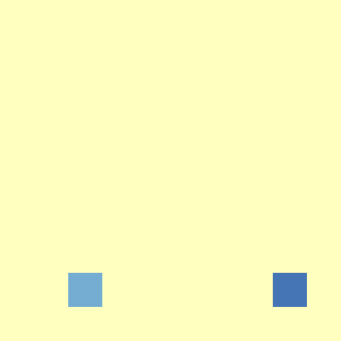
Figure 3. Base scenario at t = 95.2199.
The first visible event comes from the cold side near the lower source cells. It is still very local here, which is consistent with the trigger having just arrived.

Early Cold Diffusion (t = 98.2199)

Figure 4. Base scenario at t = 98.2199.
A couple seconds later that cold event is already being averaged through the wrapped neighborhood. The cool region starts stretching across the boundary instead of stopping at the edge, so this frame is a nice quick check that the wrapped surface is working.

First Hot Trigger (t = 112.438)
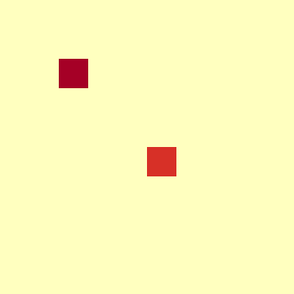
Figure 5. Base scenario at t = 112.438.
Now the hot source comes in and the two hot cells show up at the configured locations. This is the cleanest frame for seeing the source cells themselves before the regular diffusion rule spreads them out.

Early Hot Diffusion (t = 114.438)
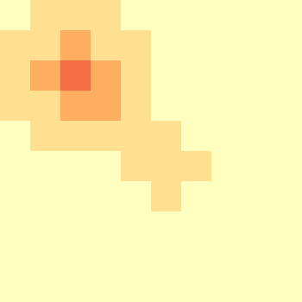
Figure 6. Base scenario at t = 114.438.
Once the averaging step runs again, the hot event starts opening into the familiar cross-like pattern. The upper hot spot is already spreading through the neighborhood while the lower one starts warming the nearby cells as well.

Later Wrapped Response (t = 213.108)
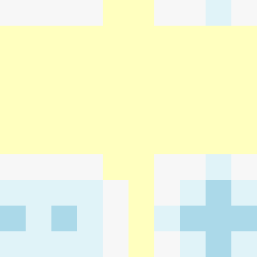
Figure 7. Base scenario at t = 213.108.
Later in the run the middle has mostly smoothed out again, but a warm band still crosses the top and bottom edge and cooler pockets remain near the lower corners. This frame shows both parts of the model at the same time: local heating and cooling together with the wraparound behavior.

Interpretation of Results
The base run behaves the way the model says it should. A source fires, the disturbance stays local at first, and then the field smooths back out through the wrapped 3 x 3 average.

Hotter Source Scenario Execution and Analysis

Experimental Frame and Scenario Setup
This scenario keeps the same grid, the same source positions, and the same trigger timing as the base case. The only change is the hot-source range, so the hot events are sampled from a higher interval. That keeps the overall structure the same, but the warm peaks stand out more clearly.

Initial State (t = 0)

Figure 8. Hotter-source scenario at t = 0.
This run starts from the same flat field as the base case. Nothing has happened yet, so this frame is mainly here to show that only the experimental input changed, not the starting layout.

First Cold Trigger (t = 95.2199)

Figure 9. Hotter-source scenario at t = 95.2199.
The first visible change is still the cold trigger, so this frame looks basically the same as the base run. That makes sense because the cold generator was not changed in this scenario.

Early Cold Diffusion (t = 98.2199)

Figure 10. Hotter-source scenario at t = 98.2199.
A couple seconds later the cold disturbance starts diffusing through the wrapped neighborhood. Up to this point the hotter-source case still behaves almost the same as the base case, which is useful because the stronger heat input has not appeared yet.

Hotter Heat Trigger (t = 112.438)
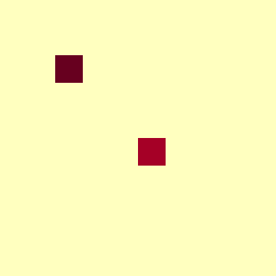
Figure 11. Hotter-source scenario at t = 112.438.
This is where the difference really starts to show. The two hot-source cells come in stronger here, especially the upper one, so the larger hot sampling range is obvious even before the heat spreads out.

Stronger Early Heat Diffusion (t = 114.438)
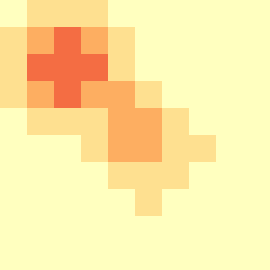
Figure 12. Hotter-source scenario at t = 114.438.
After diffusion kicks in, the warm region around the hot cells is thicker and brighter than in the base run. The shape is still the same, so the model logic did not change. It is just the hotter input pushing the field harder.

Later Warm Field (t = 238.314)
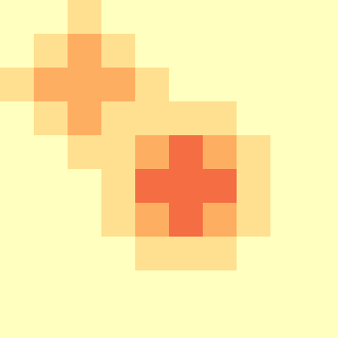
Figure 13. Hotter-source scenario at t = 238.314.
Later in the run the two hot regions are still easy to pick out. They have spread and softened, but they still stand out more than they did in the base case, which makes the long-term effect of the stronger heat input pretty clear.

Interpretation of Results
This run does exactly what it was meant to do. The timing and the overall pattern stay close to the base case, but the warm peaks are stronger and they hang around more. So it is a good example of changing the experimental frame without changing the model itself.

Reduced Cooling Scenario Execution and Analysis

Experimental Frame and Scenario Setup
This scenario keeps the base heating behavior but weakens the cooling side by removing one of the two cold sources. So the model still receives both hot and cold perturbations, just not the same amount of cooling as before.

Initial State (t = 0)

Figure 14. Reduced-cooling scenario at t = 0.
The run starts flat just like the base case. Every cell is sitting at the same starting value, so nothing stands out yet. This frame makes it clear that the only change in this scenario is the cooling setup, not the initial field.

Single Cold Trigger (t = 95.2199)
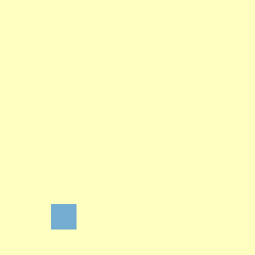
Figure 15. Reduced-cooling scenario at t = 95.2199.
This is the first place where the scenario change really shows up. Only one cold cell appears, which is exactly what should happen once one of the two cold sources is removed.

Early One-Sided Cooling (t = 98.2199)

Figure 16. Reduced-cooling scenario at t = 98.2199.
A few seconds later that cold event starts spreading through the wrapped neighborhood. The pattern already feels uneven compared to the base run because the cooling is now coming from one side instead of being balanced between two cold sources.

First Hot Trigger (t = 112.438)

Figure 17. Reduced-cooling scenario at t = 112.438.
The hot side was not changed here, so both hot cells still show up in their usual positions. That is useful because it isolates the experiment pretty cleanly: heating stays the same while cooling is the only thing that got weaker.

Early Warm Diffusion (t = 114.438)

Figure 18. Reduced-cooling scenario at t = 114.438.
Once the averaging step runs, the warm region starts opening out from the source cells. Since there is less cooling pushing back, the surface starts leaning warm a bit sooner and the heat pattern feels less opposed than it did in the base case.

Later Warm-Dominant Field (t = 213.108)

Figure 19. Reduced-cooling scenario at t = 213.108.
This later frame is probably the clearest one for the whole scenario. The remaining cold pocket still appears near the lower side, but most of the visible activity is warm and spread out. That is basically the reduced-cooling case in one picture: cooling still exists, it is just not strong enough to pull the field down the same way as before.

Interpretation of Results
This run behaves as expected. The model itself did not change, but once one cold source is removed the temperature field spends more time on the warm side and the response looks less balanced. The hot events still follow the same diffusion rule, but with weaker cooling around them the later frames stay warmer overall.

Nonuniform Initial Condition Scenario Execution and Analysis

Experimental Frame and Scenario Setup
This run keeps the same source setup as the base case, but the grid does not start flat. Six cells at (4,1), (4,2), (4,3), (5,1), (5,2), and (5,3) start at 32.0 while every other cell still starts at 24.0. So instead of waiting for the first generator event, the model begins with extra heat already sitting in the field.

Initial warm block (t = 0)
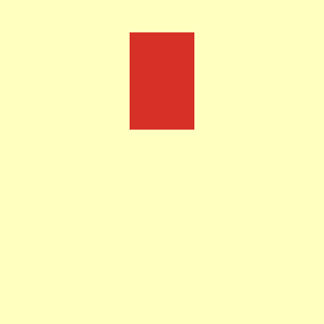
Figure 20. Nonuniform-initial scenario at t = 0.
Right away this one looks different from the other runs. The field is already warm in one small patch before any hot or cold trigger happens, so this frame is basically the check that the nonuniform initial condition was loaded the way it was supposed to be.

First averaging step (t = 1)
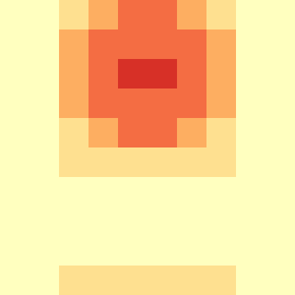
Figure 21. Nonuniform-initial scenario at t = 1.
After one step the hard edges of that starting block are already gone. The center is still the warmest part, but now the heat has started spreading into the surrounding cells, which is exactly what the local averaging rule should do.

Second averaging step (t = 2)
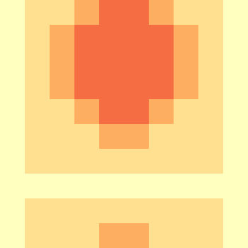
Figure 22. Nonuniform-initial scenario at t = 2.
By t = 2 the warm area is wider and smoother. It is no longer just a rectangular block. The shape is starting to follow the wrapped Moore-neighborhood averaging, so this frame is a nice early sign that the diffusion part of the model is behaving properly.

Third averaging step (t = 3)

Figure 23. Nonuniform-initial scenario at t = 3.
A little later the field is already much more blended. The initial hotspot is still there, but it has spread enough that the whole area around it looks warm instead of sharp. This is probably the clearest frame for showing how fast the model smooths out a changed starting field.

Later cool-source response (t = 95.2199)
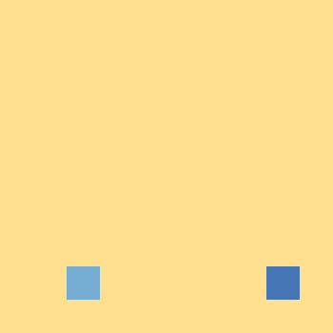
Figure 24. Nonuniform-initial scenario at t = 95.2199.
Once the run moves past the opening few seconds, the usual source-driven behavior starts showing up again. Here the cold source cells stand out near the bottom, but the background is still warmer than in the base case because this run started with extra heat already in the system.

Cooling starts to spread (t = 96.2199)

Figure 25. Nonuniform-initial scenario at t = 96.2199.
One step later that cooling disturbance starts pulling down the nearby cells. The grid still looks warm overall, but the colder area now cuts into it. That contrast also shows that the later generator events are still working normally even though the run began from a different state.

Wrapped cold pattern (t = 97.2199)

Figure 26. Nonuniform-initial scenario at t = 97.2199.
By t = 97.2199 the cooling effect is more developed and the wrapped behavior is easier to notice in the shape. The disturbance does not stay boxed into one cell. It spreads through the neighborhood the same way the earlier warm patch did, just now on top of a field that is already carrying extra heat from the start.

Later hot-source event (t = 112.438)
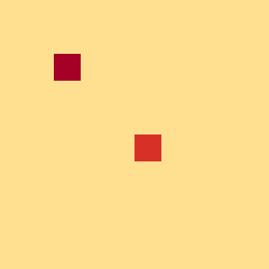
Figure 27. Nonuniform-initial scenario at t = 112.438.
When the hot trigger shows up later, the two hot-source cells are still easy to pick out even on the warmer background. That is what makes this scenario more interesting than the others. It starts with a nonuniform field, smooths that out quickly, and then still reacts the same way to later source events.

Interpretation of Results
This is probably the most interesting run because it shows two things at once. First, the model reacts right away to a changed initial condition. Second, once that starting hotspot smooths out, the normal hot and cold source behavior still comes through the same way it does in the other scenarios.
So the model is not only reacting to external triggers. It is also sensitive to how the field is initialized, and it handles that change in a pretty clean way. The extra heat at the start does not stay frozen in place; it diffuses out fast, then the later source events keep shaping the field from there.

Variations from the Original Specification
The core Heat Diffusion model did not change across the experiments. It stayed the same wrapped 10 x 10 grid with the same Moore neighborhood, transport delay, coupled structure, and generator logic. Only the test case around it changed.
That split matters because the model defines how heat moves, while the experimental frame only changes the test case. The logs and screenshots make the effect easy to see: stronger heating raises peaks, weaker cooling keeps the field warmer, and a warm initial patch smooths out quickly.

