**Name:** Ishaque Surya

**Roll Number:** 20102A2005

**Assignment 1**

**Title:**

Create a website with a navbar, at least three pages, and a footer. Make use of HTML and CSS.

**Requirements / Technology Used:**

Language: HTML and CSS

Code editor: Visual Studio Code

Browser: Microsoft Edge / Google Chrome

**Theory:**

* In this assignment we had to create at least three HTML pages that contain a Navbar and a Footer.
* Firstly, the basic styling of the webpage was done by setting font size and font style, margin and padding, etc.
* To create the navbar an Unordered List of hyperlinks was added inside the <nav> tag.
* The hyperlinks are used to help user to go from one webpage to another.
* Then the CSS was added to remove the bullets from the unordered list, setting the position of each list item next to each other with appropriate styling such as margin and padding, and once all done, the navbar was complete.
* After the navbar, the <h2> tag was used to display the description of each webpage.
* Then the footer was created. In the footer the <address> tag was used to define the contact information such as name, roll number and email.
* The email is a hyperlink so when it is clicked, it automatically opens the mail app to let the user mail the author directly.
* Then a good background image for the webpage was selected and minor changes were made in the CSS part of the code to make the webpage look attractive

**Output:**

**1. Home Page:**

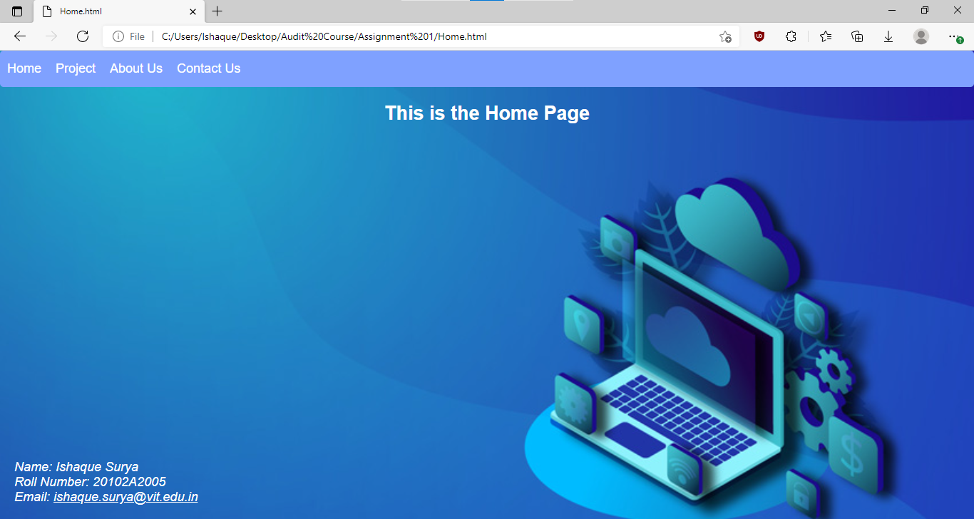

**2. Projects Page:**

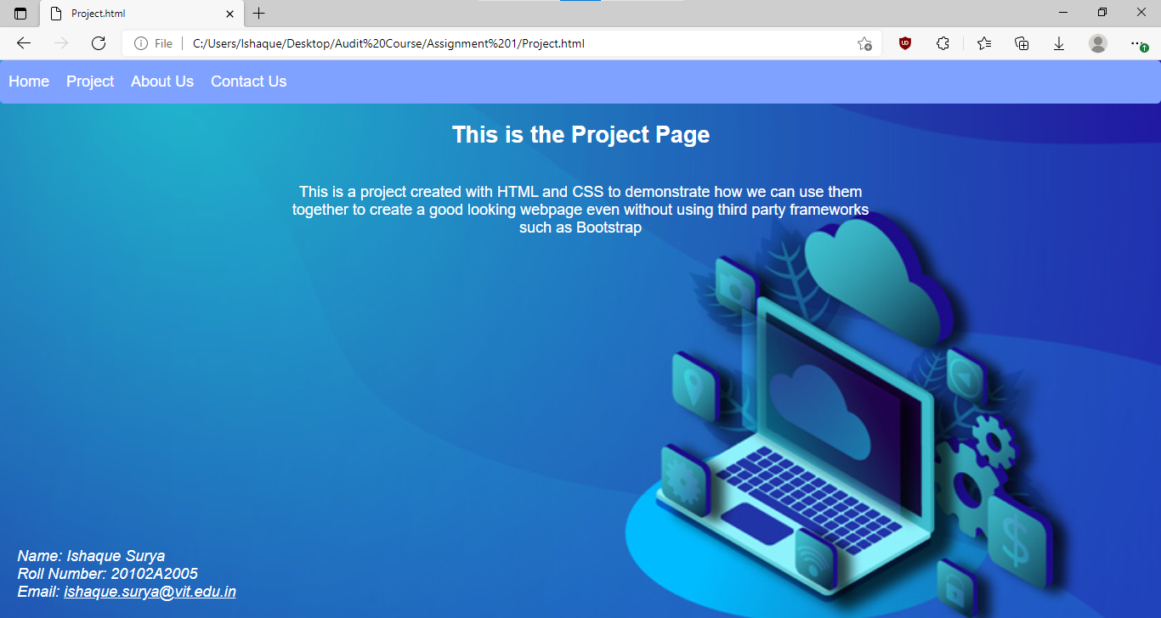

**3. About Us Page:**

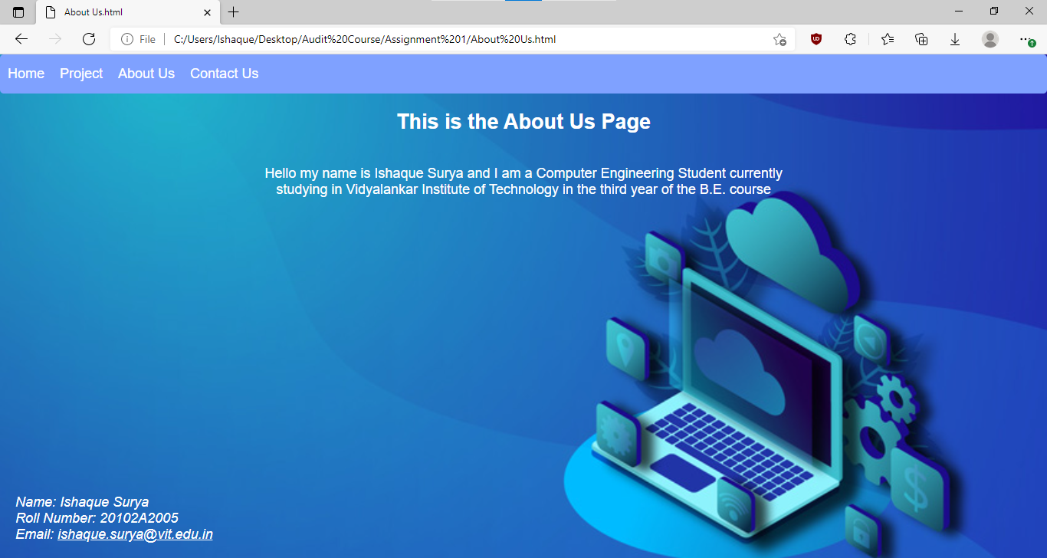

**4. Contact Us Page:**

