**Deep_Learnig_Lab04**

**Answer for question 07**

**Why are there 1783 boxes?**

There are 1783 boxes because after applying the confidence threshold (0.5 in this case) only 1783 of the many initial candidate boxes have a confidence score big enough to be kept.

**Maximum Number of Boxes**

This will yield a total of 1805 maximum boxes. That's the total candidate boxes if none is filtered.

**Minimum Number of Boxes**

In case none of the candidate boxes' confidence scores are higher than the threshold, we get a minimum of 0 boxes.

**Answer for question 07**

**Advantage of Using Anchor Boxes**

It, therefore, means that anchor boxes allow the YOL0 model to handle objects in the same image that have very different sizes and aspect ratios. Using multiple anchor boxes would lead to the model predicting even more unshapely or differently sized objects, which improves object detection accuracy.

**Sizes of Anchor Boxes**

Anchor box sizes are normally figured out through K-means clustering. Here, this procedure will look at the dimensions of the ground truth bounding boxes in the training dataset and create clusters of them. The anchor box sizes correspond to the centroids of these clusters, making sure they correspond to the most common object dimensions in the data.

**Answer for question 10**

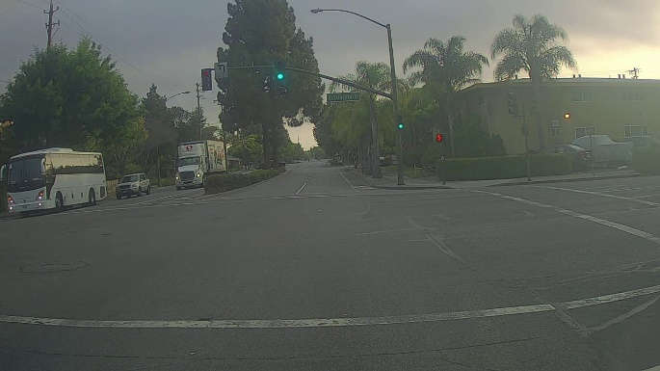**Original images**

Figure 1: 0103.jpg

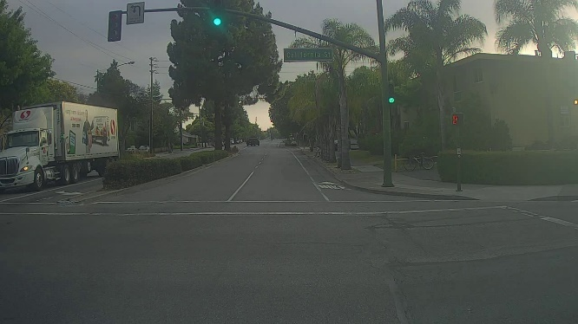

Figure 2: 0104.jpg

**Output images**

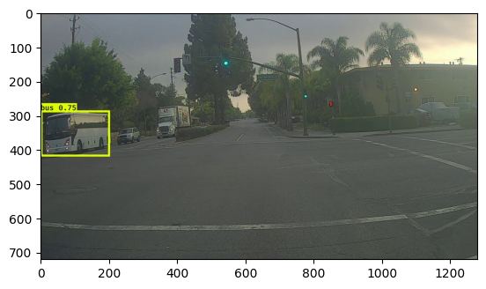 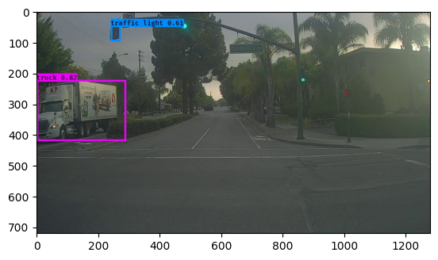

Figure 3: 0103.jpg Figure 4: 0104.jpg

**Image 1: 0103.jpg**

* Correctly Detected Objects:

The model detected a bus with a confidence score of 0.75.

* Incorrectly Detected Objects:

None observed.

* Undetected Objects:

The model failed to detect other vehicles and traffic lights present in the image.

* Incorrect Bounding Boxes:

The bounding box around the bus appears accurate in terms of its location and size.

**For Image 0117.jpg**

* Correctly Detected Objects:

The model correctly detected a truck with a confidence score of 0.82 and a traffic light with a confidence score of 0.61.

* Incorrectly Detected Objects:

None observed.

* Undetected Objects:

None observed.

* Incorrect Bounding Boxes:

The bounding boxes for both the truck and the traffic light appear accurate.

**Answer for question 11**

**Adjusting max_boxes**

I have tried to change the max_boxes parameter to another value, leaving the other two parameters, score_threshold and iou_threshold, the same. I ran the cells again and reviewed the output images. It seems no improvement compared with step 10 for the detected objects and bounding boxes.

**Adjusting score_threshold**

I changed the score_threshold value and reran the required cells. The improvement in the detection results was still not vivid. Output images for 0103.jpg and 0104.jpg were still the same as in step 10, without the detection of new objects or the fixing of incorrect bounding boxes.

**Adjusting iou_threshold**

Finally, I changed the iou_threshold value and reran the cells. Similar to the above changes, results for the detection of the chosen images did not improve at all. The output images were still the same as those from step 10.