**Deep Learning Lab 08**

**Question 1: Markov Decision Process and Q-Learning**

6. Change the Modified_Markov_Decision_Process file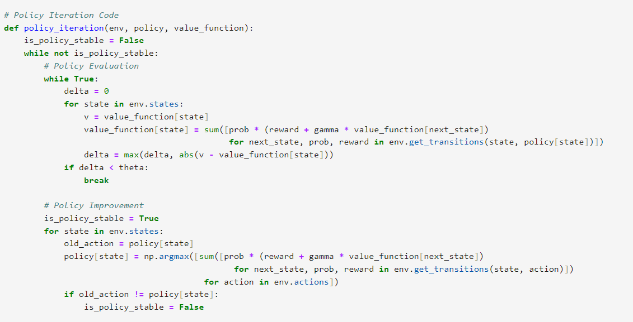

Markov_Decision_Process

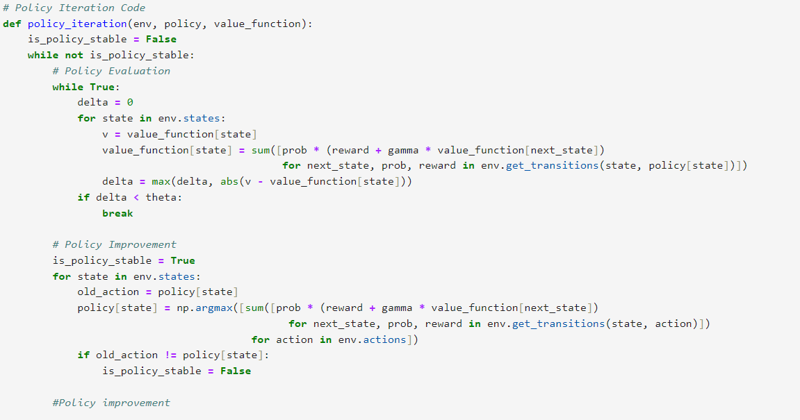

Markov_Decision_Process

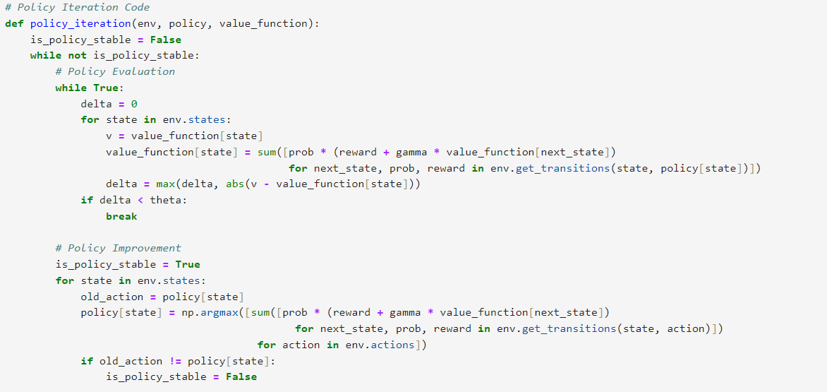

Markov_Decision_Process

Change the Gridworld file

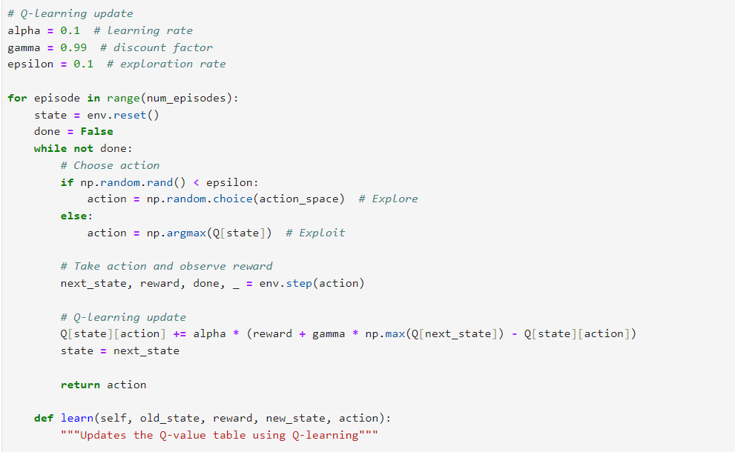

Gridworld

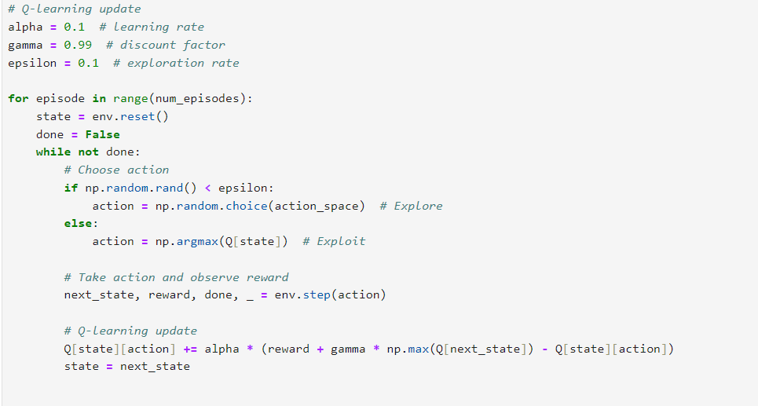

Gridworld

**Question 2: Model-Based vs Model-Free Reinforcement Learning**

2. **Model-Based Reinforcement Learning:**

In Model-Based methods, the agent builds a model of the environment's dynamics (transition probabilities and rewards).

The agent uses this model to make decisions and plan actions, which allows for optimal policy derivation through algorithms like Policy Iteration or Value Iteration.

These methods are often more sample efficient, as they rely on fewer interactions with the environment to learn optimal strategies.

**Model-Free Reinforcement Learning:**

Model-Free methods, such as Q-Learning, do not rely on a model of the environment. Instead, the agent learns the value of actions based on experience gained from interacting with the environment.

The agent updates its knowledge of the expected rewards without any prior knowledge of the dynamics, making these methods more flexible but potentially less efficient.

These approaches are generally easier to implement but can require more time to converge to an optimal policy due to the trial-and-error nature of learning.

3. **Markov_Decision_Process – Screen Shot**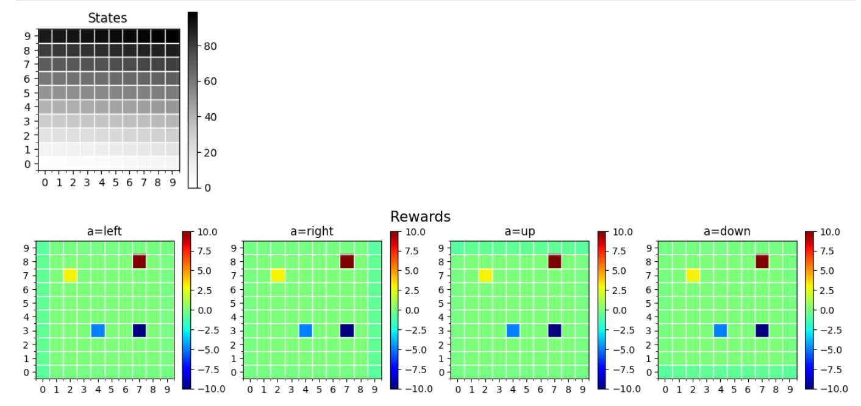

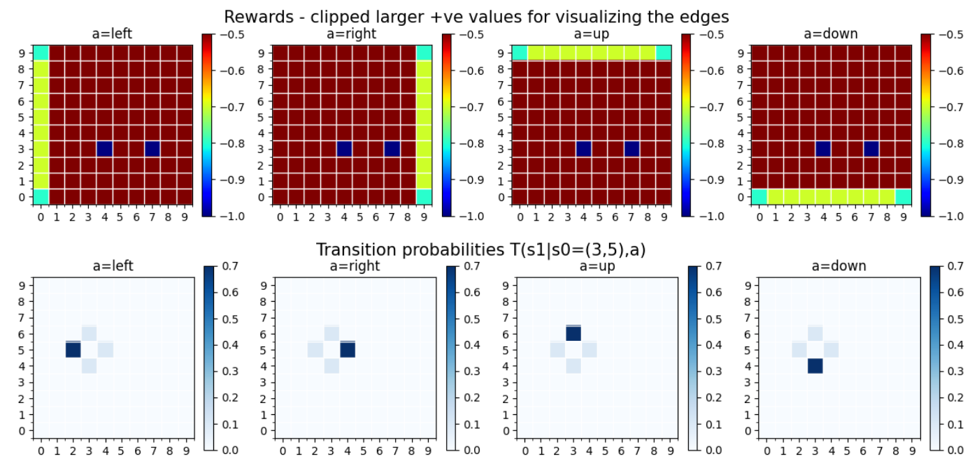

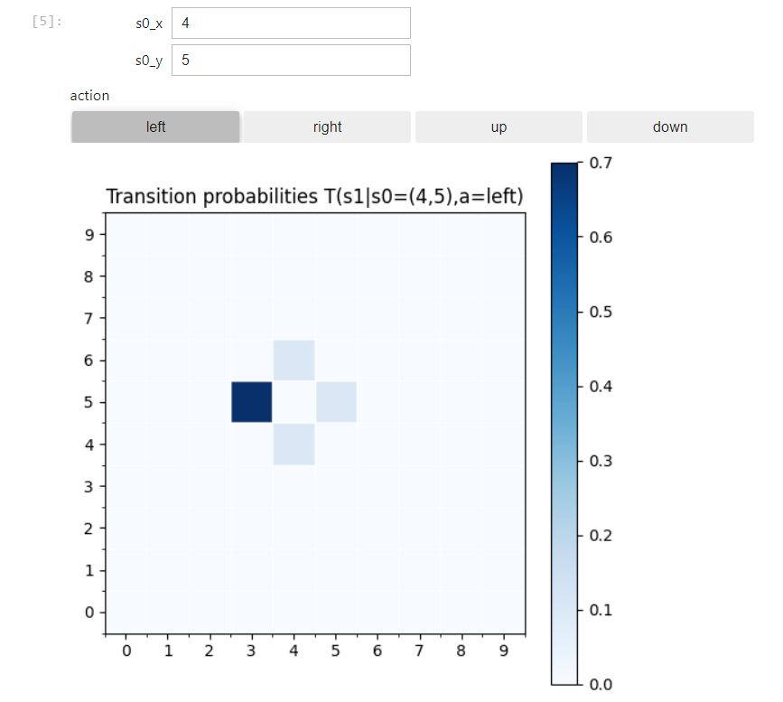

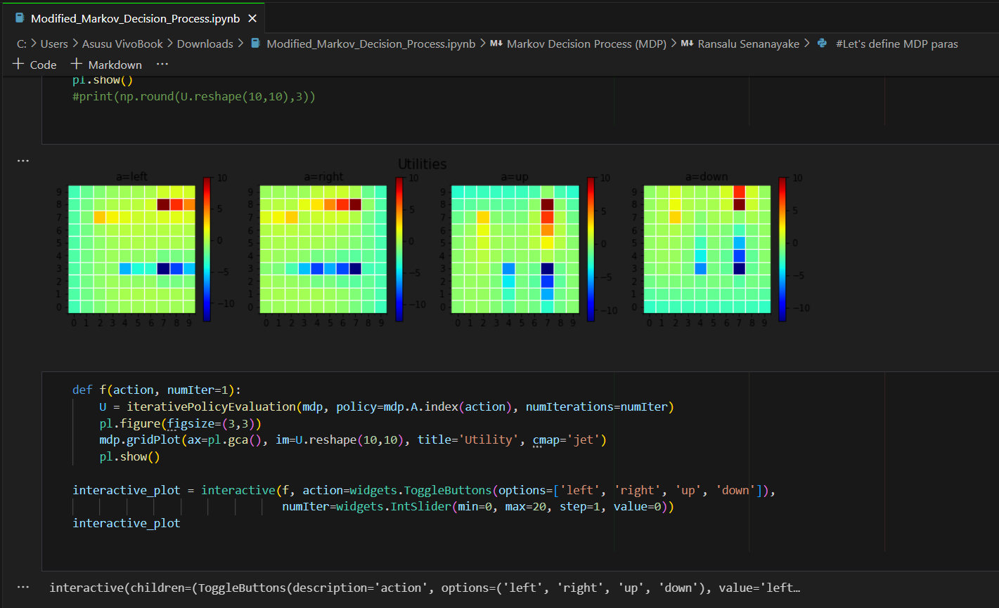

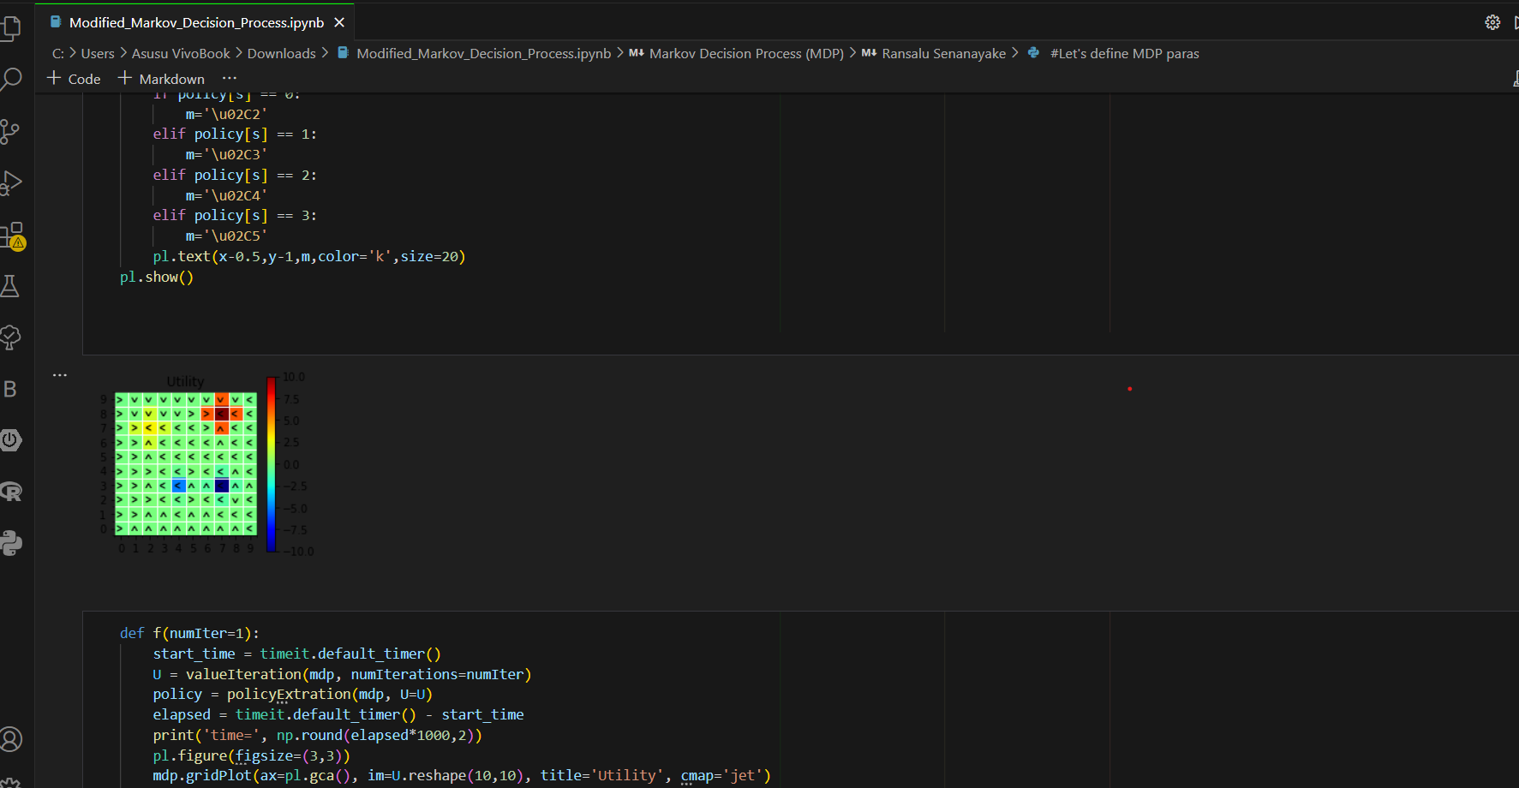

**Question 3: Introduction to Deep Q-Learning (DQN)**

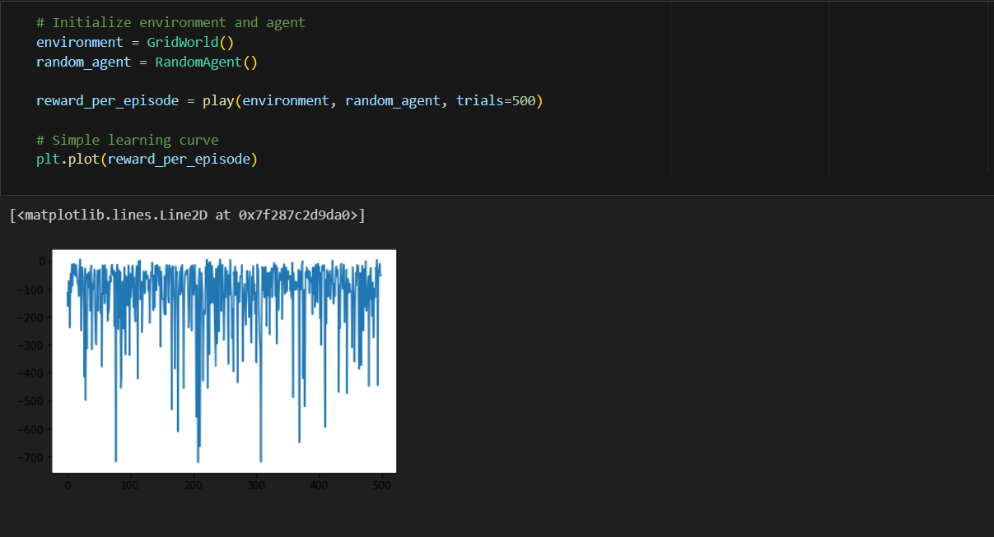

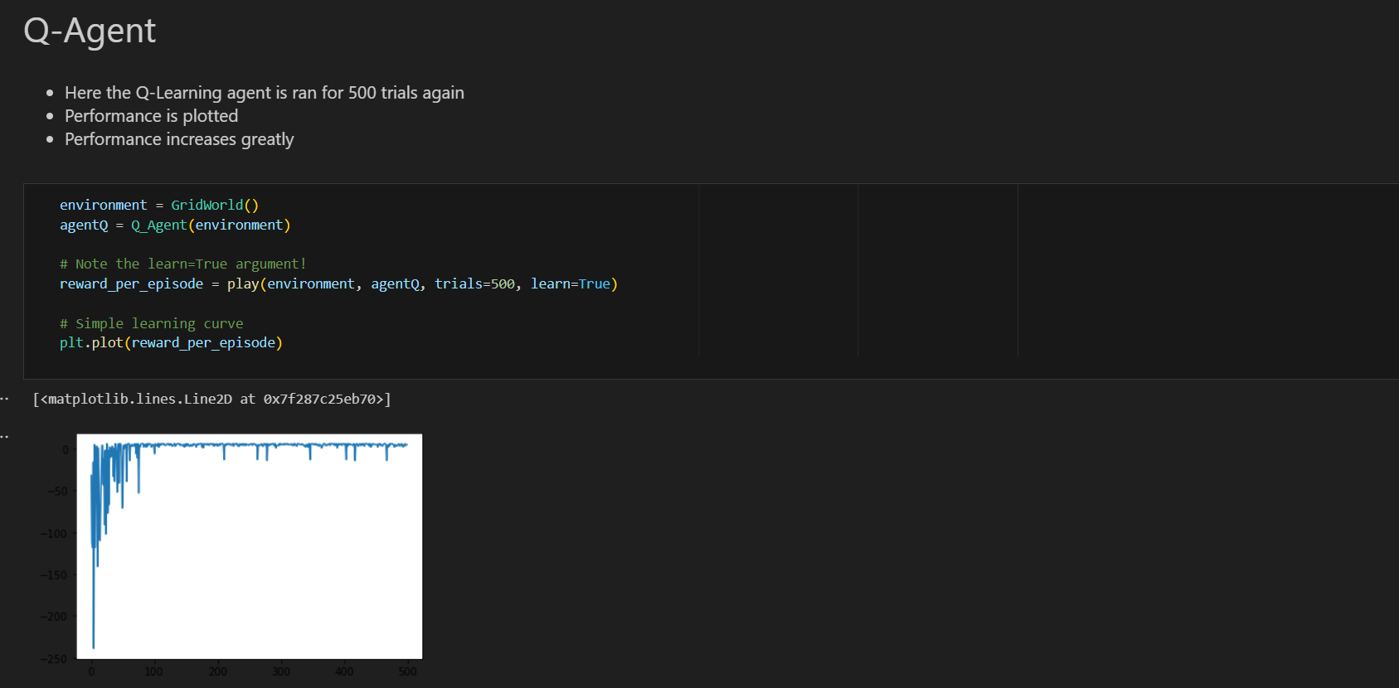

Git Link: <https://github.com/Ishara-Pramod-0770/Deep_Learning_Lab08.git>

