**Deep Learning Lab 09**

Part 01

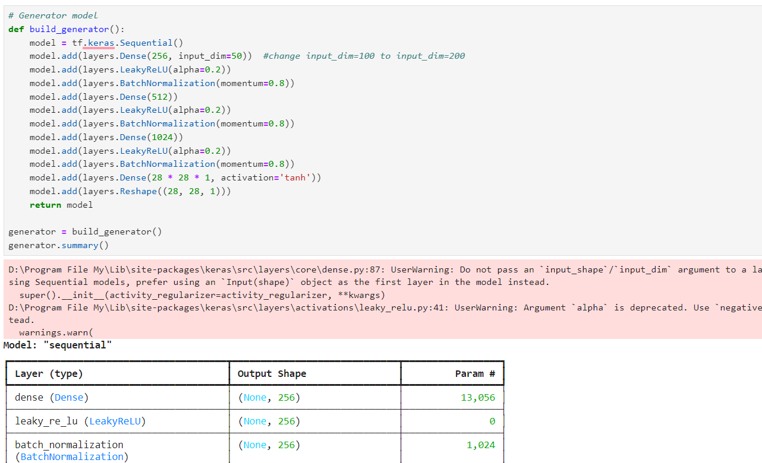

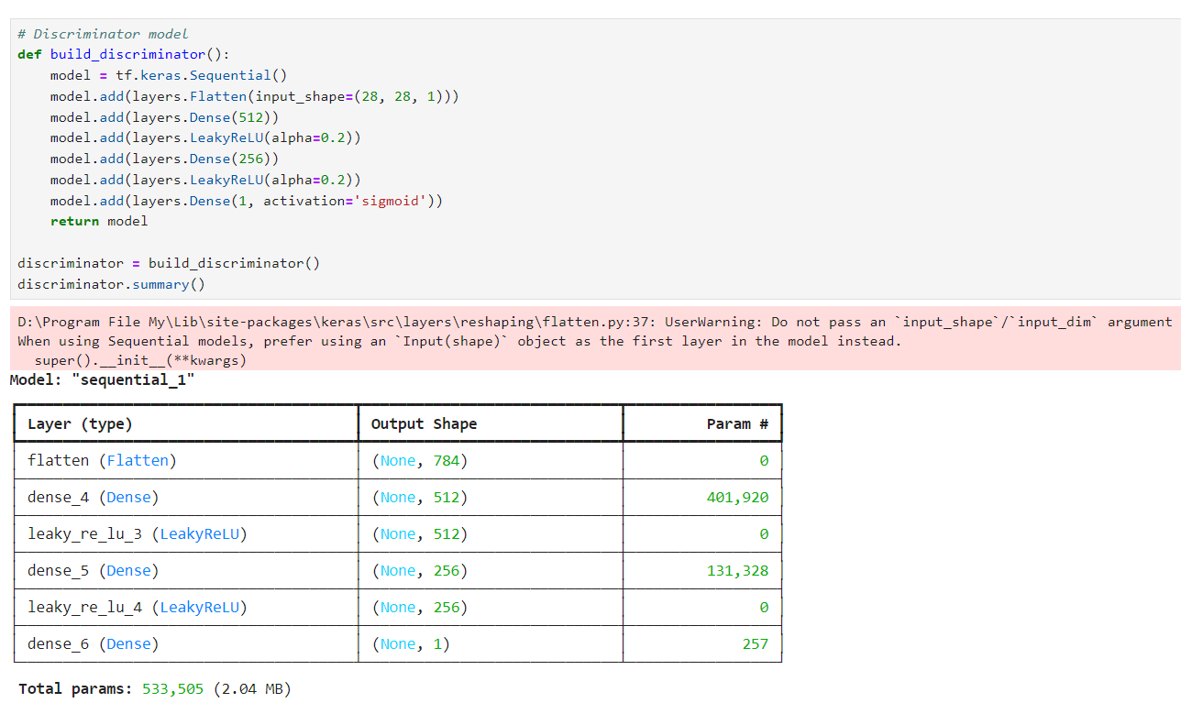

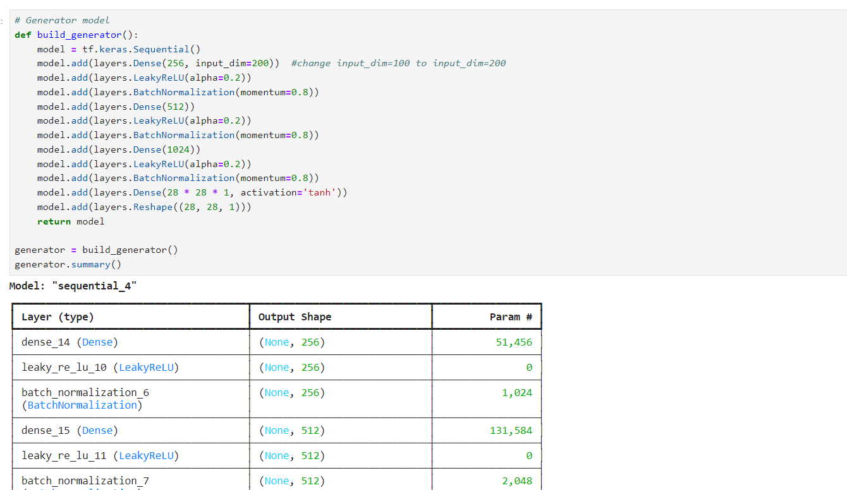

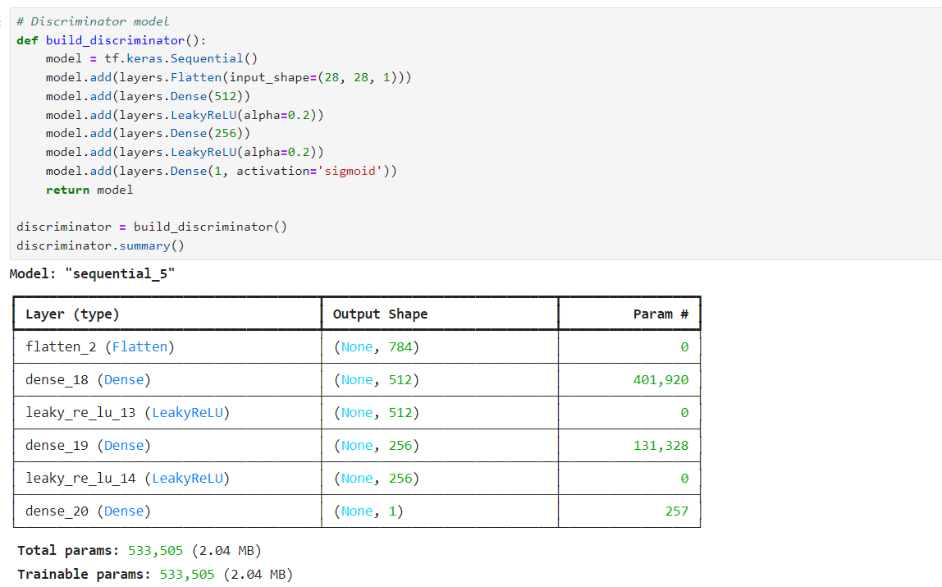

Part 02

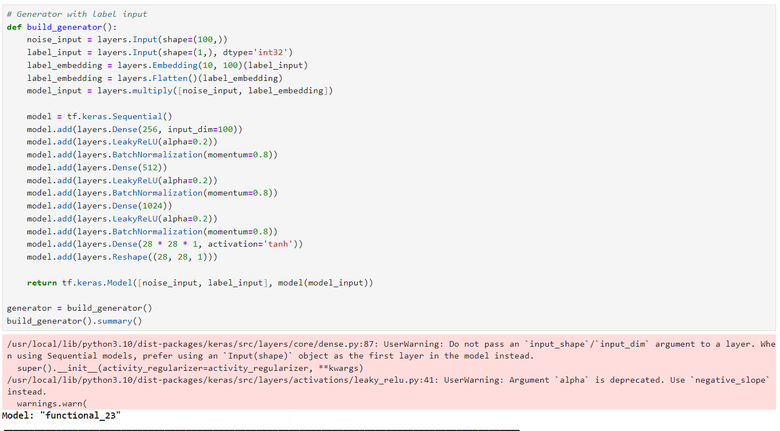

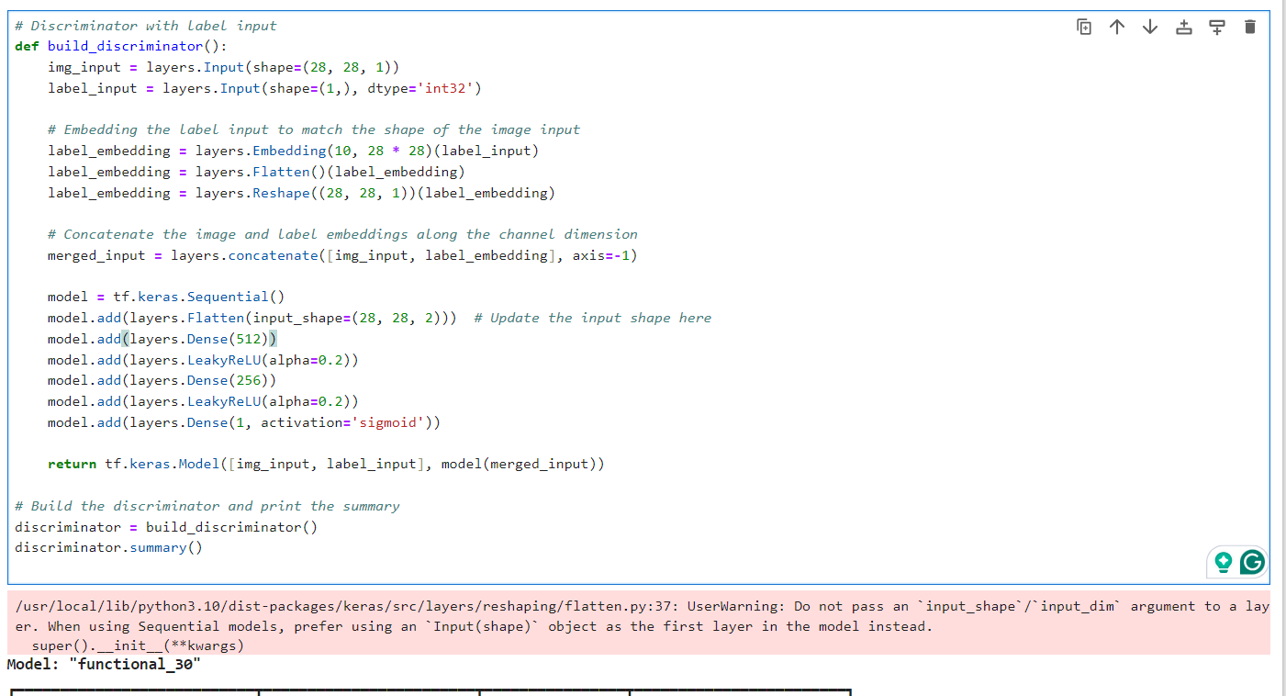

Part 03

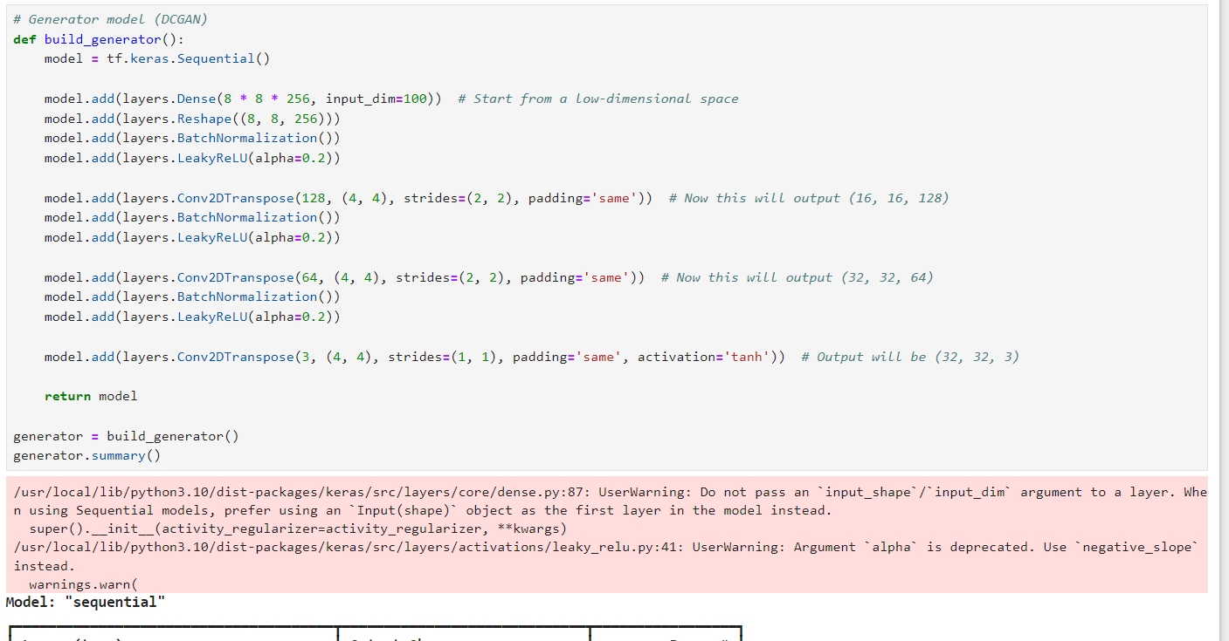

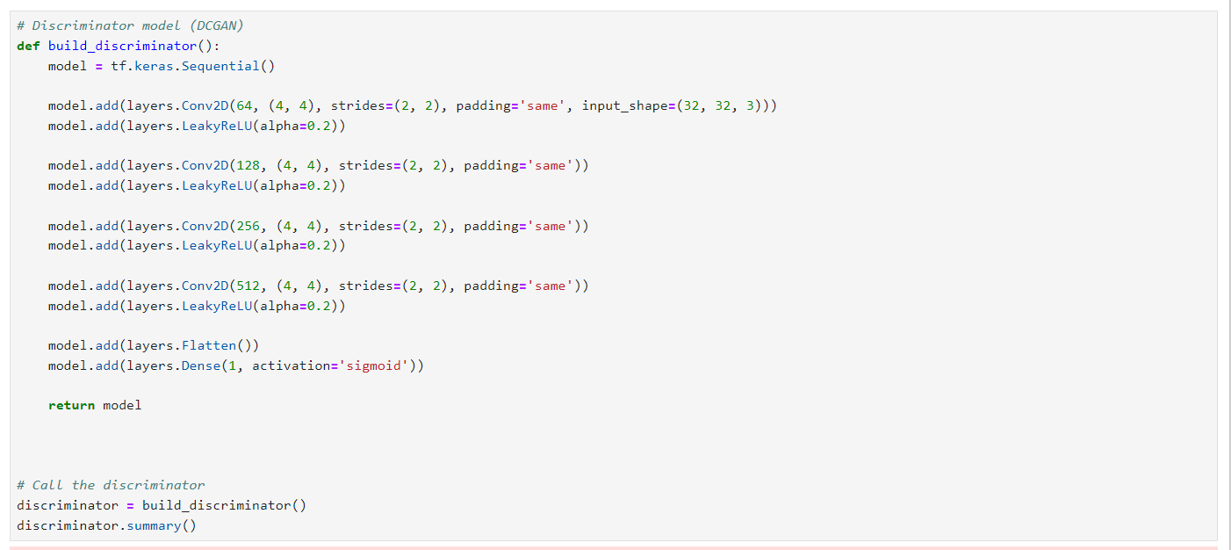

**Question 01: Modify the Latent Space Size**

* Latent Space = 50: Images were less diverse and less detailed due to reduced information.
* Latent Space = 200: Images showed more variety and clearer details but took longer to converge.

**Question 02: Train the GAN for 10,000 Epochs**

* Early epochs (1,000): Generated images were mostly noise.
* Mid epochs (3,000-5,000): Recognizable digit shapes started to appear.
* Final epochs (10,000): Images became sharp and nearly identical to real MNIST digits.

**Question 03: Change the Optimizer**

* Adam: Fast convergence with high-quality images.
* RMSprop: Slower but stable convergence, with comparable image quality.
* SGD: Much slower training, and images were less sharp after 10,000 epochs.

**Question 04: Experiment with Batch Sizes**

* Small batch size (32): Slower convergence, noisier training, but good final results.
* Large batch size (256): Faster convergence but less variety in images.
* Moderate batch size (128): Balanced speed and image quality.