Assignment – 4

Create a class for propositional symbols. For example: If you have a Symbol class for creating any propositional symbol, it should be written as: p = Symbol('P')

Define unary and binary logic operations/logical connectives for handling simple propositional logic. (Define operations for not, or, and, conditional, and double conditional). The inputs to your operations are all the possible values (boolean) of the constituent symbols and the outputs are also boolean values. Include another operation for printing a truth table for an operation that should mimic a truth table in the propositional logic.

1. ~P->Q  
   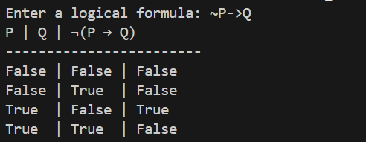
2. ~P ∧ ~Q