**User Guide - Hangman Game**

1. **Software requirements/recommendations for this program**

The software requirements and recommendations for running this program include:

* An up-to-date, compatible Operating System.
  + Only recent and compatible Operating Systems can run Java applications.
  + The Operating Systems that are compatible with Java programs are recent versions of Windows, MacOS, Linux and Solaris OS. If you are not using either of these Operating Systems, please install one of them in order to be able to run this Java program.
* Any application that is capable of opening and extracting ZIP files.
  + When you receive the ZIP file that contains this program, you must have a way to extract all of its files and save them in a reliable location.
  + A recommended application that you can use to extract files out of a ZIP file is **WinRAR.**
* A safe place to store the Java program.
  + You must have a safe, reliable place to store this program, such as on a Hard-Drive or a USB.
* Java Virtual Machine (JVM) and Java Netbeans installed on your computer
  + You can only run this Java program when a JVM and Java Netbeans are installed on your computer. Without these applications, you will not be able to run any Java programs, including this one.
* A means of receiving the software application.
  + You must have a way to receive the ZIP file that contains this Java program.
  + For example, if you were to have a Gmail account, you would be able to receive this program through an email that is sent to you.
* Access to a reliable source of Wifi.
  + Without a reliable internet connection, you may have trouble receiving the ZIP file that contains this program.
* A Software Security System installed onto your computer.
  + It is highly recommended that you have a software security system installed on your computer. This will ensure the protection of the information that is stored on your computer, including your personal information/data, as well as this program.
  + A well known, trusted software security system is **McAfee**, but there are various different softwares that may fit your needs.

1. **Hardware requirements/recommendations for this program**

The hardware requirements and recommendations for running this program include:

* A modern PC that is capable of handling/processing large quantities of information.
  + Your computer must be able to run Java applications. Any user with an obsolete/old computer will not be able to use this application.
  + Your computer must also have the memory capacity available to store this program. This program requires about 2500 KB of storage space, so make sure that your computer’s storage significantly exceeds this.
* A mouse, keyboard and monitor.
  + Required to be able to use this program.
* A speaker system or headphones connected to your computer.
  + This game contains sound effects, which enhance the gaming experience, and make this game more enjoyable.
  + It is recommended that you have some way to listen to these sound effects, such as through headphones, or with a speaker system connected to your computer.

1. **Age requirement**

The recommended age for the users of this application is 6 years old or older. This is because those below this age may not fully understand the rules of the game, as well as how to use the computer program itself.

1. **How to install and run this program**
2. Instructions for the installation of this program
3. You will first receive a ZIP file via email, which contains the program itself
4. Download this file, and open it.
5. If you have an application that is capable of opening ZIP files (ex. WinRAR), that application will automatically be used to open the ZIP file. If not, please download such an application before you proceed.
6. Use the “Extract” function within the ZIP file opening application to store the program files, within the ZIP file, in a safe location (ex. A Hard-Drive, USB, etc.)
7. Once you do this, the program will be successfully saved, and ready to use.

b Instructions for running this program

1. Open the Java Netbeans application.
2. Click File > Open Project, and then choose the Hangman program, located wherever you previously saved it.
3. Open the program, and click the “Run” button at the top of the Java Netbeans window. The symbol for this button is a green arrow. Another way you can run the Java program is by pressing “F6” on your keyboard.
4. When you do so, you will now be playing the Hangman game!
5. **Purpose of this program**

The purpose of this program is to provide a very fun and self-challenging game for all to play. This project is quite educational, especially towards children, because it gets them to challenge themselves, and utilize their problem-solving/processing skills to determine what the mystery word is. It can also be beneficial to young students, as they can learn to recognize new words, based on their length and the positions of key letters within them. This would, overall, improve their vocabulary by helping them learn new, more complex words, and expand their overall knowledge.

I have decided to create a Hangman game application because Hangman is a very popular pen and paper game, and because of that, there are not many well developed versions of it online. The lack of online Hangman games may make it harder for people on the internet to find a game that they enjoy playing, when Hangman may be the right game for them. So, I believed that this would be a great opportunity to create a project that solves this issue.

1. **Instructions related to how to use the program (With screen captures, that display/demonstrate each of the screen layouts)**
2. Introduction Screen

* When you first open the application, you will see an Introduction Screen, like so:

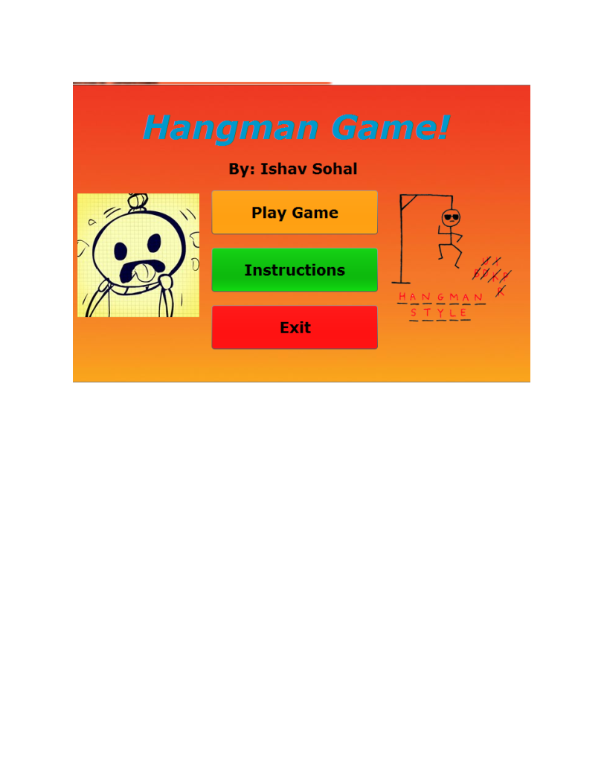

* Here you can see that there are three options for you:
  + “Play Game” - This will redirect you to a new screen, where you will be able to play the Hangman game itself.
  + “Instructions” - This will open up the Instructions Screen, which provides a full set of instructions as to how this Hangman game works, and what the rules of this game are. The Instructions Screen will look like this: 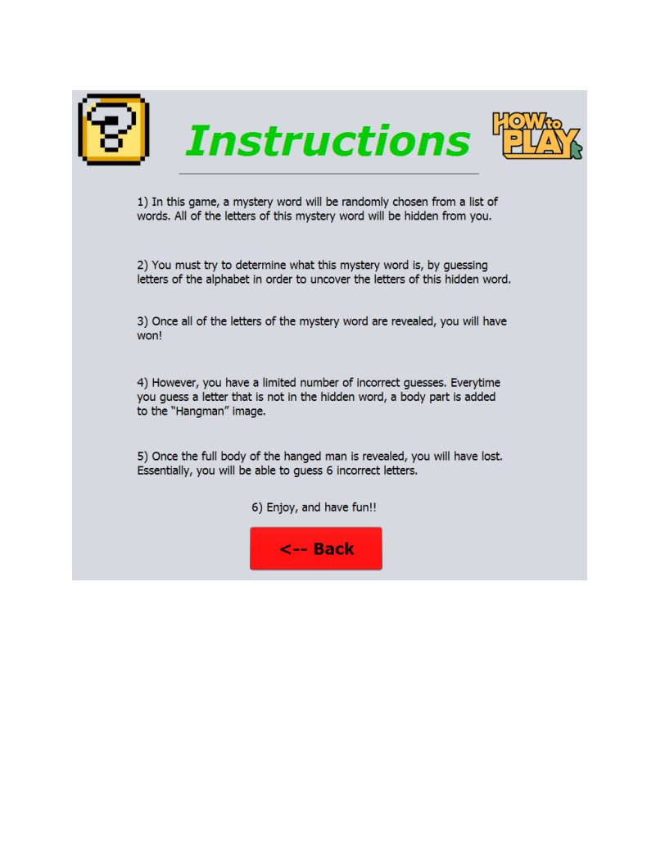

* + - From here, click the “Back” button to return to the Introduction Screen
  + “Exit” - This button allows you to exit the program.

1. Main Game Screen

* When you click the “Play Game” button, a new screen containing the Hangman game itself will appear. It will look like this: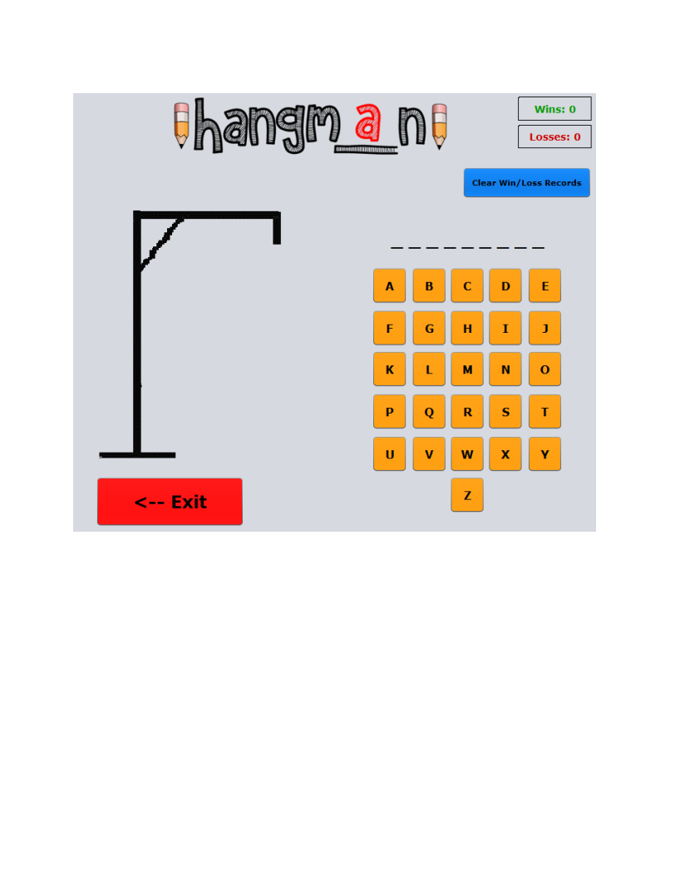
* Here, you can see that there is:
  + A Set of Dashes - These blank dashes represent the letters of the mystery word, which has been randomly selected from a list of random words. The letters of this mystery word are initially all hidden, as you can see, so you must guess letters of the alphabet in order to try to uncover the letters of the mystery word.
  + Letters of the Alphabet - These are buttons that allow you to guess different letters that you believe may be in the specific mystery word. Note, that once you guess a letter, you cannot guess that letter again.
  + Hangman Structure Image - This image will update with a new body part of a hanged man every time you guess a letter that is not within the mystery word. These body parts include a head, body, two arms and two legs. Once the entire body of the hanged man is revealed, you will have lost. Essentially, you have 6 incorrect letter guesses before you lose.
  + Scoreboard - In the top right corner, you can see that there is a small scoreboard, which tracks the number of wins and losses that have occurred.
  + Back button- This button will allow you to return to the introduction screen. Note, that once you click the Back button, your current game data will be lost, but your overall score record (wins/losses) will be saved.
  + Clear Win/Loss Records button - This button will clear your Win/Loss records for all of the times that you have used this program.
    - In this program's directory, you will find an XML file, called “Score.xml”. This file will contain your Win/Loss records for each and every time that you have used this program.
    - When this button is clicked, and the XML file has been cleared of its Win/Loss records, a message will appear to the left of the button, which will tell you that your Win/Loss records have successfully been cleared.
    - If you would like to access this file, and see your Win/Loss records, go into the files of the program, find the file named “Score.xml”, right click on this file and open it using Notepad. The XML file will look like this:

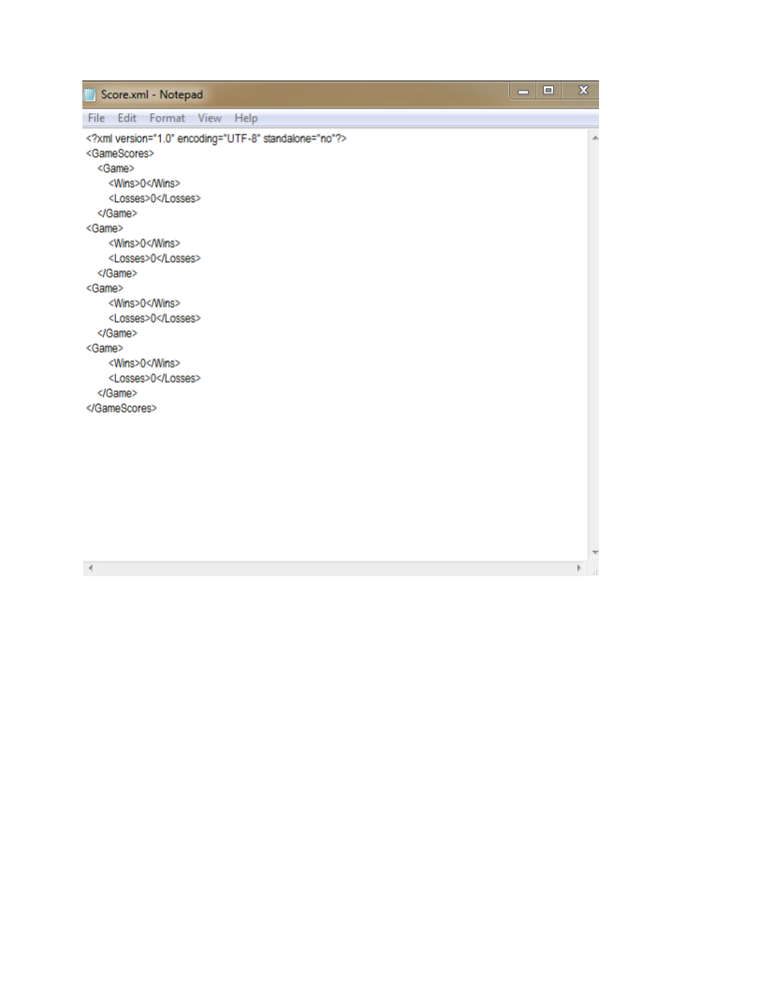

* + - The “GameScores” heading is the root element, which holds all of the Win/Loss records. Each “Game” heading stores the Win/Loss record for one time that you have used the program. For every time the program is started up and used, a new Win/Loss record will be created.
    - Please note, that in order to see the updated version of your Win/Loss records, you must open up the XML file again from the project directory.
    - **Warning: Do not edit this XML file**! The information within this file is very sensitive. If you were to delete the root element of this XML file, for example, the program would crash. You are, however, allowed to view the contents of this file, which are all of your Win/Loss records. If you would like to clear your Win/Loss records, please refrain from editing the file manually, and instead, use the “Clear Win/Loss Records” button.

1. Win Screen

* If you successfully uncover all of the letters of the mystery word, you will have won, and the Win screen will appear. It will look like this:

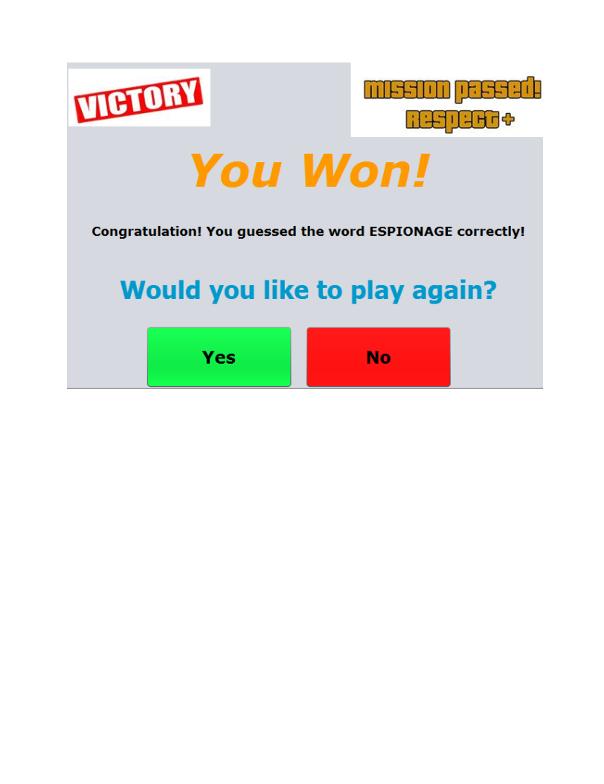

* As you can see, this screen includes:
  + The word that was correctly guessed (The position where “ESPIONAGE” is will contain the specific mystery word that was guessed correctly).
  + A question, which asks you if you would like to play the Hangman game again.
    - If you click “Yes” - The program will go back to the Main Game Screen, and you will be able to play the Hangman game again, this time with a new mystery word that must be guessed.
    - If you click “No”, the program will close.

1. Lose Screen

* If you do not successfully guess all of the letters within the mystery word, and you reveal the entire body of the hanged man, you will have lost. The Lose screen will then appear. It will look like this:

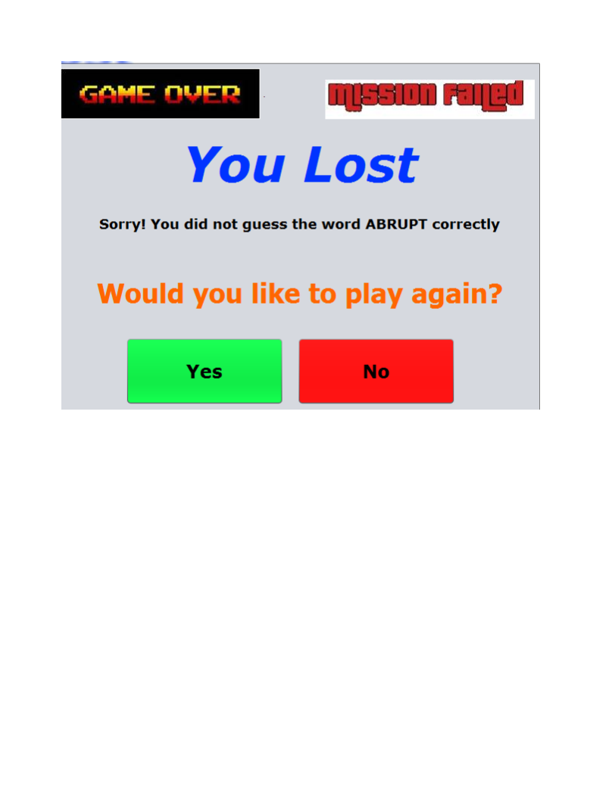

* As you can see, this screen includes:
  + The word that was not guessed correctly (The position where “ABRUPT” is will contain the specific mystery word that was not guessed correctly).
  + A question, which asks you if you would like to play the Hangman game again.
    - If you click “Yes” - The program will go back to the Main Game Screen, and you will be able to play the Hangman game again, this time with a new mystery word that must be guessed.
    - If you click “No”, the program will close.

1. **A description of the special/key features of this program**

Instructions: On the Introduction screen, there is a button that is labeled “Instructions”. When you click this button, a full set of instructions will appear, which will tell you how this Hangman game works, and what the rules of the game are.

Word Selection: From a large list of words, the program will choose a random word for you to try to guess.

Letter Selection: There will be a section of buttons, containing the letters of the alphabet. You will be able to use these buttons to guess letters that you believe are in the mystery word. However, once a specific letter has been guessed, it cannot be guessed again.

Hangman GUI: The classic image associated with the Hangman game, which is a man that is hanged up to a structure, will be within this program. This image will initially be invisible, but whenever you guess a letter that is not within the mystery word, the image will update to reveal a new body part (head, body, 2 arms, then 2 legs). Once the man's full body is revealed on the screen, you will have lost.

Word Update: There will be a set of dashes, which will represent the letters of the mystery word that have not been guessed yet. Initially, all of the dashes will be blank, but once you guess a letter that is within the mystery word, the dashes will be updated to reveal the position(s) of the correctly guessed letter within the mystery word.

Win/Loss Count: There will be a section of the GUI that tracks the amount of games that you have won and lost, so you always know how well you’re performing.

Sound Effects: There will be sound effects that play after each event occurs. Different sound effects will be used for different events, such as when a correct or incorrect letter is chosen, and if you win or lose.

Different Screens: There will be various different screens in this program, such as an introduction screen, main game screen and win/lose screens.

Images: There will be various images that will be used throughout this program to enhance your experience while playing this game.

1. **Additional Tips**

* Make sure that you minimize all other windows/applications that you may have open while playing this game.
  + This is due to the fact that the application screens of this program may become hidden behind any other windows/applications that you may have open while playing this game.
  + In order to avoid this inconvenience and enhance your experience while playing this game, it is recommended that you minimize all other windows/applications while playing.
* Do not adjust the size of the application screens of the program.
  + The application screens of this program have been designed to remain at the specific dimensional sizes that have been set for them. So, please do not manually adjust the sizes of any of these screens.
  + If you were to manually adjust the size of an application screen, the objects on that screen (images, text, buttons, etc.) would become misplaced, and would be placed in random positions on the newly sized screen. This would make it unpleasant and less enjoyable to continue using this program. Also, it will make it quite difficult to navigate throughout the program.
* Make sure that you adjust your volume settings as you play this game.
  + Some of the sounds in this game may be too loud, or too quiet, so make sure that you adjust your volume level appropriately, in order to meet your needs and to enhance your experience while playing this game.
* Do not edit any of the files within this programs directory.
  + The files within the directory of this program are very sensitive, and are vital for the functionality of this program. These files are what make up the entirety of this program, including its various features, such as sound effects and images.
  + If any of these files are altered in any way (ex. renamed, deleted, edited, etc.), there is a chance that the program will stop working.
* Try not to guess letters randomly.
  + If you were to randomly guess letters of the alphabet in an attempt to uncover the mystery word, without putting much thought, decision making and effort into your choices, it would be very difficult for you to win.
  + Instead, try to think logically as you are guessing the mystery word. Think about the letters of the alphabet that are most commonly found in English diction (ex. vowels). These are the letters that have the highest chances of being in the mystery word.
  + Also, look at the letters that have already been correctly guessed, and their positions within the mystery word. This can help you figure out what letters can successfully fill the remaining positions of the mystery word, as certain letters are commonly paired with each other.