***DMPM Assignment 3***

Name: Rushikesh Jyoti

Division: A

Roll no: 27

SRN: 201901139

Question: Preprocess and clean the given dataset

Code

# install.packages("tidyverse")

# install.packages("Hmisc")

library(tidyverse)

library(dplyr)

library(Hmisc)

df = read.csv('ToyotaCorolla.csv')

dirty_df = read.csv('ToyotaCorolla - Dirty.csv')

check = function(dataset) {

print(cat("Number of null values", sum(is.na(dataset)), " "))

print(cat("% of null values", mean(is.na(dataset)), " "))

print("Mean of all colums")

for (i in 1:ncol(dataset)) {

print(mean(dataset[,i], na.rm = TRUE))

}

}

check(dirty_df)

head(rename(dirty_df, Kilometers = KM))

clean_df = na.omit(dirty_df)

head(select(clean_df, -MetColor))

head(arrange(clean_df, Age))

slice(clean_df, 4:17)

head(filter(clean_df, FuelType == 'Petrol'))

glimpse(clean_df)

boxplot(clean_df$Price)

boxplot(clean_df$Age)

boxplot(clean_df$Weight)

print("Outliers of Weight are ")

boxplot.stats(clean_df$Weight)$out

# Numerical Imputation

dirty_df$Age = impute(dirty_df$Age, fun=mean)

dirty_df$CC = impute(dirty_df$CC, fun=mean)

dirty_df$Weight = impute(dirty_df$Weight, fun=mean)

for (i in 1:ncol(dirty_df)) {

print(sum(is.na(dirty_df[,i])))

}

print("Phew! No null values anymore!")

Output

Null Values of dataset and mean of every column

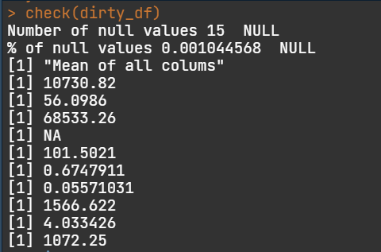

Fourth column is categorical data so it can’t be `meaned`

Renaming a column

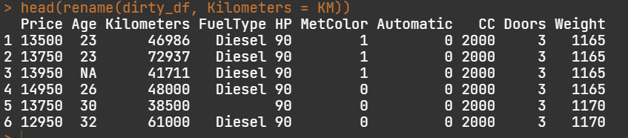

Omitting the NA values

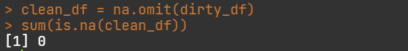

Removing a column (MetColor) from dataset

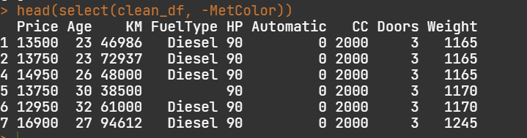

Taking a slice of dataset

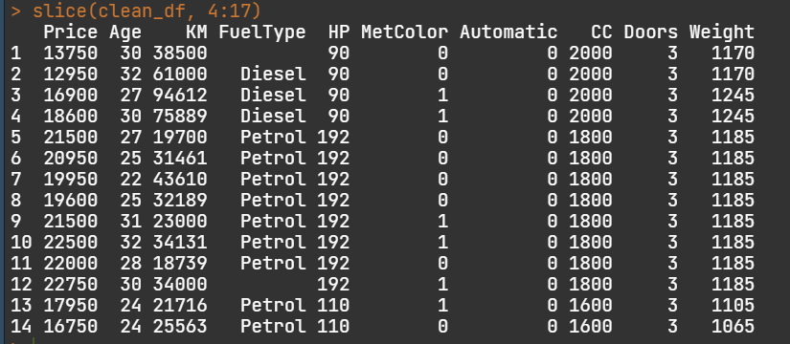

Filtering the dataset to get all petrol vehicles

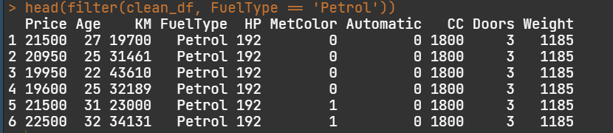

Taking a glimpse of our dataset

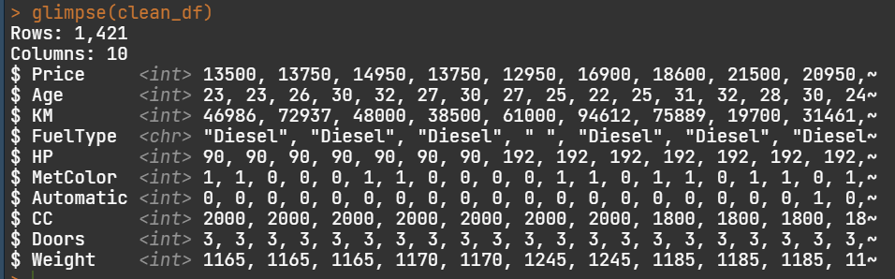

Boxplot of Price of vehicles

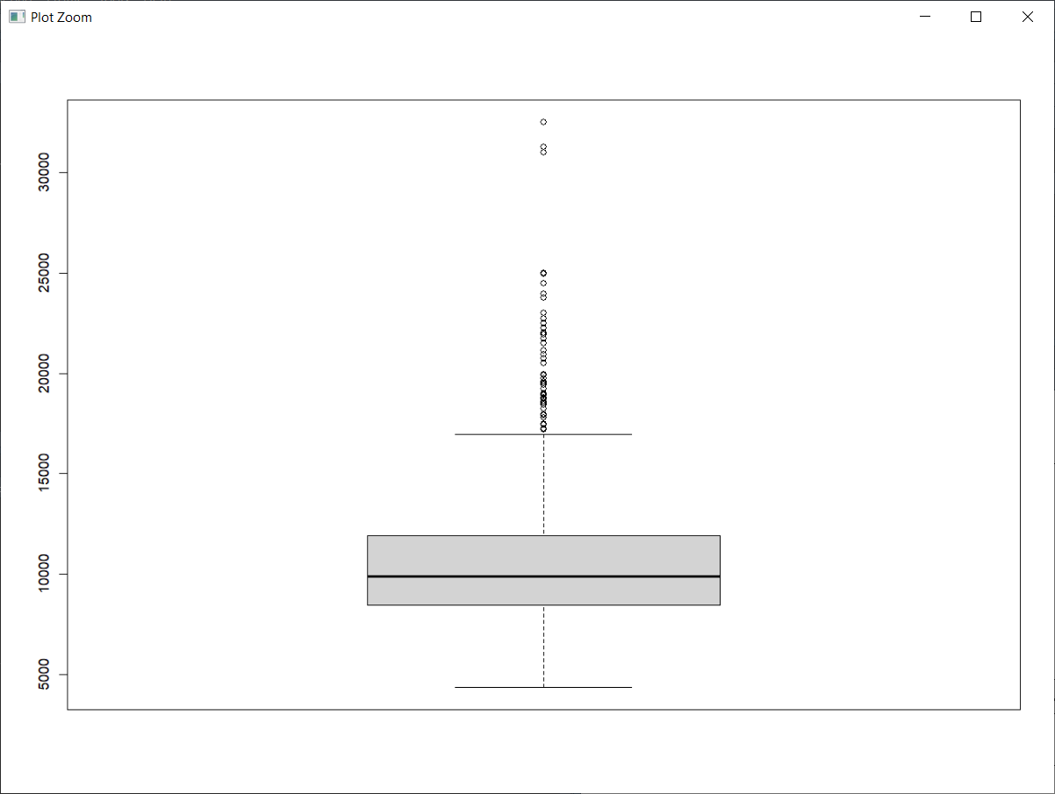

Boxplot of Age of Vehicles

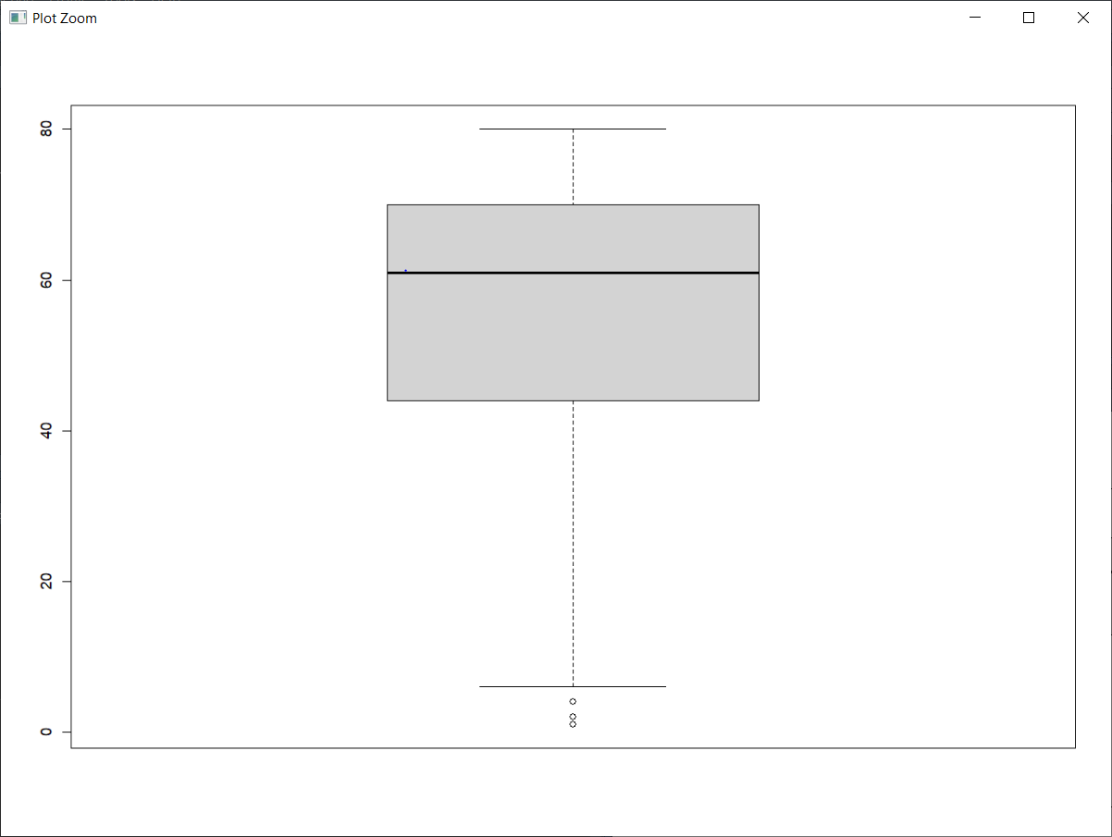

Boxplot of Weight of vehicles

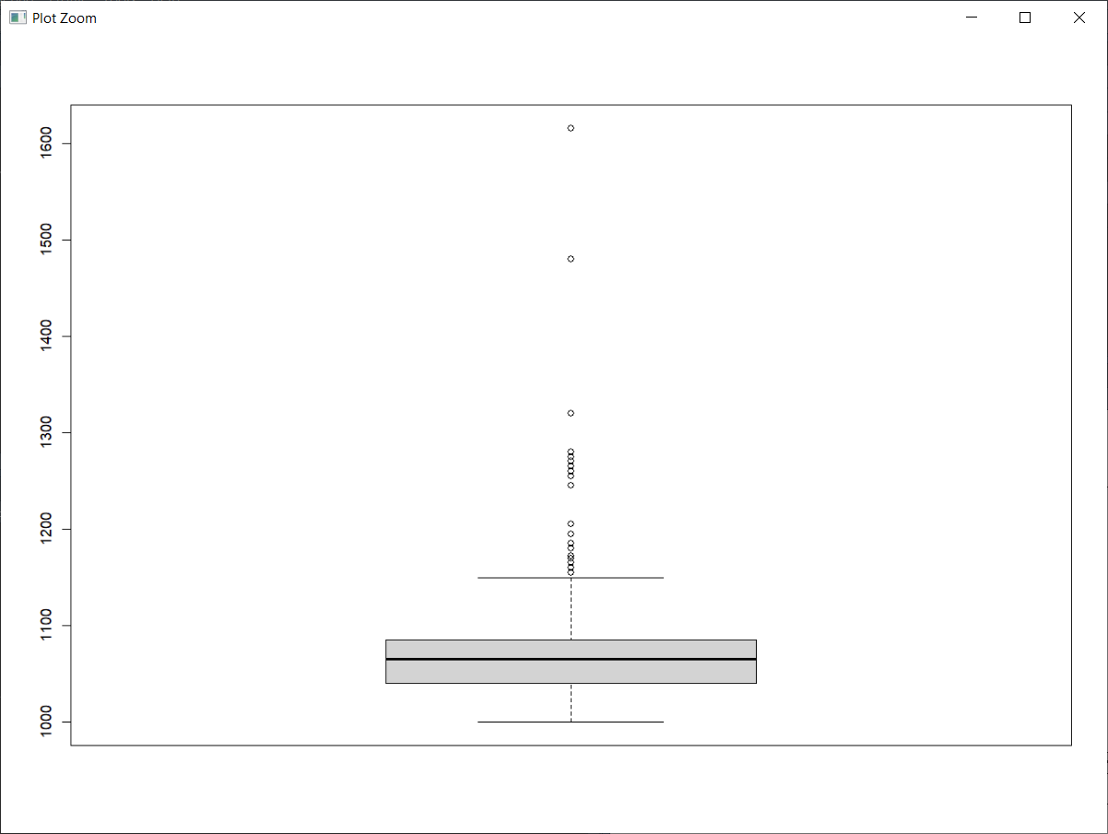

Getting all outliers of weight

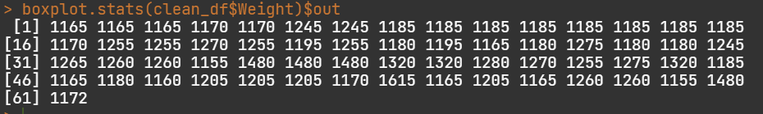

Impute the columns with NA values

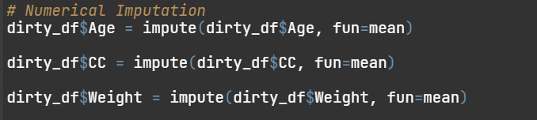

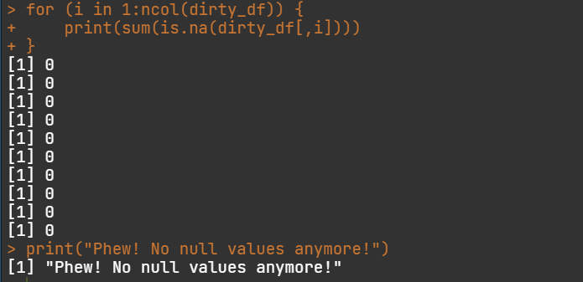

The dataset is now clean