***DMPM Assignment 5***

Name: Rushikesh Jyoti

Division: A

Roll no: 27

SRN: 201901139

Question: build a Linear Regression Model

Code

library(tidyverse)

library(ggplot2)

library(dplyr)

library(Metrics)

library(caret)

library(scales)

library(caTools)

library(corrplot)

dataset <- read.csv("AB_NYC_2019.csv")

summary(dataset)

# Find NA Values

print(colSums(is.na(dataset)))

# Fill 0 into NA

dataset$reviews_per_month[is.na(dataset$reviews_per_month) == TRUE] <- 0

data_new <- tidyr::separate(dataset, last_review, c("Year", "Month", "Day"), sep = "-")

data_new$Year[is.na(data_new$Year) == TRUE] <- 0

data_new$Month[is.na(data_new$Month) == TRUE] <- 0

data_new$Day[is.na(data_new$Day) == TRUE] <- 0

data_new$neighbourhood_group <- as.factor(data_new$neighbourhood_group)

data_new$room_type <- as.factor(data_new$room_type)

data_new$Year <- as.integer(data_new$Year)

data_new$Month <- as.integer(data_new$Month)

data_new$Day <- as.integer(data_new$Day)

head(data_new)

print(colSums(is.na(data_new)))

data_new <- na.omit(data_new)

summary(data_new)

# Correlation

correlation <- cor(data_new[, sapply(data_new, is.numeric)])

corrplot(cor(data_new[, sapply(data_new, is.numeric)]))

# Plotting the graphs

ggplot(data = data_new, mapping = aes(neighbourhood_group, fill = room_type)) +

geom_bar(colour = "Black", position = position_dodge())

price_roomtype <- data_new %>%

group_by(neighbourhood_group, room_type) %>%

summarise(Mean_Price = mean(price))

ggplot(price_roomtype, aes(x = reorder(neighbourhood_group, -Mean_Price), y = Mean_Price, fill = room_type)) +

geom_bar(stat = "identity", colour = "black", position = position_dodge())

ggplot(data_new, aes(y = price, x = minimum_nights, color = neighbourhood_group)) +

geom_jitter()

ggplot(data = data_new, mapping = aes(number_of_reviews, price)) +

geom_point() +

facet_wrap(data_new$room_type)

ggplot(data = data_new, mapping = aes(availability_365, price)) +

geom_point()

ggplot(data = data_new, mapping = aes(neighbourhood_group, availability_365)) +

geom_boxplot()

# Building the model

model <- lm(price ~ host_id + neighbourhood_group + latitude + longitude + room_type + minimum_nights + number_of_reviews +

Year + calculated_host_listings_count + availability_365, data = data_new)

print(model)

print(summary(model))

pred1 <- predict(model)

resd1 <- residuals(model)

x <- cbind(data_new$price, pred1)

x <- data.matrix(x)

x <- rescale(x)

x <- as.data.frame(x)

mae <- MAE(x$V1, x$pred1)

mse <- mse(x$V1, x$pred1)

rmse <- RMSE(x$V1, x$pred1)

r2 <- R2(x$V1, x$pred1)

cat("\nMAE:", mae, "\n\nMSE:", mse, "\n\nRMSE:", rmse, "\n\nR-squared:", r2, "\n\n")

ggplot(data_new, aes(y = pred1, x = data_new$price)) +

geom_point() +

geom_abline(intercept = 0, slope = 1, colour = "Red") +

labs(y = "Predicted Values", x = "Actual Values", title = "Predicted vs. Actual Values")

**Output**

Taking a look at dataset

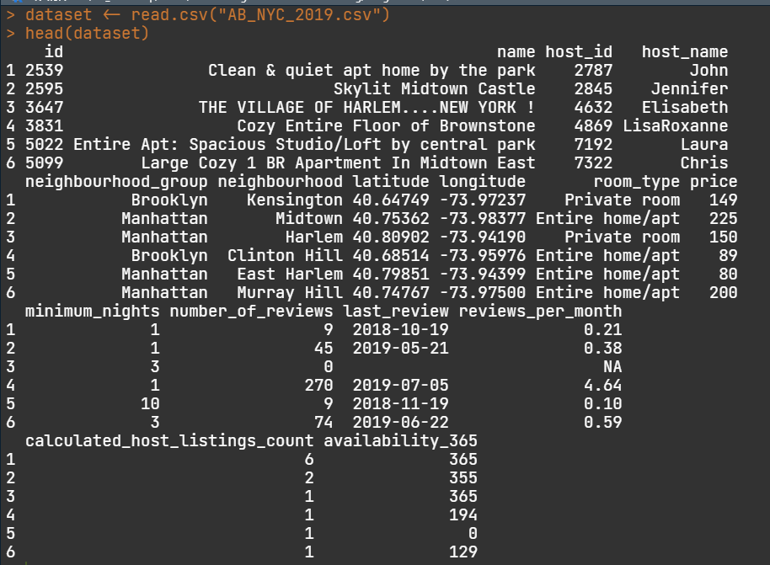

NA values in variables

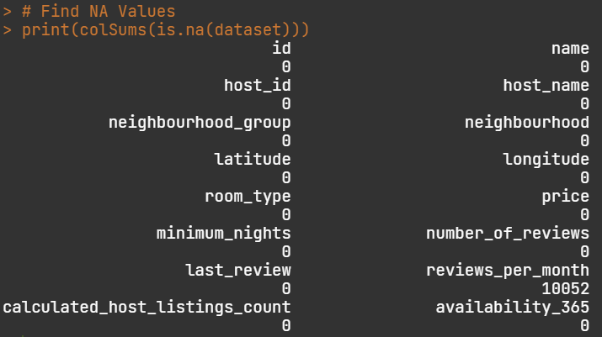

After omitting NA values

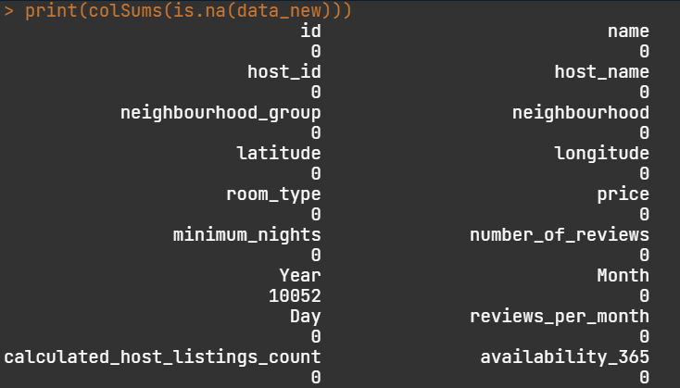

Correlation Matrix

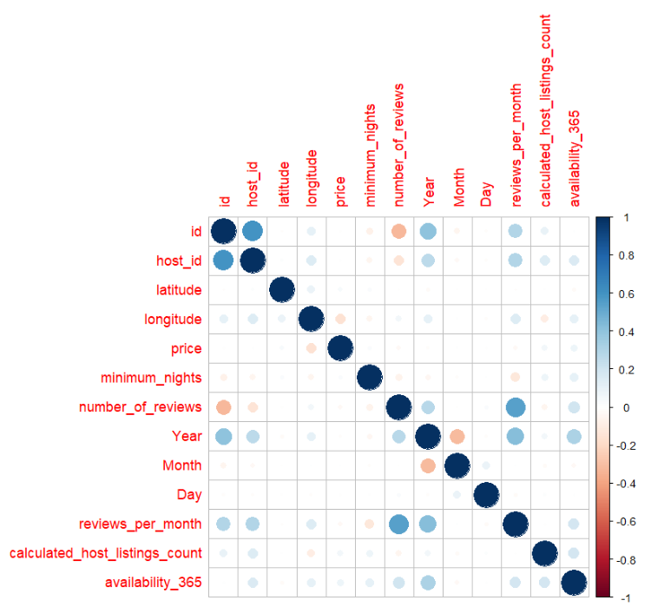

Count of each neighbourhood group

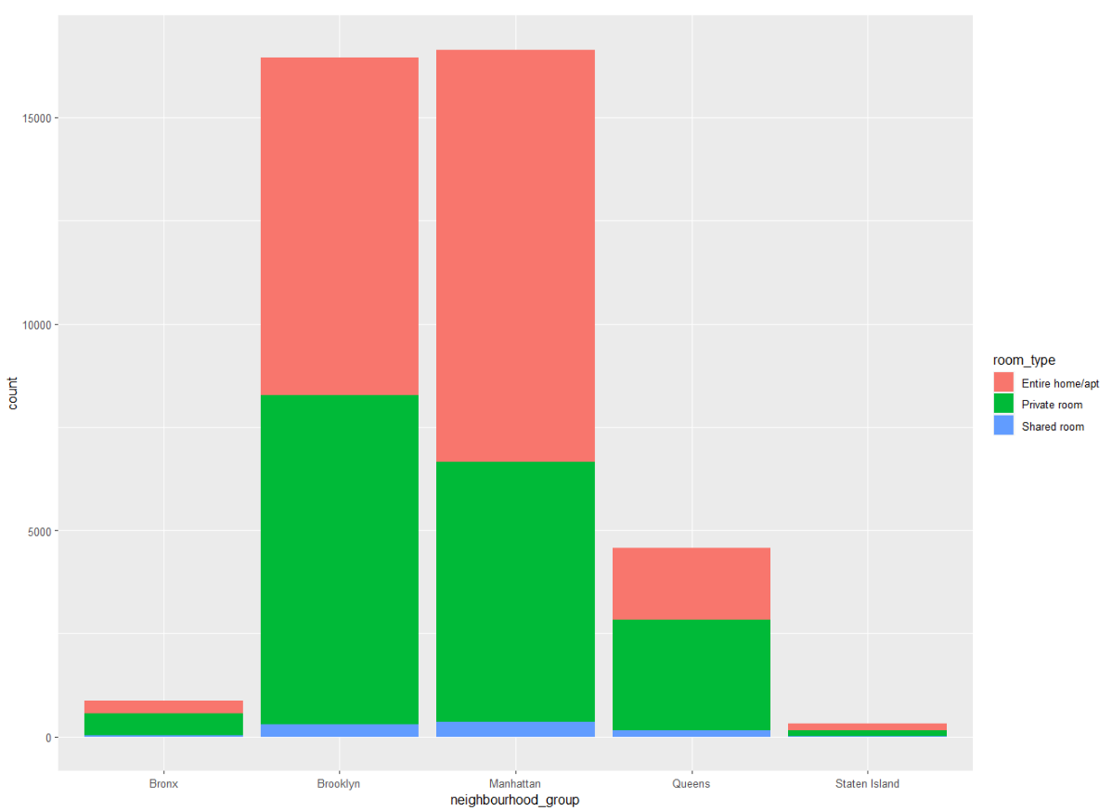

Mean price for each neighbourhood

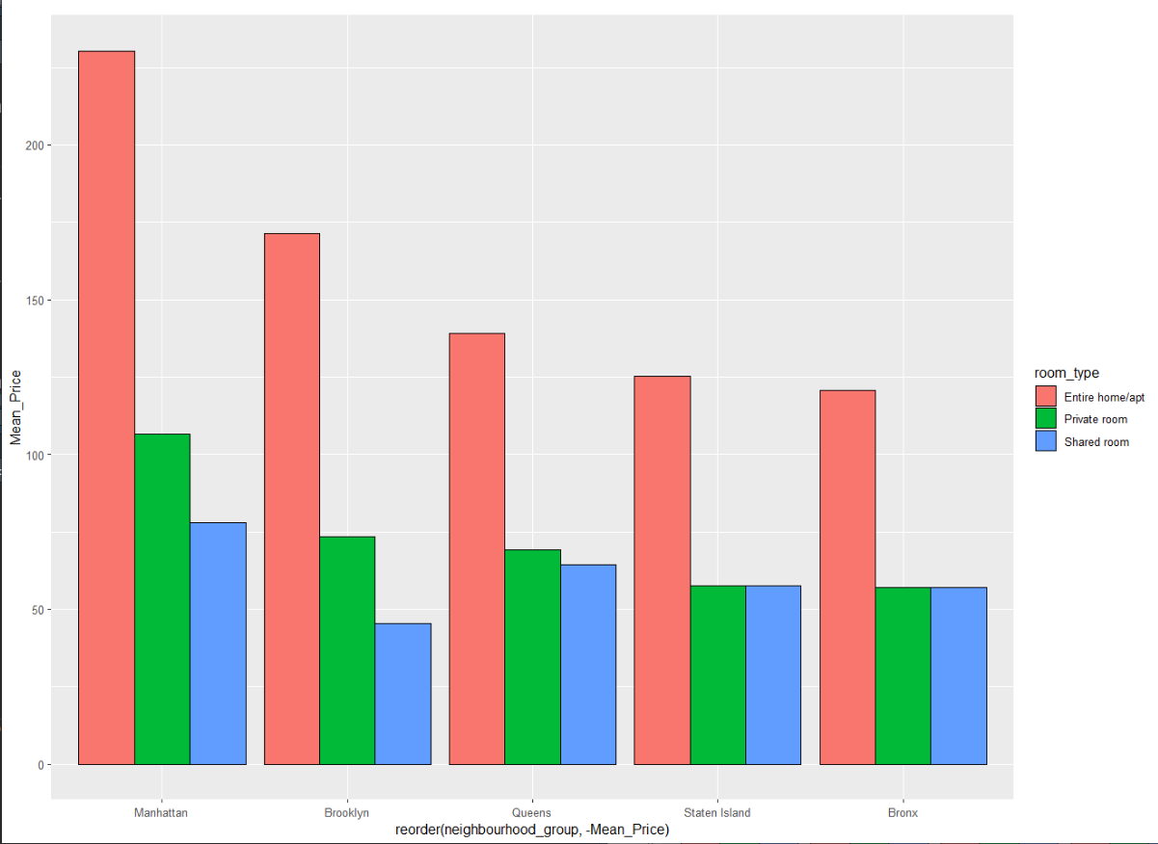

Price of rooms based on reviews grouped by type of room

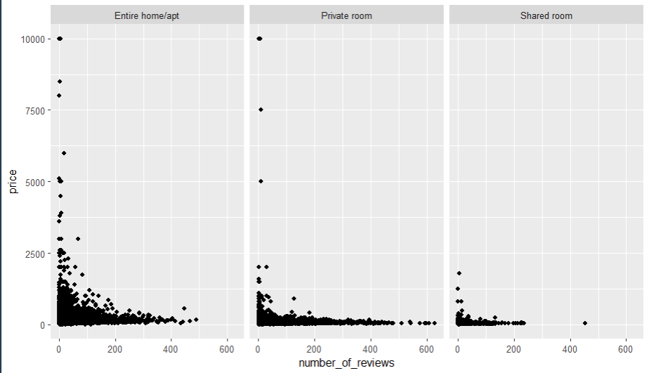

Box plot of room availability and neighbourhood

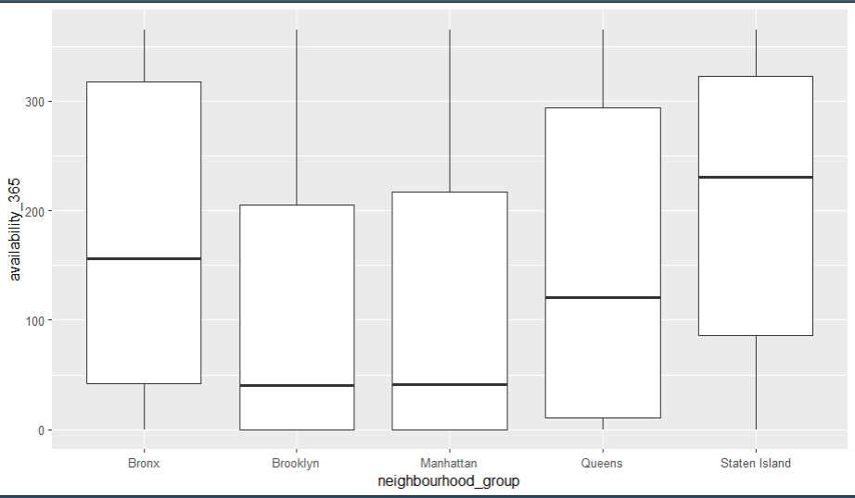

Building the model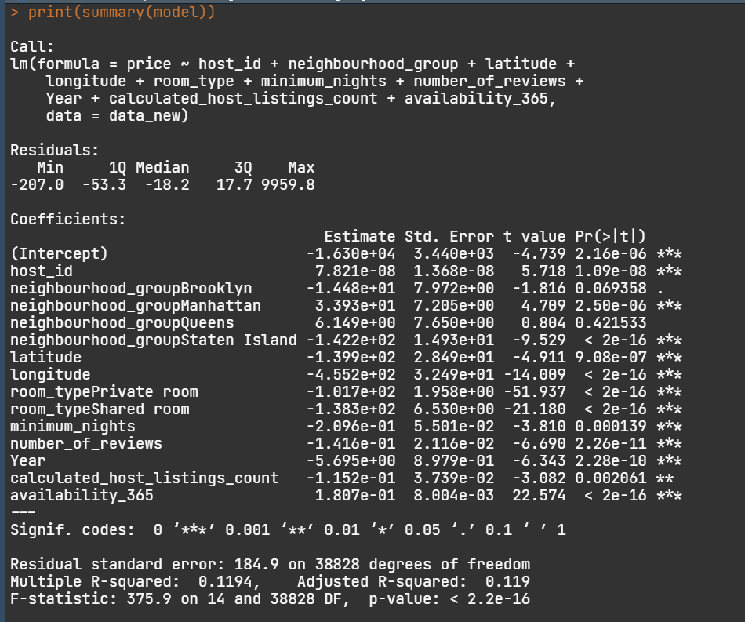

Metrics

