**Realtime Blood Management System**

**A PROJECT REPORT**

***Submitted by***

***Aayush Kumar Singh(21BCS7008)***

***Anoop Kumar(21BCS7055)***

***Dhuriya Ankit Subhash(21BCS6952)***

***Ishica(21BCS7050)***

***Sakshi Bajpai(21BCS6938)***

***in partial fulfillment for the award of the degree of***

**BACHELOR OF ENGINEERING**

**IN**

Computer Science and Engineering



**Chandigarh University**

MAY,2023



**BONAFIDE CERTIFICATE**

Certified that this project report **“Realtime Blood Management System”** is the Bona fide work of

**“Aayush Kumar Singh, Anoop Kumar, Dhuriya Ankit Subhash, Ishica, Sakshi Bajpai”** who carried out the project work under my/our supervision.

**SIGNATURE SIGNATURE**

Er. Puneet Kumar Divya Verma

**SUPERVISOR**

**HEAD OF THE DEPARTMENT** Assistant Professor

Computer Science Engineering Computer Science Engineering

Submitted for the project viva-voce examination held on

**INTERNAL EXAMINER EXTERNAL EXAMINER**

**TABLE OF CONTENTS**

List of Figures ............................................................................................................................. 7

List of Tables .............................................................................................................................. 8

List of Standards ......................................................................................................................... 9

**CHAPTER 1.** **INTRODUCTION ........................................................................ 09**

1.1. Identification of Client/ Need/ Relevant Contemporary issue ...................................... 09

1.2. Identification of Problem ............................................................................................... 10

1.3. Identification of Tasks .................................................................................................... 11

1.4. Timeline ............................................................................................................................. 12

1.5. Organization of the Report ................................................................................................ 13

**CHAPTER 2.** **LITERATURE REVIEW/BACKGROUND STUDY .............. __**

2.1. Timeline of the reported problem ................................................................................... 14

2.2. Existing solutions ........................................................................................................... 14

2.3. Bibliometric analysis ...................................................................................................... 14

2.4. Review Summary ........................................................................................................... 14

2.5. Problem Definition ............................................................................................................. 14

2.6. Goals/Objectives ................................................................................................................ 14

**CHAPTER 3.** **DESIGN FLOW/PROCESS ....................................................... 14**

3.1. Evaluation & Selection of Specifications/Features ........................................................ 14

3.2. Design Constraints ......................................................................................................... 14

3.3. Analysis of Features and finalization subject to constraints .......................................... 14

3.4. Design Flow ................................................................................................................... 14

3.5. Design selection ............................................................................................................. 14

3.6. Implementation plan/methodology ................................................................................ 14

**CHAPTER 4.** **RESULTS ANALYSIS AND VALIDATION ............................ 14**

4.1. Implementation of solution ............................................................................................ 14

**CHAPTER 5.** **CONCLUSION AND FUTURE WORK .................................... 15**

5.1. Conclusion ......................................................................................................................... 15

5.2. Future work ....................................................................................................................... 15

**REFERENCES ..................................................................................................... 16**

**APPENDIX ........................................................................................................... 17**

1. Plagiarism Report ................................................................................................................. 17
2. Design Checklist .................................................................................................................. 17

**USER MANUAL ................................................................................................. 18**

**List of Figures**

**Figure 1.1** Pie chart of blood management survey.

**Figure 1.2** Gantt Chart

**Figure 2.1 …………………………………………………………………………….……**

### List of Tables

**Table 3.1** Requirement of blood for different transfusion.

**Table 3.2 ……………………………………………………………………….………….**

**Table 4.1 ……………………………………………………………………….…….……**

### List of Standards (Mandatory for Engineering Programs)

|  |  |  |  |
| --- | --- | --- | --- |
| **Standard** | **Publishing**  **Agency** | **About the standard** | **Page no** |
| IEEE  802.11 | IEEE | IEEE 802.11 is part of the IEEE 802 set of local area network (LAN) technical standards and specifies the set of media access control (MAC) and physical layer  (PHY) protocols for implementing wireless local area network (WLAN) computer communication. | Mention page nowhere standard is used |

Note: Text in Red is presented as an example (replace with relevant information)

**ABSTRACT**

**-****---------------------------- New Page -------------------------**

**GRAPHICAL ABSTRACT**

**---------------------------- New Page -------------------------**

**ABBREVIATIONS**

**---------------------------- New Page -------------------------**

**SYMBOLS**

**---------------------------- New Page -------------------------**

**INTRODUCTION**

1. **Identification of Client/Need/Relevant Contemporary issue**
   1. According to a study conducted by WHO in 2022, almost 12,000 people die regularly because of not getting the blood required in time. This includes not getting blood at time or not having the required blood type.
   2. A report released by "Johns Hopkins Medicine" in the journal "Anesthesia & Analgesia" discovers that the blood stored in cold storage for longer than 3 weeks begins to lose the capacity to carry oxygen. This is way shorter than the 6 weeks standard for most blood banks.
   3. Reports from “Indian times” (also known as times of India) and “The New Indian Express” says, that the estimated death per day because of blood unavailability is more than 12,000 in India. Most of the times a person is not aware about the donors near them, because of which time became a big factor which threaten the life.
   4. Blood Banks:
   * Gives proper details about inventory so that blood bank can request/arrange missing stock of blood
   * Will have proper details about blood as date_recieved, donor_name, donor_health and more
   1. Blood donors (or Blood donation organizations):
   * Will be able to give details directly from donors to blood banks which will be seamless and paperless
   * Making the others know about the benefits of donating blood and inspiring them to help the patient by becoming an active donor.
   1. Hospitals / Patients:
   * Would be able to request the relatively fresh blood of the suitable type.
   * Easier way to find the required blood, near to their location. Including the details of the doner for the emergency contacts if to be made.

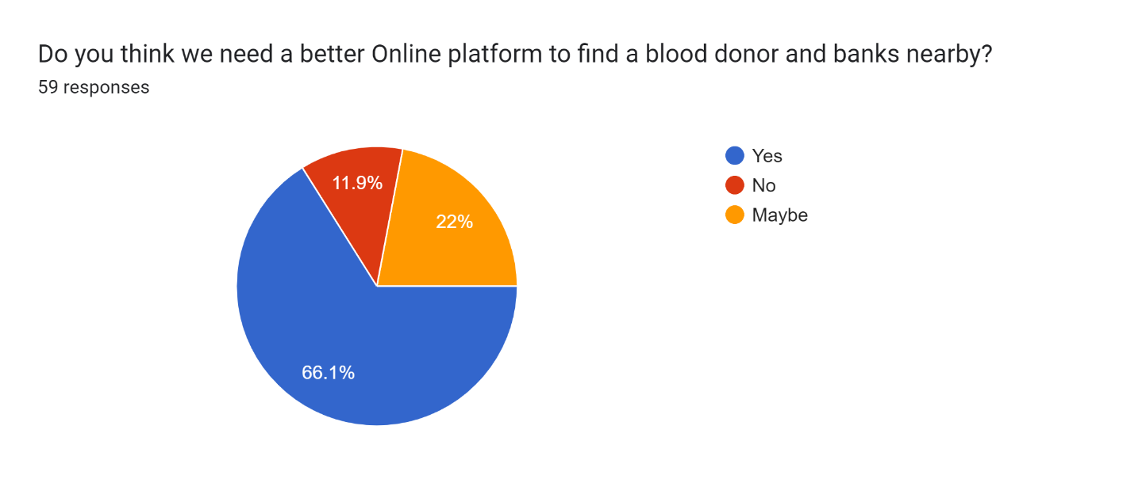

***Figure 1.1:*** *Pie chart of blood management survey*

As given in the *Figure 1.1* survey done by us also say the same, majority of people (66.1%) think that we need a better system related to this matter and 22% of people believe that maybe there must be a better way to provide help in this field.

1. **Identification of Problem**

Medical science may had been developed till now, but the way the facility reaches to the patients had remained same because of which some patients who can be saved at that fraction of time also gets an unnecessary death. In today’s world everything is online and has an efficient way to serve people by their service but medical is the only field which seem to be fall out of this race of development in terms of reaching to the needed ones.

And even if the facilities are provided, they are not so good enough to provide users a simple interface and ease to use that interface.

The major cause of death is because of unavailability of blood or lack of awareness related to the blood transfusion. Even though if the blood is arranged there are some issues with the blood or with the donor which can be life threatening to the patients.

While finding the compatible blood some common issues are face by the individual:

* Availability of blood nearby.
* Compatibility issues in blood.
* Lack of awareness about nearby donors.
* No online medium to check nearby availability.
* No direct interact with donor provided.

These problems are mostly faced because of no online medium availability to find the donor of blood groups needed nearby the location of a recipient.

Some real examples of Blood use in daily bases in India:

|  |  |
| --- | --- |
| Types of cases | Amount of blood required |
| Automobile Accident | *50 units of blood* |
| Heart Surgery | *6 units of blood / 6 units of platelets* |
| Organ Transplant | *40 units of blood / 30 units of platelets* |
| 20 bags of cryoprecipitate | *25 units of fresh frozen plasma* |
| Bone Marrow Transplant | *120 units of platelets/ 20 units of blood* |
| Burn Victims | *20 units of platelets* |

***Table 1.1:*** *Requirement of blood for different transfusion.*

1. **Identification of Task**

Real-time Blood management system is a way to facilitate a person by providing them a way to make the arrangement of the needed blood type required. This is a system which provides an interface to the user through which their problem can be solved in a fraction of seconds.

In this system we had tried to make this interface which will resolve this problem by making them aware about the donors and blood banks near them by using Realtime updates. In the process of making this system there was two major terms to be discussed and these terms are told below further in this document.

The two major work in making this Real time blood management is that must have and easy to understand UI/UX and the second is to have a database connected to it, which will provide the information to the front-end or interface to show the information which is needed by that person/user.

The front page or the landing page of our system will be the information interface which will provide a brief introduction about the system and the way we provide user help, after sliding a little below a person will get two options; if a person wants to became a donor or a person is in need of blood. As per their choice the webpage will get refreshed and a webpage with the needed information will get opened.

If a person wants to became a donor, he/she have to fill a form will the essential details like:- First Name, LastName, Email ID, Aadhaar Card ID, Address, Pin code and Mobile Number.

And, if a person needs blood, then there will be an option to fill about the type of blood, he/she want with any specific blood components or whole blood and then the list of the donors near his/her location will get visible and the preferred blood banks.

Sign in will only be compulsory when the person wants to be an Active donor.

About the database from where we fetch the data will get update as per the availability of the blood groups.

The whole backend load is given to the server and the database from where we fetch the data to show the information at the interface/user side.

The webserver will be responsible for performing various tasks like: -

* The webserver is responsible for performing various tasks like:
* interacting with Front-end for blood donations and requests,
* finding suitable blood for patients
* interacting with the database for insertion of suitable blood donation entries
* rejection of blood donation which come from donor suffering from any blood disease.

The Database included in the backend is responsible for the following operations: -

* Storing data from blood donations
* Has a detail record of all the blood requests
* Stores data about the current inventory of the blood bank.

The major goal of this system is to provide a functioning system to the users, where they find the specific needed blood and the ones who want a platform to help other by donating the blood to the needed ones at their worst times, but the donor must be physically fit to be an active donor.

1. **TimeLine**

The project timeline is divided into various phase which are listed below:

* **Phase 1 (Project Definition)**

This phase involves with the research and definition of project scope. It deals in introducing us to the background knowledge required to build the project like shelf-life of blood, current shortage of blood and so on. The phase also deals with the division of task within the team and planning of deadlines.

* **Phase 2 (Content Phase)**

This phase deals with creating Skeleton or idea of how the end-product should be expected to function. This phase also deals with the actual content that is present as well as the arrangement of the content.

* **Phase 3 (Design Phase)**

This phase deals with the details like the user-experience and interface of the project. It also details with the review of the page design so that any underwhelming page design could be reworked and improved in this phase.

* **Phase 4 (Development Phase)**

This phase deals with actual development of the project. In this phase, all the coding related to the front-end and back-end of the project. At end of the phase project will be fully functional.

* **Phase 5 (Review Phase)**

In this phase, the research paper related to the project is created and the project report is created. The project is fully functional and can be given for grading.

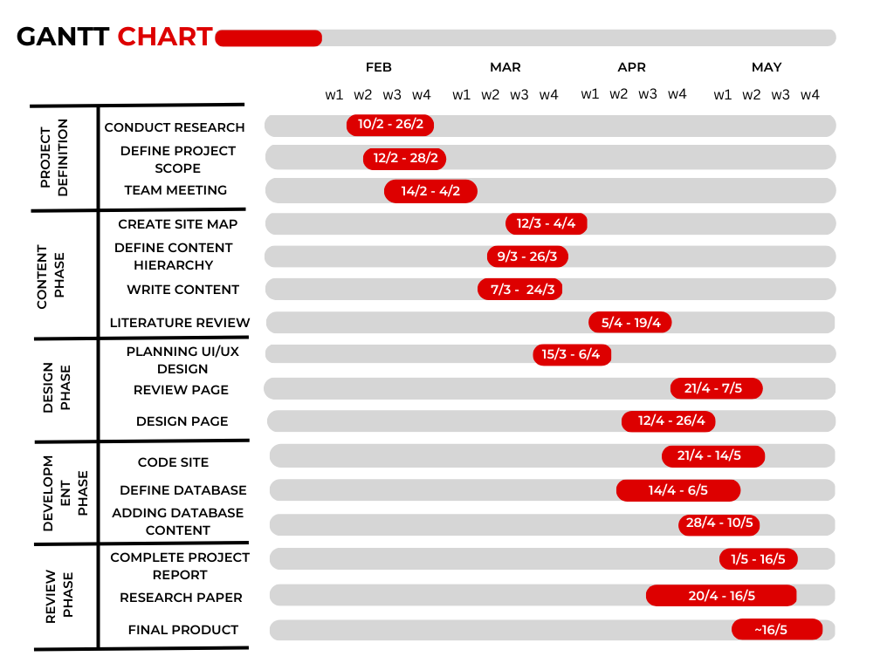

***Figure 1.2:*** *Gantt Chart*

1. **Organization of Report**

In this section we will be providing an overview of our project report. Our project report will be having five major chapters:

* 1. Introduction
  2. Literature Review/Background Study
  3. Design Flow/Process
  4. Result Analysis and Validation
  5. Conclusion and Future Scope

In ***Introduction*** section we are providing the basic idea of our project that what we are expecting our outcomes to be. It also includes the problem identification and client requirement from the real-world scenario which is the base of our idea behind this project.

In ***Literature Review/Background study*** we are going to describe the ideas which we got from the pre-existing project for blood management system and what are the problems and shortcomings in those projects and out of those shortcomings what we will try to implement in our project.

In ***Design Flow and Process*** we are going to choose the Design of our system from the various designs we proposed and will discuss about the facilities we are going to provide in our system. It will also contain the description of flow of our project.

In ***Result Analysis and Validation*** part we will be validating the actual outcomes of our project along with the Limitations of our project. We have also mentioned the difference between what we thought of and what we have created i.e., difference between our actual and expected outcomes.

In Last phase, ***Conclusion and Future Scope***, we will talk over the advancements with which we have concluded it in context of pre-existing projects over this topic. In this phase we will also state about the future research areas for our system.