# QUIZ GAME

**A PROJECT REPORT**

***Submitted by***

Anas Khan(21BCS7251)

Anoop Kumar(21BCS7055)

Ayush Anand(21BCS2339)

Padmapada Nayak(21BCS9841)

Shobhit Kumar(21BCS8333)

***in partial fulfillment for the award of the degree of***

**BACHELOR OF ENGINEERING**

**IN**

Computer Science and Engineering



**Chandigarh University**

MAY,2022



## BONAFIDE CERTIFICATE

Certified that this project report **“QUIZ GAME”** is the Bona fide work of

**“Anas Khan, Anoop Kumar, Ayush Anand, Padamapada Nayak and**

**Shobhit Kumar”** who carried out the project work under my/our supervision.

**SIGNATURE SIGNATURE**

Ankita Sharma Gaurav Bathla

**SUPERVISOR HEAD OF THE DEPARTMENT**

Assistant Professor

Computer Science Engineering Computer Science Engineering

Submitted for the project viva-voce examination held on

##### INTERNAL EXAMINER EXTERNAL EXAMINER

Chandigarh University, Gharuan, District

–Mohali, Punjab -140413, Tel. (0160)

3014444 Fax No.: (0150) 3014402

Website: [www.cuchd.in](http://www.cuchd.in)

**ACKNOWLEDGEMENT**

I would like to express my gratitude and appreciation to all those who

gave me the possibility to complete this report. Special thanks to my supervisor Ms. Ankita Sharma, Assistant Professor, Chandigarh University whose help, stimulating suggestions and encouragement helped me in all time of fabrication process and in writing this report. I also sincerely thanks for the time spent proofreading and correcting my many mistakes.

I would also like to acknowledge with much appreciation the crucial role of the staff in Computer Lab, who gave me a permission to use the lab Computers and also the machine and to design the Game and giving a permission to use all the necessary tools in the laboratory.

Date: Anas Khan, Anoop Kumar,

Ayush Anand, Padmapada Nayak,

Shobhit Kumar

This is to certify that the above statement made by the candidate is correct to the best of my knowledge.

**Supervisor: Ms. Ankita Sharma**

Designation: Assistant Professor

Department: Computer Science and Engineering

Chandigarh University

Chandigarh-160012, India

**Table of Contents**

**1. Introduction**……………………………………………….…………. **5**

**2. Literature Review**…………………………………………….……… **6**

**3. Design Flow/Process**………………………………………….……… **7**

**4. Result Analysis and validation**…………………………….…………**9**

**5. Conclusion and future work**…………………………………………**12**

**6. References** …………………………………………………….………**12**

**Introduction**

"Quiz Game" application that has broad questions about current events and computers. It includes multiple-choice questions and scores for each correct response. It is beneficial to kids and families since it aids in the development of a broad knowledge about the world, sports, and computers.

Knowledge is power in today's society, and it is not limited by age. However, simply having knowledge is not enough; one must also be able to recall that information when the time comes. Even if someone possesses both of these qualities and does not have access to a platform where they can improve their talents. As a result, people lose their ability to respond quickly and recall information that they previously had.

Every company needs exceptional personnel to work for them who can keep the firm running smoothly and help it grow. And a Quiz Game can help a person sharpen his or her knowledge and brush up on their ability to recall information to the brain.

The major goal of "Quiz Game" is to provide a user-friendly environment for all users while also reducing manual labors. A quiz begins with one question and four options based on computer, general knowledge etc. If the response is accurate, the score is increased by one point, and there are no penalties for incorrect answers. After answering a few limited questions, the quiz application will finally send you to the scoring page, where you will see your total result.

**Literature Review**

This section provides a comprehensive review of previous reports on “Quiz Games” by different Authors. The design and structure of the game are made by taking all these reports in consideration as a result of a literature review.

The following parts address the extensive review of literature that corresponds to each component.

|  |  |  |
| --- | --- | --- |
| **Author** | **Work Done** | **Conclusion** |
| Tara Khairiyah Md Zali,  Nora S Sani,  Abdul Hadi Abd Rahman,  Mohd Aliff  (2019) | Introduced the use of MCQs format to display answer to the user | We have used the MCQs format to show the user four option and he can click on any one option and it will tell the answer is correct or wrong |
| Cf Klopfer (2011) | Proposed to give learner option to choose the difficulty of the questions | With the help of this we have provided three options easy, medium and hard. From this user can choose any level and respective of that selection the level of question will get decided |
| Adarsh Paul,  Rajat Kumar Singh,  Jayant Singh and  Tulasi Sai Shweta  (2017) | Given the idea to tell the score to the user for the correct answers | We have implemented this thought as after the game is over the total score will be displayed to the user |

**Design Flow/Process**

When we present any work, it is must to explain ‘How it works?’ to tell other about the background processes of the Design you had made.

Similarly, our program also had many processes going at the back-end to work the way it works, and we had explained below the same in detailed manner.

Some primary thing which we had used to make this QuizGame are as Follow:

* **Python**: Python is an interpreted, object-oriented, high-level programming language with dynamic semantics developed by Guido van Rossum. It was originally released in 1991. Designed to be easy as well as fun, the name "Python" is a nod to the British comedy group Monty Python.
* **Python Libraries Tkinter**: Python provides a standard GUI library named *Tkinter*. *Tkinter* module helps in creating GUI applications in a fast and easy way. *Tkinter* provides 15 types of widgets. Some common ones are Button, Label, Frame, Menu.
* **File Handling**: File Handling is a way in programming languages to access text and binary files to save or extract data from them.

The Quiz Game program which we had made using Python programming language works on these three things. Firstly, we use the Tkinter module of python to add a GUI and then we use many other functions of that module to insert labels and buttons to provide a way for the user to give response to the questions displayed on the screen. Up to this thing were happing in the first frame.

In the Second frame, we display the score once the user starts the game the score will update one by one as the user will select one option from the four given options. +1 if the player gets question right and one live deducted when the player gets the question wrong.

The difficulty level of the questions depends on the user, and according to the selection made by a user we select the file we have to open in python to read and give the question to the Player. Once the player starts the game, he/she will get three lives, if he/she get answers wrong three times, the game will show the score and life left to the player in the new pop-up window and “Game Over” message on the main screen.

Design is also important to attract players to play a game, so we also had done some research on the designs, which we can use in our Quiz game.

Some design which we examined during finalizing the design of our Quiz Game are as follows:

**First Design**: In this we thought to add check box options in which user click on the option’s box to check the box and click next button to see it the answer is correct or incorrect.

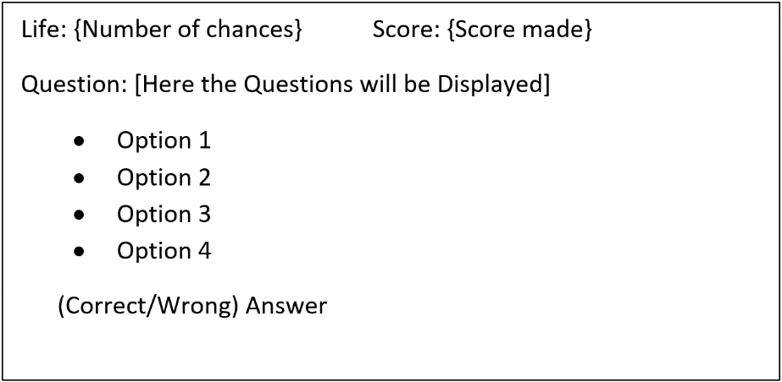

**Second Design**: In this we thought to add options in which user type his/her selected answer and then check if his/her answer is correct.

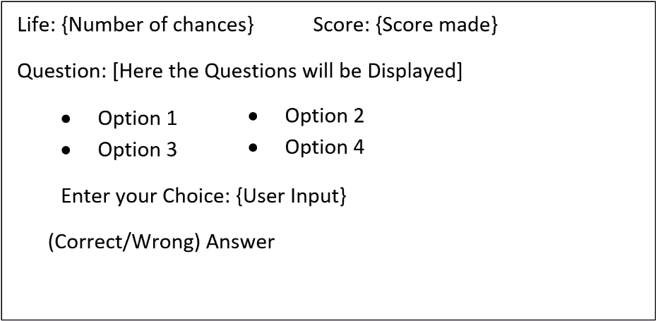

**Third Design**: In this we thought to add buttons as options and player just had to select the option and to automatically tells, either it’s right or wrong, if right score is added else right answer is shown to the user. And user uses next button to move to the next question.

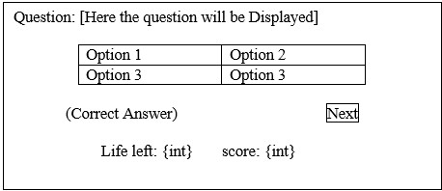

**Result** **Analysis and validation**

The list of questions comprised in the project are learning oriented (directly as well as obliquely), which makes it more than just a quiz ‘game’. It is much rather a platform which makes learning a much more intriguing, engaging and beautiful process. That being said, the interface of the project is GUI based i.e., Graphic User Interface which allows the ‘Game’ to be visually aesthetic as to be pleasing on the eye of the user. In addition to that, here are some of the screenshots which perfectly and sequentially delineate the working of this fruitful program:

When a player starts the game, he/she will be introduced with this window:

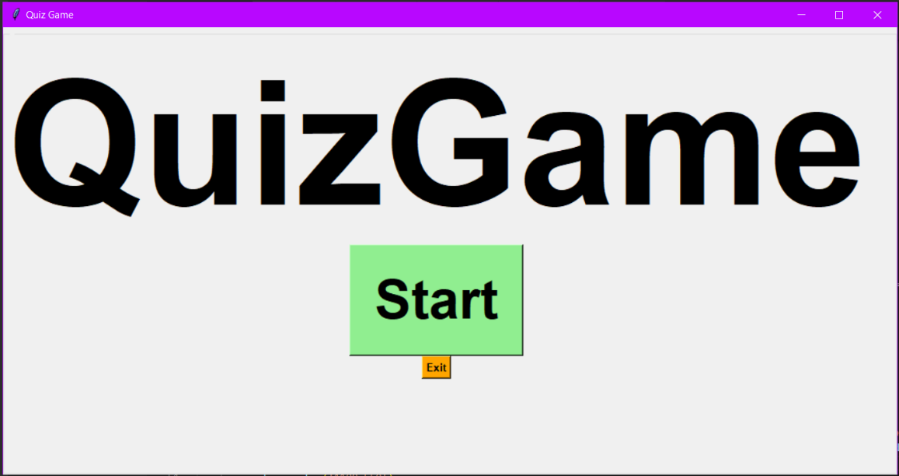

After clicking, on the start button, a new window will appear where the user shall be asked to select the difficulty level as per his scope and magnitude of knowledge:

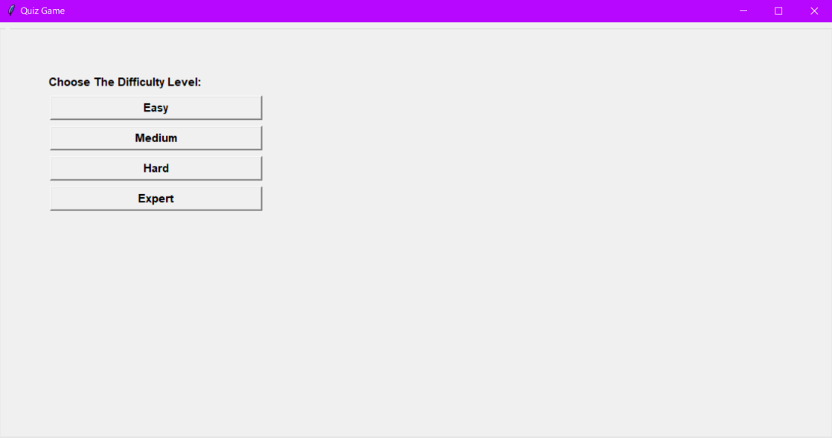

As the name suggests, each level of difficulty encompasses the easy, medium, hard and expert type questions respectively.

Subsequently, user will be able to see questions and answer them by selecting an option on the screen. The chosen box will become either green or red upon selection. Green symbolizes the correct outcome of the answer contrary to red; which signifies wrong answer of a particular question (as shown in pictures below).

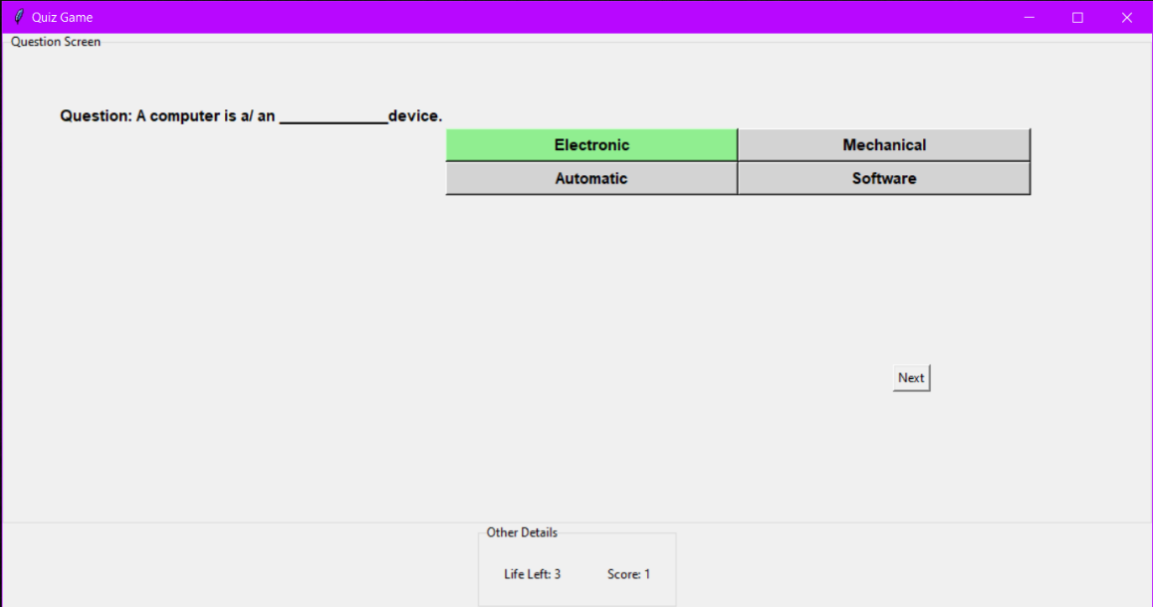

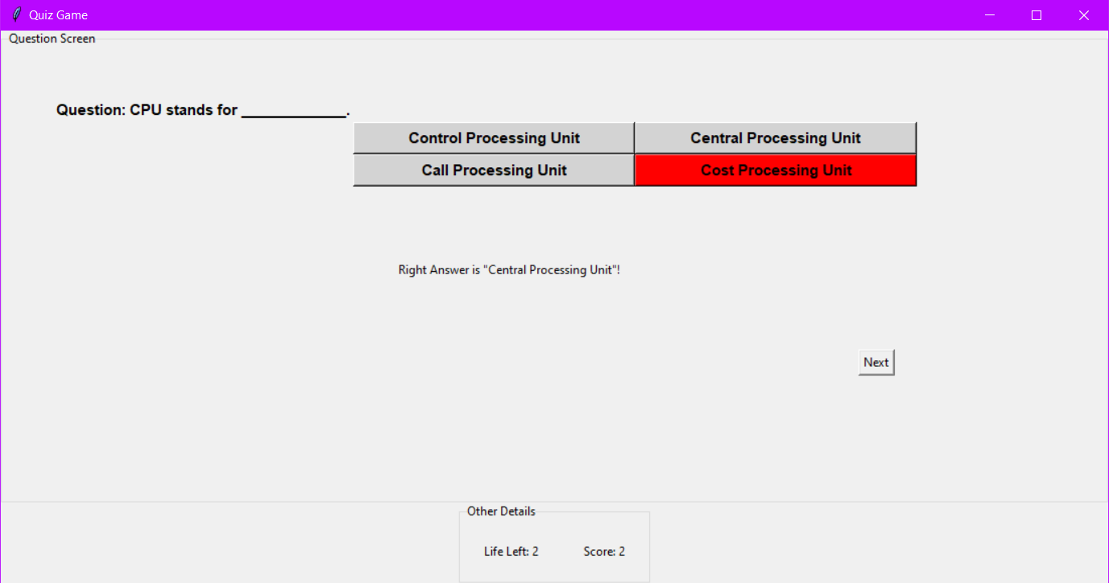

As it is visible on the bottom of the screen of the game, there is a section which tells the number of lives a user has. Lives here is a euphemism for the number of attempts a user can have in one go. Each correct answer will also result in increment of score by one point.

When user finishes all of his lives, following window will appear on the screen:

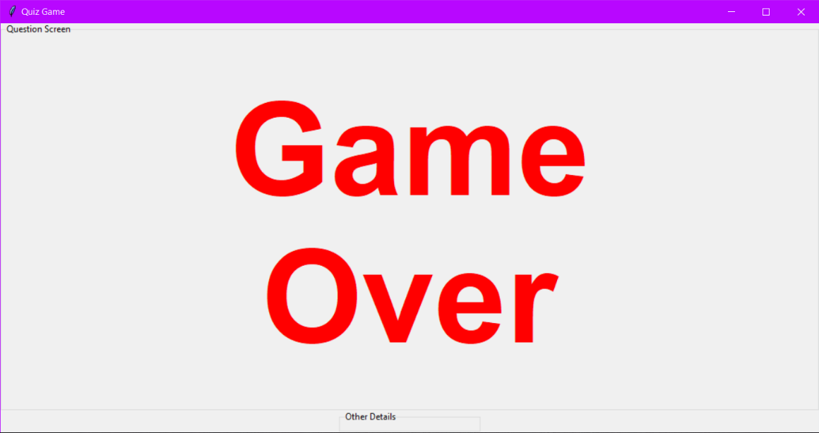

This window will tell the score and number of lives a player has left:

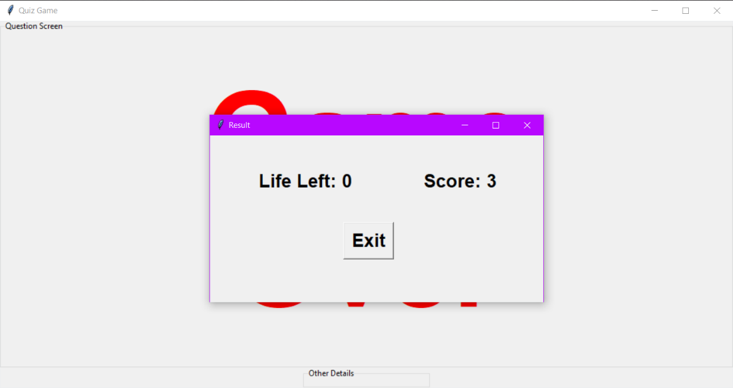

**Conclusion and future work**

In this report, we had, written about our “Quiz Game” project, and the way it’s implemented. We had written about the literature review; we had done on other people’s works and what we adapted from their works and what new we had made in our project.

For the future purposes, this Project can be modified for edutainment purpose, it can be uploaded for public use, if worked beneficially for the Player and also can be used as an online examination platform in future.

**References**

1. Zali, T. K. M., Sani, N. S., Abd Rahman, A. H., & Aliff, M. (2019). Attractiveness Analysis of Quiz Games. *International Journal of Advanced Computer Science and Applications*, *10*(8), 205-210.
2. Valk, J. H., Rashid, A. T., & Elder, L. (2010). Using mobile phones to improve educational outcomes: An analysis of evidence from Asia. *International Review of Research in Open and Distributed Learning*, *11*(1), 117-140.
3. Paul, A., Singh, J., Singh, R.K., & Shweta, T.S. (2017). Students Guide: Offline Android Quiz Application. *International Journal of Advance Research and Innovative Ideas in Education, 3*, 772-777.