**Realtime Blood Management System**

**SRS DOCUMENT REPORT**

***Submitted by***

***Aayush Kumar Singh(21BCS7008)***

***Anoop Kumar(21BCS7055)***

***Dhuriya Ankit Subhash(21BCS6952)***

***Ishica(21BCS7050)***

***Sakshi Bajpai(21BCS6938)***

**BACHELOR OF ENGINEERING**

**IN**

Computer Science and Engineering



**Chandigarh University**

24, MAY,2023

**TABLE OF CONTENTS**

List of Figures ...................................................................................................................................07

List of Tables ....................................................................................................................................08

**1. INTRODUCTION ................................................................................................09**

**1.1. Purpose ....................................................................................................................................09**

**1.2. Project Scope............................................................................................................................09**

**1.3. Product Perspective ................................................................................................................09**

**1.4. Product Features .....................................................................................................................09**

**1.5. Operating Environment .........................................................................................................09**

**1.6. Design and Implementation Constraints ..............................................................................09**

**1.7. Assumptions and Dependencies ............................................................................................09**

**2. PROJECT PLANNING AND ESTIMATION ................................................. 09**

**2.1 Software Project Planning....................................................................................................... 09**

**2.2 Project Estimation Techniques: ............................................................................................. 09**

**3 EXTERNAL INTERFACE REQUIREMENTs ...................................................................... 09**

**3.1 User Interfaces: ........................................................................................................................ 09**

**3.2 Hardware Interfaces: .............................................................................................................. 09**

**3.3 Software Interfaces: ................................................................................................................ 09**

**4. NON-FUNCTIONAL REQUIREMENTS** **........................................................ 09**

**4.1 Performance Requirements .................................................................................................... 09**

**4.2 Safety Requirements ................................................................................................................ 09**

**4.3 Security Requirements ............................................................................................................ 09**

**4.4 Software Quality Attributes .................................................................................................... 09**

**5. FUNCTIONAL REQUIREMENTS................................................................... 09**

**1 INTRODUCTION**

**1.1 Purpose:**

The purpose of this Software Requirements Specification (SRS) document is to outline the requirements and specifications for the Real Time Blood Management System. The system can provide a platform for donors to register, recipient to apply for blood and facility to find nearest donor location and blood bank to full fill the specific requirement.

The SRS describes the scope of the system and its various subsystems, including any limitations or constraints that may impact its development and implementation.

**1.2 Project Scope:**

The real-time blood management system is an innovative solution to the problem of blood shortage and the difficulties in arranging blood for patients in need. This system provides a user-friendly interface that allows people to find the blood type quickly and easily they require. The system works by leveraging real-time updates to provide users with accurate and up-to-date information about blood donors and blood banks near their location.

One of the most critical aspects of this system is the concept of real-time updates. This means that the system continuously monitors blood banks and donors in real-time, and updates the information on the platform as soon as it becomes available. This ensures that the information presented to users is accurate and up-to-date, helping them to make informed decisions quickly and easily.

Another crucial aspect of this system is the use of a user-friendly interface. The interface is designed to be intuitive and easy to use, allowing users to quickly find the information they need without any hassle. The system is designed to be accessible to everyone, regardless of their technical knowledge or experience, and it can be accessed from any device with an internet connection.

Overall, the real-time blood management system is an essential tool in the fight against blood shortage. By leveraging real-time updates and a user-friendly interface, this system provides a fast and effective solution to the problem of arranging blood for patients in need.

**1.3 Product Perspective:**

The Real Time Blood Management System is a new, self-contained product that will be integrated into the existing healthcare IT infrastructure.

The blood donor component of the system would include features such as registration of blood donors, tracking of blood donations, and management of blood banks. It would also include tools for communication with donors, such as reminders for upcoming donation appointments and notifications about the availability of blood donations.

It will interface with other healthcare software applications, such as Electronic Health Records (EHR), Laboratory Information Management Systems (LIMS), and Clinical Decision Support Systems (CDSS) to ensure seamless information flow across systems. The system will be designed to comply with all relevant regulatory and industry standards, including HIPAA, FDA, and AABB.

**1.4 Product Features:**

The major features of the Real Time Blood Management System include real-time inventory tracking, blood product utilization analytics, electronic blood product ordering and transfusion management, user authentication and access control, and robust reporting capabilities. Additionally, the system will be designed to integrate with other healthcare software applications to ensure seamless information flow across systems.

A Blood Management System typically includes the following key features:

* **Donor registration:** The system allows individuals to register themselves as blood donors by providing their personal and medical information.
* **Real-time location:** This feature allows the healthcare organization to track the current location of the blood, allowing the doctors to get a rough prediction about the time in which the surgery should start.
* **Donor search:** The system allows patients and healthcare organizations to search for registered blood donors based on the required blood type and the location of the request.
* **Blood inventory management:** The system keeps track of the blood inventory available with the blood bank and ensures that the inventory is properly managed and updated.
* **Appointment scheduling:** The system allows donors to schedule appointments for donating blood and provides reminders for the same.
* **Donor communication:** The system facilitates communication between the donor and the patient or the healthcare organization regarding the donation process and other relevant information.
* **Reporting and analytics:** The system provides reports and analytics on the blood donation and request activities, including the number of donors, blood units donated and requested, and other key metrics.
* **SMS/Email Notifications:** This feature sends notifications to donors and hospitals about blood donation schedules, appointments, and other updates.
* **Donor Management:** This feature helps in managing the information and records of donors, including their donation history and eligibility status.

**1.5 Operating Environment:**

The Real Time Blood Management System will operate on a variety of hardware platforms and operating systems, including Windows and Linux. The following integrations will be provided by the system:

1. **Hardware**: This includes the physical components of the system such as servers, workstations, storage devices, and network devices.
2. **Software:** This refers to the programs and applications used to run the system, including the operating system, database management system, and the blood donor and receiver management software.
3. **Network:** This refers to the communication infrastructure used to connect the various components of the system and enable data transfer between them. This may include local area networks (LANs), wide area networks (WANs), and the internet.
4. **Database:** This is the repository of all the blood donor and receiver data, including personal information, blood type, donation history, and medical records.
5. **Security:** This includes the measures put in place to ensure the confidentiality, integrity, and availability of the blood donor and receiver data, as well as the overall system security.
6. **User Interface:** This is the graphical user interface (GUI) that allows users to interact with the system and perform tasks such as registering as a blood donor, scheduling appointments, and accessing medical records.
7. **Support and Maintenance:** This includes the processes and procedures used to provide technical support, perform system maintenance and upgrades, and ensure the system is running smoothly and efficiently.

**1.6 Design and Implementation Constraints:**

The Real Time Blood Management System will be designed and implemented in compliance with all relevant regulatory and industry standards, including HIPAA, FDA, and AABB. It will also need to interface with a variety of healthcare IT applications and will therefore need to adhere to established communication protocols and data exchange standards. Finally, the system will need to support secure user authentication and access control to ensure data privacy and security.

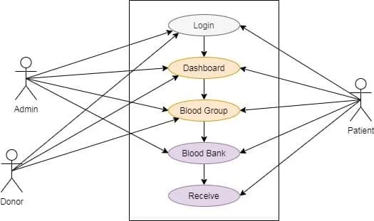

***Figure 1.6.1****: Software based diagram to show the access in the system*

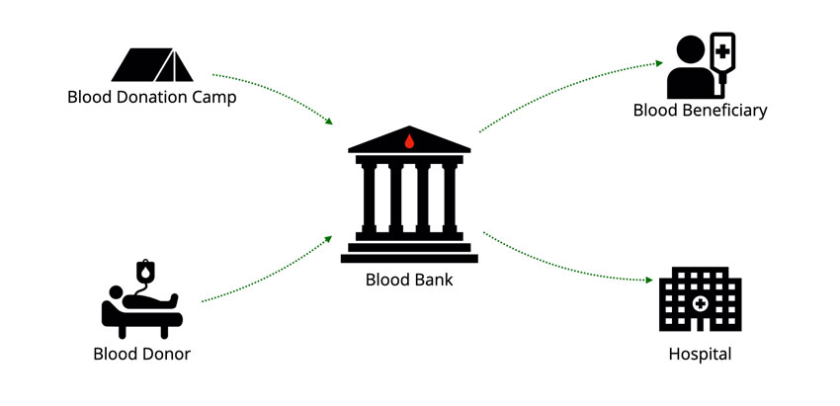

***Figure 1.6.2****: Physical based diagram to show the access in the system*

**1.7 Assumptions and Dependencies:**

It is assumed that the Real Time Blood Management System will be integrated into an existing healthcare IT infrastructure, including EHR, LIMS, and CDSS. The system will be developed using industry-standard software development practices and will be compliant with all relevant regulatory and industry standards. Additionally, the system will depend on a robust and reliable network infrastructure to ensure real-time data exchange and communication between subsystems.

***Assumptions:***

1. Availability of eligible blood donors: The Blood Donor and Receiver management system assumes that there are enough eligible donors who are willing to donate blood when needed.
2. Accurate and up-to-date donor information: The system assumes that the donor information in the database is accurate and up-to-date. This includes details such as blood group, contact information, and medical history.
3. Availability of blood testing facilities: The system assumes that there are reliable facilities available to test donated blood for infectious diseases and other potential risks.
4. Availability of willing donors: The system assumes that there are willing donors available to donate blood when needed.

***Dependencies:***

1. Donor registration: The blood donor and receiver management system depend on the registration of donors in the database.
2. Donor screening: The system depends on the screening of donors to ensure that they are eligible to donate blood and that their blood is safe for transfusion.
3. Receiver information: The system depends on the availability of accurate and up-to-date information about the receiver, including their blood group and medical history.

**2 Project Planning and estimation**

**2.1 Software Project Planning:**

The software project planning for the Real Time Blood Management System will involve defining the project scope, objectives, and deliverables, as well as identifying the resources, timelines, and risks associated with the project. This will include:

* Defining the project scope: This will involve identifying the specific functionalities and requirements of the system and clarifying the project goals and objectives.
* Developing a project schedule: This will involve creating a timeline for the project that includes key milestones and deadlines.
* Identifying project risks: This will involve identifying potential risks and issues that may arise during the project and developing contingency plans to mitigate these risks.
* Establishing communication protocols: This will involve defining the communication channels and protocols that will be used to ensure effective communication between project team members, stakeholders, and end-users.
* Identifying project resources: This will involve identifying the personnel, hardware, software, and other resources needed to complete the project.
* Developing a budget: This will involve estimating the project costs and developing a budget that includes all necessary expenses, such as personnel, hardware, software, and other resources.

**2.2 Project Estimation Techniques:**

There are several techniques that can be used to estimate the time and resources required for the Real Time Blood Management System project, including:

* Expert judgment: This involves consulting with subject matter experts to estimate the time and resources required for specific project tasks.
* Analogous estimation: This involves using historical data from similar projects to estimate the time and resources required for the current project.
* Bottom-up estimation: This involves breaking down the project into smaller tasks and estimating the time and resources required for each task individually.
* Three-point estimation: This involves using optimistic, pessimistic, and most likely estimates to calculate the expected time and resources required for a specific project task.
* Parametric estimation: This involves using statistical models and data to estimate the time and resources required for specific project tasks.

The most appropriate estimation technique for the Real Time Blood Management System project will depend on the specific requirements and constraints of the project. A combination of techniques may be used to develop a comprehensive and accurate estimate.

**3 External Interface Requirements**

**3.1 User Interfaces:**

The logical characteristics of the user interface might include a clear and intuitive layout that displays information about available blood products, patient information, and any other relevant data. Sample screen images could include a dashboard showing the status of blood inventory and any pending requests or transfusions. GUI standards or product family style guides might dictate the use of consistent branding, fonts, and colour schemes across the application. Screen layout constraints might include using a responsive design that adjusts to different screen sizes and orientations or ensuring that key information is prominently displayed on the screen. Standard buttons and functions might include options to search for specific patients or blood products, submit requests for blood transfusions, or view reports on blood usage. Keyboard shortcuts could be provided for common functions, such as submitting a request or cancelling a transfusion. Error message display standards might dictate that any errors or warnings are clearly displayed to the user, with suggestions for how to resolve the issue.

**3.2 Hardware Interfaces:**

The hardware interfaces for a real-time blood management system might include support for a variety of medical devices, such as blood testing equipment, IV pumps, or transfusion monitoring devices. The software would need to be able to communicate with these devices to receive real-time data on blood levels and transfusion status. Communication protocols might include Bluetooth or other wireless protocols, as well as USB or other wired connections. The system would need to be able to handle different types of data and control interactions, such as receiving data from a blood testing machine or sending a signal to an IV pump to stop a transfusion.

**3.3 Software Interfaces:**

The software interfaces for a real-time blood management system might include connections to other healthcare software components, such as electronic medical records (EMRs), laboratory information systems (LIS), or inventory management systems. Data items or messages coming into the system might include patient information, blood test results, or inventory levels. Data going out might include requests for transfusions, updates on transfusion status, or reports on blood usage. Services needed might include the ability to query and update patient records, receive real-time updates on inventory levels, or send alerts to healthcare providers if blood levels drop below a certain threshold. The system might need to use specific communication protocols, such as Health Level Seven (HL7), to integrate with other healthcare software components. Data that will be shared across software components might include patient identifiers, blood product codes, or transfusion orders. Implementation constraints might include using a specific database schema or programming language to ensure compatibility with other healthcare systems.

**4 Non-functional Requirements**

**4.1 Performance Requirements**

* The system must be able to process at least 500 transactions per minute with a response time of less than 1 second.
* The system must be able to handle a peak load of 1000 transactions per minute with a response time of less than 2 seconds.
* The system must be able to handle a maximum of 100 concurrent users.

**4.2 Safety Requirements**

* The system must comply with all relevant safety standards and regulations.
* The system must have a fail-safe mechanism in case of a critical error or malfunction.
* The system must not allow unauthorized access to sensitive patient data.

**4.3 Security Requirements**

* The system must use strong encryption to protect all sensitive data in transit and at rest.
* The system must have user authentication and authorization mechanisms to ensure that only authorized personnel can access the system and its data.
* The system must have mechanisms in place to prevent and detect any attempts at unauthorized access or data breaches.

**4.4 Software Quality Attributes**

* The system must be maintainable, with a low rate of defects and ease of debugging.
* The system must be reliable, with minimal downtime and high availability.
* The system must be usable, with a clear and intuitive user interface.

**5 Functional Requirements**

* The system must allow users to register new patients and their information, including blood type and medical history.
* The system must allow users to request blood donations for specific patients.
* The system must allow users to search for available blood donations by type, location, and availability.
* The system must track the status of each donation request and update the requester accordingly.
* The system must allow users to schedule blood donations and track upcoming appointments.
* The system must maintain a detailed record of each blood donation, including the donor, the recipient, and any relevant medical information.
* The system must send notifications to donors and recipients regarding upcoming appointments and donation statuses.
* The system must have mechanisms in place to detect and prevent any fraudulent or illegal activities, such as selling or trading blood donations.

**Appendix A: Glossary**

1. Realtime Blood Management System (RBMS) - the software product being described in this SRS
2. RBMS User - a user of the RBMS, including hospital staff, clinicians, and blood bank personnel
3. Patient - an individual receiving medical treatment who may require blood products
4. Donor - an individual who donates blood or blood products for transfusion to patients
5. Blood Bank - a facility responsible for the collection, storage, and distribution of blood and blood products
6. Transfusion - the transfer of blood or blood products from a donor to a patient
7. Transfusion Reaction - an adverse reaction that occurs because of a transfusion, such as an allergic reaction or hemolytic reaction
8. Electronic Health Record (EHR) - a digital record of a patient's health information, including medical history, test results, and treatment plans
9. Blood Product - a component of blood that can be separated from whole blood, such as red blood cells, plasma, or platelets
10. Blood Type - a classification of blood based on the presence or absence of certain antigens on the surface of red blood cells
11. Crossmatching - a laboratory procedure used to determine compatibility between donor blood and patient blood before a transfusion
12. FDA - the Food and Drug Administration, a government agency responsible for regulating the safety and efficacy of drugs and medical devices
13. HIPAA - the Health Insurance Portability and Accountability Act, a U.S. law that regulates the privacy and security of patient health information
14. HL7 - Health Level Seven International, a non-profit organization that develops standards for the exchange of electronic health information
15. LIS - Laboratory Information System, a software system used to manage laboratory data and workflows
16. EMR - Electronic Medical Record, a digital record of a patient's medical history and treatment within a single healthcare organization
17. GUI - Graphical User Interface, a user interface that includes graphical elements such as icons and menus to facilitate interaction with the software
18. API - Application Programming Interface, a set of protocols and tools used to build software applications
19. SSL - Secure Sockets Layer, a protocol used to provide secure communication over the internet
20. OAuth - an open standard for authorization that allows third-party applications to access user data from a service without requiring the user to provide their login credentials.

**Appendix B: Analysis Models**

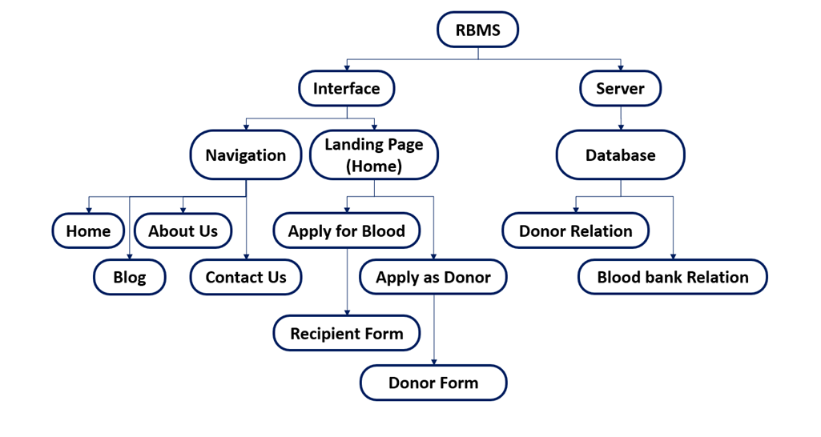

***Figure B.1****: Diagram showing the structure of application.*

Our Real time Blood management system initially is divided into two parts Interface part and Server part.

Interface part act a way of communication between the recipient, donor and blood bank, here we divide the different part of system in components; Like: Navigation and Landing Page or Home.

Both Navigation and Landing Page/Home are further divided into many other sections as per the requirement of the user interface.

Server has database which have two relations, one having information about the donors and the other having the information about the blood banks present in the specific reason and resource available in the blood banks