MINOR PROJECT REPORT

EKATRA – ADAPTIVE MULTI-AGENT ORCHESTRATION FRAMEWORK FOR AUTONOMOUS SOFTWARE DEVELOPMENT

Submitted in partial fulfilment of the requirements
for the award of the degree
Bachelor of Technology
in
Artificial Intelligence & Machine Learning

under the guidance of

[Name of Supervisor]

Submitted by
Tejas Bhalla, [Enrollment Number], [Branch & Section]
[Name of Group Member 2], [Enrollment Number], [Branch & Section]
[Name of Group Member 3], [Enrollment Number], [Branch & Section]


VIVEKANANDA INSTITUTE OF PROFESSIONAL STUDIES - TECHNICAL CAMPUS
Grade A++ Accredited Institution by NAAC
NBA Accredited for MCA Programme; Recognized under Section 2(f) by UGC;
Affiliated to GGSIP University, Delhi; Recognized by Bar Council of India and AICTE
An ISO 9001:2015 Certified Institution

Academic Year: 2026-27
DECLARATION
This is to certify that Minor Project Report titled "Ekatra – Adaptive Multi-Agent Orchestration Framework for Autonomous Software Development", for the Minor Project (AIML451) submitted by Name-1 (Enrollment No-1), Name-2 (Enrollment No-2), Name-3 (Enrollment No-3) in partial fulfillment of the requirement for the award of degree B.Tech. in Artificial Intelligence and Machine Learning pursued from School of Engineering & Technology, VIPS-TC (affiliated to GGSIP University, Delhi) comprises of our original work. The due affirmation has been made within the report for utilizing the referenced work.
Date:
<Signature>
<Name of Student, Enrollment No>
<Signature>
<Name of Student, Enrollment No>
<Signature>
<Name of Student, Enrollment No>
CERTIFICATE
This is to certify that Minor Project Report titled "Ekatra – Adaptive Multi-Agent Orchestration Framework for Autonomous Software Development" for the Minor Project (AIML451) is submitted by Name-1 (Enrollment No-1), Name-2 (Enrollment No-2), Name-3 (Enrollment No-3) in partial fulfillment of the requirement for the award of degree B.Tech in Artificial Intelligence and Machine Learning, VIPS-TC (affiliated to GGSIP University, Delhi). It is a record of the candidates own work carried out by them under my supervision. The matter embodied in this report is original and has not been submitted for the award of any other degree.

Date: <Signature of Supervisor>
<SUPERVISOR NAME, DESIGNATION>

Dr. Adeel Hashmi
HOD, Dept. of AIML
ACKNOWLEDGEMENT
We would like to express our heartfelt gratitude to all those who have contributed to the successful completion of our minor project report. First and foremost, we would like to extend our deepest appreciation to our supervisor, [Supervisor's Name], for [his/her] constant guidance, valuable insights, and unwavering support throughout this journey. We are also indebted to the staff and faculty members of School of Engineering & Technology, VIPS-TC, whose expertise and cooperation were instrumental in enhancing our learning experience. Additionally, we are grateful to our fellow students who provided us with invaluable feedback and encouragement.
TABLE OF CONTENTS
Chapter-1. INTRODUCTION 1
1.1 Background and Motivation 1
1.1.1 Background 1
1.1.2 Motivation 1
1.2 Objectives and Scope 2
1.2.1 Objectives 2
1.2.2 In scope 2
1.2.3 Out of scope 3
1.3 Research Question and Hypothesis 3
1.4 Technologies Used 4
1.5 Literature Survey 4
1.5.1 LLM-based software agents 4
1.5.2 Multi-agent software teams 4
1.5.3 Resource adaptation in other fields 5
1.5.4 Gap addressed 5
1.6 Methodology, Feasibility and Requirements 6
1.6.1 Development Methodology 6
1.6.2 Feasibility Study 6
1.6.3 Functional requirements 7
1.6.4 Non-functional requirements 7
1.6.5 Hardware and software environment 7
1.7 Organisation of the Report 8
Chapter-2. EKATRA – ADAPTIVE MULTI-AGENT ORCHESTRATION FRAMEWORK FOR AUTONOMOUS SOFTWARE DEVELOPMENT 9
2.1 Problem Statement 9
2.2 Software Design 9
2.2.1 Overall architecture 9
2.2.2 The six agent roles and their prompts 10
2.2.3 Task model, agent lifecycle and communication 11
2.3 Adaptive Controller Design 12
2.3.1 Feedback loop, workload score and actions 12
2.3.2 Decision order and safeguards of the controller 13
2.3.3 Why the language model does not control scaling 14
2.3.4 Worked example of a controller decision 15
2.3.5 Simulated-clock engine and a worked trace 16
2.3.6 Seeding and determinism of the experiments 17
2.4 Real Build Pipeline and Project Types 17
2.4.1 Real build mode 17
2.4.2 The stages of a real build in detail 18
2.4.3 Project profiles and project types 18
2.4.4 Check pipeline 20
2.4.5 Change or fix an existing project 20
2.4.6 Change requests in detail 20
2.4.7 Fallback behaviour 21
2.5 Implementation 21
2.5.1 Code organisation 21
2.5.2 Gemini integration and rate limits 22
2.5.3 Planning and task execution 22
2.5.4 Checks and blame assignment 22
2.5.5 Settings and secrets 23
2.5.6 Live orchestration, observability and restoring 23
2.5.7 API and dashboard 24
2.6 Security, Testing and Verification 24
2.6.1 Security and privacy design 24
2.6.2 Threat model 25
2.6.3 Testing 25
2.6.4 Test strategy 26
2.7 Problems, a Worked Build and Design Decisions 27
2.7.1 Problems met and how they were solved 27
2.7.2 End-to-end example of a build 27
2.7.3 Version control 28
2.7.4 Architecture decisions 28
Chapter-3. USER INTERFACE 29
3.1 Home Screen and Mode Selector 29
3.2 Build Panel 29
3.3 Validation Issues, Change Panel and Project Checks 31
3.4 Agent Organisation and Adaptive Controller 32
3.5 Workload, Risk and Task Flow 33
3.6 Events and Experiment Metrics 33
3.7 Walkthroughs, Command Line and Interface Design 34
3.7.1 Building a new project 34
3.7.2 Changing a finished project 35
3.7.3 Comparing strategies 35
3.7.4 Command-line Interface 35
3.7.5 Interface Design Principles 35
3.7.6 Error Handling in the Interface 36
Chapter-4. DISCUSSION & FUTURE SCOPE 38
4.1 Experimental Set-up and Scenarios 38
4.1.1 Experimental scenarios 38
4.2 Results 38
4.2.1 Waiting time 39
4.2.2 Peak number of agents 40
4.2.3 Spawns and terminations 40
4.2.4 Reproducing the results 41
4.3 Discussion of Results 41
4.3.1 Where adaptation helped 41
4.3.2 Why the parallel backlog benefits 41
4.3.3 Where adaptation made no difference 42
4.3.4 Summary across scenarios 42
4.3.5 Resource Use 42
4.3.6 Time and resources together 43
4.3.7 Statistical caution 43
4.3.8 Implications for building AI software teams 43
4.4 Real Builds with Gemini 43
4.4.1 Case study: recipe-sharing website 44
4.4.2 Case study: student wellbeing website 44
4.4.3 Case study: command-line to-do manager 44
4.5 Limitations and Threats to Validity 45
4.5.1 Threats to Validity 46
4.6 Lessons Learned, Responsible Use and Objectives 46
4.6.1 Lessons Learned 46
4.6.2 Responsible Use 47
4.6.3 Status of the objectives 47
4.7 Conclusion and Future Scope 47
4.7.1 Conclusion 47
4.7.2 Future Scope 48
REFERENCES 49

LIST OF FIGURES
2.1 Architecture of Ekatra 10
2.2 Task state transitions 11
2.3 Adaptive feedback loop 13
3.1 Home screen with the mode selector, orchestration flow and run controls 29
3.2 Build panel with project types, description box, generated files and agent activity log 30
3.3 Validation issues, change panel and project checks 31
3.4 Agent organisation graph and the deterministic Adaptive Controller panel 32
3.5 Workload and risk cards and the task board 33
3.6 Event timeline, research metrics and fixed-versus-adaptive comparison 34
4.1 Completion time by scenario, fixed versus adaptive 39
4.2 Average task waiting time by scenario 40
4.3 Peak number of active agents by scenario 40
4.4 Agents spawned and terminated by the adaptive strategy 41
LIST OF TABLES
1.1 Technologies and their purpose 4
1.2 Comparison of Ekatra with related approaches 5
1.3 Sprint plan and outcome 6
2.1 Agent roles and responsibilities 10
2.2 Actions of the Adaptive Controller 13
2.3 Configurable parameters 15
2.4 Workload calculation for the backend role 15
2.5 Supported project types 19
2.6 Checks applied to a generated project 20
2.7 Security threats and countermeasures 25
2.8 Test coverage by area 26
2.9 Problems encountered during development 27
4.1 Scenarios used in the evaluation 38
4.2 Completion time of fixed and adaptive strategies (simulated seconds) 38
4.3 Waiting time, peak agents and success rate 39
4.4 Real builds that were run 43
4.5 Threats to the validity of the results 46
4.6 Status of the objectives 47

Chapter-1. INTRODUCTION

1.1 Background and Motivation

1.1.1 Background
Software development is a collaborative activity. A real project is rarely written by one person: a product manager decides what must be built, an architect decides how the parts fit together, developers write the code, testers look for defects and security engineers look for weaknesses. Large language models (LLMs) have recently become capable enough to play each of these roles. A model can read a description, break it into tasks, write source files, write tests and review code written by someone else.
This has led to a growing interest in multi-agent systems for software engineering. In such a system several LLM-driven agents, each with a specialised role and a specialised prompt, cooperate to build software. The agents exchange messages, hand work to each other and review each other's output. Frameworks of this kind have shown that a team of specialised agents can often produce better results than a single agent given the whole problem at once.
Almost all of these systems, however, use a fixed organisation. The set of agents is decided before the run starts and does not change. If a project turns out to contain a large number of backend tasks and very few frontend tasks, the one backend agent becomes a bottleneck while the frontend agent sits idle. If the project is security sensitive, the single security agent cannot be reinforced when the risk rises. The team is static even though the work is not.
Ekatra (the Sanskrit word for "together") is a research prototype that asks whether the organisation of an AI software team should itself be dynamic. It models a virtual software company made of six roles and adds a deterministic Adaptive Controller that watches the project and, when measurable conditions justify it, spawns extra agents, terminates idle ones, reassigns tasks and raises the priority of risky work.

1.1.2 Motivation
The motivation for the project comes from three observations.
- Workload is uneven. Different phases of a project load different roles. A static team is either too small for the busy phase or too large for the quiet phase.
- Risk changes during a run. A security finding discovered late in a build should be able to attract more security capacity, which a fixed team cannot provide.
- Resources cost money. Every extra LLM agent consumes tokens and time. Keeping agents that have nothing to do is wasteful, so an organisation that releases idle capacity is preferable.
A further motivation came during development. A first version of Ekatra only simulated software development: the agents produced mock outputs and the evaluation could only compare scheduling. The project was therefore extended so that the same orchestration drives agents that really write, test, review and repair actual software using the Gemini API. This turned Ekatra from a model of an AI software company into a working tool that builds runnable projects from a text description.

1.2 Objectives and Scope

1.2.1 Objectives
The objectives of the project are:
- To design a virtual software organisation of six specialised agents (Project Manager, Architect, Frontend Developer, Backend Developer, QA and Security).
- To implement a deterministic Adaptive Controller that computes workload and risk scores and chooses one of five actions: CONTINUE, SPAWN, TERMINATE, REASSIGN or PRIORITIZE.
- To keep the LLM out of the scaling decision so that every adaptation is measurable, repeatable and explainable.
- To implement a fixed baseline organisation that uses exactly the same task model and execution semantics, so that orchestration is the only experimental variable.
- To build a real build mode in which Gemini-driven agents plan, write, test, review and repair actual software, and to support eight kinds of project rather than websites only.
- To allow a finished project to be changed or fixed later through a plain-text request.
- To provide a FastAPI backend and a Next.js dashboard that show agents, tasks, spawns and files live while a build runs.
- To evaluate fixed versus adaptive orchestration on controlled scenarios using a deterministic simulated clock and to report the results honestly, including the cases where adaptation does not help.

1.2.2 In scope
- Role-based multi-agent orchestration with a shared task model (PENDING, ASSIGNED, RUNNING, COMPLETED, FAILED, RETRY).
- A deterministic controller based on workload and risk formulas with configurable thresholds.
- Real software generation for eight project types: website, REST API service, command-line tool, Python library, data-analysis script, database application, text game and automation script.
- Automatic checks of the generated software (static analysis, running the program and running the tests the QA agent wrote), followed by repair rounds.
- Change and fix requests applied to an existing generated project.
- REST and Server-Sent-Events API, and a dashboard with Demo, Experiment, Live Backend and Build modes.
- Experiments on a simulated clock with seeded randomness.

1.2.3 Out of scope
- Mobile applications, which need platform toolchains (Android or iOS) that the checking pipeline does not provide.
- Claims about the quality of LLM output in general. Real builds are demonstrated, not statistically benchmarked.
- Letting the LLM decide how many agents to run. This is deliberately excluded.
- Distributed execution across machines and persistent databases for telemetry.

1.3 Research Question and Hypothesis
The research question is: can a software-engineering multi-agent organisation that adapts its team size to measurable workload and risk achieve comparable or better outcomes than a fixed team of the same roles?
The working hypothesis is that adaptive orchestration reduces completion time and queue waiting when a role has several tasks that can run in parallel, and that it adds no benefit (and should therefore be expected to behave like the fixed baseline) when the work is a strictly sequential chain. The second half of the hypothesis is as important as the first: a controller that spawns agents which cannot be used is only overhead.

1.4 Technologies Used
Table 1.1. Technologies and their purpose
Technology | Purpose
Python 3.13 | Core language of the orchestration engine, agents, build pipeline and API
LangGraph 1.2 | State-graph workflows for the fixed and adaptive demonstration workflows
Google Gemini (gemini-3.5-flash-lite) | LLM used by agents through the google-genai SDK in JSON mode
Pydantic and pydantic-settings | Typed configuration and validation; the API key is held as a secret value
FastAPI and Uvicorn | REST endpoints and Server-Sent Events for live build streaming
Next.js 16, React, framer-motion | Dashboard front end
pytest | Automated tests (475 tests) and the tests written by the QA agent for generated projects
matplotlib | Charts for the evaluation chapter
Git and GitHub | Version control and collaboration

1.5 Literature Survey
This section places Ekatra among existing work. The purpose is not to survey the whole field but to identify the ideas that Ekatra borrows and the one gap that it tries to address.

1.5.1 LLM-based software agents
Early work on language-model agents showed that interleaving reasoning with actions (the ReAct pattern) lets a model use tools and correct itself. Later systems applied this to software engineering. SWE-agent introduced a purpose-designed interface between a model and a computer, so that the model can browse a repository, edit files and run tests. These systems demonstrate that a single agent can fix real defects, but a single agent carries the whole task in one context and one prompt.

1.5.2 Multi-agent software teams
MetaGPT organises agents as a software company and makes them exchange structured documents such as requirement documents and design documents instead of free conversation. ChatDev models a virtual software company in which agents with roles such as chief executive, programmer and tester talk to each other in phases (design, coding, testing). AutoGen provides a general framework in which customisable agents converse with each other and with humans to solve tasks. These systems share a common property: the number and roles of agents are chosen in advance and stay the same for the whole run.

1.5.3 Resource adaptation in other fields
Adaptive resource allocation is well established outside AI. Cloud platforms scale the number of replicas of a service up and down according to measured load, for example CPU use or queue length. In autonomic computing, the MAPE-K loop (Monitor, Analyse, Plan, Execute over shared Knowledge) is a standard model of a self-adaptive system. Ekatra's observe-analyse-decide-allocate-execute-evaluate-adapt loop follows the same idea, applied to a team of software agents instead of servers.

1.5.4 Gap addressed
Role-based multi-agent software systems exist, and autoscaling exists, but there is little work that combines the two and measures it fairly against a fixed team. Ekatra therefore contributes (a) a deterministic controller that scales agent roles using explicit workload and risk scores, (b) a baseline that differs only in orchestration, and (c) an evaluation that reports the cases where scaling does not help, together with (d) a real build mode that shows the approach working on actual software.
Table 1.2. Comparison of Ekatra with related approaches
Aspect | MetaGPT / ChatDev style | AutoGen style | Ekatra
Roles | Fixed company roles | User-defined agents | Six fixed roles, several instances each
Team size at run time | Fixed | Fixed by the program | Changes by controller decisions
Who decides scaling | Not applicable | Not applicable | Deterministic controller, not the LLM
Baseline comparison | Usually against other systems | Usually task benchmarks | Fixed team with identical task model
Output | Code project | Task result | Code project, tests, reports; change requests
Checks of output | Varies | Varies | Static, runtime and agent-written tests with repair

1.6 Methodology, Feasibility and Requirements

1.6.1 Development Methodology
The project followed an incremental, agile approach. Work was divided into sprints, and each sprint followed the rule Implement, Test, Run, Review, Commit before the next feature was started. A subsystem was not extended while the previous one was unstable. This kept the deterministic core small and well tested before the LLM-driven parts were attached to it.
Table 1.3. Sprint plan and outcome
Sprint | Content | Result
0 | Requirements, architecture, environment, Git, documentation | Stable foundation and design documents
1 | Static six-role LangGraph workflow | Basic fixed multi-agent workflow
2 | Task model, queue, states, dependencies, retries | Reliable deterministic state management
3 | Structured agent inputs and outputs, shared state | Functional six-agent organisation
4 | Adaptive Controller, workload score, spawn and terminate | First working adaptive loop
5 | Risk score, risk-aware priority and security allocation | Adaptation by workload and risk
6 | File, test and development tools | Agents able to operate on a workspace
7 | Event log, metrics, experiment records, dashboard | Observable runs
8 | Fixed versus adaptive experiment harness | Scenario dataset
9 | Simulated clock, evaluation, real Gemini builds, project profiles, change feature, report | Evaluation and a working software builder

A first analysis of the project at the start of the later sprints found problems that made the research question impossible to answer. Spawned agents never executed any task, task dependencies were not checked before a task started, mock execution took microseconds so timing comparisons were meaningless, and waiting time was reported as hundreds of days because two different clocks were mixed. These were fixed before any comparison was made, as described in Chapter 2.

1.6.2 Feasibility Study
The project is technically feasible because every component exists in Python or JavaScript, and because the Gemini API returns JSON, which makes plans and generated files machine readable. The orchestration core needs no network, so it can be tested offline. It is economically feasible because the free tier of the Gemini API and open-source libraries were enough, and the cost of a build is bounded by capping the number of agents and the number of simultaneous model calls. It is operationally feasible because a user needs only a description and a browser, and nothing beyond the API key has to be configured. The main risks were rate limits and unreliable model output, which are handled by backoff, plan validation, fallback plans and repair rounds.

1.6.3 Functional requirements
- The system shall accept a software description and a project type.
- It shall decompose the description into tasks with roles, priorities, complexity and dependencies, and shall never start a task whose dependencies are not completed.
- It shall track task states and retry failed tasks without losing their history.
- It shall compute workload and risk scores on a 0–100 scale from normalised inputs and choose one of CONTINUE, SPAWN, TERMINATE, REASSIGN or PRIORITIZE, logging the reason, and shall never terminate an agent that is running a task.
- It shall provide a fixed baseline that never scales, so that orchestration is the only difference between the two strategies.
- It shall generate real project files, tests and reports with Gemini-driven agents, check them, and repair the problems it finds.
- It shall modify an existing project from a text request, and stream the progress of a build to a dashboard.
- It shall record metrics and the full configuration of every experiment run.

1.6.4 Non-functional requirements
- Reproducibility: experiments use seeded randomness and store their configuration.
- Configurability: weights, thresholds, agent limits and retry limits are settings, not constants.
- Security: the API key is never printed or committed; generated code runs in a subprocess with a scrubbed environment.
- Testability: all deterministic components have automated tests that need no network.
- Observability: every decision records what happened, why and what changed.
- Robustness: failures of the model (rate limits, malformed output) must not crash a build.

1.6.5 Hardware and software environment
The system was developed and tested on Windows 11 with Python 3.13 and Node.js 22. The Python packages are langgraph, google-genai, pydantic, pydantic-settings, fastapi, uvicorn, pytest, matplotlib and httpx, and the front end uses Next.js 16, React, framer-motion and lucide-react. The only external service is the Google Gemini API (model gemini-3.5-flash-lite). An ordinary laptop is sufficient, because inference is remote and no GPU is needed.

1.7 Organisation of the Report
Chapter 1 introduces the problem and the objectives. Chapter 2 states the problem formally, describes the software design (architecture, agents, task model, adaptive controller, build pipeline, project profiles, change feature, API) and explains the implementation and testing. Chapter 3 presents the user interface with screenshots of every screen. Chapter 4 discusses the experimental results, the real builds that were run, the limitations and the future scope. The report ends with references and an appendix.
The main terms used are the following. An agent is an LLM-driven worker with a role, a prompt and a tool policy; a role is a responsibility such as Backend, and a pool is the set of agents currently available for one role. The controller is the deterministic component that changes the pools. The fixed strategy keeps one agent per role for the whole run, and the adaptive strategy lets the controller grow and shrink the pools. A profile describes one project type, with its layout, prompts and checks. Blame means assigning a failed check to the file and the agent that own it, and a repair round is a cycle of fix tasks followed by new checks. The simulated clock is the virtual time used in the experiments so that results are deterministic. SSE stands for Server-Sent Events, the one-way stream from the server to the browser, and ADR for architecture decision record.

Chapter-2. EKATRA – ADAPTIVE MULTI-AGENT ORCHESTRATION FRAMEWORK FOR AUTONOMOUS SOFTWARE DEVELOPMENT

2.1 Problem Statement
Multi-agent systems are increasingly used to automate software development. Existing approaches organise the agents into predefined roles and workflows, and each agent keeps the same responsibility for the whole run. Role specialisation divides complex work well, but a fixed team cannot respond to a changing project. A project that temporarily contains many backend tasks and few frontend tasks creates a bottleneck at a single backend agent while other agents have spare capacity. Assigning several agents to a lightly loaded role wastes computation and tokens. A security-sensitive implementation may need extra analysis that the initial team cannot supply.
The problem addressed by this project is therefore twofold:
- Design an orchestration layer that observes measurable workload and risk during execution and adapts the team (spawn, terminate, reassign, prioritise) using deterministic rules rather than LLM judgement.
- Make the system actually build software, not only simulate it, so that the orchestration is exercised on real work: planning, writing code, testing, reviewing and repairing, for several kinds of software.
The system must be evaluated fairly against a fixed-team baseline, and the evaluation must report the situations in which adaptation gives no advantage.

2.2 Software Design

2.2.1 Overall architecture
Ekatra is organised in layers. The top layer is the user interface (a Next.js dashboard). It talks to a FastAPI backend through REST calls and a Server-Sent-Events stream. The backend starts builds, which are executed by the build engine. The build engine contains the planner, the agent pool, the Adaptive Controller, the project workspace and the checking and repair pipeline. The LLM is reached only through a single wrapper module. Figure 2.1 shows the main components and the flow between them.
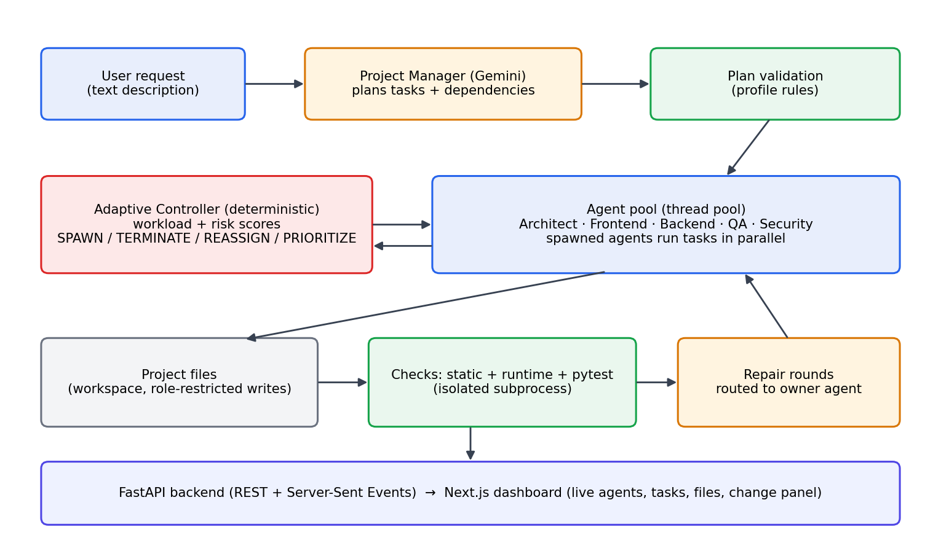
Figure 2.1. Architecture of Ekatra
The central design rule is a separation of responsibilities. The LLM is used for creative work: planning the tasks, writing files, writing tests and reviewing code. The deterministic controller is used for every resource decision: how many agents exist and what they do next. Because the controller is ordinary code with explicit thresholds, each decision can be logged with its reason and reproduced exactly.

2.2.2 The six agent roles and their prompts
Table 2.1. Agent roles and responsibilities
Role | Responsibility | May write
Project Manager | Turns the description into a task plan with dependencies and chooses the package name | Plan only
Architect | Writes the architecture document: modules, public functions, data formats and contracts | docs/
Frontend Developer | Writes user-facing files (HTML, CSS, JavaScript) or the CLI / interface layer for non-web projects | Role prefixes of the profile
Backend Developer | Writes server, storage and business-logic modules | Role prefixes of the profile
QA / Testing | Writes pytest tests and the final QA report; updates tests when behaviour changes | tests/, docs/
Security | Reviews the code and writes the security report | docs/

Each role has a tool policy that restricts which directories it may write. A backend agent cannot overwrite the tests, and a QA agent cannot rewrite the source it is testing. This prevents an agent from "fixing" a failing test by weakening it.
Every agent has a role-specific instruction, a structured input and a structured output, and may access only the tools it needs. The instructions are produced by a template that is filled with the project description, the profile and the files relevant to the task. Giving each role its own narrow instruction keeps the prompts short and reduces the chance that an agent drifts out of its responsibility.
The Project Manager receives the description, the project type and the rules of the profile (and, for a change, the list of existing files) and returns a JSON plan with the package name and the tasks. The Architect receives the description and the plan and writes docs/architecture.md, which lists the modules, function signatures, data formats and the command or endpoint contract. The Frontend and Backend developers receive the task text, the architecture document and the files of earlier tasks, and return a JSON mapping of file paths to complete file contents. QA receives the architecture document and the implemented source and writes pytest files in tests/ and a QA report. Security receives the same material and writes docs/security-report.md with findings and severities.
The write policy of each role is enforced in code. A file returned by the model is accepted only when its path starts with one of the prefixes that the role may write; otherwise the file is rejected and the task is marked as failed so that it can be retried with the error in its prompt. In a repair task the agent also receives the text of the failing check and the current content of the file, so that it changes only what is wrong.

2.2.3 Task model, agent lifecycle and communication
Every unit of work is a task with an identifier, a role, a complexity value, a priority, dependencies and a status. A task starts as PENDING, becomes ASSIGNED when an agent is chosen, RUNNING while the agent works and COMPLETED when it finishes. A failed task moves to FAILED and, while retries remain, to RETRY and back into the queue under the same identifier so that its history is preserved. A task may start only when all of its dependencies are COMPLETED.
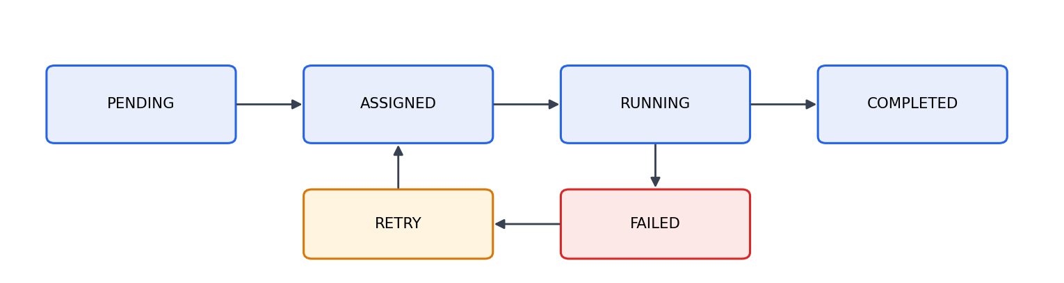
Figure 2.2. Task state transitions
The task is the unit that every component shares: the planner creates it, the manager tracks it, the controller reads it, the agents execute it and the metrics describe it. Its fields are fixed so that all components interpret it in the same way.
- id: a stable identifier such as TASK-7 that is kept across retries and reassignment.
- role and description: the role that must execute the task and what it must produce; for developers the description names the files.
- priority and complexity: integers (priority 1 to 3) used when several tasks are ready and by the workload model and the simulator.
- dependencies: identifiers of tasks that must be COMPLETED first.
- risk and status: a risk value that lets high-risk tasks be prioritised, and one of PENDING, ASSIGNED, RUNNING, COMPLETED, FAILED or RETRY.
- assigned_agent, retry_count and timestamps: the current owner, the number of retries and the times of creation, start and finish read from the active clock.
An agent is created, becomes idle, becomes active while it executes a task, returns to idle and may finally be terminated. The system always knows which agents are available, active, busy, completed or terminated. An active agent is never terminated. A role is not the same as an agent: the system has six roles, but a role may have a pool of several agents. In the fixed organisation every pool has exactly one agent. In the adaptive organisation each pool starts with one agent and the controller may grow it up to a configured limit. Spawned agents receive identifiers such as BACKEND-2 and BACKEND-3, so the dashboard and the logs can tell them apart.
Agents do not hold free conversations. They communicate through structured shared state: the output of a task, such as the architecture document, becomes input to the tasks that depend on it. This keeps the information flow explicit, limits the size of each prompt, and makes it possible to log exactly what each agent knew. In real builds the files written by earlier tasks are given to later tasks as context, which is how a frontend task knows the endpoints that the backend task created.

2.3 Adaptive Controller Design

2.3.1 Feedback loop, workload score and actions
The controller follows the feedback loop in Figure 2.3. It observes the task queue, running tasks, complexity, delay, failures and agent availability. It analyses them into two scores between 0 and 100, then decides an action.
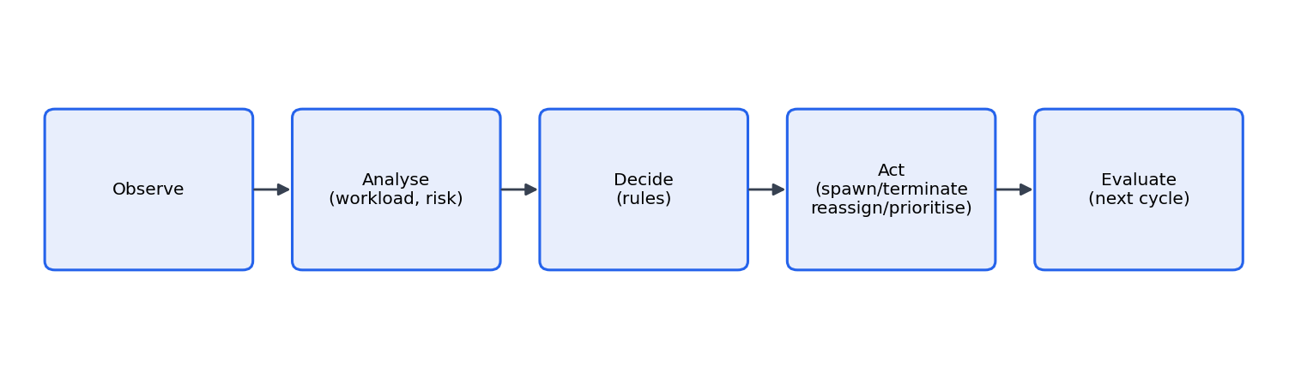
Figure 2.3. Adaptive feedback loop
The workload score of a role is a weighted sum of four normalised inputs:
W = 0.40 x QueueLength + 0.30 x Complexity + 0.20 x ExecutionDelay + 0.10 x FailureRate
The risk score is computed from measurable indicators such as security findings, failed security checks, repeated failures and the number of high-risk tasks. Thresholds for both scores are configuration values, not constants hidden in the logic. The five actions are:
Table 2.2. Actions of the Adaptive Controller
Action | When it is chosen | Effect
CONTINUE | Scores are within thresholds | No change
SPAWN | A role's workload exceeds the spawn threshold and the role is below its agent limit; or risk is high and security capacity is low | A new agent of that role joins the pool and takes ready tasks
TERMINATE | Workload stays low and a spawned agent is idle with no pending work | The idle spawned agent is released; an active agent is never terminated
REASSIGN | A task waits on a busy agent while an idle suitable agent exists | The task moves to the idle agent keeping its id and history
PRIORITIZE | A high-risk or blocking task has a priority below the maximum | Its priority is raised and the change is logged

The fixed baseline never calls the controller. It keeps one agent per role for the whole run. Both strategies use the same planner, the same task model and the same execution code, so the only difference between them is the orchestration.

2.3.2 Decision order and safeguards of the controller
In every cycle the controller first computes a workload score for each role and one risk score for the project. It then evaluates its rules in a fixed order, so the same state always produces the same decision. The rule for SPAWN picks the role with the highest workload, and fires only if that workload is above the spawn threshold and the pool of that role is smaller than the limit. A second SPAWN rule fires for the Security role when the risk score is above the high-risk threshold and the security pool is below its limit. The rule for TERMINATE looks for a spawned agent that is idle, for which no pending task exists, while the workload is low. REASSIGN moves a task that is waiting for a busy agent to an idle agent of the same role. PRIORITIZE raises the priority of tasks whose risk is above the high-risk task threshold and whose priority is still below the maximum. If no rule fires the decision is CONTINUE, and the reason records the range of workload scores and the risk score that were observed.
Several safeguards keep the controller safe. The number of agents per role never exceeds the configured limit, so a mistaken threshold cannot create an unlimited number of agents. An agent that is running a task is never terminated, so no work is lost. The original agent of each role is never removed, so the organisation always keeps one agent per role. A task keeps its identifier and history when it is reassigned, so the metrics remain correct. And every decision is written to the event log together with the scores, the thresholds and the pool sizes before and after, so that a reader can verify afterwards that the controller followed its rules.

2.3.3 Why the language model does not control scaling
A natural design for an AI software team would be to ask the language model, from time to time, whether more agents are needed. Ekatra deliberately does not do this. Four reasons led to the decision. First, reproducibility: a model may answer differently to the same question on two occasions, so an experiment that depended on its answer could not be repeated and the comparison with the fixed baseline would be confounded by randomness. Second, testability: the controller is ordinary code, so a test can construct a state, call the controller and assert that it returns SPAWN, TERMINATE or CONTINUE, which would be impossible with a model in the loop. Third, cost and latency: every question to the model costs tokens and time, and the purpose of the controller is to save both. Fourth, explainability: a decision made by a formula can be explained exactly, by naming the score, the threshold and the state that produced it, whereas a decision made by a model can only be described afterwards.
The language model is therefore confined to the work in which it is strong, which is understanding text and producing code and documents. Whatever it returns about the number of agents is ignored, and a plan that tried to set the team size would not be accepted by the plan validator.
The workload formula requires inputs on a common scale, so each component is normalised to 0–100 and clamped. The queue length is scaled against a reference of ten tasks (a queue of ten or more tasks gives a full queue component). Complexity is the average complexity of the outstanding tasks divided by the maximum on the 1–5 complexity scale. The execution-delay component is the observed delay ratio multiplied by 100, and the failure component is the observed failure ratio multiplied by 100. The weighted sum is again clamped to 0–100. The default thresholds are 40 and 70: below 40 the workload is normal, between 40 and 70 it is monitored, and above 70 the controller considers a spawn. All of these values (weights, reference queue, thresholds) are configuration, not constants in the decision code. The score is computed from outstanding work only, not completed work, because finished work no longer loads the system; this is what makes TERMINATE reachable, since the score falls as queues drain and idle spawned agents can then be released.
- Security findings and authentication or authorisation problems reported by the Security agent.
- Failed security checks and tasks that needed repeated retries.
- The number of tasks whose risk value is above the high-risk task threshold.
- Suspicious code found by the static checks of the generated files.
When the risk score is above the high-risk threshold and the security pool is below its limit, the controller spawns a security agent. Independently, the controller may raise the priority of tasks whose risk is above the high-risk task threshold when their priority is below the maximum.
Table 2.3. Configurable parameters
Parameter | Meaning
Workload weights | Weights of queue, complexity, delay and failure rate in the workload score
Workload thresholds | Score below which the controller continues, and above which it considers a spawn
Risk thresholds | Score above which risk is considered high
max_agents_per_role | Upper limit of agents in a pool (four in experiments, three in real builds)
max_task_retries | How often a failed task is retried
Simulation parameters | Base duration unit, jitter, seeds and failure probabilities
max_retries, repair_rounds | Real build: task retries and repair rounds (three and two by default)
max_concurrent_llm | Real build: simultaneous Gemini calls (two by default)
Model settings | Provider and model name taken from the environment

2.3.4 Worked example of a controller decision
The following example uses the default configuration to show how the numbers lead to a decision. Suppose the backend role has eight outstanding tasks with an average complexity of 3.5, the delay ratio is 0.5 and 10 percent of recent attempts have failed, and the role has one agent.
Table 2.4. Workload calculation for the backend role
Component | Raw value | Normalised (0–100) | Weight | Contribution
Queue length | 8 tasks (reference 10) | 80 | 0.40 | 32.0
Complexity | 3.5 (maximum 5) | 70 | 0.30 | 21.0
Execution delay | ratio 0.5 | 50 | 0.20 | 10.0
Failure rate | 0.10 | 10 | 0.10 | 1.0
Workload score |  |  |  | 64.0

A score of 64 lies between 40 and 70, so the controller only monitors. If two more tasks arrive and the queue reaches ten, the queue component becomes 100 and the score rises to 72.0, which is above 70. The role has one agent and the limit is four, so the controller chooses SPAWN, creates BACKEND-2, records the decision with the reason "workload 72.00 for backend exceeded spawn threshold 70" and logs the state before and after. In the next scheduling step the ready backend tasks are shared between BACKEND-1 and BACKEND-2. When the backend queue later drains and the score falls below the low threshold while BACKEND-2 is idle, the controller chooses TERMINATE for BACKEND-2. BACKEND-1 is never terminated, and neither is an agent that is running a task.

2.3.5 Simulated-clock engine and a worked trace
Mock agents finish in microseconds, so wall-clock timing cannot show whether extra agents help. The experiments therefore run on a deterministic discrete-event engine with a virtual clock. Each task takes a duration proportional to its complexity with a seeded jitter, and failures are drawn from a seeded generator. The engine repeatedly collects ready tasks, lets the controller act (adaptive strategy only), assigns ready tasks to every idle agent of the right role, advances the clock to the next completion and completes or fails that task. Because durations and failures are hashed from the scenario seed and the task identity, paired runs of the two strategies see exactly the same task durations and failures. This makes a comparison between strategies a paired comparison.
Consider a role with three independent tasks of equal complexity, each lasting 100 simulated seconds, and a fixed organisation with one agent for the role. The engine starts the first task at time 0, finishes it at 100, starts the second and finishes it at 200, and finishes the third at 300. In the adaptive organisation the controller sees a queue of three tasks before the first assignment. If the workload crosses the threshold it spawns a second agent, and the engine assigns the first two tasks at time 0 and the third at 100, so that all work finishes at 200. The completion time falls by one third. If the three tasks were a chain, each depending on the one before, only one of them could be ready at any time. The extra agent would have nothing to start, and the completion time would stay at 300 whatever the controller did. This simple example is the mechanism behind the results of the parallel backlog scenario on one hand and of the high backend scenario on the other.
The engine breaks ties deterministically: tasks are sorted by priority and then by identifier, and agents by identifier, so the same inputs always give the same schedule. Failures use the same seeded draw for a given task and attempt in both strategies, so a failure that occurs in the fixed run also occurs in the adaptive run.

2.3.6 Seeding and determinism of the experiments
Reproducibility in the experiments depends on one rule: nothing is random except through a seed. The duration of a task is its complexity multiplied by a base unit and by a jitter factor, and the jitter is a hash of the scenario seed, the repetition number and the task identifier. Whether an attempt fails is decided in the same way, from a hash of the seed, the task identifier and the attempt number. Because the hash does not depend on which agent runs the task, the fixed and the adaptive strategy see identical durations and identical failures, and the only thing that differs between them is how many agents are available. Repeating an experiment with the same settings gives identical numbers, and changing only the repetition number gives a new but equally reproducible sample.

2.4 Real Build Pipeline and Project Types

2.4.1 Real build mode
In real build mode the same controller drives agents whose work is performed by Gemini. A build proceeds in stages:
- The Project Manager asks Gemini for a JSON plan: a package name and a list of tasks with role, description, complexity, priority and dependencies. The plan is validated against the rules of the chosen project profile. If the model fails or returns an invalid plan, a deterministic fallback plan for that profile is used and the dashboard shows that the plan source was a fallback.
- Tasks are executed in dependency order by a thread pool. A semaphore limits concurrent LLM calls so that the API rate limit is respected. Each developer task is told which files it owns and receives the architecture document and the files it depends on.
- After the tasks finish, the project is checked: static checks (syntax, imports, required files, presence of tests), then a runtime check that runs the program's entry command and the tests in an isolated subprocess with a scrubbed environment.
- Each problem found is traced to the file and the agent that owns it. Repair tasks are scheduled for those agents and the checks run again, for up to a configured number of repair rounds. Repair tasks may also create a missing module.
- The result is saved to the project folder together with a README and a machine-readable run record (ekatra-run.json).

2.4.2 The stages of a real build in detail
A real build has six stages. In the planning stage the Project Manager receives the description and the rules of the profile and returns a plan. The prompt states the allowed roles, the directory layout of the profile, the files that each role may write and the rule that tasks must form an acyclic graph. The reply is parsed and validated: roles must exist, dependencies must refer to tasks of the plan and must not form a cycle, the file prefixes of each task must belong to its role, and a QA task and a Security task must be present where the profile requires them. If validation fails after retries, the deterministic fallback plan of the profile is used, and the dashboard marks the plan source as fallback.
In the execution stage a thread pool runs the tasks in dependency order. The Architect runs first and writes the architecture document, which becomes part of the context of every later task. Developer tasks receive the files that they depend on, so that a frontend task sees the endpoints that a backend task created. QA tasks run after the code they test exists and write pytest files. A task that fails, for example because the model returned invalid JSON or a file outside the allowed prefixes, is retried up to the retry limit, and the previous error is added to its prompt.
In the review stage the Security agent reads the code and writes a report, and the final QA task writes a QA report. In the check stage the project is examined by the static and runtime checks described in Section 2.4. In the repair stage each issue is traced to the file and the agent that own it, repair tasks are created for those agents, and the checks run again; this cycle can repeat for the configured number of repair rounds, and a repair task may create a file that is missing. In the final stage a README with run instructions and the machine-readable run record are written to the project folder. The dashboard receives a complete state after every step, so each stage is visible while it happens.

2.4.3 Project profiles and project types
To avoid building websites only, behaviour that differs by project type is collected in a profile. A profile defines the directory layout, which role writes which directories, the prompts, the fallback plan and the checks. Eight profiles exist.
Table 2.5. Supported project types
Type | Output | How it is checked
Web app | FastAPI backend with static HTML, CSS and JavaScript | Static validation and an HTTP smoke test
REST API service | FastAPI service with endpoints | Import check, tests, optional launch
Command-line tool | Python package with argparse commands | Runs --help and pytest
Python library | Importable package with documentation | Import check and pytest
Data-analysis script | Script that reads and summarises data | Runs demo command and pytest
Database app | SQLite-backed Python application | Runs demo command and pytest
Text game / simulator | Playable text game with deterministic logic | Runs demo command and pytest
Automation script | Script that automates a file or text task | Runs demo command and pytest

Each profile is intended for a different kind of request. The table gives, for each type, the kind of description it expects and what a user can do with the result.
Each profile is meant for a different kind of request. A web app is described, for example, as a student wellbeing website with counsellor booking and a mood journal, and yields a FastAPI back end with HTML, CSS and JavaScript that can be launched from the dashboard. A REST API service (an inventory service with endpoints to add and list items) yields a FastAPI service with tests. A command-line tool (a to-do manager) yields a Python package with argparse commands that is run with python -m. A Python library yields an importable package with documented functions. A data-analysis script reads a file such as a CSV and prints a summary, a database app keeps its data in SQLite, a text game (a number-guessing game) has deterministic logic that can be tested, and an automation script (renaming files by date) offers a safe dry-run mode. Of these, the web app, the command-line tool and the change feature were run with the real model during the project; the others are covered by automated tests with a fake model.
These descriptions are examples of the kind of request each type accepts. Of them, the web app, the command-line tool and the change feature were run with the real model during the project; the remaining types are covered by automated tests with a fake model and are listed as future work for real-model runs.
The layout depends on the profile, but all Python profiles follow the same convention, which keeps the checks simple. A project contains a package folder named after the project (for example todo_cli), a tests folder, a docs folder with the architecture document and the QA and security reports, a README and a requirements file. Web projects contain a backend folder and a static frontend folder instead. Two records are stored in each project folder: ekatra-run.json (the state of the build, its tasks and its issues) and, after each change, ekatra-change-N.json.

2.4.4 Check pipeline
Table 2.6. Checks applied to a generated project
Level | Check | Detects
Static | Parse every Python file with the ast module | Syntax errors
Static | Resolve imports to files in the project | Imports of modules that do not exist
Static | Required files of the profile are present | Missing files such as the architecture document or tests
Static | Tests are present | Projects without any test
Runtime | Run the profile's entry command in a subprocess | Crashes at start-up and broken command-line parsing
Runtime | Run pytest in a subprocess | Failing tests and import errors raised by tests
Web | Start the generated site and request its pages | Servers that do not start or return errors

Each finding is stored as an issue with a severity, the file blamed and the message. For failing tests, the parser reads the traceback or the short pytest summary to find the innermost project file. If the failure is an import error, both the importing file and the module that should define the missing name are blamed. The issues are grouped by owning role and turned into repair tasks.

2.4.5 Change or fix an existing project
A finished project can be modified with a text request such as "Add a clear command that deletes completed tasks". The Project Manager receives the list of existing files, the architecture document and the request, and plans a minimal set of tasks, usually only the files that must change. Developer agents rewrite the assigned files, QA updates the tests, and the normal checks and repair rounds run. If the request is empty, the system re-runs the checks and repairs the remaining issues. If a change cannot be planned, the project is left exactly as it was and the reason is reported. Each change is saved as ekatra-change-N.json, and projects are restored from disk when the server starts.

2.4.6 Change requests in detail
A change request reuses the machinery of a build but plans much less. The Project Manager receives the list of files that already exist, the architecture document and the text of the request, and is asked for the smallest set of tasks that achieves the change. The plan is validated in non-strict mode, because a change often needs only one or two files and no new QA or Security task. For each file the planner decides which role owns it, using the same write prefixes as in the original build. The developers receive the current content of the files they must rewrite and the request, and QA updates the tests so that they match the new behaviour. Afterwards the normal checks and repair rounds run, and a change always receives at least two repair rounds, whatever the original build used.
Two safeguards protect the existing project. The request is limited to 600 characters, which keeps the prompt focused. If the change cannot be planned or fails before any file is written, the previous state is restored and the reason is shown in the dashboard, so a failed request leaves the project exactly as it was. Every successful change is saved as a numbered record, ekatra-change-N.json, so the history of a project can be read later, and the server reloads the newest record when it starts.

2.4.7 Fallback behaviour
Every stage has a fallback so that an unreliable model does not stop a build. If the plan returned by the model is invalid after validation, a deterministic plan for the profile is used. If a task fails, it is retried with the previous error added to its prompt. If a file is missing after all tasks have finished, a repair task creates it. If the model service returns a temporary error, the call is retried after the delay it suggests. The dashboard displays whether the plan came from Gemini or from the fallback, so the user always knows.

2.5 Implementation

2.5.1 Code organisation
The Python source is organised into packages under src/ekatra. About eleven thousand lines of source and six thousand lines of tests were written.
The Python source is divided into the following packages. The agents package holds the agent base class, the role definitions and the fixed and adaptive agent pools. The tasks package holds the task manager with its dependency checks and state transitions. The orchestration package holds the observer, the workload and risk models, the Adaptive Controller and the code that applies its decisions. The graph package holds the LangGraph fixed and adaptive workflows. The experiments package holds the scenarios, the simulation engine and the experiment runner. The observability package holds the event log, the metrics and the experiment records. The llm package holds the Gemini wrapper. The build package holds the profiles, the planner, task execution, the checks, the live build engine and the change feature. The api package holds the FastAPI application, and the config package holds the settings that are read from the environment.

2.5.2 Gemini integration and rate limits
All LLM access goes through one function that sends a prompt, requests JSON output and returns the parsed result. The Gemini free tier limits the request rate and sometimes returns temporary errors, so the wrapper retries with exponential backoff and honours the retry delay returned by the service. A semaphore in the live build limits the number of simultaneous calls to two. Responses containing control characters or partial JSON are repaired or retried. The model name is read from the environment (gemini-3.5-flash-lite was used).
The free tier of the Gemini API allows only a limited number of requests per minute. A build with several agents can exceed this limit if all agents call the model at once. The implementation therefore combines three measures. A semaphore limits the number of simultaneous calls to two. When the service answers with a rate-limit or overload error, the wrapper waits for the delay suggested by the service, or for an exponentially increasing delay, and tries again. And the number of agents per role in real builds is capped at three. With these measures the builds finished without losing tasks, at the cost of some waiting time that appears in the activity log.

2.5.3 Planning and task execution
The planner builds a prompt from the profile, asks for the plan and validates it. Validation checks that roles exist, dependencies refer to real tasks and form no cycle, file prefixes belong to the role, and a QA task and a Security task exist where the profile requires them. For change requests the validation is non-strict so that a small plan with only a few tasks is accepted.
A developer task builds a prompt that contains the project description, the architecture document, the files the task depends on and the list of files the agent must produce. The agent answers with JSON containing file paths and contents. Before any file is written, the path is checked against the role's allowed prefixes. QA developer tasks write pytest tests; the Architect writes the architecture document; the Security task writes a review document. Previous errors are fed back to a task that is being retried so that the model can correct itself.

2.5.4 Checks and blame assignment
The Python checks parse every file with the ast module, verify that imports resolve to files that exist, and confirm that required files and tests are present. The runtime check runs the profile's entry command and pytest in a subprocess. When a test fails, the traceback is parsed to find the file that raised the error. The failing test's imports are also inspected, and an ImportError of the form "cannot import name X from Y" blames both the test and the module that should define X. This was added after a real build showed that blaming only the test file left the real defect unrepaired. Every issue is assigned to the agent that owns the blamed file, and repair rounds are routed accordingly.

2.5.5 Settings and secrets
All configuration is read from the environment by a settings class. It contains the provider and model name, the API key, and the limits used by the build engine. The API key is stored in a secret type, so printing the settings object, logging it or converting it to a dictionary does not reveal the value, and the only place where the real value is extracted is the call that creates the Gemini client. Error messages from the service are scrubbed of the key before they are shown. The tests replace the settings with a version that has no key and does not read the real .env file; this was introduced after an early test run printed the key, and a shared fixture now makes the isolation automatic for every test.

2.5.6 Live orchestration, observability and restoring
The live build extends the simulation engine so that the same scheduling logic, controller and event log are used, while task completion is determined by real LLM calls and a wall clock. A thread pool runs tasks in parallel, so a spawned agent genuinely executes tasks concurrently with its sibling. The number of agents per role is capped by configuration (three by default in real builds) to stay within API limits.
Every important occurrence (task started, completed, failed, retried, decision made, agent spawned or terminated, quality observation) is recorded as an event with a timestamp from the active clock. Metrics are computed from the event log: completion time, average task time, queue waiting time, queue length over time, peak and average active agents, utilisation, spawns, terminations, success rate, failures and retries. Each experiment record stores the configuration used (weights, thresholds, limits, seeds and model name without secrets) so that any result can be reproduced.
The events recorded are: task created, assigned, started, completed, failed and retried; agent spawned and terminated; task reassigned and priority changed; workload and risk calculated; adaptive decision; and quality observation, which QA and Security use to record defects, pass rates and findings. Each event carries a timestamp from the active clock, so the same log serves the simulated experiments and the real builds.
When the backend starts, it scans the projects folder for folders that contain a run record. For each valid folder it creates a build entry with the identifier disk-<folder name>, loads the most recent state (the latest change record if one exists) and marks the build as finished. Folder names are matched against a strict pattern so that unexpected names are ignored. This makes it possible to continue working on projects created in an earlier session, for example to apply a change or to run the tests again.

2.5.7 API and dashboard
The backend exposes endpoints to list project types, start a build, read its state, stream its events, list and read generated files, run the generated tests or demo, launch and stop a generated web site or API, and submit a change request. The SSE stream carries the full build state each time an agent starts or finishes a task, so a client can render the current picture without replaying history. The dashboard is a single page with four data modes: Demo (a replayed recorded run), Experiment (comparison dataset), Live Backend (a run orchestrated by the backend) and Build (real Gemini-driven builds).
The API follows ordinary REST conventions. A build is created with a POST request that carries the description, the project type and the strategy, and the response contains the identifier of the build. The state of the build, which contains the tasks, the agents, the files, the issues, the metrics and the status, can be fetched at any time with a GET request, and the same state is pushed on the stream. Each message on the stream is a complete state, so a client that connects late sees the present situation immediately. Errors use standard HTTP codes: 404 for an unknown build or file, 400 for an invalid request (for example a missing API key or an empty change with no issues to fix), and 409 when the request conflicts with the state of the server (for example a second build or a change request while a build is still running). Cross-origin requests are allowed only from the local dashboard origin.
The dashboard is a Next.js application written in TypeScript. A React context holds the state of the current mode. In Build mode, an EventSource connects to the build's stream and the context replaces the build state each time an event arrives. A function that normalises the response fills in default values for fields that an older backend might not send, so that the page does not crash when the backend and the front end are at different versions; this was added after such a crash occurred. The components (agent cards, task board, workload and risk cards, build panel, change panel, event timeline) are pure views of this state.

2.6 Security, Testing and Verification

2.6.1 Security and privacy design
- The Gemini API key is stored in a local .env file that is ignored by Git and is held in a SecretStr, so it is not printed by accident. Error messages are scrubbed for the key.
- Generated code is executed only in a separate subprocess with a scrubbed environment that removes variables containing KEY, TOKEN, SECRET or PASSWORD, and with timeouts.
- Running a generated project's tests or demo starts only when the user presses a button in the dashboard.
- Role-based write prefixes prevent agents from modifying files outside their responsibility.
- Generated projects are stored in a projects/ folder that is not committed to the repository.
Generated code is untrusted. The runtime checks therefore run in a separate subprocess with a timeout. The environment of that subprocess is built from the parent's environment after removing every variable whose name contains KEY, TOKEN, SECRET or PASSWORD and after removing PYTHONPATH, so generated code cannot read the Gemini key. Bytecode writing is disabled so that the project folder stays clean. This is not a complete sandbox; it prevents accidental leakage but does not stop deliberately hostile code, which is listed as a limitation.

2.6.2 Threat model
Table 2.7. Security threats and countermeasures
Threat | Countermeasure
API key leaks into logs, output or the repository | Key in a secret type; scrubbing of error text; .env ignored by Git; tests isolated from .env
Generated code reads secrets from the environment | Subprocess environment is scrubbed of variables with KEY, TOKEN, SECRET or PASSWORD in the name
Agent overwrites files it should not touch | Role-based write prefixes checked before writing
Path traversal through a file name in model output | Paths are validated to stay inside the project folder
Runaway generated program | Timeouts on every subprocess
Unwanted execution of generated code | Running tests, demo or site starts only from an explicit button press
Cross-site requests to the local API | CORS limited to the local dashboard origin
Oversized change request | Request length limited to 600 characters

2.6.3 Testing
The project has 475 automated tests. They cover the task state machine, the controller's decisions, the agent pools, the simulation engine, the metrics, the experiment runner, the profile and plan validation, the checks, the build engine with a fake LLM, the change feature, and the API including the Server-Sent-Events stream. Tests never contact the real Gemini service and never read the real .env file; a shared fixture isolates settings. Real Gemini builds were run manually as end-to-end tests.
Table 2.8. Test coverage by area
Area | Verified behaviour
Task management | Dependency checks, valid and invalid state transitions, retries
Controller | Each of the five actions fires in a crafted state; limits respected
Simulation | Dependencies respected, spawned agents execute tasks, same seed gives identical output, fixed strategy never spawns
Profiles and plans | Eight profiles produce valid plans and layouts; invalid plans are rejected or replaced by a fallback
Checks | Syntax errors, missing imports, failing tests and blame assignment
Change feature | Minimal plans, owner inference, failure restores the previous state
API | Build lifecycle, SSE stream, file access, run endpoints, change endpoint, disk restoration

2.6.4 Test strategy
The tests follow the structure of the system. The deterministic core (task manager, controller, pools, simulation, metrics) is tested directly with constructed states. The build engine, the planner and the change feature are tested with fake language models that return fixed JSON, so that the whole pipeline, including the checks and repair rounds, runs in seconds without network access. For example, one fake model deliberately returns code with a missing import, and the test asserts that the blame logic assigns the issue to the right agent and that the repair round removes it. The API is tested with an in-process client, including the Server-Sent-Events stream; one stream test was made robust against timing by slowing the fake model, after it proved flaky. A build is also exercised for every one of the eight profiles, and the tests for the change feature check that a failed request restores the previous state.
The final automated suite contains 475 tests and passes. The dashboard compiles with the production build and passes the TypeScript compiler. Real builds with the Gemini API were run for web applications, a command-line tool and a change request, as described in Chapter 4.

2.7 Problems, a Worked Build and Design Decisions

2.7.1 Problems met and how they were solved
Table 2.9. Problems encountered during development
Problem | Solution
Tests printed the real API key | Key held as a secret value; shared fixture isolates settings from .env
Spawned agents never executed tasks in the first design | A shared scheduler assigns ready tasks to every idle agent of a role
Waiting time appeared as about 260 days | All timestamps use the same injectable clock
Gemini rate-limit (429) and overload (503) errors | Exponential backoff using the retry delay, and a concurrency cap
Generated recipe site crashed because a module was missing | Repair tasks may create missing files; two repair rounds; runtime smoke test
Source folder hidden by .gitignore pattern build/ | Pattern anchored as /build/; verified with a fresh clone
Test failures blamed only the test file | Imports of failing tests are inspected and the defining module is also blamed
Dashboard crashed when the backend lacked a new field | Dashboard fills defaults for missing fields; backend restarted

2.7.2 End-to-end example of a build
The command-line to-do manager that was built during the project illustrates the full flow. The user chose the command-line tool type and wrote the description "A command-line to-do manager". The Project Manager returned a plan with the package name todo_cli and eleven tasks: an architecture task, two backend tasks (storage and manager), a frontend task for the command-line interface, two QA tasks that write tests, a security review, a QA report, and later repair tasks.
- The Architect wrote docs/architecture.md describing the modules, the public functions and the commands add, list, done, delete and stats.
- The backend agent wrote todo_cli/storage.py and todo_cli/manager.py, and the frontend agent wrote todo_cli/cli.py and todo_cli/__main__.py.
- QA wrote tests/test_storage.py, tests/test_manager.py and tests/test_cli.py.
- The runtime check ran the tests. One test failed because the command-line interface exited in a way the test did not expect, and an import problem in another module was reported.
- The blame logic traced the failures to todo_cli/storage.py, todo_cli/manager.py and the test files; repair tasks were scheduled for the backend and QA agents; the checks ran again and the project reached 15 of 16 passing tests, with the remaining issue reported to the user.
- A later run of Fix remaining issues repaired the failing test, and a change request to add a clear command was planned as three tasks and completed with 18 passing tests.
Real builds took from about one minute (the command-line to-do manager finished in one minute and fourteen seconds as shown in the dashboard) to several minutes, depending on the number of tasks, the repair rounds and the waiting caused by rate limits. These times were not measured under a controlled protocol and should be read as an indication of order of magnitude only.

2.7.3 Version control
The code is stored in a Git repository and was developed in small commits, for example one commit for the eight project profiles with QA-written tests and runtime checks, one for blaming the modules a failing test imports, and one for the change feature. A collaborator found that a .gitignore rule for build/ had hidden the source package src/ekatra/build from the repository; the rule was anchored to the repository root and the result was verified by cloning the repository afresh.

2.7.4 Architecture decisions
Important decisions were recorded as short architecture decision records (ADR) in the repository.
The decisions were recorded as short architecture decision records in the repository. They chose LangGraph for the six-role workflow (ADR-001), a hosted LLM, first OpenAI and later Gemini because of its free tier and JSON output (ADR-002 and ADR-006), a deterministic controller separate from the LLM so that decisions are measurable and repeatable (ADR-003), shared agent state for structured communication (ADR-004), and seeded scenarios for reproducible experiments (ADR-005). A seventh record, for the simulated clock, is planned, since the wall-clock times of mock agents are meaningless.

Chapter-3. USER INTERFACE
The user interface is a single-page dashboard built with Next.js. The page is arranged as a story that follows the life of a run: header and mode selector, orchestration flow, the build panel, the organisation of agents, the workload and risk analysis, the task flow, and the events and metrics. The dashboard has four data modes selected from the top of the page, so the same visual components can show a recorded demo, an experiment dataset, a run orchestrated by the backend, or a real build.

3.1 Home Screen and Mode Selector
The first screen shows the project name, a short description, the current mode and the mode selector. The Demo mode replays a recorded run so the system can be shown without a backend. The Experiment mode loads the comparison dataset of fixed and adaptive runs. The Live Backend mode asks the FastAPI backend to orchestrate a run. The Build mode starts a real build with Gemini-driven agents. A step player (reset, previous, play, next) and a row of numbered step markers allow the user to move through a recorded run.
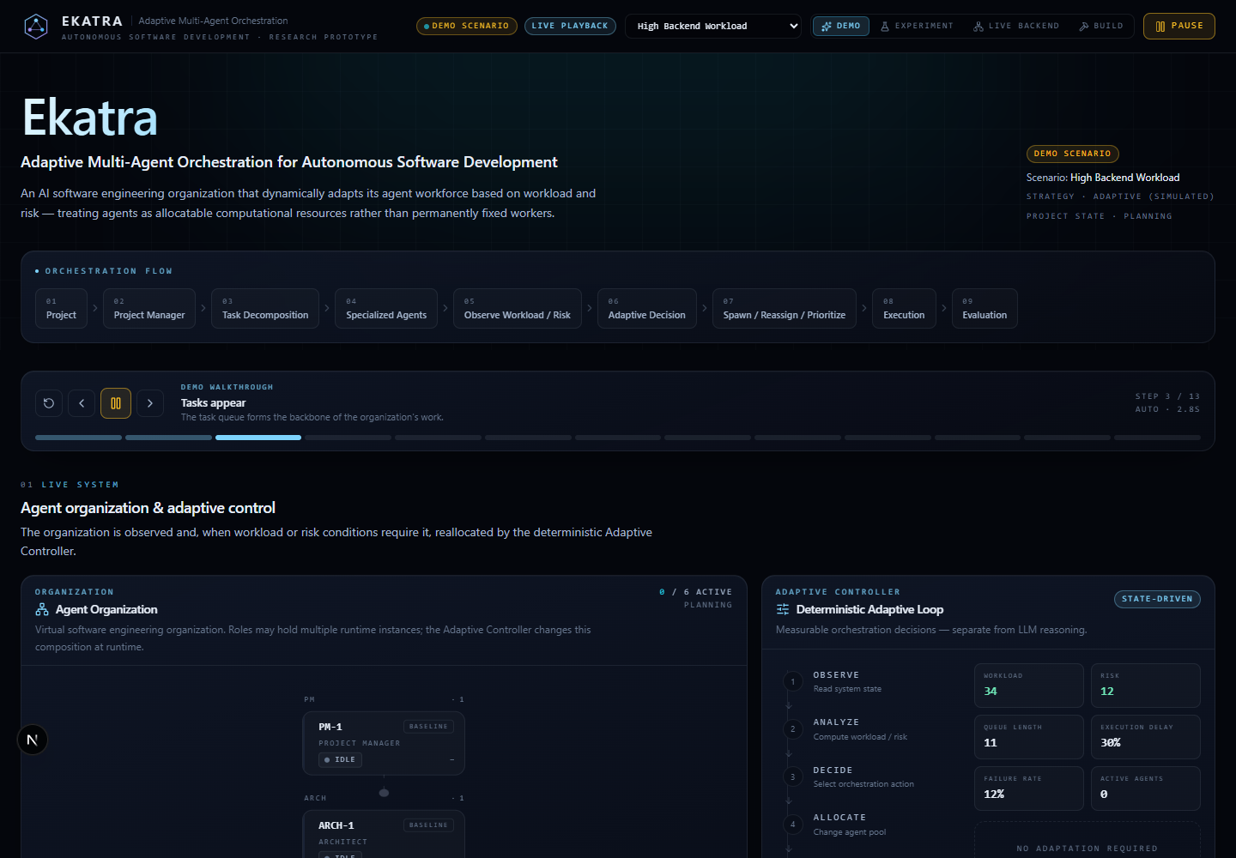
Figure 3.1. Home screen with the mode selector, orchestration flow and run controls

3.2 Build Panel
The Build panel is where a real build is started. The user first selects one of the eight project types (web app, REST API service, command-line tool, Python library, data-analysis script, database app, text game / simulator, automation script). A short line explains what that type produces, and a link, "Use an example", fills the text box with a sample description. The user writes the description of the software and presses Start build. A status label beside the button shows the strategy (fixed or adaptive), the elapsed time and whether the plan came from Gemini or from the fallback.
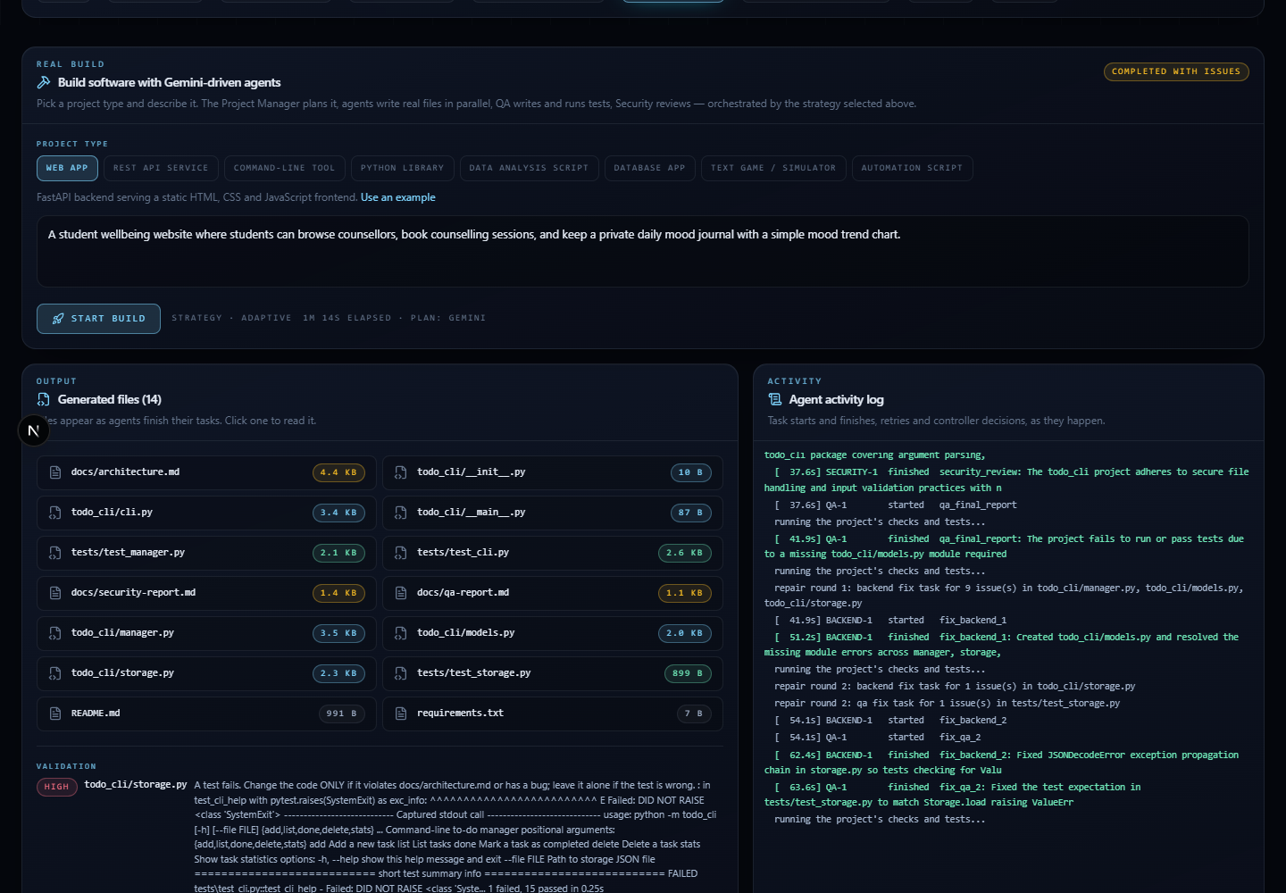
Figure 3.2. Build panel with project types, description box, generated files and agent activity log
After the build starts the panel splits into two columns. The left column lists the generated files as they appear, with their sizes; clicking a file shows its content in a viewer. The right column is the agent activity log, which prints each task start and finish, retries, the check results and the repair rounds. The status chip at the top right of the panel shows the state of the build, for example running, completed, or completed with issues.
In use, the panel makes the cost of a request visible. A short description produces a small plan and finishes quickly, while a long one produces more tasks and more files, and the elapsed time beside the Start build button shows the difference. The choice between the fixed and the adaptive strategy is made before the build starts; because both use the same planner and the same checks, the user can run the same description twice and compare the two organisations on the same work.

3.3 Validation Issues, Change Panel and Project Checks
Below the files, the Validation section lists any issue found by the checks. Each issue shows its severity, the file blamed and the message from the failing test or check. The Change or fix this project panel contains a text box and two buttons. Apply change sends the request to the agents, which plan and carry out a minimal modification of the existing project. Fix N remaining issues re-runs the checks and repairs what they report, with no text needed. If a change cannot be planned, an error box explains why and the project is left unchanged. A list of earlier change requests is kept below.
The Run the command-line tool panel (the heading changes with the project type) offers Run tests and Run demo. These execute the generated project on the user's machine and display the output, and they start only when the user presses the button. For web apps and API services a preview panel starts the generated site and links to it.
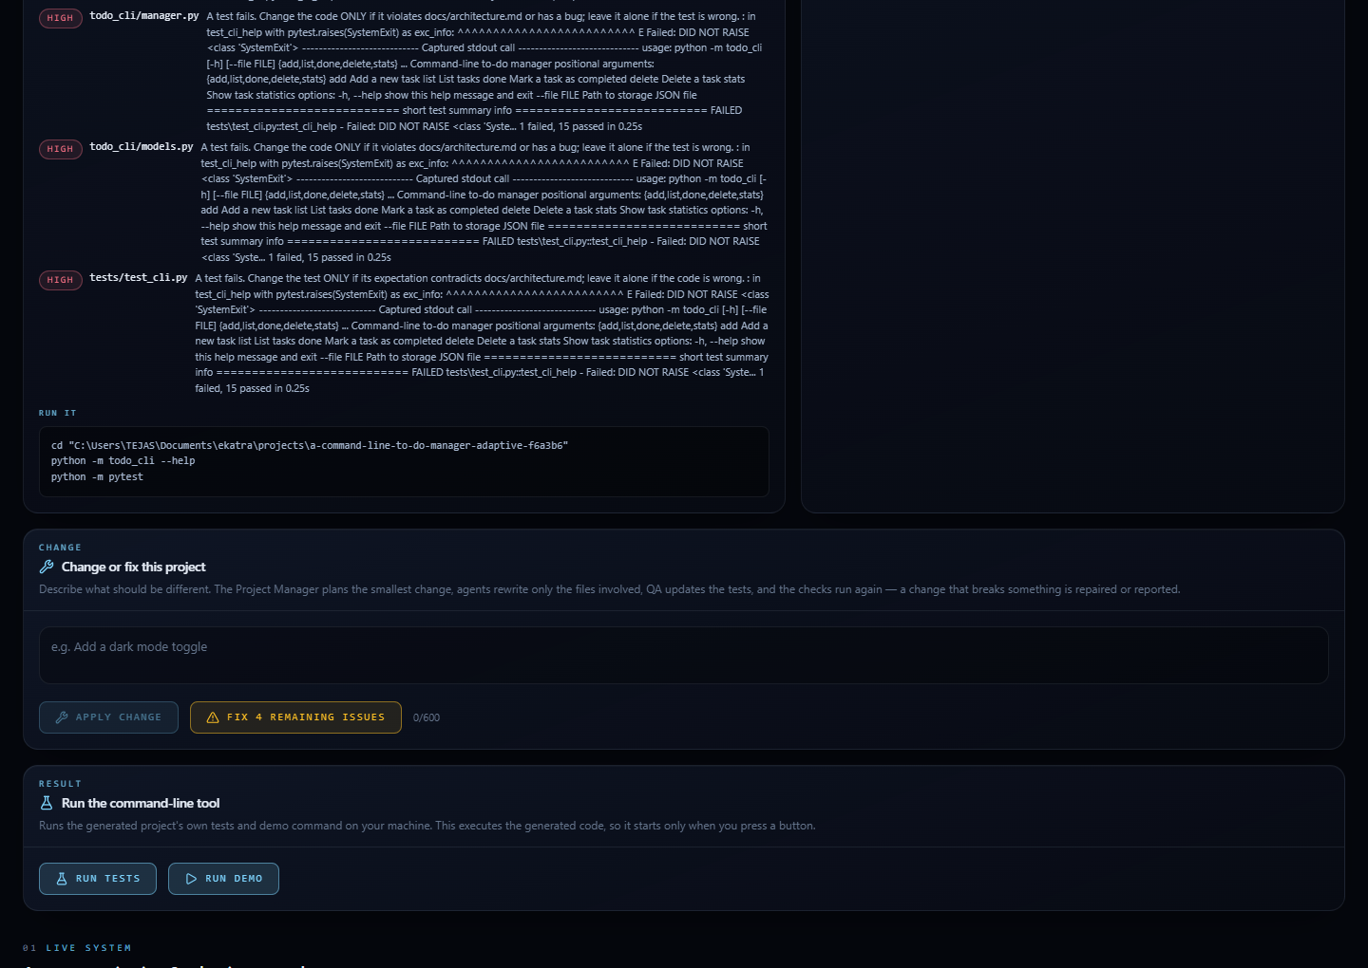
Figure 3.3. Validation issues, change panel and project checks
These three parts form the loop that follows a build. The user reads the issues, decides whether a fix or a change is wanted, and uses the project checks to see the result on the real machine. The loop is deliberately manual at the last step: the dashboard never runs generated code or starts a generated site unless the user presses the button, because that code was written by a model and has not been reviewed by a person. The output of the tests or the demo is shown in the panel, with the exit code, so a failure can be read without leaving the page.

3.4 Agent Organisation and Adaptive Controller
The Agent Organisation panel draws the virtual company as a graph: the Project Manager at the top, the Architect below, and Frontend, Backend, QA and Security agents beneath. Each agent card shows its role, its status (IDLE, RUNNING and so on) and its task count. When the controller spawns an agent, a new card appears next to its sibling; when it terminates one, the card disappears. Clicking a card opens a detail panel with the agent's history.
Beside the organisation, the Adaptive Controller panel displays the feedback loop (observe, analyse, decide, allocate, execute, evaluate, adapt) and the latest decision with its reason, for example "Conditions within thresholds; CONTINUE", together with the threshold values in force.
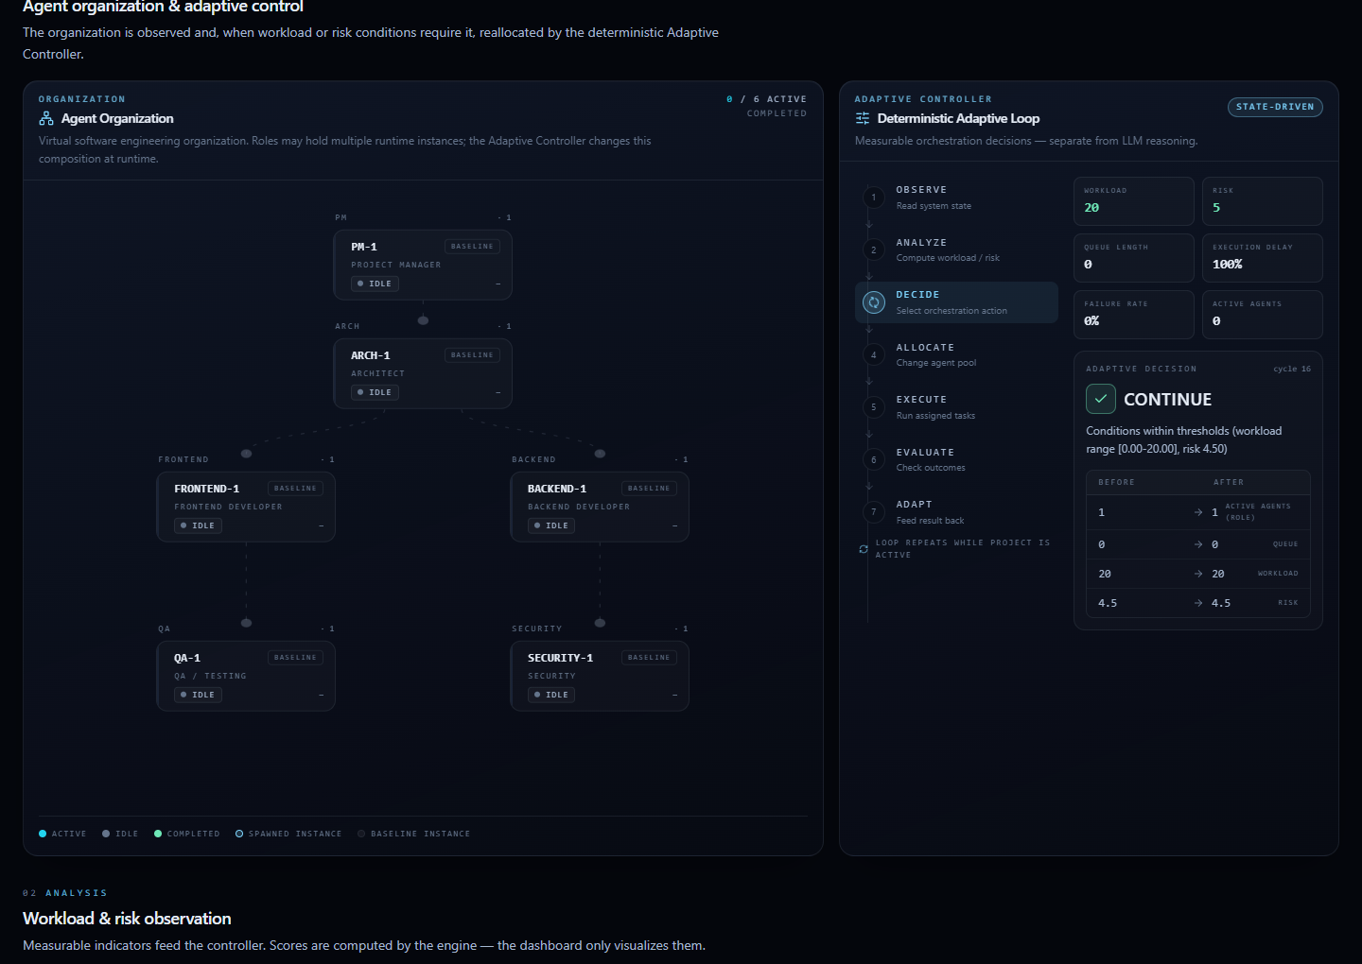
Figure 3.4. Agent organisation graph and the deterministic Adaptive Controller panel
This screen is where the central claim of the project can be seen. In a fixed run the graph never changes: each role has one card from start to finish. In an adaptive run additional cards appear beside the original ones when the controller spawns an agent and vanish when it terminates one, and the decision panel beside the graph explains each change in words and numbers. A viewer who wants to check that adaptation is real, and not only claimed, can compare the graph with the event timeline and the task board: the new agent's card should show tasks taken from the queue.

3.5 Workload, Risk and Task Flow
The Workload card shows the current workload score as a dial and the four inputs behind it: queue length, task complexity, execution delay and failure rate, each as a bar. The Risk card shows the risk score and the indicators that produced it, such as security findings and high-risk tasks. The Task Board lists every task in columns by status (PENDING, ASSIGNED, RUNNING, COMPLETED, FAILED, RETRY) and shows for each task its identifier, priority, description, role, complexity, retry count and agent. Filter buttons restrict the board to one status.
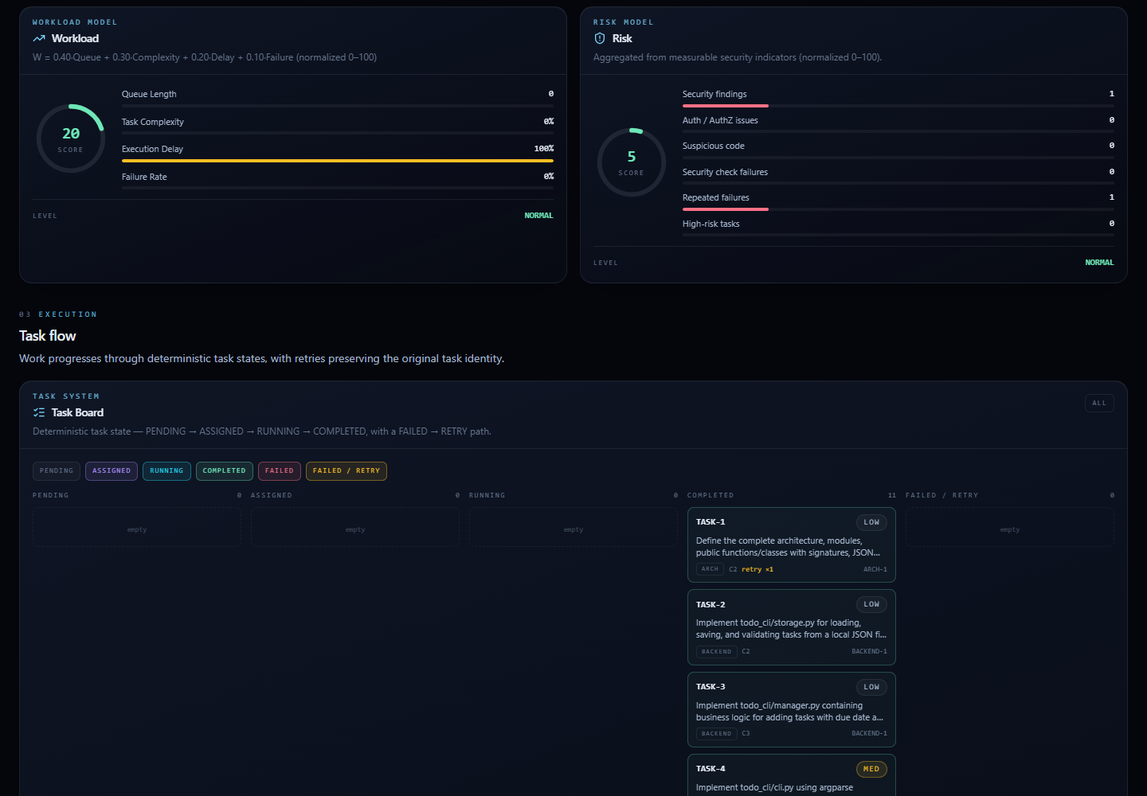
Figure 3.5. Workload and risk cards and the task board
The cards are views of numbers computed by the engine, not independent estimates made by the page. The dial of the workload card moves when the queue grows or the failure rate rises, and the bars show which of the four components dominates, so the viewer can see why a score is high. On the task board, a task that was retried keeps its identifier and shows the number of retries, which makes failures and recoveries visible; tasks that are waiting for a dependency stay in the pending column until the task they depend on is completed.

3.6 Events and Experiment Metrics
At the bottom of the page the Adaptive Event Timeline lists decisions and task events in order with their timestamps, so that any change in the organisation can be traced to the decision that caused it. The Research Metrics card summarises the run: number of tasks, success rate, total completion time, average waiting time, peak and average active agents, spawns, terminations and retries. In the Experiment mode a comparison card places the fixed baseline and the adaptive strategy side by side.
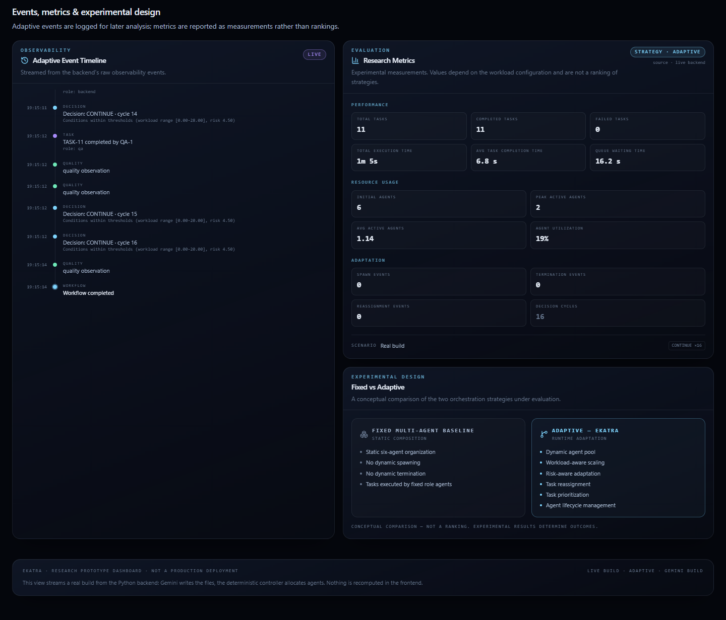
Figure 3.6. Event timeline, research metrics and fixed-versus-adaptive comparison
The timeline and the metrics make a run auditable. A reader can start from a number in the metrics, for example three spawns, and find the three decision events in the timeline that produced it, with the scores and reasons recorded at the time. This traceability from a summary figure to the individual events is the reason that every component writes to the same log.

3.7 Walkthroughs, Command Line and Interface Design

3.7.1 Building a new project
- Open the dashboard and select the Build mode in the mode selector at the top of the page.
- Choose the project type, for example Command-line tool. The helper line below the chips changes to describe what that type produces.
- Type a description of the software or press Use an example to fill one in.
- Press Start build. The button is disabled while a build runs, and the status chip changes to running.
- Watch the file list grow and the activity log fill. The agent cards in the organisation panel change from IDLE to RUNNING when they take a task, and the task board moves each task through its states.
- When the build ends, the chip shows completed or completed with issues. Any issues appear under Validation with the file blamed and the error message.
- Open a generated file by clicking it in the file list. Press Run tests or Run demo to execute the project, or, for web and API projects, start the site from the preview panel.

3.7.2 Changing a finished project
- Select a finished build from the list of builds. Projects created in earlier sessions are restored from disk when the backend starts.
- In the Change or fix this project panel, describe the change in plain words, for example "Add a clear command that deletes completed tasks".
- Press Apply change. The build status returns to running and the dashboard re-attaches to the stream. The task board shows the few tasks that were planned for the change.
- When it finishes, the new request appears in the list of changes, and the issue list shows whether the checks pass.
- If the build ended with issues and no change is wanted, press Fix N remaining issues instead.

3.7.3 Comparing strategies
The strategy selector in the header chooses fixed or adaptive orchestration. In the Experiment mode the same scenario is shown under both strategies, so the number of agents, the queue and the completion time can be compared side by side. In the Build mode the strategy decides whether the controller may spawn extra agents during the build.

3.7.4 Command-line Interface
A build can also be started without the dashboard. The command python -m ekatra.build accepts a description and options for the project type, the strategy (fixed or adaptive), the output folder, the maximum agents per role, the number of repair rounds and a switch to skip the smoke test. The same agents, controller and checks are used, and the result is written to the projects folder.

3.7.5 Interface Design Principles
- One page that tells a story. The sections follow the order of a run: input, organisation, analysis, execution, observation. A viewer can scroll from cause to effect.
- Show the state, not a replay. Every update from the backend carries the complete state, so the page never depends on the order of events and can reconnect at any time.
- Make decisions explainable. Each controller decision is displayed with its reason and the thresholds, so that the viewer sees why the organisation changed.
- Dark, high-contrast theme. Status colours are used consistently: green for completed, blue for running, amber for waiting or retry and red for failed or high risk.
- Safe by default. Actions that run generated code or modify a project start only when the user presses a button.
- Honest failure display. A build that ends with problems says so, lists the problems and offers a way to repair them rather than hiding them.

3.7.6 Error Handling in the Interface
The interface reports problems instead of failing silently. If the backend cannot be reached, the Live Backend and Build modes display the error message returned by the request. If a change cannot be applied, an error box explains why and states that the project was left unchanged. If the backend is older than the dashboard and omits a field, the page substitutes a default value rather than crashing. While a build is running, buttons that would conflict with it, such as Start build and Apply change, are disabled.

Chapter-4. DISCUSSION & FUTURE SCOPE

4.1 Experimental Set-up and Scenarios
The evaluation compares the fixed baseline with the adaptive strategy on nine scenarios. Each scenario is a fixed set of tasks with roles, complexities and dependencies, run on the simulated clock with five repetitions per strategy using different seeds. The scenarios correspond to the evaluation plan: low, medium and high workload, unbalanced workload (high backend and high frontend), risk-heavy, failure-heavy, a backlog of tasks that can run in parallel, and a risk-triage case. One scenario deliberately contains a strictly chained set of tasks so that the report can show where adaptation cannot help. Durations and failures are hashed from the seed and the task identity, so both strategies face identical conditions and the comparison is paired. The values reported are means over the five repetitions.

4.1.1 Experimental scenarios
Each scenario is a fixed list of tasks with roles, complexities and dependencies, a seed and failure settings. The same scenario object is given to both strategies.
Table 4.1. Scenarios used in the evaluation
Scenario | Purpose | Characteristic
Low workload | No adaptation needed | 5 tasks, one per role
Medium workload | Moderate load | 10 tasks across roles
Mixed high workload | Many roles loaded | 13 tasks
High backend workload | Unbalanced load | 11 tasks, most for the backend role
High frontend workload | Unbalanced load | 11 tasks, most for the frontend role
Security risk | Risk-heavy | 22 tasks with many security tasks
Parallel backlog | Parallelisable work | 19 tasks with many independent tasks of one role
Failure heavy | Reliability | 10 tasks with a high failure probability
Risk triage | Prioritisation | 9 tasks with high-risk items

4.2 Results
Table 4.2. Completion time of fixed and adaptive strategies (simulated seconds)
Scenario | Tasks | Fixed | Adaptive | Change | Spawns
Low workload | 5 | 783.1 | 783.1 | 0.0% | 0.0
Medium workload | 10 | 702.7 | 702.7 | 0.0% | 0.0
Mixed high workload | 13 | 1678.6 | 1678.6 | 0.0% | 0.0
High backend workload | 11 | 2303.9 | 2303.9 | 0.0% | 3.0
High frontend workload | 11 | 2448.9 | 2448.9 | 0.0% | 3.0
Security risk | 22 | 2797.2 | 2197.4 | -21.4% | 6.0
Parallel backlog | 19 | 3118.9 | 1484.3 | -52.4% | 3.0
Failure heavy | 10 | 1773.2 | 1773.2 | 0.0% | 0.0
Risk triage | 9 | 1255.7 | 1255.7 | 0.0% | 0.0

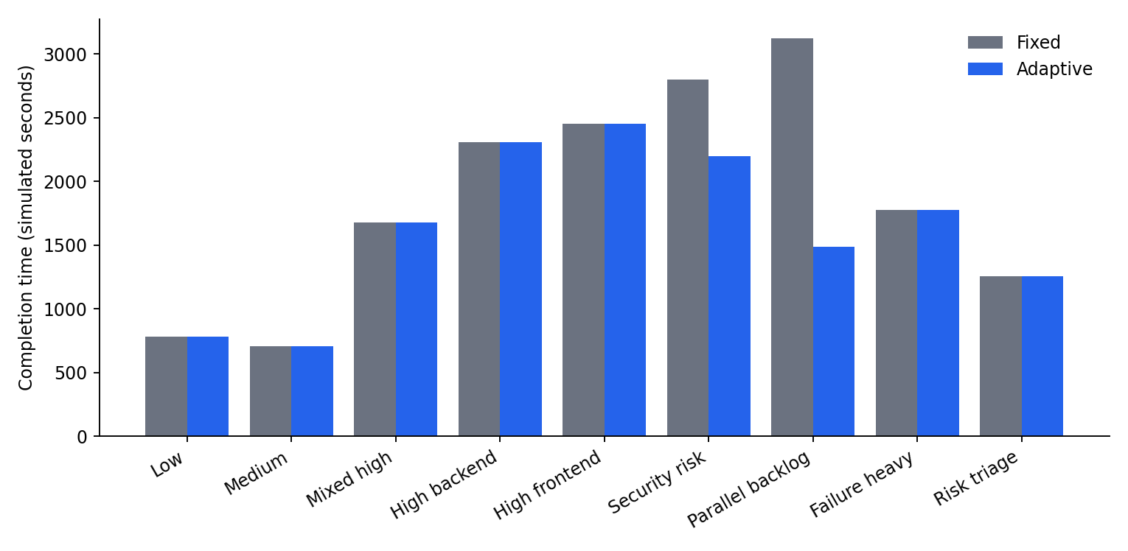
Figure 4.1. Completion time by scenario, fixed versus adaptive
Table 4.3. Waiting time, peak agents and success rate
Scenario | Avg wait fixed | Avg wait adaptive | Peak fixed | Peak adaptive | Success
Low workload | 388.0 | 388.0 | 2.0 | 2.0 | 100.0%
Medium workload | 349.8 | 349.8 | 3.2 | 3.2 | 100.0%
Mixed high workload | 743.1 | 743.1 | 4.0 | 4.0 | 100.0%
High backend workload | 885.4 | 885.4 | 3.0 | 3.0 | 100.0%
High frontend workload | 954.5 | 954.5 | 3.0 | 3.0 | 100.0%
Security risk | 1203.8 | 1138.2 | 3.0 | 4.0 | 100.0%
Parallel backlog | 1259.4 | 668.7 | 2.0 | 5.0 | 100.0%
Failure heavy | 728.2 | 728.2 | 2.0 | 2.0 | 94.0%
Risk triage | 519.3 | 570.2 | 2.0 | 2.0 | 100.0%

4.2.1 Waiting time
Waiting time is the time a task spends between becoming eligible and starting. It follows the completion time closely: it falls only in the scenarios in which completion time falls. In the parallel backlog scenario the average wait is nearly halved, and in the security risk scenario it is reduced slightly.
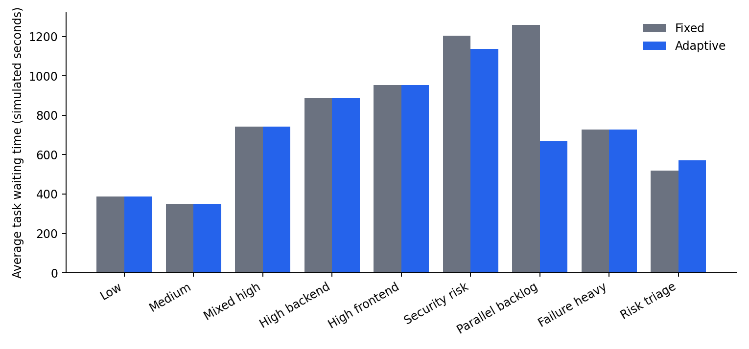
Figure 4.2. Average task waiting time by scenario

4.2.2 Peak number of agents
Peak active agents shows how much capacity was used at the busiest moment. The adaptive strategy reaches a higher peak only where the controller acted and the extra agents were used.
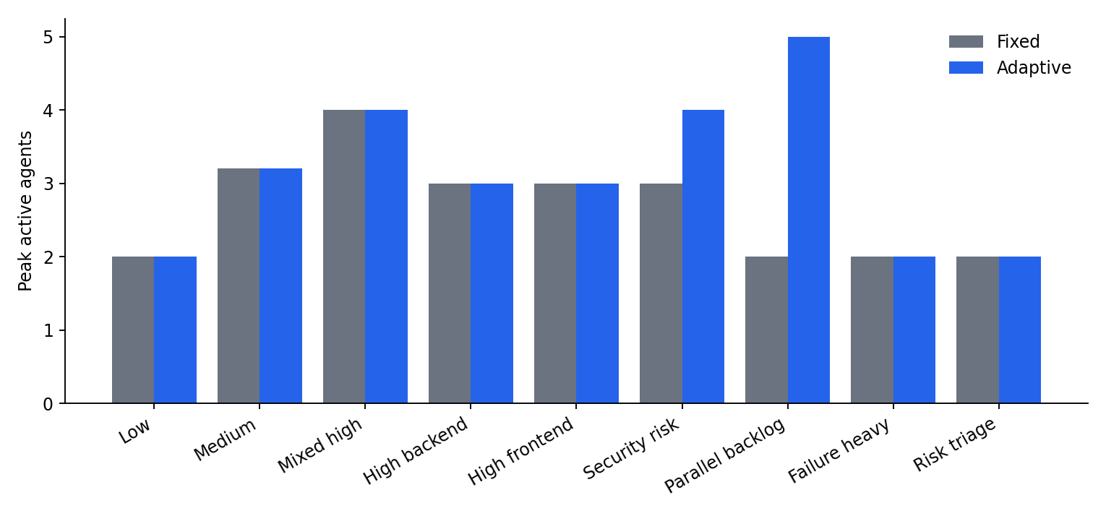
Figure 4.3. Peak number of active agents by scenario

4.2.3 Spawns and terminations
Every spawned agent in the evaluation was later terminated, which shows that the release mechanism works and that capacity was temporary. The number of spawns is highest in the parallel backlog and security risk scenarios. The high backend and high frontend scenarios show spawns that did not shorten the run, as discussed below.
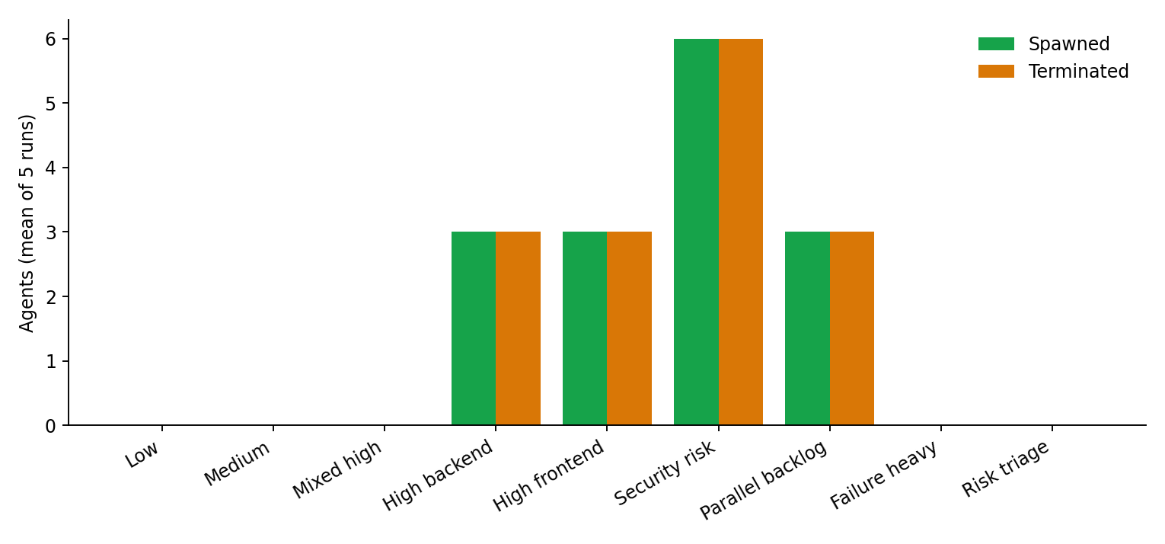
Figure 4.4. Agents spawned and terminated by the adaptive strategy

4.2.4 Reproducing the results
The results can be reproduced from the repository. The experiment runner is called with the list of evaluation scenarios, a number of repetitions and the simulated engine. Because durations and failures are derived from the scenario seed and the task identity, a second run with the same settings produces identical numbers. The record of each run stores the configuration that was used (weights, thresholds, agent limits, retry limit, simulation parameters, seed and model name without secrets), so a result can always be traced back to the settings that produced it.

4.3 Discussion of Results

4.3.1 Where adaptation helped
Two scenarios show a clear benefit. In the parallel backlog scenario, which contains many independent tasks for the same role, the adaptive strategy finished in 1484 simulated seconds against 3119 for the fixed team, a reduction of about 52 percent, and the average waiting time fell from 1259 to 669 seconds. Peak active agents rose from 2 to 5, which is the expected cause: the spawned agents really executed tasks in parallel. In the security risk scenario the adaptive strategy reduced completion time from 2797 to 2197 seconds, about 21 percent, by adding security capacity while the risk score was high.

4.3.2 Why the parallel backlog benefits
The parallel backlog scenario shows the mechanism of adaptation most clearly. It contains many tasks of the same role that do not depend on one another, so as soon as the controller adds a second and a third agent, tasks that would have waited in a queue start at once. Completion time falls almost in proportion to the number of agents that can be kept busy, and the waiting time falls with it. The result is close to what simple queueing arguments predict: with a queue of independent jobs, the time to finish is roughly the total work divided by the number of servers. The benefit therefore comes from the structure of the work and not from any property of the controller, and the controller's contribution is to notice the backlog and to provide the servers.

4.3.3 Where adaptation made no difference
In the low, medium, mixed-high and failure-heavy scenarios the completion times of the two strategies are identical. In the low and medium cases the controller correctly did nothing because the workload stayed below the spawn threshold, so no resources were wasted. In the failure-heavy scenario the workload score never crossed the spawn threshold, so the controller did not spawn; the retries were handled by the existing agents.
The high-backend and high-frontend scenarios are the most instructive negative result. The controller spawned three agents and terminated them again, yet the completion time did not change. The most likely reason is that the tasks of the busy role depend on one another, so only one of them was ready at any time and the new agents had nothing to execute. This confirms the second half of the hypothesis: adaptation helps only when there is parallelisable work, and a high workload score alone does not guarantee a benefit. It also shows a limitation of the controller, which reacts to the size of the queue rather than to how many queued tasks are actually ready.
In the risk-triage scenario the adaptive strategy had a slightly higher average waiting time (570 against 519 seconds) with an equal completion time, most likely because raising the priority of risky tasks delayed some other tasks. This is a small cost of prioritisation rather than a defect, and it is reported as measured.

4.3.4 Summary across scenarios
Taken together the scenarios show a consistent pattern: spawning reduces time only when it increases the number of tasks that can really run at the same time. Spawning without parallel work only adds the cost of the extra agents.

4.3.5 Resource Use
Peak active agents rose in the parallel backlog scenario from 2 to 5 and in the security risk scenario from 3 to 4, while it stayed equal in the scenarios where the controller did not act. Because every spawned agent was terminated when its work was done, the extra capacity was temporary. The number of spawns reflects the controller's reaction to queue size rather than the benefit obtained, which is why the high backend and high frontend scenarios show spawns without any time saved. A controller that checked the number of ready tasks before spawning would remove these unproductive spawns, and this is listed as the first item of future work.

4.3.6 Time and resources together
Completion time is not the only measure. Each additional agent costs tokens and attention, so a strategy that shortens the run by adding agents must be judged by what it spends. Two features of the adaptive strategy limit the cost. The extra capacity is temporary, because every spawned agent was released when its pool emptied, and the capacity is bounded by the per-role limit. The results also show the cost of reacting to the size of a queue alone: in the high backend and high frontend scenarios the controller spawned agents that could not be used. A future controller that spawns only when ready tasks exist would keep the benefit in the backlog scenario and remove the waste in the chained scenarios.

4.3.7 Statistical caution
The simulation is deterministic apart from the seeded durations, and only five repetitions per scenario were run. The report therefore presents descriptive statistics and makes no claim of statistical significance. The durations are simulated, not measured from real agents, and the scenarios are controlled workloads designed to exercise the controller. The results demonstrate that the mechanism works as designed; they do not prove that adaptive orchestration is better in all real projects.

4.3.8 Implications for building AI software teams
The experiment suggests three practical lessons for designers of multi-agent software systems. First, team size should follow the shape of the task graph: parallel work justifies parallel agents, while sequential work does not. Second, the decision to scale can be made by a simple, inspectable rule, and a language model is not needed for it. Third, an adaptive system must be compared against a fixed baseline under identical conditions, because an increase in the number of agents is not in itself an improvement. These lessons agree with experience in human teams, where adding people to a project helps only for work that can be divided, and they agree with the practice of cloud autoscaling, where a replica is useful only if there is a request waiting for it.

4.4 Real Builds with Gemini
The real build mode was exercised with the Gemini API on several projects. The results are summarised below; they are demonstrations, not a benchmark.
Table 4.4. Real builds that were run
Project | Type | Outcome
Recipe-sharing website | Web app | Built and ran after repair rounds; an initial crash from a missing backend module was fixed by allowing repair tasks to create missing files
Student wellbeing website | Web app | Built and ran after the repair improvements
Command-line to-do manager | Command-line tool | Built with 16 tests; 15 passed at first, then a blame fix routed the failing test to the right file and the issue was repaired
Change request on the to-do manager: clear command | Change feature | Planned as 3 tasks (architect, backend, QA); succeeded; the clear command printed the number of removed tasks and all 18 tests passed

These runs show that the system produces runnable software, that the check-and-repair loop recovers from realistic errors, and that a built project can be modified afterwards. They also showed weaknesses: the model sometimes writes a test whose expectation does not match the code, and repair depends on the failure being attributed to the correct file, which is why the blame logic was improved. The other project types (API, library, data, database, game, automation) are implemented and covered by automated tests with a fake LLM, but have not yet been run end to end with the real model.

4.4.1 Case study: recipe-sharing website
The first real build was a small recipe-sharing website. The Project Manager planned tasks for the architecture, the backend, the frontend, the tests and a security review. The first version of the generated site crashed at start-up because a backend module that other files imported did not exist. This failure showed that the original repair logic could only edit existing files. The repair logic was changed so that a fix task can create a missing file, the fix tasks were given the content of the sibling files for context, and a second repair round was allowed. A runtime smoke test, which starts the site and requests its pages, was added so that such a crash is detected by the system rather than by the user. After these changes the site ran and could be launched from the dashboard preview.

4.4.2 Case study: student wellbeing website
The second web build was a student wellbeing website with counsellor browsing, session booking and a private mood journal with a trend chart. It was built after the repair improvements described above and ran. It confirmed that the fixes made for the recipe site also worked for a different description, without being specific to it.

4.4.3 Case study: command-line to-do manager
The command-line tool profile was tested with a to-do manager that supports adding, listing, completing and deleting tasks and showing statistics. Fourteen files were produced, including three test modules and the QA and security reports. Of sixteen tests, fifteen passed in the first run. The failing test expected the command-line interface to exit with an error for a bad input, while the generated code did not. The first version of the blame logic assigned this failure only to the test file, so the repair rounds rewrote the test without removing the cause. The blame logic was then extended to read the pytest short format and to blame the modules imported by the failing test, and a rerun repaired the problem.
A change request was then applied to this project: "Add a clear command that deletes all completed tasks and prints how many were removed". The Project Manager planned three tasks (architect, backend and QA) instead of rebuilding the project. All three finished, the checks ran, and the project's eighteen tests passed. Running the new command on a list with one completed task printed that one completed task had been removed. The original project folder had not been modified, because the experiment was carried out on a copy.
Four design decisions follow from these runs. Repair tasks may create missing files, because the model sometimes omits a module that other files import. Either a test or the code may be repaired, according to the failure, because the model sometimes writes a test that contradicts its code. Concurrency is capped and retries honour the delay given by the service, because rate-limit errors appear with several parallel agents. And the blame logic reads tracebacks, pytest output and test imports, because a repair attributed to the wrong file does not help. The wish to adjust a finished project led to change requests and the fix-only action.

4.5 Limitations and Threats to Validity
- Experiment durations are simulated; real agents have variable latency and token cost that were not measured.
- Only five repetitions per scenario and descriptive statistics were used.
- The controller does not distinguish between queued tasks that are ready and those blocked by dependencies, which wastes spawns on chained work.
- Real-build quality depends on the model, and the free API tier limits speed and concurrency.
- Generated code is checked by tests that another agent wrote, so a shared misunderstanding between agents can pass unnoticed.
- Mobile applications are not supported.
- Generated code is run on the user's machine in a subprocess, which is not a full sandbox.

4.5.1 Threats to Validity
Table 4.5. Threats to the validity of the results
Threat | Effect | Mitigation or note
Simulated durations | Real agent latency may differ | Durations scale with complexity and are seeded; stated as a limitation
Designed scenarios | Results depend on how scenarios were built | Scenarios cover low to high load, risk, failure and a parallel backlog; negative cases kept
Few repetitions | Small sample | Descriptive statistics only; no significance claims
Mock agents in experiments | Output quality is not measured in the simulation | Quality was examined separately in real builds
Single model | Findings about real builds may not apply to other models | Model is configurable; only one was used
Tests written by agents | Shared misunderstandings can pass unnoticed | Static and runtime checks and human inspection of generated files
Threshold values | Initial thresholds are experimental | Thresholds are configurable and recorded with every run

4.6 Lessons Learned, Responsible Use and Objectives

4.6.1 Lessons Learned
- A research claim can be impossible to test even when the code looks complete. Spawned agents that never execute any task make every comparison meaningless, so the first step was to verify that adaptation changes the execution.
- Time must come from one clock. Mixing a virtual clock and the wall clock produced a waiting time of hundreds of days.
- Reporting negative results makes the study more credible. The high-backend scenario, in which the controller spawned agents to no effect, is the most informative result of the evaluation.
- LLM output must be treated as untrusted input. Plans, files and JSON are validated, and each stage has a fallback.
- Attributing a failure to the right owner matters as much as detecting it. Early repair rounds failed because the blame fell on the wrong file.
- Keeping the scaling decision outside the LLM made the system testable: each decision can be reproduced by constructing the same state.
- Secrets must be protected structurally, not by care. Holding the key as a secret value and isolating tests from the real environment file prevented a repeat of an accidental key print.

4.6.2 Responsible Use
A system that writes and runs code carries risks. Ekatra does not execute generated code unless the user asks for it, it removes secrets from the environment of that code, and it limits where each agent may write. Nevertheless the output of a language model can be wrong or insecure, and the generated projects must be reviewed before they are used for anything important. The Security agent's review is an additional check, not a guarantee. The Gemini API key is private and is kept out of the repository and out of the logs, and the generated projects folder is not committed.

4.6.3 Status of the objectives
Table 4.6. Status of the objectives
Objective | Status
Six specialised agents | Achieved: six roles with role-specific prompts and write policies
Deterministic controller with five actions | Achieved: all five actions are implemented and tested
LLM kept out of scaling | Achieved: the controller is ordinary code
Fixed baseline with identical semantics | Achieved: the same task model and engine
Real build mode with several project types | Achieved for eight types; web, command-line and change feature run with the real model, the others are tested with a fake model
Change requests on existing projects | Achieved and demonstrated with a real change
API and live dashboard | Achieved
Evaluation with honest reporting | Achieved on nine scenarios with the simulated clock; the analysis scripts and a formal statistical study remain future work

4.7 Conclusion and Future Scope

4.7.1 Conclusion
Ekatra demonstrates an adaptive multi-agent organisation for autonomous software development in which resource decisions are deterministic, logged and reproducible, and in which the same orchestration drives real Gemini agents that build, test, repair and later modify actual software of eight kinds. The experiments show that adaptive orchestration can reduce completion time substantially when parallelisable work exists (about 52 percent in the parallel backlog scenario) and when risk justifies extra security capacity (about 21 percent), and that it correctly does nothing, or cannot help, when the work is sequential. A project report that stated only the gains would be misleading, so the negative results are part of the findings.

4.7.2 Future Scope
- Make the controller aware of ready tasks, so that it spawns an agent only if there is an executable task for it.
- Run a larger statistical study with more repetitions and with real latency and token cost recorded per task, and add confidence intervals and effect sizes.
- Run all eight project types end to end with the real model and report a pass-or-fail table.
- Add mobile application support with an Android or Flutter toolchain and an emulator-based check.
- Run generated code inside a container for a stronger sandbox.
- Let several models serve different roles and compare their cost and quality.
- Add a human review step before a change is applied, and a diff view of what changed.
- Persist telemetry in a database and add comparison dashboards across many runs.
- Learn the controller thresholds from past runs instead of fixing them by hand, while keeping the decision rule deterministic and auditable.

REFERENCES
[1] Google, "Gemini API documentation," Google AI for Developers. https://ai.google.dev/gemini-api/docs
[2] LangChain, "LangGraph documentation: building stateful, multi-actor applications with LLMs." https://langchain-ai.github.io/langgraph/
[3] S. Hong et al., "MetaGPT: Meta Programming for A Multi-Agent Collaborative Framework," arXiv:2308.00352, 2023.
[4] C. Qian et al., "ChatDev: Communicative Agents for Software Development," arXiv:2307.07924, 2023.
[5] Q. Wu et al., "AutoGen: Enabling Next-Gen LLM Applications via Multi-Agent Conversation," arXiv:2308.08155, 2023.
[6] S. Yao et al., "ReAct: Synergizing Reasoning and Acting in Language Models," arXiv:2210.03629, 2022.
[7] S. Ramírez, "FastAPI documentation." https://fastapi.tiangolo.com/
[8] Vercel, "Next.js documentation." https://nextjs.org/docs
[9] Pydantic, "Pydantic documentation." https://docs.pydantic.dev/
[10] pytest development team, "pytest documentation." https://docs.pytest.org/
[11] I. Sommerville, Software Engineering, 10th ed. Pearson, 2015.
[12] R. S. Pressman and B. Maxim, Software Engineering: A Practitioner's Approach, 9th ed. McGraw-Hill, 2019.
[13] J. Yang et al., "SWE-agent: Agent-Computer Interfaces Enable Automated Software Engineering," arXiv:2405.15793, 2024.
[14] J. O. Kephart and D. M. Chess, "The Vision of Autonomic Computing," IEEE Computer, vol. 36, no. 1, pp. 41–50, 2003.
[15] Kubernetes Authors, "Horizontal Pod Autoscaling." https://kubernetes.io/docs/concepts/workloads/autoscaling
[16] J. Wei et al., "Chain-of-Thought Prompting Elicits Reasoning in Large Language Models," in Advances in Neural Information Processing Systems (NeurIPS), 2022, arXiv:2201.11903.
[17] A. Vaswani et al., "Attention Is All You Need," in Advances in Neural Information Processing Systems (NeurIPS), 2017, arXiv:1706.03762.
[18] T. B. Brown et al., "Language Models are Few-Shot Learners," in Advances in Neural Information Processing Systems (NeurIPS), 2020, arXiv:2005.14165.
[19] M. Chen et al., "Evaluating Large Language Models Trained on Code," arXiv:2107.03374, 2021.
[20] C. E. Jimenez et al., "SWE-bench: Can Language Models Resolve Real-World GitHub Issues?," in International Conference on Learning Representations (ICLR), 2024, arXiv:2310.06770.
[21] L. Wang et al., "A Survey on Large Language Model based Autonomous Agents," Frontiers of Computer Science, vol. 18, 2024, arXiv:2308.11432.
[22] X. Hou et al., "Large Language Models for Software Engineering: A Systematic Literature Review," ACM Transactions on Software Engineering and Methodology, 2024, arXiv:2308.10620.
[23] K. Beck et al., "Manifesto for Agile Software Development," 2001. https://agilemanifesto.org
[24] M. Wooldridge, An Introduction to MultiAgent Systems, 2nd ed. Wiley, 2009.
[25] R. T. Fielding, "Architectural Styles and the Design of Network-based Software Architectures," Ph.D. dissertation, University of California, Irvine, 2000.

