BIT-TRACE
MVP EXECUTION & EVIDENCE DOCUMENT
Transaction Investigation Core • Final Recorded Run
203,769 | 136,265 | 36,824 | 13
TOTAL TX | TRAIN | UNSEEN TEST | FEATURES
EXECUTION PROOF
BIT-TRACE — TRANSACTION-ONLY LARGE-SCALE FINAL TEST
Transactions loaded : 203,769
Training : 136,265 (time 1–34)
Validation : 30,680 (time 35–41)
Test : 36,824 (time 42–49)
Isolation Forest ✓ LOF ✓ Ensemble ✓ Temporal split ✓
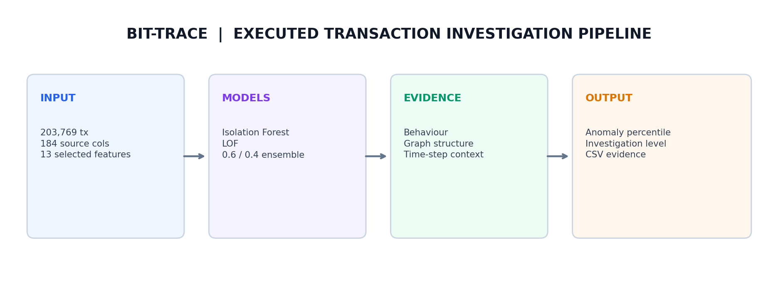
Purpose of this document
This is an evidence-first record of the executed transaction MVP: dataset verification, temporal split, model execution, large-scale test results, post-hoc evaluation, prioritisation and generated output files. It is intended to let an evaluator verify what was actually run.

01 DATA + EXECUTION VERIFICATION
The final recorded run confirms the complete transaction population and the time-based separation used for testing.
CHECK | RECORDED RESULT
Feature source | txs_features.csv
Class source | txs_classes.csv
Source columns | 184
Loaded transaction rows | 203,769
Selected model features | 13
Time range | 1–49
Missing txId | 0
Missing time | 0
NaN after cleaning | 0
Inf after cleaning | 0
Missing labels after merge | 0
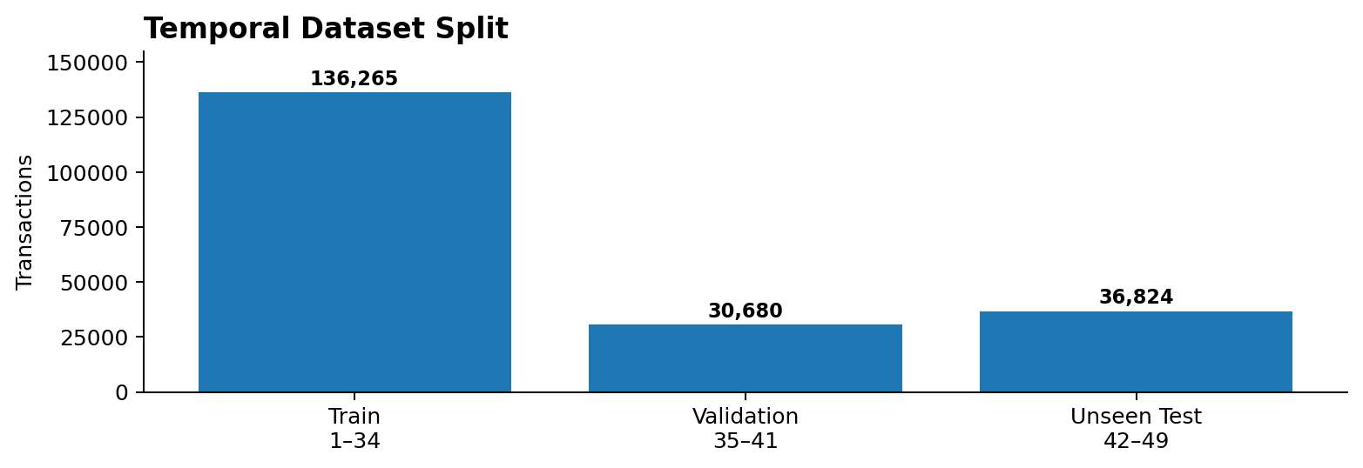
Temporal split
SET | TIME | ROWS | ROLE
TRAIN | 1–34 | 136,265 | Model fitting
VALIDATION | 35–41 | 30,680 | Validation
TEST | 42–49 | 36,824 | Unseen evaluation
MODEL EXECUTION PROOF
Scaler fitted ONLY on training data
Isolation Forest: trained • 300 trees
LOF: trained
Ensemble weights: IF 0.6 + LOF 0.4
Labels during training: NOT USED

02 MODEL RESULTS — ACTUAL OUTPUT
MODEL | MEAN | STD | MIN | MEDIAN | MAX
Isolation Forest | 0.648509 | 1.273773 | -0.261848 | 0.012529 | 5.853333
LOF | 38.498680 | 1180.247073 | -0.512223 | 0.648270 | 114345.767514
Ensemble | 15.788578 | 472.125253 | -0.324809 | 0.596950 | 45738.357340
POST-HOC EVALUATION
Class-3 ROC-AUC : 0.3175
Class-3 PR-AUC : 0.6716
These labels were attached AFTER anomaly scoring for evaluation; they were not used to train Isolation Forest or LOF.
Class-wise test anomaly analysis
CLASS | SAMPLES | MEAN | STD | MIN | MEDIAN | MAX
1 | 408 | 0.998433 | 2.697072 | -0.287230 | 0.541476 | 33.571585
2 | 8,433 | 34.781004 | 729.131998 | -0.314507 | 1.102545 | 27,744.364960
3 | 27,983 | 10.280635 | 364.683330 | -0.324809 | 0.423839 | 45,738.357340
Top-K evidence
TOP-K | CLASS-3 COUNT | CLASS-3 % | OVERALL TEST % | ENRICHMENT
50 | 24 | 48.00% | 75.991% | 0.632
100 | 70 | 70.00% | 75.991% | 0.921
250 | 148 | 59.20% | 75.991% | 0.779
500 | 241 | 48.20% | 75.991% | 0.634
1,000 | 620 | 62.00% | 75.991% | 0.816
2,500 | 1,587 | 63.48% | 75.991% | 0.835
5,000 | 2,945 | 58.90% | 75.991% | 0.775
10,000 | 6,245 | 62.45% | 75.991% | 0.822
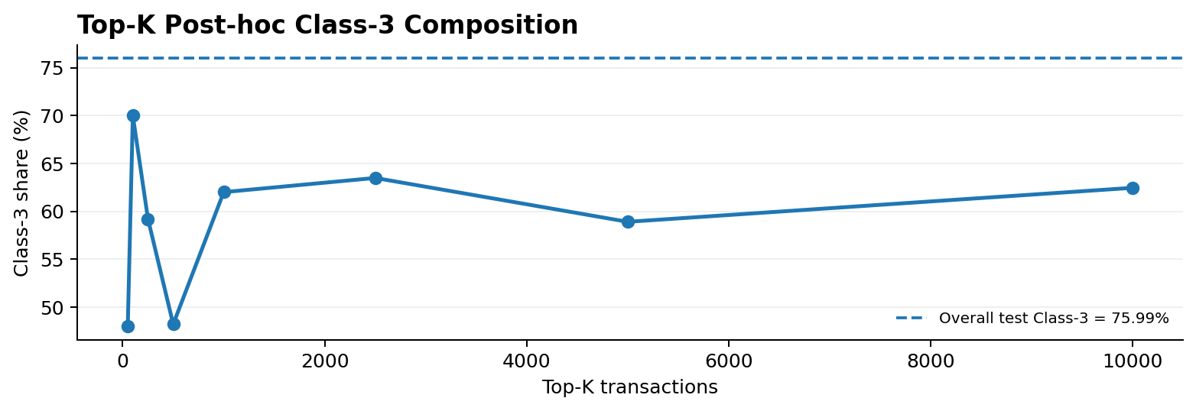

03 ALERT GENERATION + INVESTIGATION EVIDENCE
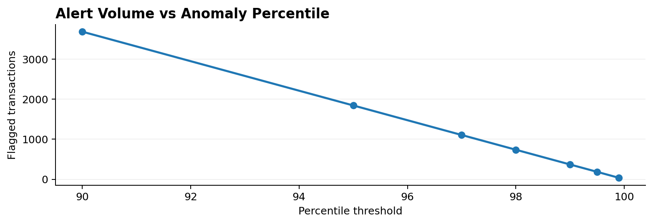
PERCENTILE | THRESHOLD | FLAGGED | CLASS-3 COUNT | CLASS-3 %
90.0 | 3.151111 | 3,683 | 2,233 | 60.63%
95.0 | 5.533998 | 1,842 | 1,176 | 63.84%
97.0 | 9.796651 | 1,105 | 695 | 62.90%
98.0 | 11.859749 | 737 | 396 | 53.73%
99.0 | 29.643092 | 369 | 190 | 51.49%
99.5 | 240.356845 | 185 | 140 | 75.68%
99.9 | 1791.766856 | 37 | 11 | 29.73%
Highest anomaly examples
TXID | TIME | CLASS | IF | LOF | ENSEMBLE
94664385 | 43 | 3 | 0.083890 | 114345.767514 | 45738.357340
6069276 | 48 | 3 | 2.346352 | 75568.866610 | 30228.954455
66435614 | 46 | 2 | 3.644349 | 69355.445876 | 27744.364960
66435532 | 46 | 2 | 3.657703 | 69284.650848 | 27716.054961
218099491 | 47 | 2 | 3.489501 | 66607.445876 | ≈26,642*
*The fifth LOF/ensemble value is truncated in the recorded terminal excerpt; it is intentionally not reconstructed here.
WHAT CONSTITUTES EVIDENCE IN BIT-TRACE
Transaction ID + time step + model scores + anomaly percentile + investigation level + behavioural evidence + transaction-graph features + temporal context.

04 OUTPUT FILES — REPRODUCIBLE EVIDENCE
GENERATED OUTPUT | PURPOSE
bittrace_transaction_large_scale_results.csv | Full transaction-level model results
bittrace_transaction_top100.csv | Top 100 anomalous transactions
bittrace_transaction_topk.csv | Top-K analysis
bittrace_transaction_temporal.csv | Temporal analysis
bittrace_transaction_thresholds.csv | Threshold / alert-volume analysis
bittrace_transaction_class_summary.csv | Class-wise summary
bittrace_transaction_score_distribution.csv | Model score distributions
Recorded run checklist
COMPONENT | RECORDED
203,769 transactions loaded | ✓
184 source columns verified | ✓
13 features used | ✓
Temporal split 1–34 / 35–41 / 42–49 | ✓
Scaler fitted only on training | ✓
Isolation Forest | ✓
LOF | ✓
Ensemble | ✓
Top-K analysis | ✓
Threshold analysis | ✓
Temporal analysis | ✓
Post-hoc evaluation | ✓
P2P/network data | Not used in this transaction run
MVP evidence in one view
EVALUATOR VIEW
DATA VERIFIED → TEMPORAL TEST SET → UNSUPERVISED DETECTION → ANOMALY SCORE → RANKING → INVESTIGATION EVIDENCE → CSV OUTPUTS
Important interpretation
The recorded results demonstrate a working transaction-analysis MVP and its investigation outputs. The model score is an anomaly signal, not a finding that a transaction is criminal or illicit. P2P/network correlation is outside this recorded transaction-only run.
BIT-TRACE | EXECUTION EVIDENCE | TRANSACTION MVP

