ATMC: what we have done and found
A self-evolving coding assistant on a local model. Results summary for guide review.

1. The project in one minute
- Goal: a coding assistant that learns from its own mistakes without being retrained.
- How: the assistant answers a question, tests run its code, and when it fails, the checker's evidence and a verified fix are saved to a memory. Later, similar questions use those notes.
- ATMC is our memory design: trust scores, forgetting and merging of notes. The research question is whether those extras beat a simple memory.
- Model: Qwen2.5-Coder 7B running locally on the laptop (no cloud, no cost). Gemini was used in the earlier experiments.

2. What is built and working
Part | Status
Chat assistant: runs generated code in a sandbox, checks it with tests | Working
Memory (simple and ATMC), automatic answer checking, strategy evolution with rollback | Working
Runs on Gemini or on the local Qwen model | Working
Learning Lab: live side-by-side demo, same questions to an assistant with no memory and one with memory | Working (full live run: 25% vs 36%)
Our own test: 110 hidden-rule questions, 30 unseen held-out questions, two rule-change streams | Built and validated by running every task
Experiment tools with statistics and predictions written before each run | Working; 200 automated tests pass

3. How we tested it
- The test: 110 coding questions. Each one hides a company rule the question never states (money in paise, dates as DD-MM-YYYY, return None instead of crashing, and so on).
- Why it is fair: on 10 ordinary control questions Qwen scored 100%, so it codes fine; it fails the others only because it does not know the rule. Every task was checked by running a correct solution and a rule-ignoring one.
- Unseen questions: questions arrive one at a time, so memory only holds earlier, different questions.
- Fair comparison: the same questions in the same order for every system, 3 different orders, paired statistics (95% interval, exact test). Predictions and pass/fail rules were written before each run.

4. Results on the main test (3 runs, 330 question comparisons each)
# | Question we asked | Result | What it means
1 | Does learning from failures work? | No memory 24.2%, simple memory 40.0% (+15.8 points, p < 0.0001) | Yes. The core claim holds.
2 | Does the original ATMC beat simple memory? | ATMC 28.5% vs simple 40.0% | No: the extras made it worse.
3 | Which ATMC part is responsible? | Trust alone 38.2% (no real change); adding forgetting 30.6% (-7.6); adding merging 30.9% | Forgetting deleted useful lessons too early. Trust was neutral.
4 | Does trust protect when the checker is wrong 25% / 50% of the time? | +0.6 and +2.4 points, both not significant | Not shown.
5 | Add verified worked examples and one retry from the checker's evidence | Simple 43.0% vs ATMC with rule cards 43.9% (+0.9, p = 0.79). About 67% after the retry | Examples and the retry help every system. ATMC adds nothing measurable.
6 | Learned utility ranking and a retry that uses memory (v4) | Simple 46.4% vs ATMC 45.5% (-0.9, p = 0.78). About 69% after the retry | Our pre-set rule (+3 points) was not met.
7 | Show only verified notes (abstention) | Simple 46.1% (no change); ATMC 40.0% (-6.1 vs simple, p = 0.006) | Does not help; it hurt ATMC.

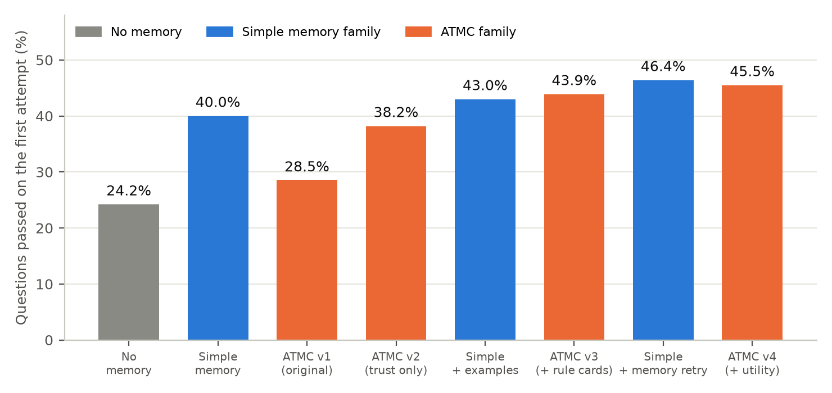
First-attempt pass rate on the 110 hidden-rule questions (average of 3 runs). ATMC improved from 28.5% to 45.5% across versions but never moved past simple memory.

5. When a rule changes (old notes become wrong)
29 questions are asked under an old rule and then again under the opposite rule (for example dates change from DD-MM-YYYY to YYYY-MM-DD), so every saved note about them is now wrong. This is the situation trust and forgetting are meant for.
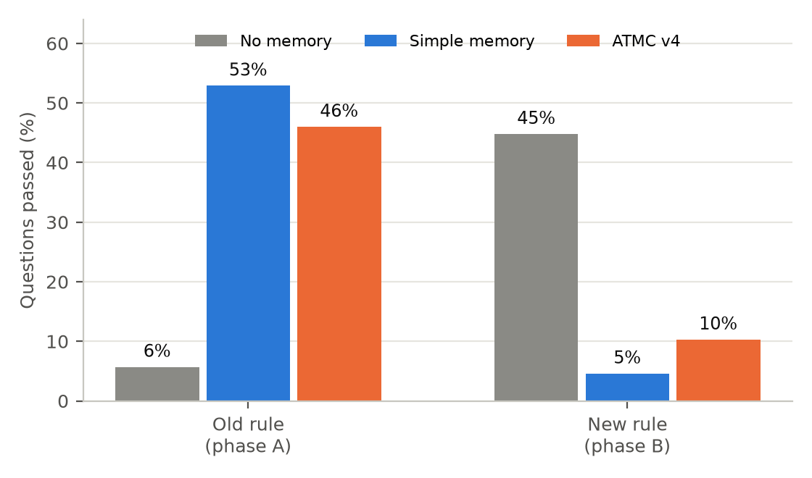
Pass rate before and after the rule flips (average of 3 runs).
- Simple memory collapses to 5%, far below having no memory at all (45%): stale notes actively mislead the model.
- ATMC v4 reaches 10% (+5.7 points over simple memory, p = 0.125, not significant). It also collapses, because its trust updates are too slow when each note is only shown a few times.
- In progress: a re-verification detector. After a failure, every stored solution for the same function is re-run against the current tests; one that now fails is proven stale and its older neighbours are demoted together. Runs are under way. A second, unseen rule-change stream is reserved for one final test with nothing changed.

6. What we can and cannot claim
We can claim (backed by data) | We cannot claim yet
A small local model learns hidden project rules from its own verified failures: 24% to 40% first attempt, about 69% after one evidence-guided retry | That ATMC beats a simple memory
It works without any cloud model, fully on the laptop, and ordinary questions are not harmed (controls stay 100%) | That trust makes learning safe when the checker is wrong
We know why each ATMC part helps or hurts, from controlled tests with predictions fixed in advance | That ATMC handles rule changes (detector still being tested)
A new validated benchmark of hidden conventions, and a live demo of the learning | That the model's weights improved (no training has been done)

Limits: the test is self-written, one 7B model, 3 runs per setting. Because the design was tuned on this test, the 30 unseen questions and the second rule-change stream are reserved for single, final runs.

7. Next steps
- Finish the re-verification detector runs; then one final run on the unseen rule-change stream.
- Run the final design once on the 30 unseen held-out questions.
- Fine-tune the local model on its own verified solutions (the model itself would change), then test on unseen questions with memory switched off.
- Update the paper, novelty analysis, slides and demo with these results.

8. Questions the guide may ask
Question | Short answer
Is the model being trained? | No. Only the memory grows. Fine-tuning is a planned next step.
Is the test rigged? | The hidden rules cannot be guessed, so failures are not coding weakness (controls 100%). It measures learning, not general coding, and we say so. Unseen sets are reserved for final checks.
So is ATMC useless? | Not shown to beat a simple memory on clean data; it improved 17 points across versions. The rule-change test is where it should matter, and it is under test now. The learning itself works either way.
Why a small local model? | It is private, free and unlimited, and it makes real mistakes, so learning is visible. The closest papers mostly use large cloud models.

All numbers come from saved result files in pilot/results and docs/results; experiment notes with the predictions are in docs/experiments.

